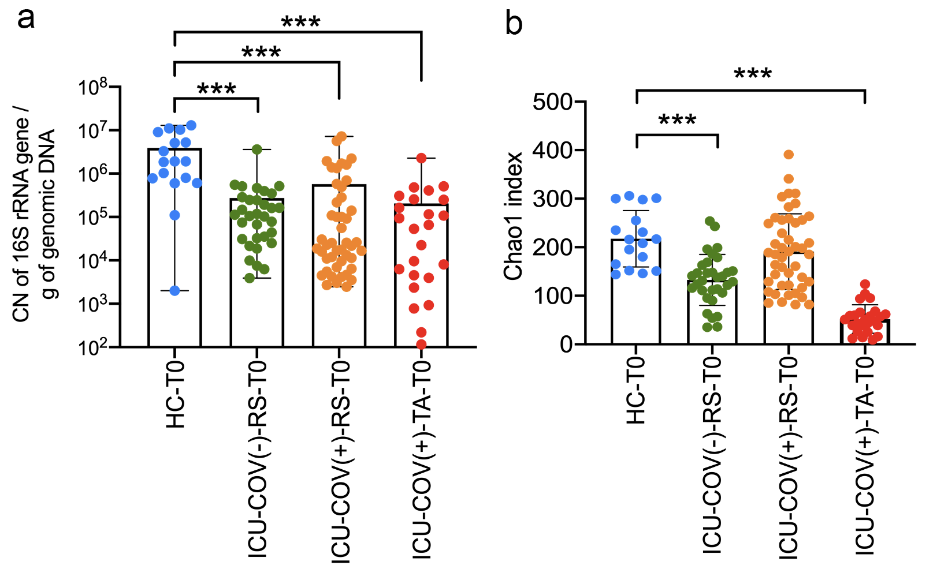

Supplementary Figure S1. a, Bacterial load in critically ill patients as assessed by qPCR of the V4 region of the 16S rRNA gene on ICU admission b, Bacterial richness as assessed by the Chao1 index analysis of the 16S rRNA sequences on ICU admission day.

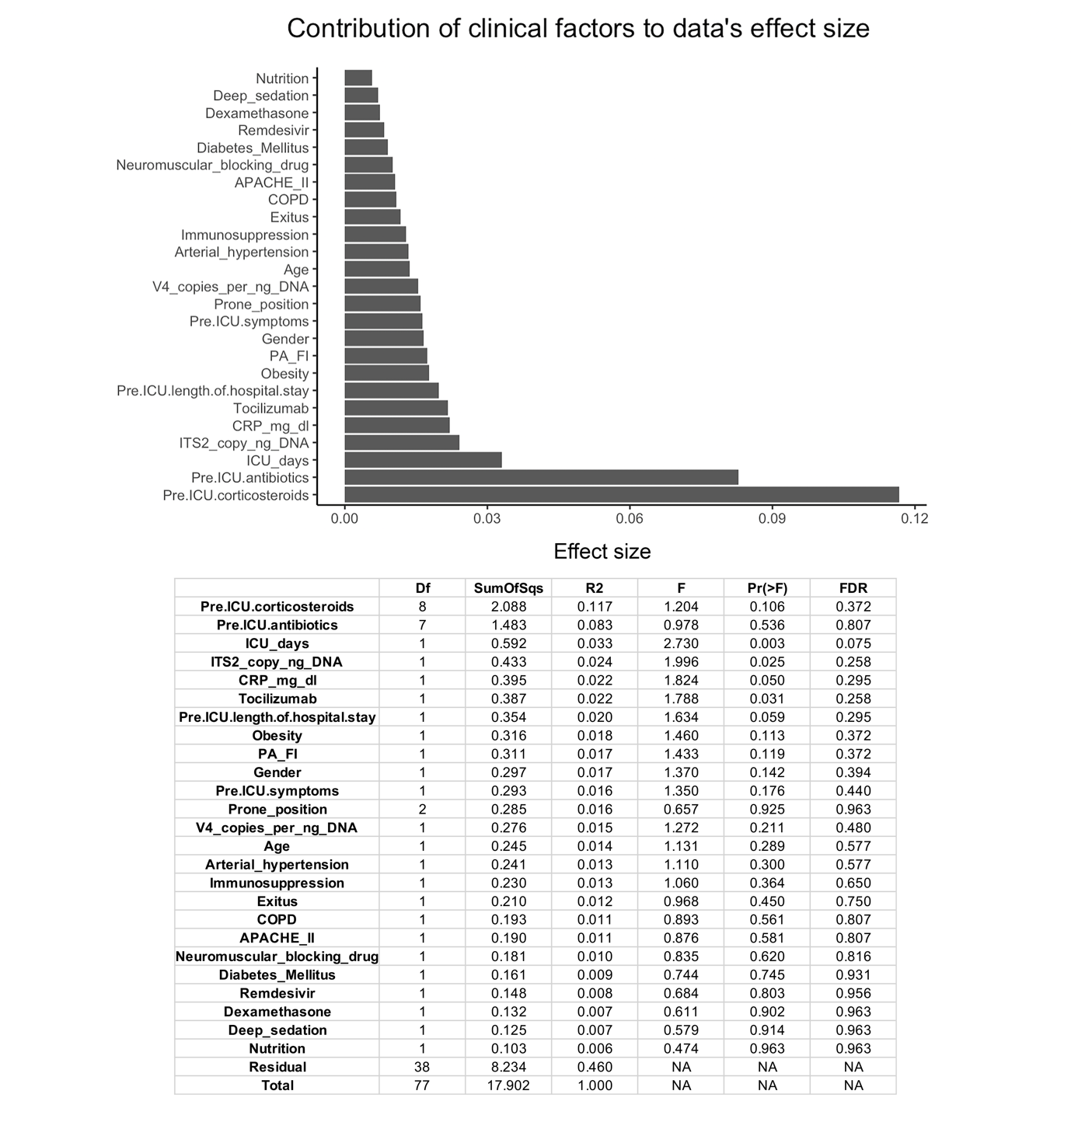
Supplementary Figure S2. Analysis of covariates with potential effect on microbiome variation in samples collected at baseline from ICU-COV(-) and ICU-COV(+) patients using the adonis test.

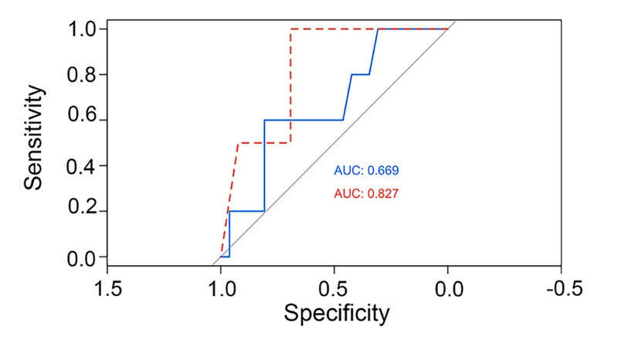
Supplementary Figure S3. Receiver operating characteristic (ROC) curves for the random forest model to predict exitus using seven gut bacterial taxa, namely Prevotella tannerae, Bulleidia moorei, Rothia mucilaginosa, and undefined species assigned to the Pseudomonas, Streptococcus, Actinomyces, Tannerella genera. The model was created by randomly splitting the population of interest into a training set (2/3, blue curve) and a test set (1/3, red curve).

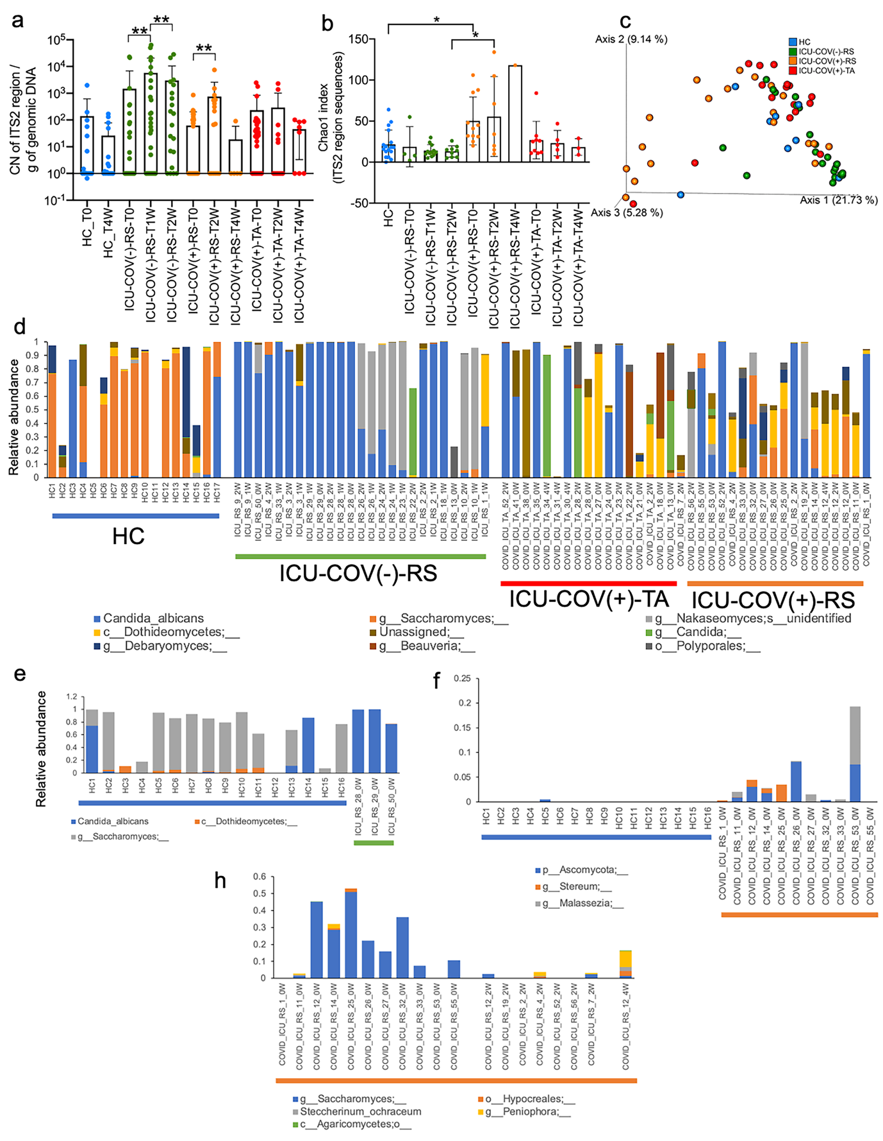

Supplementary Figure S4. Alteration of the fungal microbiome in the ICU. a, Dynamic of the fungal load as assessed by qPCR of the ITS2 region in gut and respiratory samples. b, Fungal richness as assessed by the Chao1 index analysis of the ITS2 sequences. c, Beta-diversity analysis based on unweighted UniFrac metric distances. d, Fungal taxonomic profiles for each gut and respiratory sample for the three groups of subjects. e, Comparison of gut microbiome of ICU-COV(-) patients with that of HCs at baseline. f, Comparison of gut microbiome of ICU-COV(+) patients with that of HCs at baseline. h, Changes over time of the gut fungal microbiome of ICU-COV(+) patients. Only taxa found significantly different between groups were plotted (FDR<0.05). MaAsLin2 tool was used for comparison analysis.

