Section II.D: Example – Falling rain
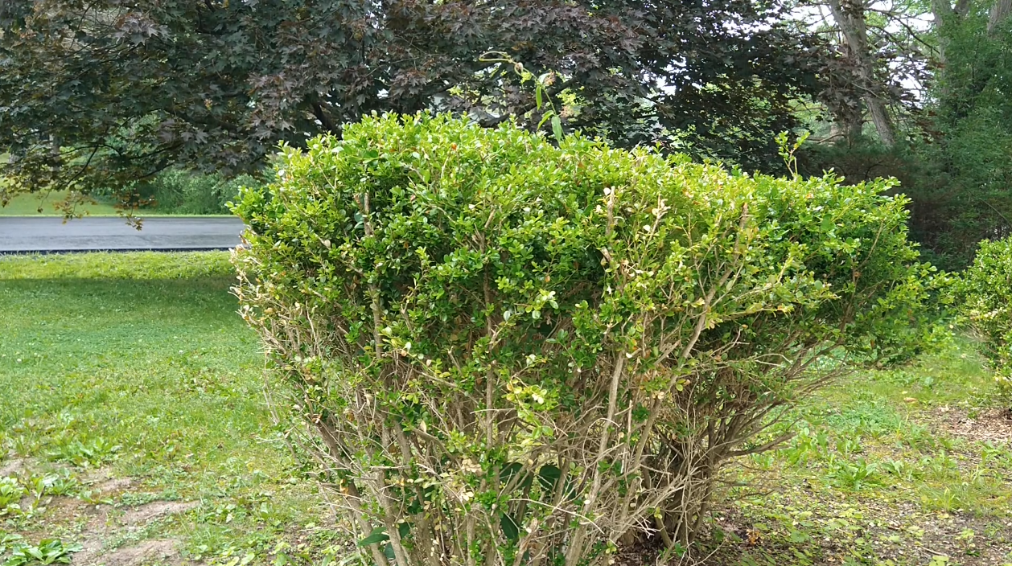 | rain_a.mp4 | High-resolution video of a rainy scene acquired with the smartphone’s camera app
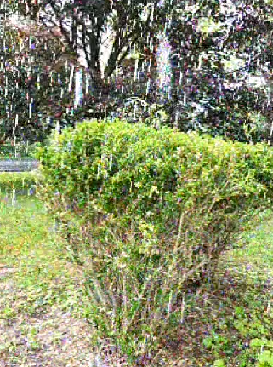 | rain_b.mp4 | MEMAD motion amplified video with α = 32, β = 1
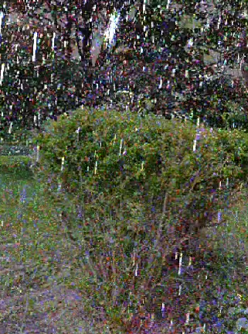 | rain_c.mp4 | MEMAD motion amplified video with α = 32, β = 0.5
Section III.A: Engineering application - Engine vibrations
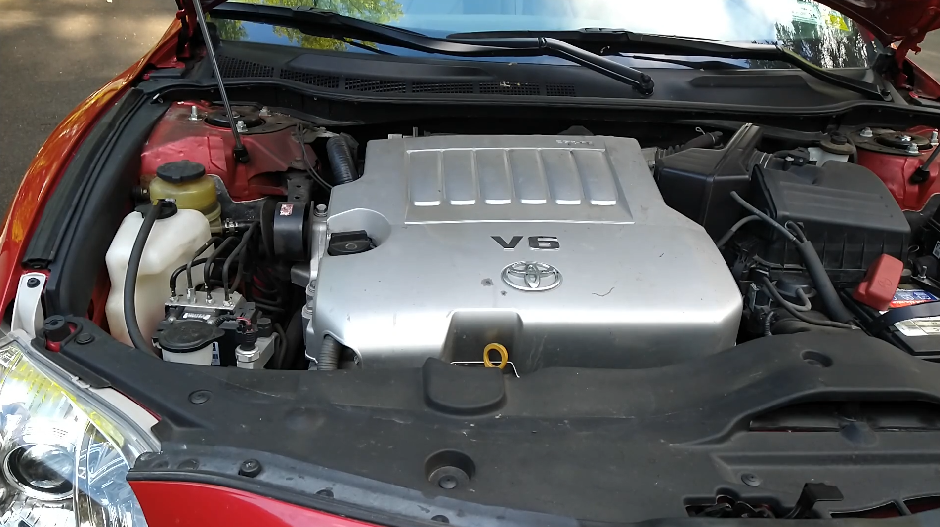 | engine_a.mp4 | High-resolution video of a car engine acquired with the smartphone’s camera app
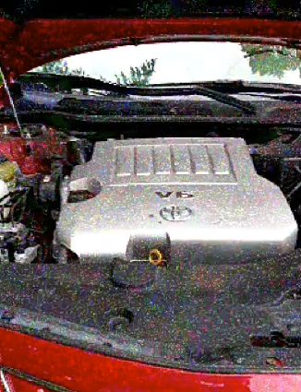 | engine_b.mp4 | MEMAD motion amplified video with α = 32, β = 1
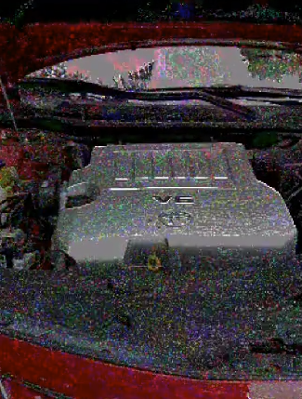 | engine_c.mp4 | MEMAD motion amplified video with α = 32, β = 0.5
Section III.B: Telehealth application - Remote pulse sensing
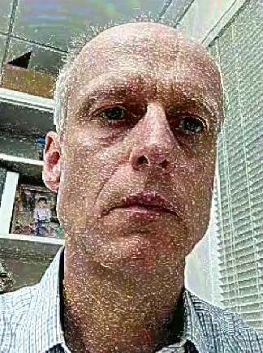 | pulse.mp4 | MEMAD video stream from the smartphone’s front camera, α = 16, β = 1.
Section III.C: Biological application – Wildlife camera trapping of small animals
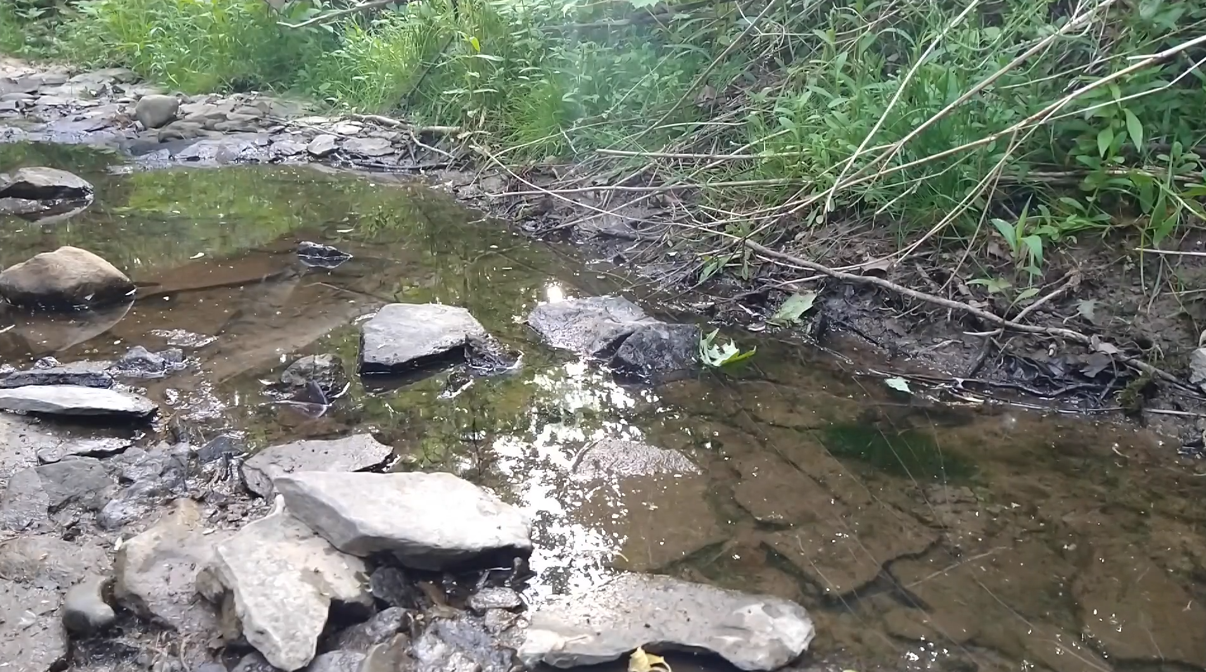 | smallanimals_a.mp4 | High-resolution video of a nature scene acquired with the smartphone’s camera app
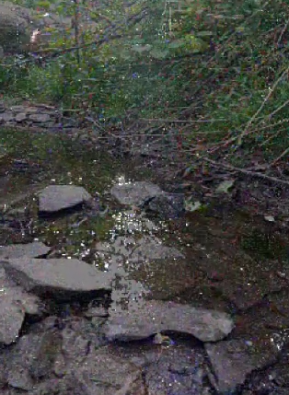 | smallanimals_b.mp4 | MEMAD motion amplified video with α = 16, β = 0.5
Table 1. Video files

