Supplementary Tables and Figures:
Supplementary Table 1: Eigenvalues of each parameter in the three PCs for bull sperm head morphometry found in sperm migrated or not migrated by thermotaxis
 | PC1 | PC2 | PC3
Length | 0.612 | 0.604
Width | -0.801 | 0.459
Perimeter | -0.108 | 0.923 | 0.164
Area |  | 0.124 | 0.948
Ellipticity | 0.999
Rugosity |  | -0.861 | 0.242
Elongation | 1
Regularity | -0.183 | 0.529 | -0.766
Explained variation (%) | 38.4 | 30.8 | 19.9
PCs: principal components

Supplementary Table 2: Mean values (±S.D.) of each morphometric parameter corresponding to different SPs from bull sperm head morphometry found in sperm migrated or not migrated by thermotaxis
 | SP1 | SP2 | SP3 |  |  | SP4
Length | 9.46 ± 0.24ª | 8.96 ± 0.28^{b} |  | 8.92 ± 0.26 ^{b} | 9.45 ± 0.30ª
Width | 4.31 ± 0.13ª | 4.01 ± 0.17^{b} |  | 4.39 ± 0.16^{c} | 4.02 ± 0.13^{b}
Perimeter | 34.79 ± 1.77ª | 30.74 ± 1.35^{b} |  | 33.55 ± 1.63^{c} | 33.68 ± 1.40^{c}
Area | 37.51 ± 1.97ª | 38.15 ± 2.35^{b} |  | 38.80 ± 1.94^{b} | 38.67 ± 1.83^{b}
Ellipticity | 2.19 ± 0.08ª | 2.24 ± 0.1^{b} |  | 2.03 ± 0.08^{c} | 2.35 ± 0.10^{d}
Rugosity | 0.39 ± 0.04ª | 0.51 ± 0.05^{b} |  | 0.44 ± 0.04^{c} | 0.43 ± 0.04^{c}
Elongation | 0.37 ± 0.01ª | 0.38 ± 0.02^{b} |  | 0.34 ± 0.02^{c} | 0.40 ± 0.02^{d}
Regularity | 0.86 ± 0.05ª | 0.74 ± 0.05^{b} |  | 0.79 ± 0.05^{c} | 0.77 ± 0.04^{d}
SPs: subpopulations; S.D.: standard deviation. Values with different superscripts (a, b, c, d) in the same row were significantly different (Kruskal-Wallis one way analysis of variance on ranks, p<0.01).

Supplementary Figure 1: Density plots showing the distribution of the 8 morphometric variables in both migrated and not-migrated spermatozoa after thermotaxis.

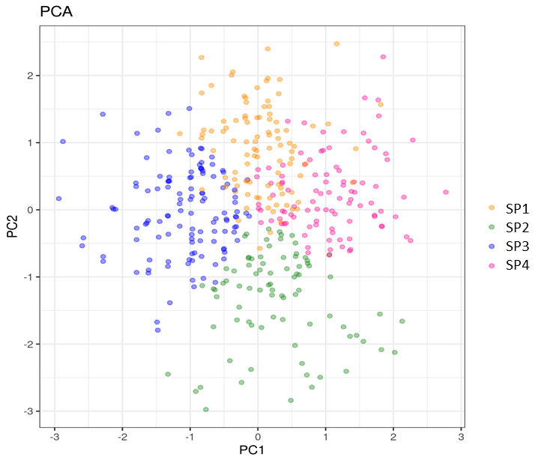
Supplementary Figure 2: Distribution of sperm subpopulations according to their PC values.

Supplementary Figure 3: Boxplots showing the distribution of the morphometric variables of the four subpopulations along with mean comparison p-values obtained by the t-test.

