Supplementary Material

GWAS of pod morphological and color characters in common bean

Carmen García-Fernández, Plant Genetic Group, Regional Service for Agrofood Research and Development (SERIDA), 33300, Villaviciosa, Asturias, Spain. cgarcia@serida.org
https://orcid.org/0000-0002-0664-796X
Ana Campa, Plant Genetic Group, Regional Service for Agrofood Research and Development (SERIDA), 33300, Villaviciosa, Asturias, Spain. acampa@serida.org
https://orcid.org/0000-0003-3970-9079
Alvaro Soler Garzón, Washington State Univ., Irrigated Agriculture Research and Extension Center, Prosser, Washington 99350, USA. alvaro.solergarzon@wsu.edu
Phil Miklas, USDA-ARS, Grain Legume Genetics and Physiology Research Unit, Prosser, Washington 99350, USA. phil.miklas@usda.gov
https://orcid.org/0000-0002-6636-454X
Juan Jose Ferreira, Plant Genetic Group, Regional Service for Agrofood Research and Development (SERIDA), 33300, Villaviciosa, Asturias, Spain. jjferreira@serida.org https://orcid.org/0000-0002-8782-8868

Figure S3 Pods variation in the SDP. Picture shows a pod per line include in the Spanish Diversity Panel

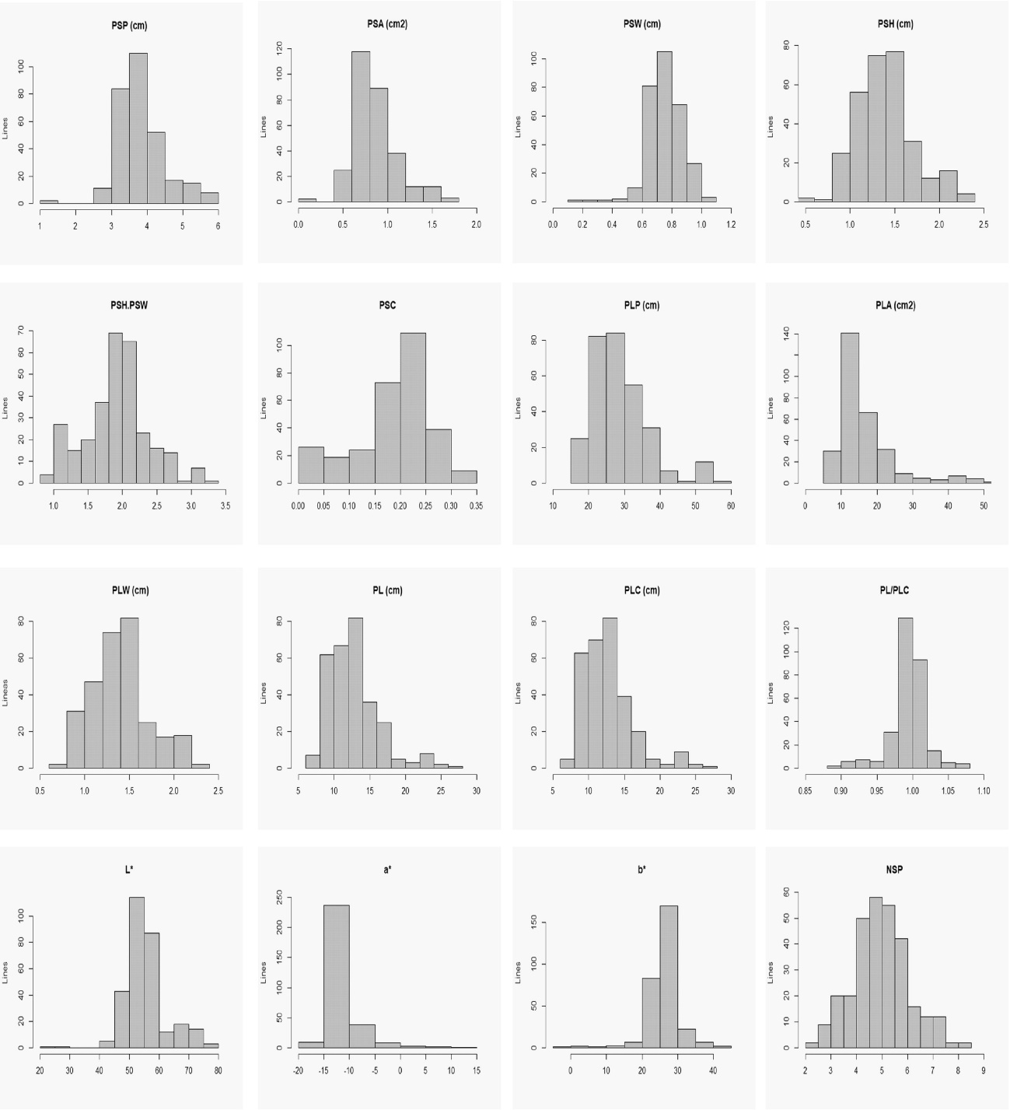

Figure S1. Histograms showing the distributions (mean environment data) for the16 quantitative pod traits assessed in the Spanish Diversity Panel

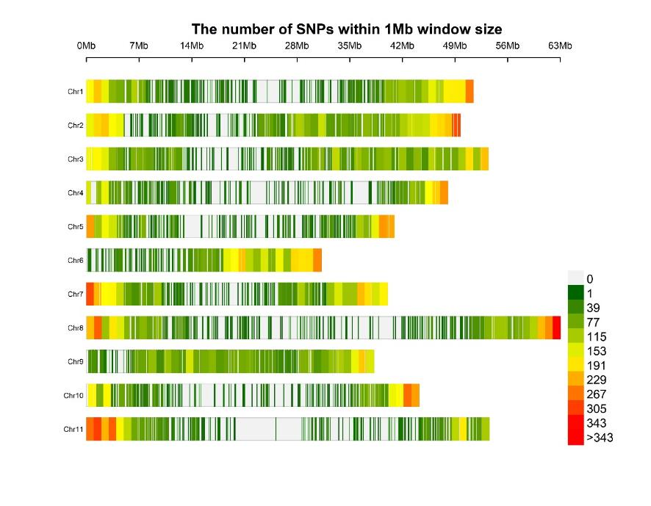
Figure S2 SNP density plot across the eleven bean chromosomes

Table S1 Observed variation for 16 quantitative traits in the in the Spanish Diversity Panel evaluated in two seasons: Mean, standard error (SE), maximum (Max) and minimum (Min) values. H², estimated broad-sense heritability.
Trait | Unidad | Mean | SE | Max | Min | H²
PodSectionPerimeter (PSP) | cm | 3.83 | ±0.05 | 5.82 | 1.06 | 0.75
PodSectionArea (PSA) | cm² | 0.86 | ±0.02 | 1.72 | 0.42 | 0.63
PodSectionWidth (PSW) | cm | 0.75 | ±0.01 | 1.06 | 0.19 | 0.31
PodSectionHeight (PSH) | cm | 1.40 | ±0.02 | 2.35 | 0.40 | 0.86
Pod Section index (PSH/PSW) |  | 1.91 | ±0.03 | 3.21 | 0.95 | 0.75
PodSection circular (PSC) |  | 0.19 | ±0.00 | 0.33 | 0.03 | 0.82
PodLengthPerimeter (PLP) | cm | 28.78 | ±0.54 | 58.44 | 16.86 | 0.90
PodLengthArea (PLA) | cm² | 16.52 | ±0.49 | 54.33 | 7.58 | 0.89
PodLengthWidth (PLW) | cm | 1.41 | ±0.02 | 2.36 | 0.72 | 0.91
PodLength (PL) | cm | 12.73 | ±0.24 | 26.49 | 7.17 | 0.89
PodLengthCurved (PLC) | cm | 12.74 | ±0.24 | 26.29 | 7.61 | 0.90
Pod Length index (PL/PLC) |  | 1.00 | ±0.01 | 1.08 | 0.89 | 0.63
PodColor_L* (L*) |  | 55.39 | ±0.71 | 77.29 | 20.18 | 0.67
PodColor_a* (a*) |  | -11.92 | ±0.25 | 13.96 | -15.51 | 0.87
PodColor_b* (b*) |  | 26.12 | ±0.38 | 40.82 | -4.38 | 0.78
N. seed per pod (NSP) | seeds | 4.97 | ±0.08 | 8.31 | 2.27 | 0.88

Table S2. Significant associations trait-SNP with -log(p) >5 detected from SL-GWAS for the 17 pod traits evaluated. For each association trait-SNP, it is indicated the percentage phenotypic variance explained (R²), minor allele frequency (MAF) and percentage of missing values (%) in the genotyping. The SNP name shows the location in the bean genome v2.1 (chromosome and bp).
Character | Trait | SNP | LOD score | R² (%) | MAF | Missing values (%)
Pod color | b* | S07_32026373 | 5.42 | 7.62 | 0.31 | 0.00
 | b* | S07_32026406 | 5.42 | 7.62 | 0.31 | 0.00
 | b* | S07_32069837 | 5.63 | 7.95 | 0.29 | 47.56
 | b* | S07_32158939 | 5.44 | 7.64 | 0.31 | 0.65
 | b* | S07_32263968 | 5.42 | 7.62 | 0.26 | 26.06
 | b* | S07_32370842 | 5.39 | 7.57 | 0.29 | 46.91
 | b* | S07_32371901 | 5.42 | 7.61 | 0.31 | 1.30
 | b* | S07_32413400 | 5.42 | 7.62 | 0.31 | 0.00
 | b* | S07_32413401 | 5.42 | 7.62 | 0.31 | 0.00
 | L* | S04_7272451 | 5.09 | 7.05 | 0.07 | 0.00
Pod length | PL | S01_45582871 | 5.42 | 6.94 | 0.24 | 4.23
 | PLC | S01_45582871 | 5.39 | 6.95 | 0.24 | 4.23
 | PLP | S01_45582871 | 5.48 | 7.14 | 0.24 | 4.23
 | PL | S01_45808553 | 6.09 | 7.93 | 0.07 | 5.86
 | PLA | S01_45808553 | 5.45 | 6.87 | 0.07 | 5.86
 | PLC | S01_45808553 | 6.45 | 8.55 | 0.07 | 5.86
 | PLP | S01_45808553 | 6.81 | 9.16 | 0.07 | 5.86
 | PL | S01_45830396 | 5.65 | 7.26 | 0.08 | 30.94
 | PLA | S01_45830396 | 5.52 | 6.95 | 0.08 | 30.94
 | PLC | S01_45830396 | 5.68 | 7.37 | 0.08 | 30.94
 | PLP | S01_45830396 | 5.77 | 7.56 | 0.08 | 30.94
 | PL | S01_45878761 | 6.09 | 7.93 | 0.07 | 0.98
 | PLA | S01_45878761 | 5.45 | 6.87 | 0.07 | 0.98
 | PLC | S01_45878761 | 6.45 | 8.55 | 0.07 | 0.98
 | PLP | S01_45878761 | 6.81 | 9.16 | 0.07 | 0.98
 | PL | S01_48090873 | 7.12 | 9.49 | 0.11 | 1.30
 | PLA | S01_48090873 | 5.25 | 6.58 | 0.11 | 1.30
 | PLC | S01_48090873 | 7.15 | 9.62 | 0.11 | 1.30
 | PLP | S01_48090873 | 7.15 | 9.69 | 0.11 | 1.30
 | PL | S01_48278829 | 6.25 | 8.29 | 0.32 | 12.70
 | PLC | S01_48278829 | 6.18 | 8.24 | 0.32 | 12.70
 | PLP | S01_48278829 | 6.20 | 8.32 | 0.32 | 12.70
 | PL | S01_48454910 | 5.33 | 6.78 | 0.13 | 0.65
 | PLC | S01_48454910 | 5.40 | 6.95 | 0.13 | 0.65
 | PLP | S01_48454910 | 5.16 | 6.64 | 0.13 | 0.65
 | PL | S01_48454962 | 5.33 | 6.78 | 0.13 | 0.33
 | PLC | S01_48454962 | 5.40 | 6.95 | 0.13 | 0.33
 | PLP | S01_48454962 | 5.16 | 6.64 | 0.13 | 0.33
 | PL | S01_49004631 | 6.39 | 8.37 | 0.07 | 0.33
 | PLC | S01_49004631 | 7.01 | 9.40 | 0.07 | 0.33
 | PLP | S01_49004631 | 7.24 | 9.82 | 0.07 | 0.33
 | PL | S02_47302543 | 5.73 | 7.39 | 0.12 | 8.79
 | PLC | S02_47302543 | 6.63 | 8.82 | 0.12 | 8.79
 | PLP | S02_47302543 | 7.17 | 9.71 | 0.12 | 8.79
 | PLC | S02_47600690 | 5.52 | 7.13 | 0.18 | 0.00
 | PLP | S02_47600690 | 5.70 | 7.45 | 0.18 | 0.00
 | PLP | S04_3787273 | 5.30 | 6.85 | 0.13 | 16.94
 | PLW | S05_31050333 | 5.37 | 6.86 | 0.12 | 30.62
 | PL/PLC | S06_11514633 | 6.15 | 8.57 | 0.09 | 24.76
 | PLA | S06_18830291 | 6.99 | 9.14 | 0.05 | 2.28
 | PLW | S06_18830291 | 5.22 | 6.59 | 0.05 | 2.28
 | PL/PLC | S06_4419626 | 5.70 | 8.00 | 0.08 | 14.66
 | PL | S10_1425611 | 5.48 | 7.00 | 0.10 | 23.78
 | PL | S10_19251851 | 6.84 | 9.10 | 0.37 | 39.09
 | PLA | S10_19251851 | 5.20 | 6.58 | 0.37 | 39.09
 | PLC | S10_19251851 | 6.98 | 9.41 | 0.37 | 39.09
 | PLP | S10_19251851 | 6.38 | 8.55 | 0.37 | 39.09
 | PL | S10_26235406 | 6.03 | 7.83 | 0.25 | 3.58
 | PLC | S10_26235406 | 6.24 | 8.22 | 0.25 | 3.58
 | PLP | S10_26235406 | 5.71 | 7.47 | 0.25 | 3.58
Pod section | PSH/PSW | S06_18830291 | 5.98 | 8.45 | 0.05 | 3.58
 | PSH | S05_39514093 | 5.84 | 8.33 | 0.05 | 3.58
 | PSP | S05_39514093 | 5.02 | 6.39 | 0.05 | 2.28

Table S3 Significant associations trait-SNP with LOD score >5 for pod section traits detected from ML-GWAS. Range of QTN effects, LOD scores, percentage of phenotypic variance explained (R²), minor allele frequency (MAF) and, percentage of missing values (%) in the genotyping are indicated for each QTN together the multi-locus GWAS method(s). The SNP name indicates the location in the bean genome V2.1 (chromosome and bp).

Trait | SNP | QTN effect |  |  | LOD score |  |  | R2 (%) |  |  | MAF | Missing values (%) | Method¹
PSP | S04_1421410 | 0.1 |  |  | 7.9 |  |  | 9.6 |  |  | 0.3 | 47.2 | 6
PSW | S10_29414658 | -0.1 | ~ | 0.0 | 9.0 | ~ | 9.1 | 16.1 | ~ | 23.6 | 0.3 | 45.0 | 1,6
PSA | S08_2442492 | 0.1 |  |  | 7.2 |  |  | 24.1 |  |  | 0.3 | 8.1 | 1
PSH | S04_44087509 | 0.1 |  |  | 6.5 |  |  | 2.3 |  |  | 0.3 | 3.9 | 5
PSH | S06_18457867 | -0.1 |  |  | 10.1 |  |  | 8.8 |  |  | 0.3 | 37.5 | 1
PSH | S06_18830291 | -0.2 |  |  | 12.1 |  |  | 8.9 |  |  | 0.1 | 2.3 | 1
PSH | S08_57231193 | -0.1 | ~ | -0.1 | 5.3 | ~ | 6.6 | 3.6 | ~ | 6.3 | 0.3 | 15.6 | 2,6
PSH | S10_36133101 | -0.3 |  |  | 7.3 |  |  | 17.9 |  |  | 0.3 | 25.4 | 4
PSH/PSW | S02_39483988 | 0.1 | ~ | 0.1 | 5.5 | ~ | 6.1 | 4.3 | ~ | 4.5 | 0.4 | 9.8 | 1,2
PSH/PSW | S04_44563602 | -0.1 |  |  | 5.8 |  |  | 7.7 |  |  | 0.5 | 1.3 | 5
PSH/PSW | S06_19126075 | 0.4 |  |  | 9.5 |  |  | 12.8 |  |  | 0.3 | 29.6 | 4
PSH/PSW | S06_19126326 | -0.1 | ~ | -0.1 | 6.5 | ~ | 12.6 | 4.5 | ~ | 12.3 | 0.2 | 30.9 | 3,6
PSH/PSW | S09_34496801 | 0.1 | ~ | 0.1 | 5.5 | ~ | 10.0 | 1.7 | ~ | 4.9 | 0.2 | 0.0 | 2,3,5
PSP | S09_27118120 | 0.2 |  |  | 8.7 |  |  | 9.3 |  |  | 0.4 | 7.8 | 6

¹ 1;:mrMLM; 2:FASTmrMLM; 3:ISIS EM-BLASSO; 4:FASTmrEMMA; 5:pLARmEB; 6:pKWmEB.

Table S4 Significant associations trait-SNP for pod length related traits detected from ML-GWAS. Range of QTN effects, LOD scores, percentage of phenotypic variance explained (R²), minor allele frequency (MAF), and percentage of missing values (%) in the genotyping are indicated together the multi-locus GWAS method(s). The SNP name indicates the location in the bean genome V2.1 (chromosome and bp).
Trait | SNP | QTN effect |  |  | LOD score |  |  | R2 (%) |  |  | MAF | Missing values (%) | Method¹
NSP | S01_51036529 | -0.2 |  |  | 6.8 |  |  | 5.5 |  |  | 0.3 | 0.0 | 6
NSP | S01_51047344 | 0.5 |  |  | 5.2 |  |  | 5.0 |  |  | 0.4 | 0.0 | 4
NSP | S02_48762536 | 0.3 | ~ | 0.3 | 5.5 | ~ | 6.2 | 4.7 | ~ | 5.1 | 0.3 | 30.3 | 1,2
NSP | S03_49492839 | -0.3 |  |  | 6.6 |  |  | 7.1 |  |  | 0.3 | 5.2 | 3
NSP | S04_45971702 | 0.3 |  |  | 5.6 |  |  | 6.3 |  |  | 0.3 | 2.9 | 1
NSP | S06_18752100 | 0.4 |  |  | 6.0 |  |  | 10.0 |  |  | 0.2 | 2.9 | 6
NSP | S08_1771186 | 0.3 |  |  | 6.2 |  |  | 7.4 |  |  | 0.2 | 33.2 | 2
NSP | S08_56050073 | -0.2 |  |  | 5.5 |  |  | 9.7 |  |  | 0.5 | 2.3 | 6
NSP | S10_2237697 | 0.2 |  |  | 8.0 |  |  | 3.9 |  |  | 0.1 | 26.1 | 3
NSP | S10_44171947 | -0.4 | ~ | -0.3 | 5.9 | ~ | 7.5 | 3.0 | ~ | 4.4 | 0.1 | 24.8 | 1,2
PL/PLC | S01_47686537 | 0.0 |  |  | 5.5 |  |  | 1.6 |  |  | 0.2 | 42.7 | 6
PL/PLC | S06_4419626 | 0.0 |  |  | 8.9 |  |  | 2.2 |  |  | 0.1 | 14.7 | 5
PL | S01_48278829 | -0.6 |  |  | 6.1 |  |  | 6.0 |  |  | 0.3 | 12.7 | 6
PL | S02_29140583 | 0.8 |  |  | 6.2 |  |  | 1.3 |  |  | 0.1 | 4.2 | 5
PL | S02_47302543 | -2.2 | ~ | -1.1 | 5.1 | ~ | 6.5 | 4.1 | ~ | 4.1 | 0.1 | 8.8 | 1,4
PL | S02_47669811 | -0.8 |  |  | 5.6 |  |  | 3.0 |  |  | 0.1 | 3.6 | 3
PLA | S01_38143057 | 2.0 |  |  | 7.1 |  |  | 5.3 |  |  | 0.1 | 5.2 | 6
PLA | S01_48090873 | -2.8 | ~ | -2.7 | 9.4 | ~ | 10.0 | 4.7 | ~ | 5.0 | 0.1 | 1.3 | 1,2
PLA | S01_48278829 | -3.8 |  |  | 8.8 |  |  | 4.8 |  |  | 0.3 | 12.7 | 4
PLA | S04_45356178 | -5.1 |  |  | 9.6 |  |  | 7.7 |  |  | 0.3 | 8.8 | 4
PLA | S04_46314118 | 2.9 |  |  | 8.4 |  |  | 11.5 |  |  | 0.1 | 41.4 | 6
PLA | S05_31050333 | 2.1 | ~ | 5.0 | 5.2 | ~ | 7.2 | 2.5 | ~ | 3.2 | 0.1 | 30.6 | 1,4
PLA | S06_18830291 | -9.0 | ~ | -6.8 | 14.8 | ~ | 29.2 | 6.8 | ~ | 22.6 | 0.1 | 2.3 | 1,2,3,5
PLA | S10_36133101 | -6.5 |  |  | 7.9 |  |  | 12.6 |  |  | 0.3 | 25.4 | 4
PLA | S10_40284910 | -2.4 |  |  | 6.1 |  |  | 3.1 |  |  | 0.1 | 0.0 | 2
PLA | S11_4616391 | -1.7 |  |  | 6.5 |  |  | 5.8 |  |  | 0.2 | 4.6 | 6
PLC | S01_13548264 | 1.1 | ~ | 1.4 | 6.3 | ~ | 8.1 | 3.3 | ~ | 5.3 | 0.1 | 2.0 | 1,2
PLC | S01_48278829 | -0.7 | ~ | -0.7 | 5.9 | ~ | 6.0 | 4.0 | ~ | 5.1 | 0.3 | 12.7 | 2,6
PLC | S02_41937636 | -1.4 | ~ | -1.2 | 5.4 | ~ | 7.0 | 3.3 | ~ | 3.6 | 0.1 | 7.8 | 3,5
PLC | S02_47302543 | -1.1 | ~ | -0.8 | 5.5 | ~ | 9.1 | 2.3 | ~ | 4.0 | 0.1 | 8.8 | 1,2,5
PLC | S02_47669811 | -1.9 | ~ | -0.7 | 5.4 | ~ | 8.3 | 2.5 | ~ | 7.8 | 0.1 | 3.6 | 2,3,4,5,6
PLC | S03_43931440 | 0.7 |  |  | 7.1 |  |  | 2.9 |  |  | 0.2 | 29.0 | 1
PLC | S06_18830291 | -2.6 |  |  | 17.4 |  |  | 10.4 |  |  | 0.1 | 2.3 | 1
PLC | S09_6248166 | -5.7 |  |  | 12.5 |  |  | 51.8 |  |  | 0.2 | 10.7 | 4
PLC | S10_10889298 | 0.8 |  |  | 6.4 |  |  | 2.1 |  |  | 0.1 | 12.4 | 3
PLC | S10_19251851 | -0.7 |  |  | 6.3 |  |  | 4.3 |  |  | 0.4 | 39.1 | 6
PLP | S01_48278829 | -3.8 | ~ | -1.6 | 5.6 | ~ | 5.8 | 3.6 | ~ | 4.7 | 0.3 | 12.7 | 1,4
PLP | S02_1719474 | -2.6 |  |  | 6.3 |  |  | 3.1 |  |  | 0.1 | 0.7 | 2
PLP | S02_47302543 | -6.0 | ~ | -2.2 | 5.4 | ~ | 7.6 | 2.4 | ~ | 7.4 | 0.1 | 8.8 | 4,5,6
PLP | S02_47600690 | 1.9 | ~ | 1.9 | 7.2 | ~ | 7.6 | 3.6 | ~ | 3.7 | 0.2 | 0.0 | 1,2
PLP | S02_47669811 | -4.3 |  |  | 6.6 |  |  | 3.9 |  |  | 0.1 | 3.6 | 4
PLP | S03_37253089 | -2.2 |  |  | 5.4 |  |  | 3.2 |  |  | 0.1 | 21.8 | 2
PLP | S06_27600824 | -1.8 | ~ | -1.3 | 5.8 | ~ | 8.2 | 2.3 | ~ | 4.3 | 0.3 | 0.0 | 1,2,3
PLP | S09_35616441 | 2.0 | ~ | 3.0 | 6.7 | ~ | 14.1 | 4.3 | ~ | 9.6 | 0.2 | 0.0 | 1,2,3,6
PLP | S09_6248166 | ### |  |  | 10.2 |  |  | 45.1 |  |  | 0.2 | 10.7 | 4
PLP | S10_40284910 | -2.7 | ~ | -2.4 | 5.4 | ~ | 7.0 | 2.3 | ~ | 4.1 | 0.1 | 0.0 | 3,5
PLW | S02_49430892 | 0.1 |  |  | 5.7 |  |  | 2.0 |  |  | 0.3 | 38.1 | 1
PLW | S04_44563602 | -0.1 |  |  | 6.7 |  |  | 5.6 |  |  | 0.5 | 1.3 | 1
PLW | S05_31050333 | 0.1 | ~ | 0.1 | 5.3 | ~ | 6.9 | 1.7 | ~ | 5.8 | 0.1 | 30.6 | 1,2,3,5,6
PLW | S06_18457867 | -0.1 |  |  | 7.4 |  |  | 8.0 |  |  | 0.3 | 37.5 | 1
PLW | S06_18830291 | -0.2 |  |  | 18.2 |  |  | 7.7 |  |  | 0.1 | 2.3 | 1
PLW | S08_2753777 | -0.1 | ~ | -0.1 | 5.1 | ~ | 8.2 | 3.3 | ~ | 10.7 | 0.2 | 24.4 | 3,6
¹ :1, mrMLM; 2:FASTmrMLM; 3:ISIS EM-BLASSO; 4:FASTmrEMMA; 5:pLARmEB; 6:pKWmEB.

Table S5 Significant associations trait-SNP for pod color traits detected from ML-GWAS. Range of QTN effects, LOD scores percentage of phenotypic variance explained (R²), minor allele frequency (MAF) and percentage of missing values (%) in the genotyping are indicated together the multi-locus GWAS method(s). The SNP name indicates the location in the bean genome V2.1 (chromosome and bp).
Trait | SNP¹ | QTN effect |  |  | LOD score |  |  | R² (%) |  |  | MAF | Missing values (%) | Method²
a* | S10_38666148 | 1.2 | ~ | 1.3 | 6.9 | ~ | 7.6 | 6.5 | ~ | 8.3 | 0.4 | 13.4 | 1,2
a* | S10_42832074 | -1.4 |  |  | 5.2 |  |  | 2.9 |  |  | 0.1 | 41.7 | 2
a* | S08_6230633 | -2.4 | ~ | -2.2 | 9.8 | ~ | 13.4 | 5.3 | ~ | 7.4 | 0.1 | 2.0 | 2,3
a* | S09_35055136 | -0.9 |  |  | 7.3 |  |  | 1.3 |  |  | 0.3 | 0.7 | 5
a* | S04_47856639 | -3.1 | ~ | -1.3 | 7.2 | ~ | 9.9 | 3.5 | ~ | 13.9 | 0.4 | 12.4 | 1,4,5
a* | S02_2438673 | -0.7 |  |  | 5.5 |  |  | 1.1 |  |  | 0.2 | 49.8 | 5
a* | S02_959169 | -1.4 |  |  | 7.7 |  |  | 3.7 |  |  | 0.5 | 42.0 | 5
a* | S02_884794 | -2.7 | ~ | -1.4 | 5.7 | ~ | 9.6 | 10.1 | ~ | 13.7 | 0.4 | 16.9 | 2,3,4
a* | S08_1752338 | 1.6 | ~ | 3.0 | 5.6 | ~ | 8.6 | 12.6 | ~ | 13.1 | 0.4 | 18.6 | 1,2,4
b* | S07_5713907 | 2.2 | ~ | 2.6 | 6.0 | ~ | 8.3 | 5.8 | ~ | 7.6 | 0.1 | 40.7 | 2,3,6
b* | S01_50878622 | -1.9 |  |  | 5.2 |  |  | 7.2 |  |  | 0.2 | 0.0 | 1
b* | S07_32371051 | 3.3 |  |  | 14.3 | ~ | 14.3 | 26.2 |  |  | 0.3 | 47.6 | 2
b* | S07_32251095 | 1.8 | ~ | 2.7 | 5.8 | ~ | 10.1 | 17.9 | ~ | 20.4 | 0.3 | 0.0 | 3,6
b* | S10_43472349 | 0.9 | ~ | 1.2 | 5.6 | ~ | 6.4 | 3.8 | ~ | 6.8 | 0.4 | 9.1 | 2,3,6
b* | S11_2821983 | 1.4 | ~ | 1.5 | 6.7 | ~ | 8.0 | 3.5 | ~ | 6.5 | 0.2 | 35.8 | 2,3,5
b* | S11_2850497 | 1.8 |  |  | 6.0 |  |  | 7.8 |  |  | 0.3 | 0.0 | 1
L* | S10_5805361 | 1.7 | ~ | 2.4 | 5.6 | ~ | 8.9 | 3.4 | ~ | 10.7 | 0.3 | 16.0 | 1,2,3,5,6
L* | S02_871566 | -2.0 |  |  | 5.8 |  |  | 5.2 |  |  | 0.3 | 0.0 | 2
L* | S03_52336057 | -3.9 | ~ | -2.0 | 5.3 | ~ | 10.4 | 3.7 | ~ | 10.9 | 0.5 | 4.2 | 1,3,4
L* | S08_60199606 | 1.9 |  |  | 7.1 |  |  | 4.6 |  |  | 0.4 | 0.0 | 5
L* | S08_60982396 | -2.7 | ~ | -2.0 | 5.6 | ~ | 10.5 | 3.9 | ~ | 5.4 | 0.2 | 0.3 | 3,5
L* | S04_7272451 | -7.1 | ~ | -2.9 | 6.0 | ~ | 6.6 | 3.5 | ~ | 7.1 | 0.1 | 0.0 | 2,4
L* | S02_2394009 | -2.2 |  |  | 6.0 |  |  | 3.9 |  |  | 0.1 | 1.6 | 6
L* | S02_884794 | -2.4 | ~ | -2.2 | 6.4 | ~ | 6.8 | 4.9 | ~ | 6.8 | 0.4 | 16.9 | 1,5
L* | S02_909958 | -2.4 |  |  | 9.9 |  |  | 10.7 |  |  | 0.4 | 0.3 | 6
L* | S07_32069837 | 4.1 | ~ | 4.6 | 10.8 | ~ | 15.4 | 20.6 | ~ | 23.6 | 0.3 | 47.6 | 2,5
L* | S08_2736554 | 4.0 |  |  | 5.2 |  |  | 13.0 |  |  | 0.4 | 0.0 | 1
PCOL | S02_49430892 | 0.1 |  |  | 8.0 |  |  | 6.5 |  |  | 0.3 | 38.1 | 6
PCOL | S04_7272451 | -0.2 | ~ | -0.2 | 6.3 | ~ | 9.4 | 3.7 | ~ | 5.8 | 0.1 | 0.0 | 1 ,6
PCOL | S04_47856639 | -0.1 |  |  | 5.5 |  |  | 6.0 |  |  | 0.4 | 12.4 | 1
PCOL | S02_174425 | -0.1 |  |  | 12.7 |  |  | 8.3 |  |  | 0.4 | 10.1 | 6
PCOL | S02_43578508 | -0.2 |  |  | 5.4 |  |  | 7.5 |  |  | 0.4 | 13.4 | 4
PCOL | S06_525323 | 0.1 |  |  | 6.0 |  |  | 6.3 |  |  | 0.2 | 34.5 | 6
PCOL | S07_36645454 | -0.2 | ~ |  | 5.4 |  |  | 5.8 |  |  | 0.2 | 0.3 | 1
PCOL | S02_884794 | -0.1 | ~ | -0.3 | 5.0 | ~ | 8.8 | 3.1 | ~ | 13.2 | 0.4 | 16.9 | 3, 4, 5
PCOL | S02_47600680 | -0.1 |  |  | 8.3 |  |  | 7.1 |  |  | 0.4 | 0.0 | 6
PCOL | S10_43424753 | -0.1 |  |  | 7.5 |  |  | 1.4 |  |  | 0.4 | 7.5 | 6
¹ 1,:mrMLM; 2:FASTmrMLM; 3:ISIS EM-BLASSO; 4:FASTmrEMMA; 5:pLARmEB; 6:pKWmEB.

