Supplemental Information for
A deeper insight into the deepest vertebrate of the sea

Wenjie Xu^{1,†}, Chenglong Zhu^{1,†}, Baosheng Wu^{1,†}, Mingliang Hu^{1,†}, Han Xu^{2,†}, Chenguang Feng¹, Xiaoni Gan³, Jiangmin Zheng¹, Jing Bo², Lisheng He², Qiang Qiu¹, Wen Wang¹, Shunping He^{1,2,3*}, Kun Wang^{1,2,*}

†These authors contributed equally to this work.
*Corresponding author. Email: wk8910@gmail.com (K.W.); clad@idsse.ac.cn (S.H.)

This file includes:
Supplementary Figs. 1-19
Supplementary Tables 1-15

Supplementary Figures
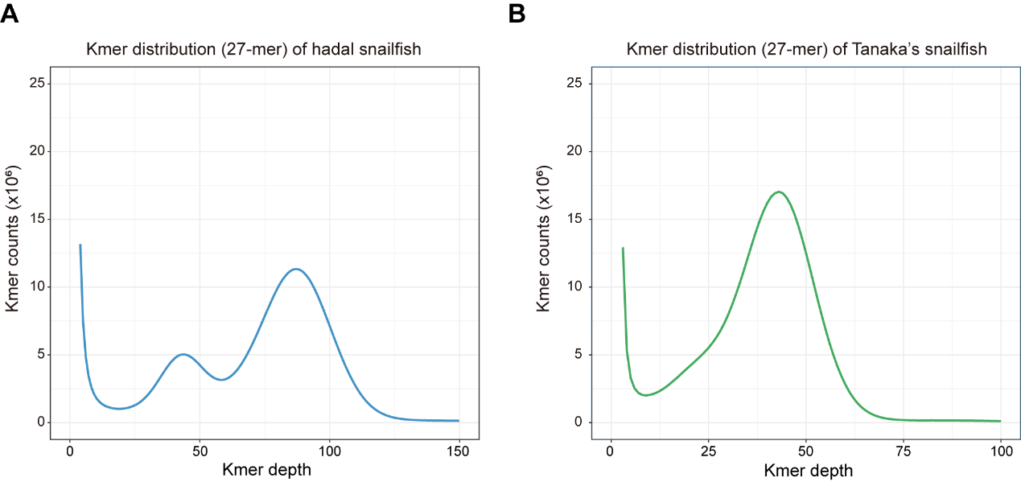

Supplementary Fig. 1. K-mer (k=27) distribution of the hadal snailfish (A) and Tanaka’s snailfish (B). Genome size was estimated by: Genome Size = knum/kdepth. The estimated genome size 633.2 Mb for hadal snailfish and 539.9 Mb for Tanaka’s snailfish respectively.
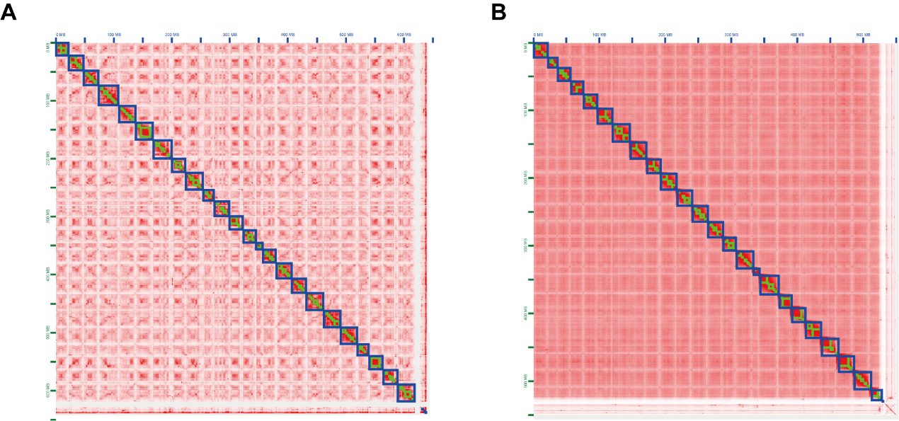

Supplementary Fig. 2. Genome assembly of hadal snailfish (C) and Tanaka’s snailfish (D), both of them assembled 24 chromosomes.
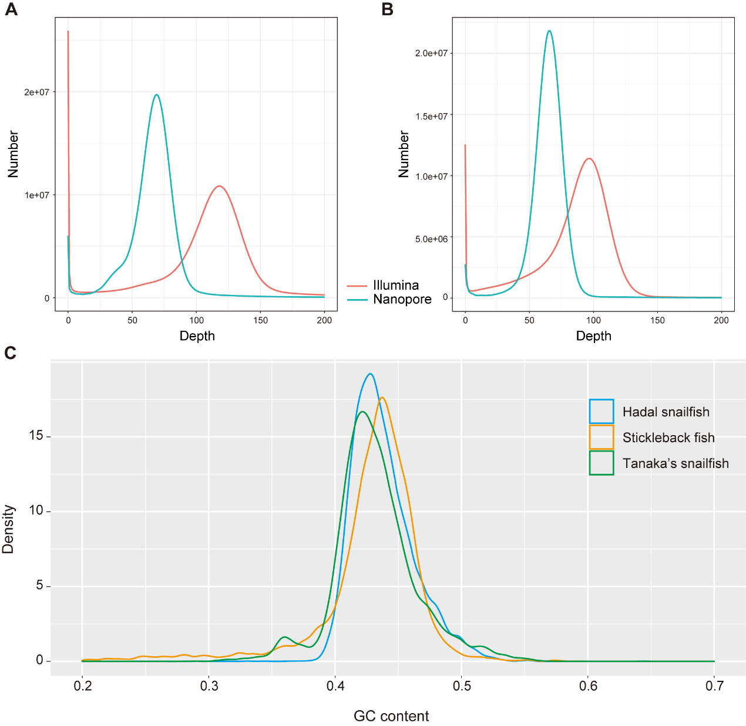

Supplementary Fig. 3. Distribution of read depths in the genomes of hadal snailfish (A) and Tanaka's snailfish (B). (C) The density of the GC content of the hadal snailfish, Tanaka’s snailfish and stickleback.

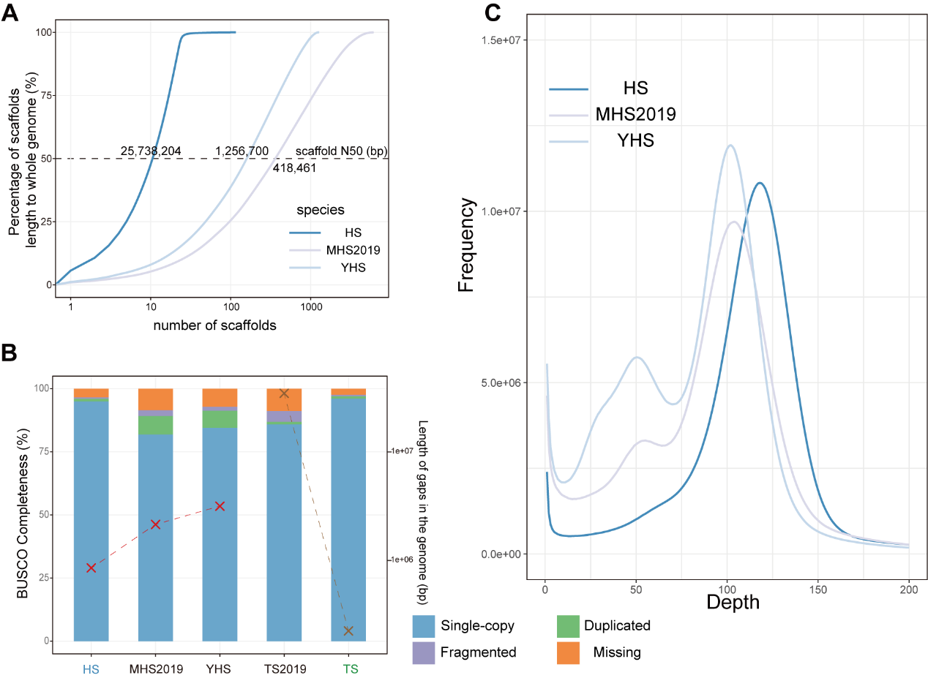

Supplementary Fig. 4. Improved genome assembly for hadal snailfish. (A) Comparison of assembly contiguity in hadal snailfish. The x-axis is the number of scaffolds, and the y-axis is the length of the scaffold as a percentage of the total genome length. HS: the hadal snailfish genome assembled in this work, MHS2019: https://figshare.com/articles/dataset/Genome_assembly_of_Mariana_hadal_snailfish/9782414?file=17520179, YHS: GCA_004335475.1. (B) Length of the gaps and BUSCO genome assessment in each genome assembly. (C) Assessment of heterozygous sequences in different versions of hadal snailfish genome. These sequences were largely resulted from assembly redundancy. The horizontal coordinate refers to the read depth, and the vertical coordinate refers to the read occurrence frequency.
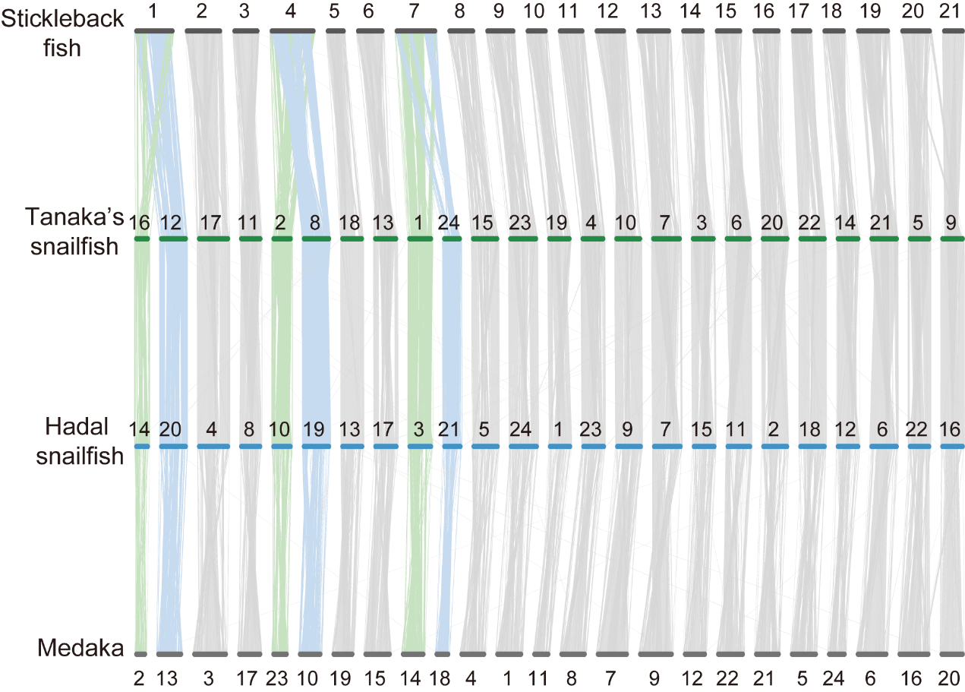

Supplementary Fig. 5. Chromosomal syntenic relationship of hadal snailfish, Tanaka's snailfish, medaka, and stickleback. Each line represents a syntenic block of 10 or more zones from the results of LAST with a similarity of 75% or more and length > 1,000 bp.

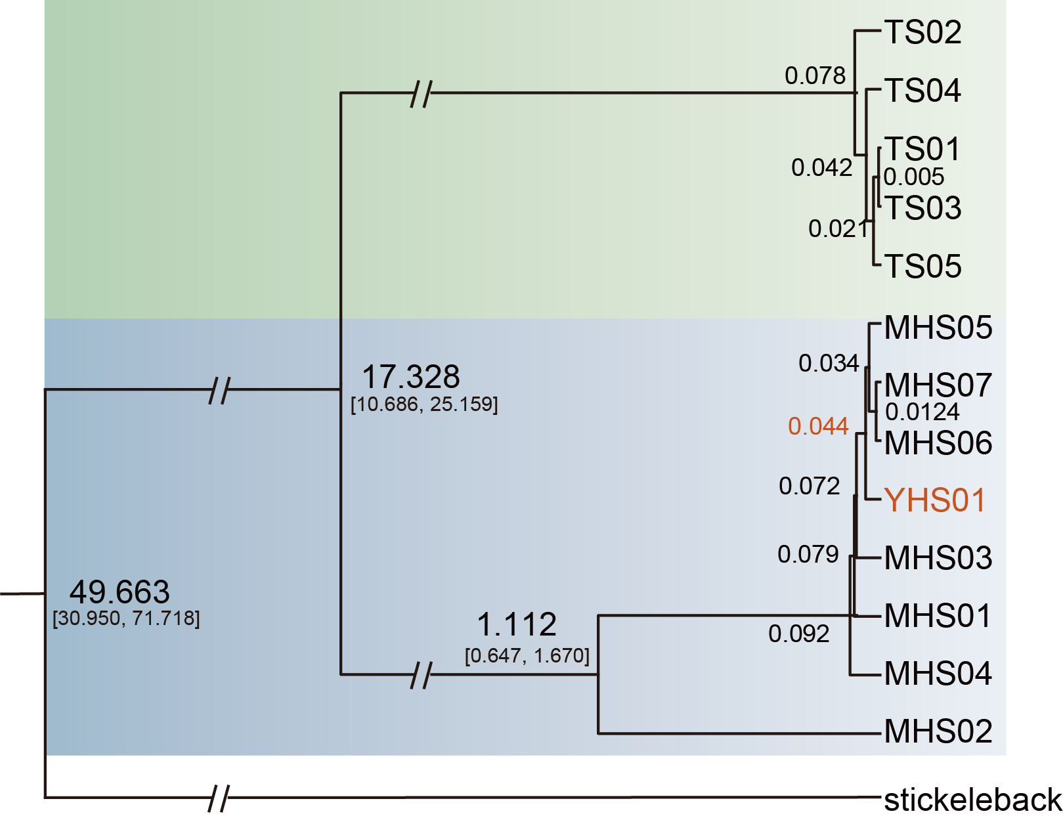

Supplementary Fig. 6. The divergence time between Yap hadal snailfish (YHS) and Mariana hadal snailfish. Phylogenetic tree constructed using the coding sequences of 13 mitochondrial genes (atp6, atp8, co1, co2, co3, cytb, nd1, nd2, nd3, nd4, nd4l, nd5, nd6), in which the divergence time between YHS and MHS was 0.044 million years ago.

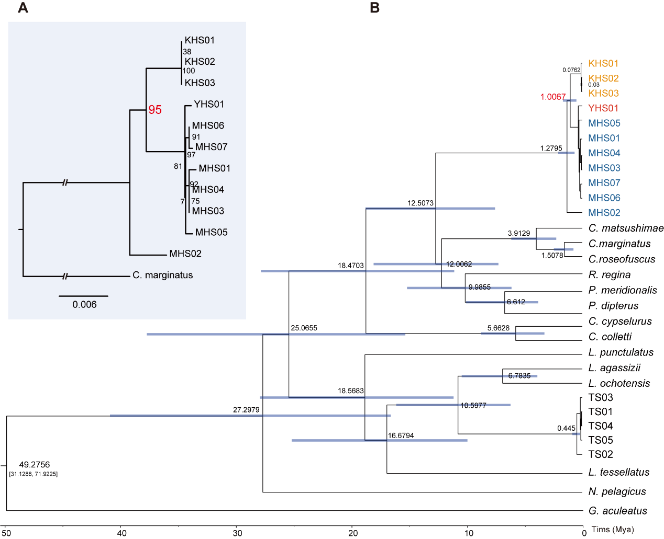

Supplementary Fig. 7. Phylogenetic relationships of the family Liparidae. (A) Phylogenetic tree constructed using RAxML with the selected parameter “-N 100” based on the coding sequences of co1 and cytb, where the support of KHS and MHS divergence nodes was 95. (B) Phylogenetic tree constructed with the coding sequences of 2 mitochondrial genes (co1 and cytb), where the divergence between KHS and MHS was 1.0067 million years ago.

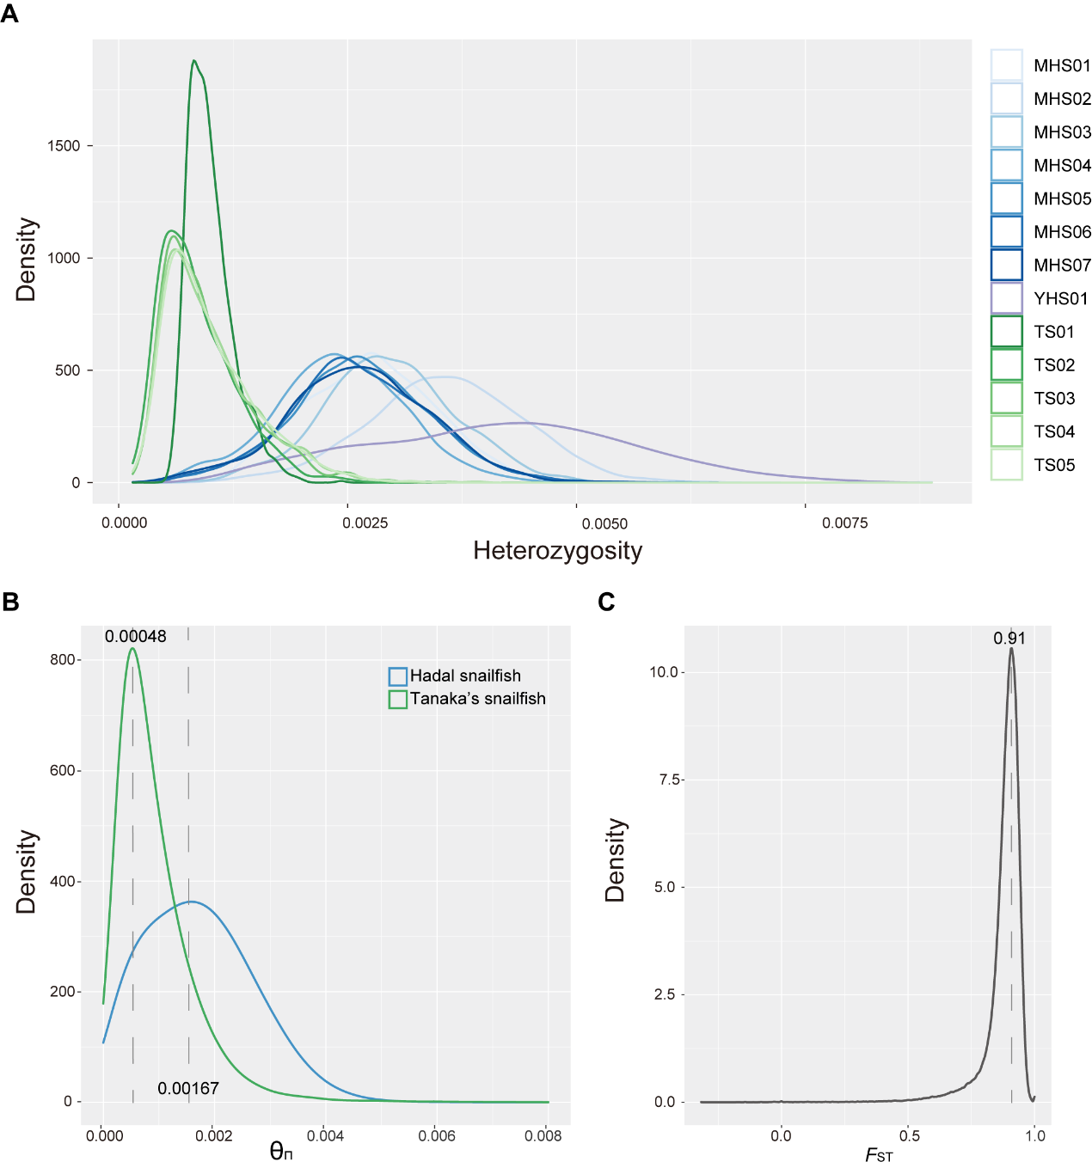

Supplementary Fig. 8. Diversity statistics. (A) Heterozygosity ratio per 500KB in different individuals of hadal snailfish and Tanaka’s snailfish. Distribution of Π of 10 kb windows (B) and FST of 10 kb windows with 1 kb steps (C).

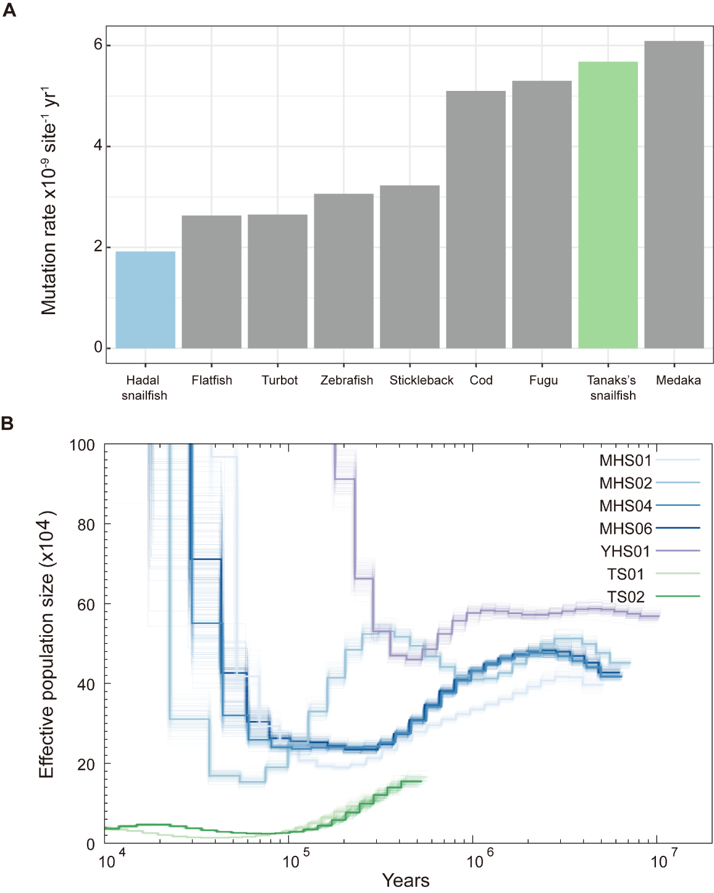

Supplementary Fig. 9. Demographic analysis. The mutation ratio among 9 teleosts and the demographic history for hadal snailfish and Tanaka’s snailfish. (A) The mutation ratio is inferred by the fourfold degenerate synonymous site (4D). (B) Demographic history for 5 hadal snailfish individuals and 2 Tanaka’s snailfish individuals inferred by PSMC based on the Illumina data using “g=1 year”.

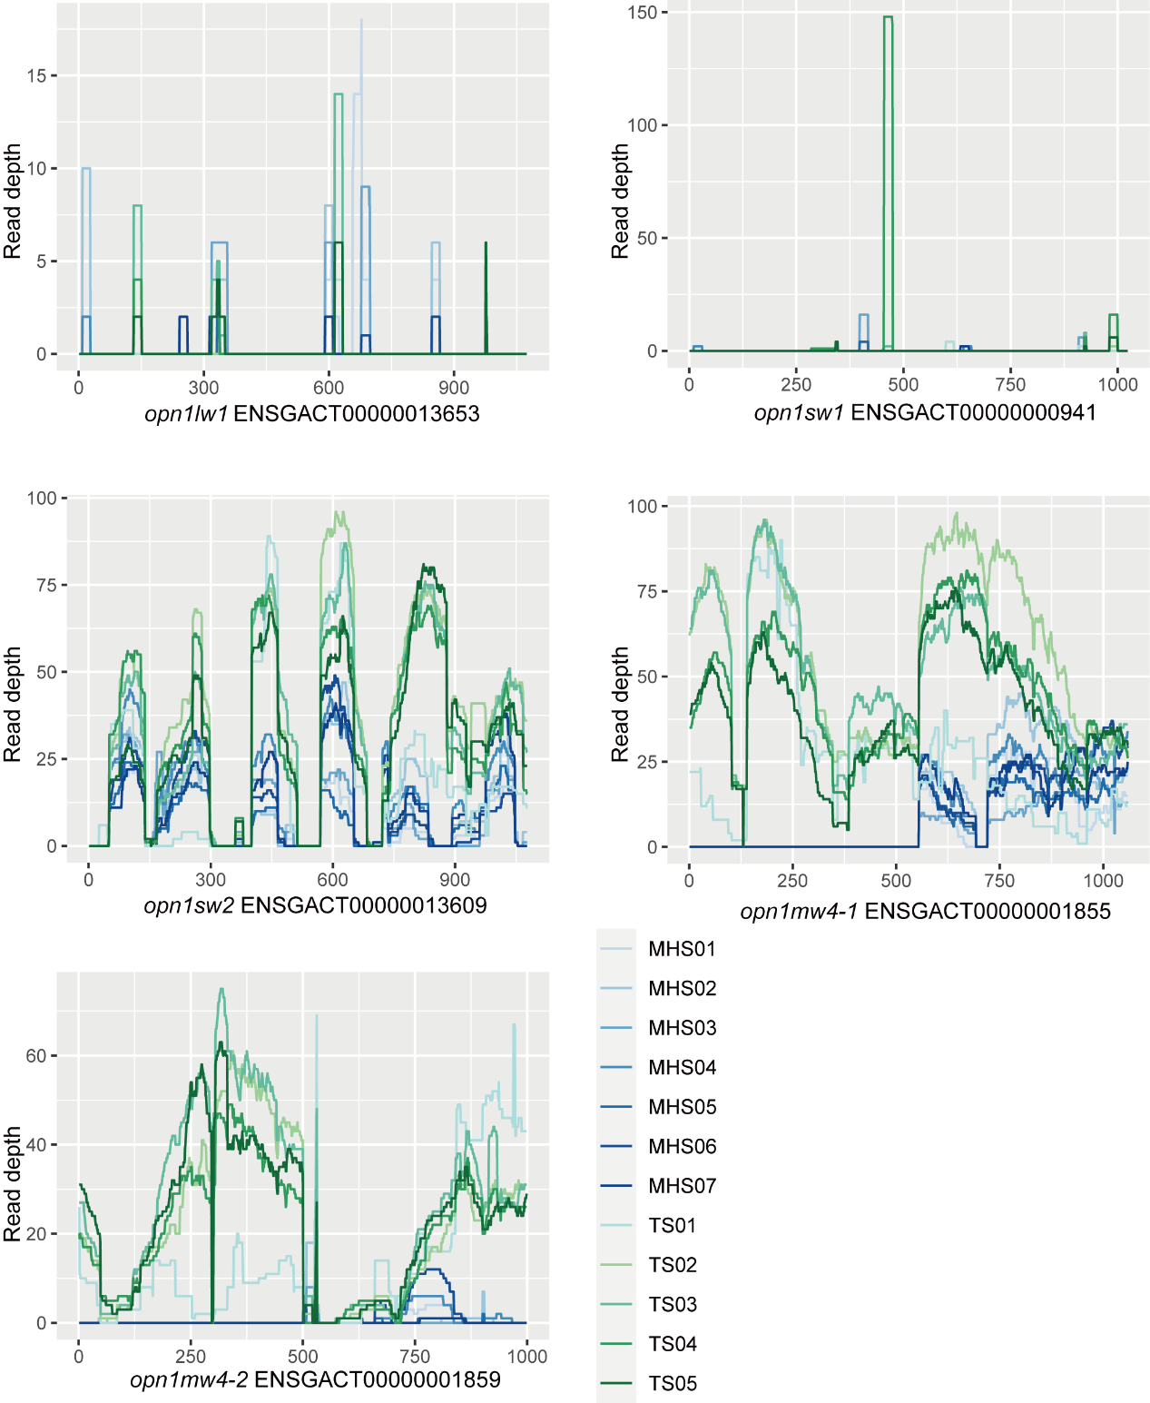

Supplementary Fig. 10. Loss of vision-related genes in hadal snailfish. Short reads from 7 hadal snailfish individuals (MHS01-MHS07) and 5 Tanaka's snailfish individuals (TS01-TS05) were mapped with stickleback's genome sequence, in which opn1lw1, opn1sw1 and rh2 genes were lost in hadal snailfish.

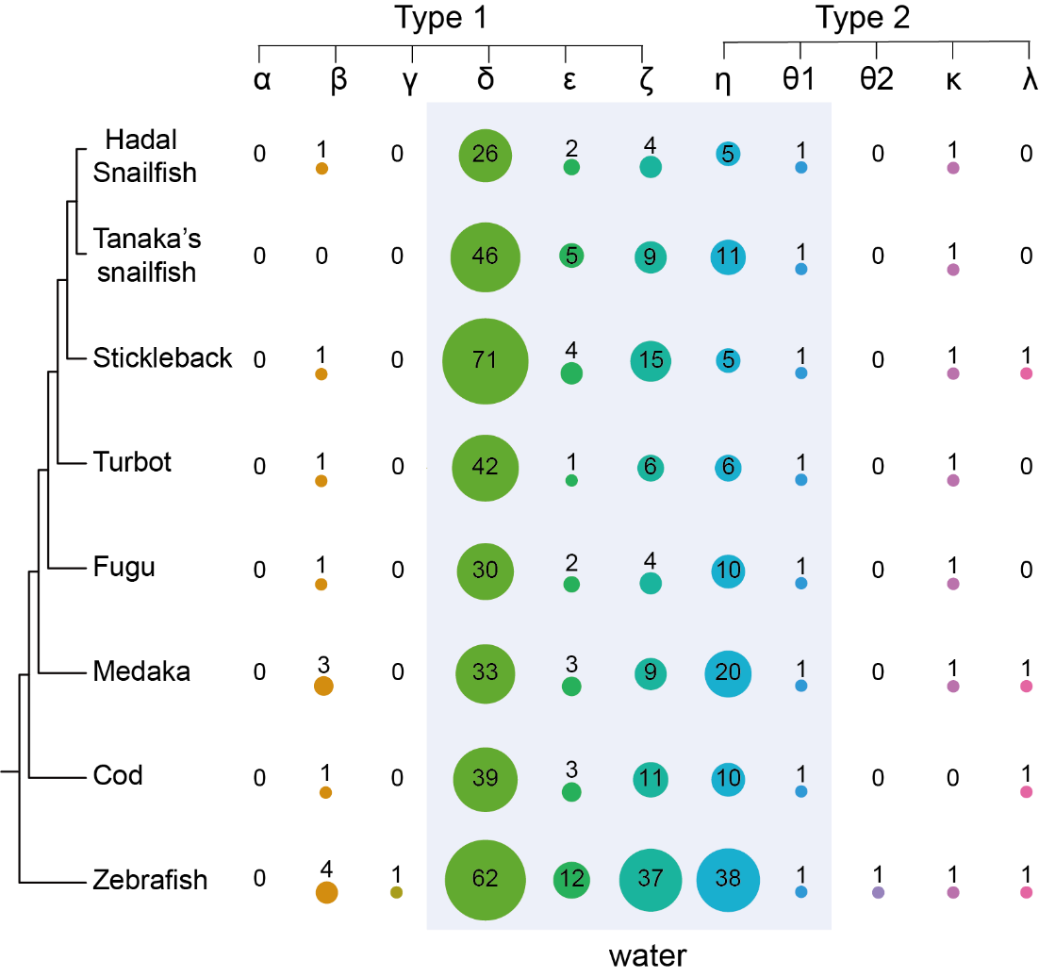

Supplementary Fig. 11. The number of olfactory receptors in eight species. "Air" (yellow circles) and "water" (blue circles) refer to the detection of airborne and water-soluble odorants, respectively. The size of the circles indicates the number of intact OR genes.

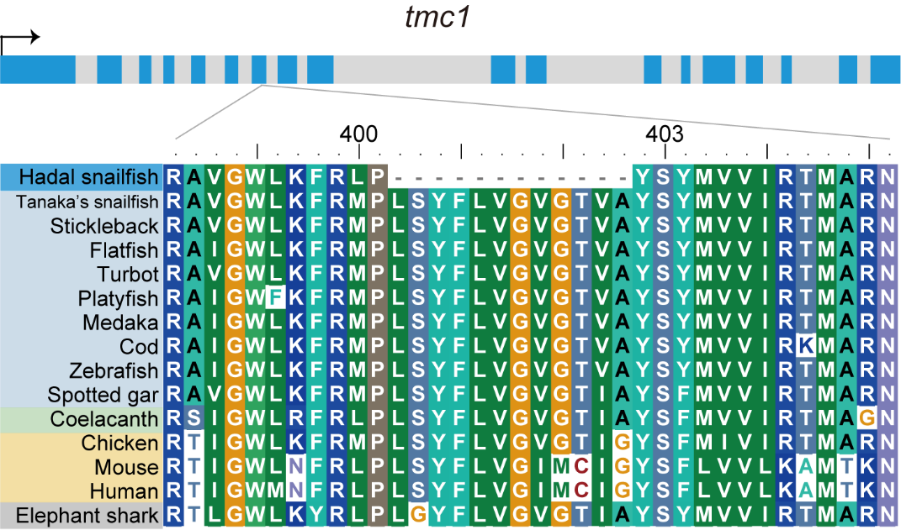

Supplementary Fig. 12. Sequence alignment revealed that the amino acid sequence of tmc1 was specifically deletion in hadal snailfish. The gray bar with blue stripes shows the exon-intron structure of tmc1.

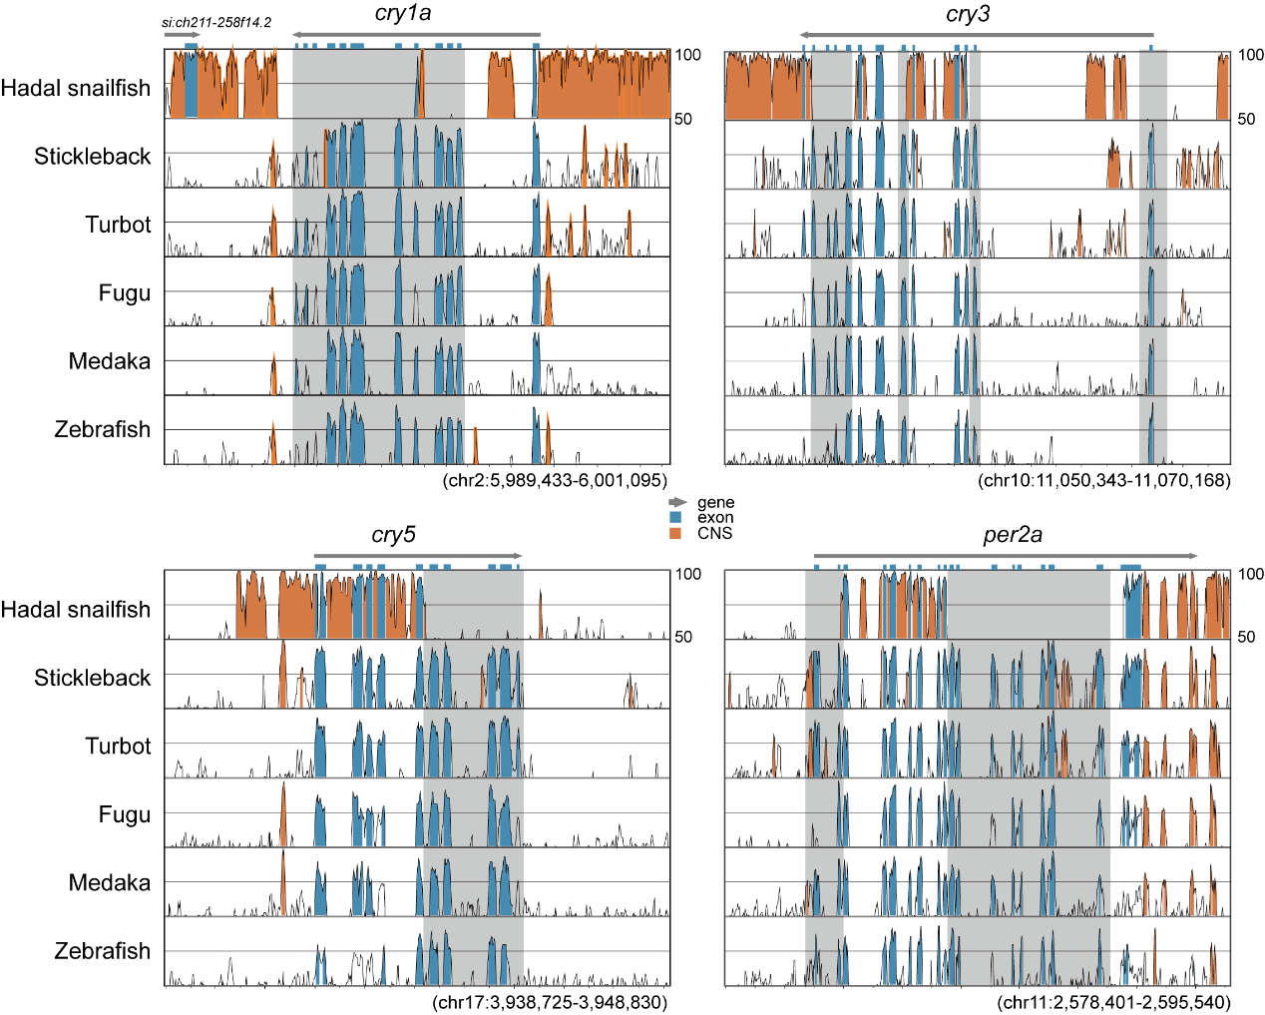

Supplementary Fig. 13. Genetic changes involved in light-mediated regulation of the molecular clock in hadal snailfish suprachiasmatic nucleus (SCN) neurons, using Tanaka’s snailfish (this work) as references.

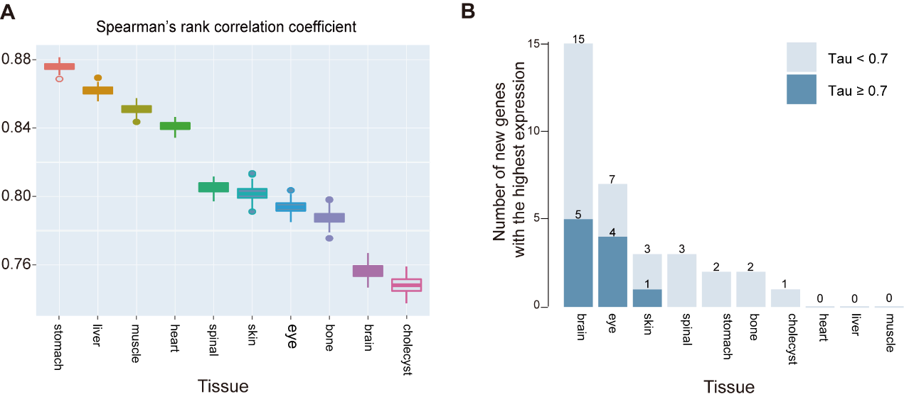

Supplementary Fig. 14. (A) Differences in gene expression between species for each organ. Box plots of Spearman rank correlation coefficients for each organ of hadal snailfish and Tanaka's snailfish based on 1000 bootstrap replicates. (B) Expression of new genes in hadal snailfish in various tissues.

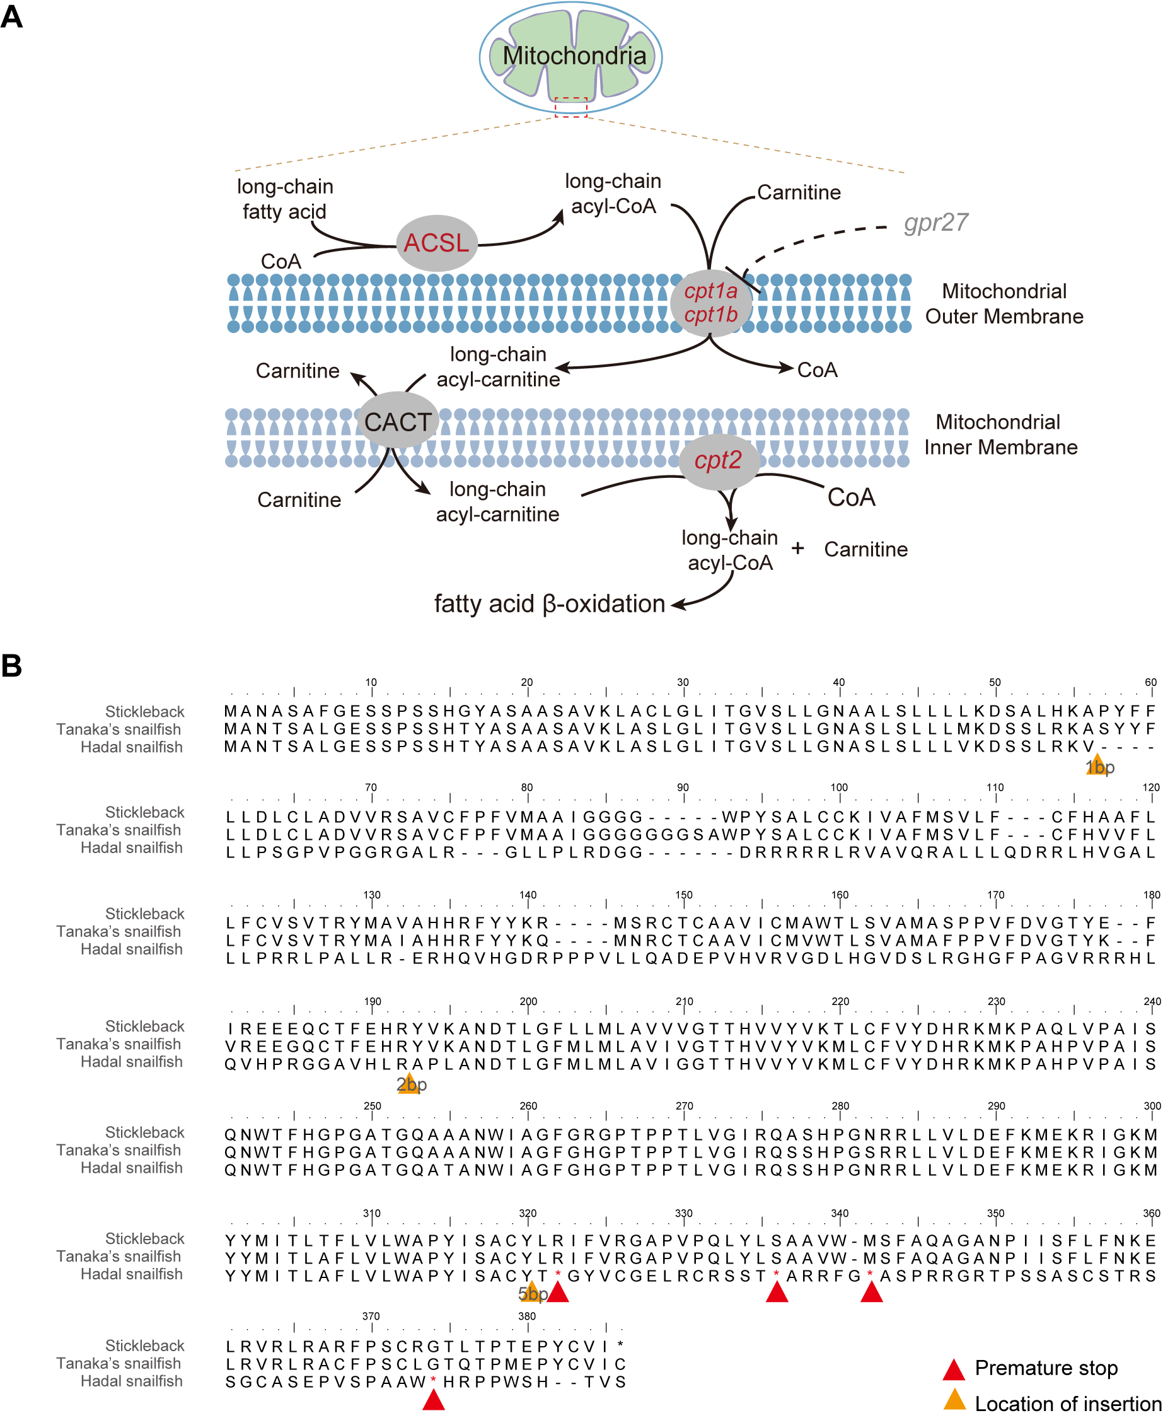

Supplementary Fig. 15. Pseudogenization of gpr27 in hadal snailfish. (A) Multiple genes associated with fatty acid entry into mitochondria were upregulated in hadal snailfish compared to Tanaka's snailfish (red). (B) The insertion changed the protein’s sequence, causing its premature termination. The numbers above the alignment represent sequence positions including gaps.

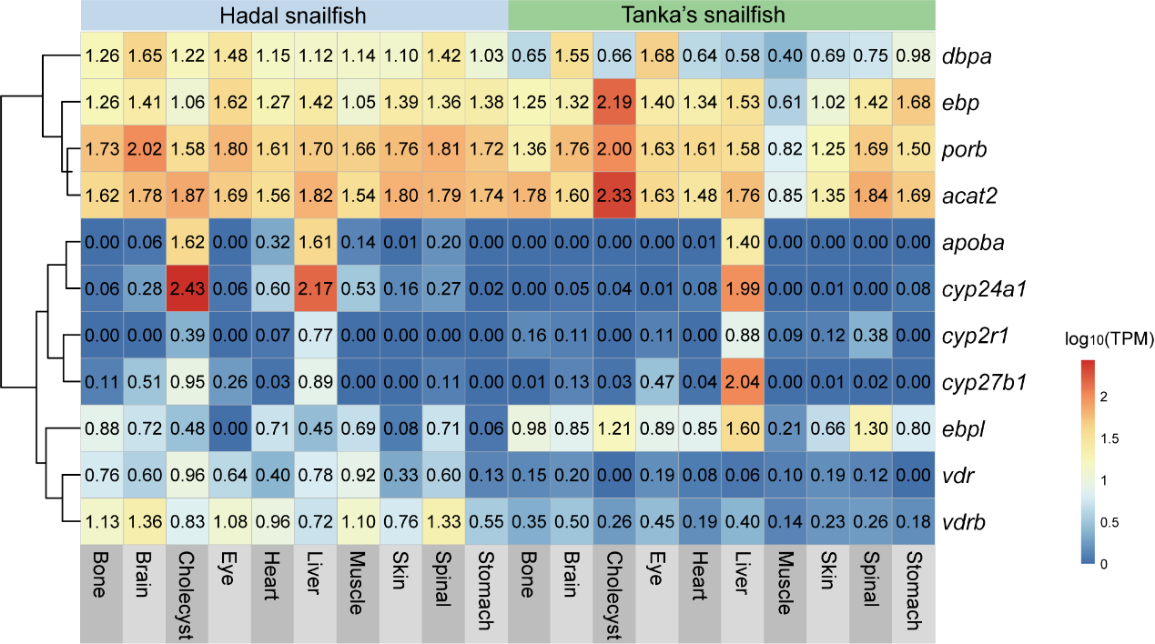

Supplementary Fig. 16. Expression of the vitamin D related genes in various tissues of hadal snailfish and Tanaka's snailfish.

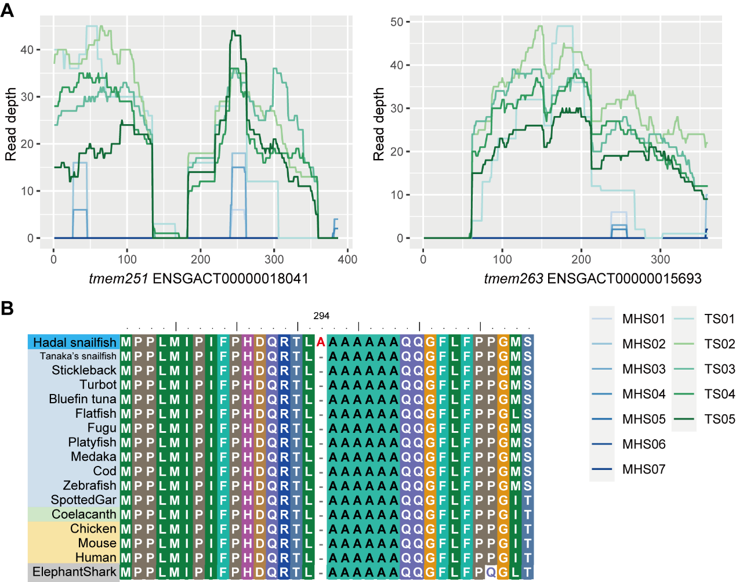

Supplementary Fig. 17. Loss of skeletal formation-related genes and site-specific mutations in hadal snailfish. (A) Short reads from 7 hadal snailfish individuals (MHS01-MHS07) and 5 Tanaka's snailfish individuals (TS01-TS05) were mapped with stickleback's genome sequence, in which tmem251 and tmem263 genes were lost in hadal snailfish. (B) Site-specific amino acid site alterations of sox6. Amino acids unique to hadal snailfish are highlighted in red; positions within each sequence are given above.

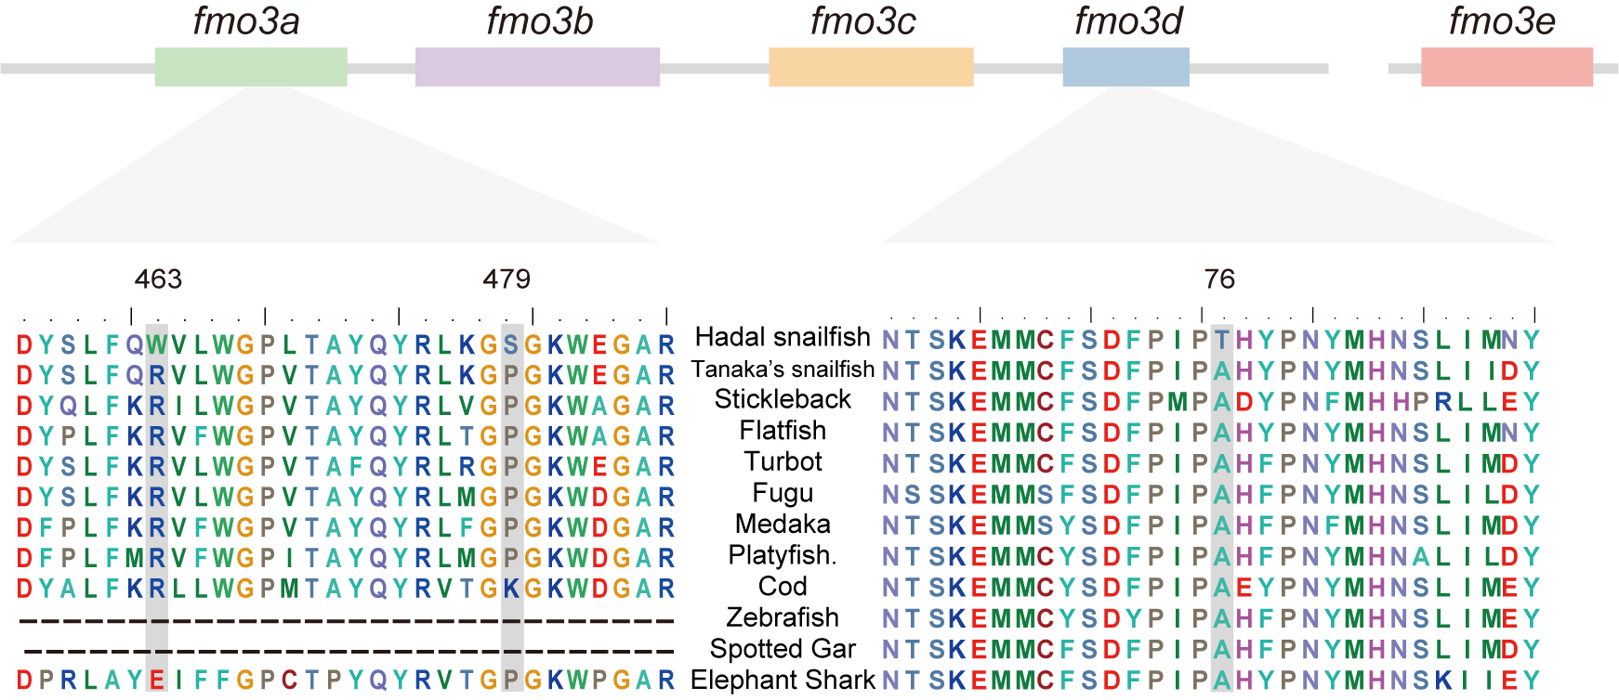

Supplementary Fig. 18. Specific amino acid sites in the fmo3 protein sequence in hadal snailfish. Partial alignment of the fmo3a and fmo3d amino acid sequences from various representative teleosts, spotted gar and elephant shark. Amino acids unique to hadal snailfish are highlighted in grey; positions within each sequence are given above.

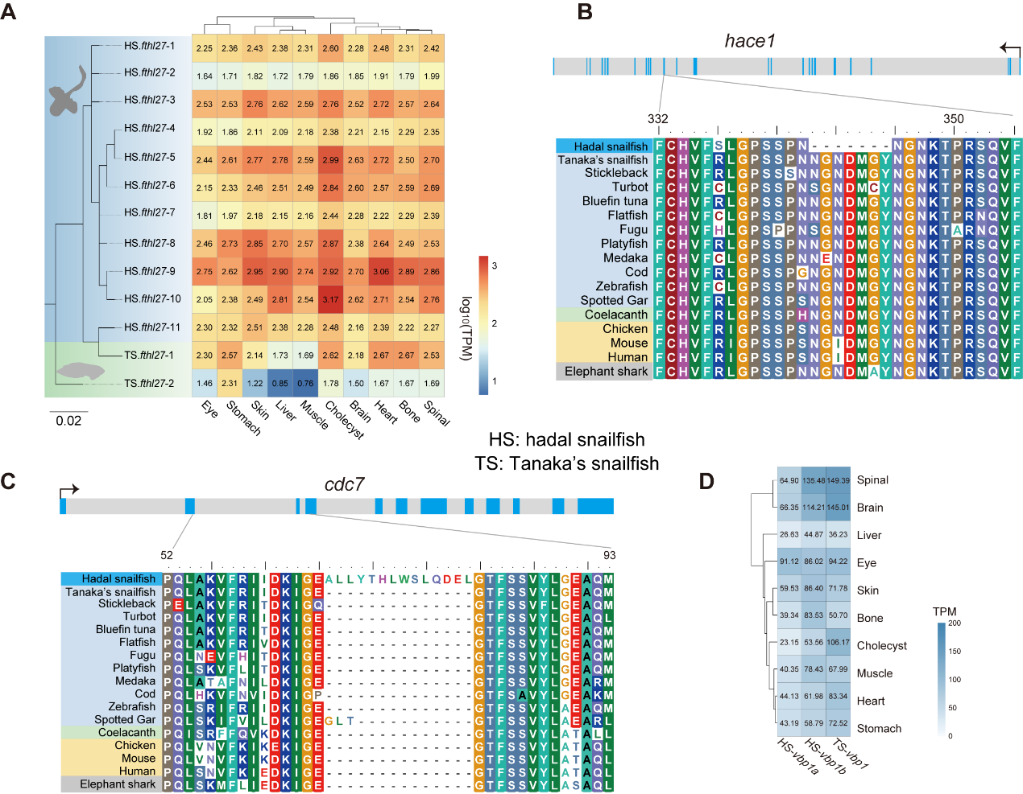Supplementary Fig. 19. Specific genetic changes in hadal snailfish. (A) Increased gene copy number of fthl27 and its expression in various tissues. (B) Sequence alignment revealed that the amino acid sequence of hace1was specifically altered in hadal snailfish. (C) Specific mutations in the cdc7 gene. (D) Expression of the vbp1 gene in various tissues of hadal snailfish and Tanaka's snailfish.

Supplementary Tables

Supplementary Table 1. Details of samples used in this study.
Species | ID in main  text | name | Sources | Location (Depth) | Sampling  date | Lander | Sex | Usage
Hadal snailfish | MHS01 | Pseudoliparis swirei | PRJNA472845 | Mariana trench | ——
Hadal snailfish | MHS02
Hadal snailfish | MHS03
Hadal snailfish | MHS04 | Pseudoliparis swirei | this work | 142°26′E, 11°07′N (7254m) | Dec 14th, 2019 | Tianya | unknown | Genome sequencing, RNA-Seq
Hadal snailfish | MHS05 |  |  |  |  |  |  | Whole Genome Resequencing, RNA-Seq
Hadal snailfish | MHS06
Hadal snailfish | MHS07
Hadal snailfish | YHS01 | Yap hadal snailfish | SRR8510169~ SRR8510172 | Yap Trench | ——
Hadal snailfish | KHS01 | Notoliparis kermadecensis | KY659195.1 | Kermadec Trench | ——
Hadal snailfish | KHS02 | Notoliparis kermadecensis | KY659197.1 | Kermadec Trench
Hadal snailfish | KHS03 | Notoliparis kermadecensis | KY659198.1 | Kermadec Trench
Tanaka's snailfish | TS01 | Liparis tanakae |  | —— | ——
Tanaka's snailfish | TS02 | Liparis tanakae | this work | 123°37.298'E, 36°22.064'N (about 60m) | Dec 3th, 2018 | —— | unknown | Genome sequencing
Tanaka's snailfish | TS03 |  |  |  |  |  |  | Whole Genome Resequencing, RNA-Seq
Tanaka's snailfish | TS04
Tanaka's snailfish | TS05

Supplementary Table 2. Sequencing reads of hadal snailfish.
Species | Sequencing technology | Sample | ID of library | Number of reads | Number of sequenced bases | Mean length of reads
Hadal snailfish | Nanopore | MHS04 | 1-E9-H9 | 898,765 | 23,358,551,553 | 25,990
Hadal snailfish | Nanopore | MHS04 | 2-E7-H7 | 851,220 | 24,489,049,393 | 28,769
Hadal snailfish | Hi-C | MHS04 | CL100089582_L01 | 1,232,922,648 | 123,292,264,800 | 100
Hadal snailfish | BGI | MHS04 | ANIcrcRAAAA-525 | 104,495,604 | 10,449,560,400 | 100
Hadal snailfish | BGI | MHS04 | ANIcrcRAAAA-526 | 96,679,592 | 9,667,959,200 | 100
Hadal snailfish | BGI | MHS04 | ANIcrcRAAAA-527 | 108,361,184 | 10,836,118,400 | 100
Hadal snailfish | BGI | MHS04 | ANIcrcRAAAA-528 | 78,114,798 | 7,811,479,800 | 100
Hadal snailfish | BGI | MHS04 | ANIcrcRAAAA-529 | 128,287,360 | 12,828,736,000 | 100
Hadal snailfish | BGI | MHS04 | ANIcrcRAAAA-530 | 112,533,976 | 11,253,397,600 | 100
Hadal snailfish | BGI | MHS04 | ANIcrcRAAAA-531 | 119,688,402 | 11,968,840,200 | 100
Hadal snailfish | BGI | MHS04 | ANIcrcRAAAA-532 | 120,058,720 | 12,005,872,000 | 100
Hadal snailfish | BGI | MHS05 | FIStkwRAAAA-513 | 59,854,372 | 5,985,437,200 | 100
Hadal snailfish | BGI | MHS05 | FIStkwRAAAA-514 | 38,293,100 | 3,829,310,000 | 100
Hadal snailfish | BGI | MHS05 | FIStkwRAAAA-515 | 45,536,016 | 4,553,601,600 | 100
Hadal snailfish | BGI | MHS05 | FIStkwRAAAA-516 | 59,909,422 | 5,990,942,200 | 100
Hadal snailfish | BGI | MHS06 | FIStkwRAAAB-529 | 57,997,078 | 5,799,707,800 | 100
Hadal snailfish | BGI | MHS06 | FIStkwRAAAB-530 | 33,763,998 | 3,376,399,800 | 100
Hadal snailfish | BGI | MHS06 | FIStkwRAAAB-531 | 55,446,658 | 5,544,665,800 | 100
Hadal snailfish | BGI | MHS06 | FIStkwRAAAB-532 | 60,286,004 | 6,028,600,400 | 100
Hadal snailfish | BGI | MHS07 | FIStkwRAAAC-544 | 62,328,744 | 6,232,874,400 | 100
Hadal snailfish | BGI | MHS07 | FIStkwRAAAC-545 | 40,695,892 | 4,069,589,200 | 100
Hadal snailfish | BGI | MHS07 | FIStkwRAAAC-546 | 60,126,202 | 6,012,620,200 | 100
Hadal snailfish | BGI | MHS07 | FIStkwRAAAC-547 | 43,180,218 | 4,318,021,800 | 100

Supplementary Table 3. Sequencing reads of Tanaka’s snailfish.
Species | Sequencing technology | Sample | ID of library | Number of reads | Number of sequenced bases | Mean length of reads
Tanaka's snailfish | Nanopore | TS2 | NPL1013-P1 | 1,659,010 | 39,023,659,346 | 23,522
Tanaka's snailfish | Hi-C | TS02 | G05 | 663,068,716 | 99,460,307,400 | 150
Tanaka's snailfish | BGI | TS02 | jirou_C | 342,123,824 | 51,318,573,600 | 150
Tanaka's snailfish | BGI | TS03 | L1_FISvdyRAAAH-525 | 28,362,384 | 4,254,357,600 | 150
Tanaka's snailfish | BGI | TS03 | L1_FISvdyRAAAH-532 | 33,617,380 | 5,042,607,000 | 150
Tanaka's snailfish | BGI | TS03 | L2_FISvdyRAAAH-525 | 28,375,328 | 4,256,299,200 | 150
Tanaka's snailfish | BGI | TS03 | L2_FISvdyRAAAH-532 | 33,597,258 | 5,039,588,700 | 150
Tanaka's snailfish | BGI | TS04 | L3_FISvdyRAAAI-502 | 31,964,998 | 4,794,749,700 | 150
Tanaka's snailfish | BGI | TS04 | L3_FISvdyRAAAI-508 | 33,161,096 | 4,974,164,400 | 150
Tanaka's snailfish | BGI | TS04 | L4_FISvdyRAAAI-502 | 30,606,316 | 4,590,947,400 | 150
Tanaka's snailfish | BGI | TS04 | L4_FISvdyRAAAI-508 | 32,079,400 | 4,811,910,000 | 150
Tanaka's snailfish | BGI | TS05 | L1_FISvdyRAAAJ-509 | 29,898,940 | 4,484,841,000 | 150
Tanaka's snailfish | BGI | TS05 | L1_FISvdyRAAAJ-510 | 28,662,948 | 4,299,442,200 | 150
Tanaka's snailfish | BGI | TS05 | L2_FISvdyRAAAJ-509 | 29,999,222 | 4,499,883,300 | 150
Tanaka's snailfish | BGI | TS05 | L2_FISvdyRAAAJ-510 | 28,830,044 | 4,324,506,600 | 150

Supplementary Table 4. Genome assembly statistics for hadal snailfish and Tanaka's snailfish.
 | Hadal snailfish |  |  |  | Tanaka's snailfish
 | Contig Size (bp) | Number | Scaffold Size (bp) | Number | Contig Size (bp) | Number | Scaffold Size (bp) | Number
N90 | 391,659 | 216 | 22,226,877 | 21 | 488,038 | 225 | 15,372,104 | 22
N80 | 1,199,949 | 127 | 23,411,436 | 19 | 961,961 | 145 | 19,898,281 | 19
N70 | 2,172,367 | 87 | 24,184,323 | 16 | 1,568,523 | 102 | 20,999,279 | 16
N60 | 2,767,116 | 62 | 24,710,793 | 14 | 2,292,284 | 73 | 22,413,529 | 14
N50 | 4,219,354 | 44 | 25,738,204 | 11 | 3,015,465 | 51 | 23,043,945 | 11
Longest (bp) | 17,068,874 |  | 35,158,290 |  | 14,501,553 |  | 29,428,813
Total Number | 1,173 |  | 199 |  | 1,666 |  | 926
Total Size (bp) | 625,564,155 |  | 626,439,101 |  | 554,057,755 |  | 554,262,586

Supplementary Table 5. Results of BUSCO evaluations of hadal snailfish and Tanaka's snailfish.
Types of BUSCOs | Hadal snailfish |  | Tanaka's snailfish
Types of BUSCOs | number | percentage | number | percentage
Complete BUSCOs | 3,496 | 96.0% | 3,531 | 97.0%
Complete and single-copy BUSCOs | 3,458 | 95.0% | 3,497 | 96.1%
Complete and duplicated BUSCOs | 38 | 1.0% | 34 | 0.9%
Fragmented BUSCOs | 22 | 0.6% | 22 | 0.6%
Missing BUSCOs | 122 | 3.4% | 87 | 2.4%
Total number | 3,640

Supplementary Table 6. The genome information of the species used in this work
Species | Genome assembly version | Scaffolds number | Total length (bp) | N50 of scaffolds (bp)
Hadal snailfish | this work | 199 | 626,439,101 | 25,738,204
Tanaka's snailfish | this work | 926 | 554,262,514 | 23,043,945
Stickleback | Ensembl (BROADS1) | 1,844 | 461,533,448 | 18,115,788
Pacific bluefin tuna | GCA_021601225.1 | 16,801 | 740,348,846 | 136,950
Medaka | Ensembl (GRCz11.98) | 24 | 677,633,405 | 28,873,095
Platy fish | Ensembl (X maculatus-5.0) | 20,632 | 729,664,433 | 1,303,070
Atlantic cod | Ensembl (gadMor1) | 398,859 | 832,114,588 | 136,353
Flatfish | GCF_001970005.1 | 9,525 | 643,911,827 | 10,546,925
Zebrafish | Ensembl (GRCz11) | 993 | 1,373,471,384 | 54,304,671
Turbot | Ensembl (ASM318616v1) | 22 | 524,979,463 | 24,811,384
Fugu | Ensembl (FUGU5) | 6,835 | 391,484,725 | 11,516,971
Spotted gar | Ensembl (LepOcu1) | 1926 | 945878036 | 50348508
Coelacanth | Ensembl (LatCha1) | 22,819 | 2,860,591,921 | 924,513
Chicken | Ensembl (Gallus gallus-5.0) | 23,475 | 1,230,258,557 | 82,310,166
Mouse | Ensembl (GRCm38) | 66 | 2,730,871,774 | 130,694,993
Human | Ensembl (GRCh38) | 194 | 3,099,750,718 | 145,138,636
Brownbanded bamboo shark | GCA_003427335.1 | 1,145,194 | 3,851,610,035 | 69,975,007
Elephant shark | Ensembl (Callorhinchus milii-6.1.3) | 21,204 | 974,498,586 | 4,521,921

Supplementary Table 7. Data on annotated genes from the hadal snailfish, Tanaka's snailfish and other species used in this study.
 | Total number | Average gene length (bp) | Average CDS length (bp) | Average exon number | Average exon length (bp) | Average intron length (bp)
Hadal snailfish | 22,470 | 22,366.98 | 1,627.98 | 9.37 | 173.75 | 2,477.90
Tanaka's snailfish | 21,370 | 21,539.68 | 1,673.33 | 9.81 | 170.53 | 2,254.29
Stickleback | 20,774 | 8,454.64 | 1,549.09 | 10.40 | 148.90 | 734.36
Turbot | 20,996 | 12,589.35 | 1,711.53 | 10.13 | 168.91 | 1,191.09
Flatfish | 22,225 | 12,373.67 | 1,665.28 | 9.84 | 169.24 | 1,211.36
Fugu | 22,225 | 12,373.67 | 1,665.28 | 9.84 | 169.24 | 1,211.36
Medaka | 22,119 | 14,872.46 | 1,640.04 | 9.29 | 176.49 | 1,595.74
Cod | 20,095 | 15,245.26 | 1,459.03 | 12.72 | 114.67 | 1,175.90
Zebrafish | 24,269 | 25,974.38 | 1,628.44 | 9.43 | 172.73 | 2,888.83

Supplementary Table 8. Summary of repetitive sequences in hadal snailfish and Tanaka's snailfish.
 |  | Repbase Tes |  | TE proteins |  | De novo |  | Combined Tes
Species | Type | Length (bp) | Percent in genome | Length (bp) | Percent in genome | Length (bp) | Percent in genome | Length (bp) | Percent in genome
Hadal snailfish | DNA | 49,969,082 | 8.00% | 522,621 | 0.08% | 70,989,907 | 11.37% | 86,032,513 | 13.76%
Hadal snailfish | LINE | 25,127,686 | 4.02% | 33,173,787 | 5.31% | 48,699,962 | 7.80% | 52,315,769 | 8.37%
Hadal snailfish | SINE | 925,347 | 0.15% | 0 | 0.00% | 2,897,295 | 0.46% | 3,197,636 | 0.51%
Hadal snailfish | LTR | 11,641,868 | 1.86% | 10,534,119 | 1.69% | 13,422,771 | 2.15% | 20,613,824 | 3.30%
Hadal snailfish | Other | 12,205,833 | 1.95% | 0 | 0.00% | 34,341,239 | 5.50% | 117,703,622 | 18.82%
Hadal snailfish | Unknown | 260,761 | 0.04% | 0 | 0.00% | 34,939,592 | 5.59% | 33,903,882 | 5.42%
Hadal snailfish | Total | 100,130,577 | 16.03% | 44,230,527 | 7.08% | 205,290,766 | 32.87% | 245,481,550 | 39.25%
Tanaka's snailfish | DNA | 61,762,107 | 11.14% | 153,360 | 0.03% | 43,627,754 | 7.87% | 71,225,926 | 12.85%
Tanaka's snailfish | LINE | 11,062,444 | 2.00% | 11,118,474 | 2.01% | 23,017,919 | 4.15% | 27,900,710 | 5.03%
Tanaka's snailfish | SINE | 559,686 | 0.10% | 0 | 0.00% | 2,726,622 | 0.49% | 3,147,544 | 0.57%
Tanaka's snailfish | LTR | 9,020,250 | 1.63% | 3,518,637 | 0.63% | 4,519,388 | 0.82% | 12,541,024 | 2.26%
Tanaka's snailfish | Other | 13,599,599 | 2.45% | 0 | 0.00% | 50,024,511 | 9.03% | 127,716,575 | 23.04%
Tanaka's snailfish | Unknown | 85,598 | 0.02% | 0 | 0.00% | 29,219,311 | 5.27% | 28,202,254 | 5.09%
Tanaka's snailfish | Total | 96,089,684 | 17.34% | 14,790,471 | 2.67% | 153,135,505 | 27.63% | 185,707,210 | 33.51%

Supplementary Table 9. The unitary pseudogenes identified in hadal snailfish.
ENSEMBLE transcript ID of stickleback | ENSEMBLE Gene ID of stickleback | gene name
ENSGACT00000000480 | ENSGACG00000000375 | NA
ENSGACT00000000788 | ENSGACG00000000611 | gpr19
ENSGACT00000001752 | ENSGACG00000001346 | rdh20
ENSGACT00000006183 | ENSGACG00000004668 | NA
ENSGACT00000007461 | ENSGACG00000005627 | NA
ENSGACT00000008086 | ENSGACG00000006099 | NA
ENSGACT00000009252 | ENSGACG00000006968 | si:dkey-178k16.1
ENSGACT00000009487 | ENSGACG00000007152 | bglap
ENSGACT00000011918 | ENSGACG00000008967 | dnah5l
ENSGACT00000014005 | ENSGACG00000010575 | gpr65
ENSGACT00000015577 | ENSGACG00000011757 | NA
ENSGACT00000015663 | ENSGACG00000011823 | gpr27
ENSGACT00000017747 | ENSGACG00000013397 | plppr3b
ENSGACT00000018536 | ENSGACG00000014008 | NA
ENSGACT00000020957 | ENSGACG00000015845 | PRTG
ENSGACT00000021892 | ENSGACG00000016544 | neil3
ENSGACT00000024186 | ENSGACG00000018259 | ccng2
ENSGACT00000025661 | ENSGACG00000019379 | NA
ENSGACT00000026992 | ENSGACG00000020382 | rrm1

Supplementary Table 10. List of genes with more copies in hadal snailfish compared to Tanaka’s snailfish.
Gene name | Gene number
Gene name | hadal snailfish | Tanaka's snailfish
acaa1 | 5 | 1
asic1a | 3 | 2
asrgl1 | 2 | 1
cldnj | 3 | 1
cu638714.1 | 14 | 2
ENSGACT00000016830 | 4 | 1
erg28 | 2 | 1
fthl27 | 11 | 2
igf1 | 6 | 1
klhl10a | 15 | 3
mxa | 4 | 2
pebp1 | 2 | 1
ptgs1 | 5 | 2
si:ch211-193k19.2 | 23 | 2
si:ch211-57b15.2 | 21 | 7
si:ch211-57f7.7 | 7 | 2
stat1a | 2 | 1
vbp1 | 2 | 1
zp3b | 12 | 8
zp3f.1 | 11 | 7
zp3f.2 | 2 | 1

Supplementary Table 11. The genes with site-specific amino acid mutations (with a length ≥ 3 amino acids) in hadal snailfish.
Gene name | Type | AA sites
tmc1 | loss | 12
atxn2 | loss | 8
hace1 | loss | 7
bnip1a | loss | 6
mtmr3 | loss | 6
mitfb | loss | 5
zgc:172139 | loss | 5
pdik1l | loss | 4
iqsec1 | loss | 4
tle1 | loss | 4
pou6f2 | loss | 4
nop56 | loss | 4
tnni1a | loss | 3
ssbp2 | loss | 3
lef1 | loss | 3
mbnl2 | gain | 70
wdr37 | gain | 68
si:ch211-244b2.1 | gain | 51
phf6 | gain | 36
senp8 | gain | 35
atpsckmt | gain | 24
grk4 | gain | 23
atad3A | gain | 19
pbdc1 | gain | 19
si:ch73-116o1.2 | gain | 18
cdc7 | gain | 11
med24 | gain | 11
chtopa | gain | 11
heatr5b | gain | 9
znrd1 | gain | 8
cluha | gain | 7
usp15 | gain | 5
tada2b | gain | 4

Supplementary Table 12. Depth of survival of some fishes of the Liparidae.
Banay | Genus | Espesye | Maximum Depth (m)
Liparidae | Careproctus | Careproctu colletti | 1350
Liparidae | Careproctus | Careproctus cypselurus | 1775
Liparidae | Careproctus | Careproctus marginatus | 950
Liparidae | Careproctus | Careproctus roseofuscus | 1950
Liparidae | Crystallias | Crystallias matsushimae | 700
Liparidae | Liparis | Liparis agassizii | 100
Liparidae | Liparis | Liparis ochotensis | 761
Liparidae | Liparis | Liparis punctulatus | 20
Liparidae | Liparis | Liparis tanakae | 121
Liparidae | Liparis | Liparis tessellatus NSMT | 346
Liparidae | Nectoliparis | Nectoliparis pelagicus | 3383
Liparidae | Paraliparis | Paraliparis dipterus | 250
Liparidae | Paraliparis | Paraliparis meridionalis | 932
Liparidae | Rhodichthys | Rhodichthys regina | 2365

Supplementary Table 13. The TPM of fmo3 gene copies in hadal snailfish and Tanaka's snailfish.
Species | Gene | bone | brain | cholecyst | eye | heart | liver | muscle | skin | spinal cord | stomach
Hadal snailfish | fmo3a | 0.11 | 4.21 | 641.01 | 0.07 | 20.15 | 842.59 | 4.14 | 17.97 | 5.24 | 0.95
Hadal snailfish | fmo3b | 7.31 | 0.36 | 57.62 | 0.02 | 1.90 | 44.83 | 0.82 | 0.84 | 0.42 | 0.17
Hadal snailfish | fmo3c | 79.88 | 1.15 | 17.65 | 1.47 | 4.30 | 18.54 | 5.77 | 3.38 | 0.66 | 7.19
Hadal snailfish | fmo3d | 41.69 | 11.58 | 44.70 | 2.35 | 16.39 | 82.67 | 12.93 | 9.86 | 6.27 | 62.19
Hadal snailfish | fmo3e | 9.26 | 15.65 | 19.62 | 7.71 | 19.60 | 16.95 | 5.63 | 8.17 | 13.03 | 4.74
Tanaka's snailfish | fmo3a | 0.20 | 0.05 | 0.58 | 0.03 | 0.41 | 899.11 | 0.05 | 0.29 | 0.23 | 0.07
Tanaka's snailfish | fmo3b1 | 0.00 | 0.00 | 0.00 | 0.00 | 0.00 | 0.00 | 0.00 | 0.00 | 0.01 | 0.00
Tanaka's snailfish | fmo3b2 | 0.00 | 0.06 | 0.14 | 0.00 | 0.00 | 6.62 | 0.00 | 0.04 | 0.00 | 0.00
Tanaka's snailfish | fmo3b3 | 0.01 | 0.04 | 3.46 | 0.00 | 0.00 | 0.00 | 0.00 | 0.00 | 0.00 | 0.10
Tanaka's snailfish | fmo3c | 0.08 | 0.02 | 0.01 | 0.06 | 0.04 | 6.53 | 0.00 | 0.07 | 0.04 | 0.00
Tanaka's snailfish | fmo3d | 7.60 | 4.50 | 12.43 | 4.87 | 3.32 | 97.81 | 0.62 | 3.77 | 4.06 | 8.36
Tanaka's snailfish | fmo3e | 5.04 | 11.50 | 1.15 | 15.27 | 6.41 | 3.65 | 1.15 | 2.62 | 8.93 | 1.20

Supplementary Table 14 These genes were significantly down-regulated in all tissues of the hadal snailfish.
Hadal snailfish | Tanaka's snailfish | ENSEMBLE transcript ID of zebrafish | Gene name
HS08485 | Tanaka01323 | ENSDART00000006436 | pink1
HS20513 | Tanaka15846 | ENSDART00000121728 | rpl19
HS00527 | Tanaka10797 | ENSDART00000036456 | cycsb
HS09857 | Tanaka18383 | ENSDART00000168182 | dglucy
HS17147 | Tanaka02988 | ENSDART00000024615 | rnpepl1
HS04375 | Tanaka06259 | ENSDART00000063912 | jun
HS13664 | Tanaka21268 | ENSDART00000079984 | rpl22l1

Supplementary Table 15 GO enrichment was significant in all organs of hadal snailfish with highly expressed genes.
GO term | Type | Function | P-value | Adjusted  P-value
GO:0000077 | Biological Process | DNA damage checkpoint | 2.21E-04 | 1.77E-02

