Supplementary Tables

Suppl. Table 1a: Primer
Name | Primer forward (5'-3') | Primer reverse (5'-3')
TRPA1 | GTC CAG GGC GTT GTC TAT CG | CGT GAT GCA GAG GAC AGA GAT
TRPV1 | CCG GCT TTT TGG GAA GGG T | GAG ACA GGT AGG TCC ATC CAC
TRPC2 | ACC AGG GCC ATA CCA TTG C | GTA GGT GTT GAT TCG GGA TAG TG
PP1A | GCT GGA CCA AAC ACA AAC GG | GCC ATT CCT GGA CCC AAA AC

Suppl. Table 1b: Antibodies
Antibody | Manufacturer | Product # | Dilution | Host | Type
TRPV1 | alomone labs | ACC-030 | 1:100 | rabbit | pab
IFI16 | LSBio | LS-C331821 | 1:100 | rabbit | pab
Sting/TMEM173 | Cell Signaling | 13647S | 1:50 | rabbit | mab
a-synuclein | BD | 610787 | 1:100 | mouse | N/A
LC3b | Cell Signaling | 2775 | 1:300 | rabbit | pab
Ceramide | Enzo | ALX-804-196 | 1:20 | mouse | mab
SQSTM1/p62 | Abcam | ab155686 | 1:200 | rabbit | pab
aCasp3 | Millipore | AB3623 | 1:100 | rabbit | pab
eIF2A | Abcam | ab169528 | 1:200 | rabbit | mab
beta-3-Tubulin | Promega | G7121 | 1:300 | mouse | mab
NF200 | Sigma | N-4142 | 1:200 | rabbit | pab
NeuN | Millipore | MAB377 | 1:200 | mouse | mab
PGP9.5 | Abcam | ab8189 | 1:100 | mouse | mab
Wheat Germ Agglutinin-Alexa-488 | Invitrogen | W11261 | 1:250
Phalloidin-Alexa-594 | Invitrogen | A12380 | 1:500
ProteoStat Aggresome Detection Kit | Enzo | ENZ-51035-K100

Supplementary Figures and Legends

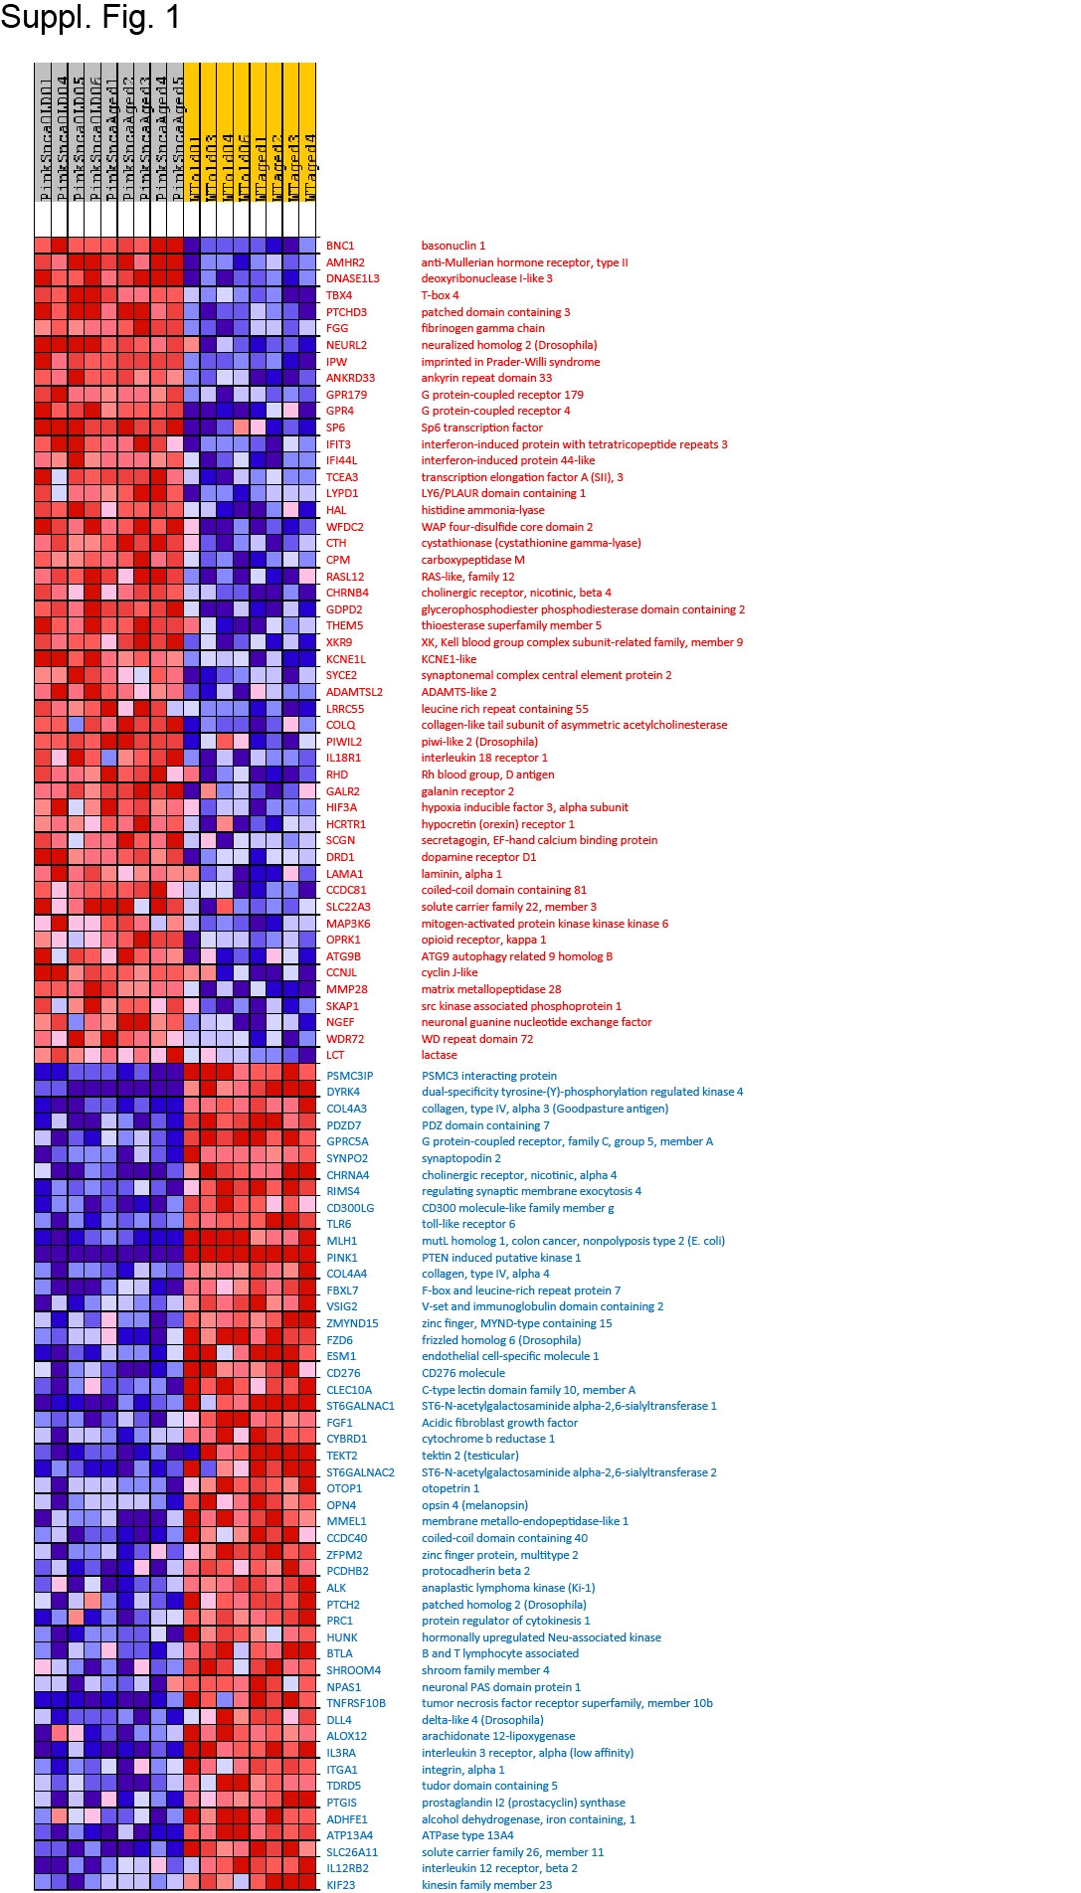

Suppl. Figure 1

Leading edge genes of Gene Set Enrichment Analysis (GSEA)
The heatmap shows the top 50 upregulated and downregulated genes according to GSEA enrichment scores which are calculated on the basis of ttest P values and fold change. GSEA does not consider overall gene expression. Therefore, high expression genes like Fgf1 (position 117 of downregulated), which normally do not reach 2-fold changes, are missed in the leading edge genes.

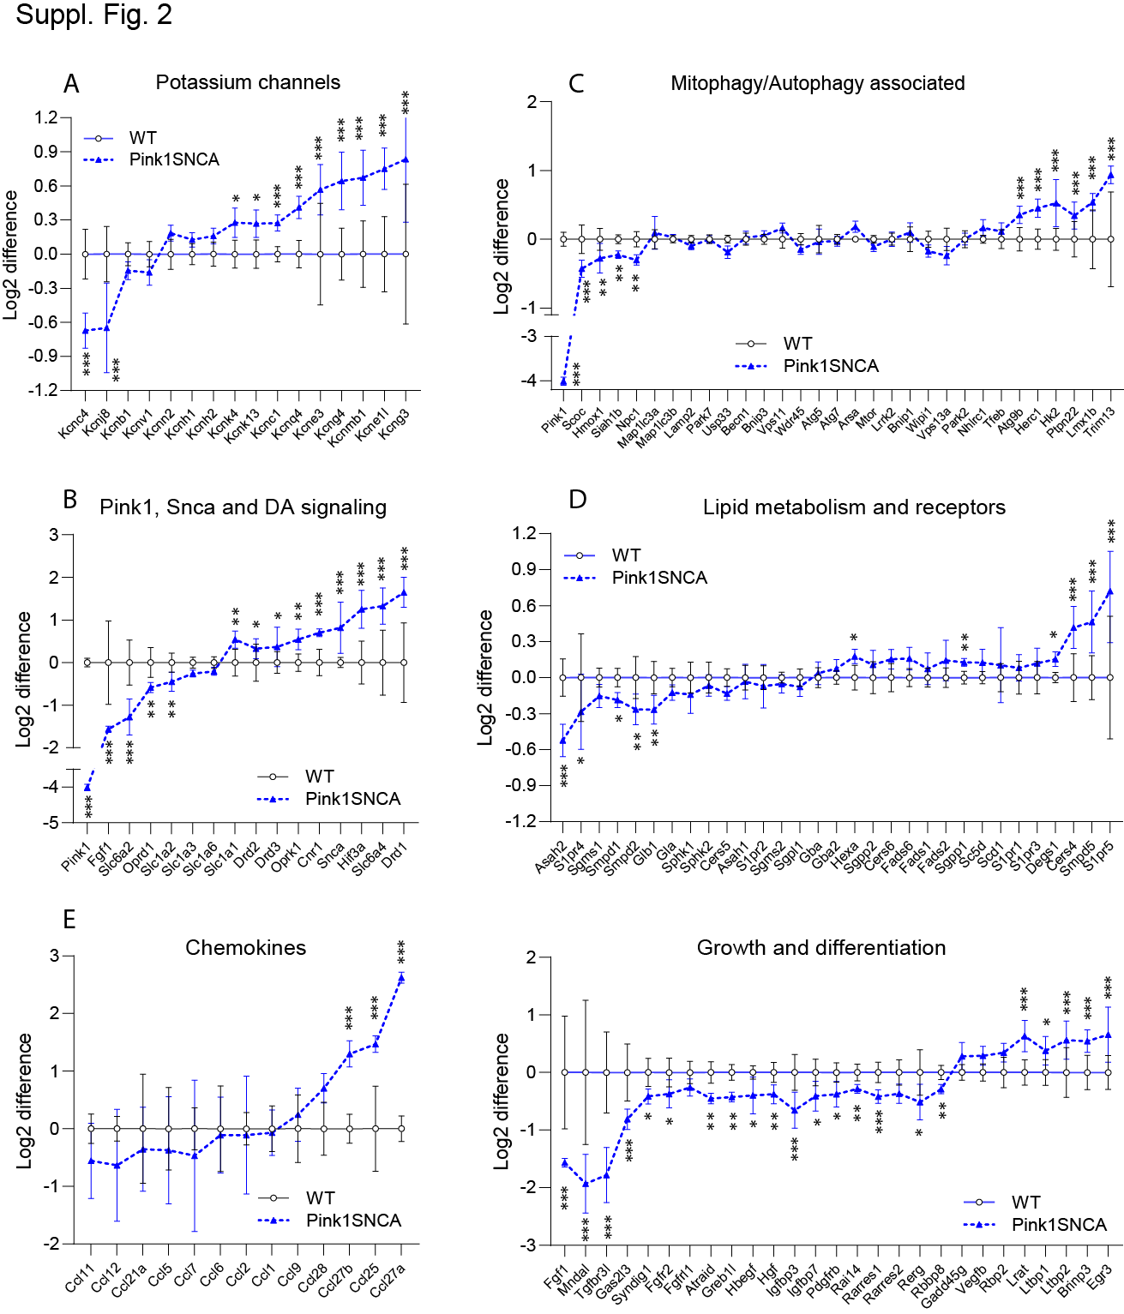

Suppl. Figure 2

RNAseq pathway and candidate gene analyses in DRGs of Pink1SNCA and wildtype mice
Mice were middle aged (10-12 months, 4 and 5) and old (18 months, each 4) at the time of tissue preparation. All mice per group were analyzed together, because age had no relevant impact on the clustering results of mice (presented in Fig. 3). For comparison, reads were normalized to the mean log2 counts of wildtype control mice, and they are expressed as the log2 difference. Data were compared per 2-way ANOVA and multiple comparisons corrected for the False Discovery Rate (FDR) according to Benjamini, Krieger and Yekutieli. Asterisks indicate multiplicity adjusted P values, *P<0.05, **P<0.001, ***P<0.0001.
Pathways were selected according to the mouse model i.e. Pink1 and SNCA associated genes and genes involved in biogenic amine signaling, on the observed alterations of sphingolipids, and on Gene Ontology enrichment analyses pointing to differences in potassium channels, chemokines and genes involved in cell differentiation.

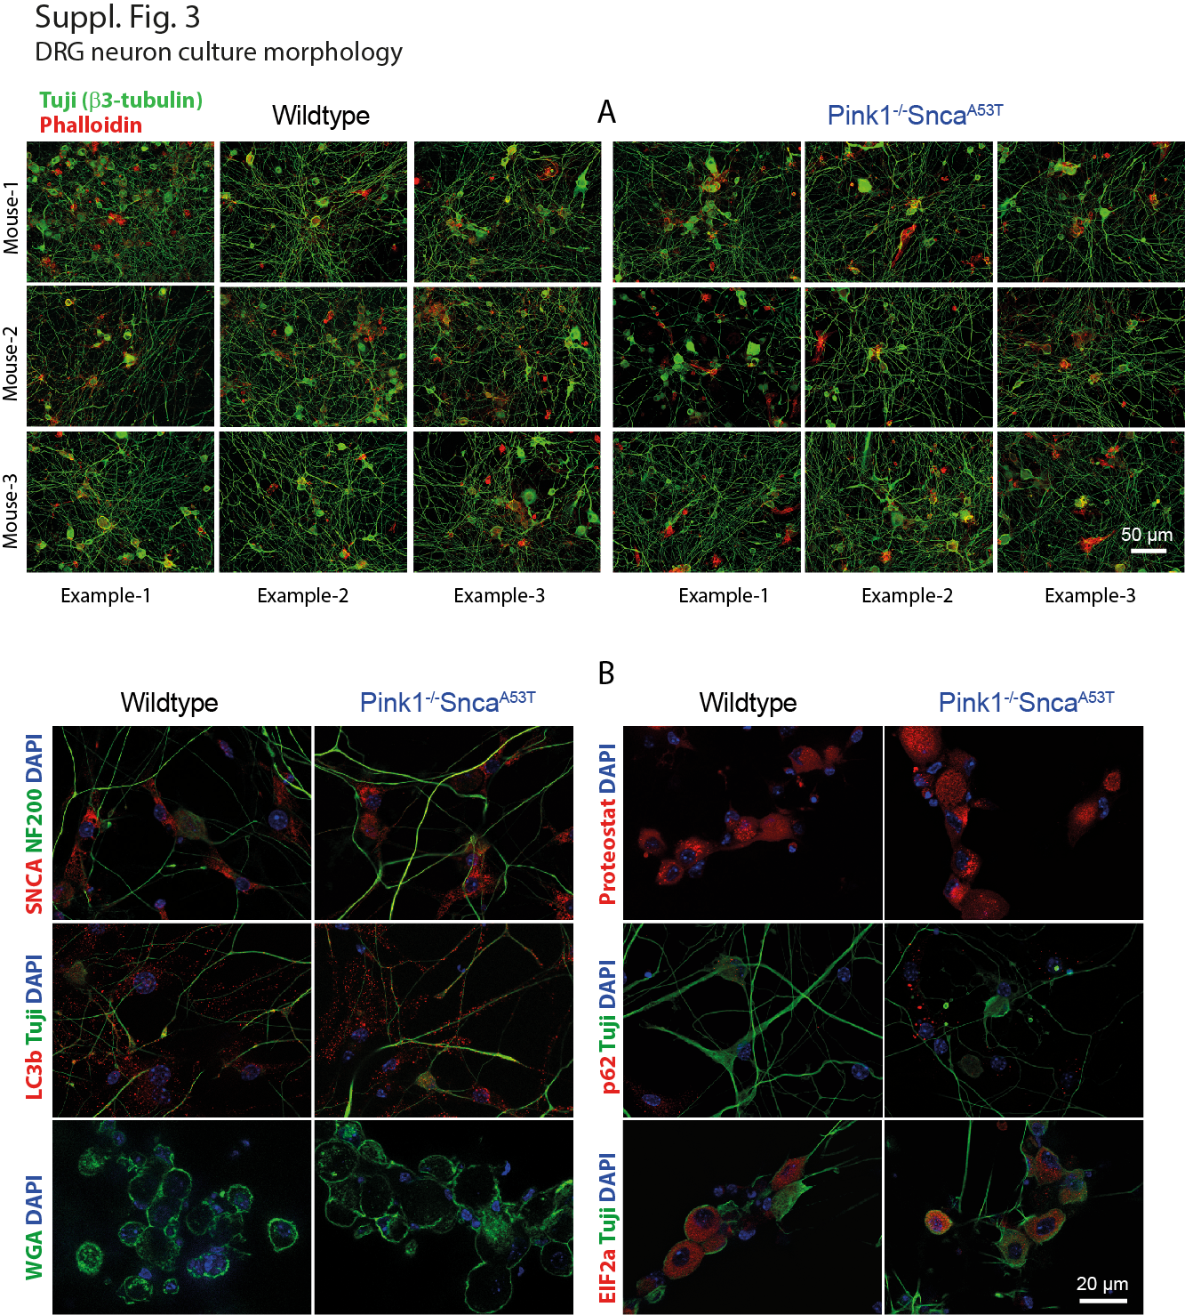

Suppl. Figure 3

Immunofluorescence analysis of morphology and outgrowth of primary DRG neuron cultures
A: DRG neuron outgrowth and morphology were assessed in primary DRG neuron-enriched cultures at 48h after plating in Pink1SNCA and wildtype control mice at 12 months of age. Tuji (β3-tubulin) was used for staining neuronal bodies and neurites, Phalloidin-Alexa594 for staining of the cytoskeleton of neurons and supporting glial cells. There were no differences of culture morphology between genotypes.
B: To assess accumulation of synuclein and protein aggregates (SNCA and proteostat), autophagy (LC3b and Sqstm1/p62), apoptosis (active caspase 3), ER (Eif2alpha) and plasma membrane morphology (wheat germ agglutinin, WGA) primary DRG cultures were prepared from 3, 5 or 12 months old Pink1SNCa and wildtype control mice, and marker proteins were detected with specific antibodies. NF200 and DAPI were used as neuronal and nuclear counterstain. Sqstm1/p62 immunoreactive dots appeared to be more abundant in neurons of Pink1SNCA mice. There were no overt differences of other markers. The quantitative analysis was based on the percentage area covered with the respective immunoreactive structures, which was assessed with FIJI ImageJ after subtraction of background and conversion to binary images. Thresholds were set with algorithms provided by FIJI.

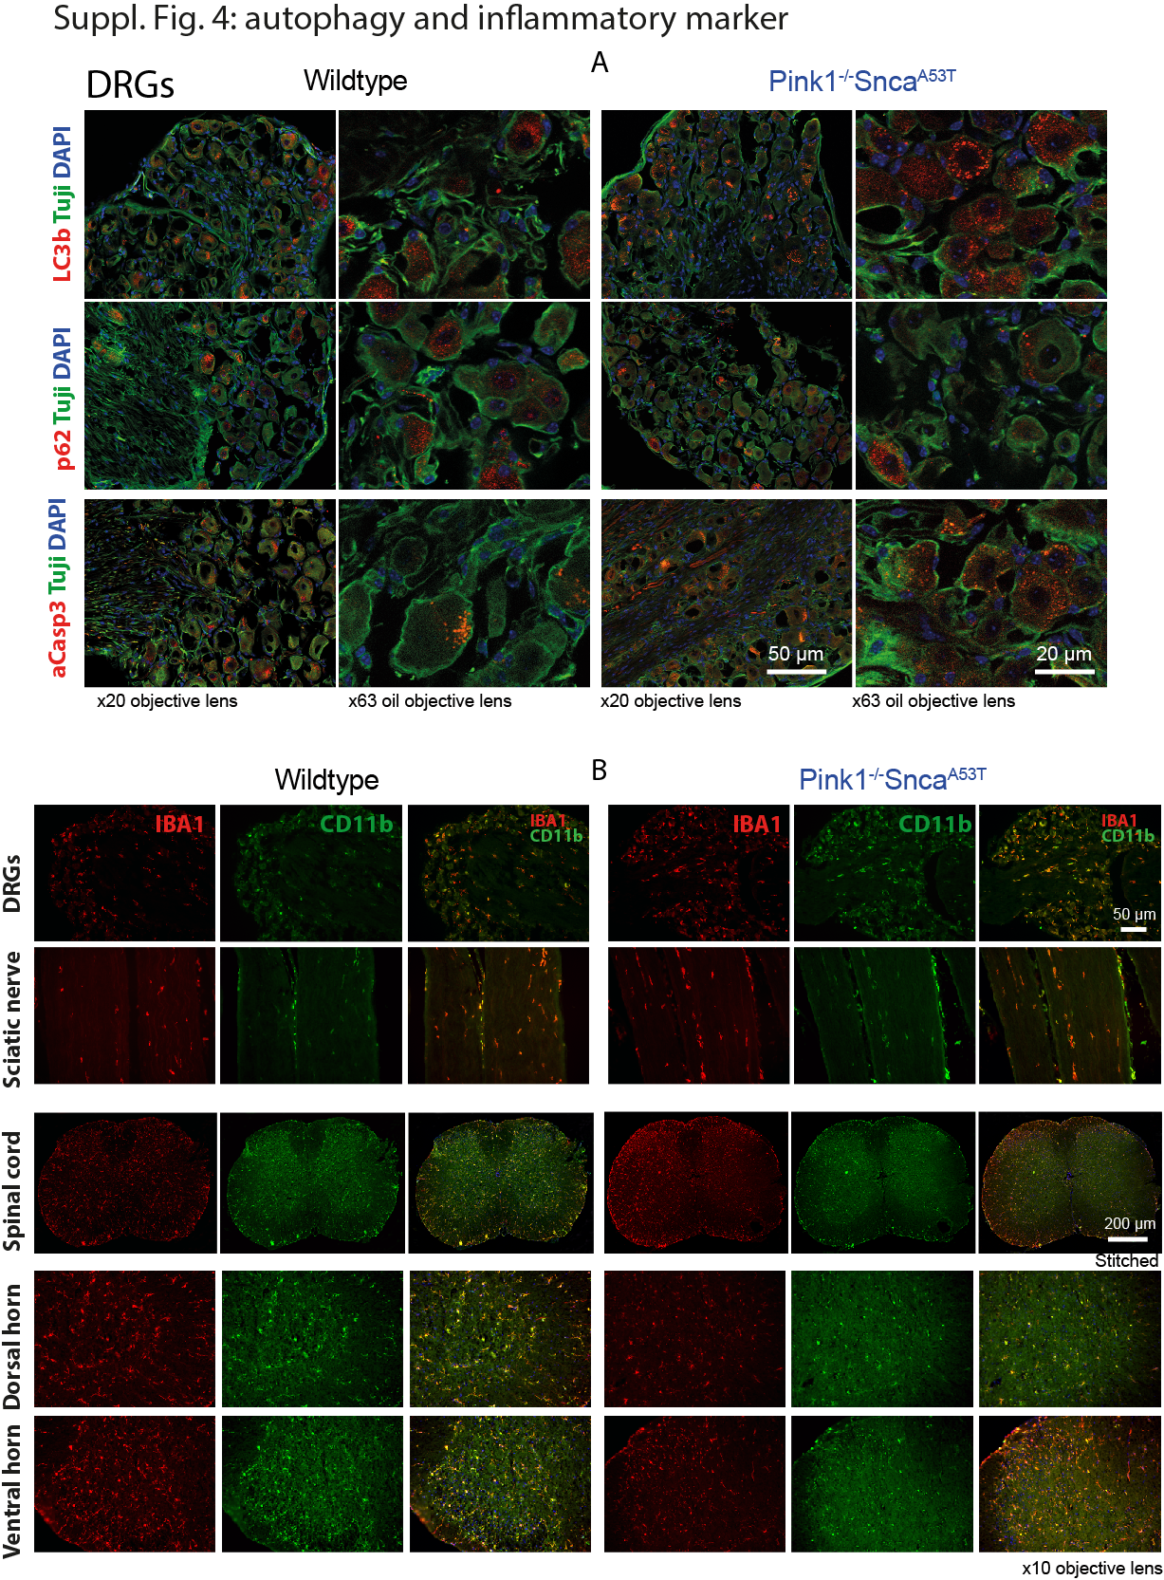

Suppl. Figure 4

Immunofluoresence analysis autophagy, apoptosis and inflammatory cells
A: Pink1SNCA and wildtype mice were 18 months old at the time of tissue preparation. Autophagy was assessed via staining of LC3b and p62, and apoptosis via staining with active caspase 3. The respective left panels show overviews, the right panels show higher magnifications. The occurrence and distribution of immunoreactive structures did not significantly differ between genotypes. The quantification was done with FIJI as in Suppl. Fig. 1.
B: Immunofluorescence analysis of the myeloid cell markers, IBA1 and CD11b in the DRGs, sciatic nerve and spinal cord reveal satellite cells or macrophages in the periphery and microglia in the spinal cord. There were no overt differences in the cellularity and distribution of the immunoreactivity of these inflammatory marker molecules in these tissues.
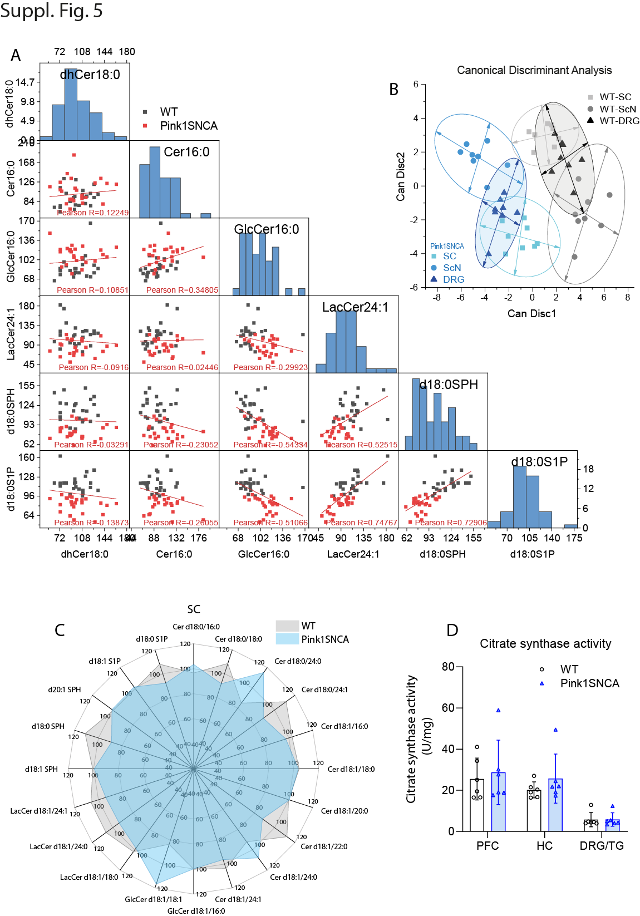

Suppl. Figure 5

Sphingolipids and ceramides in DRGs, sciatic nerve and spinal cord
A: Scatter matrix of the sphingolipid species, which were strongly deregulated in Pink1SNCA mice. Mice (n = 8 per group) were 12 months old at the time of tissue preparation. Percentages were used because total lipid concentrations differ by several orders of magnitude. The respective lipid mean of all samples was set to 100%. The dots are individual mice, and each mouse is represented 3-times for DRG, ScN and SC. d18:0 SPH = sphinganine, d18:1 = sphinganine-1-phosphate.
B: CanDisc score plots of the first two components showing the separation of the genotypes for each tissue based on 19 sphingolipid species used as input for a canonical discriminant analysis.
C: Polar plots of the mean lipid percentages in the spinal cord, where lipids were mostly unaffected. The respective polar plots of DRGs and ScN are presented in Figure 5.

D: Glucosylceramides are supposed to disrupt mitochondrial function. To assess the metabolic capacity of the mitochondria, citrate synthase activity was assessed via Oxygraph analysis in brain and sensory ganglia. Citrate synthase is the initial enzyme of the tricarboxylic acid (TCA) cycle. There were no differences between genotypes.
Lipids: Dehydro-Ceramides Cer d18:0/16:0, Cer d18:0/18:0, Cer d18:0/24:0, Cer d18:0/24:1; ceramides Cer 18:1/16:0, Cer 18:1/18:0, Cer 18:1/20:0, Cer 18:1/22:0, Cer 18:1/24:0, Cer 18:1/24:1; glucosylceramide (GlcCer 16:0) and lactosylceramides (LacCer 18:0, LacCer 24:0, LacCer 24:1), sphinganines (d18:0 SPH, d20:0 SPH), sphingosine (d18:1 SPH) and the respective phospho-SPH's (d18:0 S1P, d18:1 S1P)

