Supplementary Methods
Expansion of the Regional Ecosystem Description Database Table
To identify vegetation communities that contained black flying fox winter diet resources, we used the Regional Ecosystem Description Database (REDD) Version 12 from the Queensland Herbarium (Queensland Herbarium 2019). Regional ecosystems are defined by a three-number identifier (e.g. 3.3.4) that corresponds to the bioregion, land zone, and vegetation community of a patch (Neldner et al. 2019). The Version 12 REDD table has 1,543 core regional ecosystems; however, some regional ecosystems have an additional letter further distinguishing vegetation communities within the same regional ecosystem (e.g. 3.2.4a).
We extracted all unique regional ecosystems written in the REDD table, resulting in 3,482 total regional ecosystems. We then acquired the list of all plant species in Queensland from the 2020 Census of Queensland flora list (Bean 2020). We further expanded this list to include all possible variations of species names including subspecies (e.g. Eucalyptus melanophloia, E. melanophloia, Eucalyptus melanophloia subsp. melanophloia, E. melanophloia subsp. melanophloia) to account for the variation in vegetation descriptions in the REDD table. We also included all genera and the phrase ‘sp’ and ‘spp’ (e.g. Ficus sp., Ficus spp.) in the list to account for uncertainty in species identification listed in the REDD table. This resulted in a list of 38,947 species or variations of floral species names.
Some regional ecosystems contain a descriptive phrase of the vegetation (e.g. “Simple to complex mesophyll to notophyll vine forest on moderately to poorly drained metamorphics (excluding amphibolites) of moderate fertility of the moist and wet lowlands, foothills and uplands.”) rather than any variation of floral species name. In such cases, we characterized the first sentence of the description as the first ‘species’ listed. We added these ‘species’ phrases into our unique list, totaling 39,066 variations of species names. We then extracted all corresponding species names and ‘species’ phrases on this list from the REDD table in order of appearance in the vegetation community description (see Table S1). This was essential as the order of species listed corresponds to the canopy layer in which they are found and the relative dominance of that species in the vegetation community (Neldner et al. 2019).
RE_ID | Vegetation Description | Species1 | Species2 | Species3 | Species4 | Species5 | Species6
3.3.69 | Melaleuca dealbata and Corymbia clarksoniana (Clarkson's bloodwood) tall open forest. A sub-canopy includes C. clarksoniana, Livistona muelleri, and Acacia crassicarpa (spoon tree). Imperata cylindrica (blady grass) forms the dominant ground cover. Occurs on alluvial plains. (BVG1M-9e) | Melaleuca dealbata | Corymbia clarksoniana | C. clarksoniana | Livistona muelleri | Acacia crassicarpa | Imperata cylindrica
Table S1. Example of Census of Queensland flora species extraction from Regional Ecosystem Description Database table.

We checked the accuracy of floral species names in the REDD table using Fuzzy Matching from the tokenizers pckg (Mullen et al. 2018). We counted the frequency of every word used in the vegetation descriptions, and then selected the words that were only used once to detect potentially misspelled words. We then found the string distance between words used only once and the unique species list using the stringdist pckg (van der Loo 2014). All floral species names from the REDD table that were one character apart from our species list were missing a space between the abbreviated genus and species name (e.g. E.crebra vs E. crebra). These misspelled species variations (n = 25) were added to the species list and we again extracted all floral species names in listed order from the REDD table.

Black Flying Fox Winter Habitat Selection
We identified regional ecosystems that contained at least one ‘major’ or ‘possible’ winter diet species, as observed from studies on black flying fox diet (Eby et al.; Palmer 1999; Vardon et al. 2001; Markus and Hall 2004; Eby and Law 2008; Griffith 2020; Bell et al. 2021). See Table S2 for list of major and possible black flying fox winter diet species. Since the abundance of productive vegetation within a patch is important for flying foxes (Eby and Law 2008), we only included regional ecosystems where the diet species of interest was listed within the top five species listed. This was to identify areas where these species were relatively ‘dominant’ or potentially of reasonable abundance to be useful for black flying fox populations.

List of Black Flying Fox Winter Diet Species
Species | Evidence | Area of Study | Study(s) | Diet
Banksia integrifolia | Observed feeding or feces | SEQ/NSW | Eby & Law 2008, Eby, Sims, & Bracks 2019, McWilliams 1985 | Major + Possible
Banksia spp. | Feces eDNA metabarcoding | Northeast NSW | Griffith 2020 | Possible
Callistemon spp | Observed feeding | Brisbane/Urban | Markus & Hall 2004 | Possible
Callistemon viminalis | Feces eDNA metabarcoding | Charters Town Roost QLD | Bradford personal comm., from Bell et al. 2021 | Major + Possible
Corymbia citriodora | Observed feeding or feces | SEQ/NSW | Eby & Law 2008 | Major + Possible
Corymbia erythrophloia | Feces eDNA metabarcoding | Charters Town Roost QLD | Bradford personal comm., from Bell et al. 2021 | Major + Possible
Corymbia maculata | Observed feeding or feces | SEQ/NSW | Eby & Law 2008, Eby, Sims, & Bracks 2019, McWilliams 1985 | Major + Possible
Corymbia polycarpa | Feces eDNA metabarcoding | Charters Town Roost QLD | Bradford personal comm., from Bell et al. 2021 | Major + Possible
Corymbia torrelliana | Feces eDNA metabarcoding | Charters Town Roost QLD | Bradford personal comm., from Bell et al. 2021 | Major + Possible
Eriobotrya japonica | Observed feeding | Brisbane/Urban | Markus & Hall 2004 | Major + Possible
Eucalyptus albens | Observed feeding or feces | SEQ/NSW | Eby & Law 2008, Eby, Sims, & Bracks 2019 | Major + Possible
Eucalyptus camaldulensis | Feces eDNA metabarcoding | Charters Town Roost QLD | Bradford personal comm., from Bell et al. 2021 | Major + Possible
Eucalyptus conica | Observed feeding or feces, not distinguished | New South Wales | Eby, Sims, & Bracks 2019 | Possible
Eucalyptus crebra | Feces eDNA metabarcoding | Charters Town Roost QLD | Bradford personal comm., from Bell et al. 2021 | Major + Possible
Eucalyptus fibrosa | Observed feeding or feces | SEQ/NSW | Eby & Law 2008 | Major + Possible
Eucalyptus fusiformis | Observed feeding or feces, not distinguished | New South Wales | Eby, Sims, & Bracks 2019 | Possible
Eucalyptus melliodora | Observed feeding or feces | SEQ/NSW | Eby & Law 2008 | Major + Possible
﻿Eucalyptus miniata | Observed feeding | Northern Territory | Palmer 1997, Vardon et al. 2001 | Possible
Eucalyptus ochrophloia | Observed feeding or feces, not distinguished | New South Wales | Eby, Sims, & Bracks 2019 | Possible
Eucalyptus paniculata | Observed feeding or feces, not distinguished | New South Wales | Eby & Law 2008, Eby, Sims, & Bracks 2019 | Possible
Eucalyptus papuana | Observed feeding | Northern Territory | Palmer 1997 | Possible
Eucalyptus pilularis | Observed feeding or feces | SEQ/NSW | Eby & Law 2008 | Major + Possible
Eucalyptus platyphylla | Feces eDNA metabarcoding | Charters Town Roost QLD | Bradford personal comm., from Bell et al. 2021 | Major + Possible
Eucalyptus polycarpa | Observed feeding | Northern Territory | Palmer 1997 | Possible
Eucalyptus seeana | Observed feeding or feces | SEQ/NSW | Eby & Law 2008, Eby, Sims, & Bracks 2019 | Major + Possible
Eucalyptus siderophloia | Observed feeding or feces | SEQ/NSW | Eby & Law 2008, Eby, Sims, & Bracks 2019 | Major + Possible
Eucalyptus sideroxlyon | Observed feeding or feces | SEQ/NSW | Eby & Law 2008, Eby, Sims, & Bracks 2019 | Major + Possible
Eucalyptus spp. | Feces eDNA metabarcoding | Northeast NSW | Griffith 2020 | Possible
Eucalyptus tereticornis | Observed feeding or feces | SEQ/NSW | Eby & Law 2008, Eby, Sims, & Bracks 2019 | Major + Possible
Eucalyptus tetradonta | Observed feeding | Northern Territory | Palmer 1997, Vardon et al. 2001 | Possible
Eucalyptus tetraplura | Observed feeding or feces, not distinguished | New South Wales | Eby & Law 2008, Eby, Sims, & Bracks 2019 | Possible
Eucalyptus xanthoclada | Feces eDNA metabarcoding | Charters Town Roost QLD | Bradford personal comm., from Bell et al. 2021 | Major + Possible
Ficus benjamina | Observed feeding | Brisbane/Urban | Markus & Hall 2004 | Major + Possible
Ficus microcarpa | Feces eDNA metabarcoding | Charters Town Roost QLD | Bradford personal comm., from Bell et al. 2021 | Major + Possible
Ficus obliqua | Observed feeding | Brisbane/Urban | Markus & Hall 2004 | Major + Possible
﻿Ficus racemosa | feces below maternity roost | Northern Territory | Palmer 1997 | Possible
Ficus sp | Feces/rejecta, some from observation | Northeast NSW | McWilliams 1985, Griffith 2020, Bradford personal comm., from Bell et al. 2021 | Major + Possible
Ficus virens | Observed feeding | Brisbane/Urban, NT | Markus & Hall 2004, Palmer 1997 | Major + Possible
Gravellia spp | Observed feeding | Brisbane/Urban | Markus & Hall 2004 | Possible
Lagunaria queenslandica | Feces eDNA metabarcoding | Charters Town Roost QLD | Bradford personal comm., from Bell et al. 2021 | Major + Possible
Ligustrum lucidum | Feces eDNA metabarcoding | Northeast NSW | Griffith 2020 | Possible
Macadamia spp. | Feces eDNA metabarcoding | Northeast NSW | Griffith 2020 | Possible
Mangifera indica | Feces eDNA metabarcoding | Charters Town Roost QLD | Bradford personal comm., from Bell et al. 2021 | Major + Possible
Melaleuca fluviatilis | Feces eDNA metabarcoding | Charters Town Roost QLD | Bradford personal comm., from Bell et al. 2021 | Major + Possible
Melaleuca leucadendra | Feces eDNA metabarcoding | Charters Town Roost QLD | Bradford personal comm., from Bell et al. 2021 | Major + Possible
Melaleuca nervosa | Feces eDNA metabarcoding | Charters Town Roost QLD | Bradford personal comm., from Bell et al. 2021 | Major + Possible
Melaleuca quinquenervia | Observed feeding or feces | SEQ/NSW | Eby & Law 2008, Eby, Sims, & Bracks 2019, McWilliams 1985 | Major + Possible
Melaleuca spp. | Feces eDNA metabarcoding | Northeast NSW | Griffith 2020 | Possible
Melaleuca viridiflora | Feces eDNA metabarcoding | Charters Town Roost QLD, Northern Territory | Bradford personal comm., from Bell et al. 2021, Palmer 1997 | Major + Possible
Melia azedarach | Feces eDNA metabarcoding | Northeast NSW | Griffith 2020, Bradford personal comm., from Bell et al. 2021 | Possible
Nauclea orientalis | Feces eDNA metabarcoding | Charters Town Roost QLD | Bradford personal comm., from Bell et al. 2021 | Major + Possible
﻿Nauclea orientalis | feces below maternity roost | Northern Territory | Palmer 1997 | Possible
﻿Passiflora foetida | feces below maternity roost | Northern Territory | Palmer 1997 | Possible
Solanum mauritianum | Feces eDNA metabarcoding | Northeast NSW | Griffith 2020 | Possible
Sygarus romanzoffiana | Observed feeding | Brisbane/Urban | Markus & Hall 2004 | Major + Possible
Syncarpia glomulifera | Observed feeding or feces, not distinguished | New South Wales | Eby & Law 2008, Eby, Sims, & Bracks 2019 | Possible
﻿Timonius timon | feces below maternity roost | Northern Territory | Palmer 1997 | Possible
Ziziphus mauritiana | Feces eDNA metabarcoding | Charters Town Roost QLD | Bradford personal comm., from Bell et al. 2021 | Major + Possible
Table S2. List of major and possible diet species for black flying foxes.

Supplementary Results
Differences in winter habitat loss between ‘major’ and ‘possible’ diet species were evident at the landscape scale (Figure S1a), but negligible at small spatial scales (Figure S1b). Northern foraging areas had no difference in habitat loss between diet lists. Southern foraging areas show a net increase for major diet species from 2013 to 2015 however we acknowledge this is an artifact of the data. Similar to the bioregional trends of winter habitat loss, most patches lost less than 12% of their previously mapped size (Figure 4c, 4d).
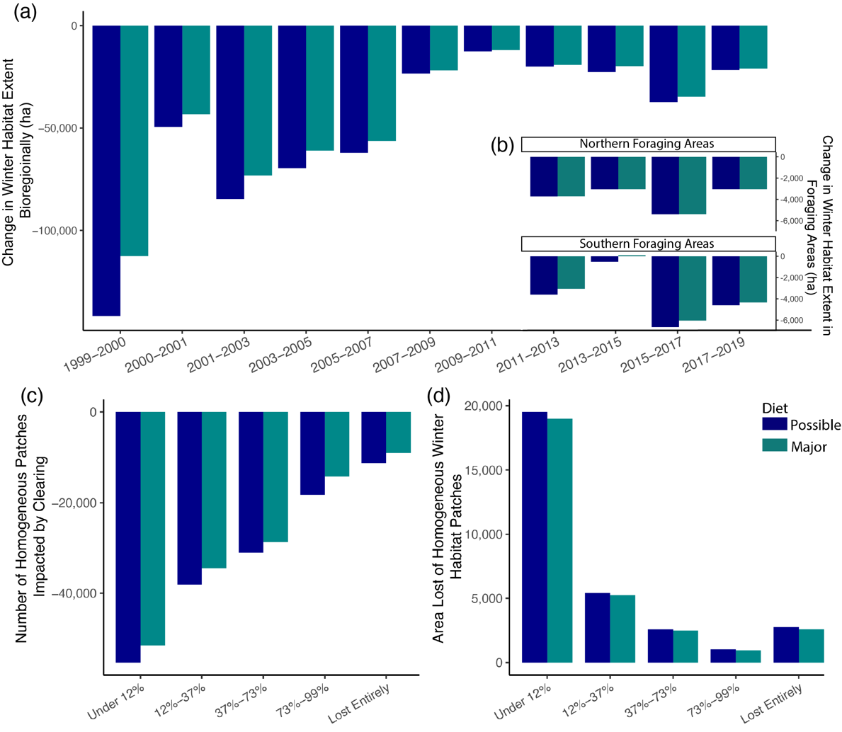
Figure S1. Extent Change of Winter Habitats for Black Flying Foxes and Homogenous Patch Loss Dynamics 1999-2019. Hectares lost or gained from the previous time point of VMRE maps colored by diet list. (a) Extent change of major (green) and possible (blue) winter habitats in bioregions of interest from 1999-2019. (b) Extent change of winter habitats for Northern and Southern foraging areas in 50km around roosts from 2011-2019. (c) Extent loss of winter habitat homogenous patches binned by the proportion of the patch that was lost. (d) Number of homogenous winter habitat patches that lost area, or were impacted by clearing, binned by the proportion of the patch that was lost.

References
A. Mullen L, Benoit K, Keyes O, et al (2018) Fast, Consistent Tokenization of Natural Language Text. J Open Source Softw 3:655. https://doi.org/10.21105/joss.00655
Bean AR (2020) Census of the Queensland Flora 2020. In: Dep. Environ. Sci.
Bell KL, Batchelor KL, Bradford M, et al (2021) Optimisation of a pollen DNA metabarcoding method for diet analysis of flying-foxes ( Pteropus spp .). Aust J Zool
Eby P, Law B (2008) Ranking the feeding habitats of Grey-headed flying foxes for conservation management. A report for The Department of Environment and Climate Change (NSW) & The Department of Environment, Water, Heritage and the Arts
Eby P, Sims R, Bracks J Flying-fox Foraging Habitat Mapping NSW spatial patterns of habitat quality for flying-foxes. 1–39
Griffith P (2020) Diet Partitioning in newly sympatric urban flying-foxes (Pteropus poliocephauls and Pteropus alecto). Aust Mammal 42:361–366
Markus N, Hall L (2004) Foraging behaviour of the black flying-fox (Pteropus alecto) in the urban landscape of Brisbane, Queensland. Wildl Res 31:345–355. https://doi.org/10.1071/WR01117
Neldner VJ, Wilson BA, Dillewaard HA, et al (2019) Methodology for survey and mapping of regional ecosystems and vegetation communities in Queensland.Version 5.0. Updated March 2019. Queensl Herb Queensl Dep Environ Sci Brisbane
Palmer CL (1999) Ecology of the black flying-fox Pteropus alecto in the seasonal tropics of Northern Territory: Resource tracking in a landscape mosaic and role in seed dispersal. Australas Bat Soc Newlettler 12–13
van der Loo M (2014) The stringdist package for approximate string matching. R J 6:111–122
Vardon MJ, Brocklehurst PS, Woinarski JCZ, et al (2001) Seasonal habitat use by flying-foxes, Pteropus alecto and P. scapulatus (Megachiroptera), in monsoonal Australia. J Zool 253:523–535. https://doi.org/10.1017/S0952836901000486

