Content:
Appendix 1: Results of demographic characteristics among different groups..........................................1
Appendix 2: Demographic information in A+T+ patients.........................................................................3
Appendix 3: Results of longitudinal analyses in brain structures and cognitive scores between discordant and concordant groups.............................................................................................................4
Appendix 4: Results of longitudinal analyses in brain structures and cognitive scores among discordant patients.......................................................................................................................................................7
Appendix 5: Results of longitudinal analyses in brain structures and cognitive scores among CN and MCI patients..............................................................................................................................................9
Appendix 6: Longitudinal analyses in brain structures and cognitive scores among A+T+ patients.....................................................................................................................................................15
Appendix 7: Results of longitudinal analyses in brain structures and cognitive scores among A+T+ patients.....................................................................................................................................................24
Appendix 8: Results of survival analyses between discordant and concordant patients.....................................................................................................................................................27
Appendix 9: Kaplan–Meier survival curves for probability of cognitive progression in discordant patients.....................................................................................................................................................28
Appendix 10: Results of survival analyses in discordant patients.....................................................................................................................................................31
Appendix 11: Kaplan–Meier survival curves for probability of cognitive progression in CN or MCI patients.....................................................................................................................................................32
Appendix 12: Results of survival analyses in CN or MCI patients…………………………………………………………….........................................................44
Appendix 13: Kaplan–Meier survival curves for probability of cognitive progression in discordant group among A+T+ patients....................................................................................................................45
Appendix 14: Results of survival analyses in A+T+ patients.....................................................................................................................................................48
Appendix 15: Demographic information with the exclusion of borderline cases....................................49
Appendix 16: Distribution plots of “N” biomarkers with the exclusion of borderline cases..................50
Appendix 17: Kaplan–Meier survival curves for probability of cognitive progression when excluding borderline cases........................................................................................................................................52
Appendix 18: Results of survival analyses when excluding borderline cases.........................................................................................................................................................58
Appendix 19: Demographic information (cut-offs for neurodegenerative biomarkers were derived from ROC analyses)..........................................................................................................................................59
Appendix 20: Distribution plots (cut-offs for neurodegenerative biomarkers were derived from ROC analyses)...................................................................................................................................................60
Appendix 21: Kaplan–Meier survival curves for probability of cognitive progression (cut-offs for neurodegenerative biomarkers were derived from ROC analyses)...................................................................................................................................................62
Appendix 22: Results of survival analyses (cut-offs for neurodegenerative biomarkers were derived from ROC analyses)................................................................................................................................68

Appendix 1: Results of demographic characteristics among different groups
Characteristics | CSF/PET profile | CSF/MRI profile | PET/MRI profile
Characteristics | p-value | p-value | p-value
Baseline CN/MCI | B-A < 0.001; C-B = 0.006; b-a = 0.443 | E-D < 0.001; F-E = 0.010; d-c = 0.002 | H-G < 0.001; I-H < 0.001; f-e = 0.016
Age (years) | B-A < 0.001; C-B = 0.892; b-a = 0.455 | E-D < 0.001; F-E = 0.004; d-c = 0.004 | H-G < 0.001; I-H = 0.219; f-e < 0.001
Female | B-A = 0.402; C-B = 0.948; b-a < 0.001 | E-D = 0.626; F-E = 0.248; d-c = 0.035 | H-G = 0.002; I-H = 0.403; f-e = 0.097
Years of education | B-A = 0.036; C-B = 0.376; b-a = 0.344 | E-D = 0.136; F-E = 0.878; d-c = 0.421 | H-G = 0.666; I-H = 0.257; f-e = 0.950
APOE ε4 positive | B-A < 0.001; C-B < 0.001; b-a = 0.252 | E-D < 0.001; F-E = 0.001; d-c = 0.011 | H-G = 0.047; I-H < 0.001; f-e = 0.132
MMSE | B-A < 0.001; C-B = 0.001; b-a = 0.778 | E-D < 0.001; F-E < 0.001; d-c = 0.157 | H-G < 0.001; I-H < 0.001; f-e = 0.180
CDRSB | B-A < 0.001; C-B = 0.001; b-a = 0.073 | E-D < 0.001; F-E < 0.001; d-c = 0.028 | H-G < 0.001; I-H < 0.001; f-e = 0.743
FAQ | B-A < 0.001; C-B < 0.001; b-a = 0.036 | E-D < 0.001; F-E = 0.001; d-c = 0.035 | H-G < 0.001; I-H < 0.001; f-e = 0.926
aHPV (mm3) | B-A < 0.001; C-B = 0.015; b-a =0.066 | E-D < 0.001; F-E < 0.001; d-c < 0.001 | H-G < 0.001; I-H < 0.001; f-e < 0.001
Entorhinal volume (mm3) | B-A < 0.001; C-B = 0.011; b-a = 0.699 | E-D < 0.001; F-E < 0.001; d-c < 0.001 | H-G < 0.001; I-H < 0.001; f-e < 0.001
Whole brain volume (mm3) | B-A = 0.002; C-B = 0.476; b-a = 0.450 | E-D < 0.001; F-E = 0.017; d-c = 0.041 | H-G = 0.007; I-H = 0.003; f-e = 0.005
FDG-PET | B-A < 0.001; C-B < 0.001; b-a < 0.001 | E-D < 0.001; F-E = 0.003; d-c = 0.040 | H-G < 0.001; I-H < 0.001; f-e < 0.001
CSF Aβ42 (pg/mL) | B-A < 0.001; C-B < 0.001; b-a = 0.006 | E-D < 0.001; F-E < 0.001; d-c = 0.006 | H-G < 0.001; I-H < 0.001; f-e = 0.974
CSF p-tau (pg/mL) | B-A < 0.001; C-B < 0.001; b-a < 0.001 | E-D < 0.001; F-E < 0.001; d-c < 0.001 | H-G = 0.147; I-H < 0.001; f-e = 0.782
CSF t-tau (pg/mL) | B-A < 0.001; C-B < 0.001; b-a < 0.001 | E-D < 0.001; F-E < 0.001; d-c < 0.001 | H-G < 0.001; I-H = 0.002; f-e = 0.594

In the CSF/PET profile, A, B and C represent CSF-/PET- group, combined group of CSF-/PET+ and CSF+/PET-, and CSF+/PET+ group, respectively. In the CSF/MRI profile, D, E and F represent CSF-/MRI- group, combined group of CSF-/MRI+ and CSF+/MRI-, and CSF+/MRI+ group, respectively. In the PET/MRI profile, G, H and I represent PET-/MRI- group, combined group of PET-/MRI+ and PET+/MRI-, and PET+/MRI+ group, respectively. a, b, c, d, e and f represent CSF+/PET- group, CSF-/PET+ group, CSF+/MRI- group, CSF-/MRI+ group, PET-/MRI+ group and PET+/MRI- group, respectively.

Abbreviations: Aβ, amyloid beta; aHPV, adjusted hippocampal volume; CDRSB, Clinical Dementia Rating Scale-Sum of Boxes; CN, cognitively normal; CSF, cerebrospinal fluid; FAQ, Functional Activities Questionnaire; FDG, 18F-fluorodeoxyglucose; MCI, mild cognitive impairment; MMSE, Mini-Mental State Examination; MRI, Magnetic Resonance Imaging; PET, positron emission tomography; p-tau, phosphorylated tau; t-tau, total tau.

Appendix 2: Demographic information in A+T+ patients
Characteristics | CSF/PET profile |  |  |  | CSF/MRI profile |  |  |  | PET/MRI profile
Characteristics | CSF-/PET- | discordant | CSF+/PET+ |  | CSF-/MRI- | discordant | CSF+/MRI+ |  | PET-/MRI- | discordant | PET+/MRI+
N | 106 | 147 | 84 |  | 104 | 157 | 76 |  | 137 | 120 | 80
Age (years) | 72.9 (6.0) | 74.0 (6.8) | 73.4 (7.0) |  | 72.3 (6.2) | 73.3 (6.9) | 75.8 (6.0) |  | 72.4 (6.5) | 74.0 (6.9) | 74.7 (6.4)
Female | 51 (%) | 66 (%) | 38 (%) |  | 47 (%) | 71 (%) | 37 (%) |  | 73 (%) | 47 (%) | 35 (%)
Years of education | 16.1 (2.3) | 15.9 (2.8) | 16.3 (2.8) |  | 16.3 (2.2) | 15.9 (2.8) | 16.0 (2.8) |  | 15.9 (2.5) | 16.2 (2.6) | 16.1 (3.0)
APOE ε4 positive | 57 (%) | 92 (%) | 62 (%) |  | 59 (%) | 95 (%) | 57 (%) |  | 78 (%) | 73 (%) | 60 (%)
MMSE | 28.5 (1.5) | 27.9 (1.8) | 27.3 (1.9) |  | 28.6 (1.4) | 27.9 (1.8) | 27.1 (1.9) |  | 28.5 (1.6) | 27.9 (1.7) | 27.1 (1.9)
CDRSB | 0.7 (0.7) | 1.3 (1.0) | 1.6 (1.1) |  | 0.7 (0.8) | 1.2 (1.0) | 1.7 (1.0) |  | 0.7 (0.8) | 1.3 (1.0) | 1.7 (1.0)
FAQ | 1.6 (3.2) | 2.7 (3.9) | 4.0 (3.9) |  | 1.5 (3.2) | 2.8 (3.8) | 4.1 (4.1) |  | 1.2 (2.7) | 3.4 (4.1) | 4.2 (4.1)
aHPV (mm³) | 7,310.9 (928.3) | 6,777.6 (928.1) | 6,509.5 (948.8) |  | 7,637.4 (638.7) | 6,881.1 (847.1) | 5,834.7 (612.5) |  | 7,609.6 (636.7) | 6,704.6 (845.2) | 5,887.5 (608.7)
Entorhinal volume (mm³) | 3,745.2 (584.4) | 3,552.2 (714.6) | 3,393.6 (660.0) |  | 3,837.3 (539.7) | 3,576.7 (689.8) | 3,191.7 (637.5) |  | 3,880.7 (587.2) | 3,516.2 (576.8) | 3,128.6 (689.4)
Whole brain volume (mm³) | 1,061,258.6 (103,111.0) | 1,046,929.5 (108,797.7) | 1,026,416.4 (94,592.7) |  | 1,068,310.1 (102,848.6) | 1,048,985.1 (103,507.5) | 1,011,397.8 (99,115.0) |  | 1,062,141.7 (105,405.8) | 1,049,001.2 (92,250.3) | 1,016,097.0 (112,830.8)
FDG-PET | 1.3 (0.1) | 1.2 (0.1) | 1.1 (0.1) |  | 1.3 (0.1) | 1.2 (0.1) | 1.2 (0.1) |  | 1.3 (0.1) | 1.2 (0.1) | 1.1 (0.1)
CSF Aβ42 (pg/mL) | 144.6 (26.8) | 135.7 (22.9) | 134.6 (22.3) |  | 145.1 (25.9) | 137.4 (23.3) | 130.5 (21.9) |  | 141.9 (23.6) | 139.3 (24.5) | 130.3 (24.1)
CSF p-tau (pg/mL) | 42.0 (16.2) | 51.4 (22.2) | 60.6 (22.4) |  | 40.2 (15.4) | 56.0 (24.9) | 54.3 (15.9) |  | 50.1 (22.8) | 50.2 (22.3) | 52.8 (18.5)
CSF t-tau (pg/mL) | 66.7 (16.5) | 111.4 (46.7) | 145.3 (43.4) |  | 65.6 (16.5) | 111.4 (43.3) | 149.3 (46.7) |  | 95.5 (44.5) | 108.2 (47.7) | 119.9 (53.5)
Abbreviations: A+, abnormal cerebrospinal fluid amyloid; Aβ, amyloid beta; aHPV, adjusted hippocampal volume; CDRSB, Clinical Dementia Rating Scale-Sum of Boxes; CN, cognitively normal; CSF, cerebrospinal fluid; FAQ, Functional Activities Questionnaire; FDG, 18F-fluorodeoxyglucose; MCI, mild cognitive impairment; MMSE, Mini-Mental State Examination; MRI, Magnetic Resonance Imaging; PET, positron emission tomography; p-tau, phosphorylated tau; T+, abnormal cerebrospinal fluid phosphorylated tau; t-tau, total tau.

Appendix 3: Results of longitudinal analyses in brain structures and cognitive scores between discordant and concordant groups

MMSE
Model 1 | Βeta | SE | p | p-total
B-A | -0.1650357 | 0.02321799 | <0.0001 | <0.0001
C-B | -0.3248426 | 0.03743397 | <0.0001
E-D | -0.2105198 | 0.02439122 | <0.0001 | <0.0001
F-E | -0.16445323 | 0.03811905 | <0.0001
H-G | -0.1583781 | 0.02443192 | <0.0001 | <0.0001
I-H | -0.28417901 | 0.03554924 | <0.0001
Model 1 adjusted for age, gender, years of education and APOE ε4

CDRSB
Model 1 | Βeta | SE | p | p-total
B-A | 0.1578318 | 0.02158627 | <0.0001 | <0.0001
C-B | 0.3413014 | 0.03414407 | <0.0001
E-D | 0.2162773 | 0.02220005 | <0.0001 | <0.0001
F-E | 0.1970525 | 0.03421439 | <0.0001
H-G | 0.1778262 | 0.02236758 | <0.0001 | <0.0001
I-H | 0.2750520 | 0.03206560 | <0.0001
Model 1 adjusted for age, gender, years of education and APOE ε4

FAQ
Model 1 | Βeta | SE | P | p-total
B-A | 0.1658564 | 0.01956894 | <0.0001 | <0.0001
C-B | 0.26522873 | 0.03108388 | <0.0001
E-D | 0.1886375 | 0.02023480 | <0.0001 | <0.0001
F-E | 0.15326973 | 0.03126544 | <0.0001
H-G | 0.1761034 | 0.01987602 | <0.0001 | <0.0001
I-H | 0.23666028 | 0.02858841 | <0.0001
Model 1 adjusted for age, gender, years of education and APOE ε4

Hippocampal volume
Model 2 | Βeta | SE | p | p-total
B-A | -0.0583288 | 0.0099566 | <0.0001 | <0.0001
C-B | -0.0479508 | 0.0151309 | 0.0015
E-D | -0.0698101 | 0.0098465 | <0.0001 | <0.0001
F-E | -0.0362194 | 0.0148538 | 0.0148
H-G | -0.0287962 | 0.01048825 | 0.0061 | <0.0001
I-H | -0.0648357 | 0.0146976 | <0.0001
Model 2 adjusted for age, gender, total intracranial volume and APOE ε4

Entorhinal volume
Model 2 | Βeta | SE | p | p-total
B-A | -0.0438084 | 0.0157011 | 0.0053 | <0.0001
C-B | -0.1350550 | 0.0234183 | <0.0001
E-D | -0.0848294 | 0.0161647 | <0.0001 | <0.0001
F-E | -0.0336659 | 0.0247208 | 0.1734
H-G | -0.0514612 | 0.0166784 | 0.0021 | <0.0001
I-H | -0.0839387 | 0.0234794 | 0.0004
Model 2 adjusted for age, gender, total intracranial volume and APOE ε4

Whole brain volume
Model 2 | Βeta | SE | p | p-total
B-A | -0.0288183 | 0.00667354 | <0.0001 | <0.0001
C-B | -0.0388664 | 0.01008342 | 0.0001
E-D | -0.0329770 | 0.00672944 | <0.0001 | <0.0001
F-E | -0.0163220 | 0.01006428 | 0.1050
H-G | -0.0173800 | 0.00694208 | 0.0124 | <0.0001
I-H | -0.0408671 | 0.00965864 | <0.0001
Model 2 adjusted for age, gender, total intracranial volume and APOE ε4

In the CSF/PET profile, A, B and C represent CSF-/PET- group, combined group of CSF-/PET+ and CSF+/PET-, and CSF+/PET+ group, respectively. In the CSF/MRI profile, D, E and F represent CSF-/MRI- group, combined group of CSF-/MRI+ and CSF+/MRI-, and CSF+/MRI+ group, respectively. In the PET/MRI profile, G, H and I represent PET-/MRI- group, combined group of PET-/MRI+ and PET+/MRI-, and PET+/MRI+ group, respectively. In all models, the latter group was the reference group. For example, in the result for B-A, A group was the reference group.
Abbreviations: CDRSB, Clinical Dementia Rating Scale-Sum of Boxes; CSF, cerebrospinal fluid; FAQ, Functional Activities Questionnaire; MMSE, Mini-Mental State Examination; MRI, Magnetic Resonance Imaging; PET, positron emission tomography; SE, standard error.

Appendix 4: Results of longitudinal analyses in brain structures and cognitive scores among discordant patients

MMSE
Model 1 | Βeta | SE | P
b-a | -0.0895554 | 0.043679 | 0.0406
d-c | -0.0206572 | 0.0448103 | 0.6449
f-e | -0.0705163 | 0.0463886 | 0.1288
Model 1 adjusted for age, gender, years of education and APOE ε4

CDRSB
Model 1 | Βeta | SE | P
b-a | 0.06645029 | 0.0381484 | 0.0818
d-c | 0.03589141 | 0.0386237 | 0.3529
f-e | 0.02594058 | 0.0391902 | 0.5082
Model 1 adjusted for age, gender, years of education and APOE ε4

FAQ
Model 1 | Βeta | SE | P
b-a | 0.11110309 | 0.0359254 | 0.0020
d-c | 0.04592851 | 0.0361788 | 0.2045
f-e | 0.0598101 | 0.0354816 | 0.0921
Model 1 adjusted for age, gender, years of education and APOE ε4

Hippocampal volume
Model 2 | Βeta | SE | P
b-a | 0.0338251 | 0.0170378 | 0.0474
d-c | 0.0274246 | 0.0196782 | 0.1638
f-e | 0.0111095 | 0.0194162 | 0.5674
Model 2 adjusted for age, gender, total intracranial volume and APOE ε4

Entorhinal volume
Model 2 | Βeta | SE | P
b-a | -0.0118854 | 0.0233814 | 0.6114
d-c | 0.0271827 | 0.0250117 | 0.2775
f-e | -0.0394259 | 0.0300207 | 0.1895
Model 2 adjusted for age, gender, total intracranial volume and APOE ε4

Whole brain volume
Model 2 | Βeta | SE | P
b-a | -0.0048907 | 0.0116236 | 0.6740
d-c | 0.0110446 | 0.0122269 | 0.3666
f-e | -0.0170019 | 0.0131985 | 0.1980
Model 2 adjusted for age, gender, total intracranial volume and APOE ε4

a, b, c, d, e and f represent CSF+/PET- group, CSF-/PET+ group, CSF+/MRI- group, CSF-/MRI+ group, PET-/MRI+ group and PET+/MRI- group, respectively. In all models, the latter group was the reference group. For example, in the result for b-a, a group was the reference group.
Abbreviations: CDRSB, Clinical Dementia Rating Scale-Sum of Boxes; CSF, cerebrospinal fluid; FAQ, Functional Activities Questionnaire; MMSE, Mini-Mental State Examination; MRI, Magnetic Resonance Imaging; PET, positron emission tomography; SE, standard error.

Appendix 5: Results of longitudinal analyses in brain structures and cognitive scores among CN and MCI patients

CN patients:
MMSE:
Model 1 | Βeta | SE | P | p-total
B-A | -0.0398804 | 0.0308009 | 0.1956 | 0.0544
C-B | -0.0786152 | 0.0707793 | 0.2669
E-D | -0.0916039 | 0.0313879 | 0.0036 | 0.0002
F-E | -0.0720709 | 0.0640654 | 0.2608
H-G | -0.0904902 | 0.0320744 | 0.0049 | 0.0073
I-H | 0.0128216 | 0.0672965 | 0.8489
b-a | 0.0563305 | 0.0709350 | 0.4277
d-c | -0.0370833 | 0.0545397 | 0.4971
f-e | 0.0865267 | 0.0497588 | 0.0830
Model 1 adjusted for age, gender, years of education and APOE ε4

CDRSB:
Model 1 | Βeta | SE | P | p-total
B-A | 0.06203511 | 0.03129685 | 0.0477 | 0.0003
C-B | 0.18951728 | 0.07217161 | 0.0087
E-D | 0.1078980 | 0.03080291 | 0.0005 | <0.0001
F-E | 0.2909018 | 0.06694394 | <0.0001
H-G | 0.1192378 | 0.03274910 | 0.0003 | <0.0001
I-H | 0.0535285 | 0.07266778 | 0.4615
b-a | -0.1252518 | 0.0620378 | 0.0442
d-c | 0.035810 | 0.080567 | 0.65794
f-e | -0.1031121 | 0.0473769 | 0.0303
Model 1 adjusted for age, gender, years of education and APOE ε4

FAQ:
Model 1 | Βeta | SE | P | p-total
B-A | 0.0513562 | 0.0317880 | 0.1064 | 0.0043
C-B | 0.1437703 | 0.0738068 | 0.0516
E-D | 0.0584261 | 0.0320540 | 0.0686 | <0.0001
F-E | 0.2705003 | 0.0698818 | 0.0001
H-G | 0.1055071 | 0.0330489 | 0.0014 | 0.0002
I-H | 0.0650181 | 0.0736628 | 0.3776
b-a | -0.0357095 | 0.0632916 | 0.5730
d-c | 0.0555118 | 0.0481239 | 0.2496
f-e | -0.0768925 | 0.0498111 | 0.1237
Model 1 adjusted for age, gender, years of education and APOE ε4

Hippocampal volume:
Model 2 | Βeta | SE | P | p-total
B-A | -0.0247419 | 0.0165444 | 0.1352 | 0.0007
C-B | -0.1014612 | 0.0353683 | 0.0042
E-D | -0.0302476 | 0.0176885 | 0.0876 | 0.0413
F-E | -0.0185240 | 0.0366720 | 0.6136
H-G | -0.0295311 | 0.0177118 | 0.0958 | 0.0045
I-H | -0.0599533 | 0.0362188 | 0.0982
b-a | -0.0196948 | 0.0245056 | 0.4224
d-c | 0.0037929 | 0.0337045 | 0.9105
f-e | -0.0361095 | 0.0309402 | 0.2445
Model 2 adjusted for age, gender, total intracranial volume and APOE ε4

Entorhinal volume:
Model 2 | Βeta | SE | P | p-total
B-A | -0.0302279 | 0.0297686 | 0.3102 | 0.0293
C-B | -0.1204756 | 0.0648642 | 0.0637
E-D | -0.0742060 | 0.0305755 | 0.0155 | 0.2159
F-E | 0.0830285 | 0.0567841 | 0.1441
H-G | -0.0428555 | 0.0307567 | 0.1639 | 0.0120
I-H | -0.0865952 | 0.0580842 | 0.1364
b-a | -0.0962666 | 0.0522435 | 0.0668
d-c | -0.0327129 | 0.0570658 | 0.5672
f-e | -0.074608 | 0.0613183 | 0.2253
Model 2 adjusted for age, gender, total intracranial volume and APOE ε4

Whole brain volume:
Model 2 | Βeta | SE | P | p-total
B-A | -0.0052343 | 0.0105927 | 0.6213 | 0.3698
C-B | -0.0130852 | 0.0228355 | 0.5668
E-D | -0.0076180 | 0.0110699 | 0.4915 | 0.9051
F-E | 0.0186386 | 0.0230277 | 0.4185
H-G | -0.0080665 | 0.0107715 | 0.4541 | 0.0457
I-H | -0.0390628 | 0.0223824 | 0.0813
b-a | -0.0289571 | 0.0185358 | 0.1195
d-c | -0.0248762 | 0.0219656 | 0.2587
f-e | -0.0132441 | 0.0213898 | 0.5364
Model 2 adjusted for age, gender, total intracranial volume and APOE ε4

MCI patients:
MMSE:
Model 1 | Βeta | SE | P | p-total
B-A | -0.2030605 | 0.03139558 | <0.0001 | <0.0001
C-B | -0.2918123 | 0.04411463 | <0.0001
E-D | -0.2427845 | 0.03386965 | <0.0001 | <0.0001
F-E | -0.1113868 | 0.04579179 | 0.0151
H-G | -0.1803175 | 0.03377202 | <0.0001 | <0.0001
I-H | -0.2466227 | 0.04252026 | <0.0001
b-a | -0.1242305 | 0.0551645 | 0.0246
d-c | 0.0300860 | 0.0568028 | 0.5965
f-e | -0.1645074 | 0.0601012 | 0.0063
Model 1 adjusted for age, gender, years of education and APOE ε4

CDRSB:
Model 1 | Βeta | SE | P | p-total
B-A | 0.1937513 | 0.02979177 | <0.0001 | <0.0001
C-B | 0.31226343 | 0.04120163 | <0.0001
E-D | 0.2493621 | 0.03135567 | <0.0001 | <0.0001
F-E | 0.1471611 | 0.04182637 | 0.0004
H-G | 0.2037161 | 0.03136581 | <0.0001 | <0.0001
I-H | 0.24351065 | 0.03893975 | <0.0001
b-a | 0.10681836 | 0.0490261 | 0.0296
d-c | -0.00406993 | 0.0500880 | 0.9353
f-e | 0.1107685 | 0.0520966 | 0.0338
Model 1 adjusted for age, gender, years of education and APOE ε4

FAQ:
Model 1 | Βeta | SE | P | p-total
B-A | 0.2001201 | 0.0256168 | <0.0001 | <0.0001
C-B | 0.2254007 | 0.0356041 | <0.0001
E-D | 0.2102080 | 0.0272159 | <0.0001 | <0.0001
F-E | 0.10195126 | 0.0364343 | 0.0052
H-G | 0.1960285 | 0.0265080 | <0.0001 | <0.0001
I-H | 0.19667640 | 0.0330512 | <0.0001
b-a | 0.1452647 | 0.0437549 | 0.0009
d-c | 0.0050420 | 0.0449932 | 0.9108
f-e | 0.1414001 | 0.0444882 | 0.0015
Model 1 adjusted for age, gender, years of education and APOE ε4

Hippocampal volume:
Model 2 | Βeta | SE | P | p-total
B-A | -0.0677317 | 0.0126542 | <0.0001 | <0.0001
C-B | -0.0311971 | 0.0171888 | 0.0697
E-D | -0.0836498 | 0.0123191 | <0.0001 | <0.0001
F-E | -0.0271968 | 0.0164039 | 0.0975
H-G | -0.0224556 | 0.0134591 | 0.0954 | <0.0001
I-H | -0.0580060 | 0.0166561 | 0.0005
b-a | 0.0597270 | 0.0216331 | 0.0059
d-c | 0.0484672 | 0.0238979 | 0.0430
f-e | 0.0225914 | 0.0244675 | 0.3562
Model 2 adjusted for age, gender, total intracranial volume and APOE ε4

Entorhinal volume:
Model 2 | Βeta | SE | P | p-total
B-A | -0.0468991 | 0.0187396 | 0.0124 | <0.0001
C-B | -0.1264053 | 0.0249916 | <0.0001
E-D | -0.0895423 | 0.0189711 | <0.0001 | <0.0001
F-E | -0.0498055 | 0.0264351 | 0.0597
H-G | -0.0521379 | 0.0200652 | 0.0095 | <0.0001
I-H | -0.0744543 | 0.0255487 | 0.0036
b-a | 0.0145759 | 0.0253554 | 0.5656
d-c | 0.0455740 | 0.0285492 | 0.1109
f-e | -0.031770 | 0.0348873 | 0.3629
Model 2 adjusted for age, gender, total intracranial volume and APOE ε4

Whole brain volume:
Model 2 | Βeta | SE | P | p-total
B-A | -0.0361878 | 0.0085636 | <0.0001 | <0.0001
C-B | -0.0363327 | 0.0115635 | 0.0017
E-D | -0.0391223 | 0.0086427 | <0.0001 | <0.0001
F-E | -0.0145982 | 0.0114344 | 0.2019
H-G | -0.0164683 | 0.0090937 | 0.0703 | <0.0001
I-H | -0.0374930 | 0.0111793 | 0.0008
b-a | 0.0015481 | 0.0145620 | 0.9154
d-c | 0.0259088 | 0.0145778 | 0.0760
f-e | -0.0270464 | 0.0170683 | 0.1136
Model 2 adjusted for age, gender, total intracranial volume and APOE ε4

In the CSF/PET profile, A, B and C represent CSF-/PET- group, combined group of CSF-/PET+ and CSF+/PET-, and CSF+/PET+ group, respectively. In the CSF/MRI profile, D, E and F represent CSF-/MRI- group, combined group of CSF-/MRI+ and CSF+/MRI-, and CSF+/MRI+ group, respectively. In the PET/MRI profile, G, H and I represent PET-/MRI- group, combined group of PET-/MRI+ and PET+/MRI-, and PET+/MRI+ group, respectively. a, b, c, d, e and f represent CSF+/PET- group, CSF-/PET+ group, CSF+/MRI- group, CSF-/MRI+ group, PET-/MRI+ group and PET+/MRI- group, respectively. In all models, the latter group was the reference group. For example, in the result for B-A, A group was the reference group.
Abbreviations: CDRSB, Clinical Dementia Rating Scale-Sum of Boxes; CN, cognitively normal; CSF, cerebrospinal fluid; FAQ, Functional Activities Questionnaire; MCI, mild cognitive impairment; MMSE, Mini-Mental State Examination; MRI, Magnetic Resonance Imaging; PET, positron emission tomography; SE, standard error.
Appendix 6: Longitudinal analyses in brain structures and cognitive scores among A+T+ patients

MMSE:

CDRSB:

FAQ:

Hippocampal volume:

Entorhinal volume:

Whole brain volume:

Abbreviations: A+, abnormal cerebrospinal fluid amyloid; CDRSB, Clinical Dementia Rating Scale-Sum of Boxes; CSF, cerebrospinal fluid; FAQ, Functional Activities Questionnaire; MMSE, Mini-Mental State Examination; MRI, Magnetic Resonance Imaging; PET, positron emission tomography; T+, abnormal cerebrospinal fluid phosphorylated tau.

Appendix 7: Results of longitudinal analyses in brain structures and cognitive scores among A+T+ patients

MMSE:
Model 1 | Βeta | SE | P | p-total
B-A | -0.1529639 | 0.03989400 | 0.0001 | <0.0001
C-B | -0.2156592 | 0.04471729 | <0.0001
E-D | -0.1789071 | 0.04151840 | <0.0001 | <0.0001
F-E | -0.1156916 | 0.04718701 | 0.0143
H-G | -0.1652586 | 0.03916906 | <0.0001 | <0.0001
I-H | -0.21739965 | 0.04666104 | <0.0001
b-a | -0.1953090 | 0.0579454 | 0.0008
d-c | -0.09142130 | 0.0582638 | 0.1171
f-e | -0.1377323 | 0.0686392 | 0.0453
Model 1 adjusted for age, gender, years of education and APOE ε4

CDRSB:
Model 1 | Βeta | SE | P | p-total
B-A | 0.1287131 | 0.03481733 | 0.0002 | <0.0001
C-B | 0.24598789 | 0.03866658 | <0.0001
E-D | 0.1845722 | 0.03609946 | <0.0001 | <0.0001
F-E | 0.13641869 | 0.04042542 | 0.0008
H-G | 0.1729962 | 0.03348803 | <0.0001 | <0.0001
I-H | 0.22646130 | 0.03954275 | <0.0001
b-a | 0.17764481 | 0.0476707 | 0.0002
d-c | 0.10511020 | 0.0489473 | 0.0321
f-e | 0.09515073 | 0.0538955 | 0.0780
Model 1 adjusted for age, gender, years of education and APOE ε4

FAQ:
Model 1 | Βeta | SE | P | p-total
B-A | 0.1412878 | 0.0322815 | <0.0001 | <0.0001
C-B | 0.19415172 | 0.0359577 | <0.0001
E-D | 0.1629049 | 0.0331678 | <0.0001 | <0.0001
F-E | 0.11285525 | 0.0372949 | 0.0025
H-G | 0.1727750 | 0.0304523 | <0.0001 | <0.0001
I-H | 0.1947896 | 0.0359821 | <0.0001
b-a | 0.19921461 | 0.0467366 | <0.0001
d-c | 0.11283713 | 0.0472842 | 0.0173
f-e | 0.09332026 | 0.0496010 | 0.0604
Model 1 adjusted for age, gender, years of education and APOE ε4

Hippocampal volume:
Model 2 | Βeta | SE | P | p-total
B-A | -0.0691370 | 0.0185949 | 0.0002 | <0.0001
C-B | -0.0158315 | 0.0195159 | 0.4174
E-D | -0.0699491 | 0.0183770 | 0.0001 | <0.0001
F-E | -0.0303948 | 0.0196799 | 0.1227
H-G | -0.0161570 | 0.0185051 | 0.3828 | 0.0034
I-H | -0.0459930 | 0.0211743 | 0.0300
b-a | 0.0329913 | 0.0261673 | 0.2080
d-c | 0.0196891 | 0.0300568 | 0.5127
f-e | 0.0193080 | 0.0300408 | 0.5208
Model 2 adjusted for age, gender, total intracranial volume and APOE ε4

Entorhinal volume:
Model 2 | Βeta | SE | P | p-total
B-A | -0.0218262 | 0.0252083 | 0.3868 | <0.0001
C-B | -0.1098920 | 0.0261557 | <0.0001
E-D | -0.0711120 | 0.0260842 | 0.0065 | 0.0015
F-E | -0.0256614 | 0.0285958 | 0.3697
H-G | -0.0557404 | 0.0251681 | 0.0270 | <0.0001
I-H | -0.0649759 | 0.0288524 | 0.0245
b-a | -0.0387874 | 0.0306966 | 0.2070
d-c | -0.0042230 | 0.0322019 | 0.8957
f-e | -0.0729807 | 0.0459977 | 0.1134
Model 2 adjusted for age, gender, total intracranial volume and APOE ε4

Whole brain volume:
Model 2 | Βeta | SE | P | p-total
B-A | -0.0442165 | 0.0113705 | 0.0001 | <0.0001
C-B | -0.0160085 | 0.0117992 | 0.1751
E-D | -0.0412504 | 0.0113851 | 0.0003 | 0.0002
F-E | -0.0074566 | 0.0121067 | 0.5381
H-G | -0.0203301 | 0.0111451 | 0.0684 | <0.0001
I-H | -0.0365299 | 0.0125559 | 0.0037
b-a | -0.0243546 | 0.0148890 | 0.1025
d-c | -0.0367518 | 0.0189513 | 0.0530
f-e | -0.0227972 | 0.0176000 | 0.1959
Model 2 adjusted for age, gender, total intracranial volume and APOE ε4

In the CSF/PET profile, A, B and C represent CSF-/PET- group, combined group of CSF-/PET+ and CSF+/PET-, and CSF+/PET+ group, respectively. In the CSF/MRI profile, D, E and F represent CSF-/MRI- group, combined group of CSF-/MRI+ and CSF+/MRI-, and CSF+/MRI+ group, respectively. In the PET/MRI profile, G, H and I represent PET-/MRI- group, combined group of PET-/MRI+ and PET+/MRI-, and PET+/MRI+ group, respectively. a, b, c, d, e and f represent CSF+/PET- group, CSF-/PET+ group, CSF+/MRI- group, CSF-/MRI+ group, PET-/MRI+ group and PET+/MRI- group, respectively. In all models, the latter group was the reference group. For example, in the result for B-A, A group was the reference group.
Abbreviations: A+, abnormal cerebrospinal fluid amyloid; CDRSB, Clinical Dementia Rating Scale-Sum of Boxes; CSF, cerebrospinal fluid; FAQ, Functional Activities Questionnaire; MMSE, Mini-Mental State Examination; MRI, Magnetic Resonance Imaging; PET, positron emission tomography; SE, standard error; T+, abnormal cerebrospinal fluid phosphorylated tau.
Appendix 8: Results of survival analyses between discordant and concordant patients

Model 1 | Βeta | P | HR (95% CI) | p-total
B-A | 1.20222 | 1.95E-11 | 3.3275 (2.3420-4.7280) | < 2e-16
C-B | 0.96115 | 9.86E-09 | 2.6147 (1.8824-3.6320)
E-D | 1.392642 | 3.25E-14 | 4.0255 (2.8093-5.7680) | < 2e-16
F-E | 0.697203 | 4.99E-05 | 2.0081 (1.4338-2.8130)
H-G | 1.37888 | 4.97E-14 | 3.9705 (2.7735-5.6840) | < 2e-16
I-H | 0.68888 | 3.56E-05 | 1.9915 (1.4366-2.7607)
Model 1 adjusted for age, gender, years of education and APOE ε4

In the CSF/PET profile, A, B and C represent CSF-/PET- group, combined group of CSF-/PET+ and CSF+/PET-, and CSF+/PET+ group, respectively. In the CSF/MRI profile, D, E and F represent CSF-/MRI- group, combined group of CSF-/MRI+ and CSF+/MRI-, and CSF+/MRI+ group, respectively. In the PET/MRI profile, G, H and I represent PET-/MRI- group, combined group of PET-/MRI+ and PET+/MRI-, and PET+/MRI+ group, respectively. In all models, the latter group was the reference group. For example, in the result for B-A, A group was the reference group.
Abbreviations: CI, confidence interval; CSF, cerebrospinal fluid; HR, hazard ratios; MRI, Magnetic Resonance Imaging; PET, positron emission tomography.

Appendix 9: Kaplan–Meier survival curves for probability of cognitive progression in discordant patients
A. CSF-PET profile
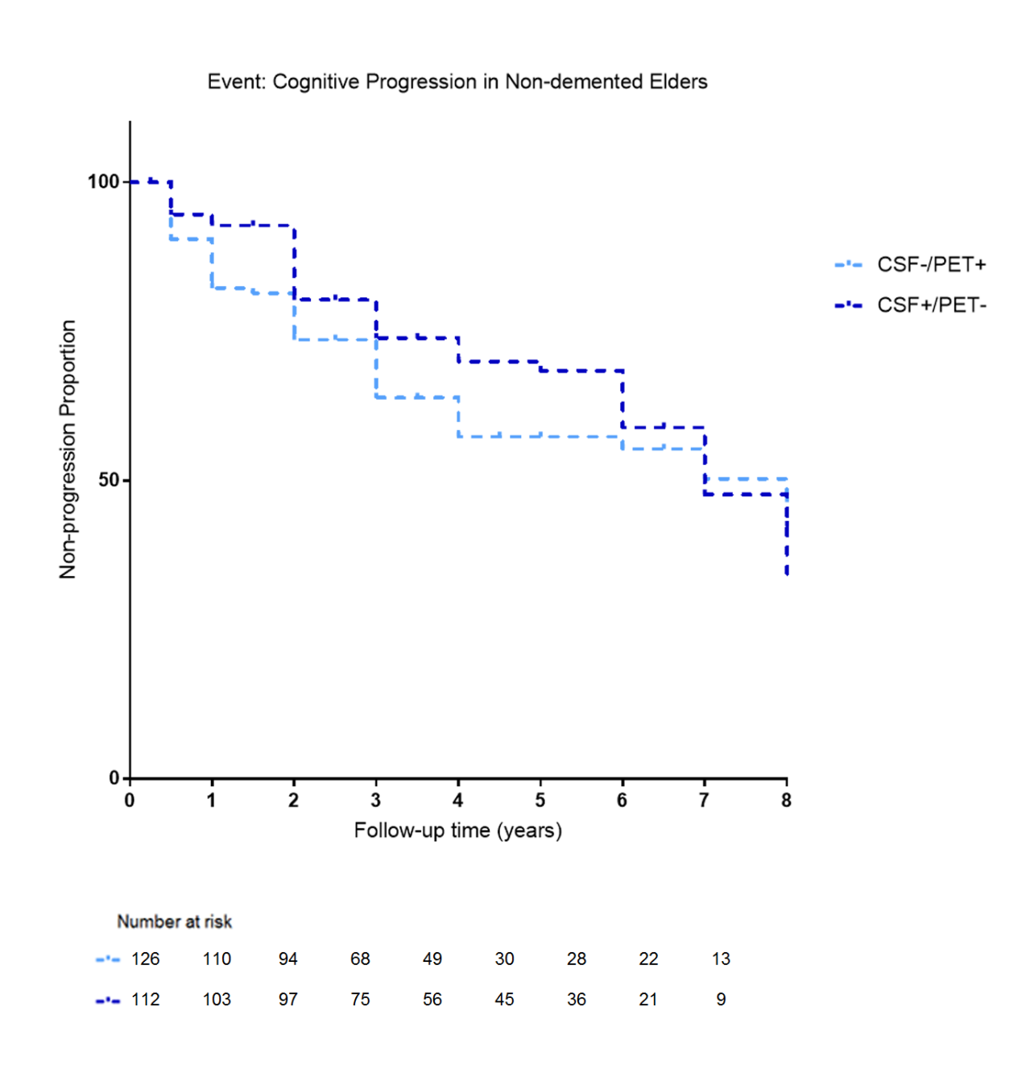

B. CSF-MRI profile
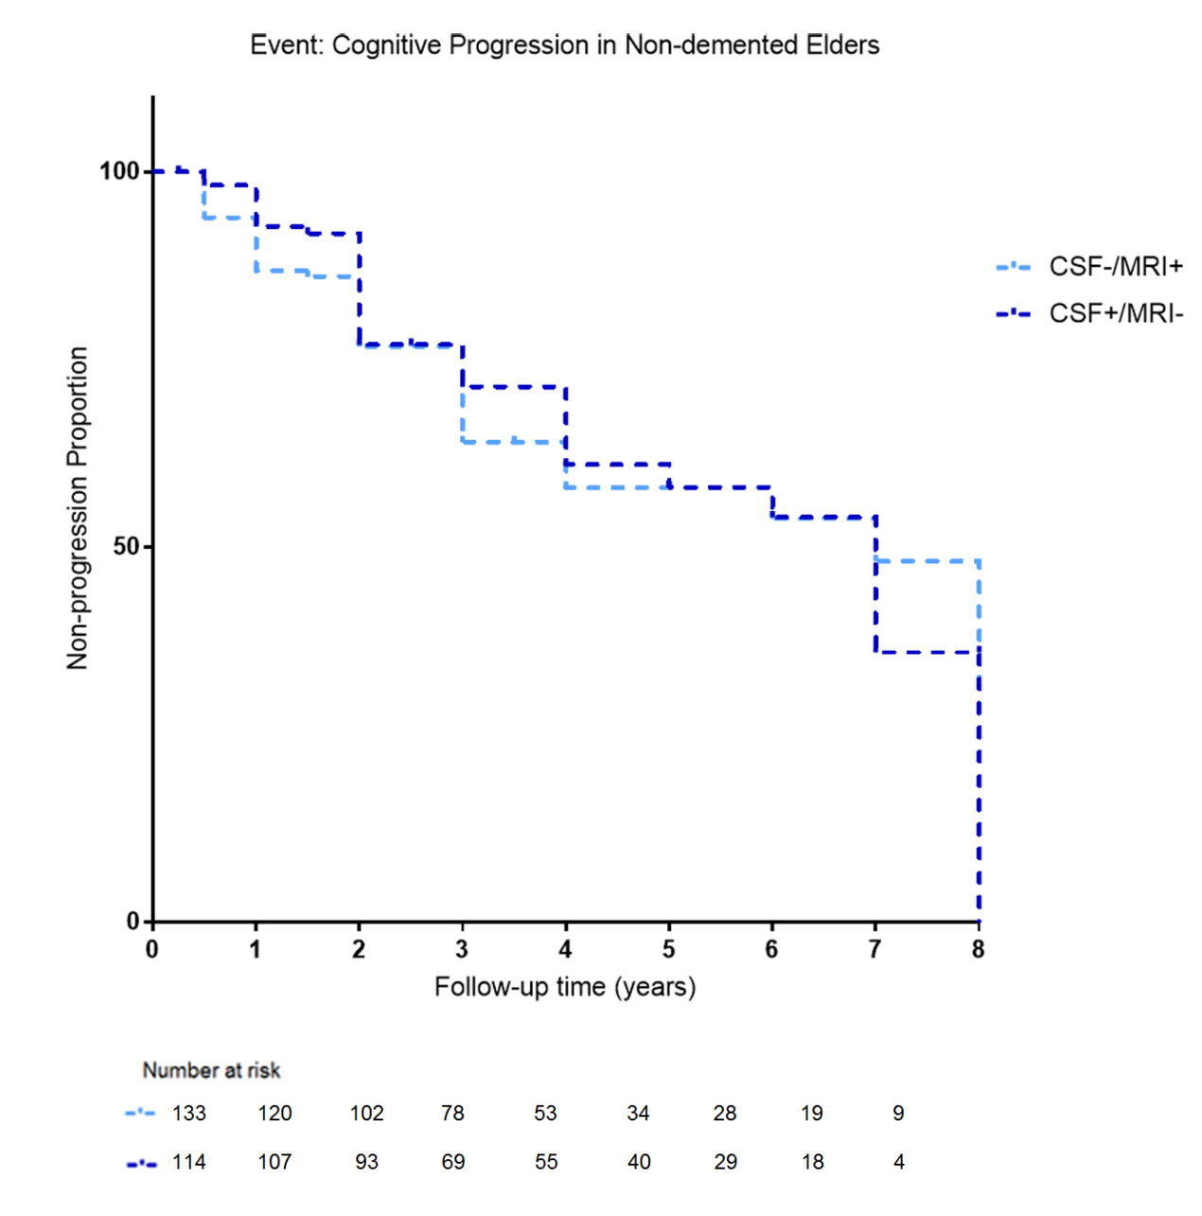

C. PET-MRI profile
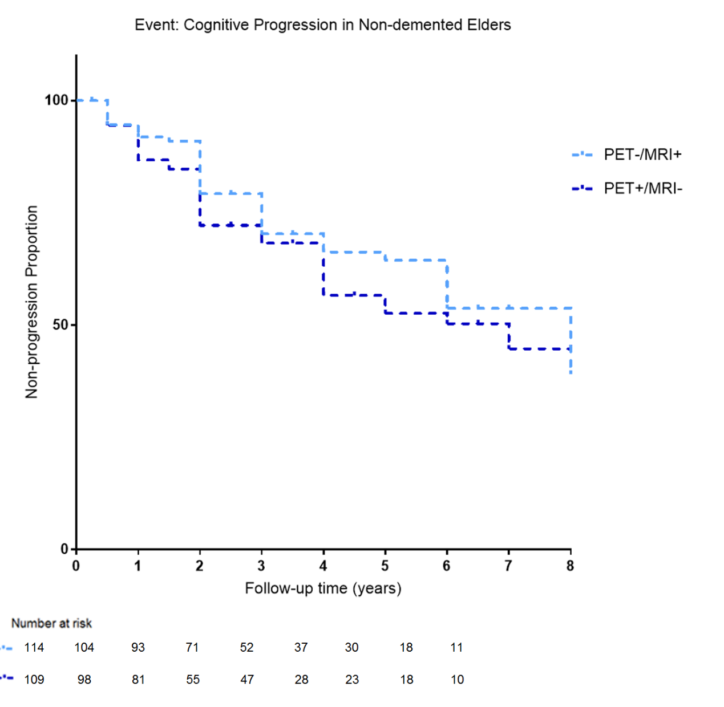
Note: Numbers of individuals at risk at different follow-up time points were presented. Survival time was calculated according to the intervals from the baseline evaluation to the time points of cognitive progression.
Abbreviations: CSF, cerebrospinal fluid; MRI, Magnetic Resonance Imaging; PET, positron emission tomography.

Appendix 10: Results of survival analyses in discordant patients

Model 1 | Beta | P | HR (95% CI)
b-a | 0.24548 | 0.24343 | 1.2782 (0.8462-1.9308)
d-c | 0.097542 | 0.632948 | 1.1025 (0.7388-1.6452)
f-e | 0.16233 | 0.457048 | 1.1763 (0.7668-1.8042)
Model 1 adjusted for age, gender, years of education and APOE ε4

a, b, c, d, e and f represent CSF+/PET- group, CSF-/PET+ group, CSF+/MRI- group, CSF-/MRI+ group, PET-/MRI+ group and PET+/MRI- group, respectively.
Abbreviations: CI, confidence interval; CSF, cerebrospinal fluid; HR, hazard ratios; MRI, Magnetic Resonance Imaging; PET, positron emission tomography.

Appendix 11: Kaplan–Meier survival curves for probability of cognitive progression in CN or MCI patients

A. CSF-PET profile

B. CSF-MRI profile

C. PET-MRI profile

Note: Numbers of individuals at risk at different follow-up time points were presented. Survival time was calculated according to the intervals from the baseline evaluation to the time points of cognitive progression.
Abbreviations: CN, cognitively normal; CSF, cerebrospinal fluid; MCI, mild cognitive impairment; MRI, Magnetic Resonance Imaging; PET, positron emission tomography.

Appendix 12: Results of survival analyses in CN or MCI patients
CN patients:
Model 1 | Βeta | p | HR (95% CI) | p-total
B-A | 0.87373 | 0.004294 | 2.3958 (1.3153-4.3640) | 4.04E-05
C-B | 0.70885 | 0.084803 | 2.0317 (0.9073-4.5493)
E-D | 0.68353 | 0.031648 | 1.9809 (1.0619-3.6950) | 0.000166
F-E | 0.97082 | 0.034606 | 2.6401 (1.0728-6.4971)
H-G | 0.94249 | 0.002337 | 2.5664 (1.3987-4.7090) | 0.000426
I-H | 0.25118 | 0.587994 | 1.2855 (0.5181-3.1897)
b-a | -0.02132 | 0.962187 | 0.9789 (0.4055-2.3633)
d-c | -0.26278 | 0.574799 | 0.7689 (0.3070-1.9257)
f-e | 0.15726 | 0.736487 | 1.1703 (0.4683-2.9250)
Model 1 adjusted for age, gender, years of education and APOE ε4

MCI patients:
Model 1 | Βeta | P | HR (95% CI) | p-total
B-A | 1.29190 | 2.57E-08 | 3.6397 (2.3098-5.7350) | <2e-16
C-B | 0.92157 | 7.80E-07 | 2.5132 (1.7436-3.6226)
E-D | 1.668517 | 2.56E-11 | 5.3043 (3.2486-8.6610) | <2e-16
F-E | 0.663330 | 0.000511 | 1.9412 (1.3353-2.8221)
H-G | 1.539148 | 1.72E-10 | 4.6606 (2.9056-7.4760) | <2e-16
I-H | 0.740836 | 5.97E-05 | 2.0977 (1.4610-3.0119)
b-a | 0.384058 | 0.1150 | 1.4682 (0.9106-2.3674)
d-c | 0.15440 | 0.50644 | 1.1670 (0.7400-1.8402)
f-e | 0.234501 | 0.360276 | 1.2643 (0.7650-2.0894)
Model 1 adjusted for age, gender, years of education and APOE ε4

In the CSF/PET profile, A, B and C represent CSF-/PET- group, combined group of CSF-/PET+ and CSF+/PET-, and CSF+/PET+ group, respectively. In the CSF/MRI profile, D, E and F represent CSF-/MRI- group, combined group of CSF-/MRI+ and CSF+/MRI-, and CSF+/MRI+ group, respectively. In the PET/MRI profile, G, H and I represent PET-/MRI- group, combined group of PET-/MRI+ and PET+/MRI-, and PET+/MRI+ group, respectively. a, b, c, d, e and f represent CSF+/PET- group, CSF-/PET+ group, CSF+/MRI- group, CSF-/MRI+ group, PET-/MRI+ group and PET+/MRI- group, respectively. In all models, the latter group was the reference group. For example, in the result for B-A, A group was the reference group.
Abbreviations: CI, confidence interval; CN, cognitively normal; CSF, cerebrospinal fluid; HR, hazard ratios; MCI, mild cognitive impairment; MRI, Magnetic Resonance Imaging; PET, positron emission tomography.
Appendix 13: Kaplan–Meier survival curves for probability of cognitive progression in discordant group among A+T+ patients

A. CSF-PET profile

B. CSF-MRI profile

C. PET-MRI profile
Note: Numbers of individuals at risk at different follow-up time points were presented. Survival time was calculated according to the intervals from the baseline evaluation to the time points of cognitive progression.
Abbreviations: A+, abnormal cerebrospinal fluid amyloid; CSF, cerebrospinal fluid; MRI, Magnetic Resonance Imaging; PET, positron emission tomography; T+, abnormal cerebrospinal fluid phosphorylated tau.

Appendix 14: Results of survival analyses in A+T+ patients

Model 1 | Βeta | P | HR (95% CI) | p-total
B-A | 1.155812 | 1.85E-06 | 3.1766 (1.9756-5.108) | <2e-16
C-B | 0.841587 | 2.13E-06 | 2.3200 (1.6382-3.2856)
E-D | 1.29353 | 1.28E-07 | 3.6460 (2.2558-5.8920) | 6.44E-15
F-E | 0.69276 | 0.000167 | 1.9992 (1.3939-2.8673)
H-G | 1.418435 | 3.87E-10 | 4.1306 (2.6492-6.4400) | <2e-16
I-H | 0.773094 | 2.48E-05 | 2.1665 (1.5125-3.1031)
b-a | 0.755004 | 0.00222 | 2.1276 (1.3116-3.4513)
d-c | 0.5062967 | 0.02951 | 1.6591 (1.0517-2.6174)
f-e | 0.2552861 | 0.3278 | 1.2908 (0.7741-2.1524)
Model 1 adjusted for age, gender, years of education and APOE ε4

In the CSF/PET profile, A, B and C represent CSF-/PET- group, combined group of CSF-/PET+ and CSF+/PET-, and CSF+/PET+ group, respectively. In the CSF/MRI profile, D, E and F represent CSF-/MRI- group, combined group of CSF-/MRI+ and CSF+/MRI-, and CSF+/MRI+ group, respectively. In the PET/MRI profile, G, H and I represent PET-/MRI- group, combined group of PET-/MRI+ and PET+/MRI-, and PET+/MRI+ group, respectively. a, b, c, d, e and f represent CSF+/PET- group, CSF-/PET+ group, CSF+/MRI- group, CSF-/MRI+ group, PET-/MRI+ group and PET+/MRI- group, respectively. In all models, the latter group was the reference group. For example, in the result for B-A, A group was the reference group.
Abbreviations: A+, abnormal cerebrospinal fluid amyloid; CI, confidence interval; CSF, cerebrospinal fluid; HR, hazard ratios; MRI, Magnetic Resonance Imaging; PET, positron emission tomography; T+, abnormal cerebrospinal fluid phosphorylated tau.

Appendix 15: Demographic information with the exclusion of borderline cases

Characteristics | CSF/PET profile |  |  |  |  | CSF/MRI profile |  |  |  |  | PET/MRI profile
 | CSF-/PET- | CSF-/PET+ | CSF+/PET- | CSF+/PET+ |  | CSF-/MRI- | CSF-/MRI+ | CSF+/MRI- | CSF+/MRI+ |  | PET-/MRI- | PET-/MRI+ | PET+/MRI- | PET+/MRI+
N | 254 | 36 | 56 | 34 |  | 240 | 50 | 49 | 41 |  | 264 | 46 | 25 | 45

Abbreviations: CSF, cerebrospinal fluid; MRI, Magnetic Resonance Imaging; PET, positron emission tomography.

Appendix 16: Distribution plots of “N” biomarkers with the exclusion of borderline cases

A. CSF t-tau versus FDG-PET

B. CSF t-tau versus aHPV

C. FDG-PET versus aHPV
Abbreviations: aHPV, adjusted hippocampal volume; CSF, cerebrospinal fluid; FDG, 18F-fluorodeoxyglucose; MRI, Magnetic Resonance Imaging; PET, positron emission tomography; t-tau, total tau.

Appendix 17: Kaplan–Meier survival curves for probability of cognitive progression when excluding borderline cases

A. CSF-PET profile

B. CSF-MRI profile

C. PET-MRI profile

Note: Numbers of individuals at risk at different follow-up time points were presented. Survival time was calculated according to the intervals from the baseline evaluation to the time points of cognitive progression.
Abbreviations: CSF, cerebrospinal fluid; MRI, Magnetic Resonance Imaging; PET, positron emission tomography.

Appendix 18: Results of survival analyses when excluding borderline cases

Model 1 | Βeta | p | HR (95% CI) | p-total
B-A | 1.50198 | 1.42E-07 | 4.4906 (2.5666-7.8570) | <2e-16
C-B | 1.62976 | 1.11E-08 | 5.1027 (2.9171-8.9257)
E-D | 1.67947 | 2.32E-08 | 5.3627 (2.9750-9.6670) | <2e-16
F-E | 1.25334 | 8.62E-06 | 3.5020 (2.0162-6.0828)
H-G | 1.653675 | 2.17E-08 | 5.2262 (2.9292-9.3240) | <2e-16
I-H | 1.403410 | 1.37E-06 | 4.0691 (2.3020-7.1924)
b-a | 0.74409 | 0.041732 | 2.1045 (1.0282-4.3074)
d-c | 0.57137 | 0.1131 | 1.7707 (0.8733-3.5900)
f-e | 0.236389 | 0.580 | 1.2667 (0.5486-2.9244)
Model 1 adjusted for age, gender, years of education and APOE ε4

In the CSF/PET profile, A, B and C represent CSF-/PET- group, combined group of CSF-/PET+ and CSF+/PET-, and CSF+/PET+ group, respectively. In the CSF/MRI profile, D, E and F represent CSF-/MRI- group, combined group of CSF-/MRI+ and CSF+/MRI-, and CSF+/MRI+ group, respectively. In the PET/MRI profile, G, H and I represent PET-/MRI- group, combined group of PET-/MRI+ and PET+/MRI-, and PET+/MRI+ group, respectively. a, b, c, d, e and f represent CSF+/PET- group, CSF-/PET+ group, CSF+/MRI- group, CSF-/MRI+ group, PET-/MRI+ group and PET+/MRI- group, respectively. In all models, the latter group was the reference group. For example, in the result for B-A, A group was the reference group.
Abbreviations: CI, confidence interval; CSF, cerebrospinal fluid; HR, hazard ratios; MRI, Magnetic Resonance Imaging; PET, positron emission tomography.

Appendix 19: Demographic information (cut-offs for neurodegenerative biomarkers were derived from ROC analyses)

Characteristics | CSF/PET profile |  |  |  |  | CSF/MRI profile |  |  |  |  | PET/MRI profile
Characteristics | CSF-/PET- | CSF-/PET+ | CSF+/PET- | CSF+/PET+ |  | CSF-/MRI- | CSF-/MRI+ | CSF+/MRI- | CSF+/MRI+ |  | PET-/MRI- | PET-/MRI+ | PET+/MRI- | PET+/MRI+
N | 320 | 51 | 244 | 106 |  | 308 | 63 | 223 | 127 |  | 450 | 114 | 81 | 76
Abbreviations: CSF, cerebrospinal fluid; MRI, Magnetic Resonance Imaging; PET, positron emission tomography; ROC, receiver operating characteristics.

Appendix 20: Distribution plots (cut-offs for neurodegenerative biomarkers were derived from ROC analyses)

A. CSF t-tau versus FDG-PET

B. CSF t-tau versus aHPV

C. FDG-PET versus aHPV

Abbreviations: aHPV, adjusted hippocampal volume; CSF, cerebrospinal fluid; FDG, 18F-fluorodeoxyglucose; MRI, Magnetic Resonance Imaging; PET, positron emission tomography; ROC, receiver operating characteristics; t-tau, total tau.

Appendix 21: Kaplan–Meier survival curves for probability of cognitive progression (cut-offs for neurodegenerative biomarkers were derived from ROC analyses)

A. CSF-PET profile

B. CSF-MRI profile

C. PET-MRI profile
Numbers of individuals at risk at different follow-up time points were presented. Survival time was calculated according to the intervals from the baseline evaluation to the time points of cognitive progression.
Abbreviations: CSF, cerebrospinal fluid; MRI, Magnetic Resonance Imaging; PET, positron emission tomography; ROC, receiver operating characteristics.

Appendix 22: Results of survival analyses (cut-offs for neurodegenerative biomarkers were derived from ROC analyses)

Model 1 | β | p | HR (95% CI) | p-total
B-A | 1.00841 | 2.39E-07 | 2.7412 (1.8698-4.0190) | <2e-16
C-B | 1.26291 | 1.05E-14 | 3.5357 (2.5672-4.8695)
E-D | 1.04783 | 1.52E-07 | 2.8514 (1.9284-4.2160) | <2e-16
F-E | 0.83664 | 2.32E-07 | 2.3086 (1.6813-3.1699)
H-G | 1.31457 | 7.98E-15 | 3.7230 (2.6721-5.1880) | <2e-16
I-H | 0.90605 | 7.24E-07 | 2.4745 (1.7292-3.5412)
b-a | 0.64526 | 0.01363 | 1.9065 (1.1418-3.1834)
d-c | 0.26131 | 0.3006 | 1.2986 (0.7918-2.1300)
f-e | 0.50014 | 0.0223 | 1.6489 (1.0737-2.5324)
Model 1 adjusted for age, gender, years of education and APOE ε4

In the CSF/PET profile, A, B and C represent CSF-/PET- group, combined group of CSF-/PET+ and CSF+/PET-, and CSF+/PET+ group, respectively. In the CSF/MRI profile, D, E and F represent CSF-/MRI- group, combined group of CSF-/MRI+ and CSF+/MRI-, and CSF+/MRI+ group, respectively. In the PET/MRI profile, G, H and I represent PET-/MRI- group, combined group of PET-/MRI+ and PET+/MRI-, and PET+/MRI+ group, respectively. a, b, c, d, e and f represent CSF+/PET- group, CSF-/PET+ group, CSF+/MRI- group, CSF-/MRI+ group, PET-/MRI+ group and PET+/MRI- group, respectively. In all models, the latter group was the reference group. For example, in the result for B-A, A group was the reference group.
Abbreviations: β, beta; CI, confidence interval; CSF, cerebrospinal fluid; HR, hazard ratios; MRI, Magnetic Resonance Imaging; PET, positron emission tomography; ROC, receiver operating characteristics.

