Supplementary File S2. Supplementary Methods, Results and Discussion

Skew Inversions in Mitochondrial Genomes Interfere with Evolutionary Analyses in Annelida

Hong-Peng Lei, Ivan Jakovlić, Hong Zou, Dong Zhang*

*Author for Correspondence: Dong Zhang, State Key Laboratory of Grassland Agro-Ecosystem, Institute of Innovation Ecology, Lanzhou University, 730000, Lanzhou, China; Phone: +86-18717167887; Email: dongzhang0725@gmail.com

Contents
Supplementary Results 2
Evolutionary history of ORIs in crustacean lineages 2
Errantia (class) 2
Sedentaria (class) 2
Erpobdella octoculata: Cox1 and 18S phylogenetic analyses 5
Supplementary methods 6
Conserved sequence motif search 6
Phylogenetic analyses 7
dN/dS 8
References 9

Supplementary Results

Evolutionary history of ORIs in crustacean lineages

Errantia (class)

Phyllodocida (order): Streptosyllis sp. (Anoplosyllinae, Syllidae)

The entire order Phyllodocida exhibited negative GC skews, except for Streptosyllis sp.. This species exhibited fully inverted (+) skews, which indicated an ORI. This is the only mitogenome available for this genus, but there are six other members of the Syllidae family available, so the ORI event maps either to the species, or the entire genus. An inverted skew in comparison to other annelids in Streptosyllis sp. was first observed by MT Aguado, S Richter, R Sontowski, A Golombek, TH Struck and C Bleidorn [1]. Unusual for annelids, mitochondrial gene orders are highly variable in Streptosyllis sp. and within the Syllinae [1]. The only taxon so far completely deviating from the putative annelid ground pattern is Syllidae (Errantia), which show completely rearranged mitochondrial genomes [2]. No conserved motif was identified for Streptosyllis sp..

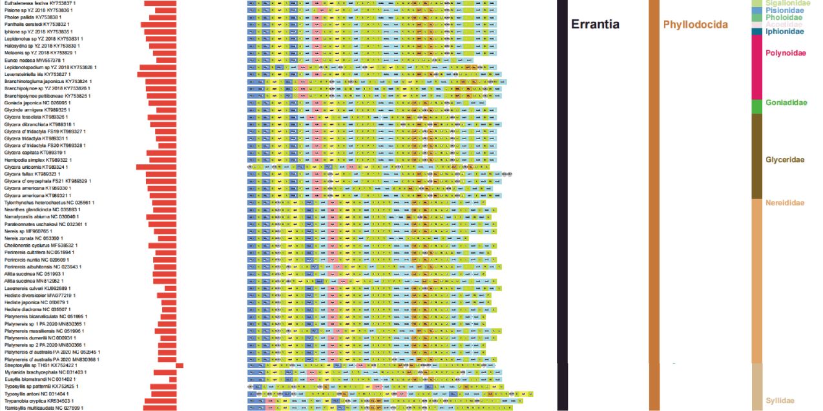
Figure S1. Architecture in the Phyllodocida. GC skews are represented by bars (axis = 0, left = negative values, right = positive values). Gene orders and taxonomy (class, order and family, respectively) are also shown.

Sedentaria (class)

Ampharetidae (family): Eclysippe & Auchenoplax CA sister genera

Ampharetidae is unlike the most mitochondrial gene order in annelids, it differs in a few rearranged genes (or blocks of genes) from the putative annelid ground pattern. Eclysippe vanelli and Auchenoplax crinita exhibited inverted GC skews, but the remaining three Ampharetidae mitogenomes (all Decemunciger sp.) did not. An inverted skew in comparison to two Terebelliformia (Annelida) worms in E. vanelli was first observed by M Zhong, TH Struck and KM Halanych [3], whereas the one in A. crinita was first observed in this study. Although a single ORI event in the common ancestor of these two genera is the most parsimonious scenario, we should also consider alternative scenarios. As Decemunciger sp. exhibits a unique mitogenome with genes encoded on both strands, it may also be possible that the common ancestor of the entire family underwent an ORI, followed by a subsequent ORI in Decemunciger, but this remains highly hypothetical given the absence of data for other lineages in this family. No conserved motif was identified in E. vanelli and A. crinita.

Sabellidae and Serpuidae (the common ancestor of sister families)

Serpulidae, Sabellidae and Fabriciidae are considered to form a single clade (Weigert and Bleidorn 2016). All available Serpulidae species exhibited inverted skews (Spirobranchus giganteus and all available mitochondrial genomes of Hydroides). The only species available for Sabellidae, Sabella spallanzanii, also exhibited an inverted skew. However, the only available species for Fabriciidae, Manayunkia occidentalis, exhibited a standard GC skew (-0.175). This prevents us from inferring an ORI event for the entire clade. If Fabriciidae is the sister-group to the other two families, the ORI might be mapped to the common ancestor of the two families. Daffe et al. only observed that the mitogenome of S. spallanzanii has a negative GC-Skew and a positive AT-Skew [4]. The inversed GC skew in the mitochondrial ‘majority strand’ was observed in this study. Within the Sedentaria, three lineages exhibit disproportionally highly elevated rates of mitogenomic architecture rearrangements: S. giganteus [5], S. spallanzanii [4] and Polydora sp. [6]. S. giganteus exhibited inverted skew and a number of unique evolutionary patterns among the annelids [5]. In Sabellidae and Serpuidae, the control region was located between trnH and trnR [7]. S. spallanzanii shows multiple deviations from the putative annelid gene order ground pattern. In other annelid mitochondrial genomes, all genes are encoded on the positive strand, except for some tRNAs in Owenia fusiformis, Magelona mirabilis [8], and Laeonereis culveri [9]. Therefore, genes encoded on the negative strand are an unusual feature of S. spallanzanii. The mitochondrial genomes of Hydroides spp. exhibited a highly positive GC skew and a negative AT skew. This was previously observed only in the mitochondrial genome of S. giganteus [10]. The S. spallanzanii mitogenome differs from that of S. giganteus where gene order is remarkably divergent from those of other annelid lineages [5]. Conserved motifs were identified mainly on the minus strand, however, only the conserved motif 4 was identified on the plus strand for Hydroides norvegica.

Figure S2. Architecture and skews in six families of Sedentaria: Ampharetidae, Sabellidae and Serpuidae. GC skews are represented by bars (axis = 0, left = negative values, right = positive values). Gene orders and taxonomy (class, order and family, respectively) are also shown.

Clitellata (order): Drawida japonica (Moniligastridae)

The commonly found gene order of Clitellata is identical to the one found in the putative ground pattern of Pleistoannelida. The Drawida japonica mitogenome exhibited a high A + T content, reversed GC-skew (0.042) and high genetic diversity, which was observed by L Zhang, P Sechi, M Yuan, J Jiang, Y Dong and J Qiu [11]. No conserved motif was identified for D. japonica.

Clitellata (order): Hirudinidae & Haemopidae CA (Hirudiniformes, Arhynchobdellida,

Euhirudinea, Hlirudinea)

We identified all available species with inverted skews within this suborder (Hirudiniformes). This allows us to infer the ORI in the common ancestor of te whole clade. Some of the associated studies reported positive GC skews [12, 13], but none of them observed that they are inverted in comparison to other Annelida. No conserved motif was identified for Hirudinidae & Haemopidae CA.

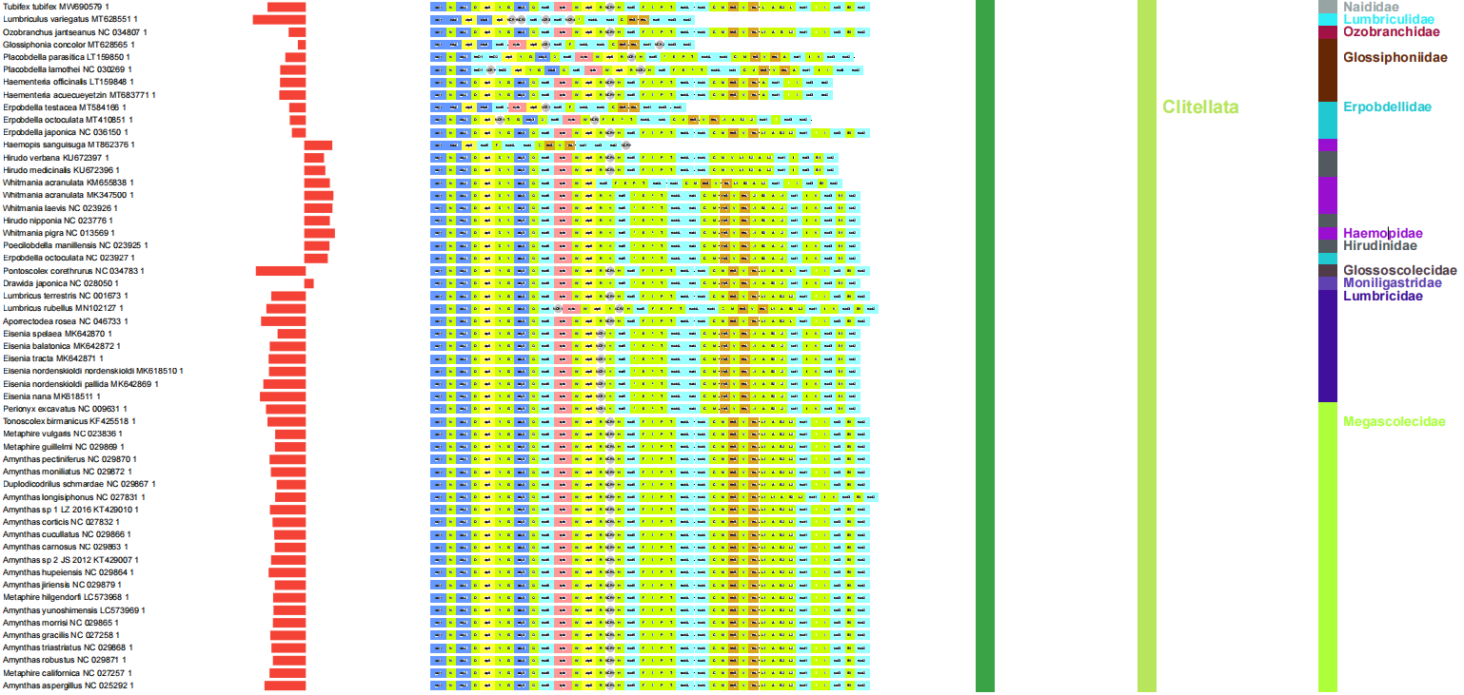
Figure S3. Architecture and skews in the Clitellata. GC skews are represented by bars (axis = 0, left = negative values, right = positive values). Gene orders and taxonomy (class, order and family, respectively) are also shown.

Basal branching lineages: Owenia fusiformis (Oweniidae)

The ORI of O. fusiformis was first observed in this study. O. fusiformis is the only available representative of the family Owenidae, so the ORI could have also occurred in the common ancestor (CA) of the entire family. The mitochondrial gene order of basal branching lineages is different from the common pattern of Pleistoannelida. O. fusiformis is one of the few annelids with genes encoded on both strands of the mitochondrial genome: tRNA-P and tRNA-T genes are encoded on the minus strand [8]. The mitochondrial genome of O. fusiformis contains as many as seven non-coding regions larger than 100 bp. The organization of the mitochondrial genome of O. fusiformis differs in one transposition, one reverse transposition, one reversal and two tandem-duplication-random-loss events to Pleistoannelida [8]. The same study also found that O. fusiformis is a ‘rogue’ species causing phylogenetic artefacts.

Figure S4. Architecture and skews in the basal-branching lineages (containing Owenia fusiformis). GC skews are represented by bars (axis = 0, left = negative values, right = positive values). Gene orders and taxonomy (class, order and family, respectively) are also shown.

Erpobdella octoculata: Cox1 and 18S phylogenetic analyses

To assess whether Erpobdella octoculata (NC_023927) mitogenome is a taxonomic identification artefact, we conducted several phylogenetic analyses. BLAST and BOLD analyses failed to resolve the problem of putative species misidentification. In more detail E. octoculata NC_023927 exhibited 100% similarity to the BOLD entry ADR3875, also belonging to E. octoculata. E. octoculata MT410851 exhibited 99.38% similarity to another E. octoculata sequence, but this sequence was not publicly available (Private status). BLAST results for their cox1 genes showed 94% coverage and 75.85% similarity. Following this, we retrieved all cox1 gene sequences of all Clitellata species from the 174 mitogenomes dataset, minus the Megascolecidae from the Genbank. After manual pruning, a total of 74 cox1 gene sequences were used for RAXML phylogenetic tree reconstruction. The result showed that E. octoculata NC_023927 clustered with Haemopidae rather than with Erpobdellidae (supplementary file S12). We also retrieved all 18S sequences belonging to Clitellata from the Genbank. After pruning (we left one sequence per species, except for E. octoculata), a total of 632 18S sequences were used for the IQ-TREE phylogenetic tree reconstruction. The result showed that E. octoculata JX885698 (the 18S corresponding to the cox1 of E. octoculata NC_023927, as the authors of both sequences were the same) clustered with Ozobranchidae rather than with Erpobdellidae (supplementary file S13). Thus, our analyses suggested that this group of authors probably misidentified the species as E. octoculata (NC_023927), but the taxon actually belongs to Haemopidae or Hirudinidae. This also explains why only this mt genome exhibited an apparent ORI event.

Supplementary methods

Conserved sequence motif search

Conserved motifs in NCRs can be used to identify the origins of replication in some metazoan lineages [14]. To assess this possibility, first we extracted 289 large (>100 bp) NCRs from the RefSeq dataset using PhyloSuite and searched for conserved sequence motifs using STREME [15]. Among the seven motifs identified in more than 30 sequences, only four consecutive motifs were below the p-value threshold (0.05). In Figure S5, the four motifs are numbered from 1 to 4.
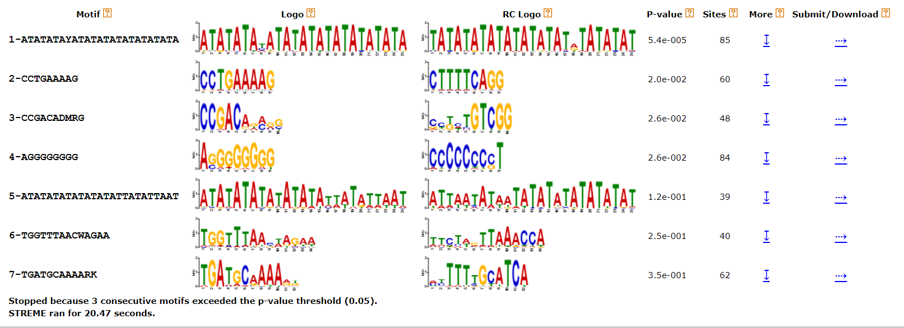
Figure S5. Identification of 7 motifs in STREME.

The above four motifs with significant p-values (motifs 1-4) were further submitted to FIMO [16] analyses, which were conducted on complete sequences of all 174 mitogenomes. We tested several different p-value thresholds to try to identify the optimal balance between the number of species in which the motif was identified, and the amount of noise in the data. The latter was assessed on the basis of congruence between strand distribution of motif and skew direction: motifs were expected to be found on the minus strand in species with fully inverted skews (positive), whereas in species with standard (negative) skew values, motifs were expected to be found on the plus strand. The default FIMO p-value threshold identified motif 1 in almost all mitogenomes, But the data is so noisy that they are not useful, especially with a high percentage of motifs identified on both strands. Even at the e-15 p-value threshold, motif 1 still produced a lot of noise in the data: motif 1 was identified in 39 mitogenomes, but 36 of them exhibited it on both strands. As for motif 2, at the p-value threshold of e-5 it was identified in 36 mitogenomes, with the predictability of 63.89%, whereas at the e-6 threshold it was identified only in 4 mitogenomes. As for motif 3, at the p-value threshold of e-5 it was identified in 47 mitogenomes, with the predictability of 14.89%, whereas at the e-6 threshold the two values were 22 and 4.6% respectively. As for motif 4, at the p-value threshold of e-5 it was identified in 85 mitogenomes, with the predictability of 61.18%, whereas at the e-6 threshold the two values were 49 and 59.18% respectively. On the basis of these analyses, we selected the e-5 threshold as the optimal threshold value (a high number of identified motifs, with high predictive power).

Phylogenetic analyses

Concatenated 13 mitochondrial protein-coding genes (PCGs) and 2rRNAs were used to conduct phylogenetic analyses. The phylogeny of the entire dataset (174 species) was inferred using the Maximum Likelihood (ML) algorithm implemented in IQ-TREE[17]. We used this ML tree to help us infer the evolutionary history of ORI events, however, we also relied on previous studies [18] for the overall phylogenetic framework for annelids to ensure that LBA artefacts did not affect our interpretation of the evolutionary history of ORI events.

dN/dS

The rate of nonsynonymous (dN) to synonymous (dS) substitutions (ω = dN/dS) is commonly used to identify protein sites that experience purifying selection (ω<1, as purifying selection tends to remove non-synonymous variation from a population), evolve neutrally (ω=1), or experience positive, diversifying selection (ω>1, as positive selection tends to promote non-synonymous variation in a population) [19, 20]. Initially, mitogenomes were thought to evolve neutrally. However, mitogenomes are not only influenced by purifying selection, but also evolve adaptively [21, 22, 23, 24, 25, 26]. Mitogenomes generally evolve under strong purifying selection, so they exhibit low ω values [27, 28], but mitogenomes of taxa evolving under a pattern sometimes characterized as ‘relaxed purifying selection’ should exhibit slightly higher ω values. Because dS estimates the number of ‘silent’ substitutions that do not change the amino acid sequence, it will be predominantly influenced by the mutation rate; dN estimates the number of substitutions that change the amino acid sequence, which is likely to include both neutral and nearly neutral changes. Because of this, dN is expected to be influenced both by the mutation rate and by population size. ω is expected to be influenced by selection and effective population size, but not the mutation rate [29].

References

1. Aguado MT, Richter S, Sontowski R, Golombek A, Struck TH, Bleidorn C: Syllidae mitochondrial gene order is unusually variable for Annelida. Gene 2016, 594(1):89-96.https://doi.org/10.1016/j.gene.2016.08.050
2. Aguado MT, Glasby CJ, Schroeder PC, Weigert A, Bleidorn C: The making of a branching annelid: an analysis of complete mitochondrial genome and ribosomal data of Ramisyllis multicaudata. Sci Rep 2015, 5(1):1-13.https://doi.org/10.1093/molbev/msv157
3. Zhong M, Struck TH, Halanych KM: Phylogenetic information from three mitochondrial genomes of Terebelliformia (Annelida) worms and duplication of the methionine tRNA. Gene 2008, 416 1-2:11-21.https://doi.org/10.1016/j.gene.2008.02.020
4. Daffe G, Sun Y, Ahyong ST, Kupriyanova EK: Mitochondrial genome of Sabella spallanzanii (Gmelin, 1791)(Sabellida: Sabellidae). Mitochondrial DNA Part B 2021, 6(2):499-501.https://doi.org/10.1080/23802359.2021.1872431
5. Seixas VC, Russo CAdM, Paiva PC: Mitochondrial genome of the Christmas tree worm Spirobranchus giganteus (Annelida: Serpulidae) reveals a high substitution rate among annelids. Gene 2017, 605:43-53.https://doi.org/10.1016/j.gene.2016.12.024
6. Ye L, Yao T, Lu J, Jiang J, Bai C: Mitochondrial genomes of two Polydora (Spionidae) species provide further evidence that mitochondrial architecture in the Sedentaria (Annelida) is not conserved. Sci Rep 2021, 11(1):13552.https://doi.org/10.1038/s41598-021-92994-3
7. Patra AK, Kwon YM, Kang SG, Fujiwara Y, Kim S-J: The complete mitochondrial genome sequence of the tubeworm Lamellibrachia satsuma and structural conservation in the mitochondrial genome control regions of Order Sabellida. Marine Genomics 2016, 26:63-71.https://doi.org/10.1016/j.margen.2015.12.010
8. Weigert A, Golombek A, Gerth M, Schwarz F, Struck TH, Bleidorn C: Evolution of mitochondrial gene order in Annelida. Mol Phylogenet Evol 2016, 94:196-206.https://doi.org/10.1016/j.ympev.2015.08.008
9. Seixas VC, Paiva PC, Russo CAdM: Complete mitochondrial genomes are not necessarily more informative than individual mitochondrial genes to recover a well-established annelid phylogeny. Gene Reports 2016, 5:10-17.https://doi.org/10.1016/j.genrep.2016.07.011
10. Sun Y, Daffe G, Zhang Y, Pons J, Qiu J-W, Kupriyanova EK: Another blow to the conserved gene order in Annelida: Evidence from mitochondrial genomes of the calcareous tubeworm genus Hydroides. Mol Phylogenet Evol 2021, 160:107124.https://doi.org/10.1016/j.ympev.2021.107124
11. Zhang L, Sechi P, Yuan M, Jiang J, Dong Y, Qiu J: Fifteen new earthworm mitogenomes shed new light on phylogeny within the Pheretima complex. Sci Rep 2016, 6(1):1-11.https://doi.org/10.1038/srep20096
12. Shen X, Wu Z, Ren J, Liu B: The complete mitochondrial genome sequence of Whitmania pigra (Annelida, Hirudinea): the first representative from the class Hirudinea. Comparative Biochemistry Physiology Part D: Genomics Proteomics 2011, 6(2):133-138.https://doi.org/10.1016/j.cbd.2010.12.001
13. Xu Y-L, Nie J: The complete mitochondrial genome sequence of Erpobdella octoculata (Hirudinea: Arhynchobdellida: Erpobdellidae). Mitochondrial DNA Part A 2016, 27(3):1924-1925.https://doi.org/10.3109/19401736.2014.971289
14. Ghiselli F, Milani L, Guerra D, Chang PL, Breton S, Nuzhdin SV, Passamonti M: Structure, transcription, and variability of metazoan mitochondrial genome: perspectives from an unusual mitochondrial inheritance system. Genome biology evolution 2013, 5(8):1535-1554.https://doi.org/10.1093/gbe/evt112
15. Bailey TL: STREME: accurate and versatile sequence motif discovery. Bioinformatics 2021, 37(18):2834-2840.https://doi.org/10.1093/bioinformatics/btab203
16. Grant CE, Bailey TL, Noble WS: FIMO: scanning for occurrences of a given motif. Bioinformatics 2011, 27(7):1017-1018.https://doi.org/10.1093/bioinformatics/btr064
17. Trifinopoulos J, Nguyen L-T, Haeseler Av, Minh BQ: W-IQ-TREE: a fast online phylogenetic tool for maximum likelihood analysis. Nucleic Acids Res 2016, 44(W1):W232-W235.https://doi.org/10.1093/nar/gkw256
18. Weigert A, Bleidorn C: Current status of annelid phylogeny. Organisms Diversity Evolution 2016, 16(2):345-362.https://doi.org/10.1007/s13127-016-0265-7
19. Kryazhimskiy S, Plotkin JB: The population genetics of dN/dS. PLoS Genet 2008, 4(12):e1000304.https://doi.org/10.1371/journal.pgen.1000304
20. Pond SLK, Frost SD: Not so different after all: a comparison of methods for detecting amino acid sites under selection. Mol Biol Evol 2005, 22(5):1208-1222.https://doi.org/10.1093/molbev/msi105
21. Ballard JWO, Rand DM: The population biology of mitochondrial DNA and its phylogenetic implications. Annu Rev Ecol Evol Syst 2005, 36:621-642.https://doi.org/10.1146/annurev.ecolsys.36.091704.175513
22. Fonseca RRD, Johnson WE, O'Brien SJ, Ramos MJ, Antunes A: The adaptive evolution of the mammalian mitochondrial genome. BMC Genomics 2008, 9(1):1-22.https://doi.org/10.1186/1471-2164-9-119
23. Shen Y-Y, Liang L, Zhu Z-H, Zhou W-P, Irwin DM, Zhang Y-P: Adaptive evolution of energy metabolism genes and the origin of flight in bats. Proceedings of the National Academy of Sciences 2010, 107(19):8666-8671.https://doi.org/10.1073/pnas.0912613107
24. Menezes AN, Viana MC, Furtado C, Schrago CG, Seuanez HN: Positive selection along the evolution of primate mitogenomes. Mitochondrion 2013, 13(6):846-851.https://doi.org/10.1016/j.mito.2013.06.001
25. Blier PU, Dufresne F, Burton RS: Natural selection and the evolution of mtDNA-encoded peptides: evidence for intergenomic co-adaptation. TIG 2001, 17(7):400-406.https://doi.org/10.1016/S0168-9525(01)02338-1
26. Castoe TA, Koning AJd, Kim H-M, Gu W, Noonan BP, Naylor G, Jiang ZJ, Parkinson CL, Pollock DD: Evidence for an ancient adaptive episode of convergent molecular evolution. Proceedings of the National Academy of Sciences 2009, 106(22):8986-8991.https://doi.org/10.1073/pnas.0900233106
27. Castellana S, Vicario S, Saccone C: Evolutionary patterns of the mitochondrial genome in Metazoa: exploring the role of mutation and selection in mitochondrial protein–coding genes. Genome biology evolution 2011, 3:1067-1079.https://doi.org/10.1093/gbe/evr040
28. Nabholz B, Uwimana N, Lartillot N: Reconstructing the phylogenetic history of long-term effective population size and life-history traits using patterns of amino acid replacement in mitochondrial genomes of mammals and birds. Genome biology evolution 2013, 5(7):1273-1290.https://doi.org/10.1093/gbe/evt083
29. Lanfear R, Ho SY, Love D, Bromham L: Mutation rate is linked to diversification in birds. Proceedings of the National Academy of Sciences 2010, 107(47):20423-20428.https://doi.org/10.1073/pnas.1007888107

