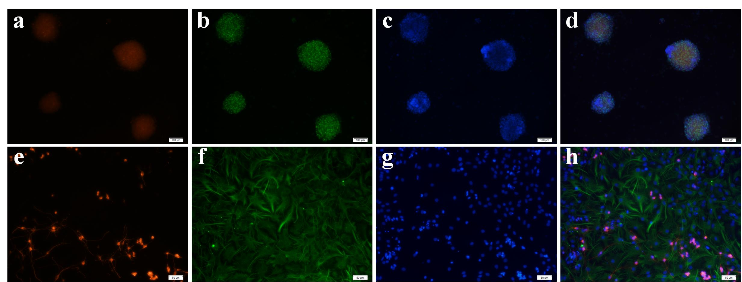
Supplementary figure 1. Identification of cells in culture. Proliferated NSC neurospheres were stained with Brdu (a), anti-SOX2 antibody (b) and DAPI (c), then merged (d), the scale bar = 100 µm for a-d. The neurons and astrocytes differentiated from NSCs were stained with anti-β-III-tubulin (e) and anti-GFAP (f), respectively, and the cell nuclei were stained with DAPI (g), then merged (h), the scale bar = 50 µm for e-h.

