Supplementary material to
Niva et al: World's human migration patterns in 2000-2019 unveiled by high-resolution data
Supplementary text
Trends in net-migration
Figure S1 showcases the trend of net-migration at communal, provincial and communal level, as well as between communes and provinces.
Socio-climatic bins
Socio-climatic bins were created by using global gridded data of aridity (Global Aridity Index; Trabucco & Zomer(1)), human development (Human Development Index; downscaled by using methodology from Kummu et al(2)) and population counts for 2000-2019 from the WorldPop program(3). Our binning divides global inhabited areas into 100 socio-climatologically analogous zones, that have similar human development and climatic conditions. The binning was conducted in two steps. First, we divided all considered grid cells into 10 population-weighted quantiles based on HDI. After that, each HDI quantile was again divided into 10 population-weighted quantiles based on aridity. This division ensured that each bin incorporates 1% of the global population. For both HDI and aridity long term averages were used.
HDI data was provided for each year between 1990-2019 and was averaged by taking a mean over 2000-2019. The Global Aridity Index and Potential Evapotranspiration defined by Trabucco and Zomer(1) provides a global estimate of aridity for 1970-2000 as a long-term average:
Aridity = MAP / MAET,
Where MAP = mean annual precipitation and MAET = mean annual evapotranspiration. The lower the aridity value, the higher the aridity and the higher the value the higher the humidity.
The original aridity raster with 30 arc-second resolution was aggregated to 5 arc-minute resolution prior to binning.
Figure S2 provides global illustrations of the HDI (long term average), aridity and derived bins.
Rural-urban classification and net-migration in rural and urban areas
Figure S3 showcases four examples of the urban extent data developed here. The data maps urban areas over two decades from 2000 to 2019. The data are provided with 5 arc-min resolution rasters, with each urban grid cell classified as 1 and rural ones as 0. Figure S3 shows the development and growth of urban areas in the South China Sea around Malesian peninsula during three timesteps and an example of global urban areas in 2019.
Urban extent rasters were used to calculate net-migration in urban and rural areas. Urban net-migration was defined by multiplying a net-migration raster with the urban extent raster for each year:
urban_migr_2000 = net_migr_2000 * urban_extent_2000
urban_migr_2001 = net_migr_2001* urban_extent_2001
...
urban_migr_2019 = net_migr_2019 * urban_extent_2019
Rural net-migration was derived for each year from net-migration data by sub-setting all raster cells where urban extent raster was 0 (i.e. defined as rural).
Figure S4 illustrates gridded net-migration in urban and rural areas in selected year (2000, 2010 and 2019).
The amount of urban and rural net-migration in national, sub-national and communal scales for each year over 2000-2019 could be then calculated as a zonal sum over each administrative area. Figure S5 illustrates a cumulated (2000-2019) and aggregated urban and rural net-migration at national, sub-national and communal scales.
Furthermore, we investigated how net-migration was divided between rural and urban areas within each administrative area. We defined areas into four classes depending on the “direction” of migration. In other words, if both urban and rural areas had net-positive migration then the admin region would be a ‘net-receiver’, whereas in the opposite case it would be a ‘net-sender’. A case where urban migration was net-positive and rural net-negative would be called ‘urban pull – rural push’ and the opposite ‘rural pull – urban push’. Figure S6 illustrates the categories at three scales: national, provincial, and communal. The tables represent the share of each administrative unit in each category. At national level for instance, net-receiving countries accounted for 20% of all countries, while 31% of the countries were net-senders. In total, 54% of the countries had net-positive urban migration (urban +), i.e. urban areas in were ‘net-receivers’ and ‘urban pull – rural push’ situations.
Administrative zoning
The regional division used in the study is pictured in Figure S7. The grouping is based on the United Nations (UN) country grouping (Statistics Division of the United Nations Secretariat(4)).
Births and deaths
Data sources
For births, we used two compiled databases, namely StatCompiler(5) and EUROSTAT(6) as well as available national census data. For deaths, we used likewise two compiled databases, namely OECD(7) regional stats and EUROSTAT(8) as well as national censuses. Figure S8 illustrates the origin of dataset used. Note that for some countries, births and deaths data was available at different source. See Limitations for further discussion.
Downscaling births and deaths
Downscaling input variables
Figure S9 illustrates the spatial distribution of downscaling input variables: HDI, population density, share of women of reproductive age (15-49) and share of life lived for an average person.
Regression model performance
The performance of the regression models used to predict cell-wise birth and death ratios were assessed. We found that the models predicted well the birth and death rates, with coefficient of determinations being 0.74 and 0.60 respectively (See Table S1).

Supplementary Figures
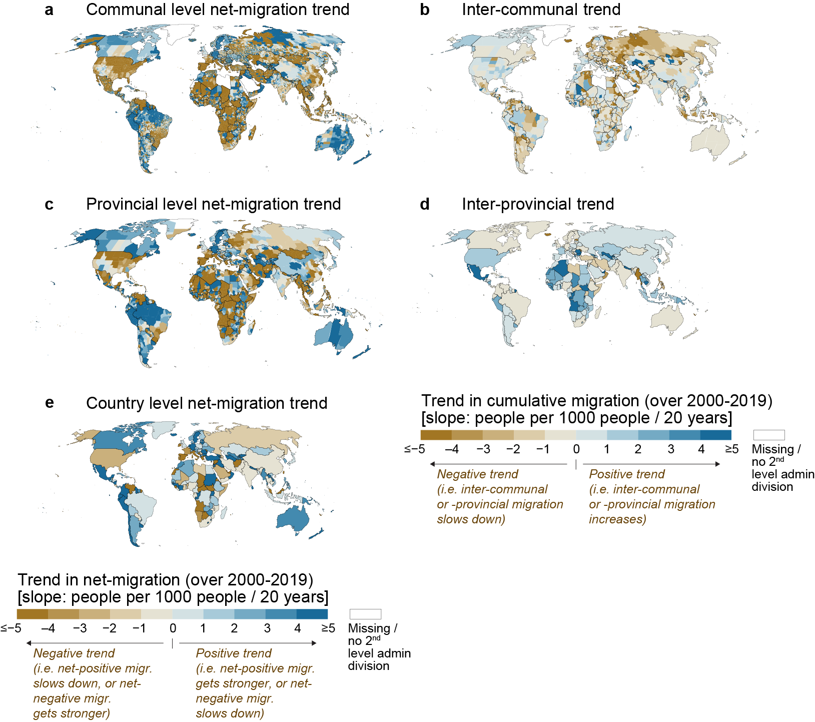
Figure S1. Trends in (a) communal, (c) provincial and (e) national level net-migration over 2000-2019. When the trend is negative, net-positive migration slows down or net-negative migration gets stronger, and the opposite for the positive trend. Trends for inter-communal and inter-provincial net-migration are presented in tiles (b) and (d), respectively.

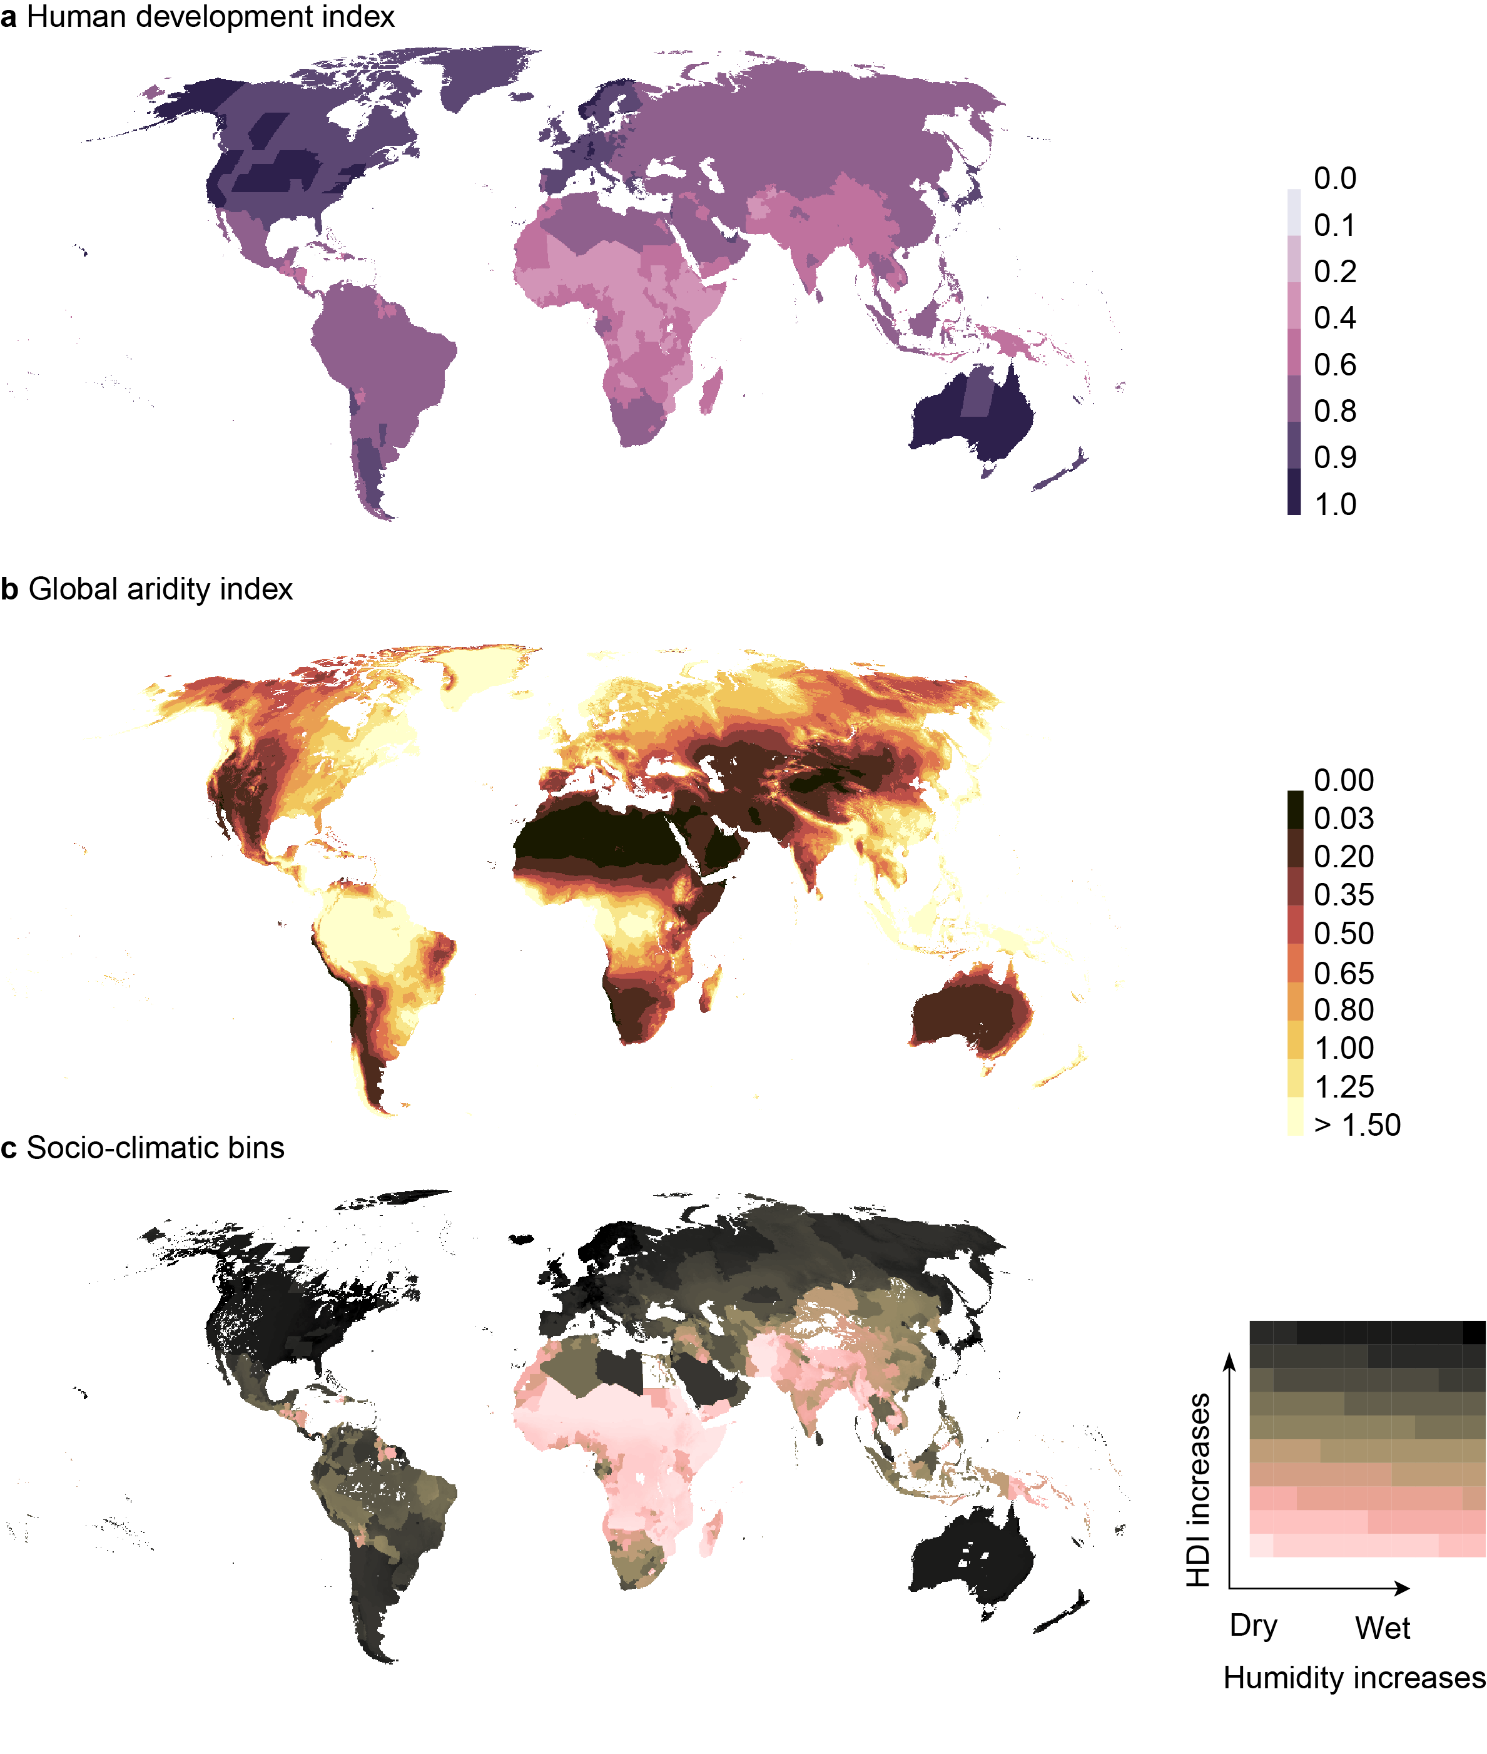
Figure S2. Global maps of (a) human development index, (b) global aridity index and (c) socio-climatic bins.

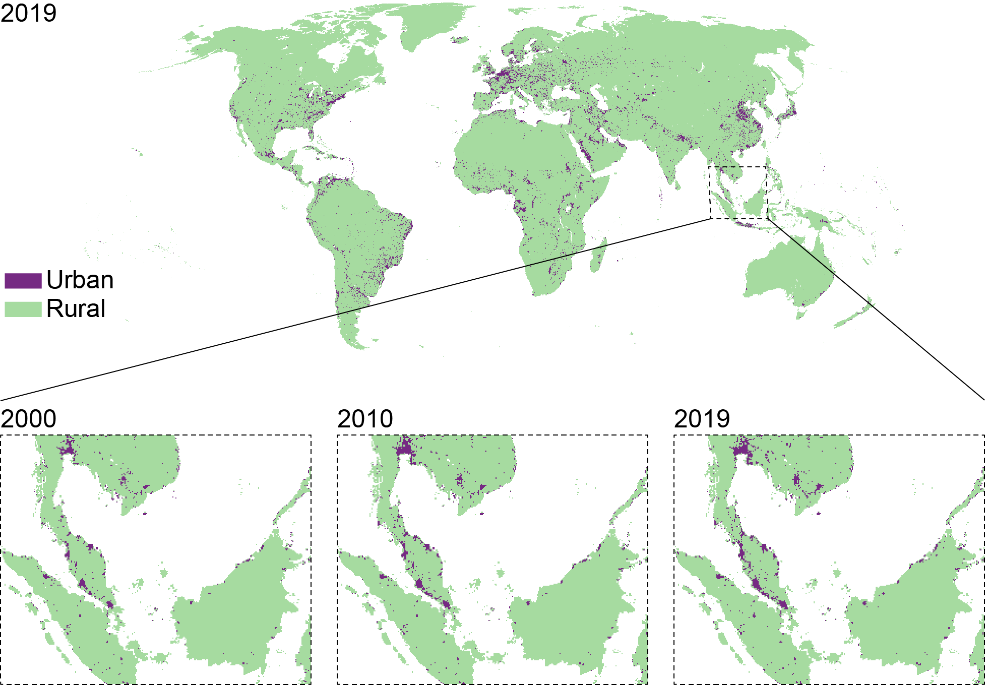
Figure S3. Example of global urban areas in 2019 and in three timesteps in the South China Sea around the Malesian peninsula.

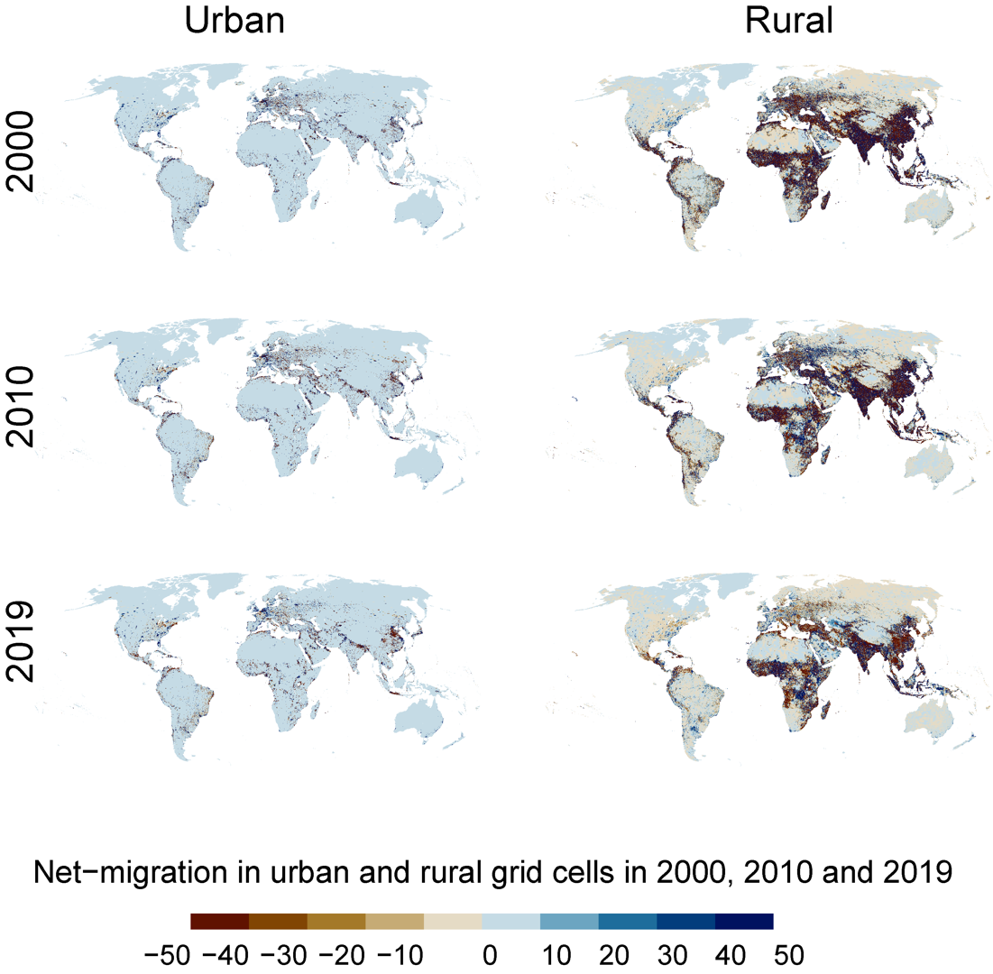
Figure S4. Net-migration in urban and rural grid cells in 2000,2010 and 2019.

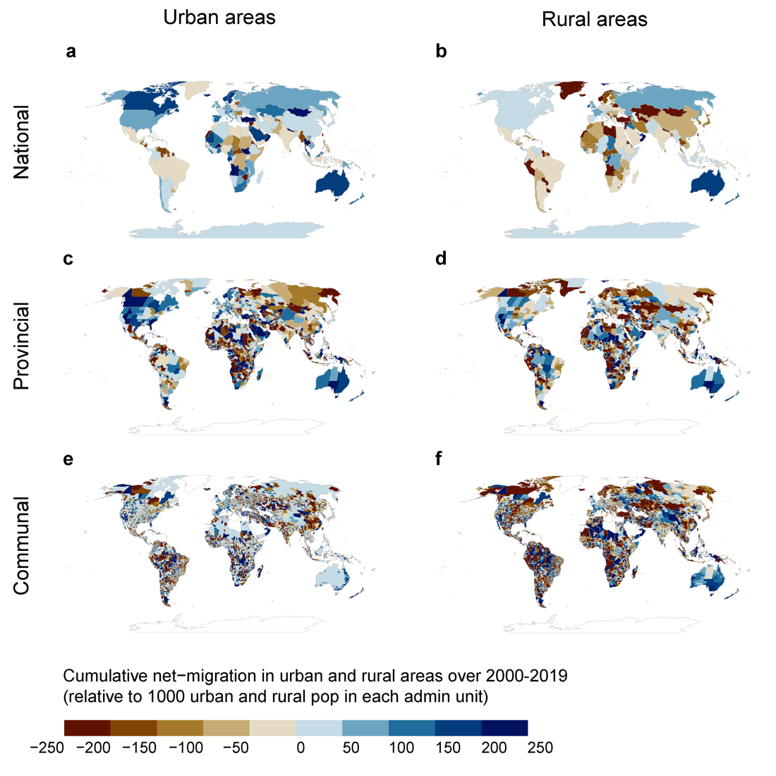
Figure S5. Cumulative net-migration (per 1000 urban and rural people in each admin unit) in urban and rural areas over 2000-2019.

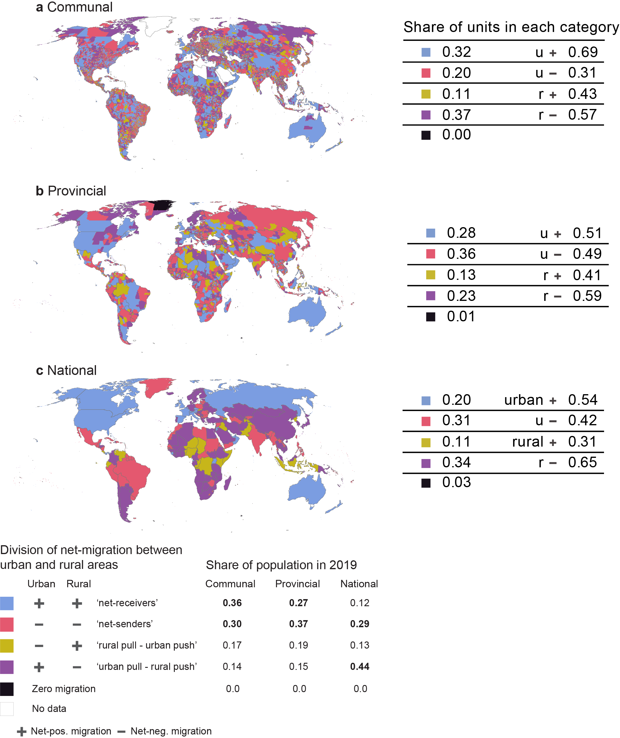
Figure S6. Division of net-migration between urban and rural areas. Tables show the share of population (in 2019) living in each category at communal, provincial, and national levels, and the share of units in each category at respective administrative levels.

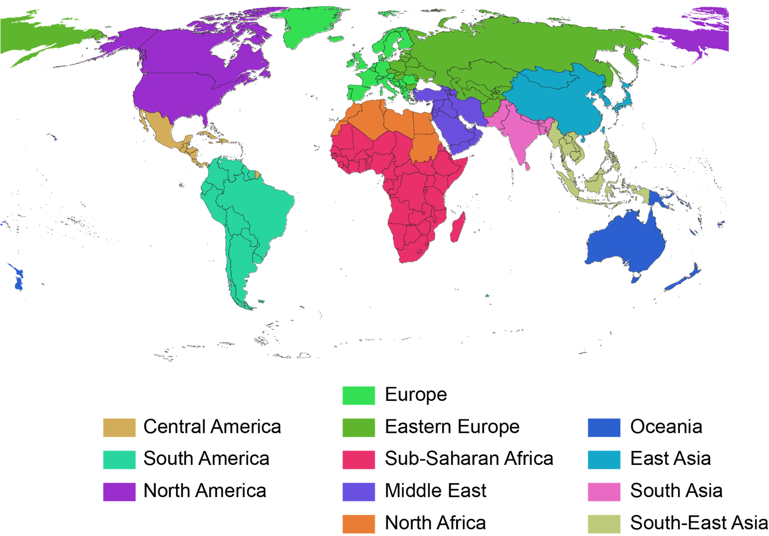
Figure S7. Regional division based on the UN country grouping.
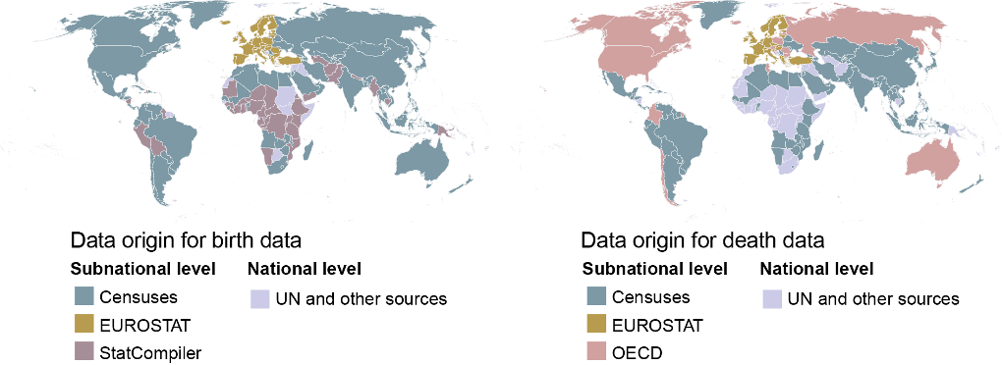
Figure S8. Origin of datasets used.

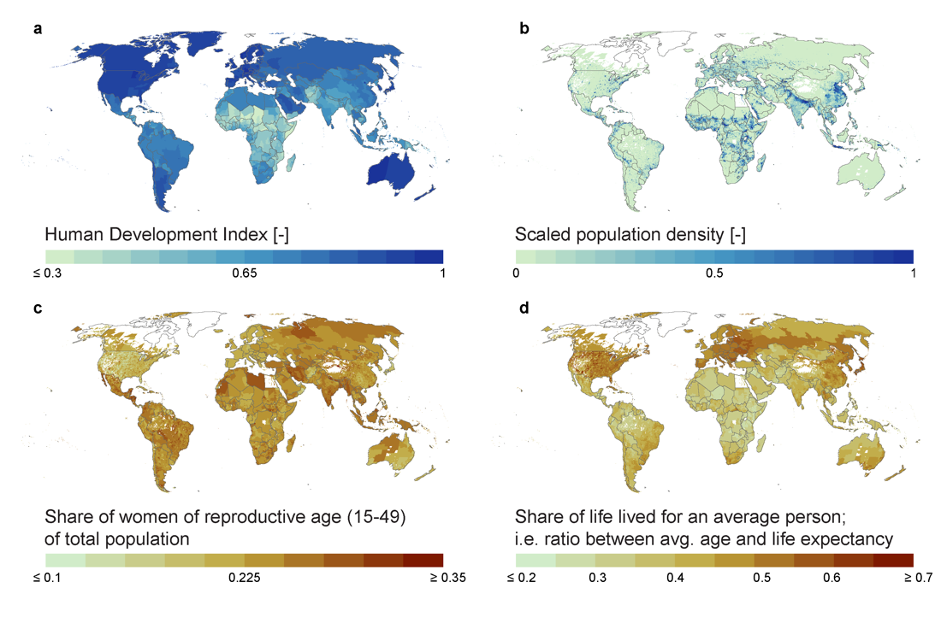
Figure S9. Input variables used for downscaling for the last timestep, i.e. year 2019. (a) Human development index, (b) population density, scaled between 0-1, (c) share of women of reproductive age (15-49) of total population and (d) share of life lived for an average person. Each dataset includes annual values for each year over 2000-2019.

Supplementary Tables
Table S1. Regression model performance to explain the reported birth and death rate with selected independent variables (see Methods).
 | R2 | RMSE | Mean absolute error
Birth rate | 0.74 | 5.84 | 4.52
Death rate | 0.60 | 2.45 | 1.80

References
1. A. Trabucco, R. Zomer J., Global Aridity Index and Potential Evapo-Transpiration (ET0) Climate Database v2 (2018), (available at https://cgiarcsi.community).
2. M. Kummu, M. Taka, J. H. A. Guillaume, Gridded global datasets for Gross Domestic Product and Human Development Index over 1990–2015. Scientific Data. 5, 180004 (2018).
3. WorldPop (www.worldpop.org - School of Geography and Environmental Science, University of Southampton; Department of Geography and Geosciences, University of Louisville; Departement de Geographie, Universite de Namur), Center for International Earth Science Information Network (CIESIN), Columbia University, Global High Resolution Population Denominators Project - Funded by The Bill and Melinda Gates Foundation (OPP1134076), (available at https://dx.doi.org/10.5258/SOTON/WP00647).
4. Statistics Division of the United Nations Secretariat, Standard country or area codes for statistical use (M49) - Geographic Regions. (2021), (available at https://unstats.un.org/unsd/methodology/m49/).
5. The DHS Program, STATcompiler (https://www.statcompiler.com/en/).
6. EUROSTAT, “Live births and crude birth rate” (The statistical office of the European Union, Unit F2: Population and migration statistics, Luxembourg, 2021), (available at https://ec.europa.eu/eurostat/web/products-datasets/-/tps00204).
7. OECD, Mortality crude rates by cause of death, large TL2 regions, small TL3 regions (2021).
8. EUROSTAT, “Deaths and crude death rate” (The statistical office of the European Union, Unit F2: Population and migration statistics, Luxembourg, 2021), (available at https://ec.europa.eu/eurostat/web/products-datasets/-/tps00029).

