Supplementary materials
Exploitation of liquid CO₂ based greener process for valorization of citronellal rich essential oils into flavor grade (-)-menthol using novel Sn/Al-B-NaYZE composites

Prashant Kumar,^{a,f} Chandan Singh Chanotiya,^{a,f} Laldingngheti Bawitlung,^{b} Anju Yadav,^{a,f} Pankaj Kumar,^{c} Anirban Pal,^{b,f} Ajit Kumar Shasany,^{d,f} Priyabrat Mohapatra,^{e*} Prasant Kumar Rout^{a,f*}

ªPhytochemistry Division, CSIR-Central Institute of Medicinal and Aromatic Plants, Lucknow, Uttar Pradesh 226015, India
E-mail: pk.rout@cimap.res.in; prasantrout@gmail.com
^{b}Bioprospection and Product Development Division, CSIR-Central Institute of Medicinal and Aromatic Plants, Lucknow, Uttar Pradesh 226015, India
^{c}Inter-UniversityAccelerator Centre, New Delhi 110067, India
^{d}Biotechnology Division, CSIR-Central Institute of Medicinal and Aromatic Plants, Lucknow, Uttar Pradesh 226015, India
^{e}Chemistry Department, C.V. Raman Global University, Bhubaneswar, Odisha 752054, India
^{f}Academy of Scientific and Innovative Research (AcSIR), Gaziabad-220025, Uttar Pradesh, India

1. Extraction of essential oils
CSIR-CIMAP has been developed two citronella varieties (CIM-Jeeva and BIO-13), which contained 38.9-41.4% of citronellal. These essential oils are available in plenty, thus selected for the value addition to (-)-menthol or l-menthol. Similarly, Corymbia citriodora is selected for the present study due to its higher citronellal (69.5%) content.
1.1. Characterization of essential oils and reaction mixtures
The percentage composition was determined by PerkinElmer GC connected to flame ionization detector (FID). WCOT column coated with diphenyl dimethyl siloxane with a dimension of 25 m x 0.25 mm x 0.25 μm (HP-5) was used for this analysis. H₂ was used as carrier gas with a flow rate of 1.2 mL min⁻¹ under initial column pressure of 42 KPa. Compounds were separated with clear baseline distinction following linear temperature program of 60 ºC-200 ºC at 2 ºC min⁻¹ and finally held at 200 ºC for 30 min. The peak normalization method was used for the calculation of the relative area percentage of the compounds. Again, PerkinElmer GC/MS was used for compound confirmation under a similar condition as GC-FID. MS conditions were detector voltage (1.5 V), Ionization Voltage (70 eV), peak width (2 s), mass range (50-400 amu), etc. Individual peaks were confirmed by comparing the mass spectra of compounds with mass spectra available in the computer libraries (NIST-1, NIST-2, Adams). Linear relative retention indices (Kovat’s indices) of the compounds were calculated from standard n-alkanes (C8-C22) chromatogram for confirmation of the isomers [1,2]. The chiral-GC-FID analysis was carried out in β-Dex column (RtTM-bDEXse, ResTek corporation) under similar reaction conditions. The composition of original essential oils, modified oils, and spent (after isolation of menthol) oils are presented in Table 1
1.2. Advanced green processes
Liquid CO₂ process
The transformation (Prins Reaction) citronellal was carried out in a laboratory specially designed stainless steel liquid CO₂ apparatus. The experimental system for the liquid-CO₂ extraction unit has been illustrated in our prior publications [2]. Citronellal (1 g) was taken in a designed beaker along with 70 mg of composites in it. The extraction process was conducted at 22 ºC with CO₂ pressure of 68-70 bar. The chilled water was circulated in the cooling figure of the apparatus at 15 ºC. The process of evaporation and condensation were repeated throughout the process for 15-45 min (Scheme S1).
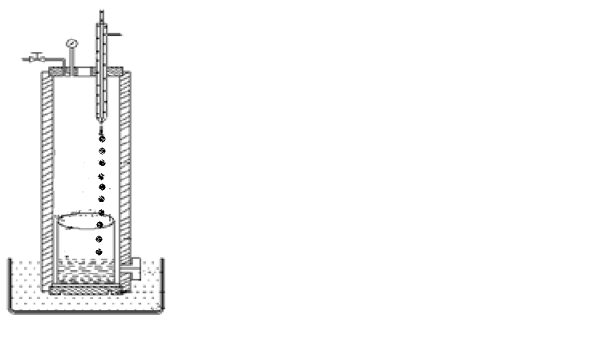
Condenser for circulation of cold water
SS pressurized vessel
Recirculation of liquid CO₂
Hot water for evaporation of liquid CO₂
Citronellal, composites in liquid CO₂

Scheme S1 Liquid CO₂ apparatus

- Catalysts
  - Preparation of composites and their efficiency towards citronellal cyclization
Composites such as Al-B-NaYZE, Sn-B-NaYZE, Al-NaYZE, and Sn-BYZE were prepared. Al-B-NaYZE and Sn-B-NaYZE have been shown complete conversion of citronellal to isopulegol. The combination of these composites, conversion of citronellal, and its selectivity percentage to isopulegol are presented in Table S1.

Table S1 The ratio of active components (mole) in the composites and their impact on conversion of citronellal to isopulegol
Rearrange to more stable carbocation
Protonated citronellal
citronellal
B | Al | YZE/  NaYZE | Citronellal | Isopulegol | B | Sn | YZE/  NaYZE | Citronellal | Isopulegol
0.09 | 0.012 | 0.3 | 75 | 70 | 0.09 | 0.012 | 0.3 | 65 | 60
0.09 | 0.014 | 0.35 | 85 | 82 | 0.09 | 0.014 | 0.35 | 82 | 78
0.09 | 0.016 | 0.40 | 95 | 92 | 0.09 | 0.016 | 0.40 | 90 | 86
0.09 | 0.018 | 0.45 | 99 | 98 | 0.09 | 0.018 | 0.45 | 95 | 92
0.09 | 0.020 | 0.50 | 97 | 95 | 0.09 | 0.020 | 0.50 | 99 | 98
0.09 | 0.024 | 0.55 | 88 | 83 | 0.09 | 0.024 | 0.55 | 94 | 91
0.09 | 0.026 | 0.60 | 75 | 67 | 0.09 | 0.026 | 0.60 | 85 | 78

These composites are also suitable for Prins reaction using organic solvents as presented in Table S2.
Table S2 Percentage of conversion and selectivity of (+)-citronellal
Catalysts | Conversion (%)  (2 h) | Enantioselectivity of (-)-isopulegol | Total isopulegol (%)
Al-B-YZE | 89 | 80 | 90
Al-B-NaYZE | 95 | 89 | 97
Sn-B-YZE | 91 | 85 | 93
Sn-B-NaYZE | 96 | 91 | 98
YZE | 50 | 38 | 45
Na-YZE | 55 | 45 | 52
ZSM-5 | 40 | 30 | 38

Reactant concentration (citronellal) = 0.0064 moles, cyclohexane

Table S3 is presented the conversion of citronellal to menthol in two step reaction.
Table S3 Catalysts for the conversion of citronellal to menthol
Catalysts | %X_{CAL}/time  (min) | Solvents | % Selectivity
Catalysts | %X_{CAL}/time  (min) | Solvents | Isopulegols | Menthols
Al-B-NaYZE | 95/120 | Cyclohexane /DCM | 97 | -
Sn-B-NaYZE | 96/120 | Cyclohexane/DCM | 98 | -
1%Pd/AC | 99/60 | Methanol/Ethanol | - | 98
1%Ru/AC | 94/60 | Methanol/Ethanol | - | 93

  - Screening of different metal catalyst for the reduction reaction
Similarly, in the second step, the different reduced metal catalysts have been prepared and their impact on the reduction of isolpulegol to menthol is presented in Fig. S1.

Fig. S1 Catalyst screening for reduction of isopulegol isomers to menthol
(Temperature: 60ºC, Pressure; 40 psi, Catalyst dosage: 10%)

Among these metal catalysts, 1%Pd/AC and 1%Ru/AC have been shown the best results. Their conversion percentage under different temperature and pressure conditions are presented in Table S4.
Table S4 Optimization process parameters using 1%Pd/AC and 1% Ru/AC catalysts by fixing the catalyst loading (10%) and reaction time (40min).
Catalyst | P(psi)/T(ºC) | Menthol isomers % | Catalyst | P(psi) /T(ºC) | Menthol isomers %
1%Pd/AC | 10/15 | 20 | 1%Ru/AC | 10/15 | 15
1%Pd/AC | 20/20 | 35 | 1%Ru/AC | 20/20 | 30
1%Pd/AC | 30/30 | 58 | 1%Ru/AC | 30/30 | 44
1%Pd/AC | 40/40 | 74 | 1%Ru/AC | 40/40 | 68
1%Pd/AC | 40/60 | 88 | 1%Ru/AC | 40/60 | 82
1%Pd/AC | 40/80 | 86 | 1%Ru/AC | 40/80 | 78
  - Characterization of catalysts
UV-Vis
Composites are characterized using UV-Vis spectrophotometer in the range of 200-400 nm in Thermo Fisher Genesys 10S bio.

Scanning Electron Microscopy (SEM) analysis
SEM evaluations of catalysts were carried out using QUANTA-250, FEI (Netherland) SEM machine. Samples (50 mg) have been coated with gold by Sputter Coater for 50 s. (Model No: Q150 TES frocoram Technology, U.K). The composites/catalysts were layered with silver sputtering. For estimating particle size and shape of the composites/catalysts, the instrument was kept at 20 kV.

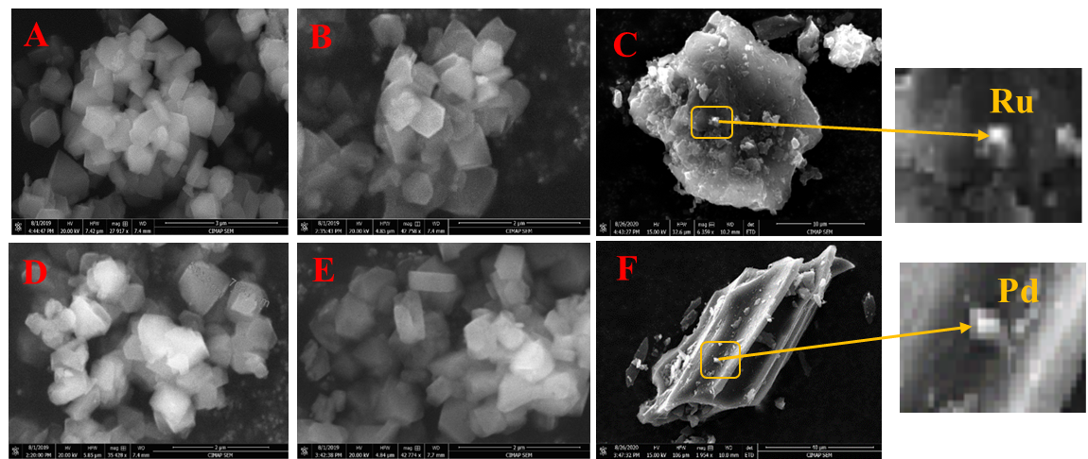

Fig. S2 Morphological study of composites using SEM (A,B) Sn-B-NaYZE, Al-B-NaYZE, (D,E) Sn-B-YZE, Al-B-YZE (C,F) 1% Ru-Ac,1%Pd-Ac

High Resolution (HR)-Transmission Electron Microscopy (TEM)
TEM was performed by using an electron microscope with a filament as a source of electrons operated at 300 kV. HRTEM imaging and mapping were carried out by using Field Emission Gun-Transmission Electron Microscope 300 Kv (HR-TEM 300 kV), FEI, Tecnai G2, F30. The TEM images of composites are presented in Fig. S3.
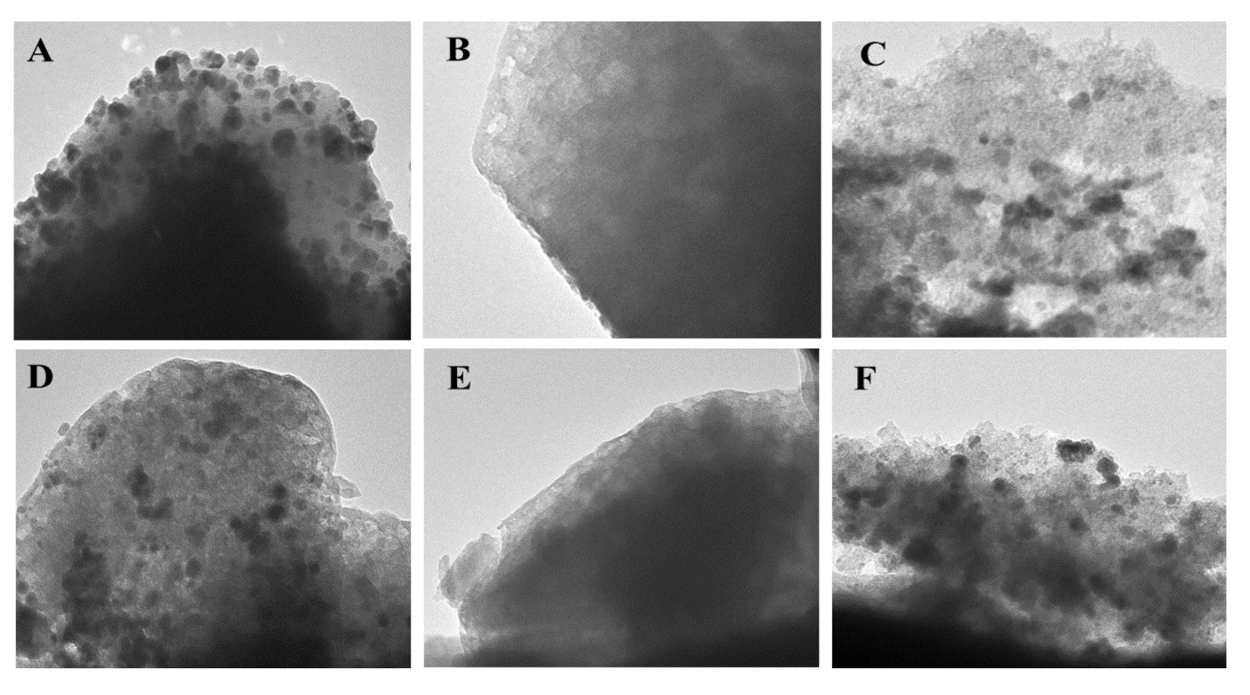
Figure S3 TEM images of catalysts (A) Sn-B-NaYZE, (B) Al-B-NaYZE, (C) 1% Pd/AC
(D) Sn-B-YZE, (E) Al-B-YZE, (F) 1%Ru/AC

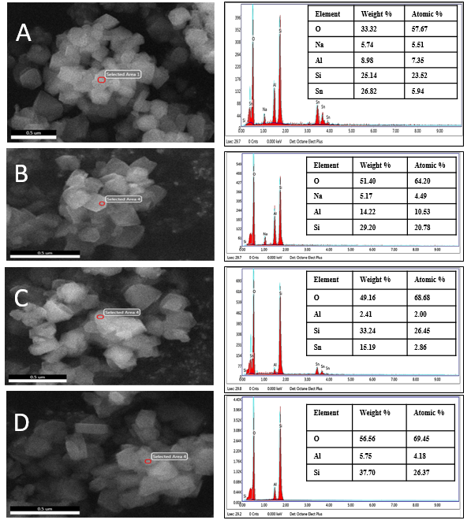
Fig. S4 SEM-EDX of (A) Sn-B-NaYZE, ( B) Al-B-NaYZE, ( C) Sn-B-YZE, (D) Al-B-YZE
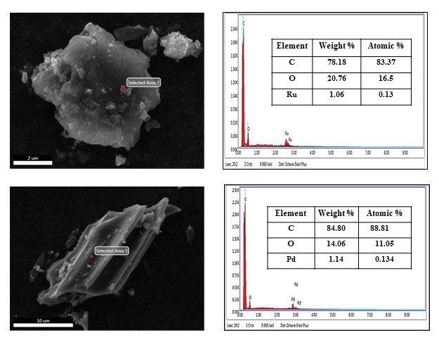
Fig. S5 SEM-EDX analysis of catalysts (a) 1wt% Ru/AC (b) 1wt% Pd/AC
X-Ray Diffraction (XRD)
The XRD spectra of the composites were recorded through Rigaku diffractometer (Rigaku, Japan) by using Cu Kα radiation at 40 kV and 130 mA in the scanning angle of 5-50º at 0.05º min⁻¹ of scanning speed. The spectra are presented with the 2θ Vs intensity as presented in Fig. S6.
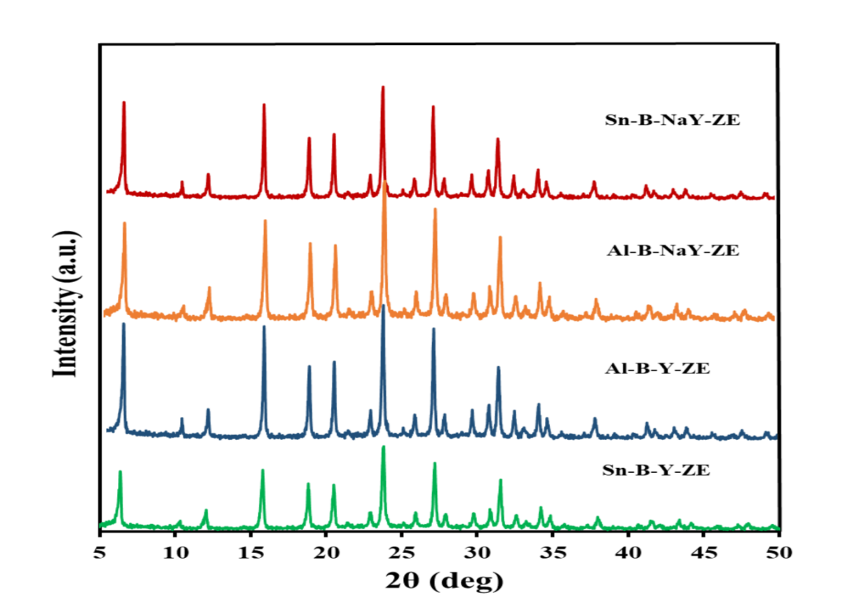
Fig. S6 XRD analysis of Sn-B-NaYZE, Al-B-NaYZE, Al-B-YZE, Sn-B-YZE

Inductive Coupled Plasma (ICP)-OES
The ICP-OES (PerkinElmer, Optima 530V, USA) analysis was used to estimate the elements present in the acid digestible solution of composites/catalysts. The elements were quantified through a calibration plot using a standard mixture comprised of Al and B. The calibration plot of Al and B are drawn using their standard solution and then these elements are quantified in positioning with the calibration plot (Table S5).

Table S5 ICP analysis of composites
Catalyst | Al mg L⁻¹ | B mg L⁻¹
Sn-B-NaYZE | 628 | 307.4
Al-B-NaYZE | 866 | 299.2
Sn-B-YZE | 46.8 | 173.7
Al-B-YZE | 191 | 201.3
NaYZE | 594 | -
YZE | 116 | -

XPS analysis
XPS and UPS measurements were conducted performed using K ALPHA+, Thermo Fischer Scientific instruments (UK). The spectra is given in Fig. S7.
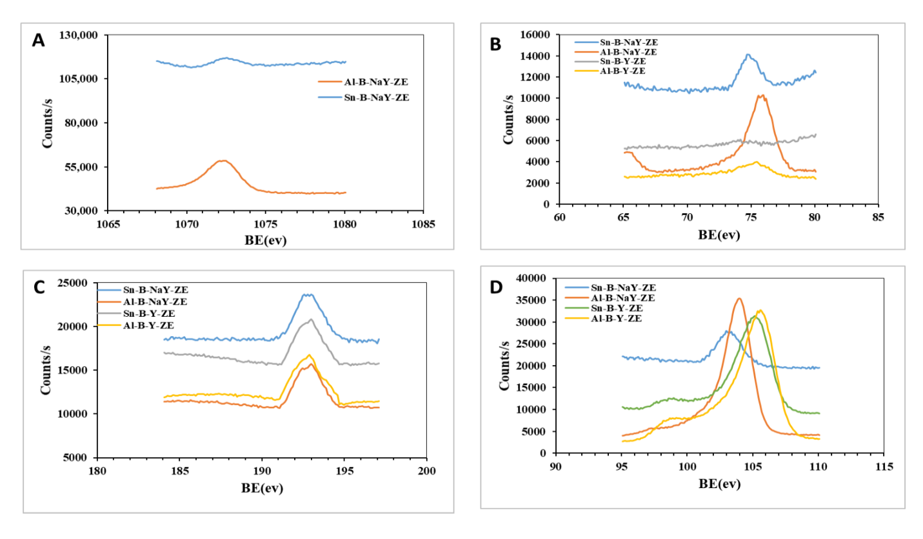
Fig. S7 XPS Spectra of different metals incorporation (A) Na, (B) Al, (C) B, (D) Si

FT-IR
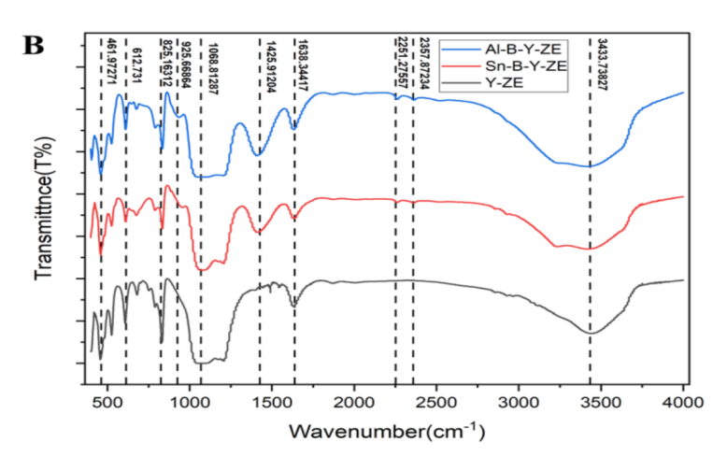
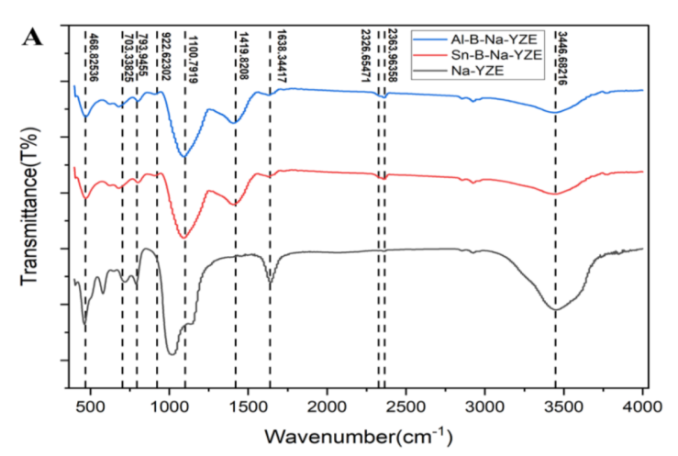
FT-IR spectra of samples were carried out by the KBR pellet method in the region 4000-500 cm⁻¹ using Nicolet 400D-Impact FT-IR spectrophotometer. Dry KBR 200 mg with 5 mg sample are well mixed to create pellets by applying 10,000 hydraulic pressure for 2-3 min. Each sample is scan 200 times and spectra recorded are plotted the wave number against transmittance (%) as presented in Fig. S8.
Fig. S8 FT-IR adsorption spectra of catalysts (A) Sn-B-NaYZE, Al-B-NaYZE, NaYZE.
(B) Sn-B-YZE, Al-B-YZE, YZE.

Surface Area Analysis
Tristar 3000 surface area (SA) analyzer of Micromeritics, USA make was utilized to determine the SA of the composites/catalysts (10 mg) using adsorbate (liquid nitrogen). Before analysis, the samples were degassed for 3 h at 150ºC before recording the SA. Isotherms have been recorded in the range of 0.05 to 0.3 of relative pressure and isotherms are found as straight curves.

True density and Pore volume
The real density of composites was computed using Ultrapycnometer 1000 (Quantachrome, USA) coupled with a temperature controller (Julabo, USA) using He (99.99% of purity) as explored gas. This measurement is calculated based on Archimedes principle, and the volume of the composite is measured according to Boyle’s law principle. The fluid displaced is a He gas that can enter into the pores for the determination of true density and pore volume. The composites density was calculated as the average of ten consecutive analyses. Before the real density measurement, the composites were prepared by eliminating the atmospheric gases and vapors present in the surface and pores of the composites by purging He for 30 min at 32 ^{º}C. The adsorption isotherms of composites are presented in Fig. S9.
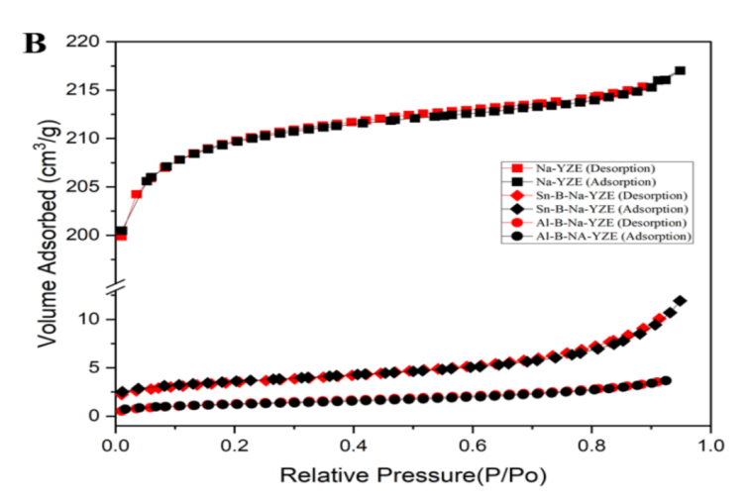
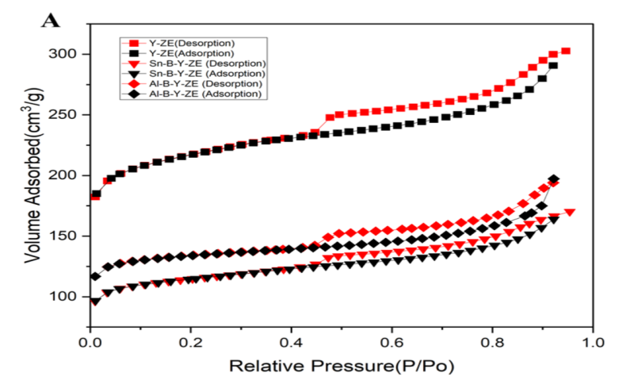
Fig. S9 Adsorption isotherms of composites (A) Sn-B-YZE, Al-B-YZE, Y-ZE.
(B) Sn-B-NaYZE, Al-B-NaYZE, NaYZE.

Thermogravimetric Analysis (TGA)
TGA evaluations of composites were analyzed using TGA/DSC 1 Star system of Mettler-Toledo make. For this, about 5 mg of samples was taken in the silica crucible and put in the weighing panel. The weight loss was recorded in the temperature program of 50-500 °C (5ºC min⁻¹), 500-1000 ºC (10 ºC/min) under nitrogen as purge gas with flow rate of 40 mL/min. The TGA data were further evaluated by taking the first derivative to obtain differential thermo-gravimetry (DTG) (Fig. S10).

Fig. S10 Comparison of thermal stability of synthesized composites and their base materials.
TGA have been displayed that the prepared composites were better stable as compared to their initial base materials (NaYZE and YZE). The total mass loss in YZE and NaYZE (base materials) are 8.5% and 14.5% at a low-temperature range of 100-200 ºC, respectively (Fig. S10). This weight difference might be due to the loss of free cations in the base materials.
Pyridine adsorption
Composite (50 mg) was kept under pyridine-saturated argon for 2 h for adsorption in the acidic site. This pyridine saturated composites were analyzed through TGA as per the above protocol (Fig. S11).

Fig. S11 TGA pattern of Sn-B-NaYZE before and after pyridine adsorption

3. Physico-chemical Properties
3.1. Cyclization of (±)-citronellal to different diastereomers
In the cyclization mechanism as mentioned in Scheme S2a, there are eight diastereomers (four pairs of enantiomers) of isopulegol that are possible as shown in Scheme S2b. Four diastereomers are originated from (+)-citronellal, and another four diastereomers are originated from (-)-citronellal (Scheme 2b).
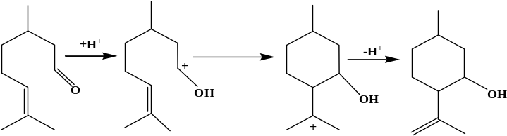
Rearrangement

Stable carbocation
Protonated isopulegol
Isopulegol
Citronellal

Scheme S2a Reaction mechanism of citronellal cyclization
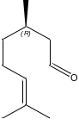
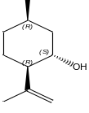
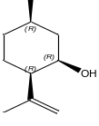
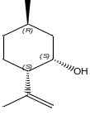
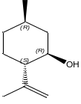
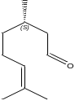
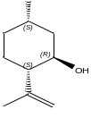
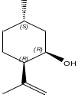
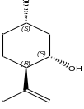
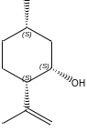
R-(+)-Citronellal
(-)- Isopulegol
(-)-Neo-isopulegol
(-)-Iso-isopulegol
(-)-Neo-isoisopulegol
S-(-)-Citronellal
(+)- Isopulegol
(+)-Neo-isopulegol
(+)-Iso-isopulegol
(+)-Neo-isoisopulegol

Scheme S2b Possible diastereomers from (+)-citronellal and (-)-citronellal

3.2 Effect of solvent effect and kinetics of the reaction
The Prins reaction and distribution of diastereomers in different solvents is shown in Fig. S12

Fig. S12 Conversion (%) of citronellal to isopulegols in different solvents.
The kinetics of isopulegol transformation is shown in Fig. S13.

Fig. S13: Kinetics of citronellal to diastereomers (A) Sn-B-NaYZE, (B) Al-B-NaYZE

3.3 Enantiospecific characterization
(+)-Citronellal is catalytically transformed to (-)-isopulegol as a major enantiomer along with (+)-neoisopulegol, (+)-neoisoisopulegol, and (+)-isoisopulegol as presented in Fig. S14.
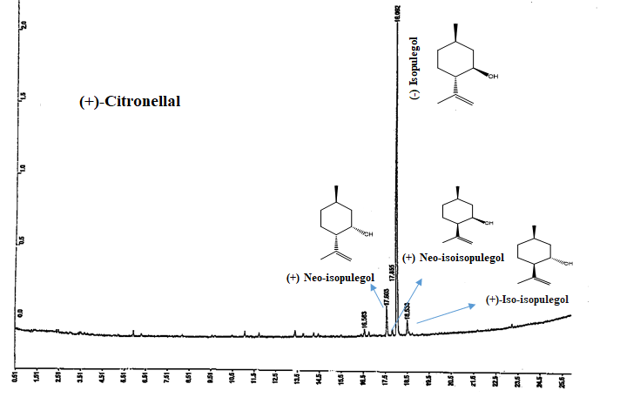
Protonated isopulegol
Fig. S14 Chiral-GC-FID analysis of (+)-citronellal conversion to isopulegol isomers using Sn-B-NaYZE
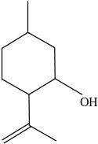
3.4 Mechanism for enrichment of (-)-menthol
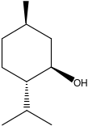
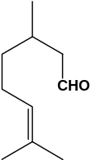
B
A

(-)-Menthol
Isopulegol isomers
(±)-Citronellal

A: Al-B-NaYZE or Sn-B-NaYZE, B: 1%Pd/AC or 1%Ru/AC
Scheme S3a Reaction mechanism of citronellal cyclization

In the semi-synthesis of citronellal to menthol, the major enantiomer was (-)-menthol followed by (+)-menthol, and other enantiomers were detected as a trace. The process for enrichment of (-)-menthyl acetate was the preparation of (±)-menthyl acetate from the enantiomeric mixture of (±)-menthol. This (±)-menthyl acetate was crystallized at 35 ºC for screening out of (-)-menthyl acetate (Scheme S3b).
(-)-menthol
+
Crystallization at 35ºC
Major enantiomers
(±)-menthyl acetate
Hydrolysis
Unwanted enantiomers remain in liquid phase
R=CH₃ or CH₂Cl

Scheme S3b Mechanism of enrichment of (-)-menthol for its enantiomeric mixture

Chair conformers have compact structure and the (-)-menthyl acetate is easily formed crystals, whereas the (+)-menthyl acetate is found difficult for making crystals due to extra stress arisen in its axial orientation of the bulky groups as presented in Scheme S3c.
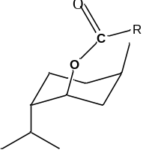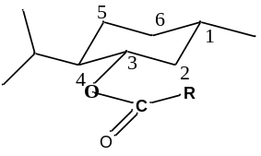

(-)-menthyl acetate
(+)-menthyl acetate
Scheme S3c Chair conformers of (-)-menthyl acetate and (+)-menthyl acetate.

3.5 ¹³C-NMR and DEPT analysis of (-)-menthol
¹³C-NMR (Brucker 500 MHz, USA) was used for the recording of carbon and DEPT signals. Sample (8 mg) was dissolved in CDCl₃ with TMS as an internal standard. ¹³C-NMR spectra of natural (essential oils) and synthetic samples (petrochemical origin) are presented in Fig. S15.

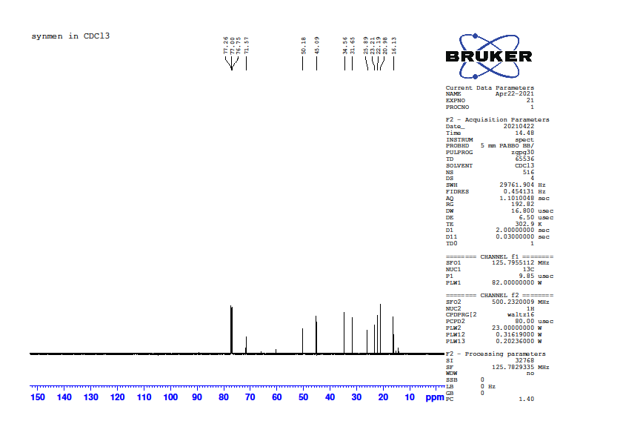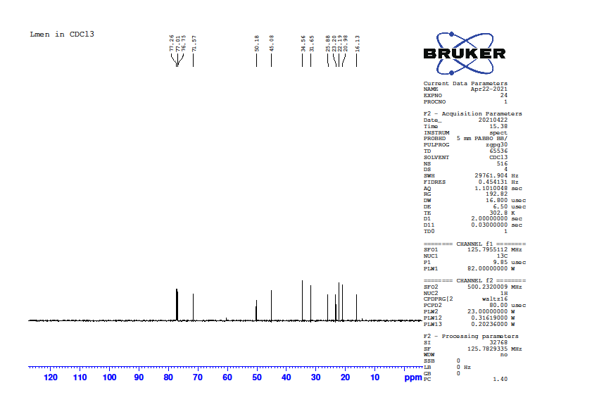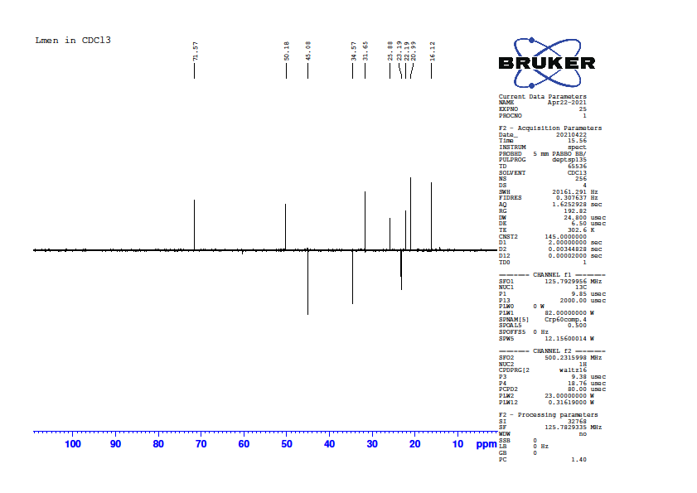
B
A
C

Fig. S15 (-)-Menthol, (a) ¹³C-NMR and (b) DEPT of isolated from the present process (essential oils); and (c) synthesized from petrochemicals available in the market

3.6 Biobased index (¹⁴C dating study)
Biobased evolution of the samples was done by quantification of ¹⁴C content. ¹⁴C is the radioactive isotope of carbon and formed by the spallation of cosmic rays with the stable isotope of nitrogen (¹⁴N). After the formation it converts to ¹⁴CO₂ and becomes part of the carbon cycle and also gets incorporated into the plants during the photosynthesis process. As long as plants are alive the isotopic ratio ¹⁴C/¹²C remains in equilibrium with nature and remains fairly constant. However, after the death of the plant, the photosynthesis process stops, so prohibited uptake of ¹⁴C and the ratio of ¹⁴C/¹²C starts decreasing as ¹⁴C disintegrate. Owing to the half-life (5730 years) of ¹⁴C, this decrease is very slow and leads to almost zero in about 50000 years, and therefore all fossilized petroleum products will have almost zero ¹⁴C concentration [3,4]. In AMS, processed samples are combusted and converted into graphite powder, the form which is suitable for the ion source of the AMS system. Automated Graphitization Equipment (AGE) system at IUAC was used for combustion to obtain CO₂ and to reduce thus produced CO₂ into graphite powder. 500 kV Ion accelerator-based AMS system was used for the quantification of ¹⁴C/¹²C present in each of the samples.
pMC (Percentage modern carbon) values obtained by AMS measurement were corrected for δ¹³C and blank values. For normalization of AMS results standard sample OXII was used. The background (blank) value during the measurement was (0.546±0.015) pMC and that corresponds to ¹⁴C/¹²C ratio (5.86±0.16) x 10⁻¹⁵. The data quality was monitored with a secondary standard sample (IAEA-C7), which was measured considering the unknown sample during measurement, its experimental result (pMC=49.75±0.27) was matching with its consensus values (pMC=49.53±0.12) within the error. The pMC values can be converted into % biobased carbon content using the following formula where the reference value is pMC for the year in which atmospheric carbon got incorporated into biomass carbon by the photosynthesis process.
% Biobased carbon = 100 x $\frac{pMC}{Ref.}$ (S1)
The reference value for the sample collected in the particular year was obtained as per ASTM D6866-16 [5].

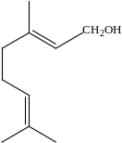4. Volatility and bioactivities with the relation of chemical compositions
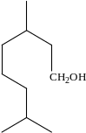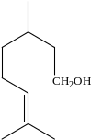 A

Dihydro-citronellol
Citronellol
Geraniol

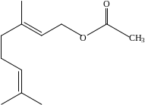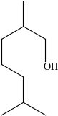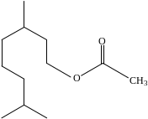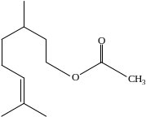

B
3,7-Dimenthyloctyl acetate
Citronellyl acetate
Geranyl acetate
2,6-Dimenthylheptanol

Scheme S4 Possible conversion of conjugated oxygenated monoterpenoids (A) Geraniol to dihydro-citronellol, (B) Geranyl acetate to 2,6-dimethylheptanol

4.1. TGA and DTG analysis
The essential oils and their modified oils (5 mg approx) were taken in a silica crucible and recorded the mass loss from 50-500 ºC@5 ºC/min. The DTG curves were taken through software for clear interpretation of the results (Fig. S11).
B
A

Fig. S16 Comparative (a) TGA and (b) DTG analysis of essential oils and modified oils

4.2. Anti-microbial activities
The antimicrobial activities of eucalyptus oil, citronella oil, modified eucalyptus, and citronella oils were determined qualitatively by disc diffusion assay and quantitatively through micro-broth dilution assay in the form of their minimum inhibitory concentration (MIC) values. Standard antibiotics were used for comparison purposes. Mueller Hinton Agar (MHA) and Sabouraud’s Dextrose Agar (SDA) were used for bacteria and fungi respectively in disc diffusion assay. Similarly, the MIC values were determined in their respective broth media. Pure bacterial strains such as SA-Staphylococcus aureus (MTCC96) and ST-Staphylococcus typhimurium (MTCC43232) were sub-cultured from stock in Brain Hearth Infusion, while the fungal strain ATCC-Candida albicans (14053) was sub-cultured on SDA. The microbial strains are traceable to the Microbial Type Culture Collection Centre (MTCC), Institute of Microbial Technology, and Chandigarh, India. C. albicans, a clinical isolate was obtained from All India Institute of Medical Science, Delhi.
Disc diffusion Assay and MIC value
To perform the disc diffusion assay, 100 µL of the pre-incubated standardized bacterial/fungal inoculums (0.5 McFarland) were uniformly spread to form even lawn over the Mueller–Hinton agar surface or Sabouraud’s Dextrose Agar plate respectively. The sample (10 µL) impregnated on a sterile paper disc was placed on the fungal/bacterial lawns. The diameter of the inhibition zone was measured after incubation of these plates for 24 h at 37 °C. The MIC values of each strain were achieved through the serial dilution of the test material. After the addition of a fixed volume of inoculums (10 μL), the highest dilution exhibiting the inhibition of growth after the addition of 20 μL of p-iodonitrotetrazolium chloride was considered as the MIC of the test compound (Table S7a-b).

Table S7a Zone of inhibition (mm) of modified C. citriodora, Citronella oil (CIM-Jeeva and BIO-13) essential oil and spent oil after isolation of menthol through Disc Diffusion Assay
Bacterial/  Fungal Strains | Disc diffusion assay (Zone of inhibition in mm) |  |  | Disc diffusion assay (Zone of inhibition in mm) |  |  | Disc diffusion assay (Zone of inhibition in mm)
Bacterial/  Fungal Strains | EU-1 | EU-2 | EU-3 | CNJ-1 | CNJ-2 | CNJ-3 | CNB-1 | CNB-2 | CNB-3
S. aureus | 11.5±0.5 | 12.5±0.5 | 19.5±0.5 | 22.5±1.0 | 20±1.0 | 20.5±0.5 | 19.5±0.5 | 14.5±0.5 | 12.5±0.5
S. typhimurium | 9.5±0.5 | 10.5±0.5 | 10.5±0.5 | 12.5±1.5 | 11±1.0 | 11.5±1.5 | 11.5±1.5 | 9.5±0.5 | 8.5±0.5
C. albicans | 10.5±0.5 | 8.5±0.5 | 8.5±0.5 | 15±0.5 | 10.5±0.2 | 11±0.5 | 19.5±0.3 | 10.5±0.2 | 11±0.5

EU-1: Fresh eucalyptus oil; EU-2: Modified oil; EU-3: Spent essential oil; CNJ-1: Fresh citronella jeeva oil; CNJ-2: Modified oil; CNJ-3: Spent essential oil; CNB-1: Fresh citronella bio-13 oil; CNB-2: Modified oil; CNB-3: Spent essential oil.

Table S7b MIC (μL) of modified C. citriodora, Citronella oil (CIM-Jeeva and BIO-13) essential oil and spent oil after isolation of menthol
Bacterial/  Fungal Strains | Minimum inhibitory concentration (µL mL⁻¹) |  |  | Minimum inhibitory concentration (µL mL⁻¹) |  |  | Minimum inhibitory concentration (µL mL⁻¹)
Bacterial/  Fungal Strains | EU-1 | EU-2 | EU-3 | CNJ-1 | CNJ-2 | CNJ-3 | CNB-1 | CNB-2 | CNB-3
S. aureus | 0.51 | 0.25 | 0.12 | 2.27 | 2.27 | 2.27 | 0.14 | 0.56 | 0.56
S. typhimurium | 250 | 250 | 0.51 | 0.28 | 0.56 | 0.56 | 2.27 | 2.27 | 2.27
C. albicans | 0.51 | 0.25 | 0.25 | 0.28 | 0.56 | 0.56 | 0.28 | 1.13 | 1.13

EU-1: Fresh eucalyptus oil; EU-2: Modified oil; EU-3: Spent essential oil; CNJ-1: Fresh citronella jeeva oil; CNJ-2: Modified oil; CNJ-3: Spent essential oil; CNB-1: Fresh citronella bio-13 oil; CNB-2: Modified oil; CNB-3: Spent essential oil.

The fresh and modified essential oils reveal that modified and spent oils have been exhibiting potent antimicrobial activities. Eucalyptus modified oil was highly active against the bacterial strains (S. aureus and S. typhimurium) and this might be due to the presence of menthol. In the case of citronella, modified oils have been shown the comparable activity as fresh oil. The higher activity in fresh citronella oil was due to the synergistic effect of major compounds citronellal, citronellol, geraniol, etc. After modification citronellal is selectively converted to menthol. But, citronellol, geraniol, geranyl acetate and citronellyl acetate were partially converted to dihydro-citronellol and 3,7-dimethyloctyl acetate (Table 1, Scheme S4). Therefore, the significant activity in modified oils might be due to menthol along with other oxygenated terpenoids.
  - Antioxidant activity
The free radical-scavenging activity of essential oils and combinations were quantified through DPPH assay. At first, 5 mg mL⁻¹ of stock solution of essential oils were prepared in methanol. Then, a stock of solution serial dilution of essential oils was prepared with varying concentrations (0.625-5 mg mL⁻¹) and added to the 2 mL DPPH solution (0.25 mM in 95% ethanol). Then, the solution mixture was then shaken and left for 60 min incubation at room temperature. Absorbance was measured at 517 nm and Ascorbic acid was used as standard and DPPH mixture without any sample served as blank. The DPPH Inhibition (I %) was calculated using the following Eq. (S2)

$I \left(\%\right)=\frac{AbsControl-AbsSample}{AbsControl} x 100$ (S2)

Where AbsControl is the absorbance of the blank sample (only DPPH) and AbsSample is the absorbance of the sample (containing essential oils).
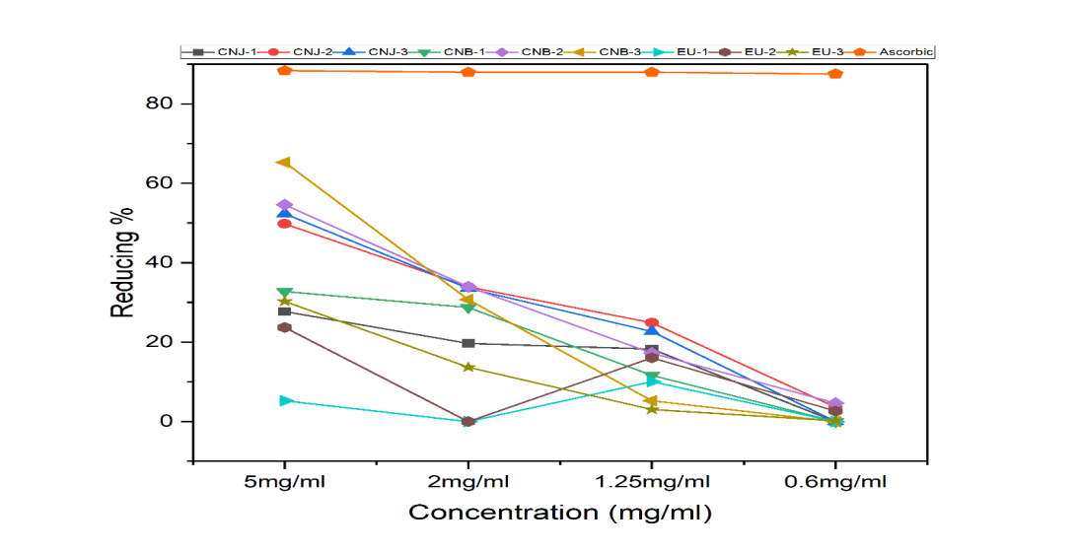
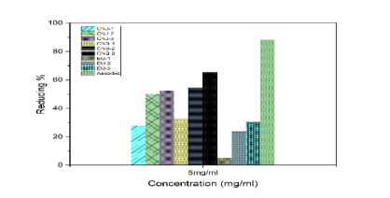
The modified and spent essential oils are showing significant antioxidant activities (Fig. S12). The highest activity is observed at 5 mg mL⁻¹ concentration and the pattern as of activity was followed at each concentration (2, 1.25, and 0.6 mg mL⁻¹).

Fig. S17 Comparative antioxidant activity of different essential oil and their modified oils

Eucalyptus essential oil, EU-1 (Fresh oil), EU-2 (Modified oil), EU-3 (Spent essential oil); Citronella (CIM-jeeva) essential oil, CNJ-1 (Fresh oil), CNJ-2 (Modified oil), CNJ-3 (Spent oil); Citronella (BIO-13) essential oil CNB-1 (Fresh oil), CNB-2 (Modified oil), CNB-3 (Spent oil)

Catalyst | Conversion (%) |  | Selectivity Isopulegol isomers (%) |  | Enantiomeric excess  (-)-isopulegol  (%) |  | Operating conditions |  | Medium/Solvent |  | Ref.
40%HPW/MCM-41 |  | 96 |  | -- |  | 65 |  | Cyclization reaction in CH₂Cl₂ at room temperature |  | Dichloromethane |  | [6]
S-Zr/MMT-15 |  | 98.52 |  | 84.56 |  | _ |  | 50 mg catalyst/ 10 mmol citronellal/ 1 mmol K₂CO₃/ 15 min microwave irradiation |  | NA |  | [7]
Sn-SBA-15  Sn-beta |  | 89  63 |  | 92  88 |  | 64  77 |  | 50 mg catalyst / 5 ml 0.5 M citronellal / 60 ºC, 4 h, RT |  | Toluene  Acetonitrile |  | [8]
Ru(Bpy)-Saponite |  | 100 |  | 89.22 |  | _ |  | 20% catalyst loading / 10 min microwave irradiation/ ammonium forate |  | Isopropanol |  | [9]
Meso-microporous ZSM-5 |  | 100 |  | 95 |  | _ |  | 80 ºC, 3 h |  | Benzene |  | [10]
25wt% WO₃-SiO₂ |  | 90 |  | 97 |  | _ |  | 10wt % catalyst loading, 50 ºC, 24 h |  | Toluene |  | [11]
Fe-Beta |  | 97 |  | 94 |  | _ |  | 90 ºC/ 24 h |  | Toluene |  | [12]
Clay extrudates |  | 100 |  | 61 |  | _ |  | 70 ºC, 10 bar of Ar with 0.086 M initial citronellal concentration |  | Cyclohexane |  | [13]
Sn-B-NaY-ZE/Al-B-NaYZE |  | 99 |  | 99 |  | 95 |  | 10% catalyst loading ,40 ºC /70 bar CO₂ / 45 min |  | Liquid CO₂ medium |  | This work
Table S8 Catalytic activity of some catalyst for citronellal cyclization

References
- Adams, R.P.: Identification of essential oil by gas chromatography/mass spectroscopy, Allured Publishing, Carol Stream, IL: USA (2007)
- Arevalo, S.F-J., Martinez, I.G., Garcia, L.A., Maldonado, R.M-T., Leon, M.G.: ¹⁴C determination in different bio-based products. Nuclear Instruments and Methods in Physics Research B, 361, 354-357 (2015)
- ASTM D6866-16, ASTM International: Standard test methods for determining the biobased content of solid, liquid, and gaseous samples using radiocarbon analysis. doi: 10.1520/D6866-16 (2016).
- Kumar, P., Chopra, S., Pattanaik, J.K., Ojha, S., Gargari, S., Joshi, R., Kanjilal, D.: A new AMS facility at Inter University Accelerator Centre, New Delhi. Nuclear Instruments and Methods in Physics Research B. 361, 115-119 (2015)
- Rout, P.K., Naik, S.N., Rao, Y.R., Jadeja, G., Maheshwari, R.C.: Extraction of essential oil from Zanthoxylum rhesta using subcritical CO₂ and conventional processes. J. Supercrit. Fluids 42, 334-341 (2007).
- Braga, P.R.S., Costa, A., de Freitas, E.F., Rocha, R.O., de Macedo, J.L., Araujo, A.S., Dias, J., Dias, S.C.L.: Intramolecular cyclization of (+)-citronellal using supported 12-tungstophosphoric acid on MCM-41, J. Mol. Catal. A 358, 99-105 (2012)

Fatimah, I., Rubiyanto, D., Huda, T.: Effect of sulfation on zirconia-pillared montmorillonite to the catalytic activity in microwave-assisted citronellal conversion, Int. J. Chem. Eng. (2014).
- Muller, P., Wolf, P., Hermans, I.: Insights into the complexity of heterogeneous liquid-phase catalysis: case study on the cyclization of citronellal. ACS Catal. 6, 2760-2769 (2016)

Fatimah, I., Rubiyanto, D., Prakoso, N.I., Yahya, A., Sim, Y.L.: Green conversion of citral and citronellal using tris (bipyridine) ruthenium (II)-supported saponite catalyst under microwave irradiation, Sustain. Chem. Pharm. 11, 61-70 (2019).

Shah, A.K., Maitlo, G., Korai, R.M., Unar, I.N., Shah, A.A., Khan, H.A., Shah S.F.A., Ismail, U., Park, Y.H.: Citronellal cyclisation to isopulegol over micro-mesoporous ZSM-5 zeolite: effects of desilication temperature on textural and catalytic properties. React. Kinet. Mech. Catal. 128, 507-522 (2019).

Vrbková, E., Šteflová, B., Zapletal, M., Vyskočilová, E. , Červený, L. : Tungsten oxide-based materials as effective catalysts in isopulegol formation by intramolecular Prins reaction of citronellal. Res. Chem. Intermed. 46, 4047-4059 (2020).

Vrbková, E., Prejza, T., Lhotka, M., Vyskočilová, E., Červený, L.: Fe-Modified Zeolite BETA as an Active Catalyst for Intramolecular Prins Cyclization of Citronellal. Catal. Lett. 151, 1993-2003 (2021).

Vajglová, Z., Simakova, I.L., Eränen, K., Mäki-Arvela, P., Kumar, N., Peurla, M., Tolvanen, S., Efimov, A., Hupa, L., Peltonen, J., Murzin, D.Y.: The physicochemical and catalytic properties of clay extrudates in cyclization of citronellal. Appl. Catal. A: Gen. 629, 118426 (2022).

