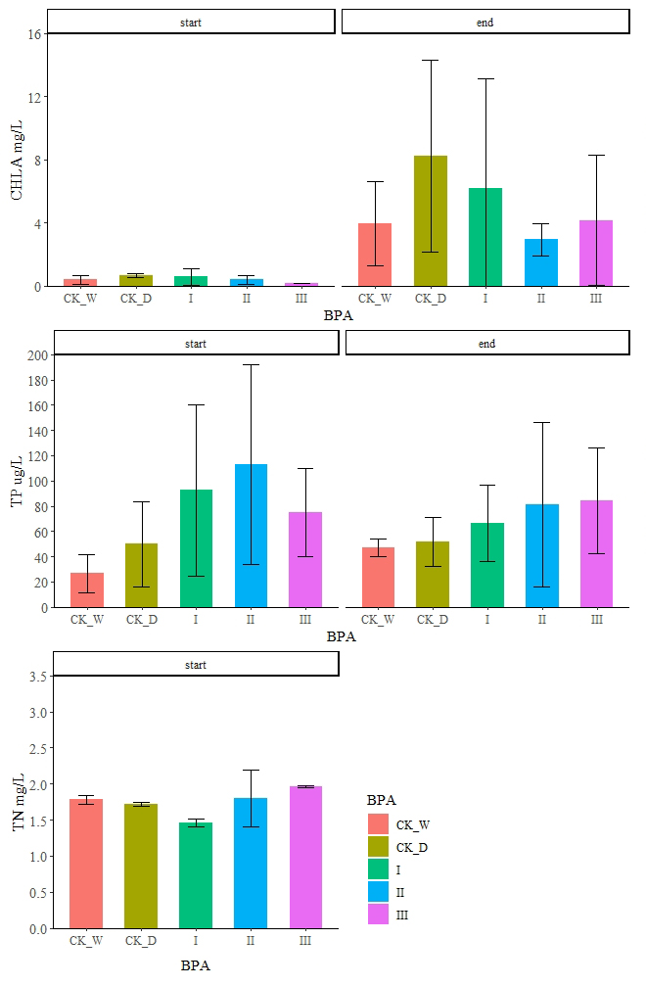
The experimental results showed that there was no significant difference in TN, TP, and CHLA between the treatments (Fig. S1). The average values were 0.54 ~ 5.51 mg/L, and 7.21~ 245.05 ug/L, 0.19 ~18.89 mg/L, respectively.
Figure S1 The changes in the concentrations of total nitrogen (TN), total phosphorus (TP) and water chlorophyll a (CHLA) with BPA loading (CK_W, CK_D, I II, III).

