SUPPLEMENTARY MATERIAL
Synthesis and cytotoxic evaluation of F16 derivatives pentacyclic triterpenoid acids possessing a polyhydroxylated ring A.

Anna Yu. Spivak,^{*1} Darya A. Nedopekina,¹ Eldar V. Davletshin,¹
Oleg I. Shuvalov,² Yuilia N. Kirdeeva,² Yuri P. Belsky³

¹ Institute of Petrochemistry and Catalysis, Ufa Federal Research Center, Russian Academy of Sciences, 141 Prospekt Oktyabrya, Ufa 450075, Russian Federation
² Institute of Cytology RAS, 194064, St-Petersburg, Russia Federation
³ Centre of Preclinical Translational Research, Almazov National Medical Research Centre,
St-Petersburg 197371, Russia Federation

* Corresponding author: Tel.: +7-917-421-71-06
E-mail addresses: spivak.ink@gmail.com (A.S.)
Table of content
¹H, ¹³C NMR of Compound 8 3
¹H, ¹³C, HSQC, HMBC, COSY, NOESY NMR of Compound 9 5
¹H, ¹³C HSQC, HMBC, COSY, NOESY NMR of Compound 10 11
¹H, ¹³C NMR of Compound 11 17
¹H, ¹³C NMR of Compound 12 19
¹H, ¹³C HSQC, HMBC, COSY, NOESY NMR of Compound 13 21
¹H, ¹³C NMR of Compound 14 27
¹H, ¹³C NMR of Compound 17 29
¹H, ¹³C NMR of Compound 18 31
¹H, ¹³C NMR of Compound 25 33
¹H, ¹³C NMR of Compound 25a 35
¹H, ¹³C NMR of Compound 28 37
¹H, ¹³C NMR of Compound 28a 39
¹H, ¹³C NMR of Compound 26 41
¹H, ¹³C NMR of Compound 26a 43
¹H, ¹³C NMR of Compound 29 45
¹H, ¹³C NMR of Compound 29a 47
¹H, ¹³C NMR of Compound 27 49
¹H, ¹³C NMR of Compound 30 51
¹H, ¹³C NMR of Compound 32 53
¹H, ¹³C NMR of Compound 32a 55
¹H, ¹³C NMR of Compound 33 57
¹H, ¹³C NMR of Compound 33a 59

Benzyl 3-oxolup-1-en-20,29-dihydrobetulinate (8).
¹³C NMR spectra (CDCl₃)

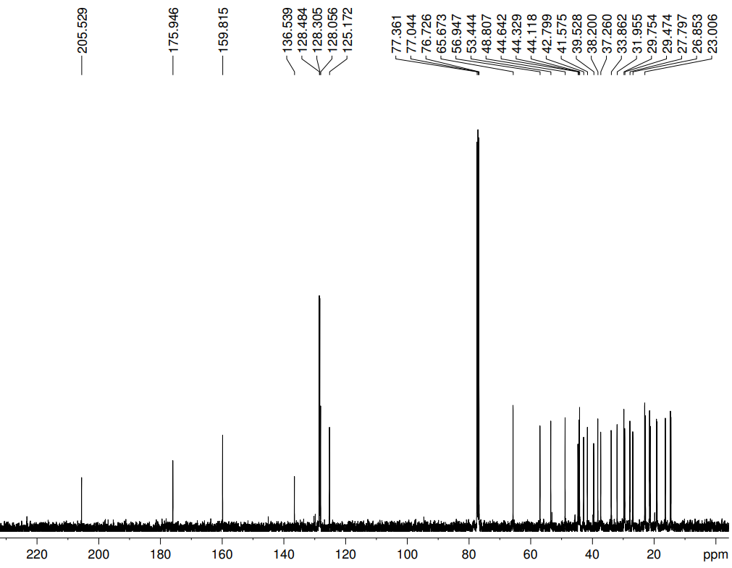

Benzyl 3-oxolup-1-en-20,29-dihydrobetulinate (8).
¹H NMR spectra (CDCl₃)

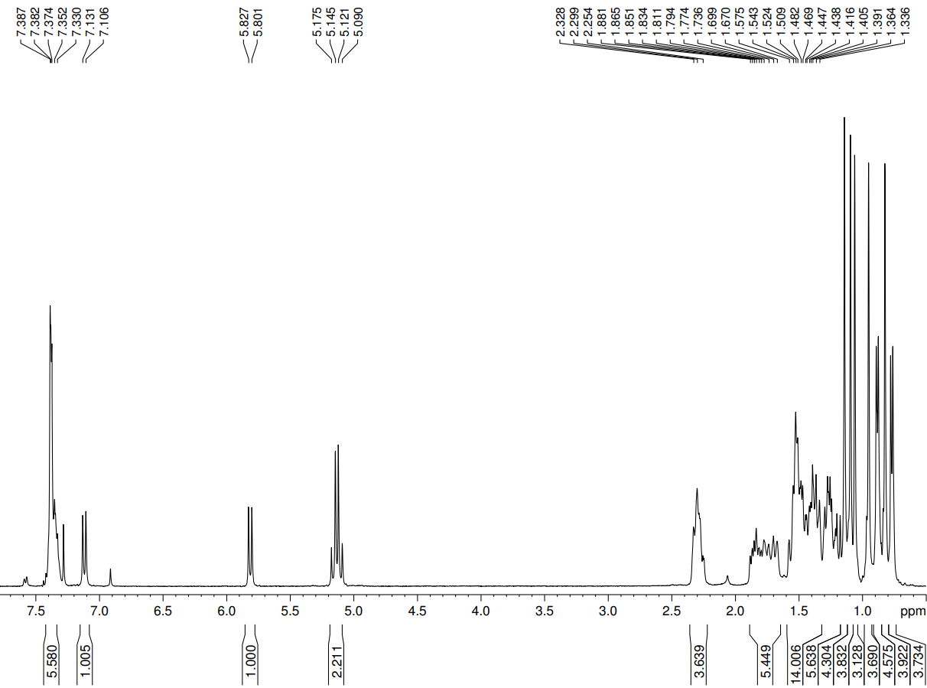

Benzyl 1α,2α-epoxy-3-oxolup-20,29-dihydrobetulinate (9).
¹³C NMR spectra (CDCl₃)

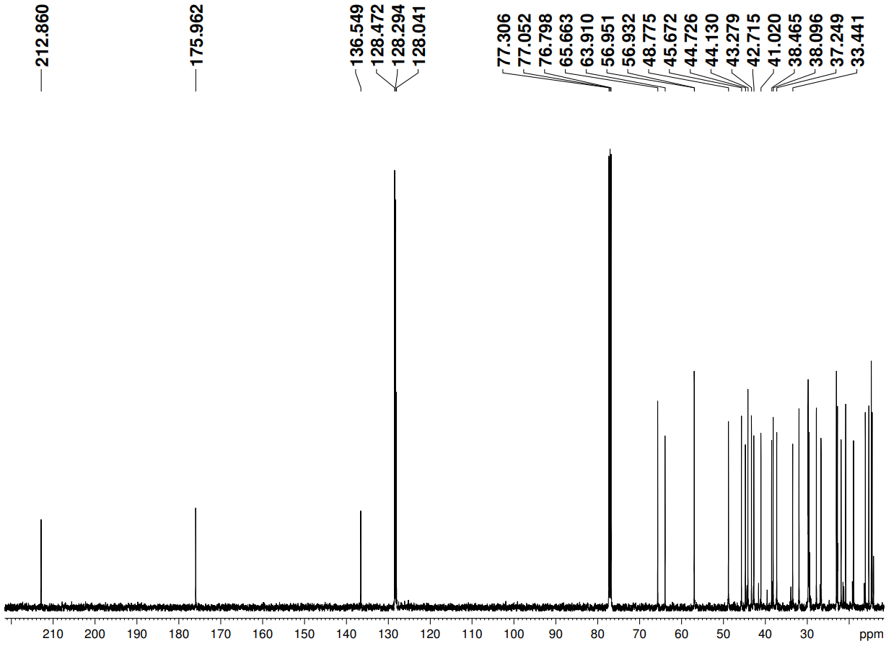

Benzyl 1α,2α-epoxy-3-oxolup-20,29-dihydrobetulinate (9).
¹H NMR spectra (CDCl₃)

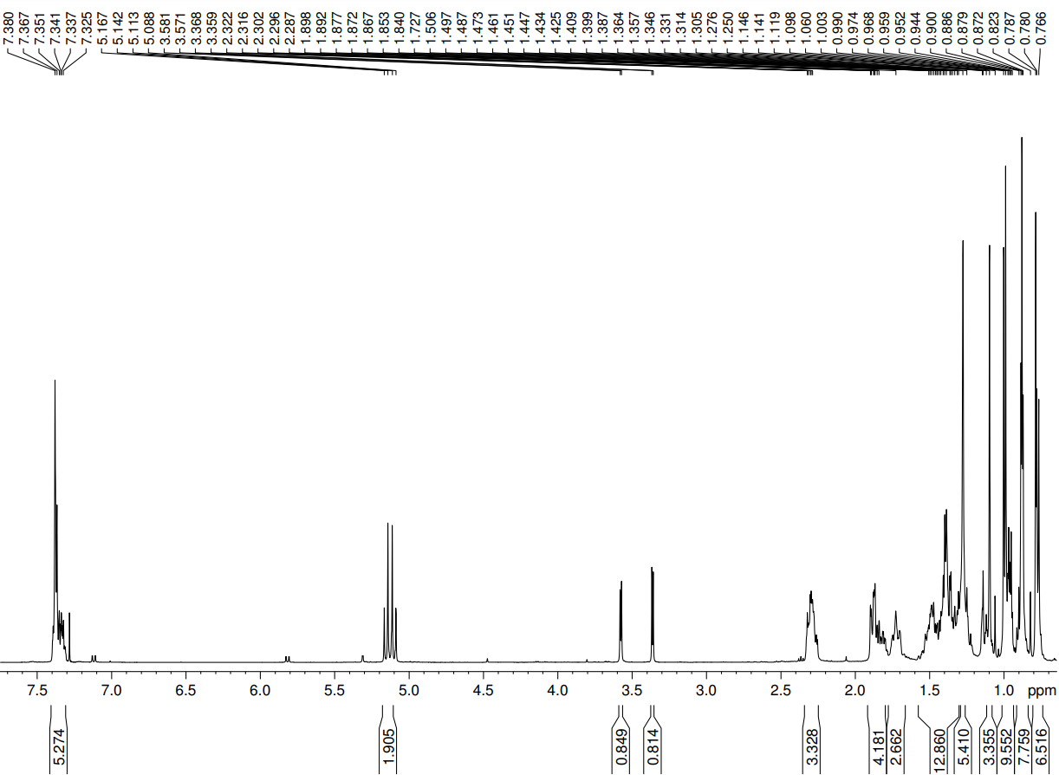

Benzyl 1α,2α-epoxy-3-oxolup-20,29-dihydrobetulinate (9).
HSQC spectra (CDCl₃)

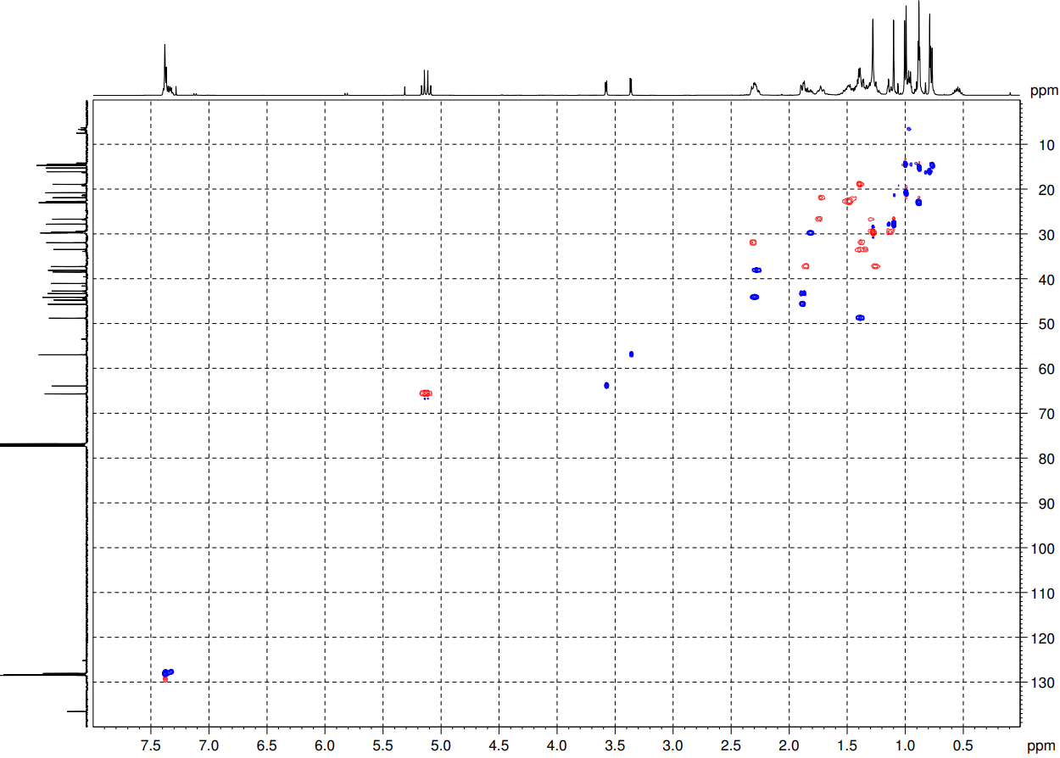

Benzyl 1α,2α-epoxy-3-oxolup-20,29-dihydrobetulinate (9).
HMBC spectra (CDCl₃)
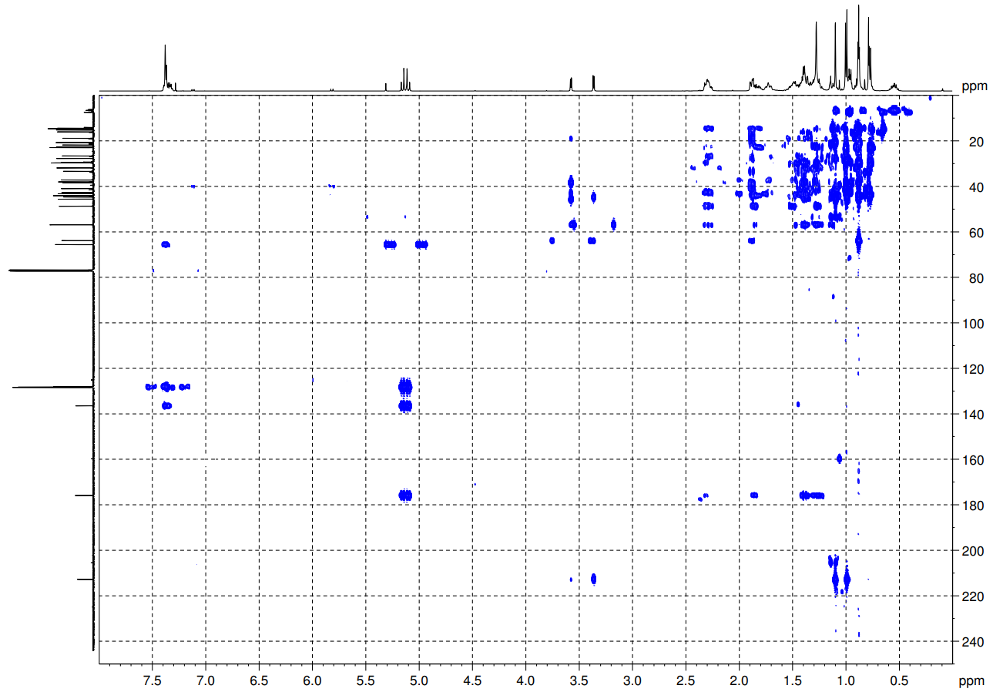

Benzyl 1α,2α-epoxy-3-oxolup-20,29-dihydrobetulinate (9).
¹H-¹H COSY spectra (CDCl₃)
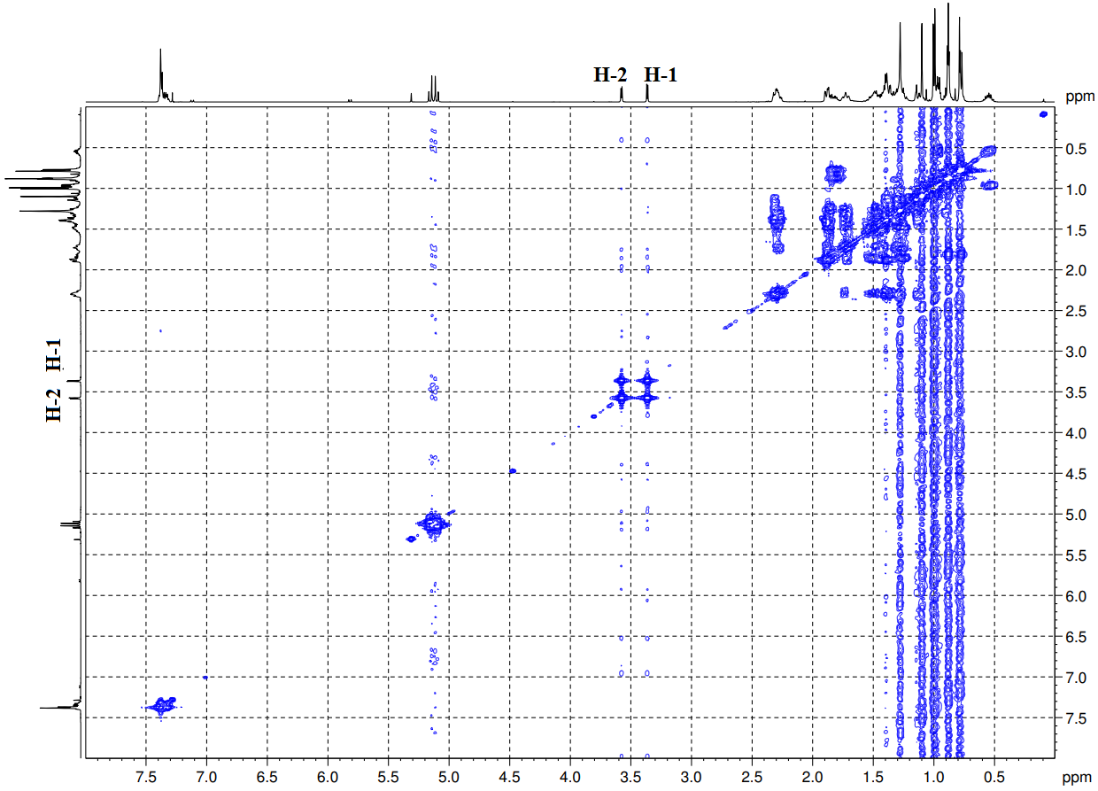

Benzyl 1α,2α-epoxy-3-oxolup-20,29-dihydrobetulinate (9).
NOESY spectra (CDCl₃)
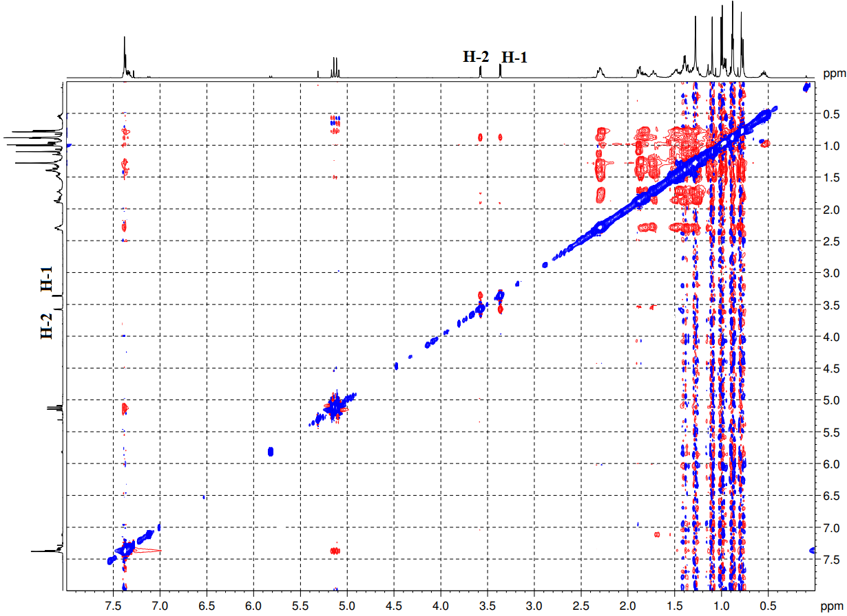
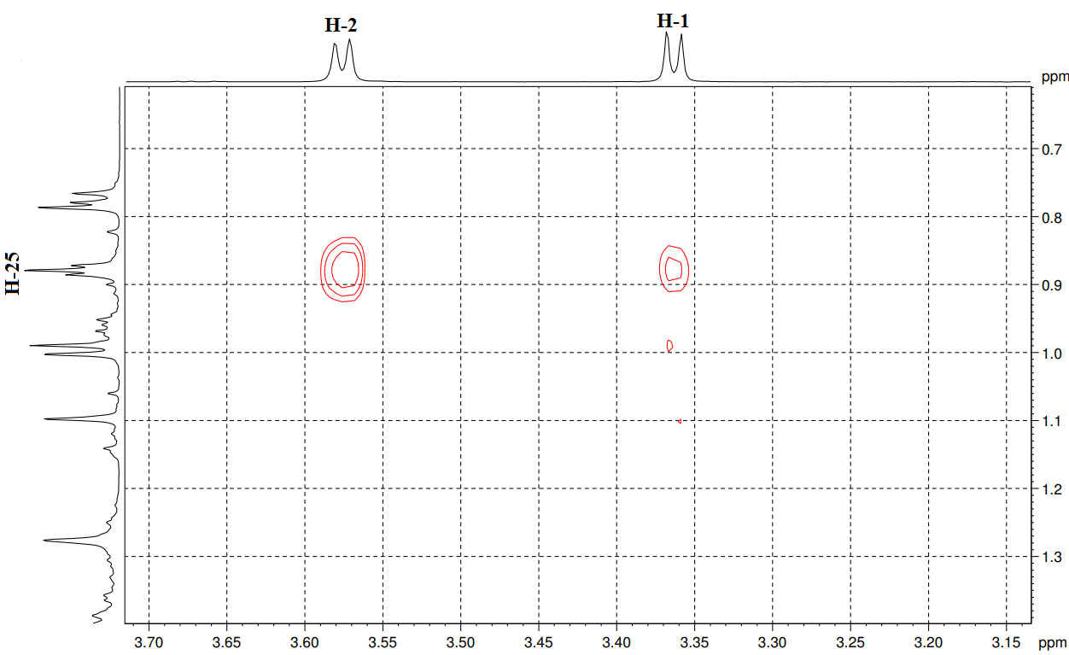

Benzyl 1α,2α-epoxy-3-hydroxylup-20,29-dihydrobetulinate (10).
¹³C NMR spectra (CDCl₃)

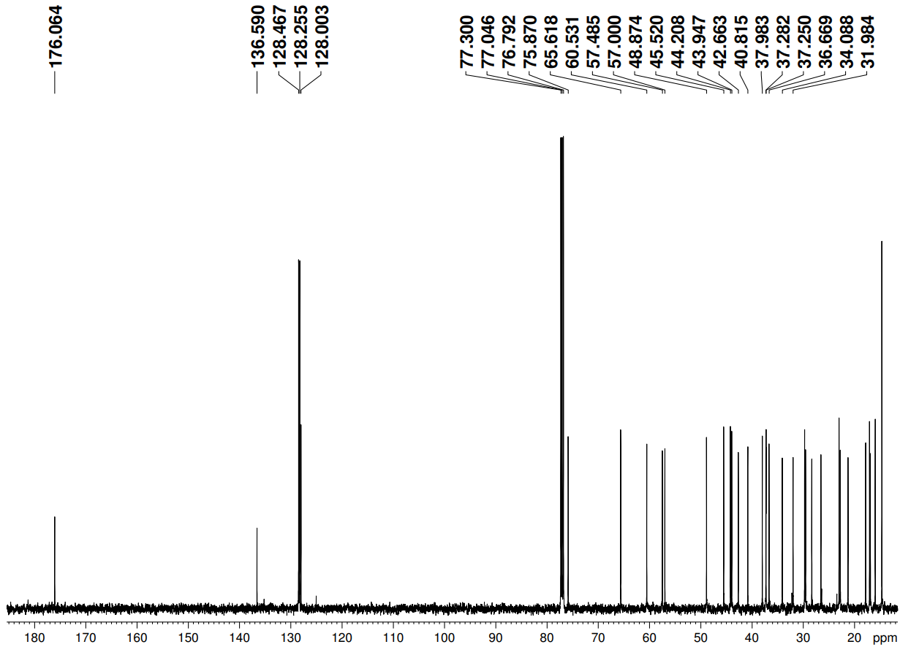

Benzyl 1α,2α-epoxy-3-hydroxylup-20,29-dihydrobetulinate (10).
¹H NMR spectra (CDCl₃)

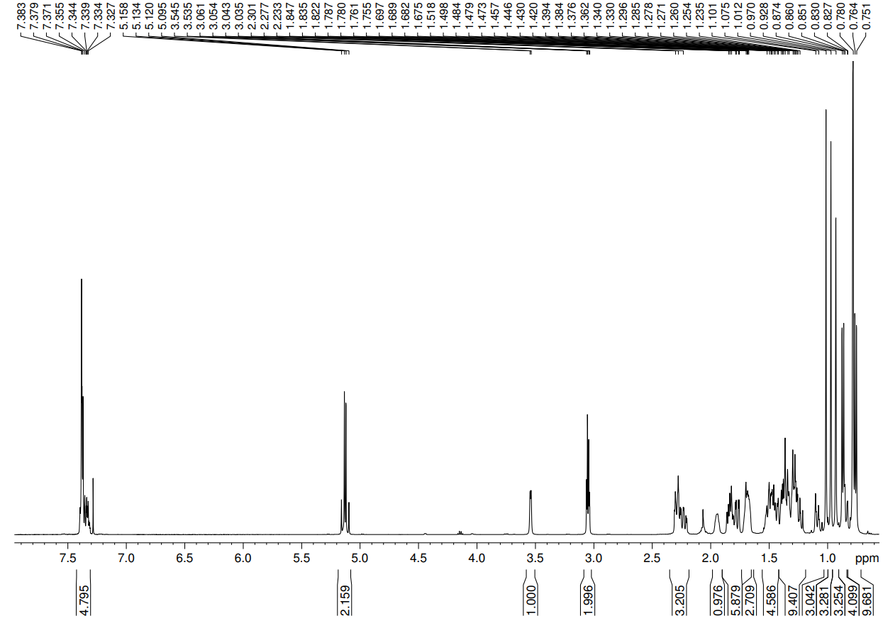

Benzyl 1α,2α-epoxy-3-hydroxylup-20,29-dihydrobetulinate (10).
HSQC spectra (CDCl₃)

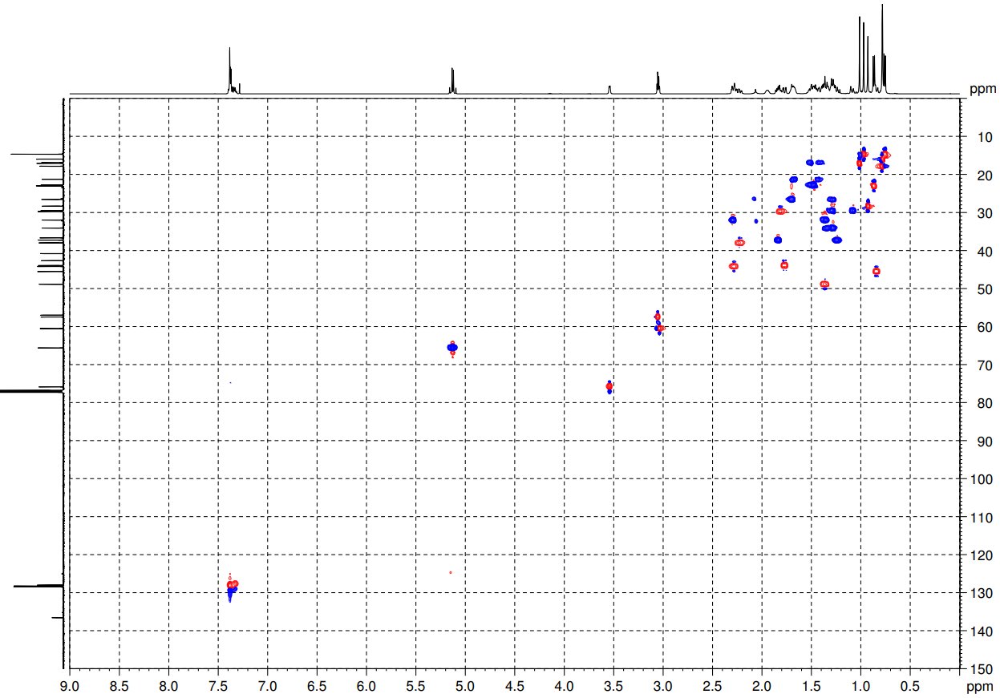

Benzyl 1α,2α-epoxy-3-hydroxylup-20,29-dihydrobetulinate (10).
HMBC spectra (CDCl₃)
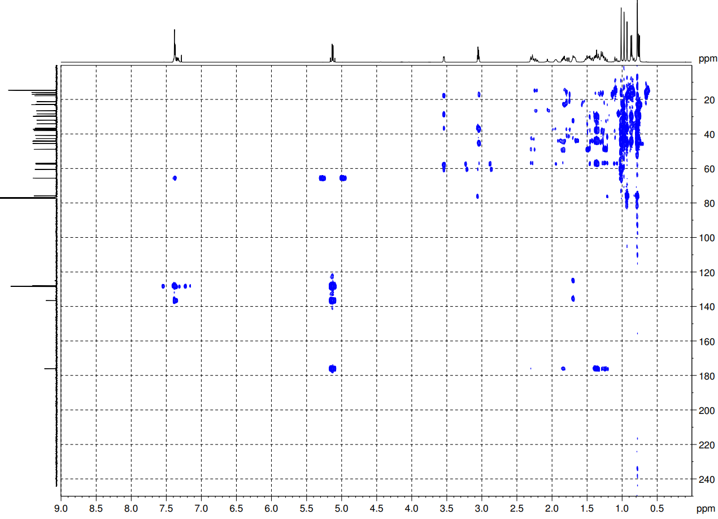

Benzyl 1α,2α-epoxy-3-hydroxylup-20,29-dihydrobetulinate (10).
¹H-¹H COSY spectra (CDCl₃)
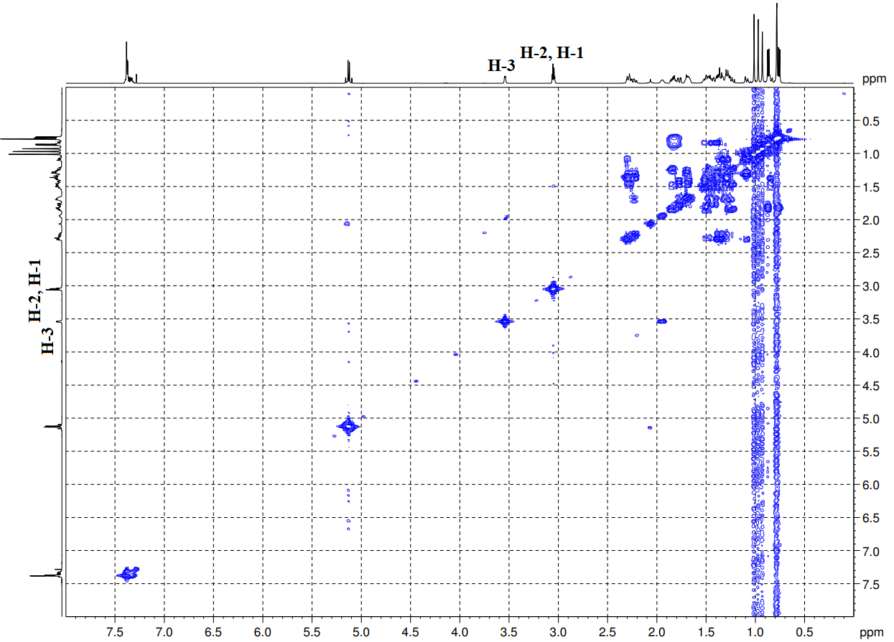

Benzyl 1α,2α-epoxy-3-hydroxylup-20,29-dihydrobetulinate (10).
NOESY spectra (CDCl₃)
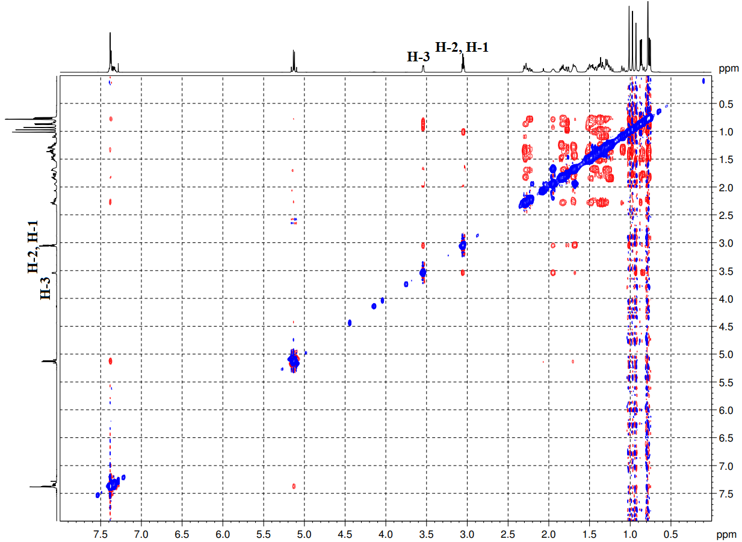
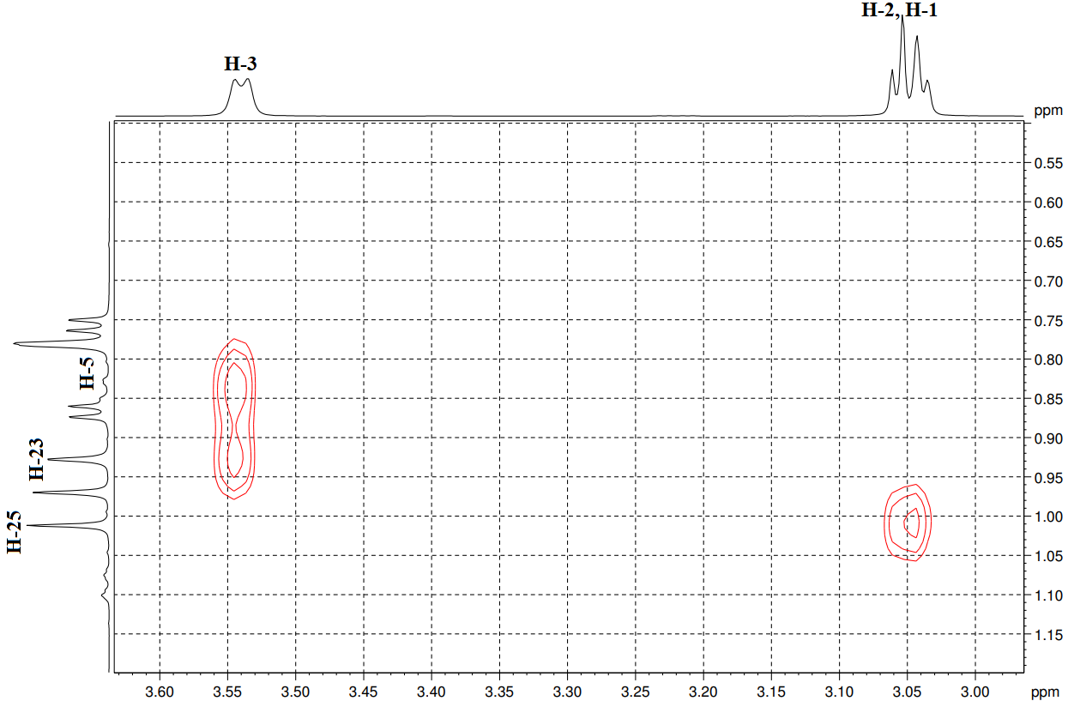

Benzyl 1α,2α-epoxy-3-acetoxylup-20,29-dihydrobetulinate (11).
¹³C NMR spectra (CDCl₃)

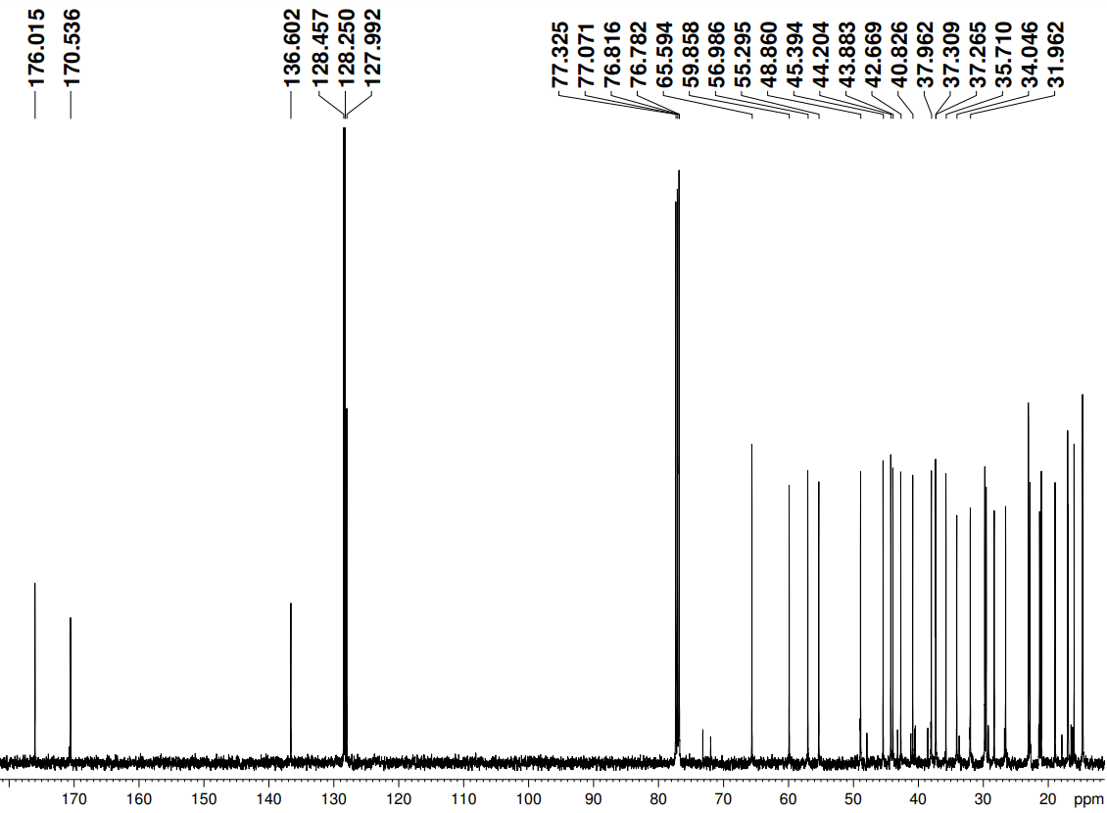

Benzyl 1α,2α-epoxy-3-acetoxylup-20,29-dihydrobetulinate (11).
¹H NMR spectra (CDCl₃)
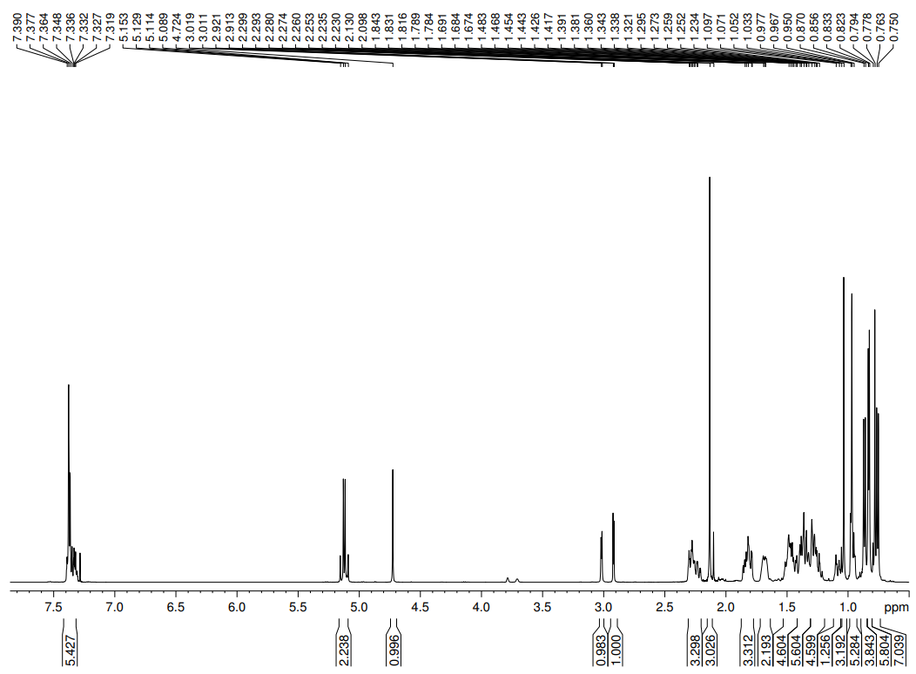

Benzyl 1α,2β,3β-triacetoxylup-20,29-dihydrobetulinate (12).
¹³C NMR spectra (CDCl₃)

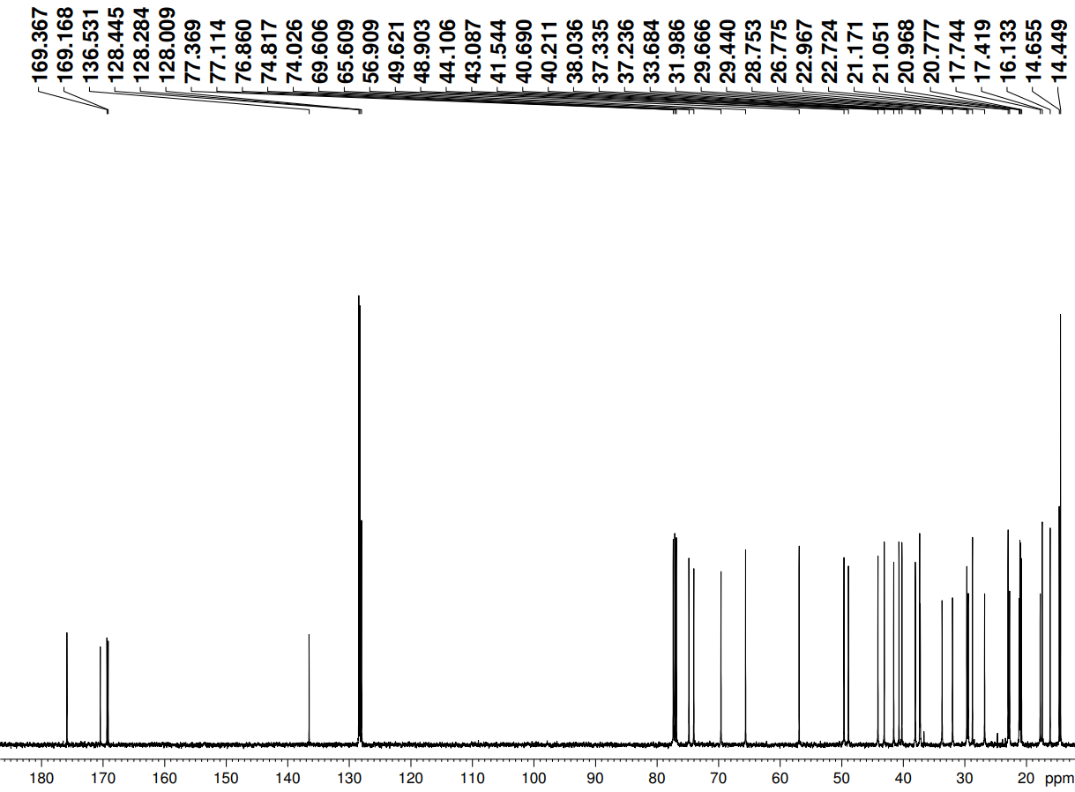

Benzyl 1α,2β,3β-triacetoxylup-20,29-dihydrobetulinate (12).
¹H NMR spectra (CDCl₃)

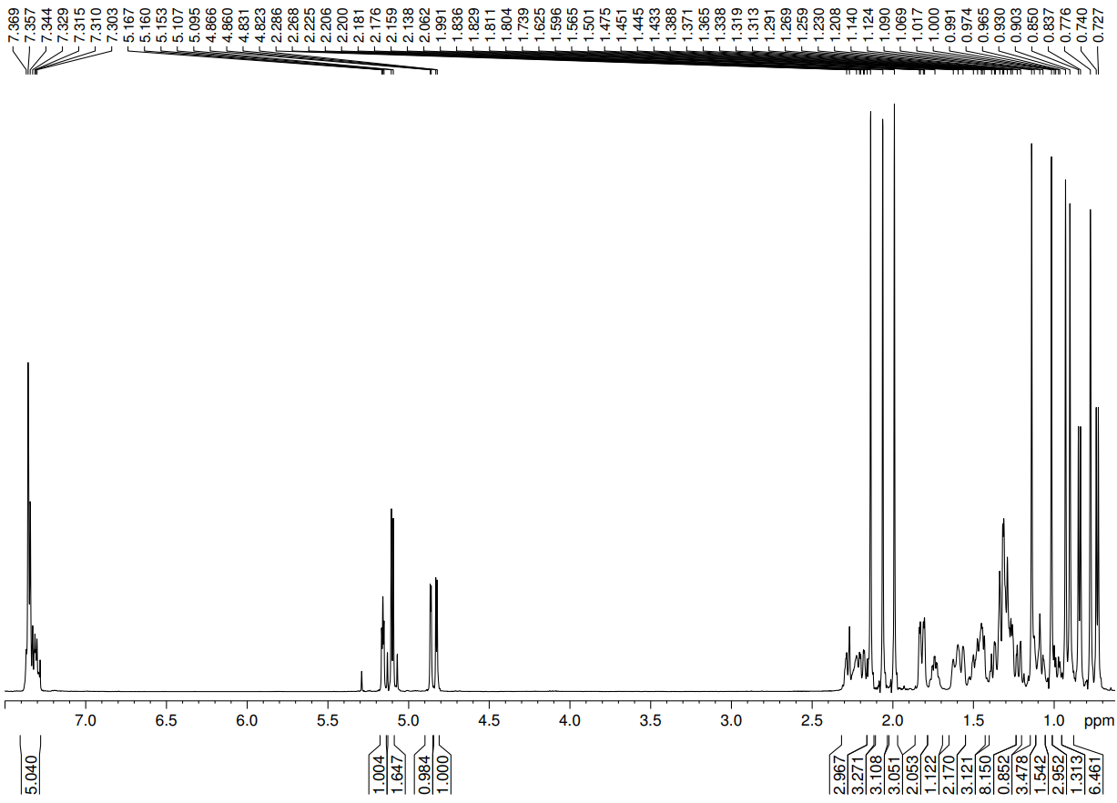

4-Bromobutyl-1α,2β,3β-triacetoxylup-20,29-dihydrobetulinate (13).
¹³C NMR spectra (CDCl₃)

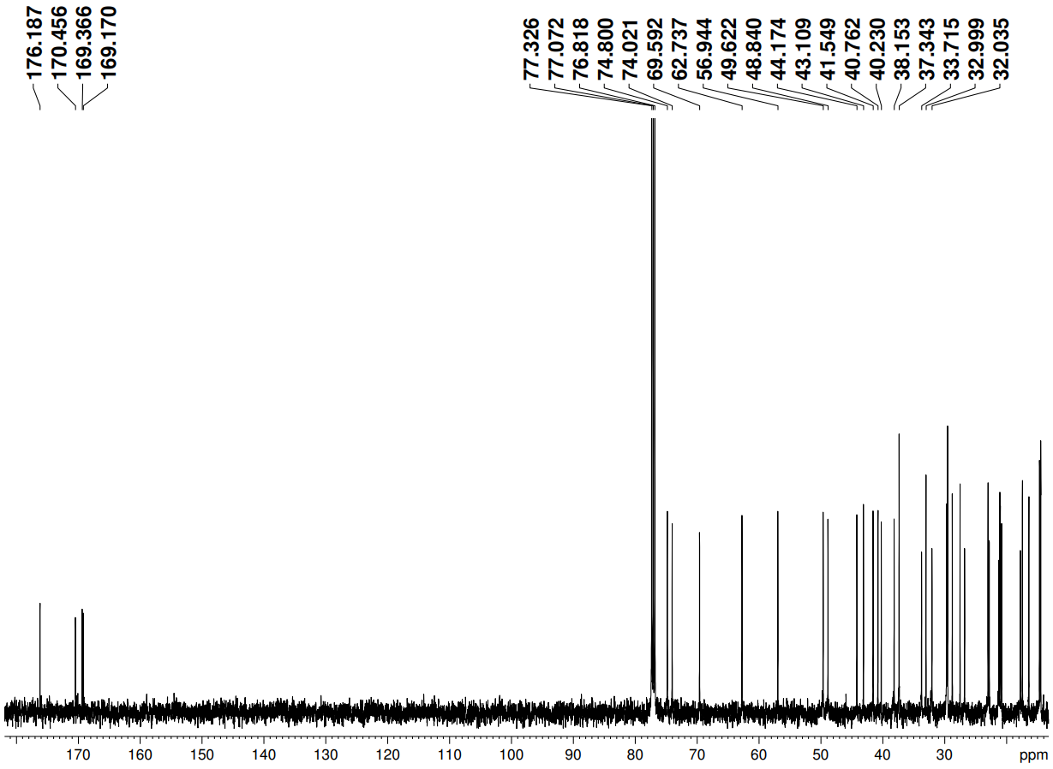

4-Bromobutyl-1α,2β,3β-triacetoxylup-20,29-dihydrobetulinate (13).
¹H NMR spectra (CDCl₃)

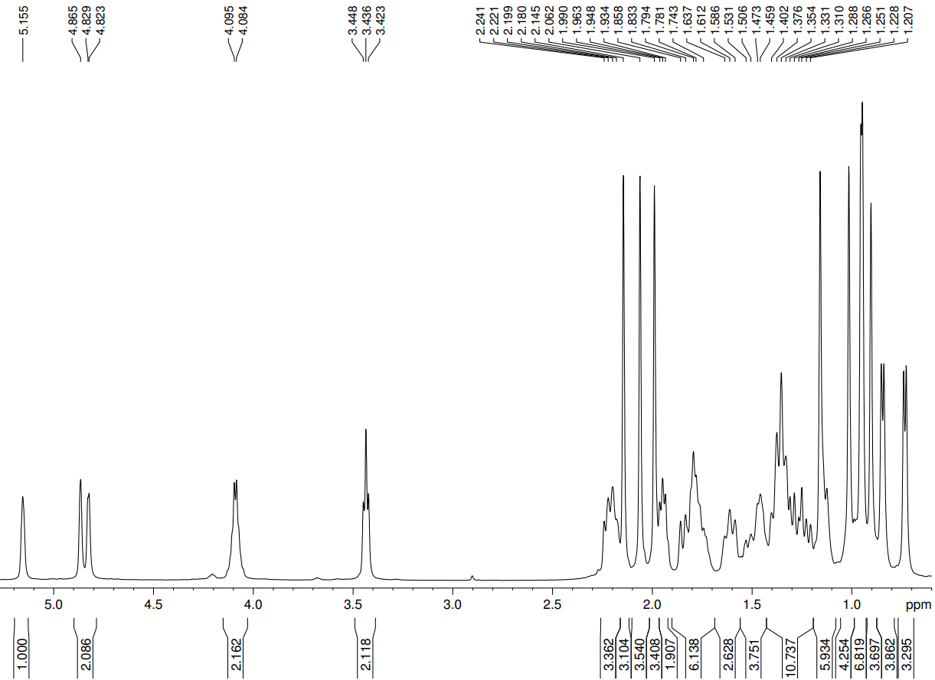

4-Bromobutyl-1α,2β,3β-triacetoxylup-20,29-dihydrobetulinate (13).
HSQC spectra (CDCl₃)

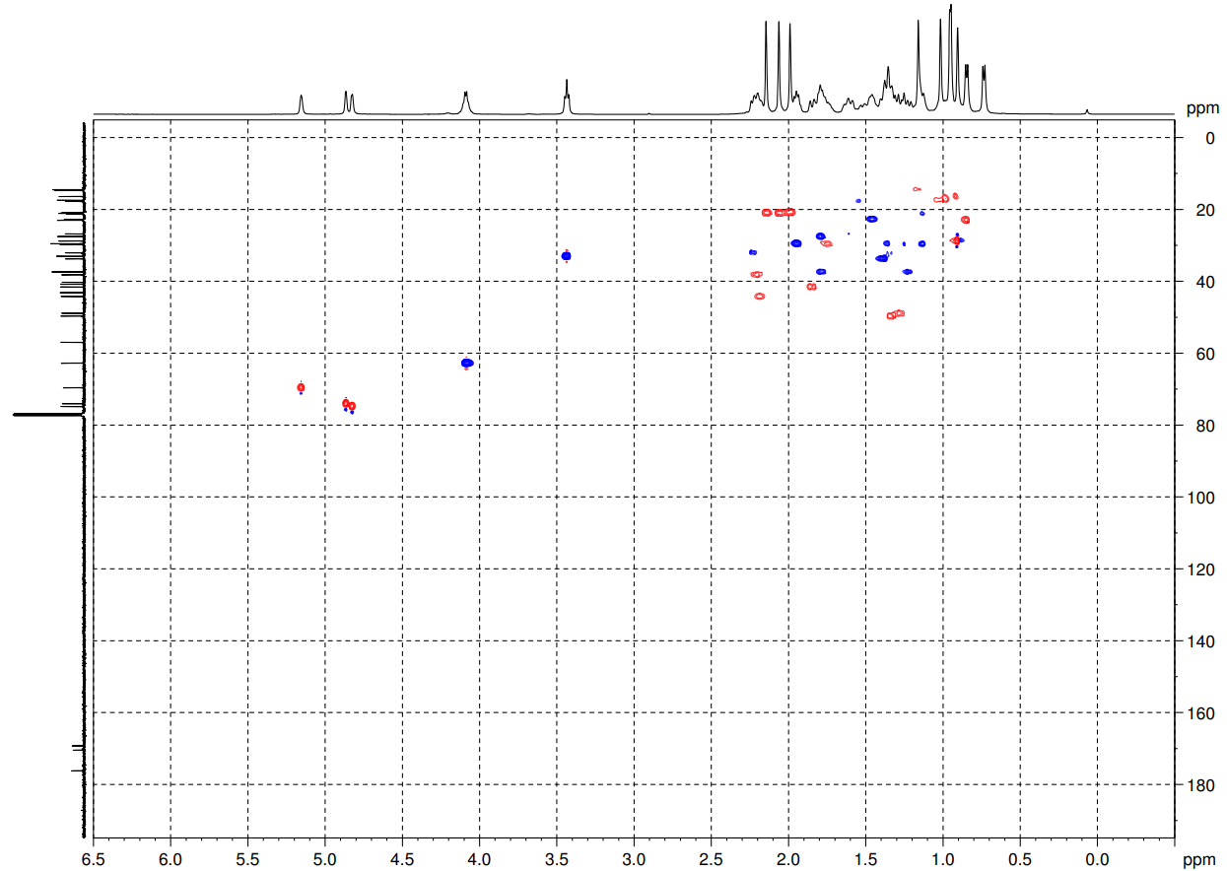

4-Bromobutyl-1α,2β,3β-triacetoxylup-20,29-dihydrobetulinate (13).
HMBC spectra (CDCl₃)
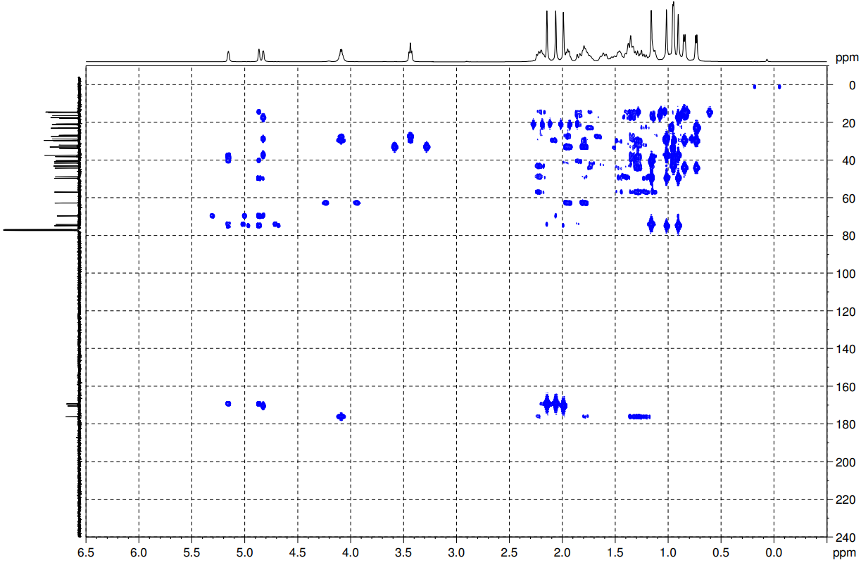

4-Bromobutyl-1α,2β,3β-triacetoxylup-20,29-dihydrobetulinate (13).
¹H-¹H COSY spectra (CDCl₃)
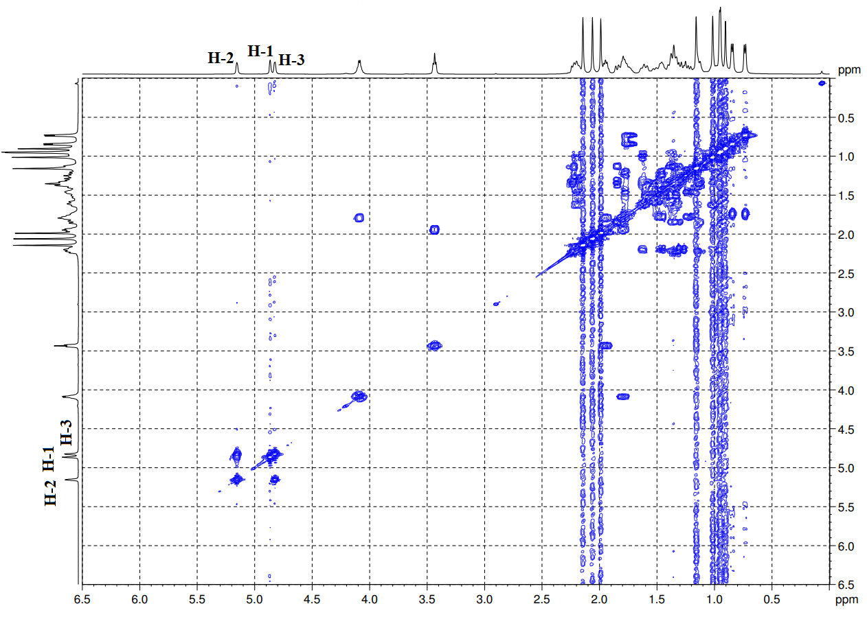

4-Bromobutyl-1α,2β,3β-triacetoxylup-20,29-dihydrobetulinate (13).
NOESY spectra (CDCl₃)
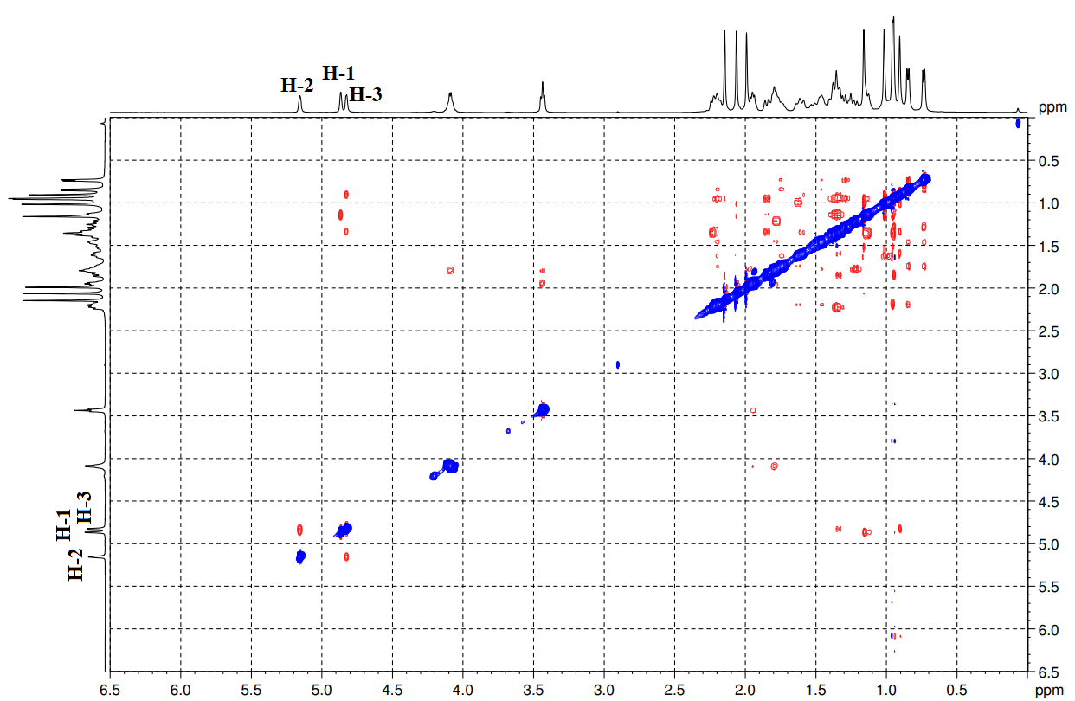
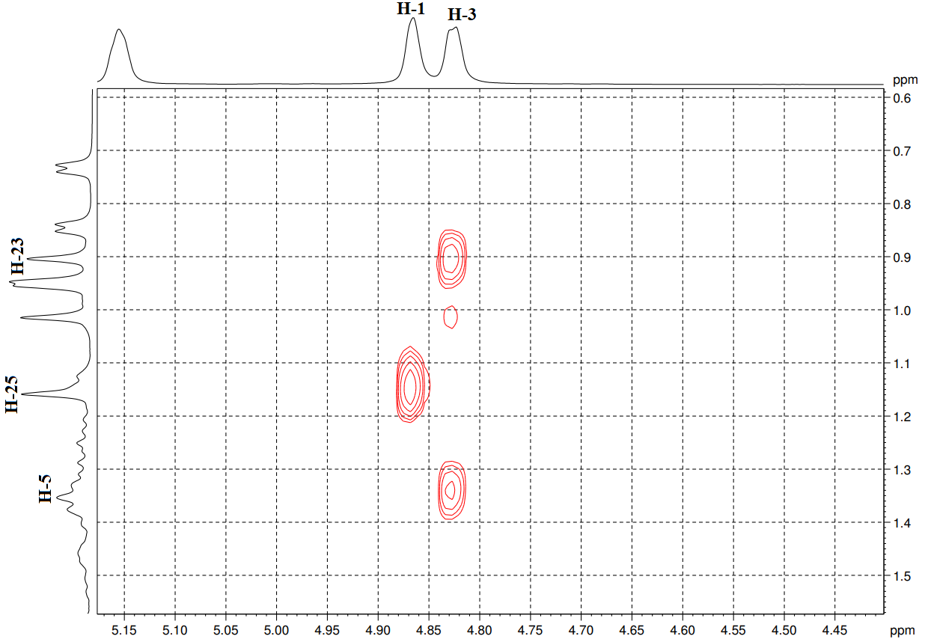

N-{4-[(1α,2β,3β-triacetoxylup-20,29-dihydrobetulinoyl)-butyl]-(E)-4-[2-(1H-indol-3-yl)-vinyl]}pyridinium bromide (14).
¹³C NMR spectra (MeOD/CDCl₃)

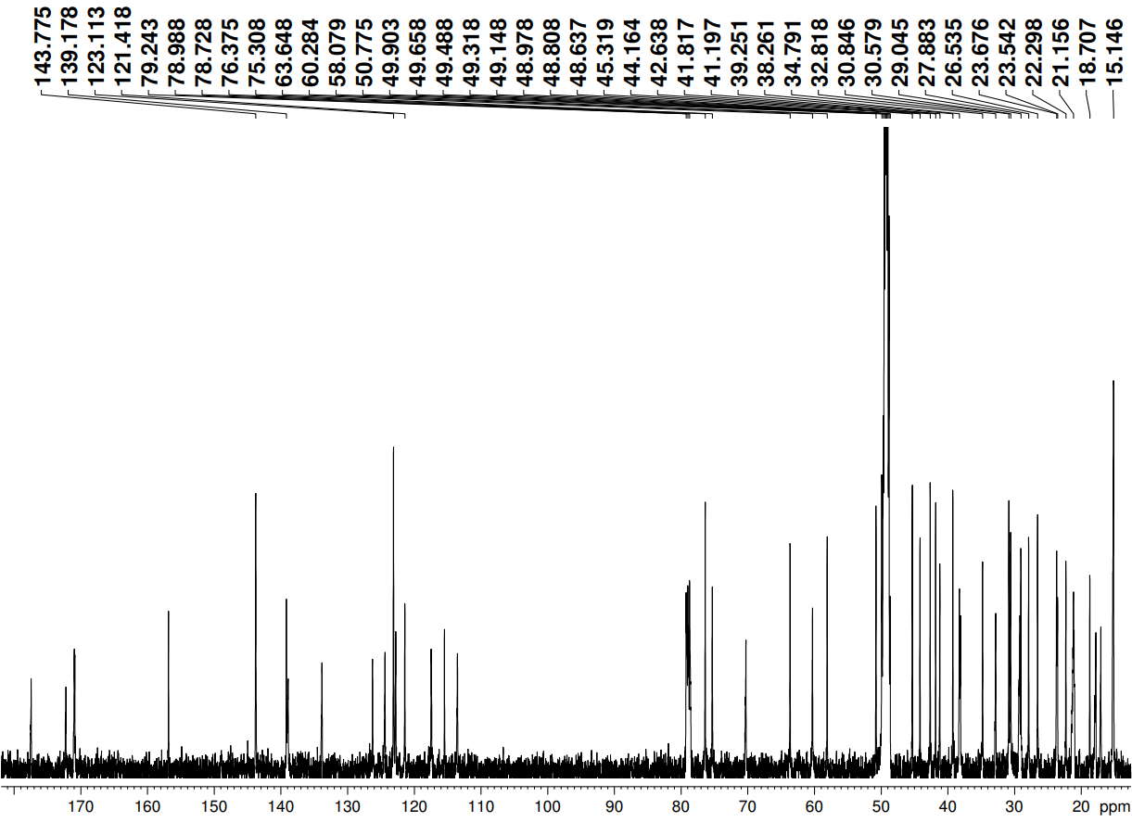

N-{4-[(1α,2β,3β-triacetoxylup-20,29-dihydrobetulinoyl)-butyl]-(E)-4-[2-(1H-indol-3-yl)-vinyl]}pyridinium bromide (14).
¹H NMR spectra (MeOD/CDCl₃)

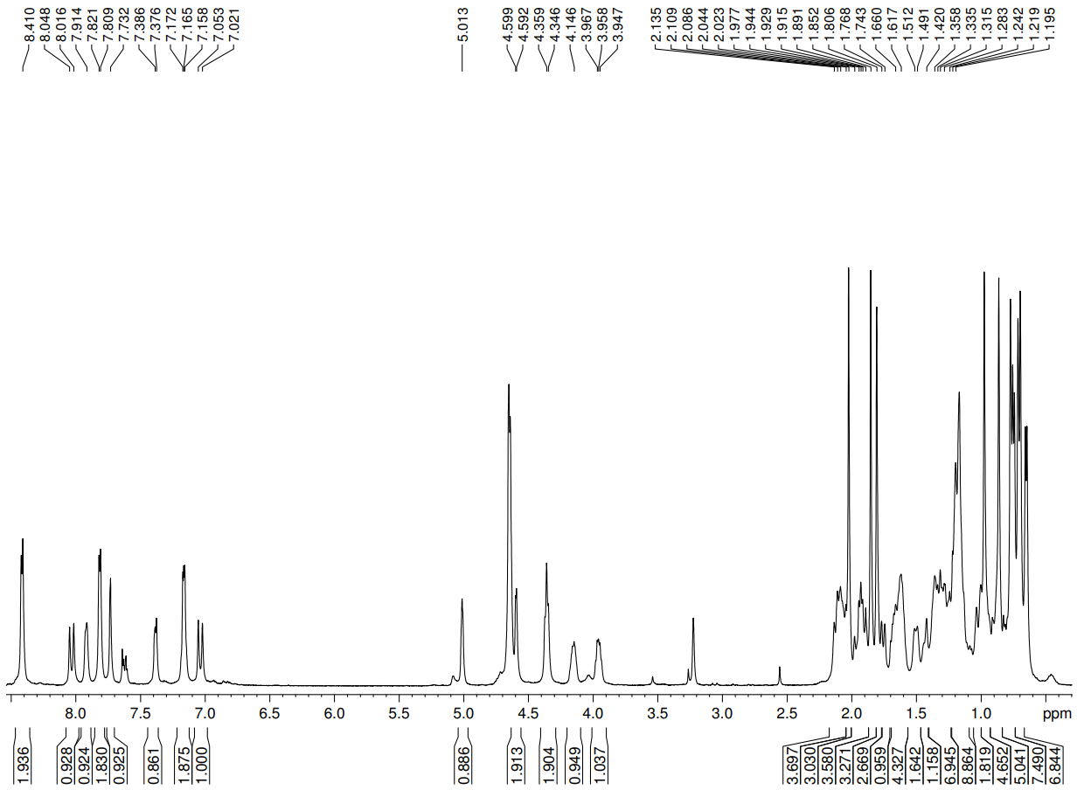

4-Bromobutyl-1α,2β,3β-triacetoxy-urs-12-en-28-oate (17).
¹³C NMR spectra (CDCl₃)
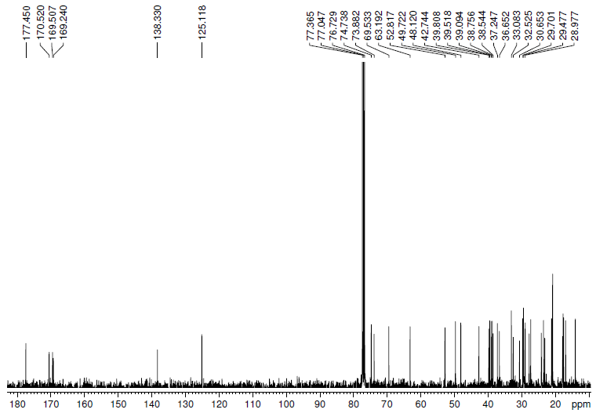

4-Bromobutyl-1α,2β,3β-triacetoxy-urs-12-en-28-oate (17).
¹H NMR spectra (CDCl₃)

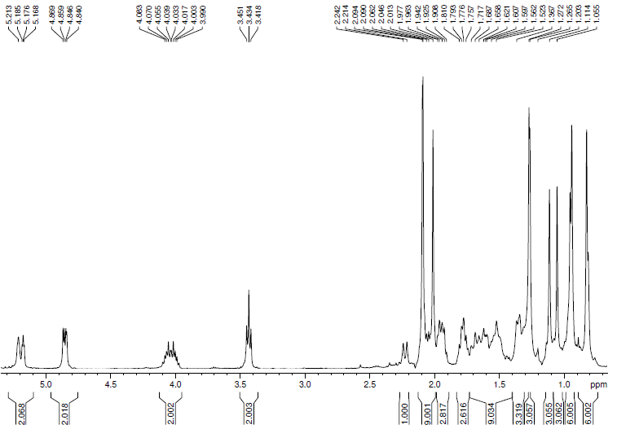

N-{4-[(1α,2β,3β-triacetoxy-urs-12-en-28-oyl)-butyl]-(E)-4-[2-(1H-indol-3-yl)-vinyl]}pyridinium bromide (18).
¹³C NMR spectra (MeOD/CDCl₃)
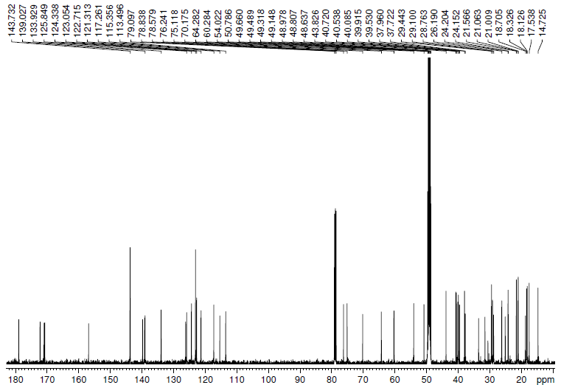

N-{4-[(1α,2β,3β-triacetoxy-urs-12-en-28-oyl)-butyl]-(E)-4-[2-(1H-indol-3-yl)-vinyl]}pyridinium bromide (18).
¹H NMR spectra (MeOD/CDCl₃)
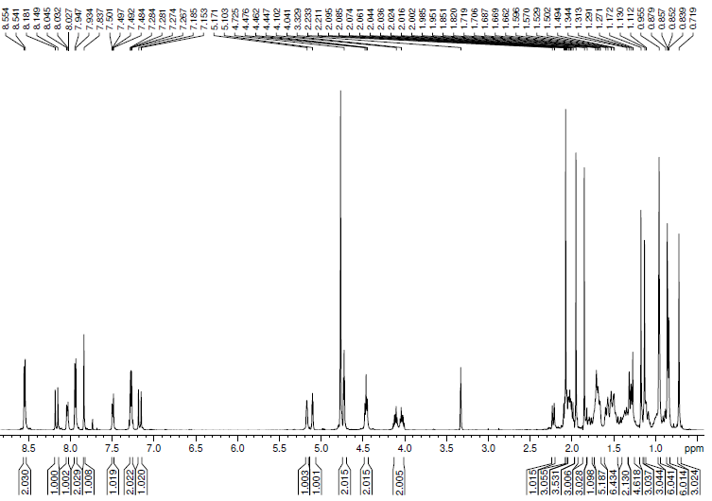

4-Bromobutyl-2α,3β-diacetoxy-olean-12-en-28-oate (25).
¹³C NMR spectra (CDCl₃)
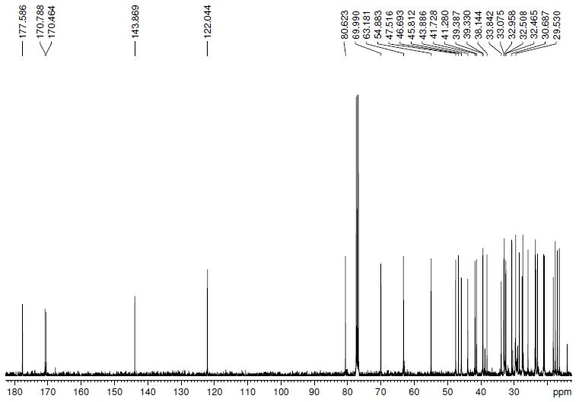

4-Bromobutyl-2α,3β-diacetoxy-olean-12-en-28-oate (25).
¹H NMR spectra (CDCl₃)
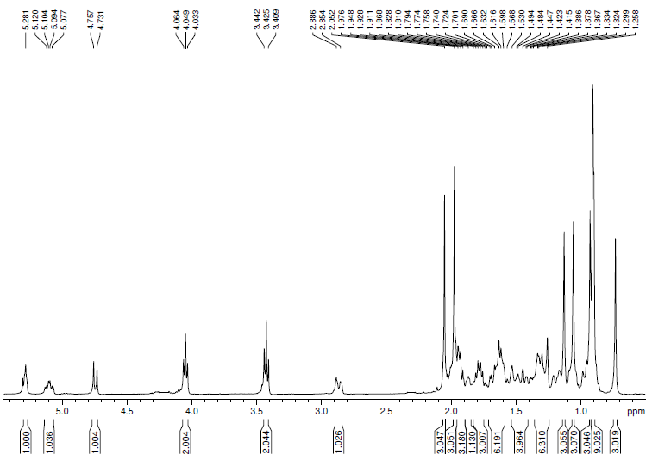

4-Bromobutyl-2α,3β-dihydroxy-olean-12-en-28-oate (25a).
¹³C NMR spectra (CDCl₃)
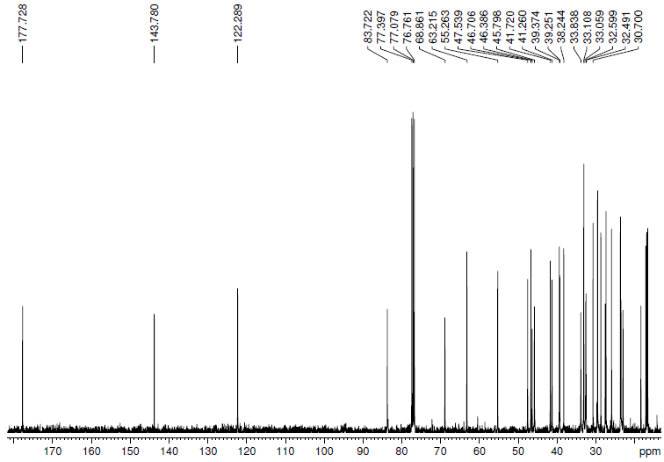

4-Bromobutyl-2α,3β-dihydroxy-olean-12-en-28-oate (25a).
¹H NMR spectra (CDCl₃)
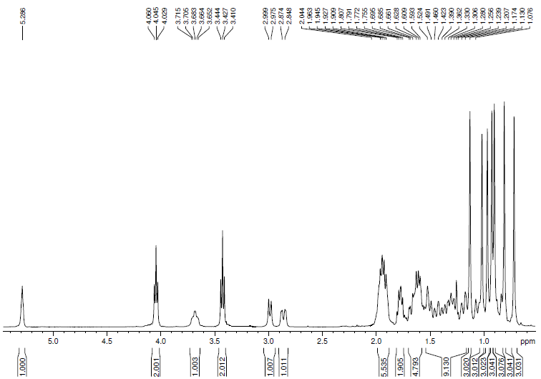

N-{4-[(2α,3β-diacetoxy-olean-12-en-28-oyl)-butyl]-(E)-4-[2-(1H-indol-3-yl)-vinyl]}pyridinium bromide (28).
¹³C NMR spectra (MeOD/CDCl₃)
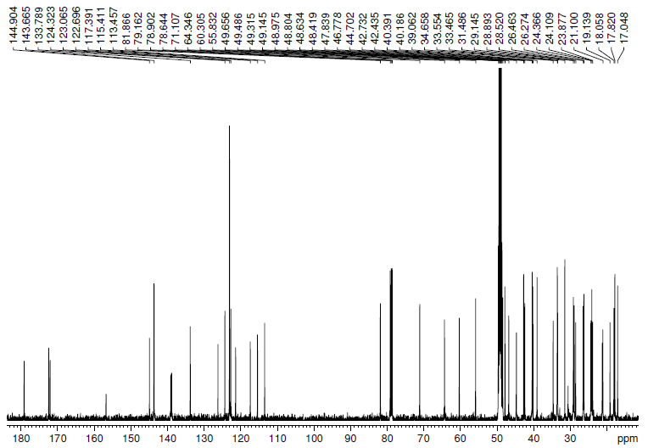

N-{4-[(2α,3β-diacetoxy-olean-12-en-28-oyl)-butyl]-(E)-4-[2-(1H-indol-3-yl)-vinyl]}pyridinium bromide (28).
¹H NMR spectra (MeOD/CDCl₃)
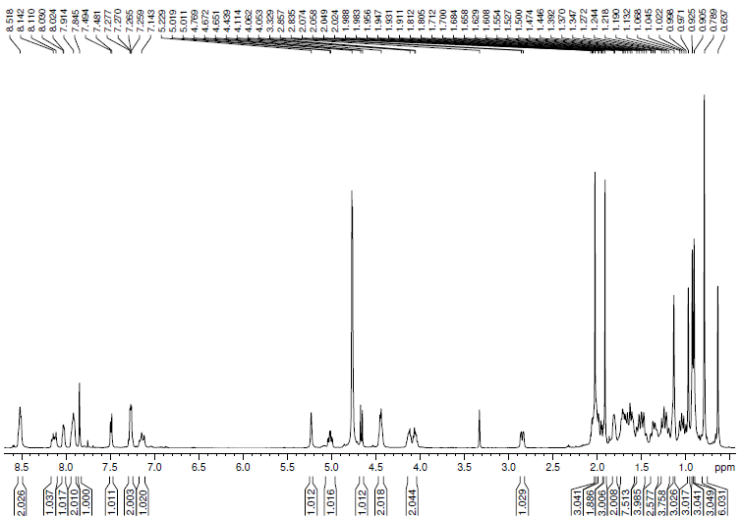

N-{4-[(2α,3β-dihydroxy-olean-12-en-28-oyl)-butyl]-(E)-4-[2-(1H-indol-3-yl)-vinyl]}pyridinium bromide (28a).
¹³C NMR spectra (MeOD/CDCl₃)
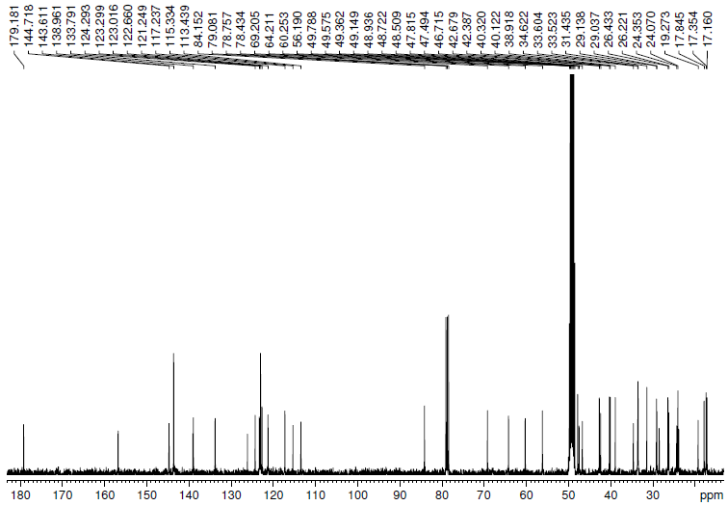

N-{4-[(2α,3β-dihydroxy-olean-12-en-28-oyl)-butyl]-(E)-4-[2-(1H-indol-3-yl)-vinyl]}pyridinium bromide (28a).
¹H NMR spectra (MeOD/CDCl₃)
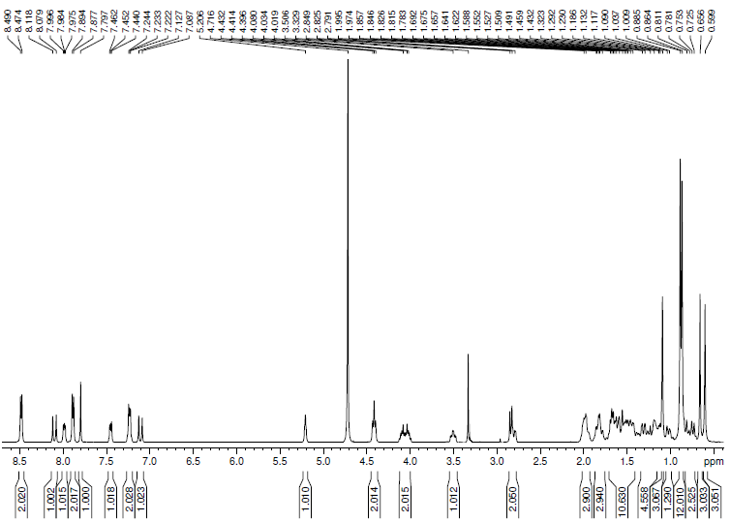

4-Bromobutyl-2α,3β-diacetoxy-urs-12-en-28-oate (26).
¹³C NMR spectra (CDCl₃)
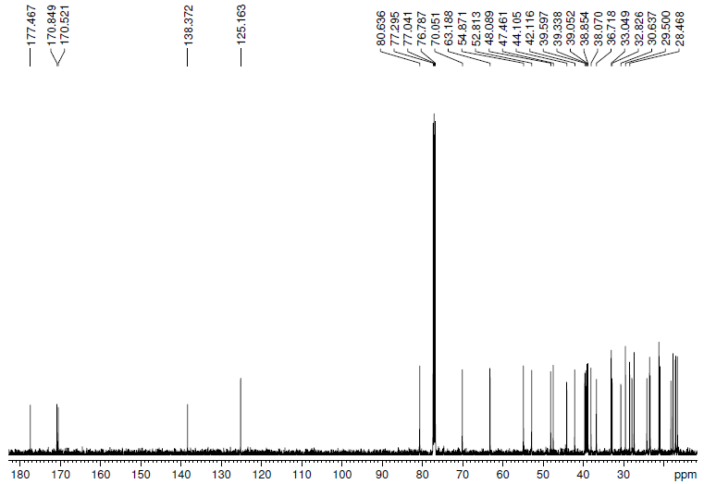

4-Bromobutyl-2α,3β-diacetoxy-urs-12-en-28-oate (26).
¹H NMR spectra (CDCl₃)
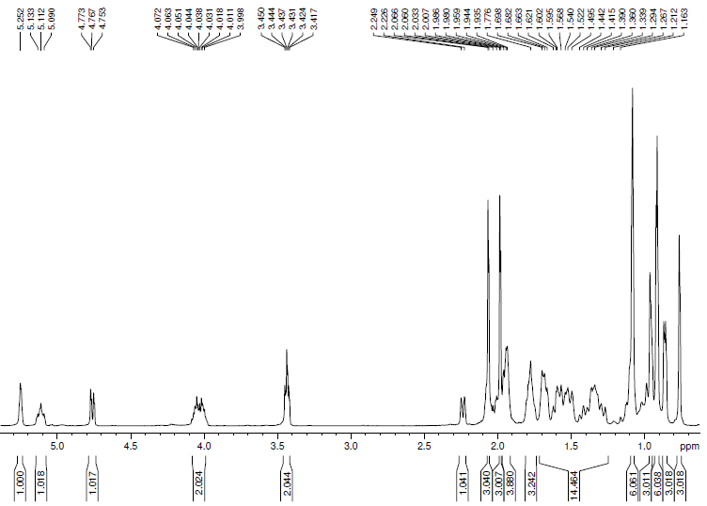

4-Bromobutyl-2α,3β-dihydroxy-urs-12-en-28-oate (26a).
¹³C NMR spectra (CDCl₃)
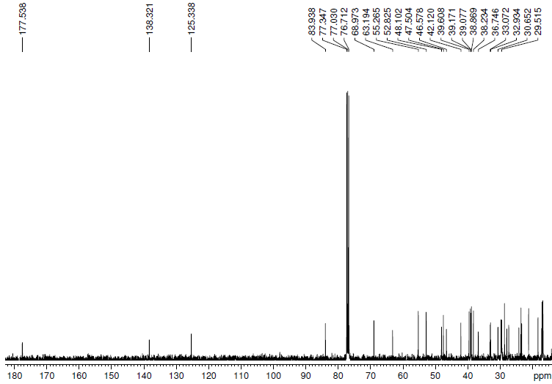

4-Bromobutyl-2α,3β-dihydroxy-urs-12-en-28-oate (26a).
¹H NMR spectra (CDCl₃)
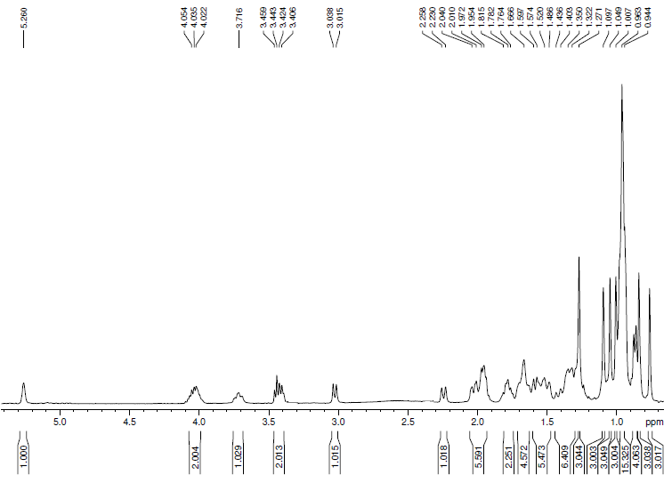

N-{4-[(2α,3β-diacetoxy-urs-12-en-28-oyl)-butyl]-(E)-4-[2-(1H-indol-3-yl)-vinyl]}pyridinium bromide (29).
¹³C NMR spectra (MeOD)
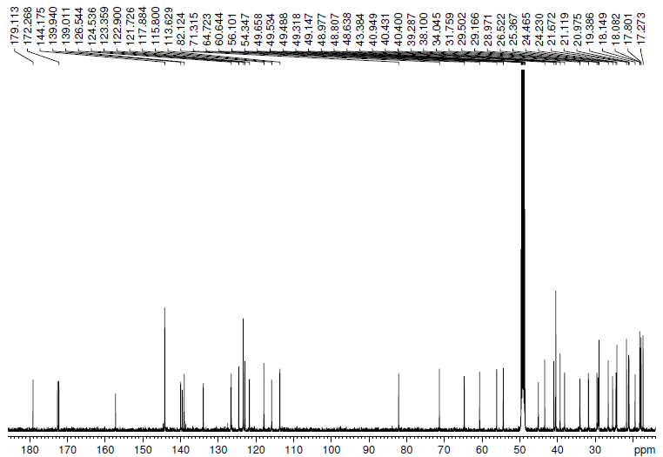

N-{4-[(2α,3β-diacetoxy-urs-12-en-28-oyl)-butyl]-(E)-4-[2-(1H-indol-3-yl)-vinyl]}pyridinium bromide (29).
¹H NMR spectra (MeOD)
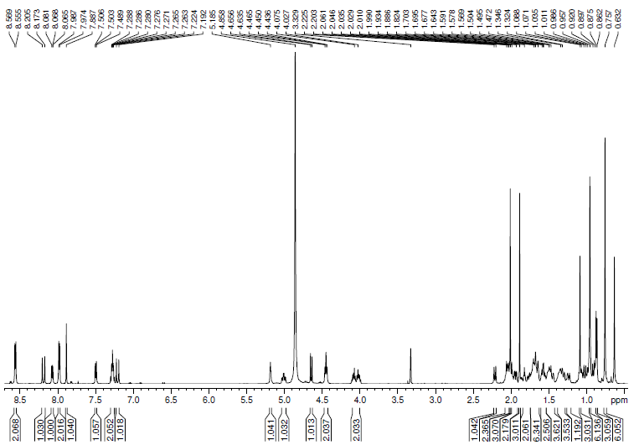

N-{4-[(2α,3β-dihydroxy-urs-12-en-28-oyl)-butyl]-(E)-4-[2-(1H-indol-3-yl)-vinyl]}pyridinium bromide (29a).
¹³C NMR spectra (MeOD)
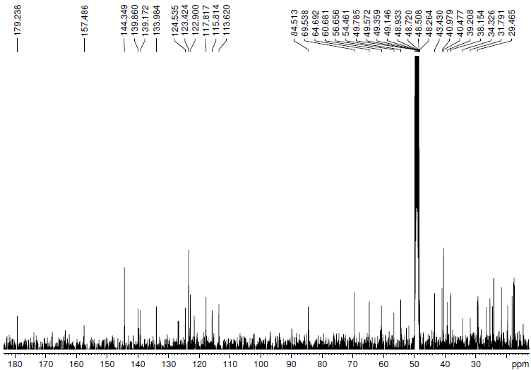

N-{4-[(2α,3β-dihydroxy-urs-12-en-28-oyl)-butyl]-(E)-4-[2-(1H-indol-3-yl)-vinyl]}pyridinium bromide (29a).
¹H NMR spectra (MeOD)
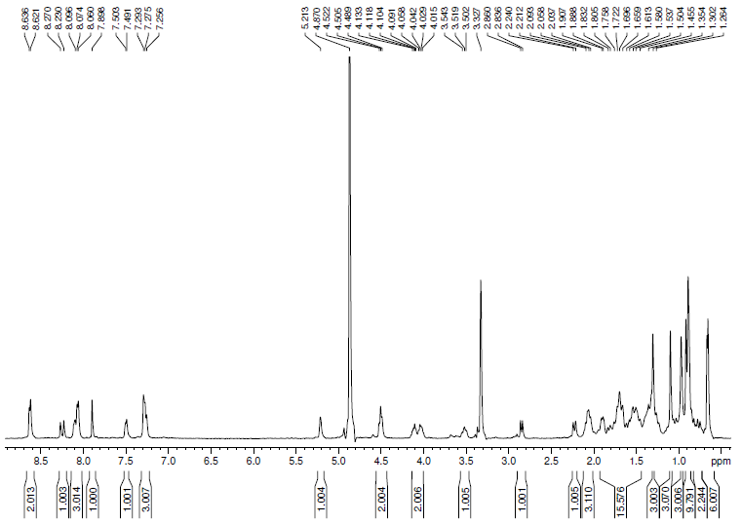

4-Bromobutyl-2α,3α-diacetoxy-urs-12-en-28-oate (27).
¹³C NMR spectra (CDCl₃)
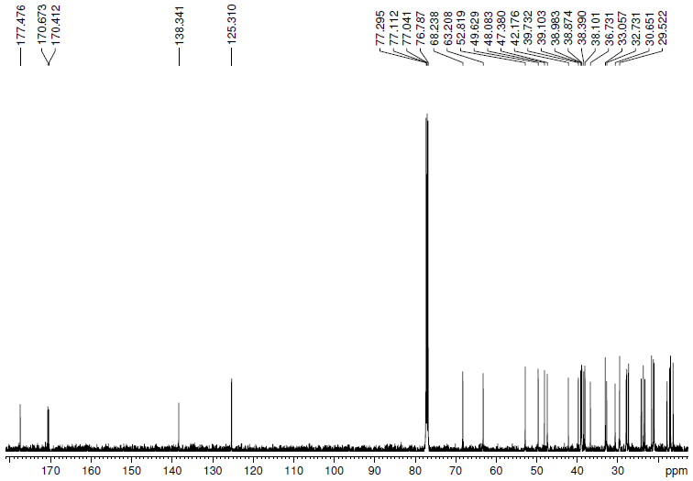

4-Bromobutyl-2α,3α-diacetoxy-urs-12-en-28-oate (27).
¹H NMR spectra (CDCl₃)
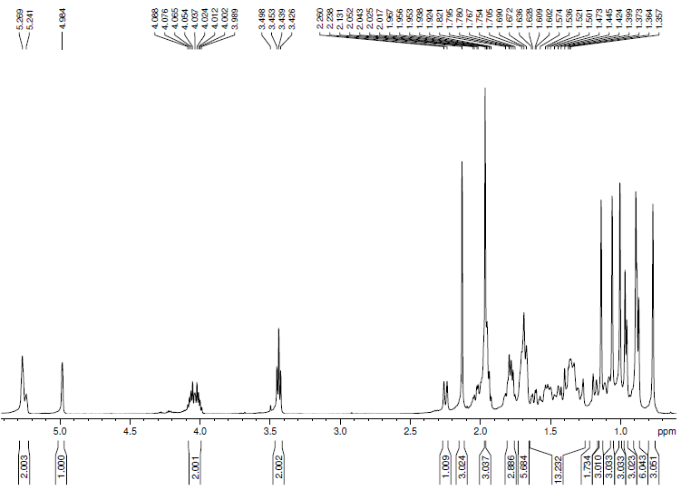

N-{4-[(2α,3α-diacetoxy-urs-12-en-28-oyl)-butyl]-(E)-4-[2-(1H-indol-3-yl)-vinyl]}pyridinium bromide (30).
¹³C NMR spectra (MeOD/CDCl₃)
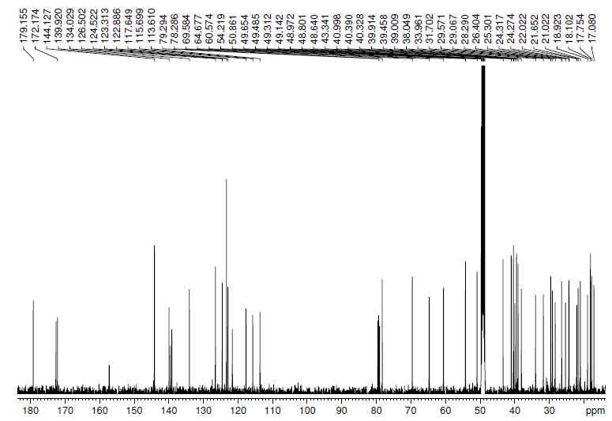

N-{4-[(2α,3α-diacetoxy-urs-12-en-28-oyl)-butyl]-(E)-4-[2-(1H-indol-3-yl)-vinyl]}pyridinium bromide (30).
¹H NMR spectra (MeOD/CDCl₃)
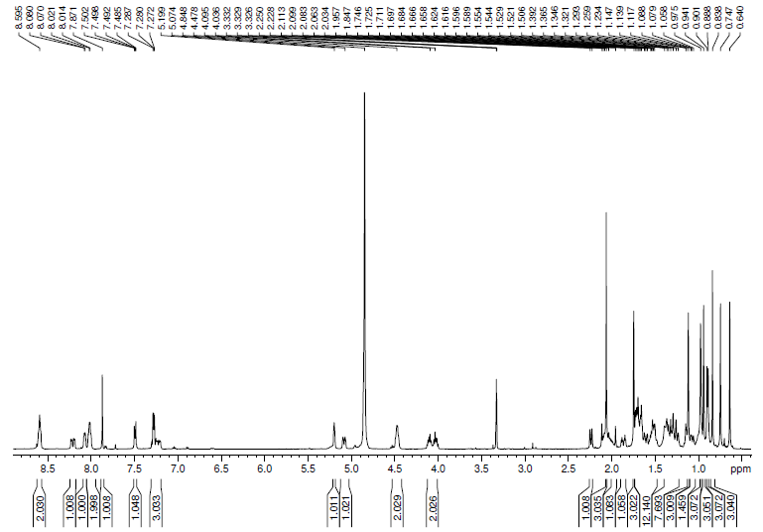

4-Bromobutyl-2α,3β,23-triacetoxy-urs-12-en-28-oate (32).
¹³C NMR spectra (CDCl₃)
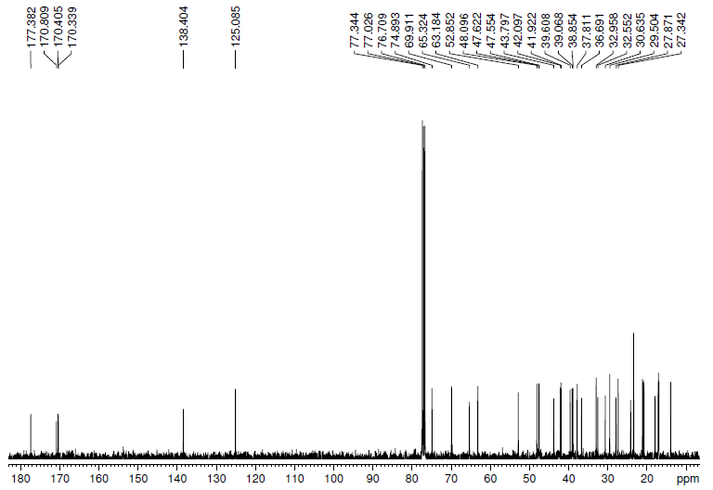

4-Bromobutyl-2α,3β,23-triacetoxy-urs-12-en-28-oate (32).
¹H NMR spectra (CDCl₃)
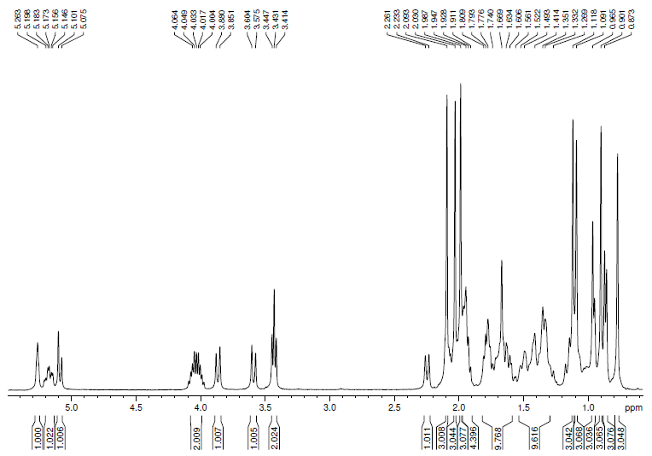

4-Bromobutyl-2α,3β,23-trihydroxy-urs-12-en-28-oate (32a).
¹³C NMR spectra (CDCl₃)

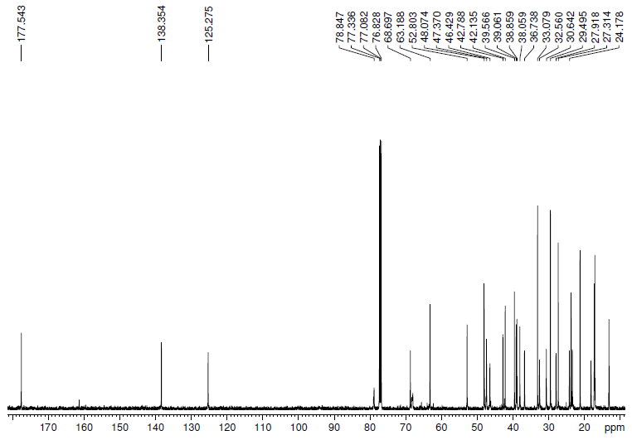

4-Bromobutyl-2α,3β,23-trihydroxy-urs-12-en-28-oate (32a).
¹H NMR spectra (CDCl₃)
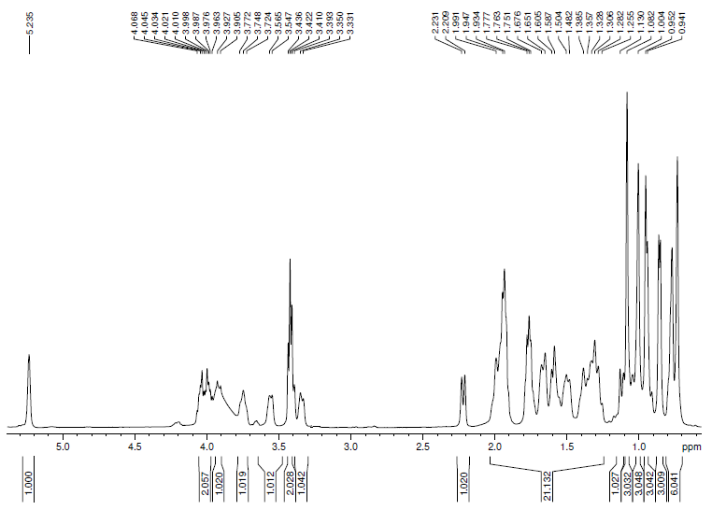

N-{4-[(2α,3β,23-triacetoxy-urs-12-en-28-oyl)-butyl]-(E)-4-[2-(1H-indol-3-yl)-vinyl]}pyridinium bromide (33).
¹³C NMR spectra (MeOD)
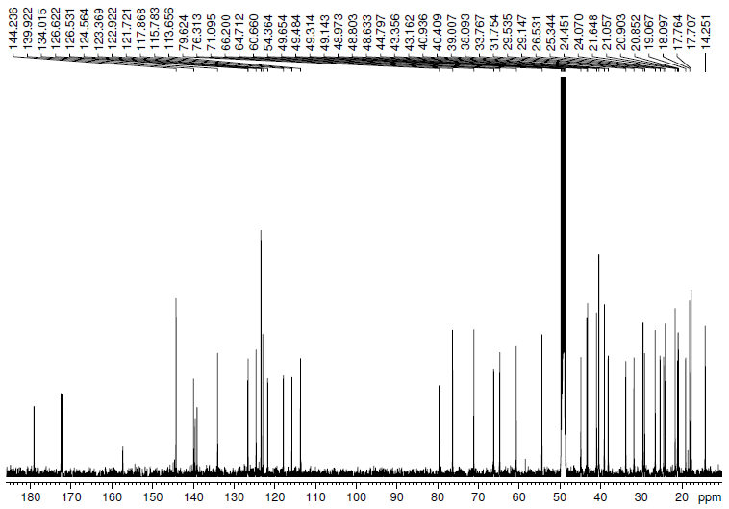

N-{4-[(2α,3β,23-triacetoxy-urs-12-en-28-oyl)-butyl]-(E)-4-[2-(1H-indol-3-yl)-vinyl]}pyridinium bromide (33).
¹H NMR spectra (MeOD)
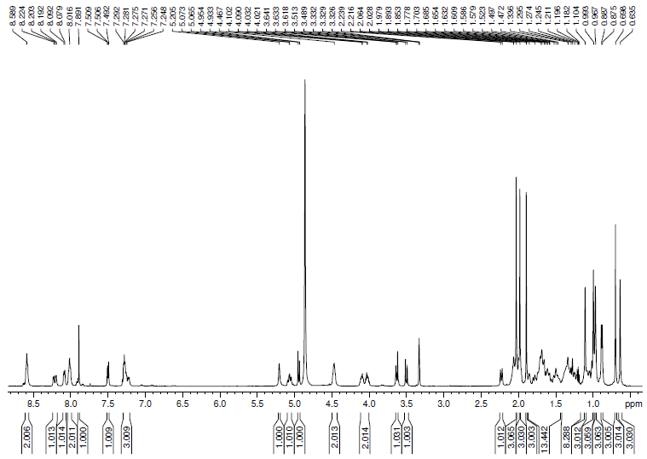

N-{4-[(2α,3β,23-trihydroxy-urs-12-en-28-oyl)-butyl]-(E)-4-[2-(1H-indol-3-yl)-vinyl]}pyridinium bromide (33a).
¹³C NMR spectra (MeOD)
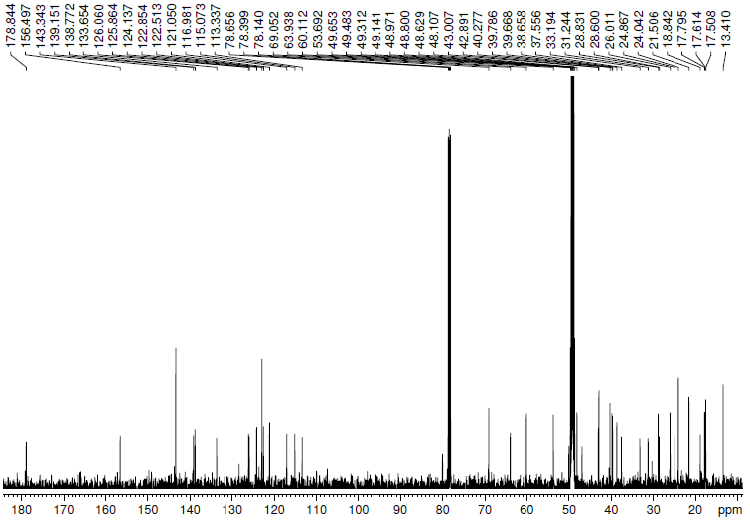

N-{4-[(2α,3β,23-trihydroxy-urs-12-en-28-oyl)-butyl]-(E)-4-[2-(1H-indol-3-yl)-vinyl]}pyridinium bromide (33a).
¹H NMR spectra (MeOD)
