500 Wh/kg Class High-Areal-Capacity Lithium Metal Pouch Cell Enabled by Practical Polymer Protective Layer
Yangyang Fengª, Yong Li^{b}*, Jing Linª, Lei Zhuª, Xiang Zhangª, Linlin Zhangª, Chuan-Fu Sunª,
Maoxiang Wuª, Yaobing Wang^{acd}*

ªCAS Key Laboratory of Design and Assembly of Functional Nanostructures, and Fujian Provincial Key Laboratory of Nanomaterials, State Key Laboratory of Structural Chemistry, Fujian Institute of Research on the Structure of Matter, Chinese Academy of Sciences; Fuzhou 350002, Fujian, P. R. China.
^{b}Fujian Science and Technology Innovation Laboratory for Optoelectronic Information of China; Fuzhou 350108, Fujian, P. R. China.
^{c}University of Chinese Academy of Sciences; Beijing 100049, P. R. China.
^{d}State Key Laboratory of Space Power-Sources Technology, Shanghai Institute of Space Power-Sources, Shanghai 200000, China
*Correspondence: wangyb@fjirsm.ac.cn (Yaobing Wang); ydx1112@126.com (Yong Li)

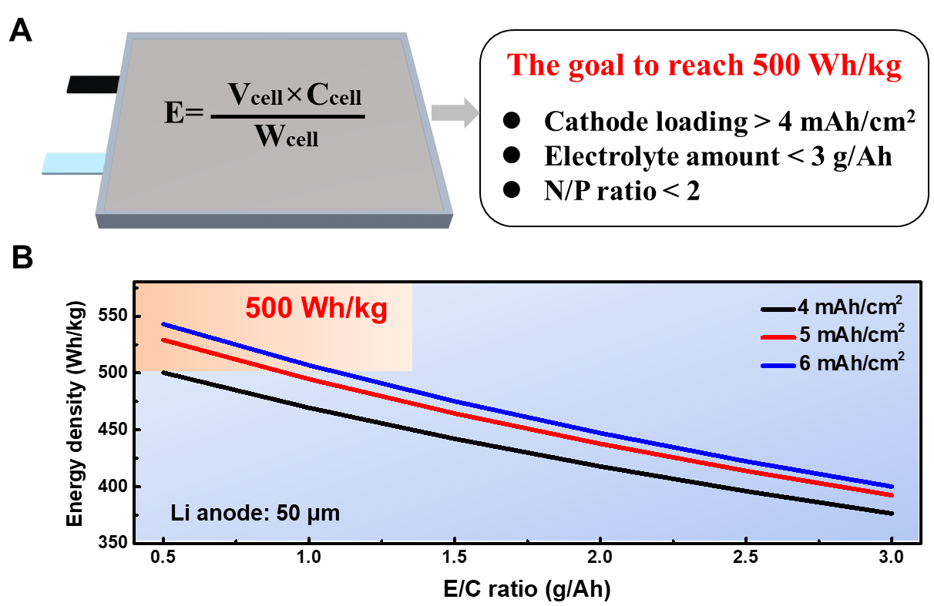
Figure S1. The pivotal paraments to achieve 500 Wh/kg. A) Schematic diagram of pouch cell under practical conditions with ultrathin Li anode, lean electrolytes, and high-loading cathode. B) The energy density calculated by different electrolyte dosage with the cathode loading of 4, 5 ,6 mAh/cm². The other cell parameters are kept the same as that in Fig. S3.

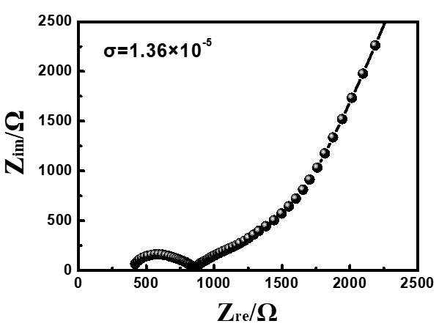
Figure S2. Nyquist impedance plots for SS|PHS |SS.

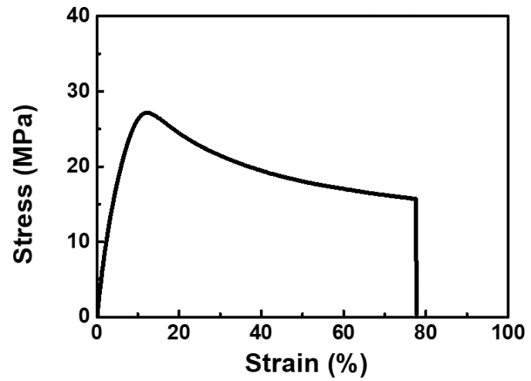
Figure S3. Stress-strain curve of PHEA. The PHEA film achieves ~77% strain before fracture.

Figure S4. Schematic diagram of the fabrication of PHS via a traditional free radical polymerization. The ratios of m and n are 3:7, 4:6, 5:5, 6:4 and 7:3.

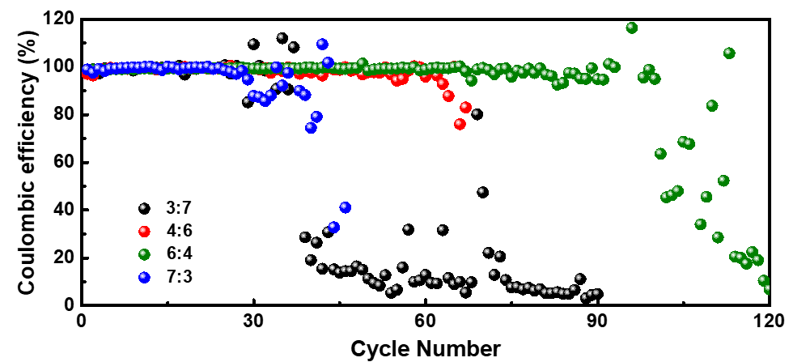
Figure S5. Cycling performance of Li|PHS-Cu asymmetric cells with various PHEA/PS ratio of 3:7, 4:6, 6:4 and 7:3 under 6 mAh/cm² at 1 mA/cm² with the same amount of electrolyte of 70 uL. These results show that the electrochemical performance is better when the PHEA/PS ratio close to 1, indicating the equal importance of PHEA and PS as one can provide soft property and one can enhance the conductivity.

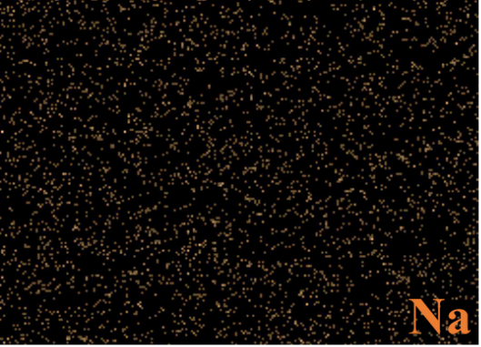
Figure S6. EDS elemental mapping of PHS-Cu for Na element.

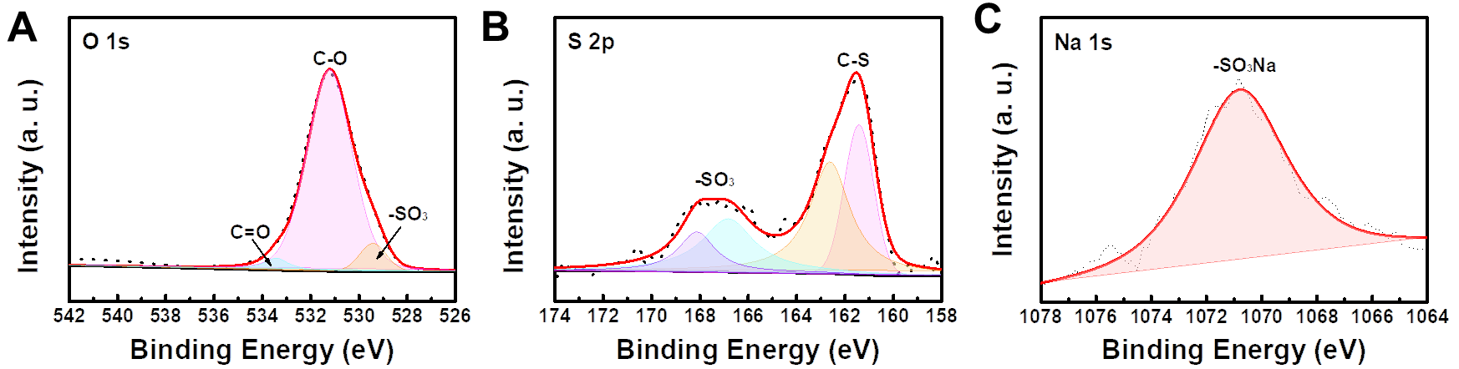
Figure S7. XPS spectrum of A) O 1s, B) S 2p and C) Na 1s for PHS-Cu.

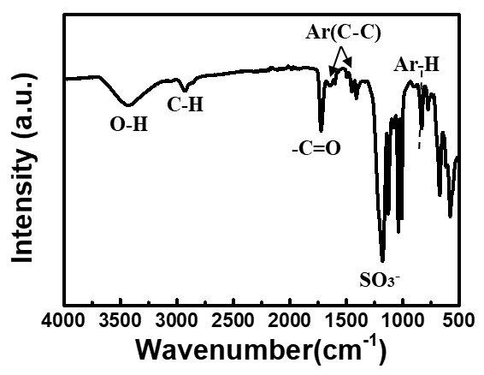
Figure S8. FTIR spectrum of PHS-Cu.

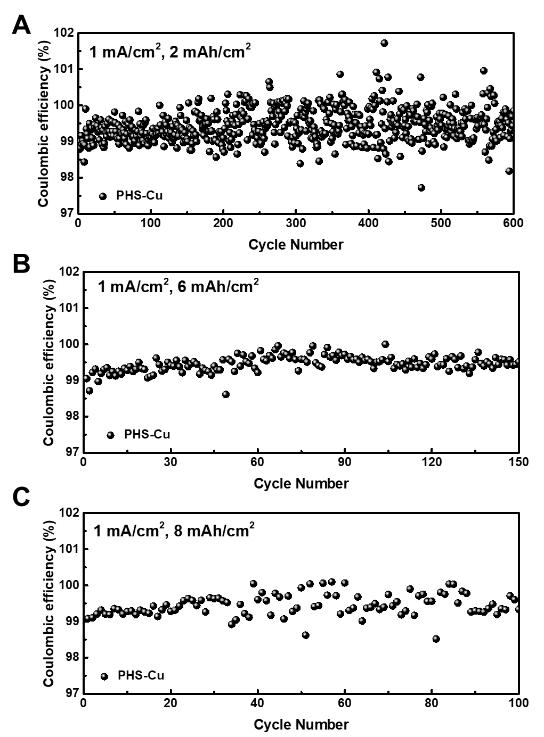
Figure S9. Cycling performances of Li|PHS-Cu asymmetric cells under various capacity of A) 2, B) 6, C) 8 mAh/cm² at 1 mA/cm² with enlarged Y-axis.

Figure S10. Cycling performances of Li|PHS-Cu asymmetric cells under 2 mAh/cm² at 2 mA/cm² with enlarged Y-axis.

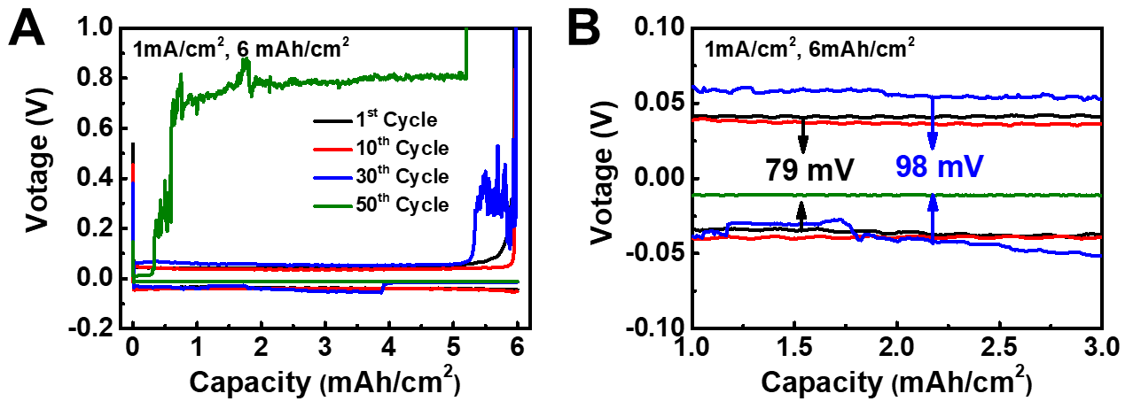
Figure S11. Voltage profiles of Li|Cu asymmetric cell with 1 mA/cm² under 6 mAh/cm².

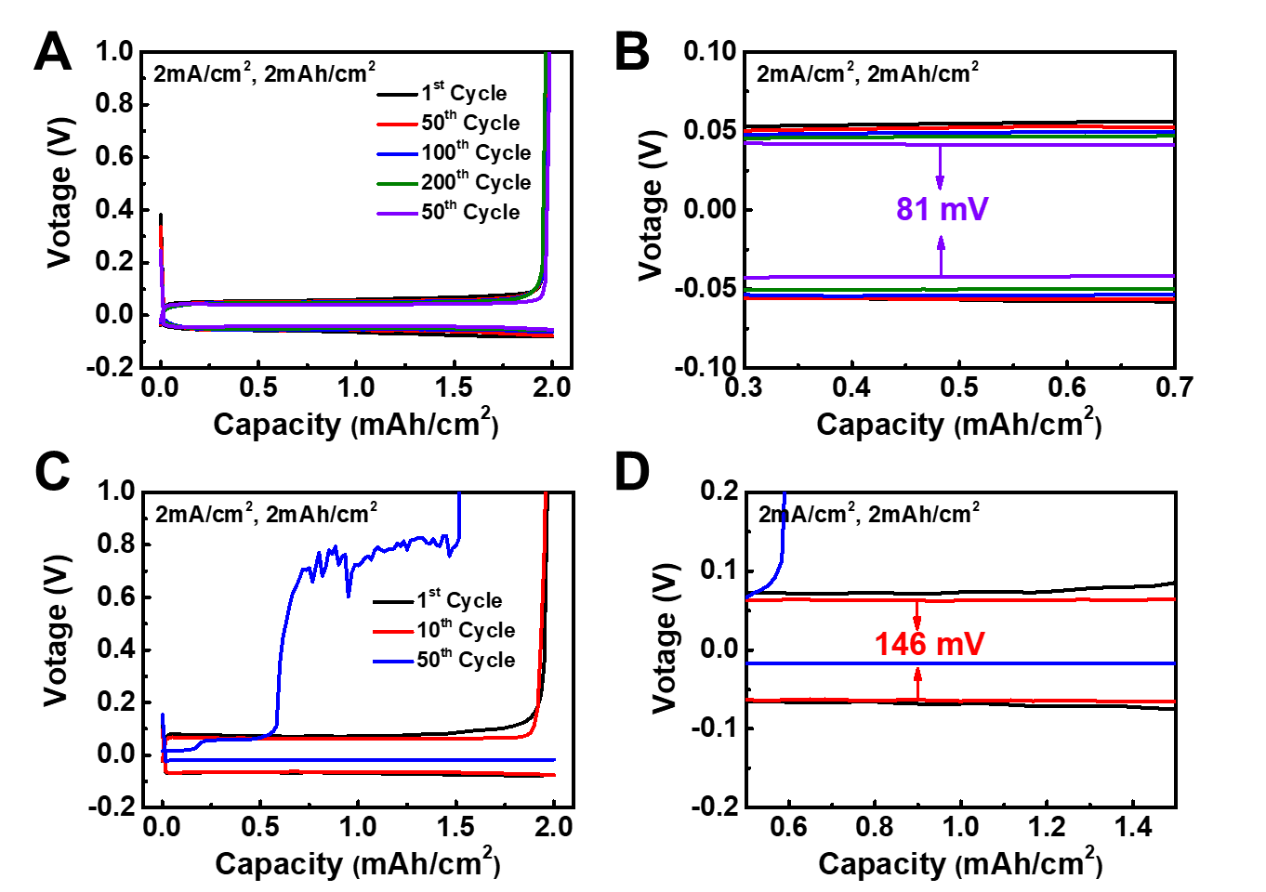
Figure S12. Voltage profiles of A-B) Li|PHS-Cu and C-D) Li|Cu asymmetric cell with 2 mAh/cm² under 2 mA/cm².

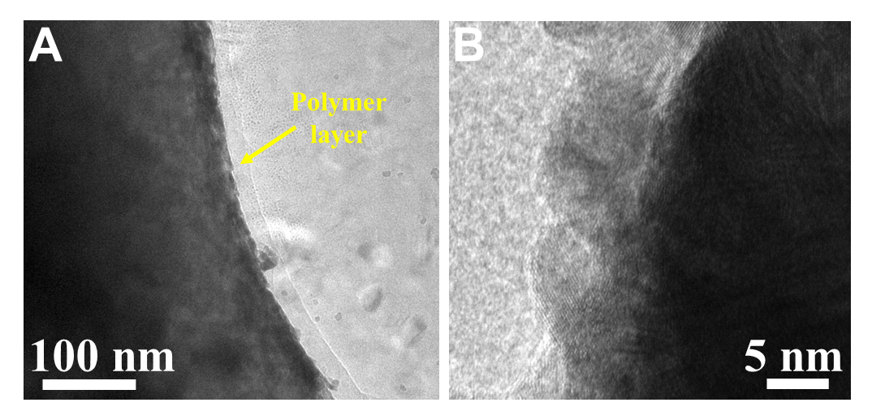
Figure S13. A) Low-resolution Cryo-TEM image of PHS-Cu after plating for 6 mAh/cm² at 1 mA/cm². B) Cryo-TEM image of Fig. 4A without labels.

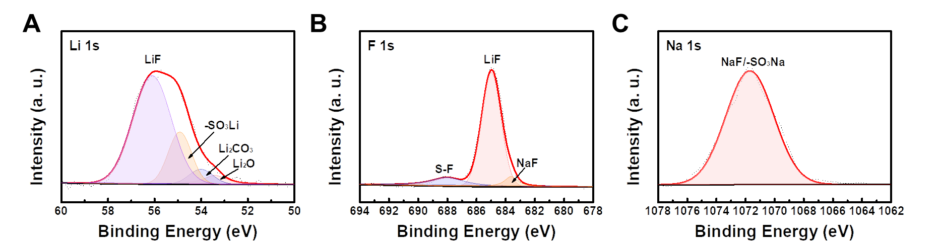
Figure S14. XPS spectra of A) Li 1s, B) F 1s and C) Na 1s for PHS-Cu after 1st cycle under 6 mAh/cm² at 1 mA/cm².

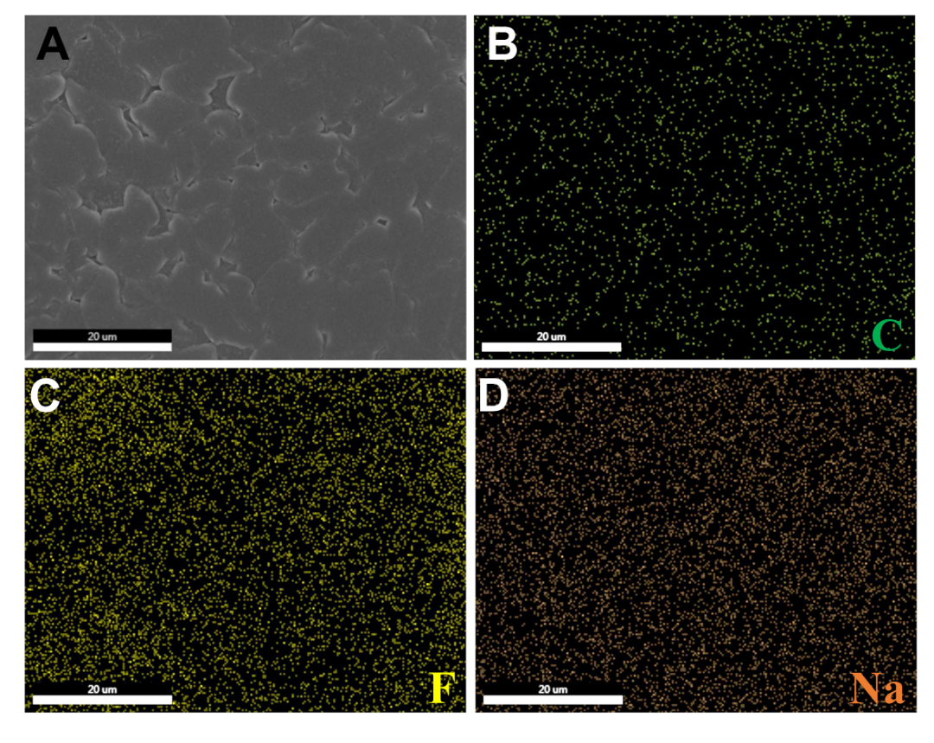
Figure S15. EDS elemental mapping of PHS-Cu after 20 cycles.

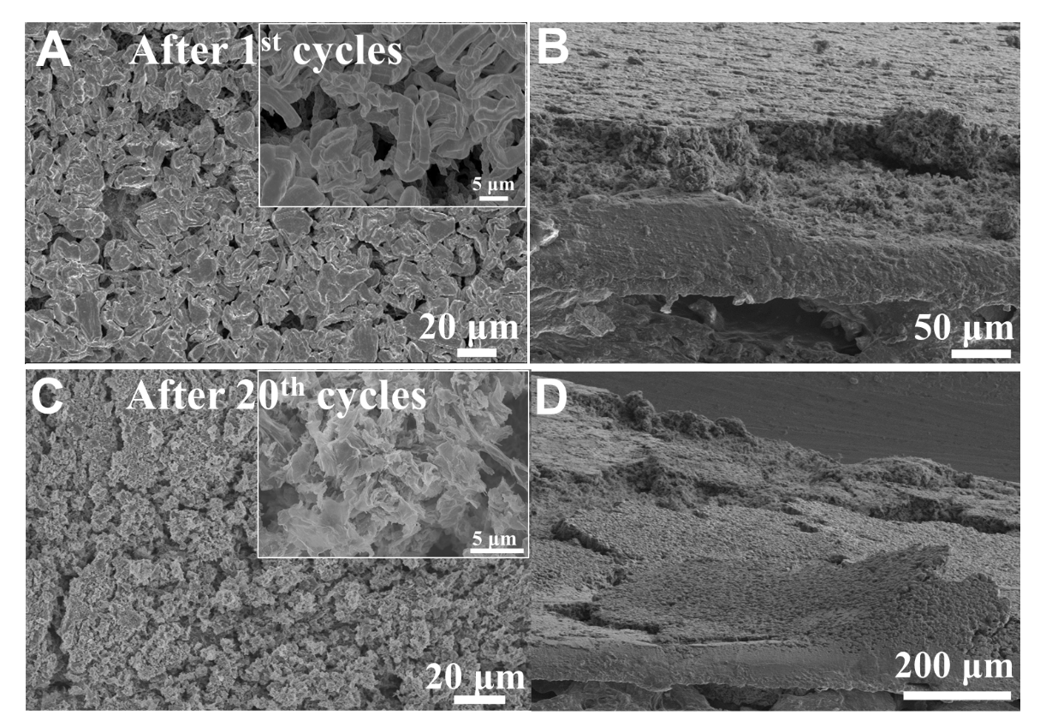
Figure S16. Lithium plating behavior of Bare Cu. A,C) SEM images and B, D) Cross-sectional SEM images of Bare Cu at the plating process after A-B) 1st and C-D) 20th cycles at the current density of 1 mA/cm² with areal capacity of 6 mAh/cm².

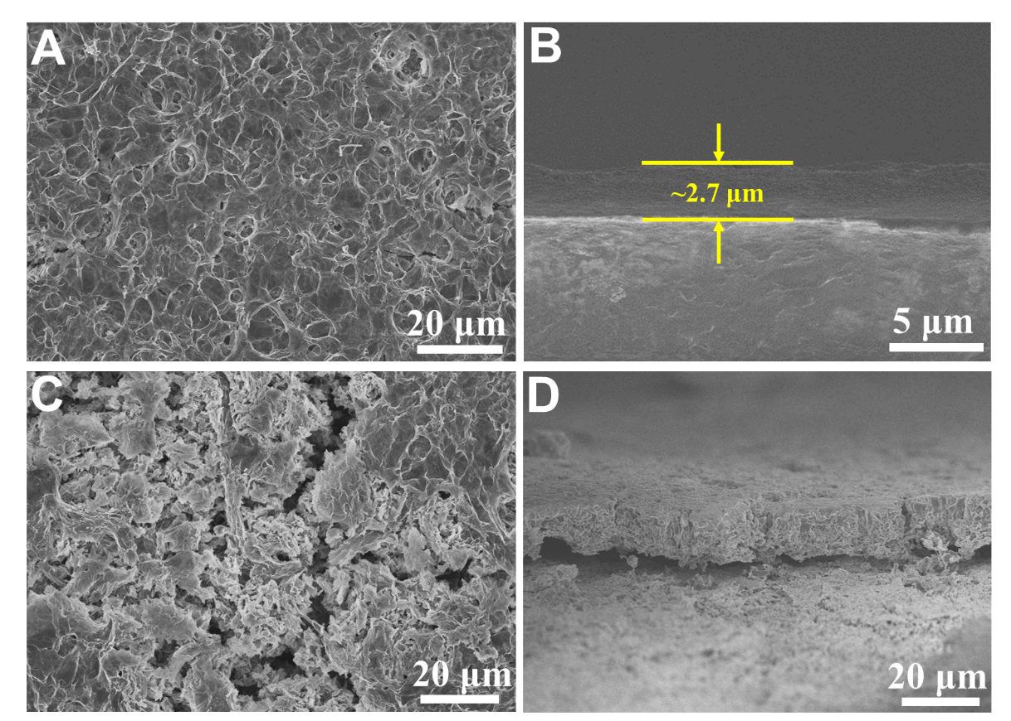
Figure S17. SEM images of A-B) PHS-Cu and C-D) Bare Cu after plating/stripping at 1 mA/cm² with 6 mAh/cm² for 1st cycle.

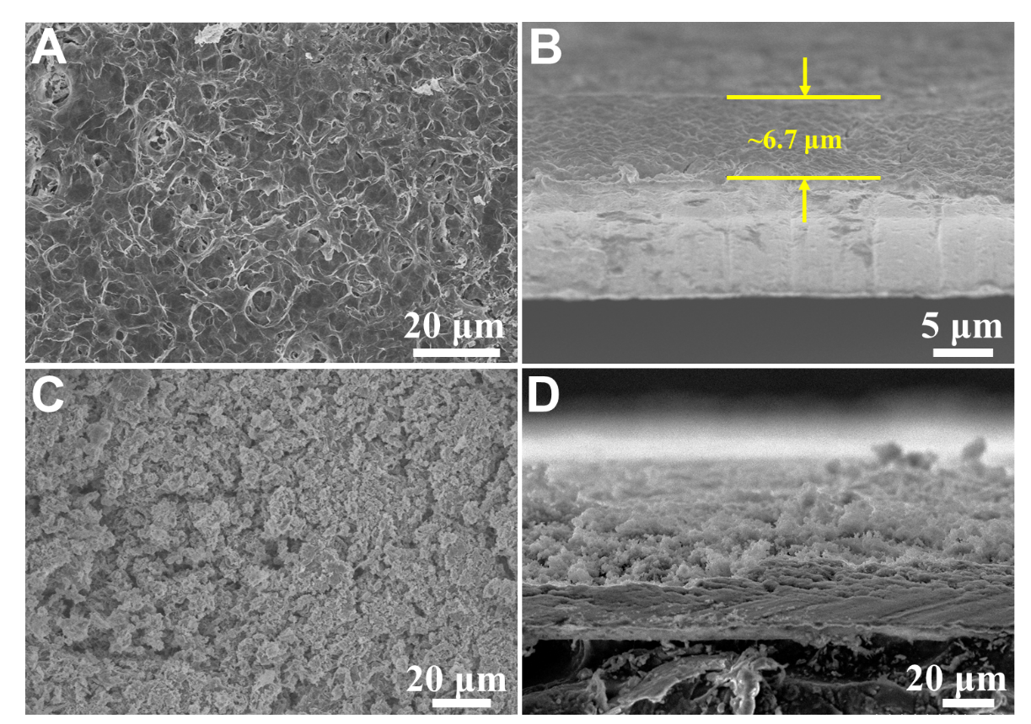
Figure S18. SEM images of A-B) PHS-Cu and C-D) Bare Cu after plating/stripping at 1 mA/cm² with 6 mAh/cm² for 20 cycles.

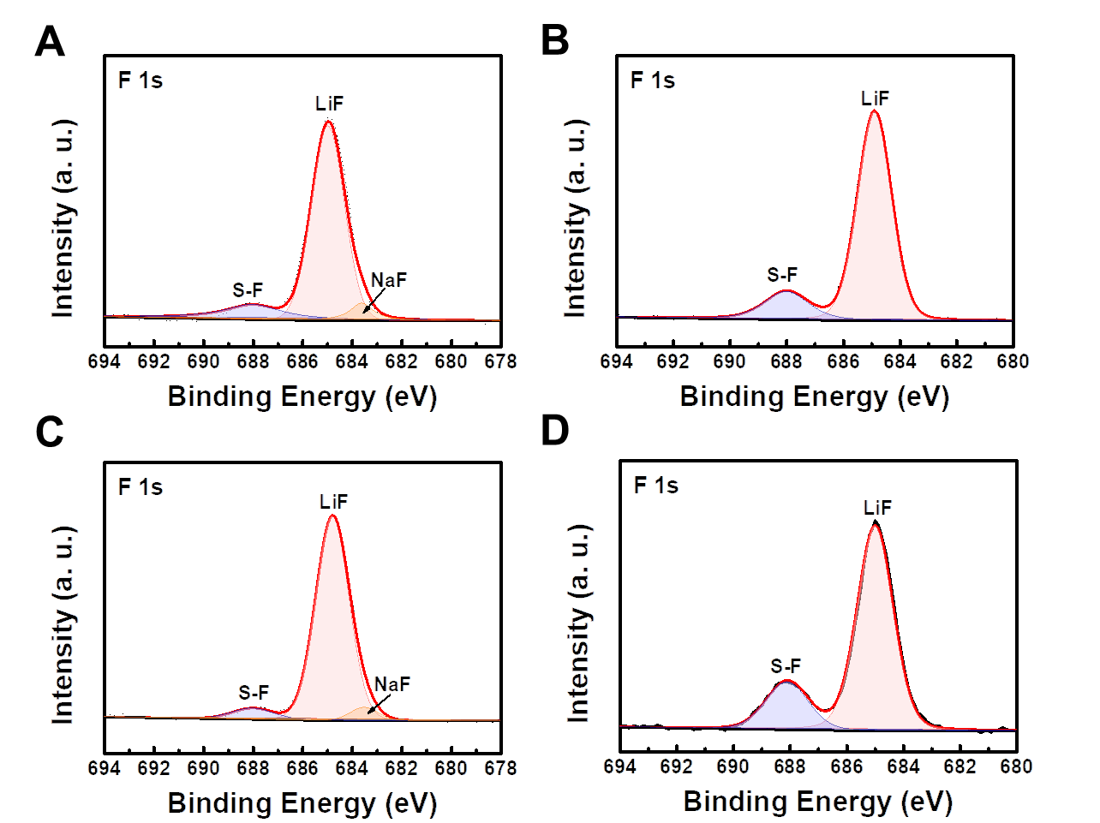
Figure S19. XPS spectra of F 1s for A,C) PHS-Cu and B, E) bare Cu after A,B) 1st cycle and C,D) 20 cycles under 6 mAh/cm² at 1 mA/cm².

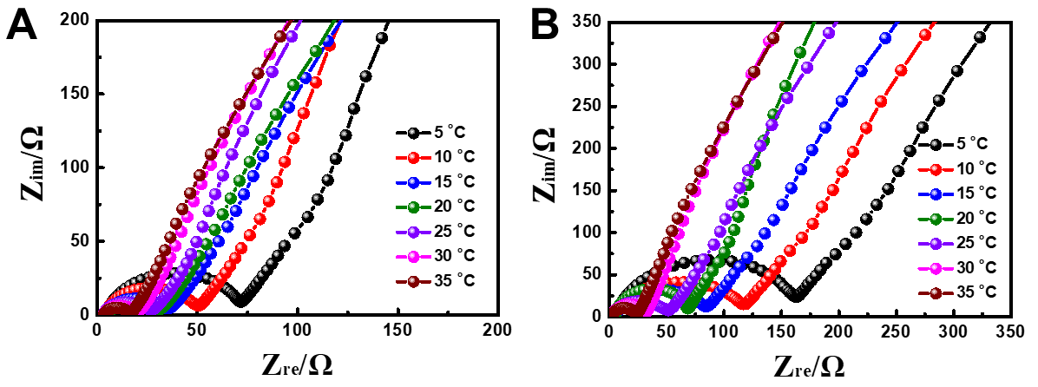
Figure. S20. Nyquist plots at various temperature form 5-35 ºC for a) Li|PHS-Cu and b) Li|Cu asymmetric cells.

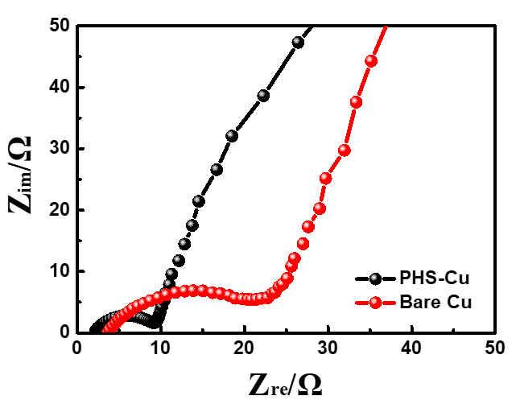
Figure S21. Nyquist plots for Li|PHS-Cu and Li|Cu tested under 6 mAh/cm² with 1 mA/cm² after1st cycle.

Figure S22. Nyquist plots for Li|Cu tested at different cycles.

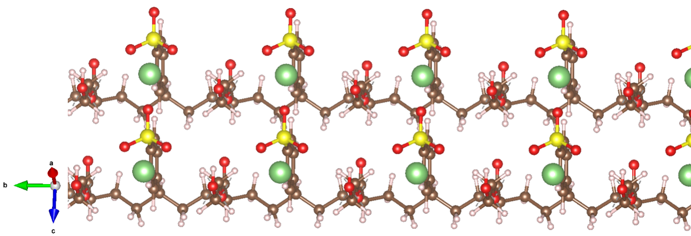
Figure S23. Atom model for chain-to-chain migration at the initial state from side view.
Computational details: Quantum mechanical calculations were performed to employ three choices of exchange-correlation density functional: the PBE functional together with a Hubbard correction (abbreviated PBE+U)¹, the Perdew-Burke-Ernzerhof (PBE)² generalized gradient approximation, and the Heyd-Scuseria-Ernzerhof ³ screened hybrid approximation (abbreviated HSE06). It is well known that the PBE functional underestimates band gaps, and the other two functionals correct this in two different ways. The climbing-image nudged elastic band (CI-NEB)⁴ method was used to determine the energy barriers for Li-ion diffusion. Five images were employed between two end points.

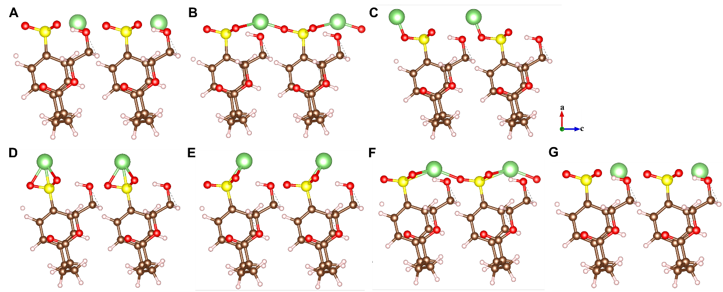
Figure S24. Li⁺ migration in the chain-to-chain pathway from A) initial, B-F) intermediate and G) final states.

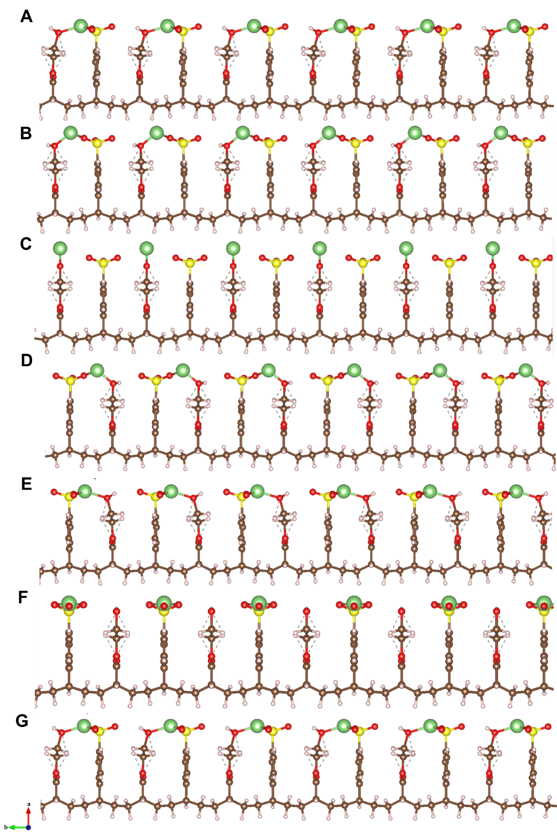
Figure S25. Li⁺ migration in the intrachain pathway from A) initial, B-F) intermediate and G) final states.

Areal capacity (mAh/g)  Electrolyte dosage (g/Ah) | 4 | 5 | 6
3.0 | 376.41 Wh/kg | 392.48 Wh/kg | 400.06 Wh/kg
2.5 | 396.03 Wh/kg | 413.85 Wh/kg | 422.28 Wh/kg
2.0 | 417.8 Wh/kg | 437.68 Wh/kg | 447.13 Wh/kg
1.5 | 442.1 Wh/kg | 464.43 Wh/kg | 475.08 Wh/kg
1.0 | 469.41 Wh/kg | 494.66 Wh/kg | 506.76 Wh/kg
0.5 | 500.31 Wh/kg | 529.09 Wh/kg | 542.96 Wh/kg
Table S1. The electrolyte dosage and the corresponding energy density with different cathode areal capacity of 4, 5, 6 mAh/cm². The cell parameters are kept the same as that in Table S3 except for electrolyte dosage and cathode loading. The N/P ratio is 2.5.

Strategy | Areal capacity (mAh/cm²) | Average CE | Cycles | Ref.
Reactive polymer composite derived SEI⁵ | 3 | 98.5% | 220 | Nat. Mater. 2019, 18, 384
Dynamic single-ion-conductive Artificial SEI⁶ | 1 | 94.9% | 250 | Joule, 2019, 3, 2761
Biomacromolecules modified Li anode⁷ | 1 | 98% | 200 | Nat. Commun. 2020,11,488
Fluorinated mesocarbon anode⁸ | 4.8 | 98.5% | 150 | Adv. Mater.2020, 32, 1906427
Electrochemically active monolayer⁹ | 6 | 98.6% | 300 | Nat. Energy, 2020,5,534
Gradient inorganic-organic coating on Lithium ¹⁰ | 0.5 | 98% | 350 | Energy Environ. Sci., 2021, 14, 4085
SnI₄ modified Li anode¹¹ | 3 | 98.7% | 120 | Angew. Chem. 2021, 133, 23172
TMSB-modified electrolyte¹² | 1 | 97.94% | 500 | Angew. Chem. Int. Ed. 2021, 60, 19232
Au@ZIF-8¹³ | 1 | 98% | 250 | Angew. Chem. Int. Ed. 2021, 60, 14040
lithium-montmorillonite SEI¹⁴ | 3 | 98.2 | 60 | Adv. Funct. Mater. 2021, 31, 2102336
Epitaxial induced plating Cu¹⁵ | 5 | 99.24% | 30 | Adv. Energy Mater. 2021, 11, 2003709
Metal fluoride spansules¹⁶ | 1 | 98.5% | 300 | Sci. Adv. 2020, 6, 3112
Protein molecules modified electrolyte¹⁷ | 1 | 98% | 100 | Nat. Commun. 2020,11,5429
Vertically aligned GO anode¹⁸ | 5 | 99.08% | 150 | Joule, 2020, 4, 938
PHS modified Cu anode | 2 | 99.45% | 600 | This work
PHS modified Cu anode | 6 | 99.46% | 150 | This work
PHS modified Cu anode | 8 | 99.43% | 100 | This work
Table S2. A summary of the public work on Li-Cu asymmetric cells.

Cell component | Specification | Parameters
Cathode(NCM83) | Number | 13
Cathode(NCM83) | Active material mass loading (mg/cm², each side) | 30.0
Cathode(NCM83) | Active material content | 0.955
Cathode(NCM83) | Discharge capacity (mAh/g) | 210
Cathode(NCM83) | Specific areal capacity (mAh/cm², each side) | 6.02
Cathode(NCM83) | NCM Weight (g) | 34.944
Cathode(NCM83) | Thickness (μm) of Al foil | 12
Cathode(NCM83) | Thickness (μm) of cathode | 172
Cathode(NCM83) | The Weight of Al foil（g） | 1.863
Cathode(NCM83) | The Weight of Al foil + NCM (g) | 36.81
Anode Li | Number | 14
Anode Li | Thickness (μm) | 100 (50 μm for each side)
Anode Li | Weight (g) | 3.95
Electrolyte | electrolyte/capacity (g/Ah) | 1.25
Electrolyte | Weight (g) | 8.58
Separator | Weight (g) | 1.89
package and lugs | Weight (g) | 2.0
package and lugs | Dimension (cm×cm) | 7x11
Full cell | Discharge capacity (Ah) | 6.87
Full cell | Mid-value voltage (V) | 3.8
Full cell | Total weight (g) | 53.23
Full cell | Specific energy (Wh/L) | 752.08
Full cell | Specific energy (Wh/kg) | 490.41
Table S3. The specifications of the NCM83|PHS-Li pouch cell. Notably, total mass of the full cell is obtained by directly weighing the pouch cell on analytical balance. The electrolyte dosage is estimated by the total mass of pouch cell and the other parts because the pouch cell undergoes secondary electrolyte extraction. Owing to the thin layer and low density of PHS, the mass of PHS layer can be negligible and included in the electrolyte dosage.

References
1. Dudarev S, Botton GA, Savrasov SY, Humphreys C, Sutton AP. Electron-Energy-Loss Spectra and the Structural Stability of Nickel Oxide: An LSDA+U Study. Phys Rev B 57, 1505-1509 (1998).
2. Perdew JP, Burke K, Ernzerhof M. Generalized Gradient Approximation Made Simple. Phys Rev Lett 77, 3865-3868 (1996).
3. Krukau AV, Vydrov OA, Izmaylov AF, Scuseria GE. Influence of the exchange screening parameter on the performance of screened hybrid functionals. J Chem Phys 125, 224106 (2006).
4. Henkelman G, Uberuaga BP, Jónsson H. A climbing image nudged elastic band method for finding saddle points and minimum energy paths. J Chem Phys 113, 9901-9904 (2000).
5. Gao Y, et al. Polymer-inorganic solid-electrolyte interphase for stable lithium metal batteries under lean electrolyte conditions. Nat Mater 18, 384-389 (2019).
6. Yu Z, et al. A Dynamic, Electrolyte-Blocking, and Single-Ion-Conductive Network for Stable Lithium-Metal Anodes. Joule 3, 2761-2776 (2019).
7. Ju Z, et al. Biomacromolecules enabled dendrite-free lithium metal battery and its origin revealed by cryo-electron microscopy. Nat Commun 11, 488 (2020).
8. Cui C, et al. A Highly Reversible, Dendrite-Free Lithium Metal Anode Enabled by a Lithium-Fluoride-Enriched Interphase. Adv Mater 32, e1906427 (2020).
9. Gao Y, et al. Low-temperature and high-rate-charging lithium metal batteries enabled by an electrochemically active monolayer-regulated interface. Nat Energy 5, 534-542 (2020).
10. Sun Y, et al. Regulated lithium plating and stripping by a nano-scale gradient inorganic–organic coating for stable lithium metal anodes. Energy Environ Sci 14, 4085-4094 (2021).
11. Jin CB, et al. Reclaiming Inactive Lithium with a Triiodide/Iodide Redox Couple for Practical Lithium Metal Batteries. Angew Chem Int Ed 60, 22990-22995 (2021).
12. Huang K, et al. Regulation of SEI Formation by Anion Receptors to Achieve Ultra-Stable Lithium-Metal Batteries. Angew Chem Int Ed 60, 19232-19240 (2021).
13. Huang M, Yao Z, Yang Q, Li C. Consecutive Nucleation and Confinement Modulation towards Li Plating in Seeded Capsules for Durable Li-Metal Batteries. Angew Chem Int Ed 60, 14040-14050 (2021).
14. Nan Y, et al. Interlamellar Lithium‐Ion Conductor Reformed Interface for High Performance Lithium Metal Anode. Adv Funct Mater 31, (2021).
15. Nanda S, Gupta A, Manthiram A. Anode-Free Full Cells: A Pathway to High-Energy Density Lithium-Metal Batteries. Adv Energy Mater 11, 2000804 (2021).
16. Yuan H, et al. An ultrastable lithium metal anode enabled by designed metal fluoride spansules. Sci Adv 6, 3112 (2020).
17. Wang T, et al. Immunizing lithium metal anodes against dendrite growth using protein molecules to achieve high energy batteries. Nat Commun 11, 5429 (2020).
18. Chen H, et al. Tortuosity Effects in Lithium-Metal Host Anodes. Joule 4, 938-952 (2020).

