Supporting Information
Theoretical atomic radii of elements (H-Cm): A non-relativistic study with Gaussian basis set using HF, post-HF and DFT methods
Krishnamohan G. Prasanna ^{ǂ}*, Sooraj Sunil §, Ajith Kumar §, James. T. Joseph §

ǂ Department of Science and Humanities, Mar Baselios College of Engineering and Technology (Autonomous), Trivandrum, Kerala 695015, India.
§ Department of Chemistry, Mar Ivanios College (Autonomous), Trivandrum, Kerala 695015, India
E-mail: krishna.mohan@mbcet.ac.in

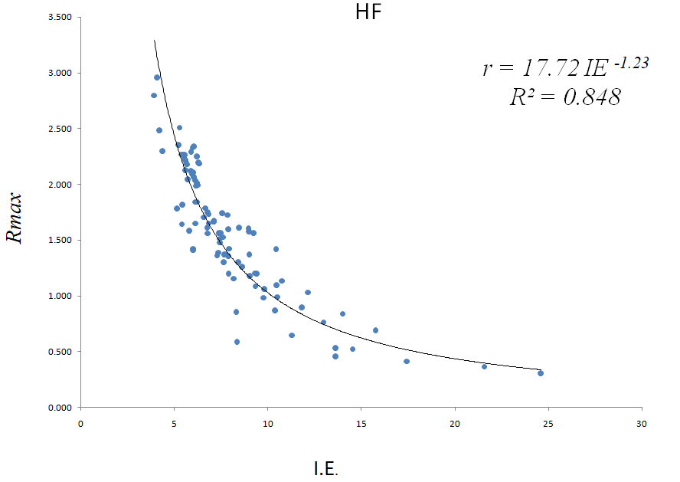
Figure S1 HF R_{max}(Å) and first ionization (experimental, in eV) energy eorrelation

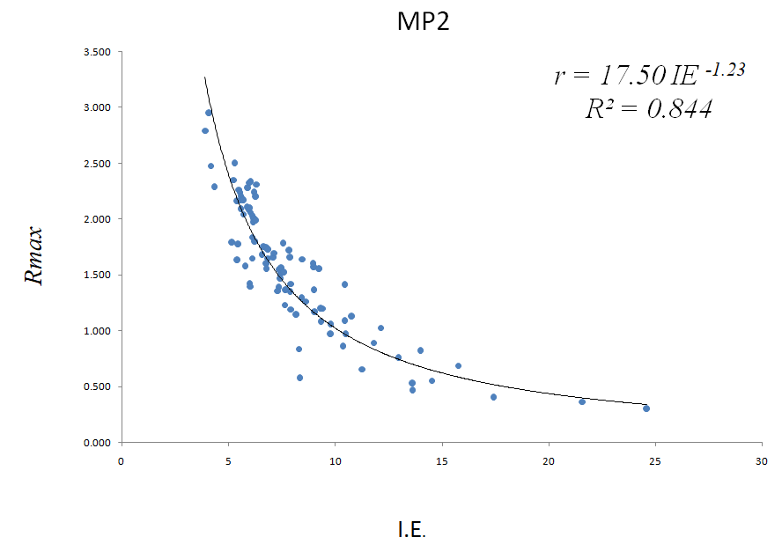
Figure S2 MP2 R_{max} and first ionization energy correlation

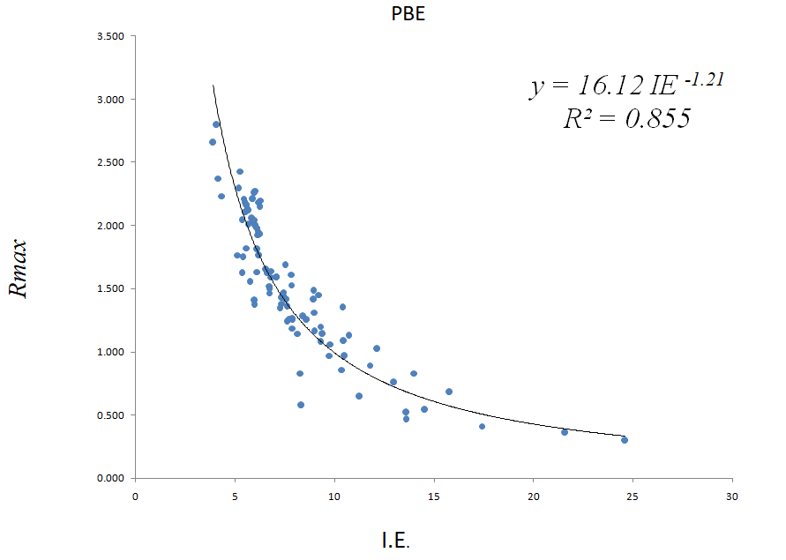
Figure S3 PBE R_{max} and first ionization energy correlation

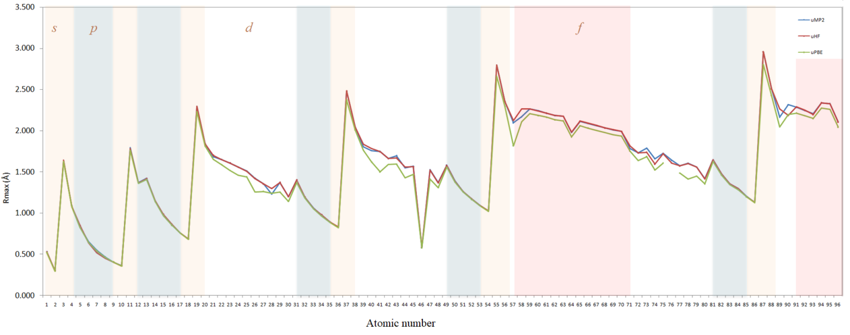
Figure S4 Non relativistic atomic raddi (HF/MP2/PBE) data with UGBS basis set

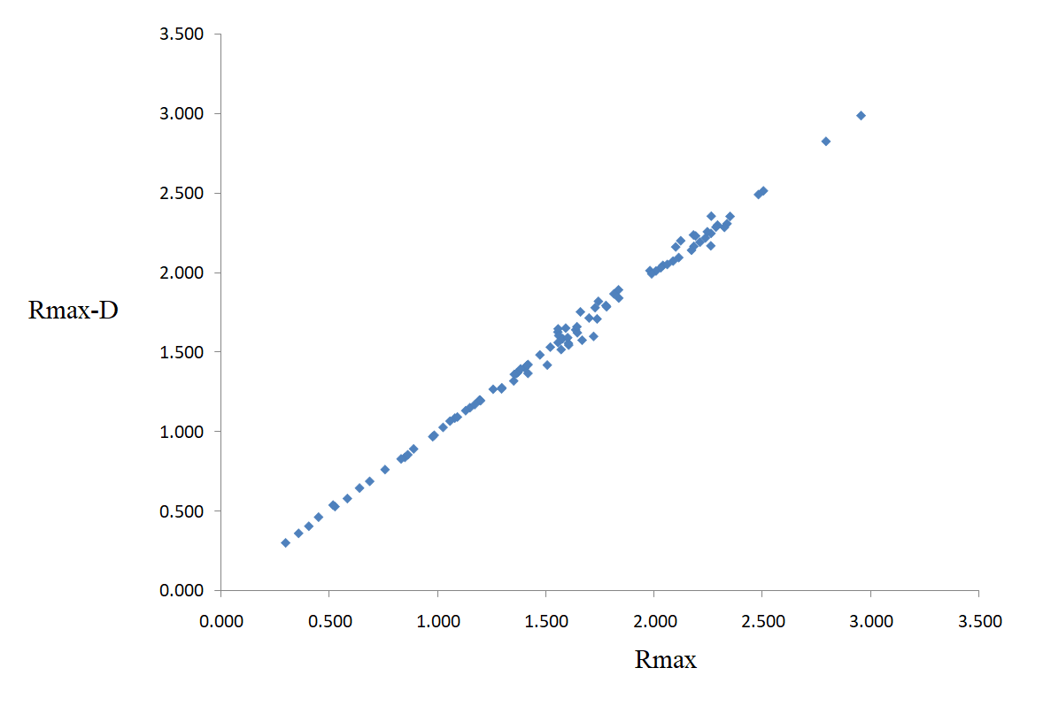
Figure S5 Correlation of R_{max} (HF) data with Desclaux’s non-relativistic HF data (R_{max}-D).

Figure S6 Comparison of experimental first ionization (NIST IE) energy and R_{max} MP2.

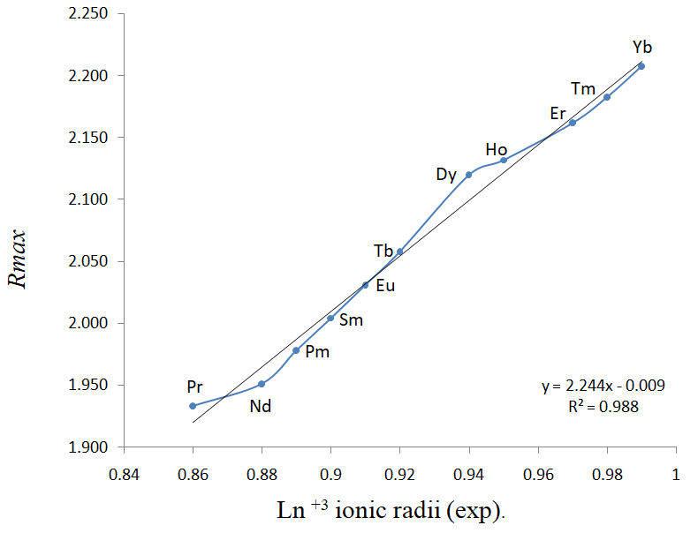

Figure S7 Correlation of R_{max} (PBE) and experimental Ln⁺³ ionic radii.

Figure S8 R² values of noble gases with MP2 data

Table S1 The theoretical atomic radii (in Angstrom) of elements, H-Cm (HF, MP2, PBE values were obtained from UGBS basis set. D_R and D_nr, represents relativistic and non-relativistic radii, respectively).

Z | Element |  | HF | MP2 | PBE | Clementi | D_R | D_nr | Rahm
1 | H |  | 0.529 | 0.530 | 0.522 | 0.530 | 0.530 | 0.530 | 1.540
2 | He |  | 0.301 | 0.300 | 0.297 | 0.310 | 0.301 | 0.301 | 1.340
3 | Li |  | 1.640 | 1.639 | 1.625 | 1.670 | 1.641 | 1.642 | 2.200
4 | Be |  | 1.082 | 1.084 | 1.082 | 1.120 | 1.086 | 1.086 | 2.190
5 | B |  | 0.852 | 0.834 | 0.827 | 0.870 | 0.840 | 0.839 | 2.050
6 | C |  | 0.642 | 0.654 | 0.648 | 0.670 | 0.646 | 0.646 | 1.900
7 | N |  | 0.520 | 0.550 | 0.544 | 0.560 | 0.539 | 0.539 | 1.790
8 | O |  | 0.453 | 0.467 | 0.465 | 0.480 | 0.463 | 0.464 | 1.710
9 | F |  | 0.408 | 0.404 | 0.406 | 0.420 | 0.406 | 0.406 | 1.630
10 | Ne |  | 0.361 | 0.361 | 0.360 | 0.380 | 0.361 | 0.362 | 1.560
11 | Na |  | 1.780 | 1.793 | 1.761 | 1.900 | 1.792 | 1.795 | 2.250
12 | Mg |  | 1.368 | 1.368 | 1.361 | 1.450 | 1.367 | 1.370 | 2.400
13 | Al |  | 1.420 | 1.423 | 1.408 | 1.180 | 1.424 | 1.423 | 2.390
14 | Si |  | 1.152 | 1.147 | 1.140 | 1.110 | 1.153 | 1.152 | 2.320
15 | P |  | 0.987 | 0.973 | 0.971 | 0.980 | 0.980 | 0.978 | 2.230
16 | S |  | 0.865 | 0.861 | 0.853 | 0.880 | 0.856 | 0.856 | 2.140
17 | Cl |  | 0.760 | 0.760 | 0.759 | 0.790 | 0.763 | 0.763 | 2.060
18 | Ar |  | 0.689 | 0.686 | 0.684 | 0.710 | 0.689 | 0.689 | 1.970
19 | K |  | 2.295 | 2.295 | 2.230 | 2.430 | 2.292 | 2.300 | 2.340
20 | Ca |  | 1.839 | 1.838 | 1.814 | 1.940 | 1.834 | 1.842 | 2.700
21 | Sc |  | 1.702 | 1.683 | 1.653 | 1.840 | 1.708 | 1.716 | 2.630
22 | Ti |  | 1.648 | 1.649 | 1.588 | 1.760 | 1.611 | 1.623 | 2.570
23 | V |  | 1.608 | 1.607 | 1.518 | 1.710 | 1.533 | 1.546 | 2.520
24 | Cr |  | 1.558 | 1.558 | 1.461 | 1.660 | 1.605 | 1.628 | 2.330
25 | Mn |  | 1.509 | 1.510 | 1.441 | 1.610 | 1.404 | 1.420 | 2.420
26 | Fe |  | 1.420 | 1.421 | 1.257 | 1.560 | 1.351 | 1.368 | 2.260
27 | Co |  | 1.354 | 1.354 | 1.264 | 1.520 | 1.302 | 1.320 | 2.220
28 | Ni |  | 1.299 | 1.229 | 1.242 | 1.490 | 1.258 | 1.277 | 2.190
29 | Cu |  | 1.373 | 1.372 | 1.255 | 1.450 | 1.344 | 1.374 | 2.170
30 | Zn |  | 1.198 | 1.199 | 1.144 | 1.420 | 1.179 | 1.200 | 2.220
31 | Ga |  | 1.405 | 1.395 | 1.374 | 1.360 | 1.405 | 1.402 | 2.330
32 | Ge |  | 1.196 | 1.192 | 1.183 | 1.250 | 1.201 | 1.200 | 2.340
33 | As |  | 1.060 | 1.061 | 1.056 | 1.140 | 1.069 | 1.067 | 2.310
34 | Se |  | 0.980 | 0.973 | 0.967 | 1.030 | 0.971 | 0.969 | 2.240
35 | Br |  | 0.892 | 0.891 | 0.889 | 0.940 | 0.894 | 0.892 | 2.190
36 | Kr |  | 0.834 | 0.825 | 0.825 | 0.880 | 0.830 | 0.830 | 2.120
37 | Rb |  | 2.484 | 2.478 | 2.371 | 2.650 | 2.451 | 2.492 | 2.400
38 | Sr |  | 2.043 | 2.043 | 2.009 | 2.190 | 2.013 | 2.047 | 2.790
39 | Y |  | 1.838 | 1.805 | 1.765 | 2.120 | 1.853 | 1.893 | 2.740
40 | Zr |  | 1.783 | 1.757 | 1.621 | 2.060 | 1.742 | 1.787 | 2.680
41 | Nb |  | 1.745 | 1.748 | 1.501 | 1.980 | 1.753 | 1.821 | 2.510
42 | Mo |  | 1.662 | 1.662 | 1.590 | 1.900 | 1.683 | 1.754 | 2.440
43 | Tc |  | 1.670 | 1.696 | 1.594 | 1.830 | 1.523 | 1.576 | 2.410
44 | Ru |  | 1.559 | 1.548 | 1.429 | 1.780 | 1.572 | 1.648 | 2.370
45 | Rh |  | 1.562 | 1.567 | 1.469 | 1.730 | 1.525 | 1.605 | 2.330
46 | Pd |  | 0.586 | 0.578 | 0.577 | 1.690 | 0.588 | 0.580 | 2.150
47 | Ag |  | 1.523 | 1.527 | 1.415 | 1.650 | 1.444 | 1.533 | 2.250
48 | Cd |  | 1.367 | 1.368 | 1.308 | 1.610 | 1.303 | 1.368 | 2.380
49 | In |  | 1.580 | 1.582 | 1.557 | 1.560 | 1.589 | 1.586 | 2.460
50 | Sn |  | 1.386 | 1.390 | 1.378 | 1.450 | 1.397 | 1.396 | 2.480
51 | Sb |  | 1.259 | 1.261 | 1.256 | 1.330 | 1.269 | 1.268 | 2.460
52 | Te |  | 1.174 | 1.173 | 1.166 | 1.230 | 1.171 | 1.171 | 2.420
53 | I |  | 1.094 | 1.092 | 1.089 | 1.150 | 1.094 | 1.093 | 2.380
54 | Xe |  | 1.028 | 1.025 | 1.023 | 1.080 | 1.028 | 1.028 | 2.320
55 | Cs |  | 2.796 | 2.796 | 2.660 | 2.980 | 2.719 | 2.827 | 2.490
56 | Ba |  | 2.353 | 2.353 | 2.296 | 2.530 | 2.273 | 2.355 | 2.930
57 | La |  | 2.125 | 2.096 | 1.817 |  | 2.106 | 2.202 | 2.840
58 | Ce |  | 2.264 | 2.169 | 2.106 |  | 2.070 | 2.170 | 2.820
59 | Pr |  | 2.265 | 2.265 | 2.208 | 2.470 | 2.147 | 2.248 | 2.860
60 | Nd |  | 2.239 | 2.240 | 2.183 | 2.060 | 2.112 | 2.219 | 2.840
61 | Pm |  | 2.214 | 2.210 | 2.162 | 2.050 | 2.082 | 2.192 | 2.830
62 | Sm |  | 2.186 | 2.184 | 2.132 | 2.380 | 2.050 | 2.167 | 2.800
63 | Eu |  | 2.175 | 2.175 | 2.120 | 2.310 | 2.022 | 2.142 | 2.800
64 | Gd |  | 1.983 | 1.977 | 1.922 | 2.330 | 1.884 | 2.014 | 2.770
65 | Tb |  | 2.116 | 2.113 | 2.058 | 2.250 | 1.967 | 2.096 | 2.760
66 | Dy |  | 2.090 | 2.088 | 2.031 | 2.280 | 1.942 | 2.074 | 2.750
67 | Ho |  | 2.063 | 2.061 | 2.004 | 2.260 | 1.915 | 2.053 | 2.730
68 | Er |  | 2.033 | 2.034 | 1.978 | 2.260 | 1.892 | 2.032 | 2.720
69 | Tm |  | 2.011 | 2.009 | 1.951 | 2.220 | 1.868 | 2.012 | 2.710
70 | Yb |  | 1.991 | 1.992 | 1.933 | 2.220 | 1.843 | 1.994 | 2.770
71 | Lu |  | 1.817 | 1.781 | 1.753 | 2.170 | 1.707 | 1.868 | 2.700
72 | Hf |  | 1.730 | 1.730 | 1.637 | 2.080 | 1.613 | 1.781 | 2.640
73 | Ta |  | 1.739 | 1.787 | 1.687 | 2.000 | 1.539 | 1.710 | 2.580
74 | W |  | 1.594 | 1.660 | 1.525 | 1.930 | 1.477 | 1.652 | 2.530
75 | Re |  | 1.723 | 1.723 | 1.608 | 1.880 | 1.422 | 1.600 | 2.490
76 | Os |  | 1.607 | 1.640 |  | 1.850 | 1.374 | 1.557 | 2.440
77 | Ir |  | 1.573 | 1.573 | 1.487 | 1.800 | 1.329 | 1.517 | 2.330
78 | Pt |  | 1.603 | 1.606 | 1.415 | 1.770 | 1.338 | 1.592 | 2.300
79 | Au |  | 1.559 | 1.558 | 1.449 | 1.740 | 1.300 | 1.562 | 2.260
80 | Hg |  | 1.415 | 1.418 | 1.354 | 1.710 | 1.217 | 1.418 | 2.290
81 | Tl |  | 1.646 | 1.648 | 1.628 | 1.560 | 1.667 | 1.661 | 2.420
82 | Pb |  | 1.475 | 1.473 | 1.462 | 1.540 | 1.486 | 1.484 | 2.490
83 | Bi |  | 1.357 | 1.356 | 1.346 | 1.430 | 1.364 | 1.362 | 2.500
84 | Po |  | 1.298 | 1.295 | 1.285 | 1.350 | 1.271 | 1.270 | 2.500
85 | At |  | 1.201 | 1.202 | 1.197 |  | 1.196 | 1.196 | 2.470
86 | Rn |  | 1.132 | 1.130 | 1.128 | 1.200 | 1.135 | 1.133 | 2.430
87 | Fr |  | 2.958 | 2.958 | 2.801 |  | 2.644 | 2.989 | 2.580
88 | Ra |  | 2.507 | 2.508 | 2.426 |  | 2.255 | 2.516 | 2.920
89 | Ac |  | 2.266 | 2.164 | 2.045 |  | 2.071 | 2.356 | 2.930
90 | Th |  | 2.184 | 2.314 | 2.195 |  | 1.937 | 2.238 | 2.890
91 | Pa |  | 2.288 | 2.284 | 2.214 |  | 1.975 | 2.288 | 2.850
92 | U |  | 2.248 | 2.244 | 2.181 |  | 1.935 | 2.259 | 2.830
93 | Np |  | 2.194 | 2.204 | 2.148 |  | 1.901 | 2.232 | 2.800
94 | Pu |  | 2.339 | 2.339 | 2.273 |  | 1.964 | 2.309 | 2.780
95 | Am |  | 2.327 | 2.328 | 2.260 |  | 1.936 | 2.286 | 2.760
96 | Cm |  | 2.102 | 2.105 | 2.042 |  | 1.805 | 2.163 | 2.640

