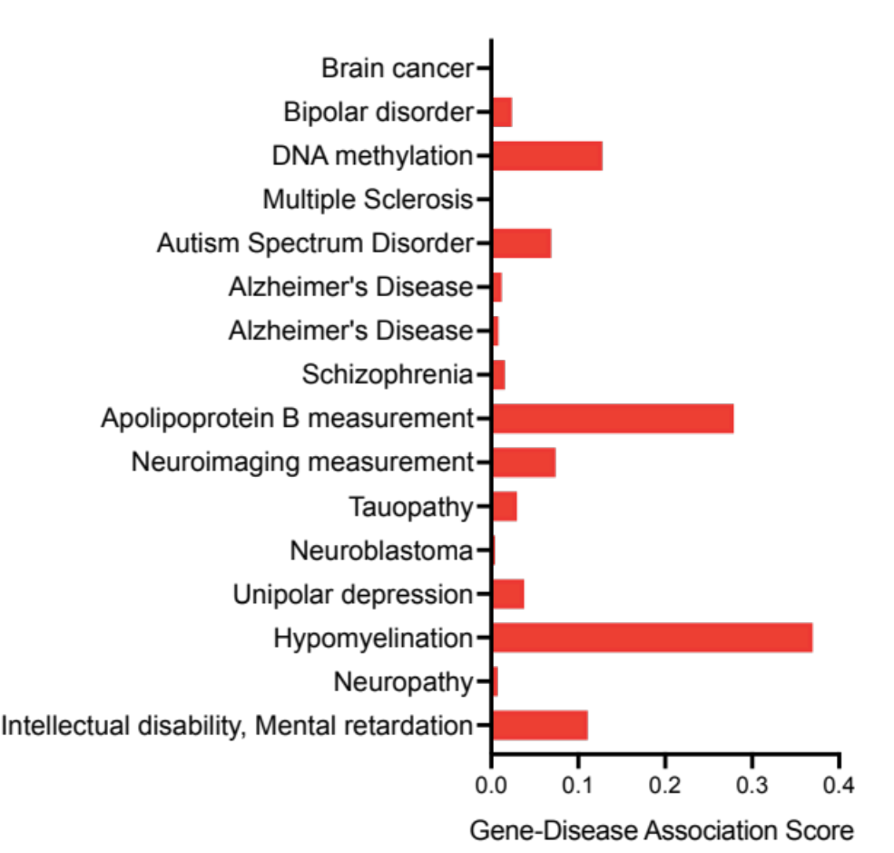
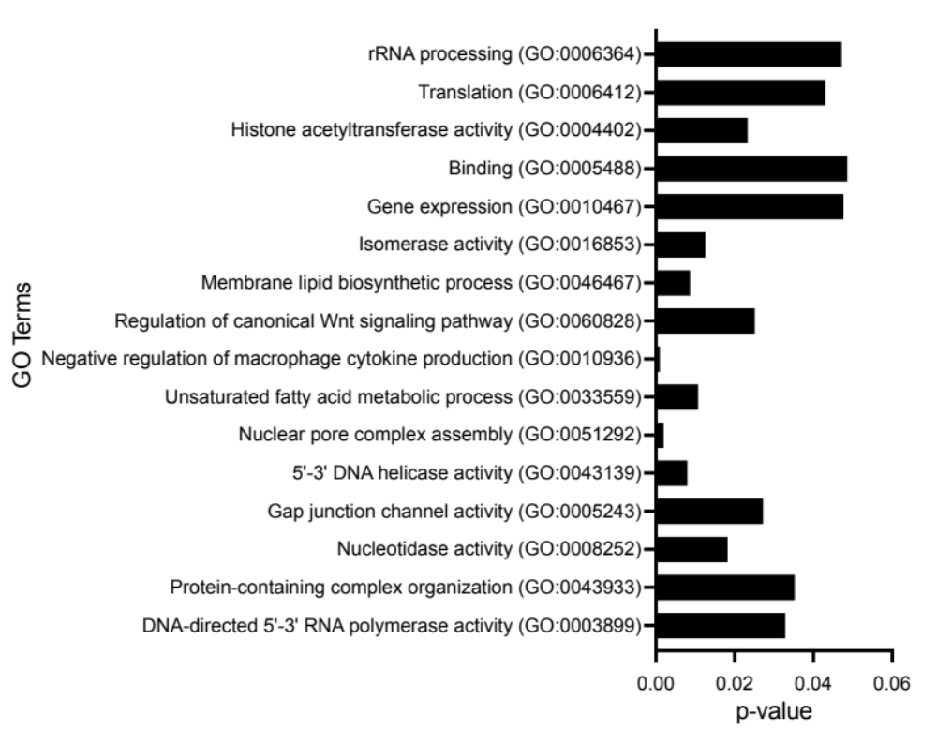
M
L
Figure S1

Figure S1. miR expression profiling and QTL analysis reveals upstream candidates of miR-9/29a/107. Related to Figure 1.

(A-B) Expression of (A) miR-29a, (B) miR-107 in hippocampi of 5-6 weeks old CC mice.
(C-D) Expression of (C) miR-29a, (D) miR-107 in hippocampi of 30-40 weeks old CC mice.
(From Figure 1. C-D). Expression of Bace1 in hippocampi of (C) 5-6 weeks old and (D) 30-40 weeks old CC mice. The percentage of CC mice showing the inverse correlation of miRs to Bace1 expression. (A) miR-29a-45%, (B) miR-107-45%, (C) miR-29a-63%, (D) miR-107-53%. Data from three CC mice hippocampi/strain for all age-groups represented as mean ± SEM.
(E-I) LOD score plots of miR expression for miR-9/29a/107 using the HAPPY package and GeneMiner. (E-G) represents the QTLs for 5-6 weeks old CC mice; (H-I) denotes the QTLs for 30-40 weeks old CC mice. The true QTL positions were considered on chromosomes (E) Chr19, Chr15, (F) Chr17, (G) Chr5 (H) Chr1 (I) Chr7, Chr12 boxed in green and red respectively.
(J-K) % Knockdown of siRNAs in N2a cell line. All the genes were knocked down using respective siRNAs and their efficiency calculated using qPCR. The knockdown protocol was optimised such that all the genes showed efficiency greater than 70%. Out of 145 genes that were identified through QTL, 131 genes were selected for the study. Remaining 14 genes were unclassified in the genome.
(L) Gene ontology (GO) analysis significantly represented for the 13 candidates (out of 23 genes) that were enriched in modules related to neurogenesis, gene regulation and neurodegeneration.
(M) Gene-Disease Association curated from EBI and DisGeNET scored based on the relationship between the gene and the disease and represented as ontological classes for the 13 candidates.

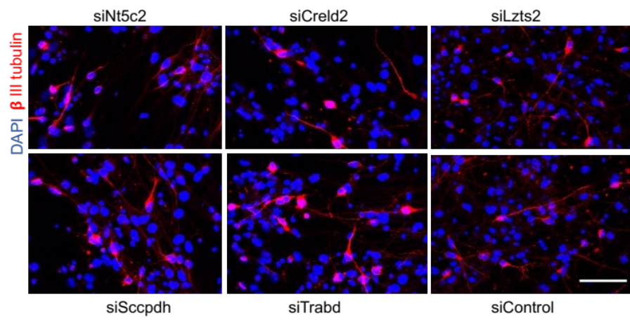
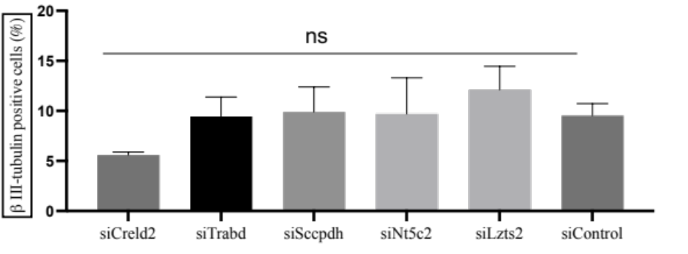
A
Figure S2
B

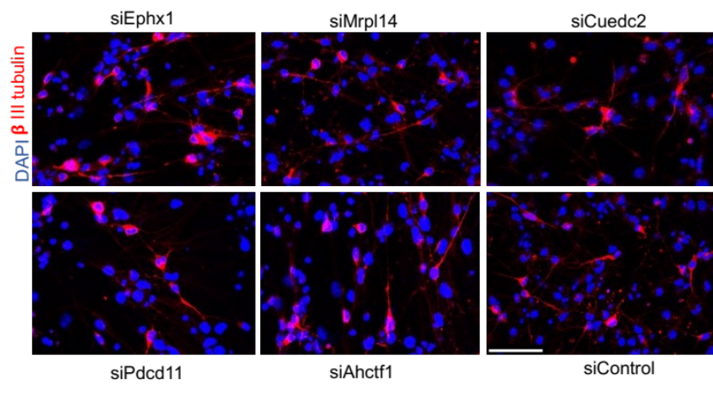
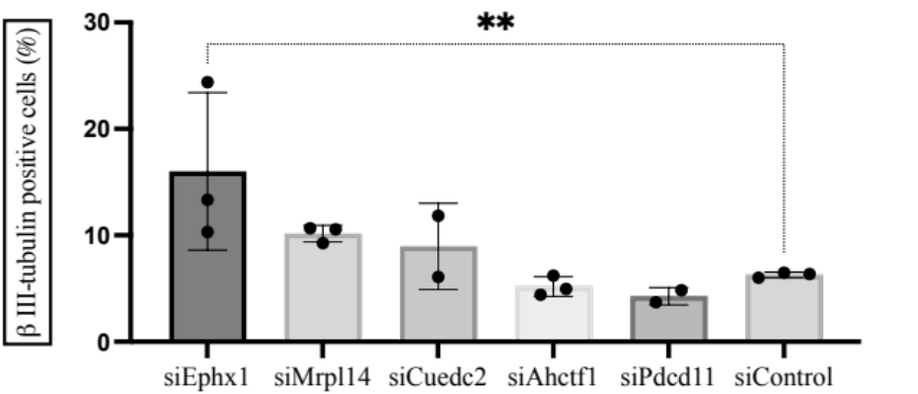
C
D

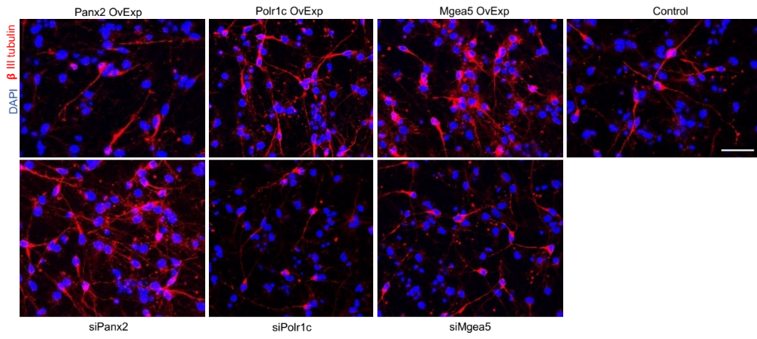
E

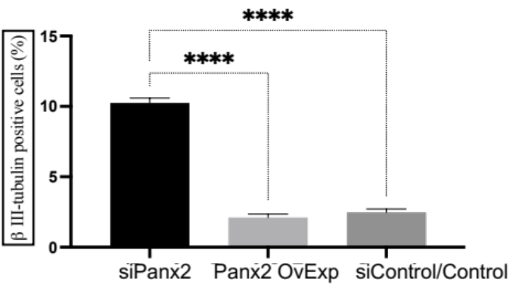
F

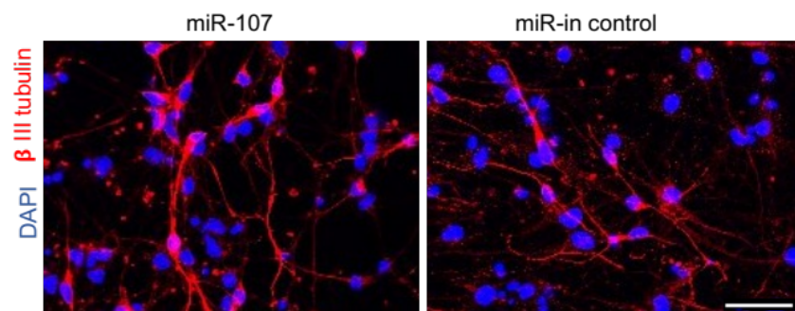
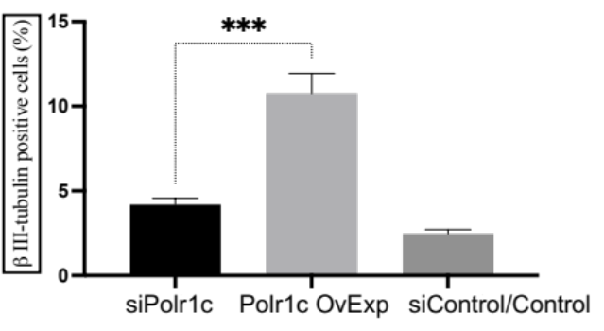
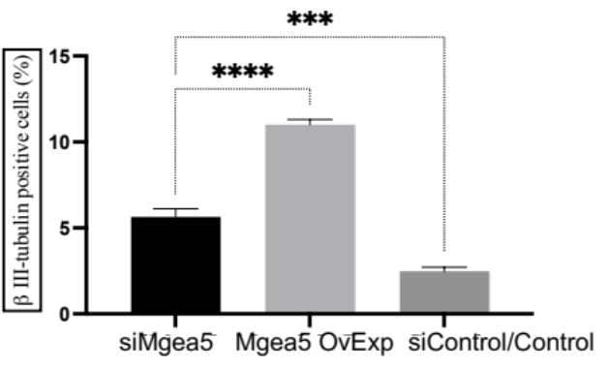
I
G
H
Figure S2
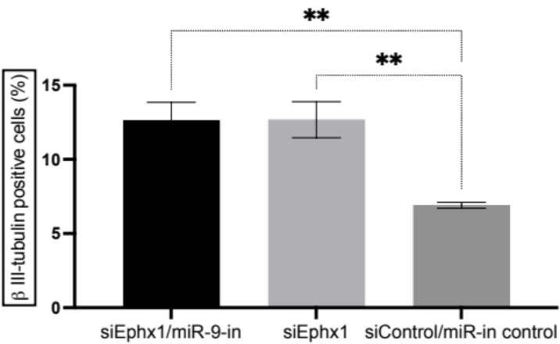
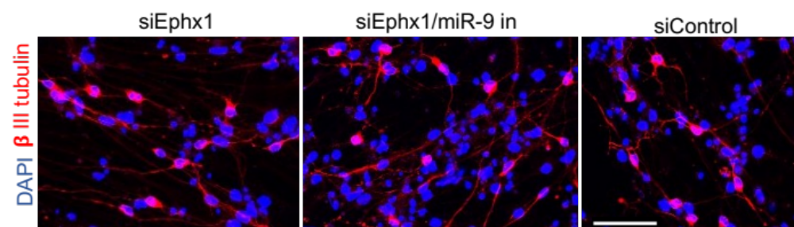
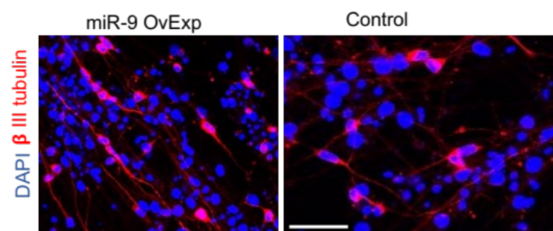
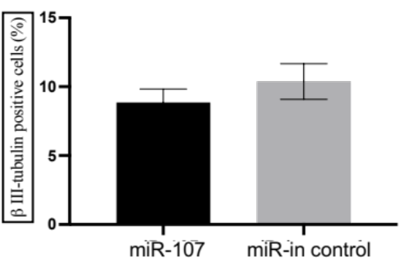
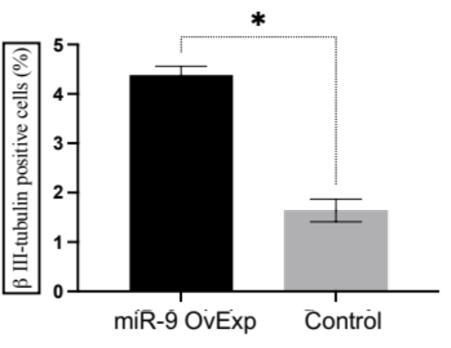
N
M
K
J
L


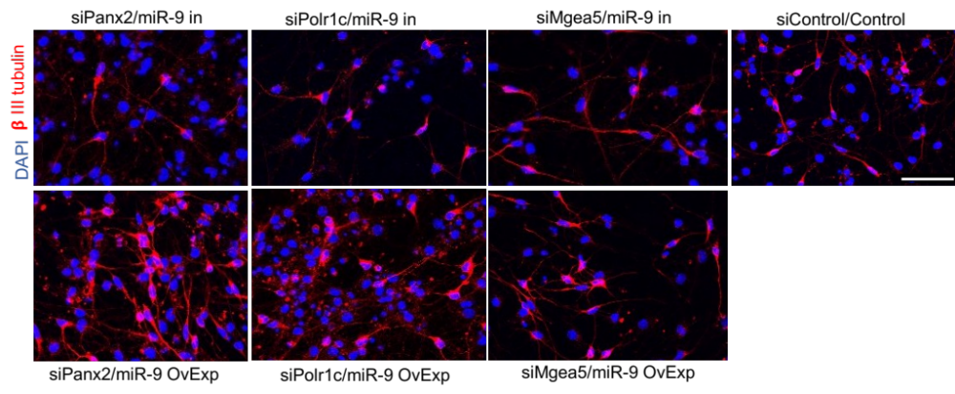
O
Figure S2

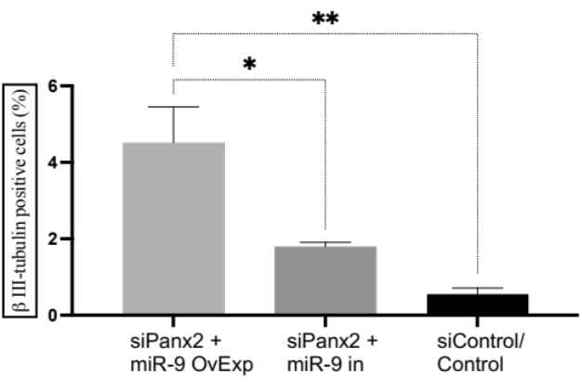
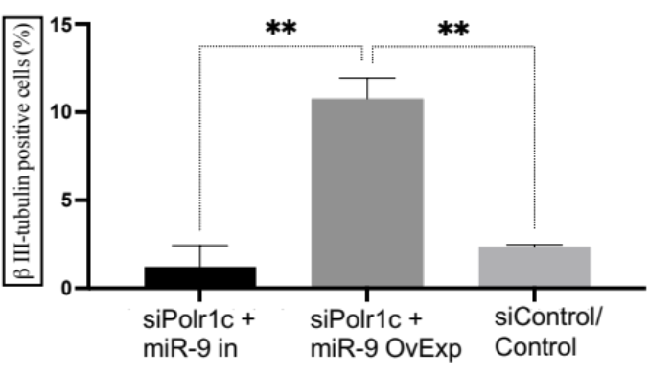
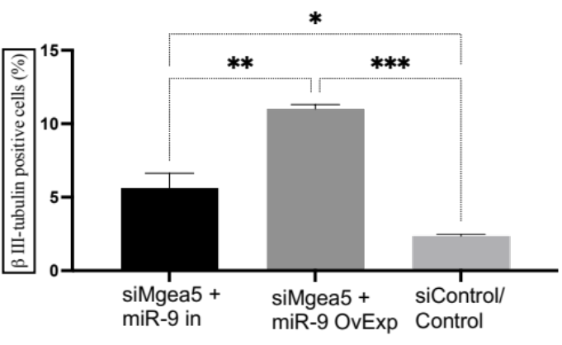
P
Q
R

Figure S2. Panx2, Polr1c and Mgea5 regulates neuronal differentiation through miR-9. Related to Figure 2.

(A-B) Role of 5 – Creld2, Trabd, Sccpdh, Nt5C2 and Lzts2 (out of 13) candidate genes in neuronal differentiation. Representative images (A) and quantification (B) of βIII-tubulin positive cells using immunostaining in differentiated mNPCs transfected with individual siRNAs and scrambled siRNA negative control.
(C-D) Role of remaining 5 – Ephx1, Mrpl14, Cuedc2, Ahctf1 and Pdcd11 (out of 13) candidate genes in neuronal differentiation. Representative images (C) and quantification (D) of βIII-tubulin positive cells using immunostaining in differentiated mNPCs transfected with individual siRNAs and scrambled siRNA negative control.
(E-H) Panx2, Polr1c and Mgea5 were overexpressed in mNPCs. Representative images (E) and quantification (F) Panx2, (G) Polr1c and (H) Mgea5 of βIII-tubulin positive cells using immunostaining in differentiated mNPCs overexpressed with individual lentiviral particles and control. OvExp: Over expression
N= 6 experiments. mean ± SEM, ****p<0.0001, ***p<0.0005, **p<0.005, *p<0.05, ns – not significant. One-way Anova. Image scale bars=10 μm.
(I-J) miR-107 did not alter neuronal differentiation as compared to the control. Representative images (I) and quantification (J) of βIII-tubulin positive cells using immunostaining in differentiated mNPCs transfected with miR-107 inhibitor and negative control. N= 4 experiments. mean ± SEM, *p<0.05, Unpaired T-test. Image scale bars=10 μm.
(K-L) mNPCs overexpressed with miR-9 increased neuronal differentiation. Representative images (K) and quantification (L) of βIII-tubulin positive cells using immunostaining in differentiated mNPCs overexpressed with miR-9 and control. N=4 experiments. mean ± SEM, Unpaired T-test, Image scale bars=10 μm.
(M-N) Ephx1 did not alter neuronal differentiation through miR-9. Representative images (M) and quantification (N) of βIII-tubulin positive cells using immunostaining in differentiated mNPCs transfected with Ephx1, Ephx1 plus miR-9-in and scrambled negative control. N= 4 experiments. mean ± SEM, **p<0.005, One-way Anova. Image scale bars=10 μm.
(O-R) Rescue experiments using Panx2, Polr1c and Mgea5 siRNAs together with miR-9 overexpressed mNPCs reversed the miR-9 mediated decrease in neuronal differentiation. Representative images (O) and quantification (P) Panx2, (Q) Polr1c and (R) Mgea5 of βIII-tubulin positive cells using immunostaining in differentiated mNPCs overexpressed with miR-9 lentiviral particles plus siRNAs of Panx2, Polr1c, Mgea5. N= 6 experiments. mean ± SEM, ****p<0.0001, ***p<0.0005, **p<0.005, *p<0.05, ns – not significant. One-way Anova. Image scale bars=10 μm.
Figure S3
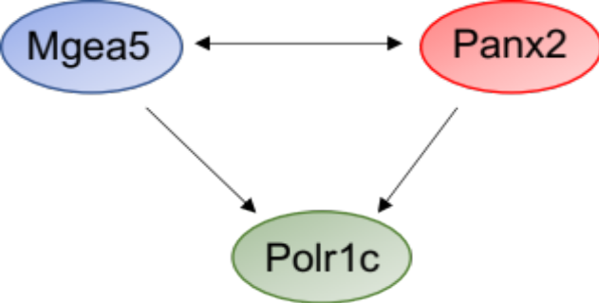
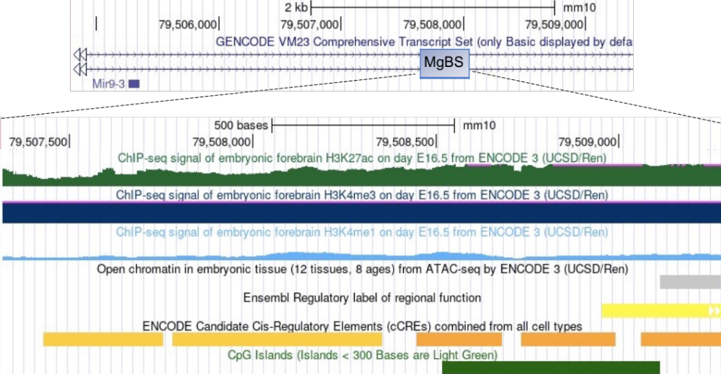
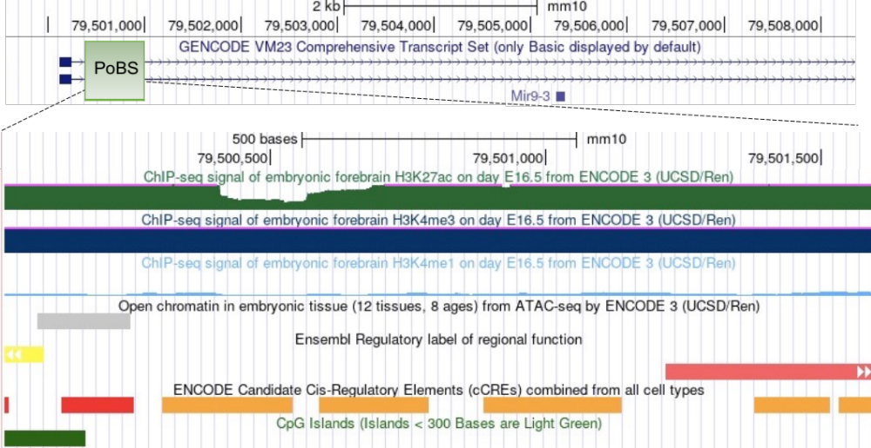
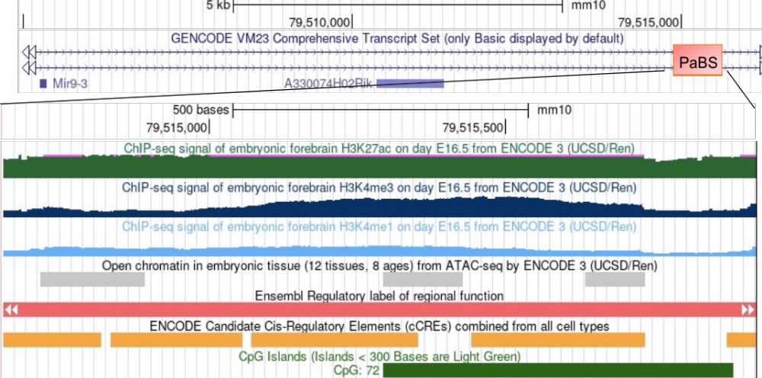
D
C
B
A
Figure S3. Panx2, Polr1c and Mgea5 binds to the miR-9 regulatory region. Related to Figure 3.

(A-C) Two peaks were selected from each experiment with a fold enrichment between 1.5 <foldchange< 4.5. Polr1c binding sites (PoBS-1 and 2) overlapped for both the experimental sets and was located at a distance -2kb from miR-9 TSS (Transcription start site). Panx2 binding peaks (PaBS-1 and 2) were located +5kb from miR-9 TSS whereas Mgea5 binding sites (MgBS-1 and 2) were located within +1kb/+2kb of miR-9 TSS respectively. Encyclopaedia of DNA Elements (ENCODE) and CpG islands are enriched in miR-9 embedding region. The ENCODE elements include H3K4Me1 mark, H3K4Me3 mark, H3K27Ac mark. The ChIP-seq results performed in Panx2, Polr1c and Mgea5 are also shown. The coloured boxes (A) Panx2 binding site (PaBS), (B) Polr1c binding site (PoBS) and (C) Mgea5 binding site (MgBS) indicate the binding sites in the miR-9 genomic locus. The regulatory elements located within the 500bp region of each of the binding sites is described here. As we can see, the positions of significant enrichment of Panx2 (A), Polr1c (B) and Mgea5 (C) are just located within the peak regions of H3K4Me3 mark and H3K27Ac histone marks. In addition, these regions are overspread with CpG islands. PaBS and MgBS shows regions overlapping with enhancers whereas PoBS has regions overlying both promoter and enhancer. Data from 1 ChIP-seq experiment is shown representative of 2 independent experiments.
(D) Schematic of association between Panx2, Polr1c and Mgea5 as identified using Co-IP. (For Panx2-IP, Polr1c and Mgea5 antibodies were used for immunoblotting; likewise, for Polr1c-IP: Panx2/Mgea5 antibody and Mgea5-IP: Panx2/Polr1c antibody were used). Panx2 and Mgea5 mutually associate with each other and also interacts with Polr1c individually.

Figure S4
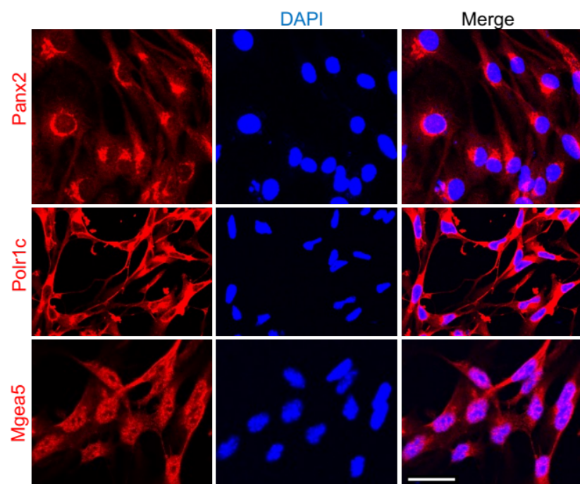
A
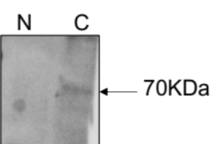
B

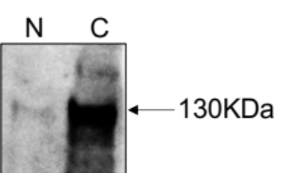
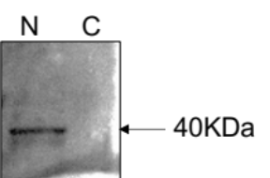
D
C

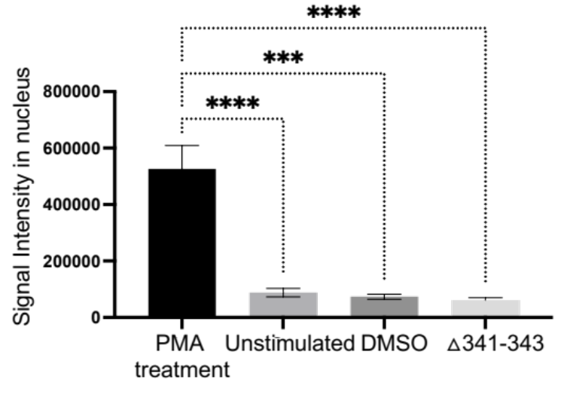
E
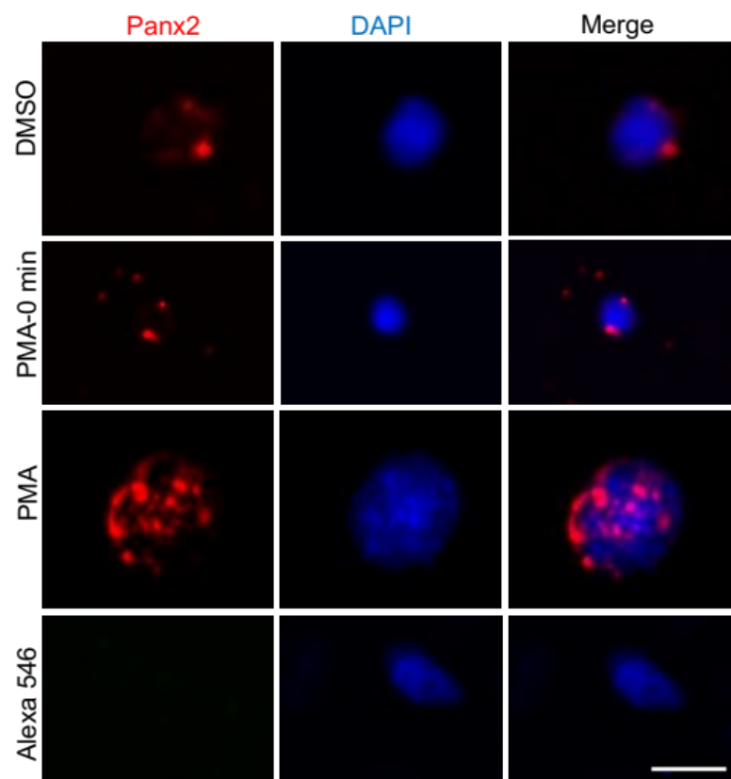
F

Figure S4. Shedding of Panx2 C-terminal fragment and nuclear translocation. Related to Figure 4.

(A) Cellular localisation of Panx2, Polr1c and Mgea5 as determined by the immunostaining of mNPCs.
(B-D) Immunoblotting of (B) Panx2, (C) Polr1c and (D) Mgea5 using the nuclear and cytoplasmic extract showing the localisation of Panx2, Polr1c and Mgea5 bands at 70KDa (cytoplasmic), 40KDa (nuclear) and 130KDa (cytoplasmic/nuclear) respectively.
(E) Signal intensity of Panx2 in the nucleus. Panx2 was quantified in the nucleus using the Image J software after treatment with PMA for 2hrs at 37ºC, in the unstimulated, vehicle (DMSO) and mNPCs transfected with mutated c-terminal fragment Panx2 (△341-343). N= 3 experiments. mean ± SEM, ****p<0.0001, ***p<0.0005. One-way Anova.
(F) Live antibody uptake experiment was performed in mNPCs to confirm the nuclear translocation by Panx2. mNPCs were immunostained with Panx2 CTF antibody at 4ºC and treated with PMA for 2hrs at 37ºC. The majority of the surface-bound antibody transported to the nuclear region with no uptake in 0 min and vehicle. Only secondary antibody was used as control for the specificity of the staining. N=3 experiments. Image scale bars=10 μm.
(G-H) This movie shows internalization of Panx2 after PMA treatment (G) against the control (H).
The nonspecific band detected in the immunoblotting could be due to non-specific protein degradation (Boassa et al., 2014). Penuela et al., also reported caspase activity of Panx2 resulting in a ∼36KDa band (Penuela et al., 2014). Another study reported that boiling of Panx2 resulted in a monomeric ∼41KDa band (Ambrosi et al., 2010).

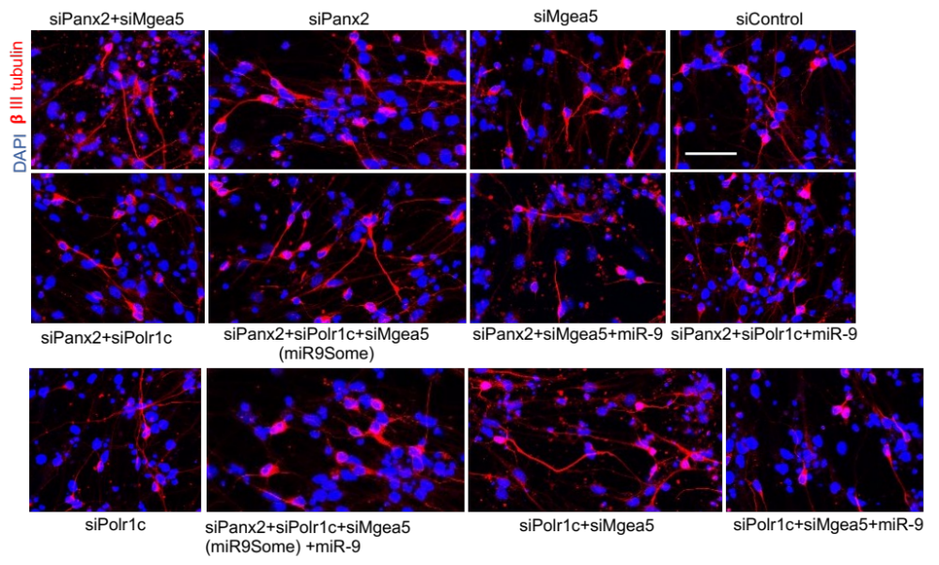
A
Figure S5

Figure S5. miR9Some regulates neuronal differentiation. Related to Figure 6.

(A) Representative images of βIII-tubulin positive cells using immunostaining in differentiated mNPCs transfected with individual siRNAs, a combination of siRNAs together with miR-9 inhibitor and scrambled negative control. N=6 experiments. Image scale bars=10 μm.

