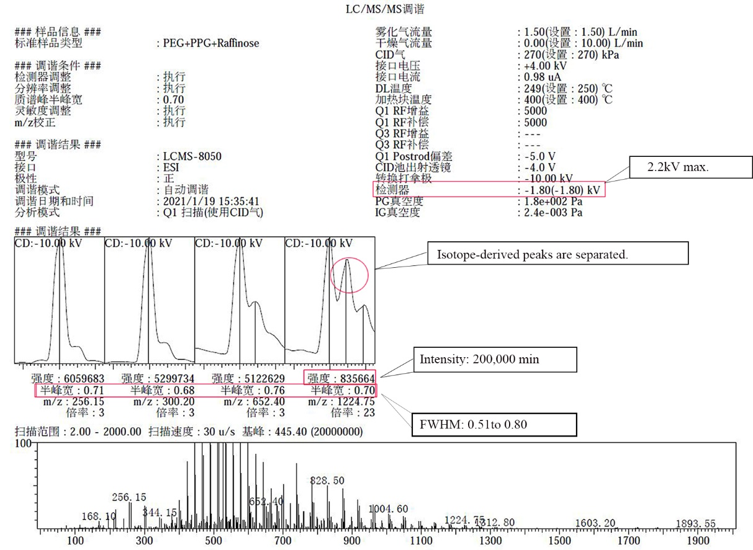
Figure S1. The tuning results report.
The tuning results are marked with red lines, and the corresponding parameter ranges for successful tuning are marked with black lines.

