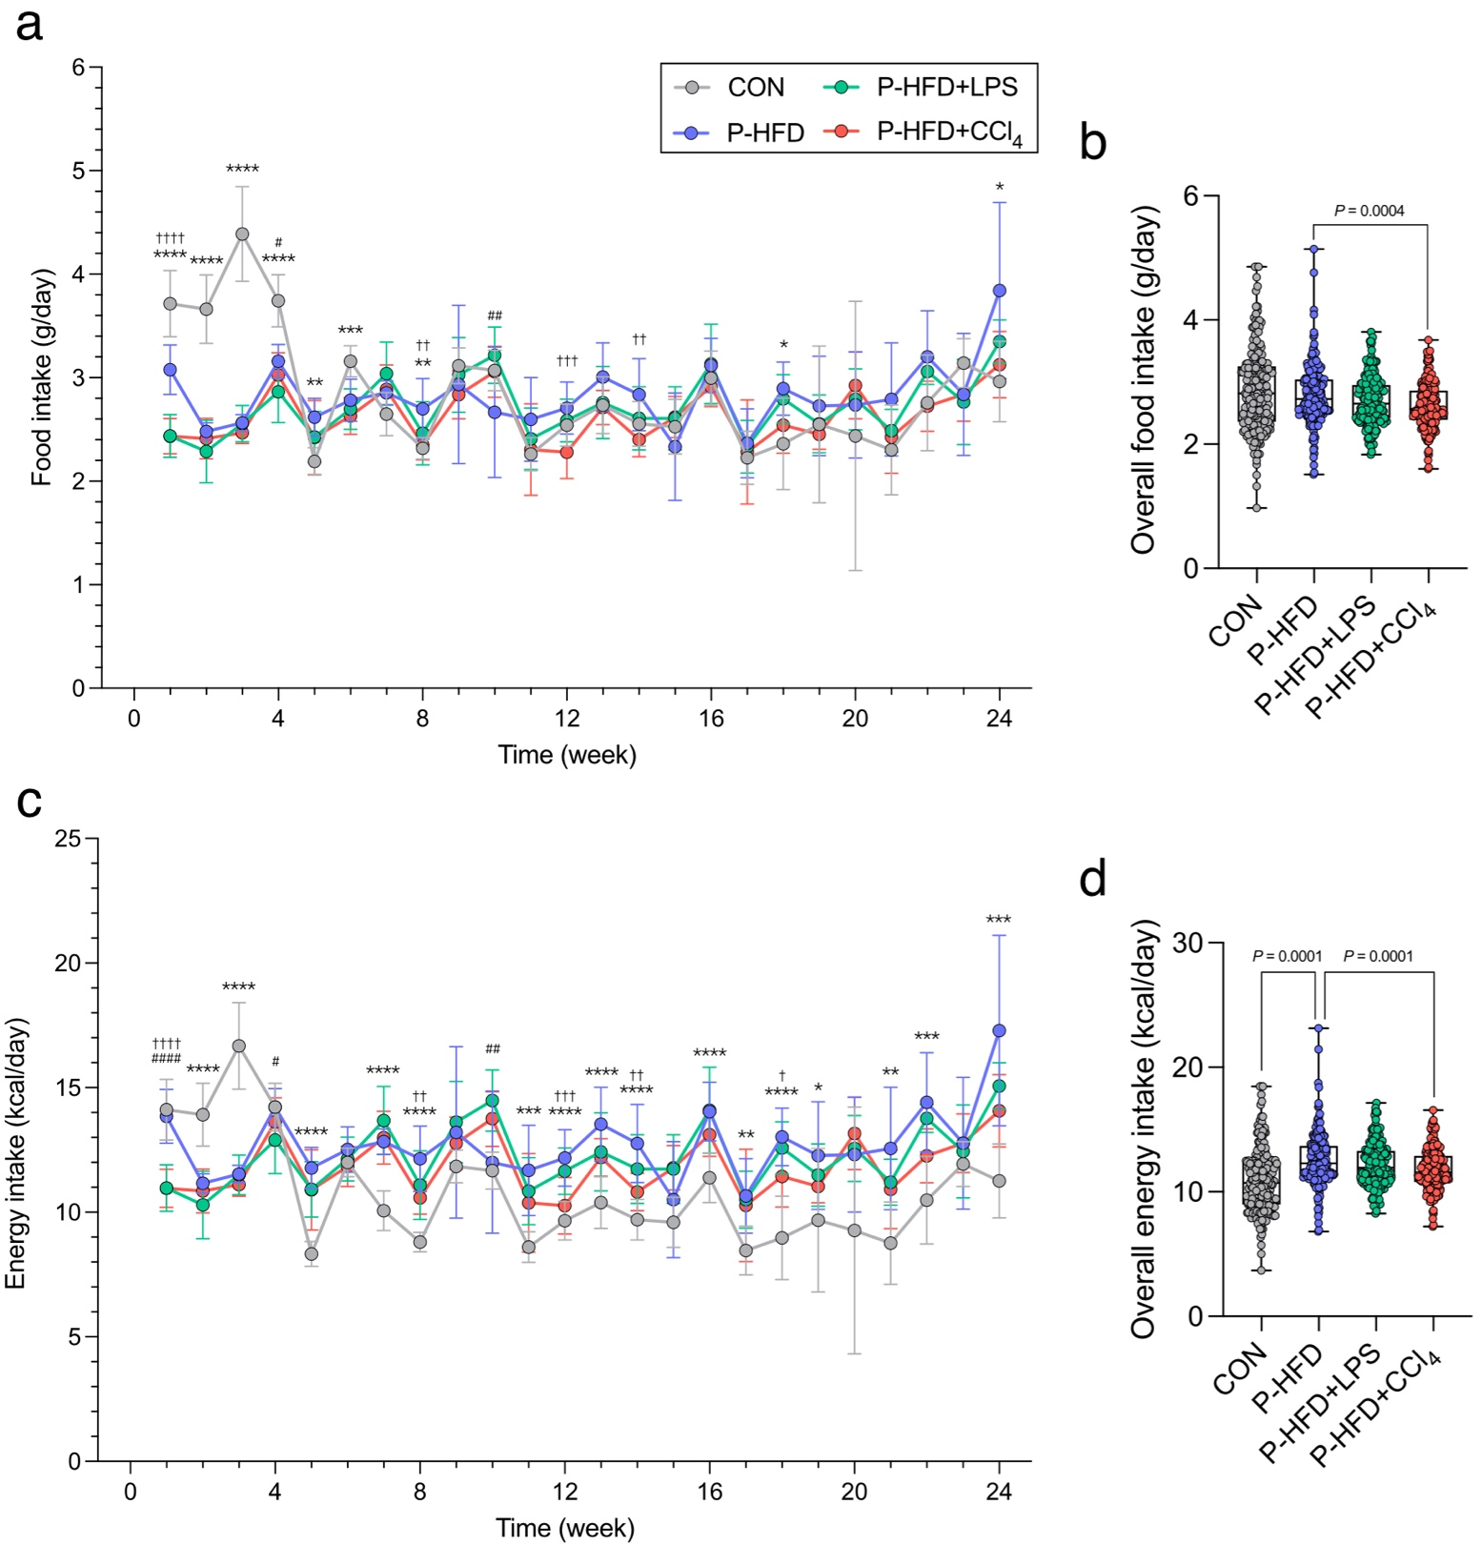
Supplementary Fig. 1| Impact of PFD, LPS, and CCl₄ on food and energy intake changes. (a) food intake change, (b) overall food intake, (c) energy intake change, and (d) overall energy intake. Data were expressed as the mean ± SD (n=7-8). Mice were fed with a control diet or palm oil-containing high-fat diet (PFD). LPS group was intraperitoneally injected with LPS (500 µg/kg bw/week); CCl₄ group was intraperitoneally injected with CCl₄ (320 µg/kg bw/week). The mice were sacrificed every four weeks (n=7-8/group). Statistical analyses were performed by one-way ANOVA with Dunnett's multiple comparison test for comparisons group means against the P-HFD group; CON vs. P-HFD (*, p < 0.05; **, p < 0.01; ***, p < 0.001; ****, p < 0.0001); P-HFD vs P-HFD + LPS (#, p <0.05; ##, p <0.01; ###, p < 0.001; ####, p < 0.0001); and P-HFD vs P-HFD + CCl₄ (†, p < 0.05; ††, p <0.01; †††, p < 0.001; ††††, p < 0.0001).
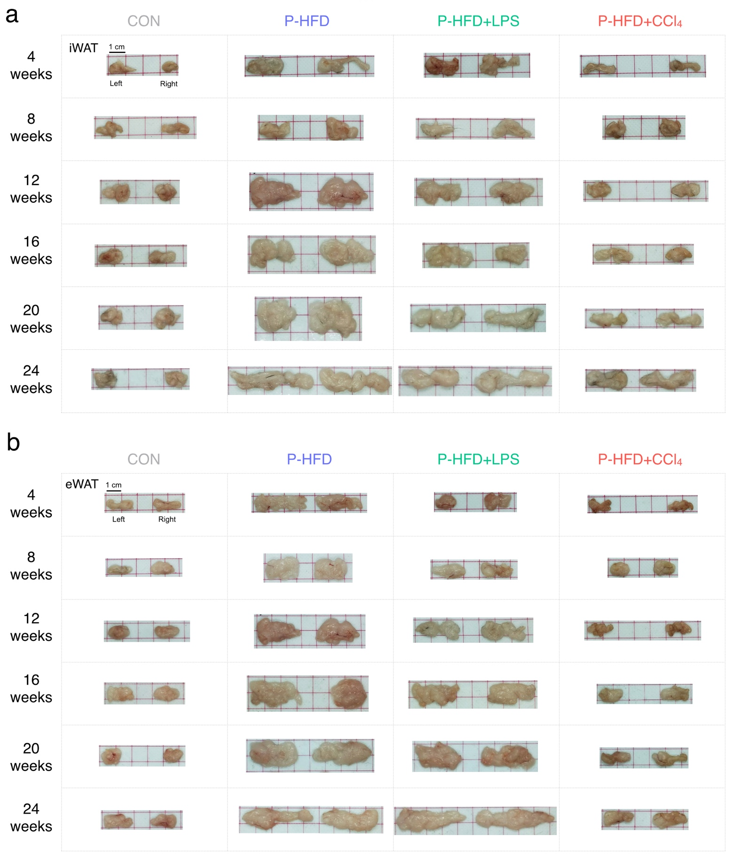
Supplementary Fig. 2| Impact of PFD, LPS, and CCl₄ on iWAT and eWAT. (a) representative image of iWAT, and (b) eWAT. Mice were fed with a control diet or palm oil-containing high-fat diet (PFD). LPS group was intraperitoneally injected with LPS (500 µg/kg bw/week); CCl₄ group was intraperitoneally injected with CCl₄ (320 µg/kg bw/week). The mice were sacrificed every four weeks (n=7-8/group).

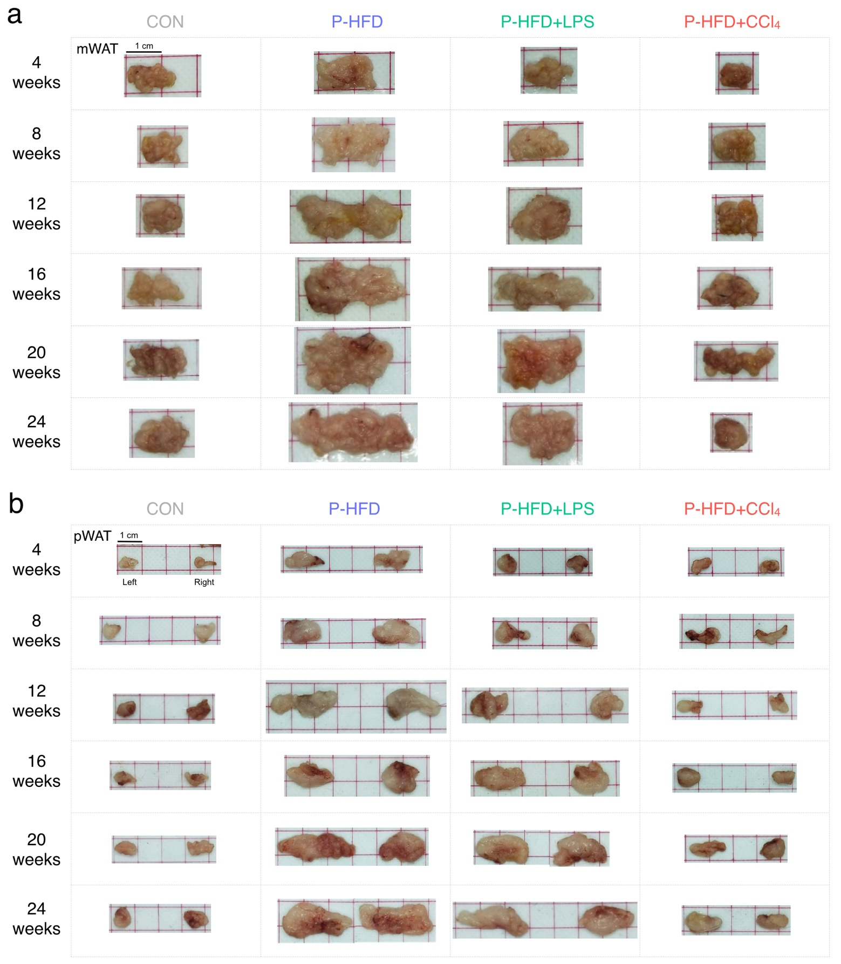
Supplementary Fig. 3| Impact of PFD, LPS, and CCl₄ on mWAT and pWAT. (a) representative image of mWAT, and (b) pWAT. Mice were fed with a control diet or palm oil-containing high-fat diet (PFD). LPS group was intraperitoneally injected with LPS (500 µg/kg bw/week); CCl₄ group was intraperitoneally injected with CCl₄ (320 µg/kg bw/week). The mice were sacrificed every four weeks (n=7-8/group).

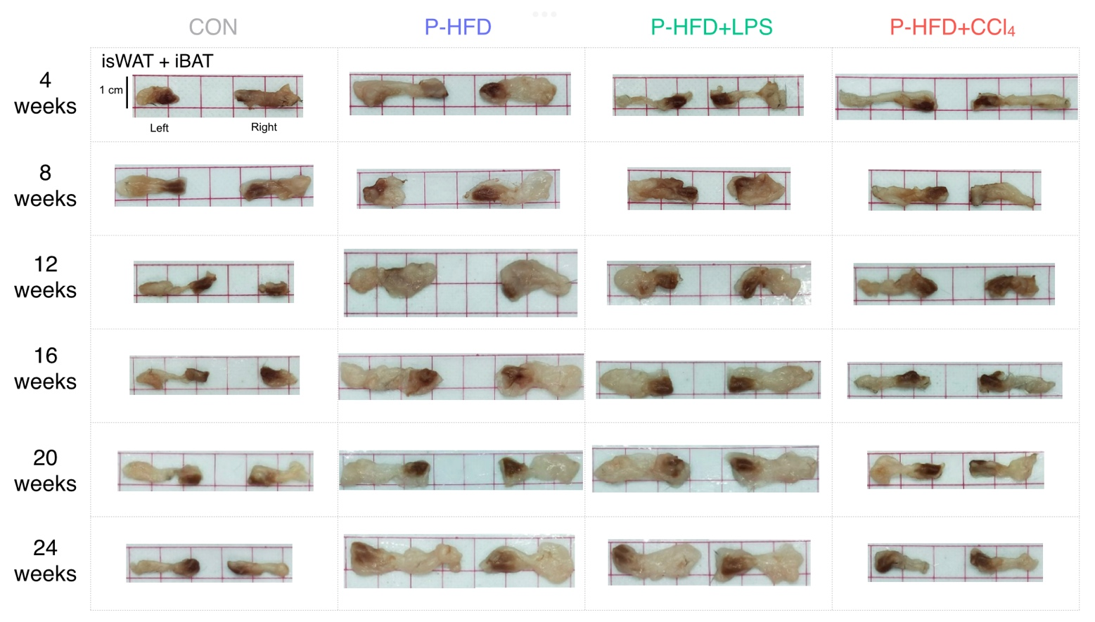
Supplementary Fig. 4| Impact of PFD, LPS, and CCl₄ on inguinal subcutaneous white adipose tissue (isWAT) and interscapular brown adipose tissue (iBAT). Mice were fed with a control diet or palm oil-containing high-fat diet (PFD). LPS group was intraperitoneally injected with LPS (500 µg/kg bw/week); CCl₄ group was intraperitoneally injected with CCl₄ (320 µg/kg bw/week). The mice were sacrificed every four weeks (n=7-8/group).

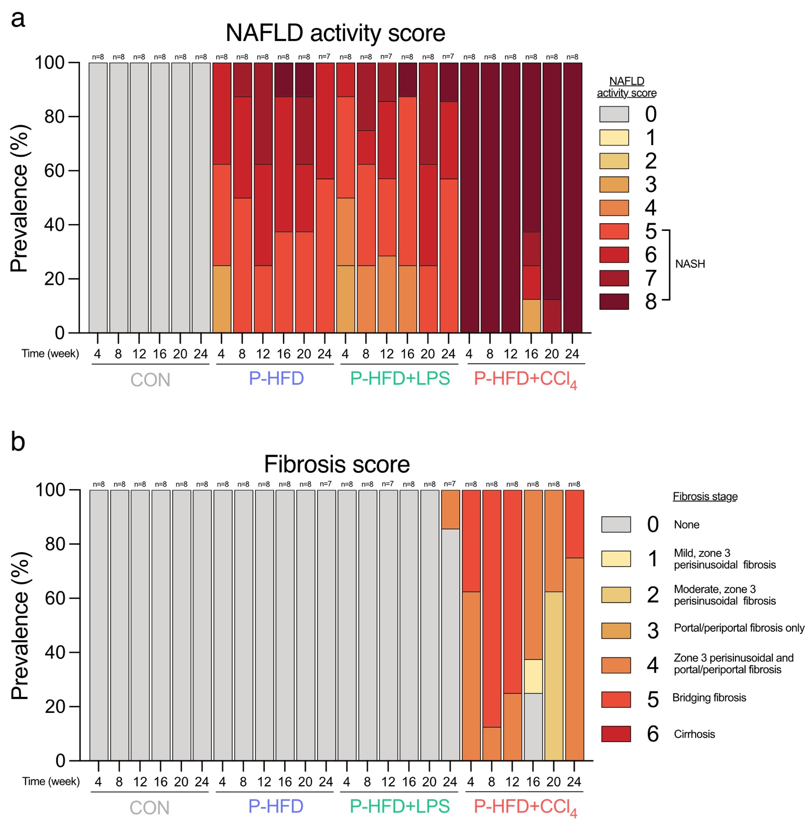
Supplementary Fig. 5| Influence of PFD, LPS, and CCl₄ on changes of histopathology of liver. (a) NAFLD activity score, and (b) fibrosis score. Mice were fed with a control diet or palm oil-containing high-fat diet (PFD). LPS group was intraperitoneally injected with LPS (500 µg/kg bw/week); CCl₄ group was intraperitoneally injected with CCl₄ (320 µg/kg bw/week). The mice were sacrificed every four weeks (n=7-8/group).

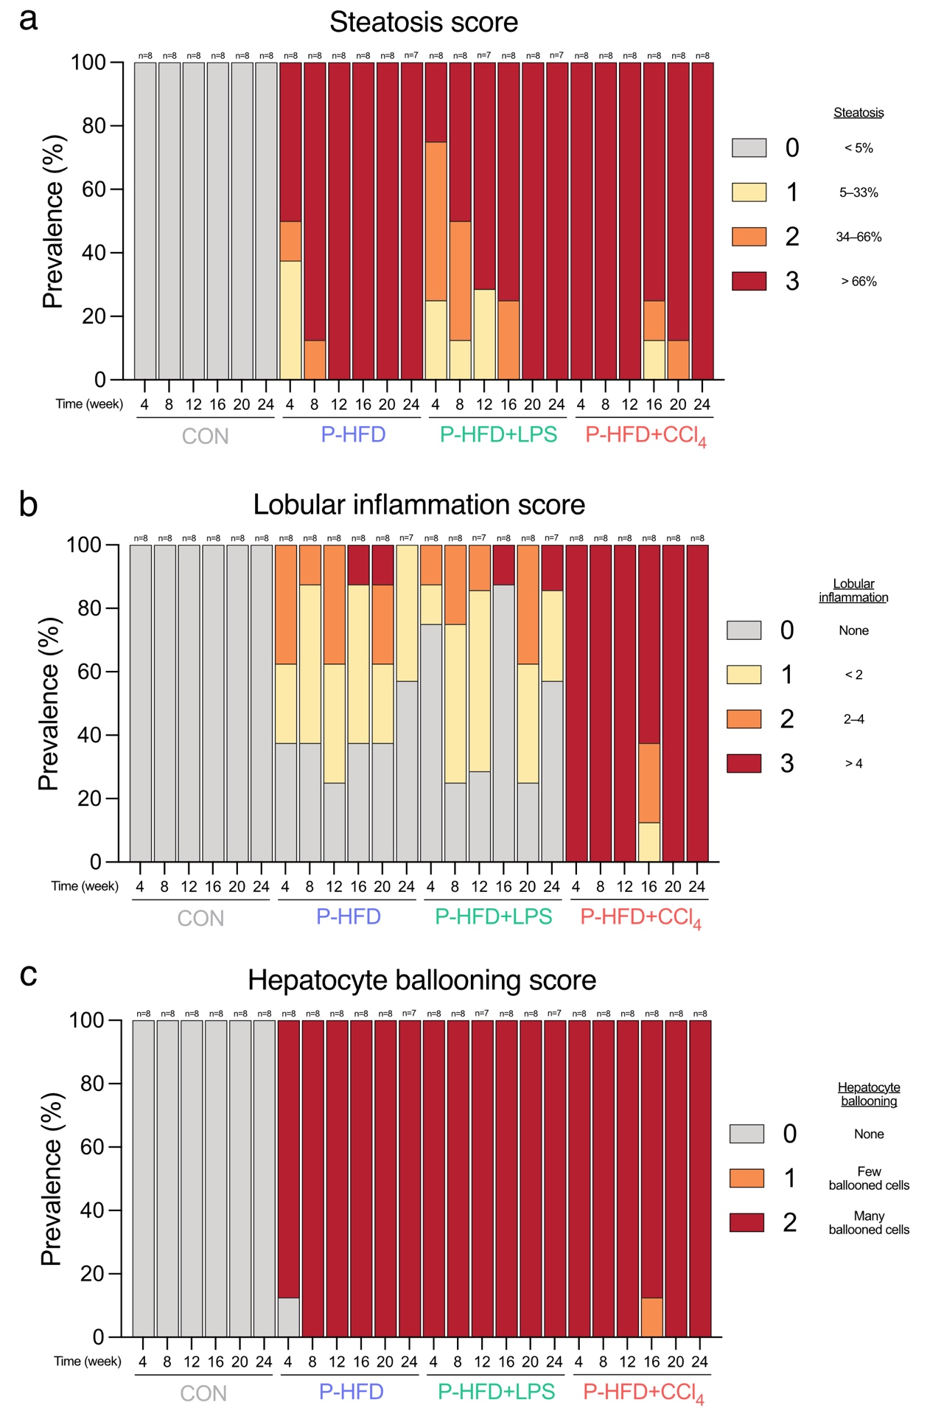
Supplementary Fig. 6| Influence of PFD, LPS, and CCl₄ on changes of histopathology of liver. (a) steatosis score, (b) lobular inflammation score, and (c) hepatocyte ballooning score. Mice were fed with a control diet or palm oil-containing high-fat diet (PFD). LPS group was intraperitoneally injected with LPS (500 µg/kg bw/week); CCl₄ group was intraperitoneally injected with CCl₄ (320 µg/kg bw/week). The mice were sacrificed every four weeks (n=7-8/group).
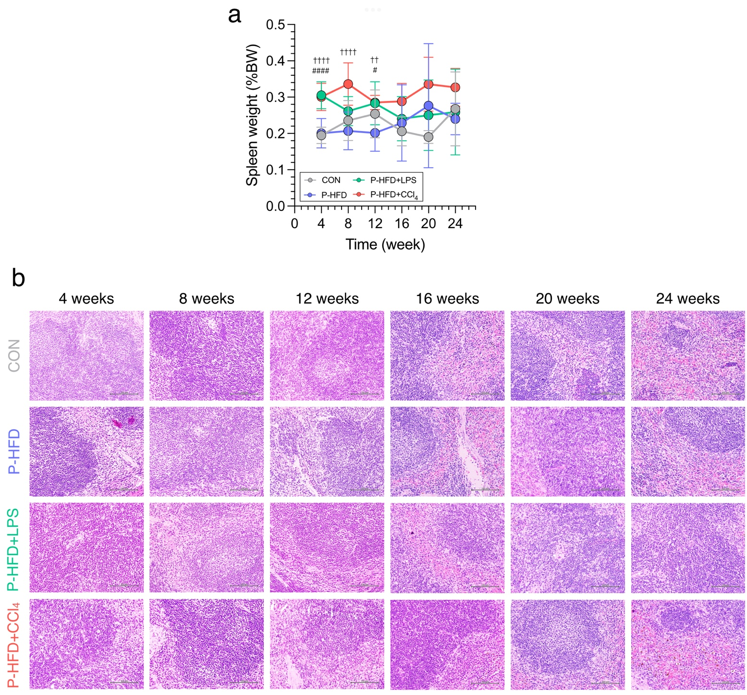
Supplementary Fig. 7| Effect of PFD, LPS, and CCl₄ on spleen. (a) relative spleen weight change, and (b) representative histological features of hematoxylin and eosin-stained spleen section. Mice were fed with a control diet or palm oil-containing high-fat diet (PFD). LPS group was intraperitoneally injected with LPS (500 µg/kg bw/week); CCl₄ group was intraperitoneally injected with CCl₄ (320 µg/kg bw/week). The mice were sacrificed every four weeks (n=7-8/group). Statistical analyses were performed by one-way ANOVA with Dunnett's multiple comparison test for comparison group means against the P-HFD group; CON vs. P-HFD (*, p < 0.05; **, p < 0.01; ***, p < 0.001; ****, p < 0.0001); P-HFD vs P-HFD + LPS (#, p <0.05; ##, p <0.01; ###, p < 0.001; ####, p < 0.0001); and P-HFD vs P-HFD + CCl₄ (†, p < 0.05; ††, p <0.01; †††, p < 0.001; ††††, p < 0.0001).
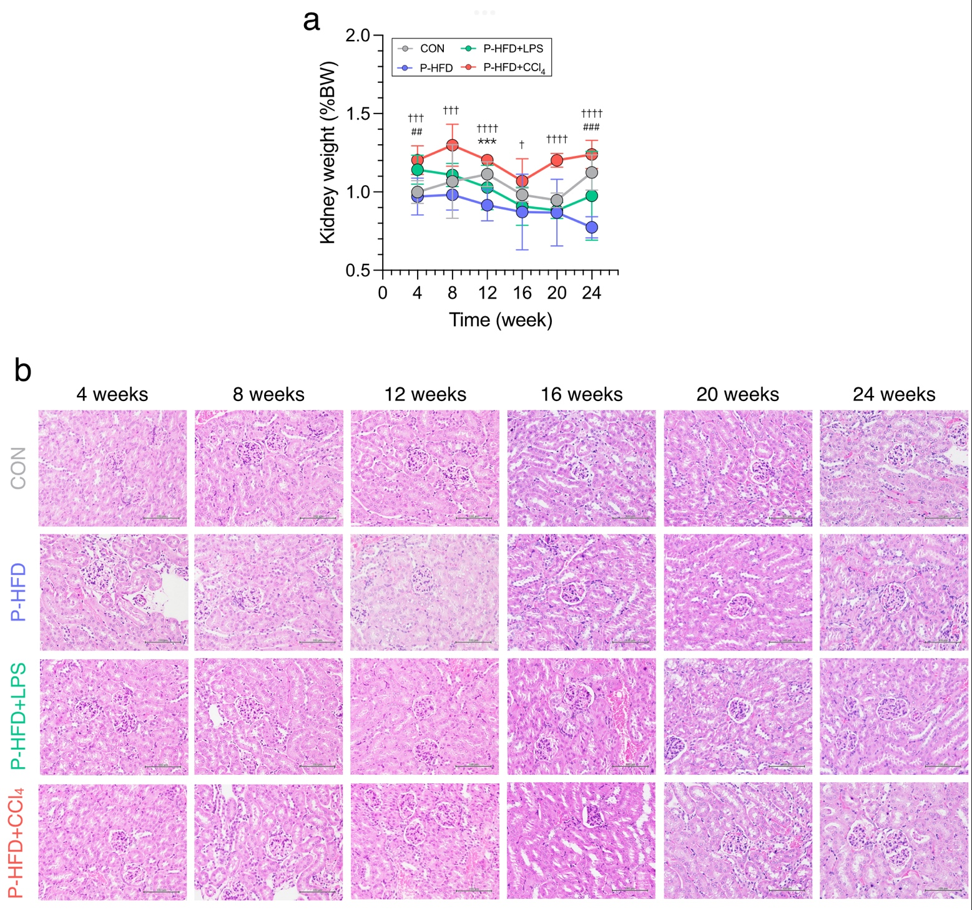
Supplementary Fig. 8| Effect of PFD, LPS, and CCl₄ on kidney. (a) relative kidney weight change, and (b) representative histological features of hematoxylin and eosin-stained kidney section. Mice were fed with a control diet or palm oil-containing high-fat diet (PFD). LPS group was intraperitoneally injected with LPS (500 µg/kg bw/week); CCl₄ group was intraperitoneally injected with CCl₄ (320 µg/kg bw/week). The mice were sacrificed every four weeks (n=7-8/group). Statistical analyses were performed by one-way ANOVA with Dunnett's multiple comparison test for comparison group means against the P-HFD group; CON vs. P-HFD (*, p < 0.05; **, p < 0.01; ***, p < 0.001; ****, p < 0.0001); P-HFD vs P-HFD + LPS (#, p <0.05; ##, p <0.01; ###, p < 0.001; ####, p < 0.0001); and P-HFD vs P-HFD + CCl₄ (†, p < 0.05; ††, p <0.01; †††, p < 0.001; ††††, p < 0.0001).
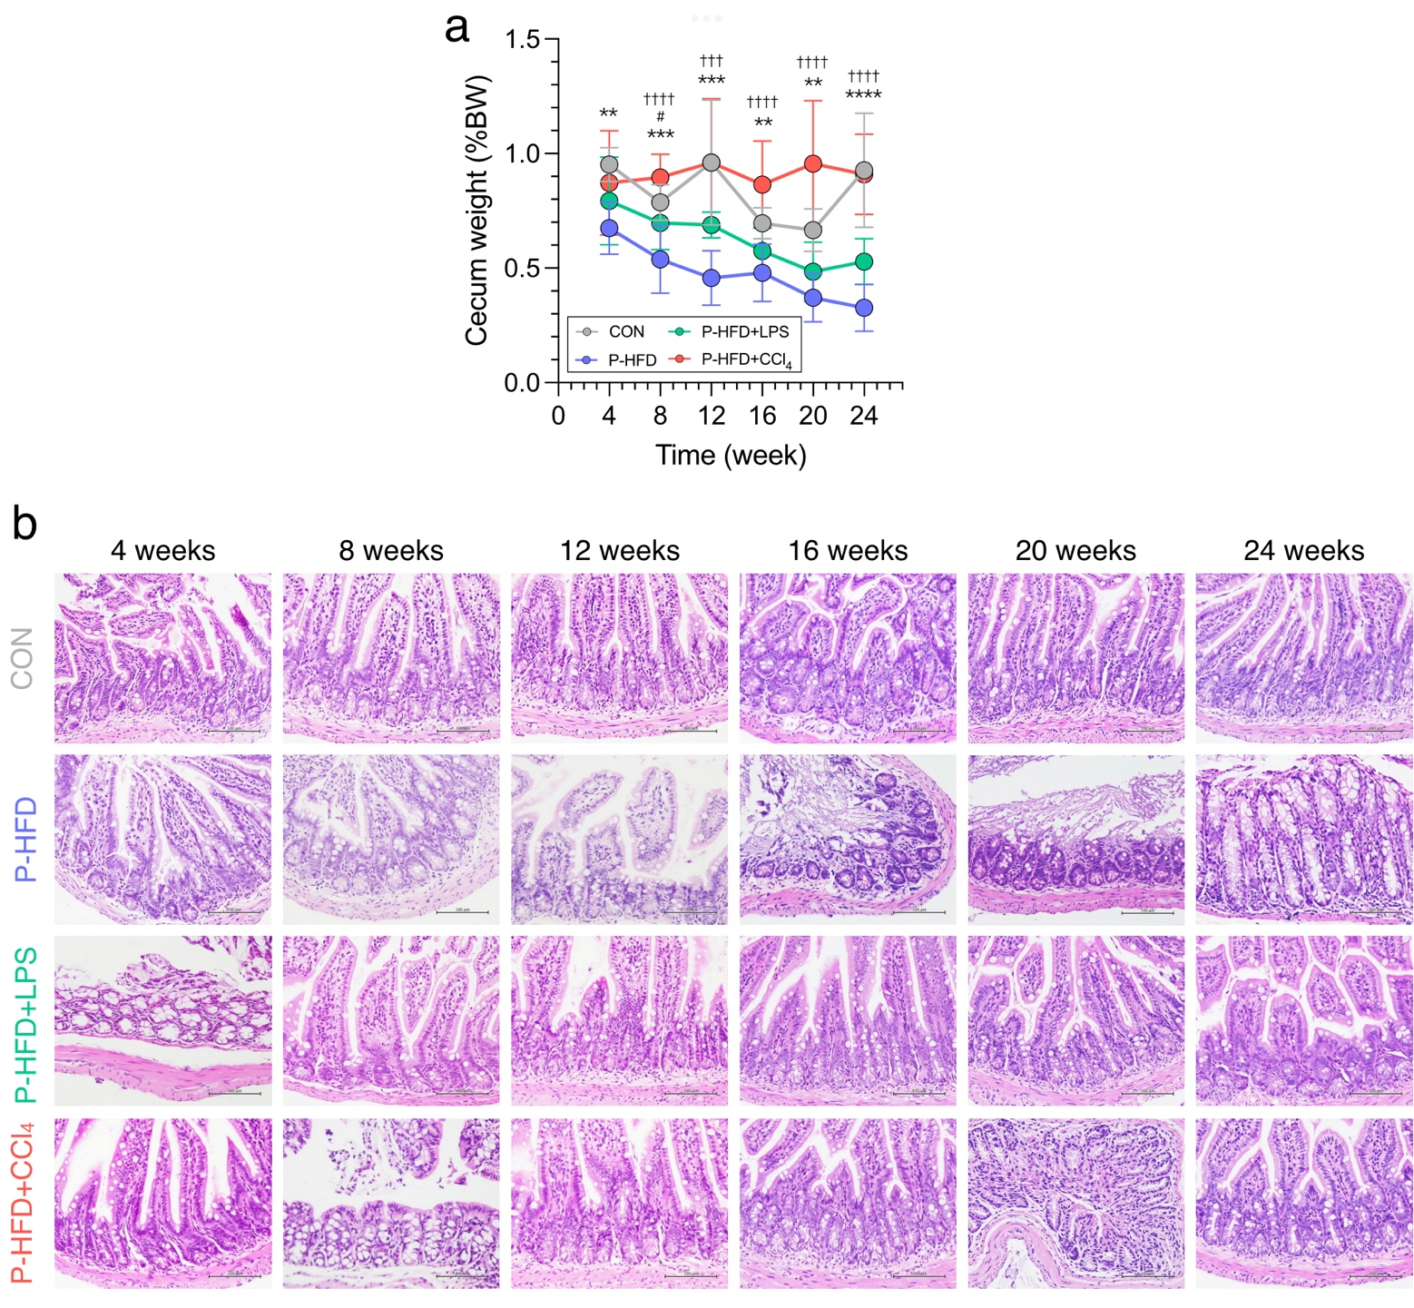
Supplementary Fig. 9| Effect of PFD, LPS, and CCl₄ on cecum and ileum. (a) relative cecum weight change, and (b) representative histological features of hematoxylin and eosin-stained ileum section. Mice were fed with a control diet or palm oil-containing high-fat diet (PFD). LPS group was intraperitoneally injected with LPS (500 µg/kg bw/week); CCl₄ group was intraperitoneally injected with CCl₄ (320 µg/kg bw/week). The mice were sacrificed every four weeks (n=7-8/group). Statistical analyses were performed by one-way ANOVA with Dunnett's multiple comparison test for comparison group means against the P-HFD group; CON vs. P-HFD (*, p < 0.05; **, p < 0.01; ***, p < 0.001; ****, p < 0.0001); P-HFD vs P-HFD + LPS (#, p <0.05; ##, p <0.01; ###, p < 0.001; ####, p < 0.0001); and P-HFD vs P-HFD + CCl₄ (†, p < 0.05; ††, p <0.01; †††, p < 0.001; ††††, p < 0.0001).
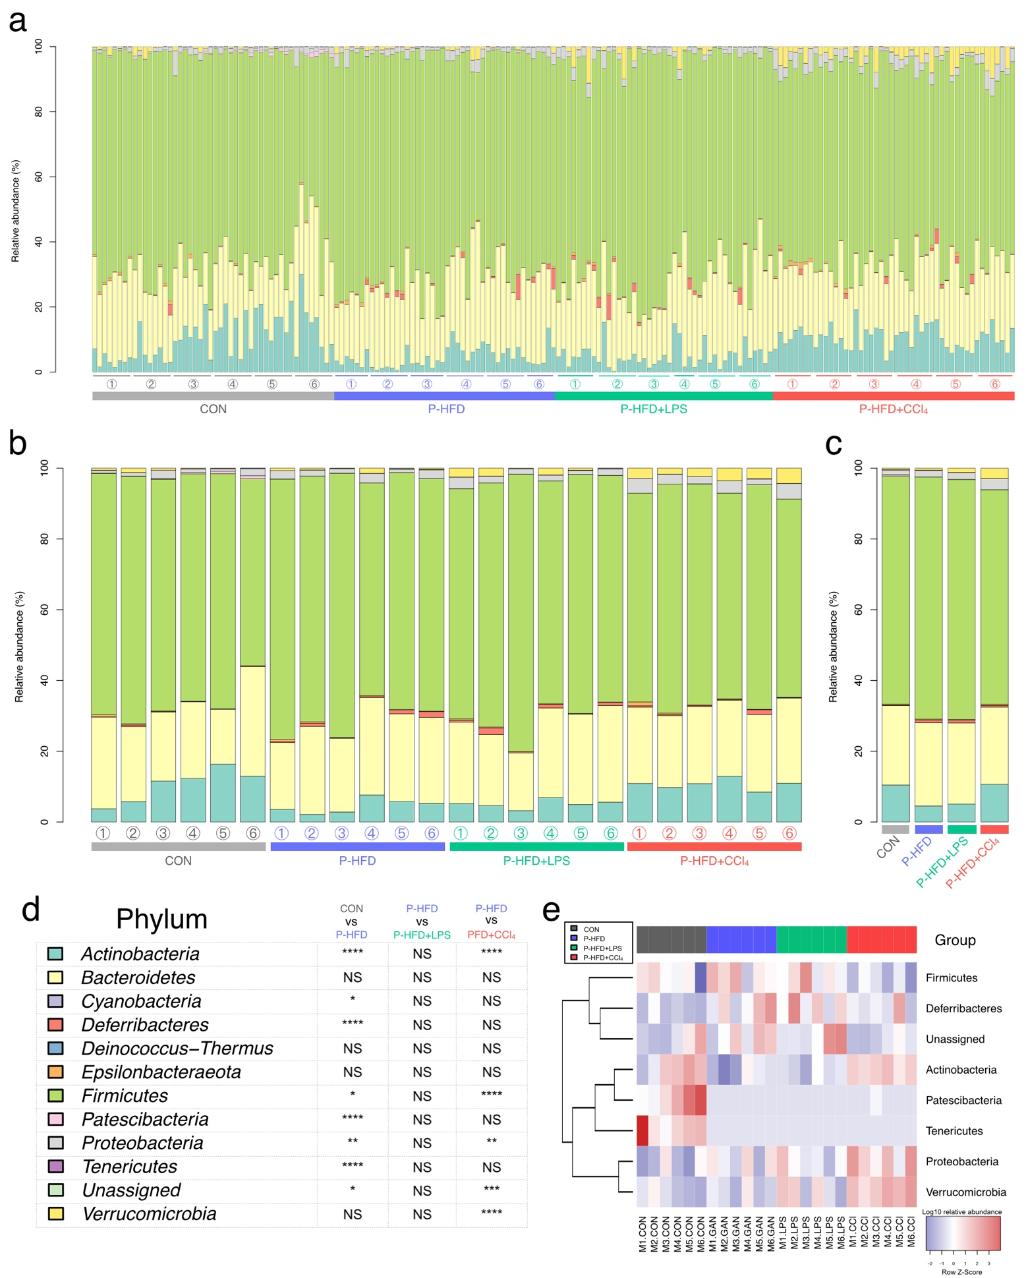
Supplementary Fig. 10| PFD, LPS, and CCl₄ modified feces microbiota composition at phylum level. Bar plot of relative abundance at phylum level based on (a) each individual, (b) time, (c) treatment group, (d) legend of bar plot and statistical results, and (e) heat map of the relative abundances at phylum level of feces microbiota with a significant difference using the Kruskal–Wallis test with FDR-adjusted p-value (q < 0.05). Mice were fed with a control diet or palm oil-containing high-fat diet (PFD). LPS group was intraperitoneally injected with LPS (500 µg/kg bw/week); CCl₄ group was intraperitoneally injected with CCl₄ (320 µg/kg bw/week). The mice were sacrificed every four weeks (n=7-8/group). Statistical analyses were performed by Kruskal-Wallis test with Dunn's multiple comparisons test for comparison group means against the P-HFD group with FDR-adjusted p-value; CON vs. P-HFD; P-HFD vs P-HFD + LPS; and P-HFD vs P-HFD + CCl₄ (*, p < 0.05; **, p < 0.01; ***, p < 0.001; ****, p < 0.0001).
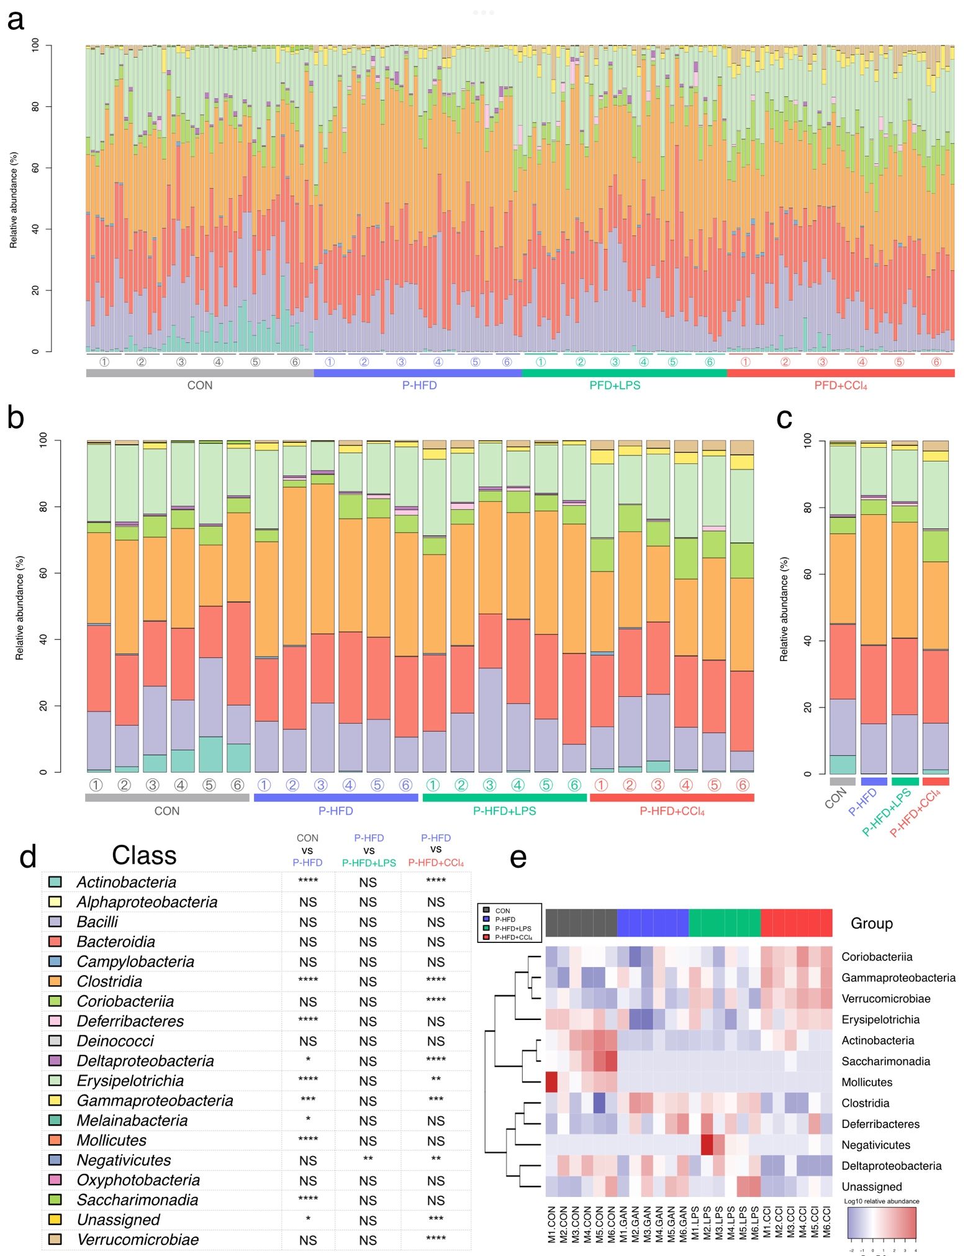
Supplementary Fig. 11| PFD, LPS, and CCl₄ modified feces microbiota composition at class level. Bar plot of relative abundance at class level based on (a) each individual, (b) time, (c) treatment group, (d) legend of bar plot and statistical results, and (e) heat map of the relative abundances at class level of feces microbiota with a significant difference using the Kruskal–Wallis test with FDR-adjusted p-value (q < 0.05). Mice were fed with a control diet or palm oil-containing high-fat diet (PFD). LPS group was intraperitoneally injected with LPS (500 µg/kg bw/week); CCl₄ group was intraperitoneally injected with CCl₄ (320 µg/kg bw/week). The mice were sacrificed every four weeks (n=7-8/group). Statistical analyses were performed by Kruskal-Wallis test with Dunn's multiple comparisons test for comparison group means against the P-HFD group with FDR-adjusted p-value; CON vs. P-HFD; P-HFD vs P-HFD + LPS; and P-HFD vs P-HFD + CCl₄ (*, p < 0.05; **, p < 0.01; ***, p < 0.001; ****, p < 0.0001).
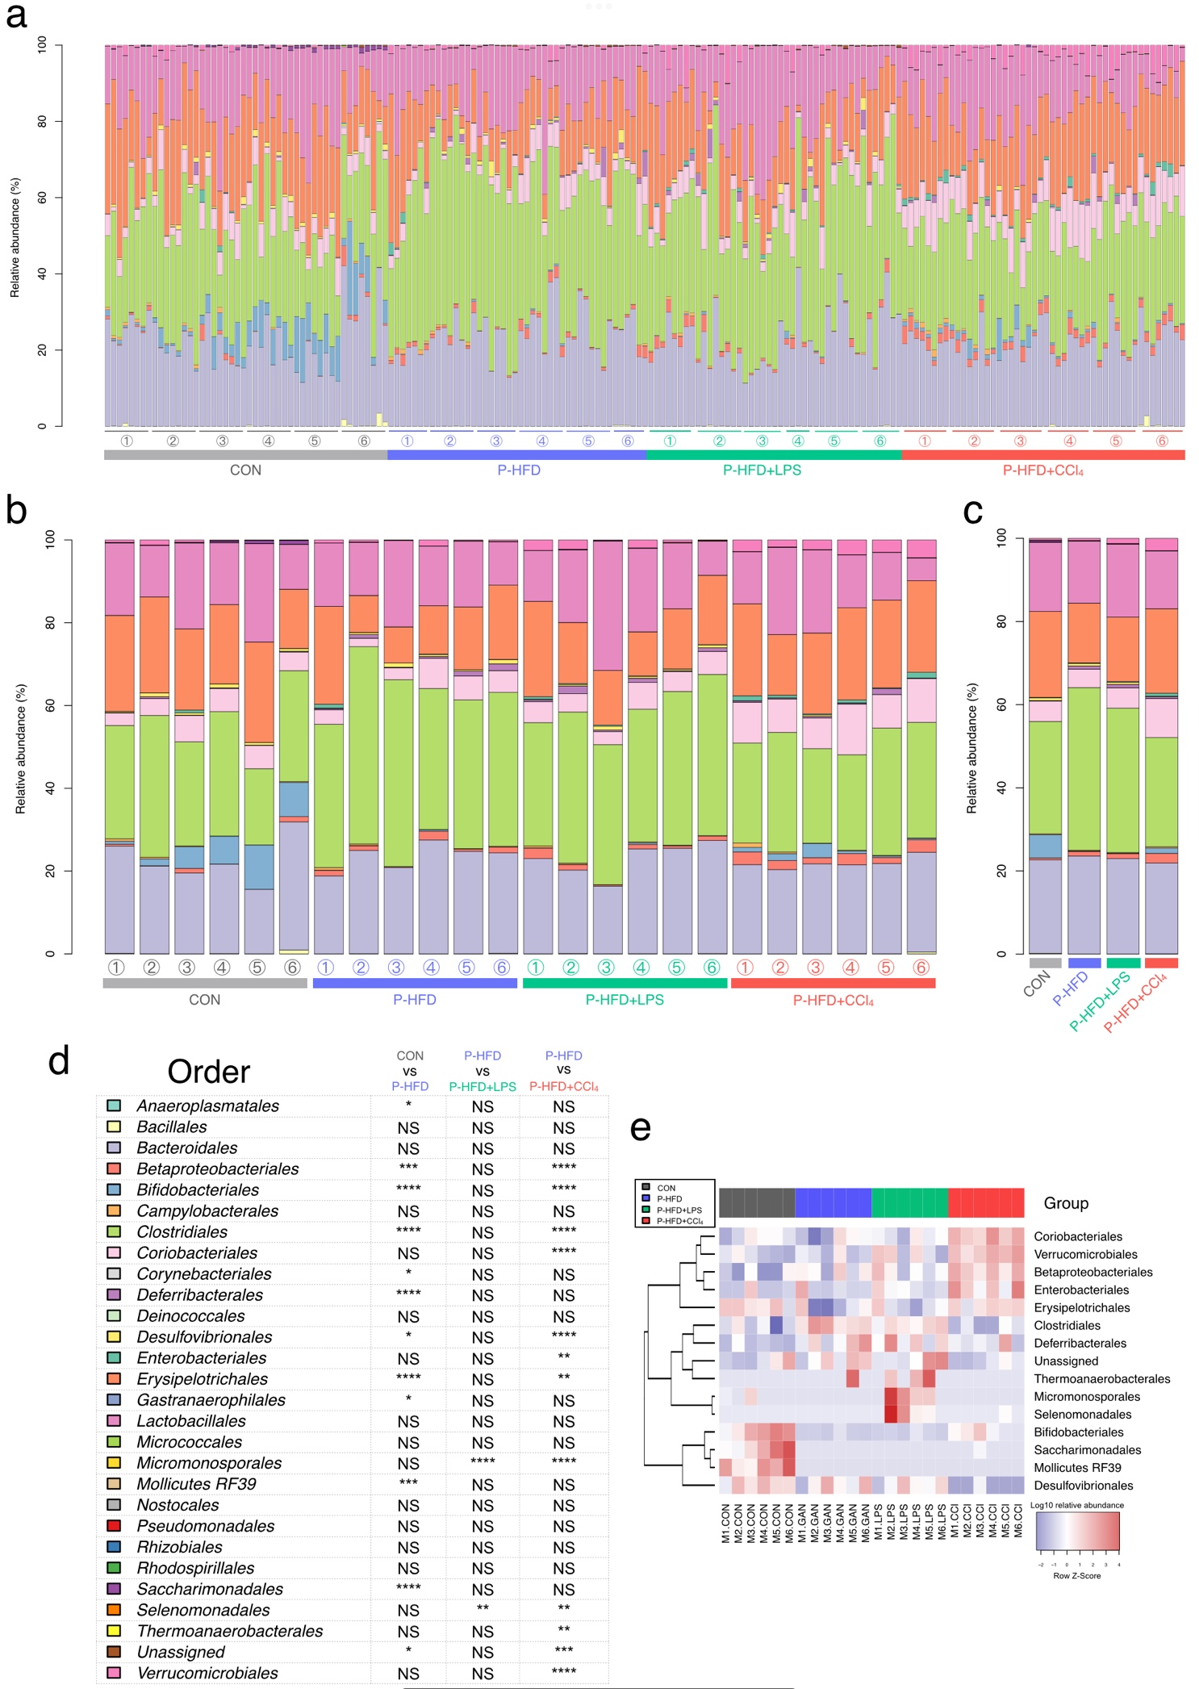
Supplementary Fig. 12| PFD, LPS, and CCl₄ modified feces microbiota composition at order level. Bar plot of relative abundance at order level based on (a) each individual, (b) time, (c) treatment group, (d) legend of bar plot and statistical results, and (e) heat map of the relative abundances at order level of feces microbiota with a significant difference using the Kruskal–Wallis test with FDR-adjusted p-value (q < 0.05). Mice were fed with a control diet or palm oil-containing high-fat diet (PFD). LPS group was intraperitoneally injected with LPS (500 µg/kg bw/week); CCl₄ group was intraperitoneally injected with CCl₄ (320 µg/kg bw/week). The mice were sacrificed every four weeks (n=7-8/group). Statistical analyses were performed by Kruskal-Wallis test with Dunn's multiple comparisons test for comparison group means against the P-HFD group with FDR-adjusted p-value; CON vs. P-HFD; P-HFD vs P-HFD + LPS; and P-HFD vs P-HFD + CCl₄ (*, p < 0.05; **, p < 0.01; ***, p < 0.001; ****, p < 0.0001).
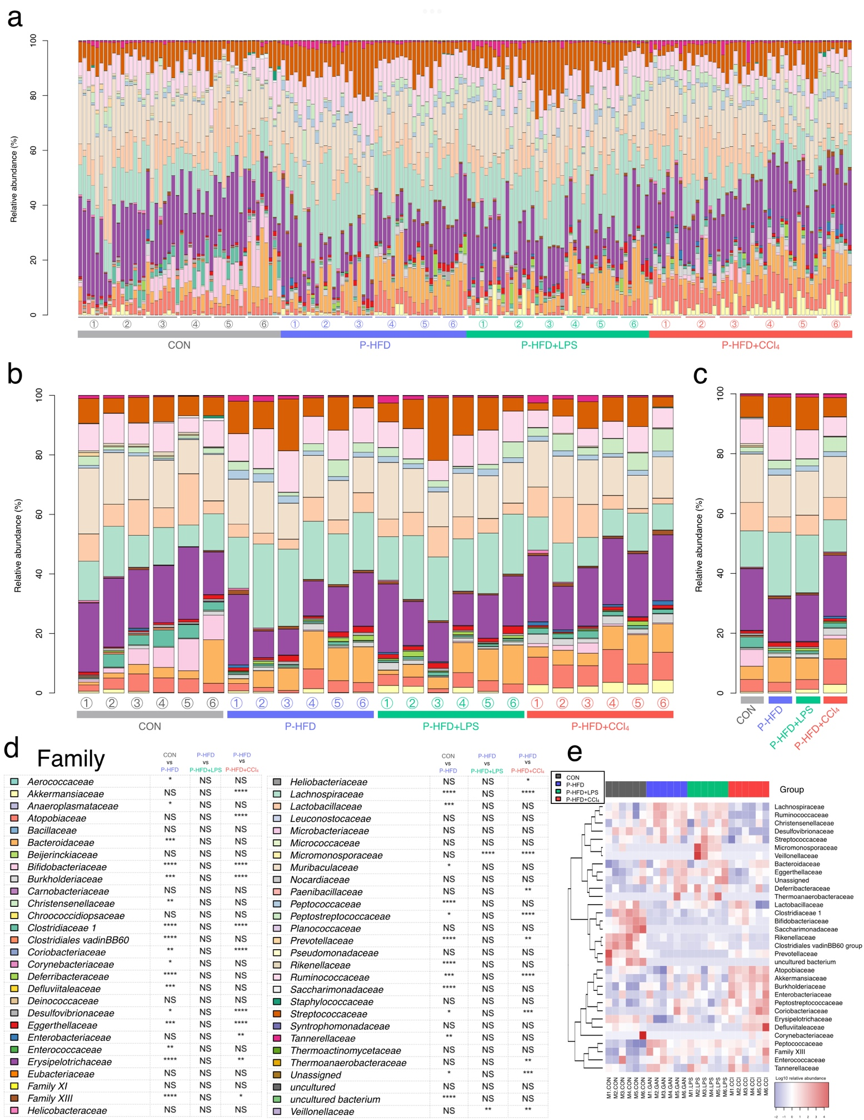
Supplementary Fig. 13| PFD, LPS, and CCl₄ modified feces microbiota composition at family level. Bar plot of relative abundance at family level based on (a) each individual, (b) time, (c) treatment group, (d) legend of bar plot and statistical results, and (e) heat map of the relative abundances at family level of feces microbiota with a significant difference using the Kruskal–Wallis test with FDR-adjusted p-value (q < 0.05). Mice were fed with a control diet or palm oil-containing high-fat diet (PFD). LPS group was intraperitoneally injected with LPS (500 µg/kg bw/week); CCl₄ group was intraperitoneally injected with CCl₄ (320 µg/kg bw/week). The mice were sacrificed every four weeks (n=7-8/group). Statistical analyses were performed by Kruskal-Wallis test with Dunn's multiple comparisons test for comparison group means against the P-HFD group with FDR-adjusted p-value; CON vs. P-HFD; P-HFD vs P-HFD + LPS; and P-HFD vs P-HFD + CCl₄ (*, p < 0.05; **, p < 0.01; ***, p < 0.001; ****, p < 0.0001).
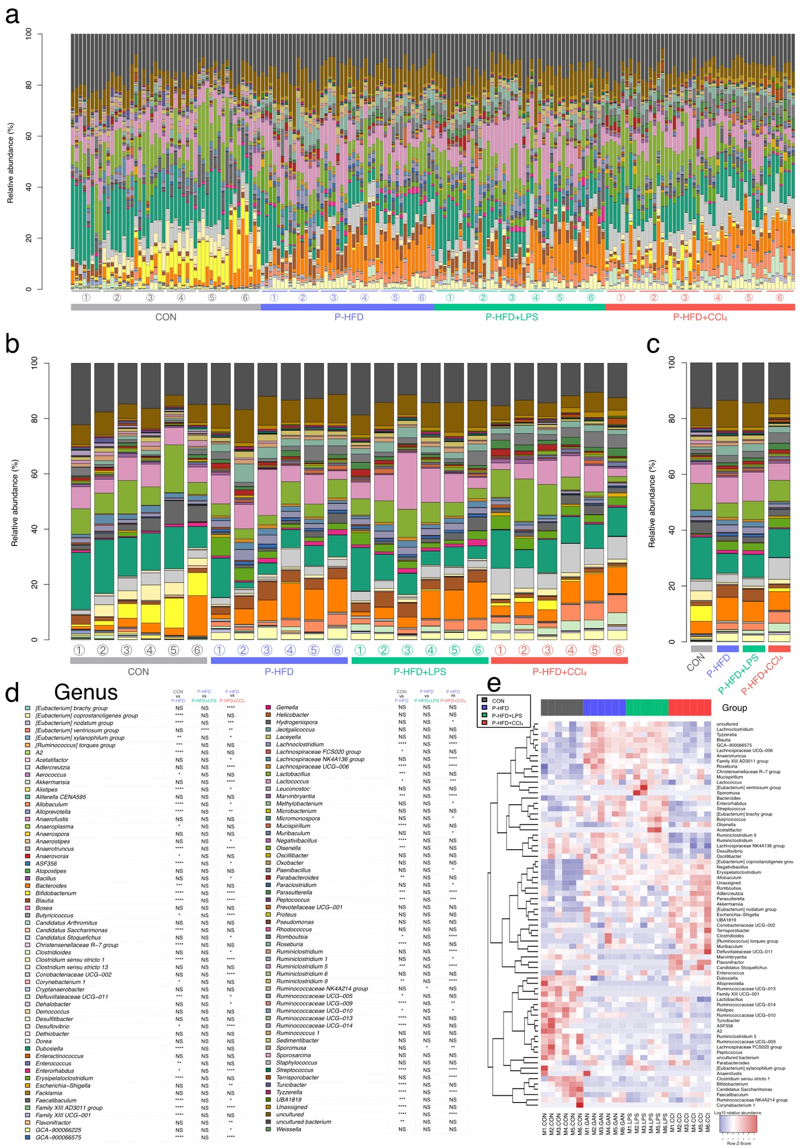
Supplementary Fig. 14| PFD, LPS, and CCl₄ modified feces microbiota composition at genus level. Bar plot of relative abundance at genus level based on (a) each individual, (b) time, (c) treatment group, (d) legend of bar plot and statistical results, and (e) heat map of the relative abundances at genus level of feces microbiota with a significant difference using the Kruskal–Wallis test with FDR-adjusted p-value (q < 0.05). Mice were fed with a control diet or palm oil-containing high-fat diet (PFD). LPS group was intraperitoneally injected with LPS (500 µg/kg bw/week); CCl₄ group was intraperitoneally injected with CCl₄ (320 µg/kg bw/week). The mice were sacrificed every four weeks (n=7-8/group). Statistical analyses were performed by Kruskal-Wallis test with Dunn's multiple comparisons test for comparison group means against the P-HFD group with FDR-adjusted p-value; CON vs. P-HFD; P-HFD vs P-HFD + LPS; and P-HFD vs P-HFD + CCl₄ (*, p < 0.05; **, p < 0.01; ***, p < 0.001; ****, p < 0.0001).
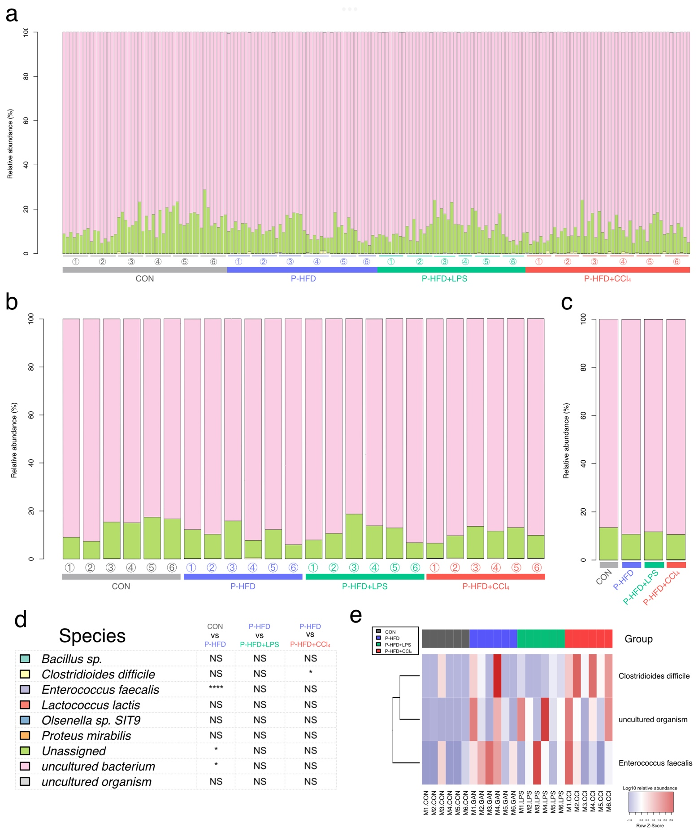
Supplementary Fig. 15| PFD, LPS, and CCl₄ modified feces microbiota composition at species level. Bar plot of relative abundance at species level based on (a) each individual, (b) time, (c) treatment group, (d) legend of bar plot and statistical results, and (e) heat map of the relative abundances at species level of feces microbiota with a significant difference using the Kruskal–Wallis test with FDR-adjusted p-value (q < 0.05). Mice were fed with a control diet or palm oil-containing high-fat diet (PFD). LPS group was intraperitoneally injected with LPS (500 µg/kg bw/week); CCl₄ group was intraperitoneally injected with CCl₄ (320 µg/kg bw/week). The mice were sacrificed every four weeks (n=7-8/group). Statistical analyses were performed by Kruskal-Wallis test with Dunn's multiple comparisons test for comparison group means against the P-HFD group with FDR-adjusted p-value; CON vs. P-HFD; P-HFD vs P-HFD + LPS; and P-HFD vs P-HFD + CCl₄ (*, p < 0.05; **, p < 0.01; ***, p < 0.001; ****, p < 0.0001).
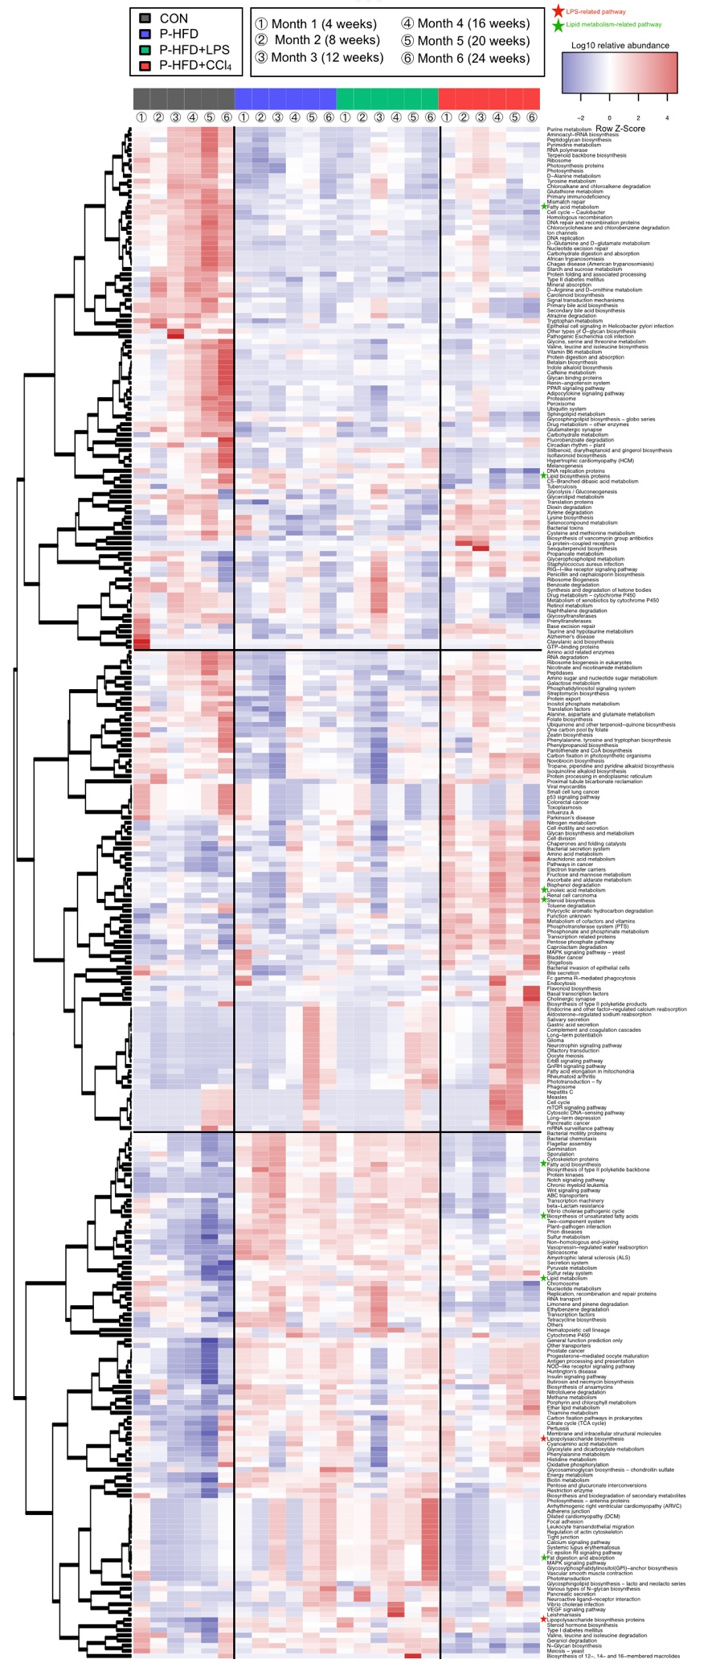
Supplementary Fig. 16| Impact of PFD, LPS, and CCl₄ on the functional capabilities changes of the feces microbiota, based on 16S rDNA amplicon. Heat map of the relative KEGG pathway with a significant difference using the Kruskal–Wallis test with FDR-adjusted p-value (q < 0.05). Relative abundance was predicted using PICRUSt2. Mice were fed with a control diet or palm oil-containing high-fat diet (PFD). LPS group was intraperitoneally injected with LPS (500 µg/kg bw/week); CCl₄ group was intraperitoneally injected with CCl₄ (320 µg/kg bw/week). The mice were sacrificed every four weeks (n=7-8/group).

