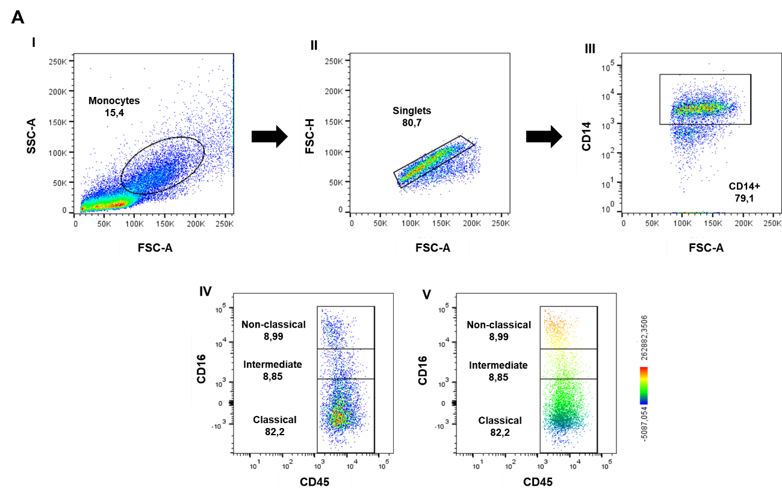
Figure 1. Monocytes subpopulations gating. Monocyte population was gated by forward scatter area (FSC-A) and side scatter area (SSC-A) using pseudocolor dot plots tool (I). Doublets were excluded applying FSC-A versus FSC-height (FSC-H) gate (II). CD14 positive cells (total monocyte population) were selected (III) and, posteriorly, monocyte subpopulations were defined applying CD45 versus CD16 dot plots (IV). CD16 heatmap gradient expression and CD16 median of fluorescence intensity (MFI) were used to delimit the monocytes subpopulations in classical (CD16-), intermediate (CD16+) and non-classical (CD16++) (V). The frequency of each monocyte subpopulations were analyzed by dot plots and the result were expressed by percent of labeled cells.

