Supplementary Information:

Alvarez varifocal X-ray lens
Vishal Dhamgaye, David Laundy, Thomas Moxham, Sara Baldock, Hossein Khosroabadi, Oliver Fox & Kawal Sawhney

Fig. S1: Back focal length tuning (red solid dots) of HKB around its focal length f_{KB} = 125 mm as a function of the lateral shift in AXL1 and AXL2 that provides a varying parabolic concave and convex profiles of a different radius of curvatures (blue line).

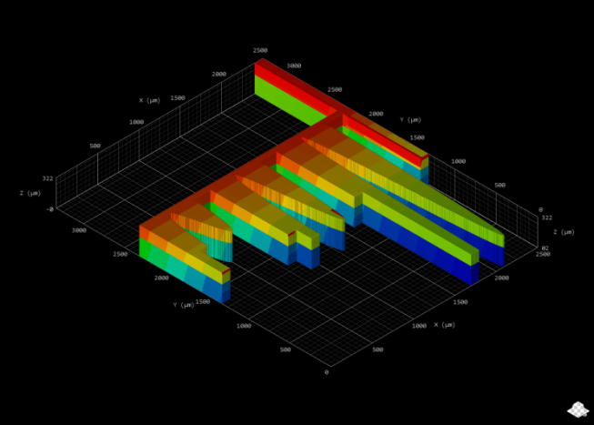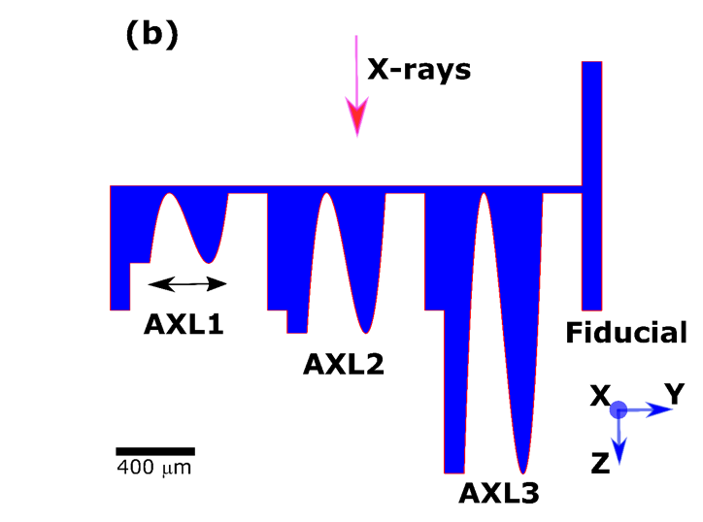
(a)
Fig. S2: Design data of Structure-B of AXL in (a) 3-dimensions and (b) 2-dimensions. The blue to red color blocks shows the sequence of block printing by a 3D printer. The geometric aperture of all AXLs was 400 μm. The fiducials shown in (b) were used for the alignment between optical elements of the AXL.

