Supplementary Material

Genetic Ancestry Inference: from AIMS to WGS application and challenges in admixed population

Luciana Maia Escher dos Santos¹, Michel S. Naslavsky^{2,3,4}, Marília O. Scliar³, Yeda A. O. Duarte^{5,6}, Mayana Zatz^{2,3}, Kelly Nunes^{2*+}, Silviene F. Oliveira^{1*+}

¹ Human Genetics Laboratory, Institute of Biological Sciences, University of Brasília, Brazil.

² Department of Genetics and Evolutionary Biology, Biosciences Institute, University of São Paulo, São Paulo, SP, Brazil.
³ Human Genome and Stem Cell Research Center, University of São Paulo, São Paulo, SP, Brazil.
⁴ Hospital Israelita Albert Einstein, São Paulo, SP, Brazil.
⁵ Medical-Surgical Nursing Department, School of Nursing, University of São Paulo, São Paulo, SP, Brazil.
⁶ Epidemiology Department, Public Health School, University of São Paulo, São Paulo, SP, Brazil.

* knunesbio@gmail.com ; silviene.oliveira@gmail.com
⁺ these authors contributed equally to this work

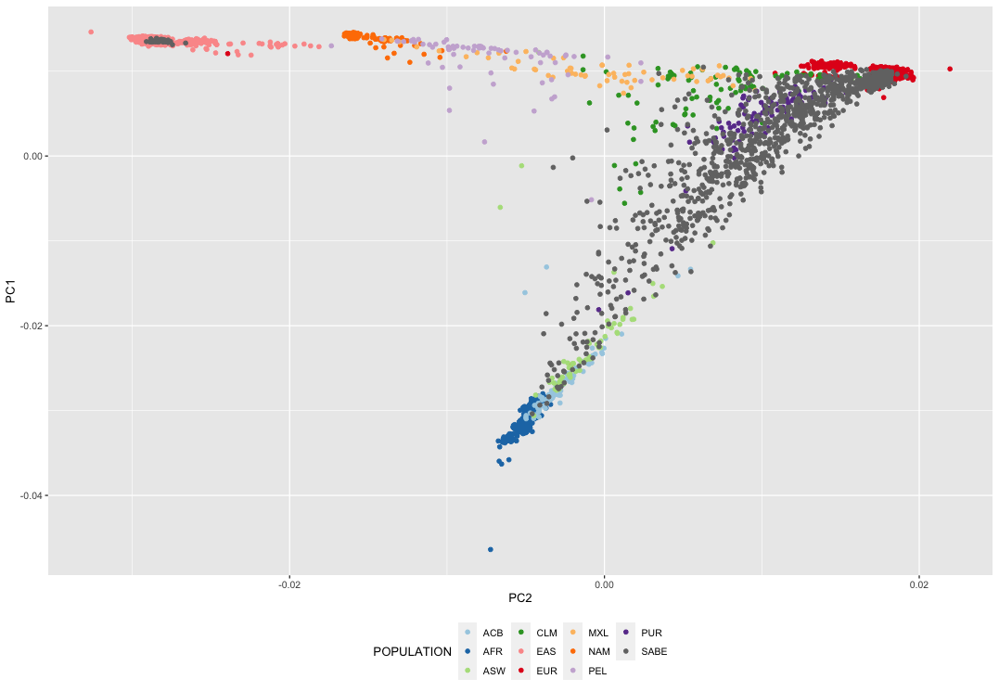
Figure S1. Principal Component Analysis (PCA) based on analysis of whole genome sequence data from the HGDP, 1KGP and SABE datasets (total of 3729 samples). The axes of the plot show the fist and second principal components, for African (AFR), European (EUR), East Asian (EAS), Native American (NAM) samples and admixed population (Afro-American - ASW; Afro-Caribbean - ACB; Colombian - CLM; Mexican - MXL; Peruvian - PEL ; Puerto Rican - PUR and Brazilian - SABE samples).

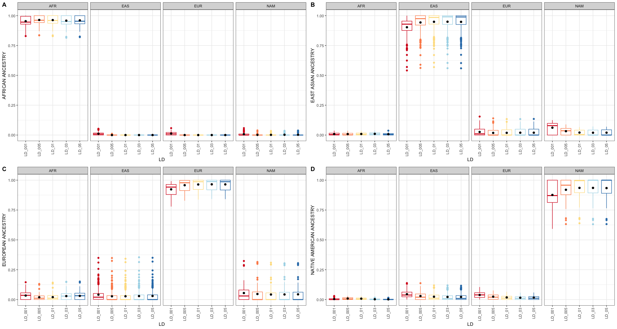

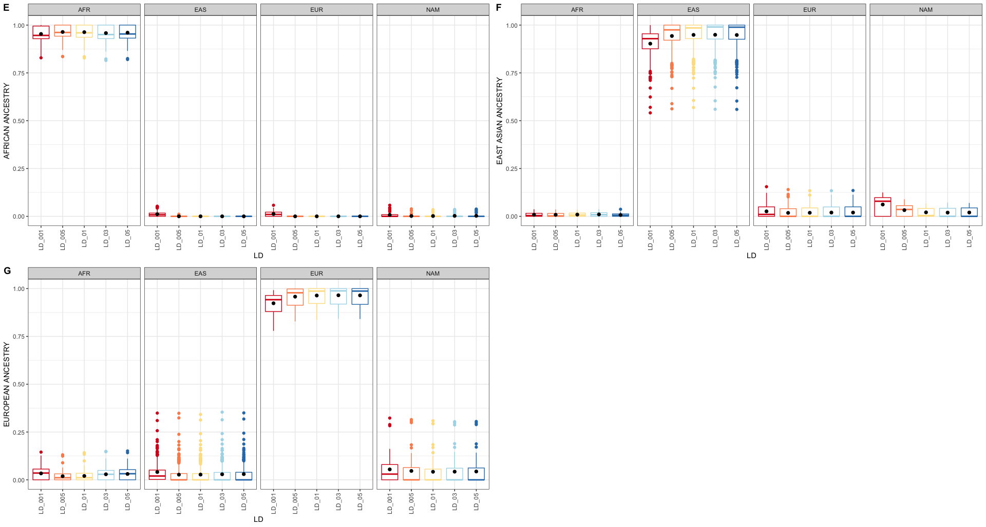

Figure S2. Boxplot with the distribution of ancestry inferences of individuals within each continental group using different thresholds for link disequilibrium coefficient. Figures A-D refer to the HGDP samples and E-G the 1KGP samples.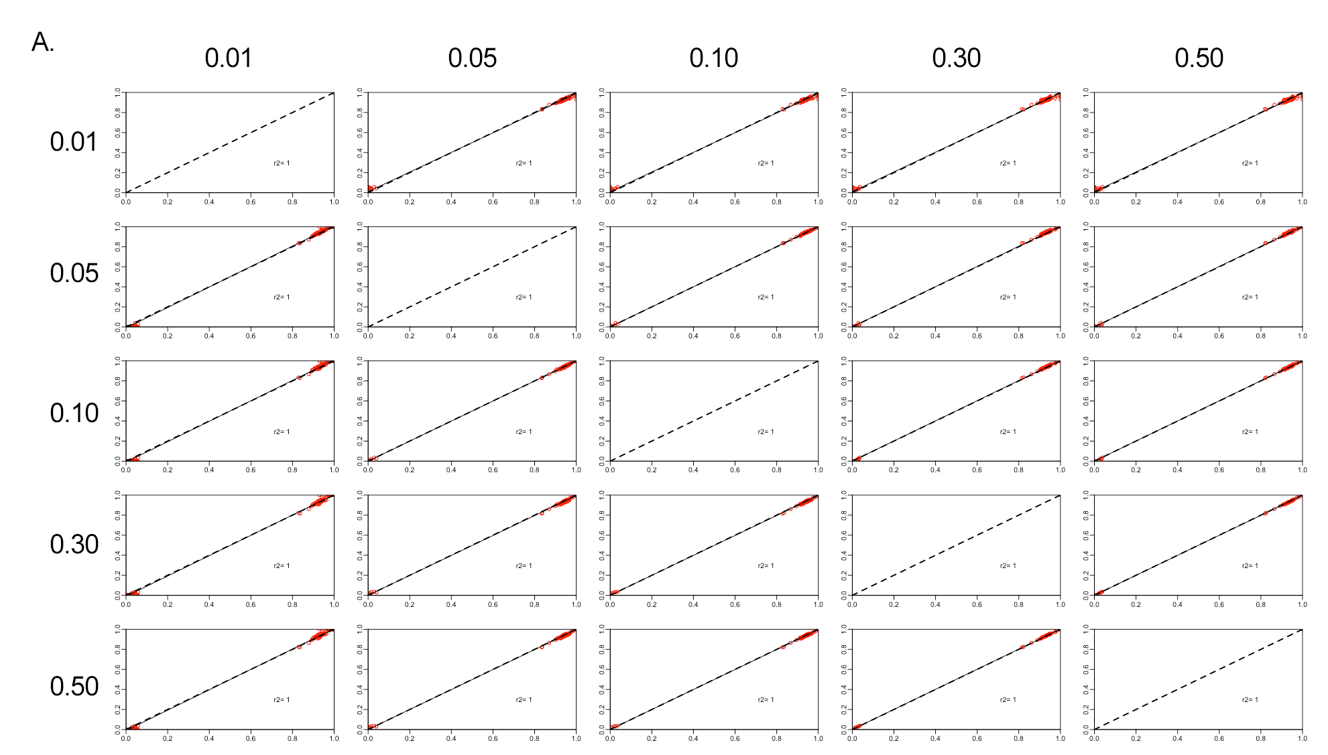

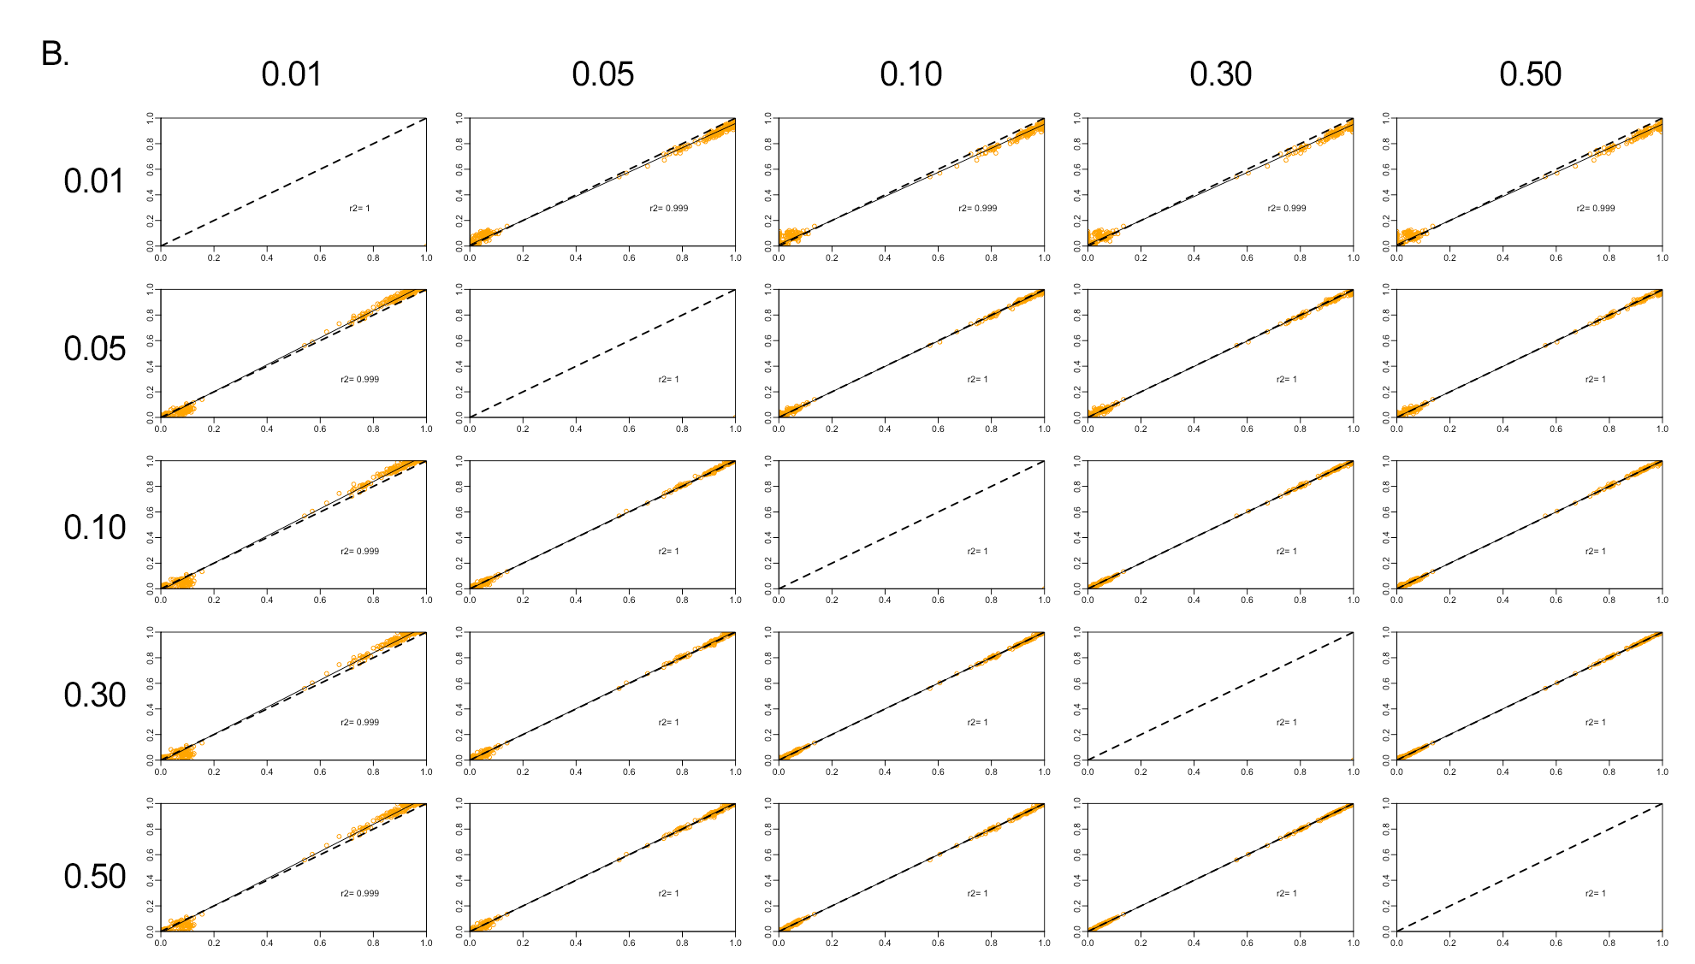

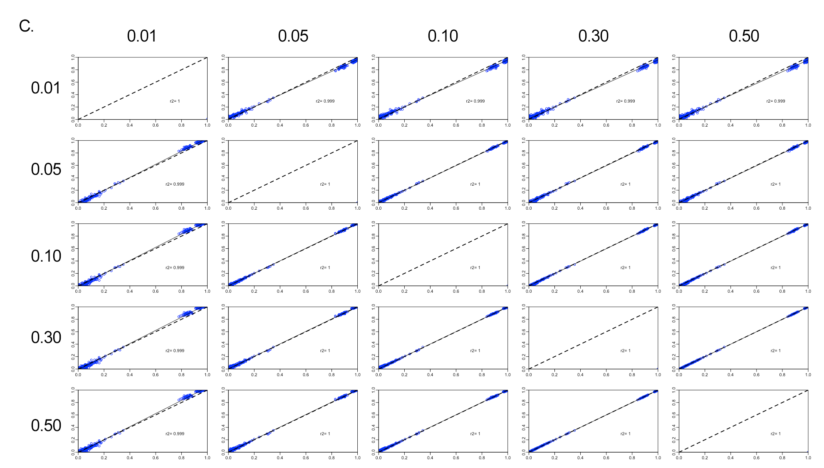

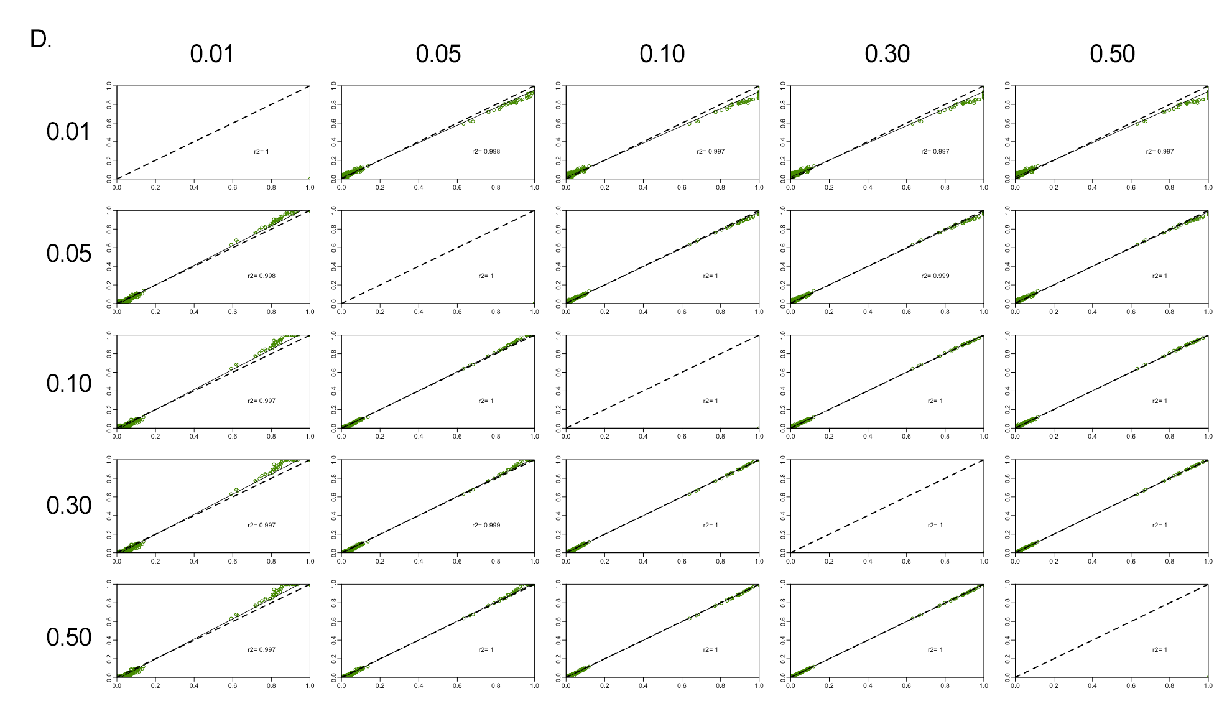

Figure S3. Pairwise comparison of ancestry inferences for the parental HGDP-WGS data with different linkage disequilibrium coefficients (0.01, 0.05, 0.1, 0.3 and 0.5). In the figure, r2 corresponds to the correlation coefficient, the black dashed line represents the trendency, and the solid black line the perfect agreement between two panels. (A) correspond to African (red), (B) East Asian (orange); (C) European (blue) and (D) Native American (green) respectively.

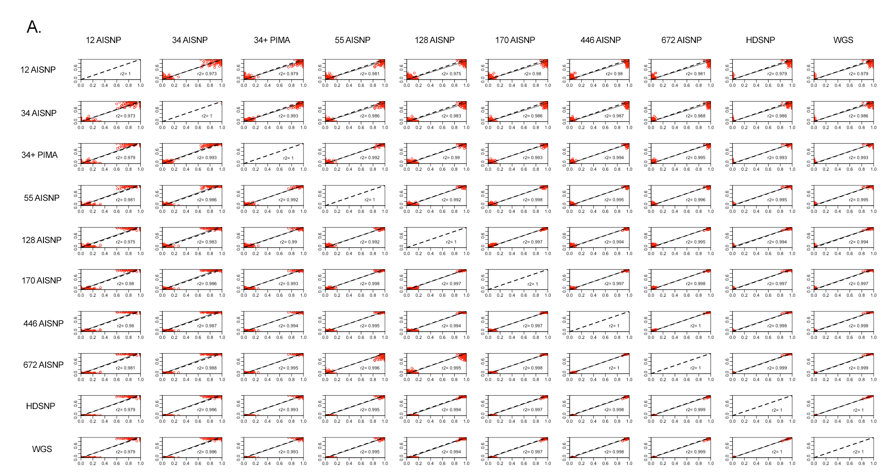
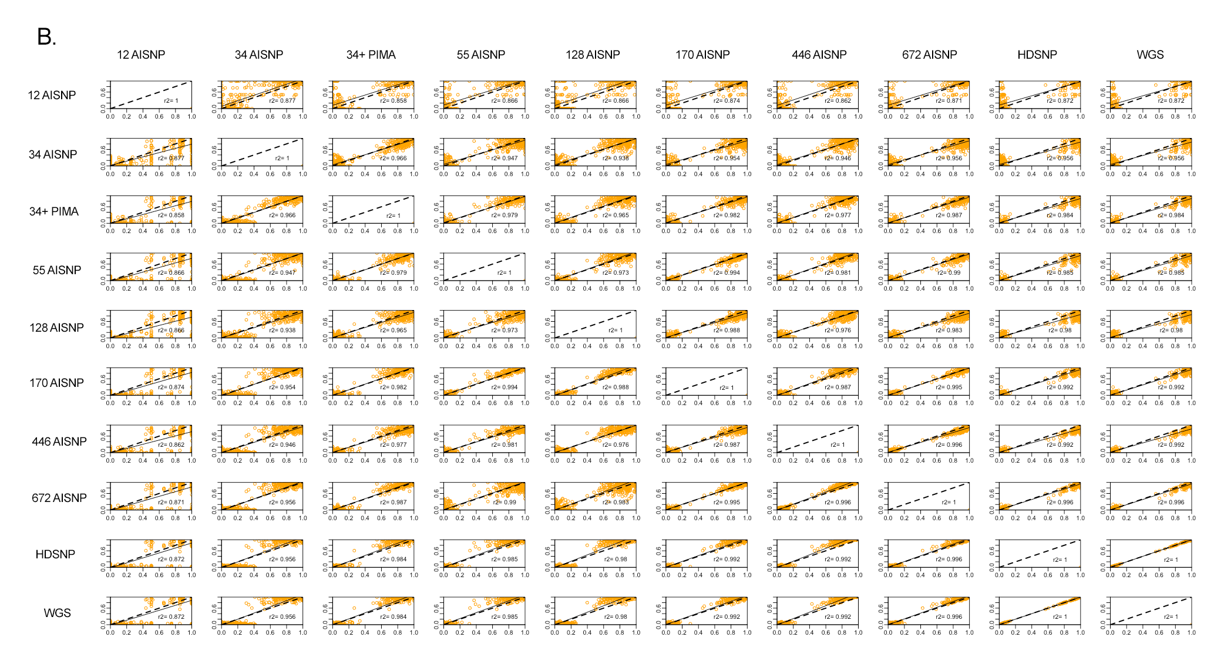

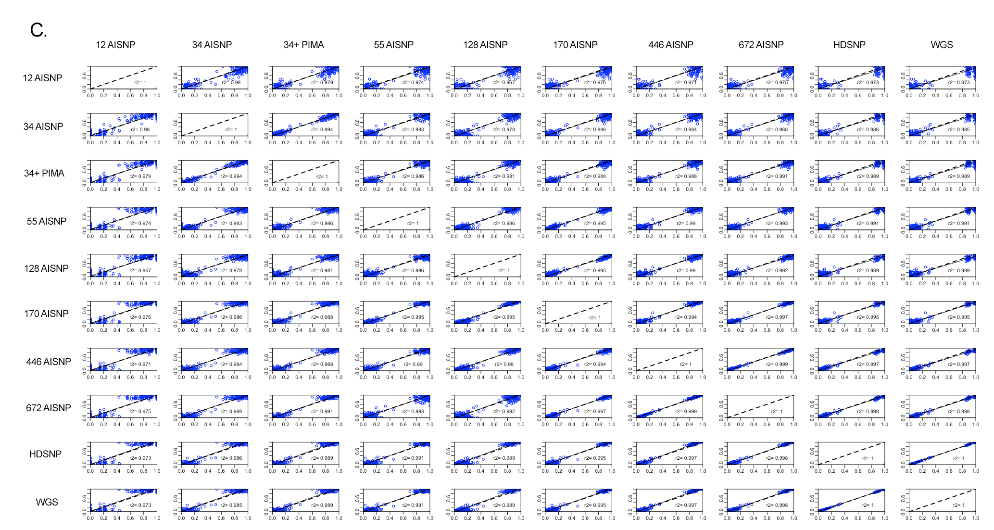

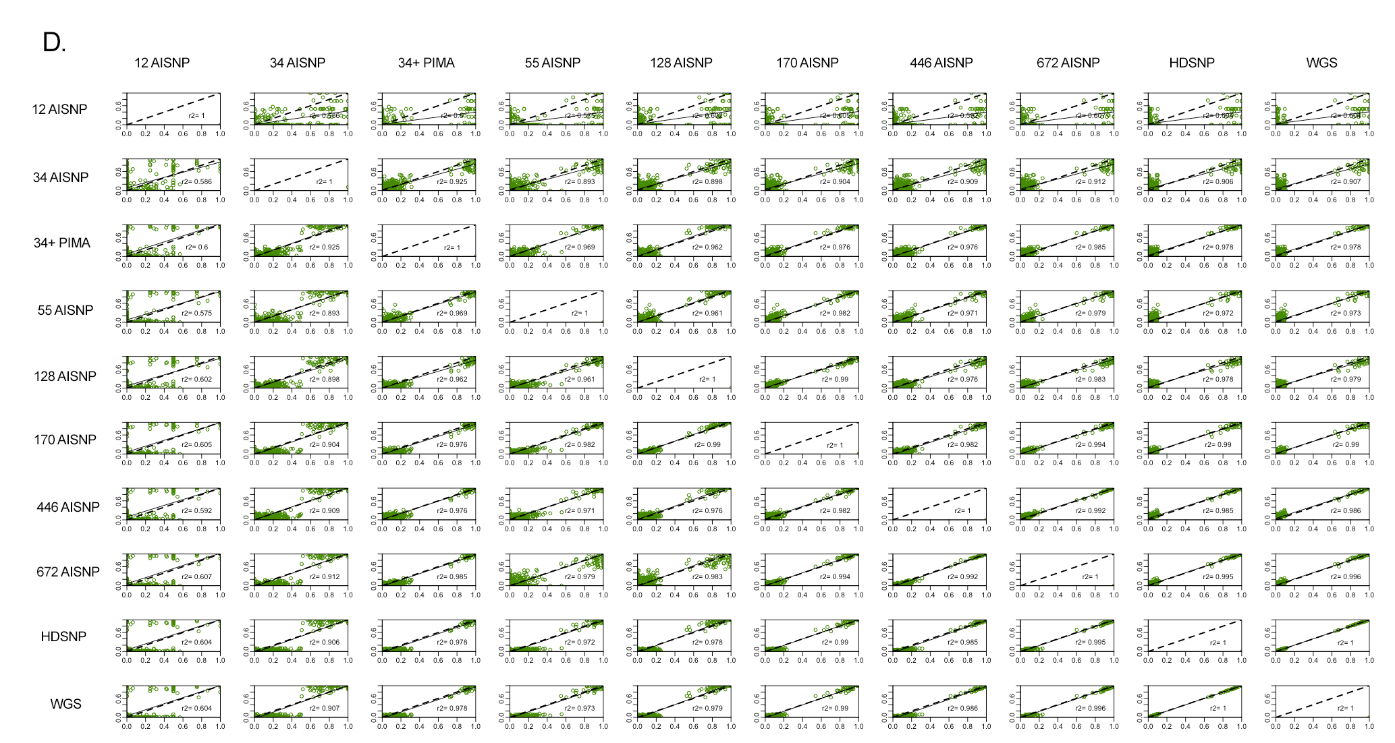

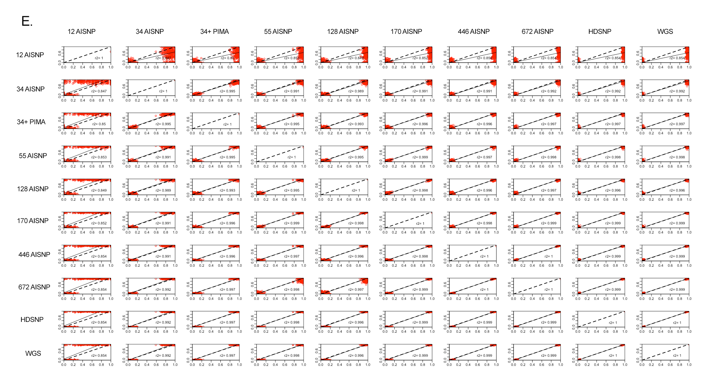

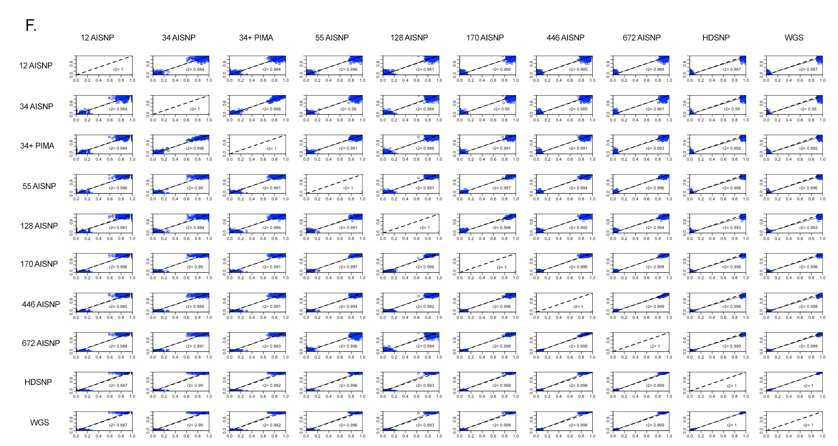

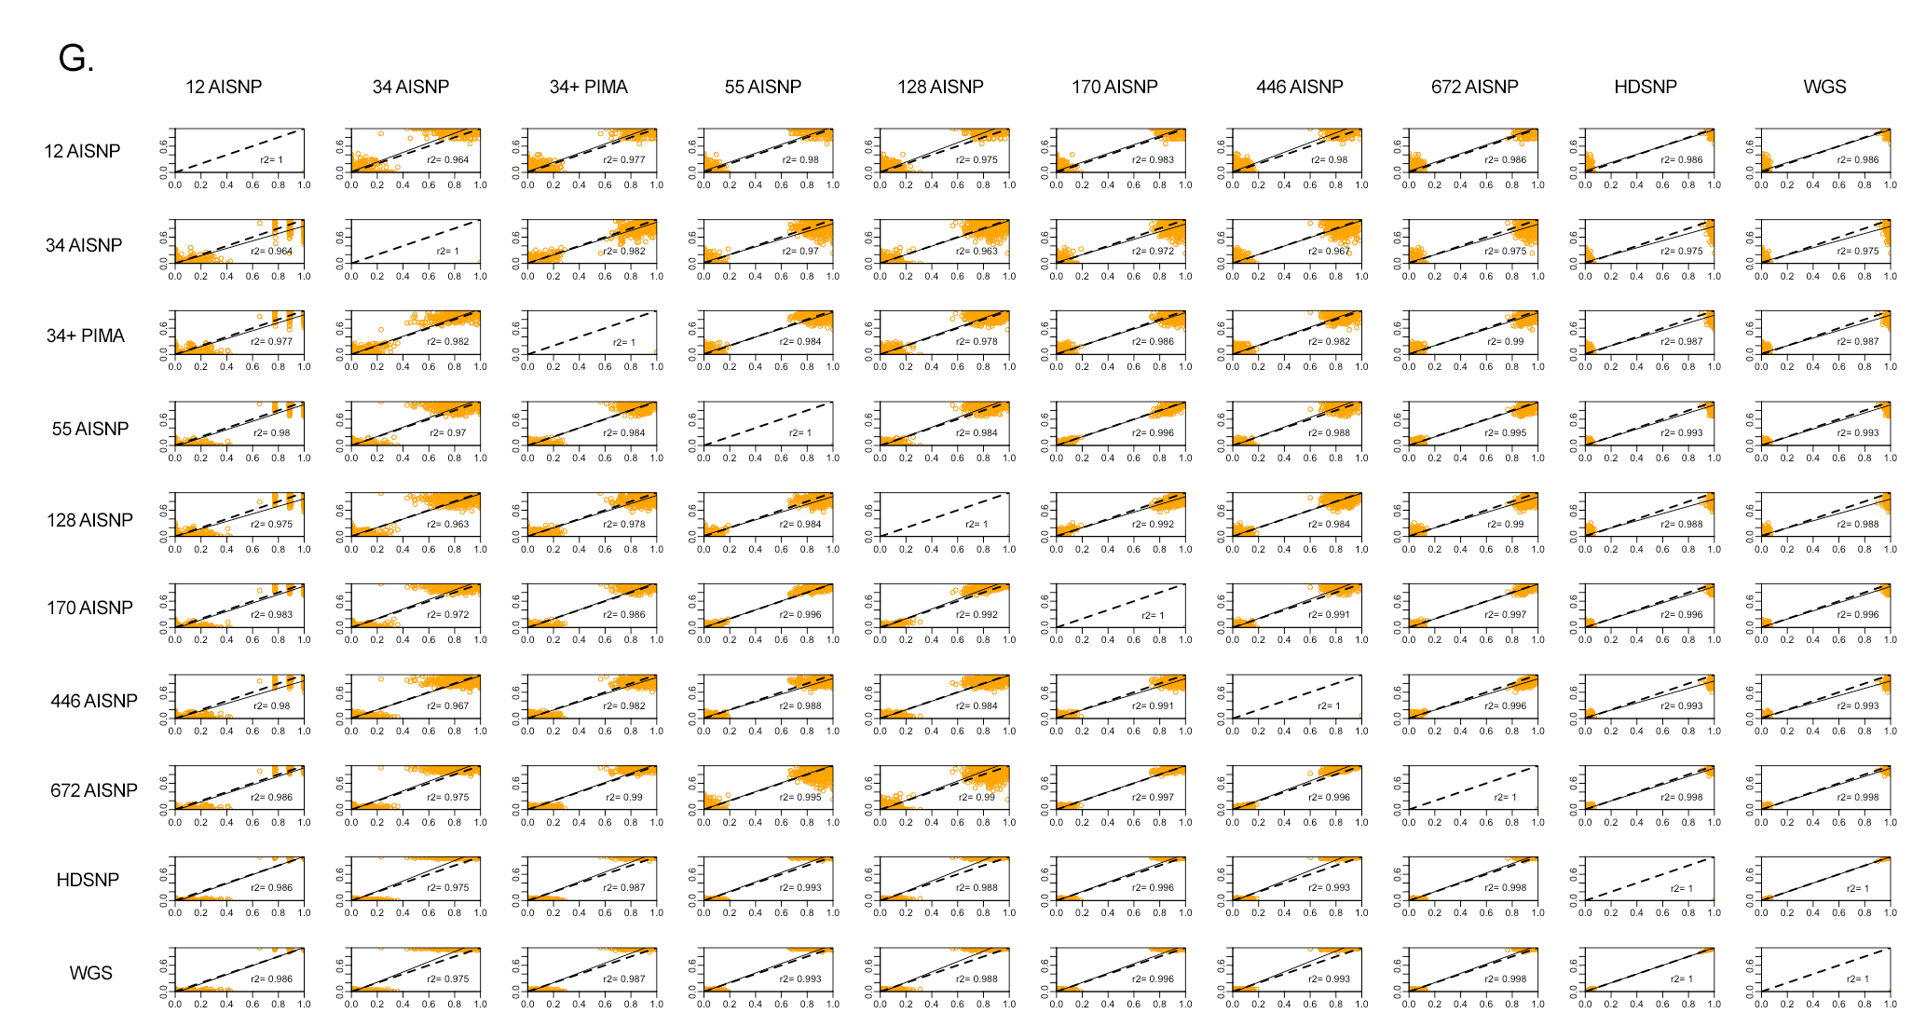
Figure S4. Pairwise comparison of ancestry inferences for the parental WGS data with the 10 panel sets evaluated (12 AISNP; 34 AISNP ; 34 AISNP +PIMA; 55 AISNP; 128 AISNP; 170 AISNP; 446 AISNP; 672 AISNP; HDSNP, WGS). In the figure, r2 corresponds to the correlation coefficient, the black dashed line represents the trendency, and the solid black line the perfect agreement between two panels. (A) correspond to HDGP-African samples (red), (B) HGDP-East Asian samples (orange); (C) HGDP-European samples (blue) and (D) HGDP-Native American samples (green). (E) 1KGP-African samples (red); (F) 1KGP-East-Asian samples; (G) 1KGP-European samples.
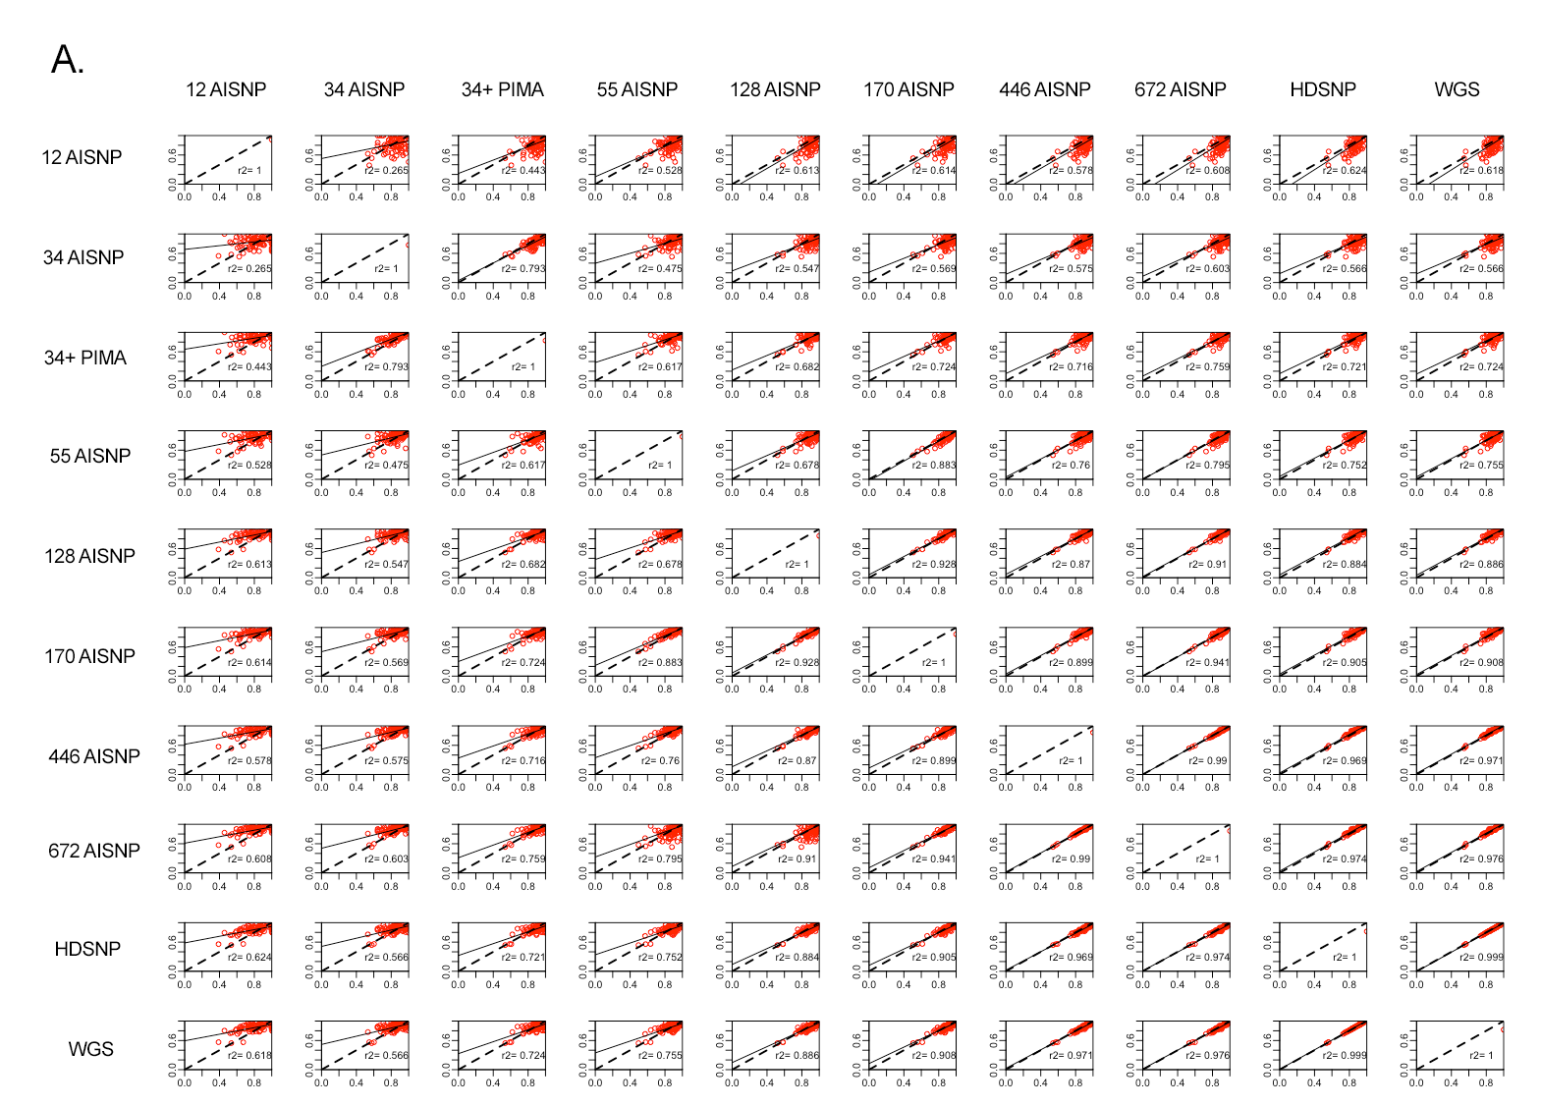
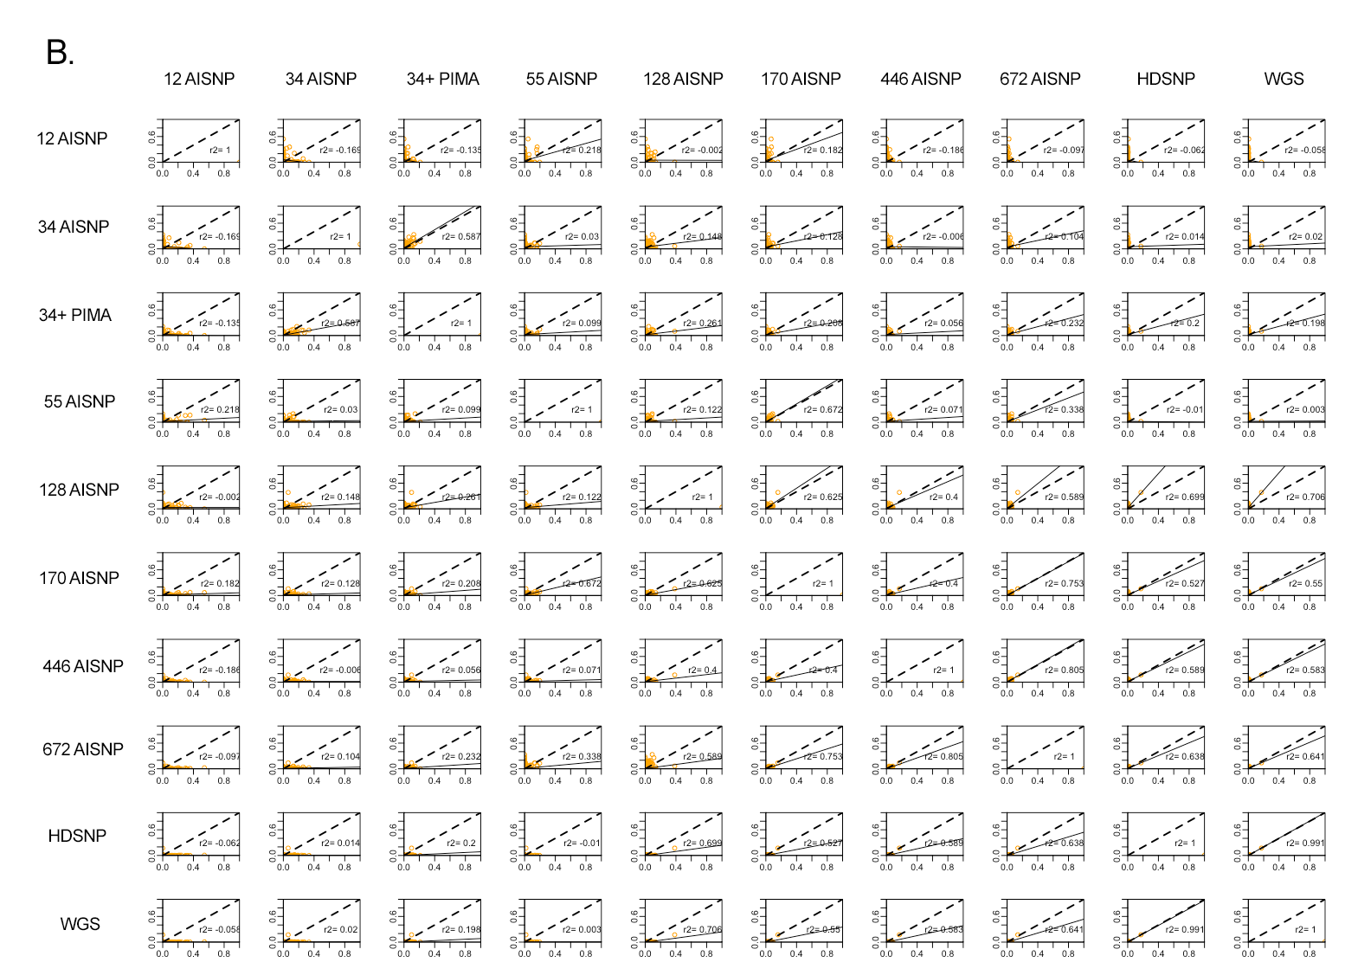

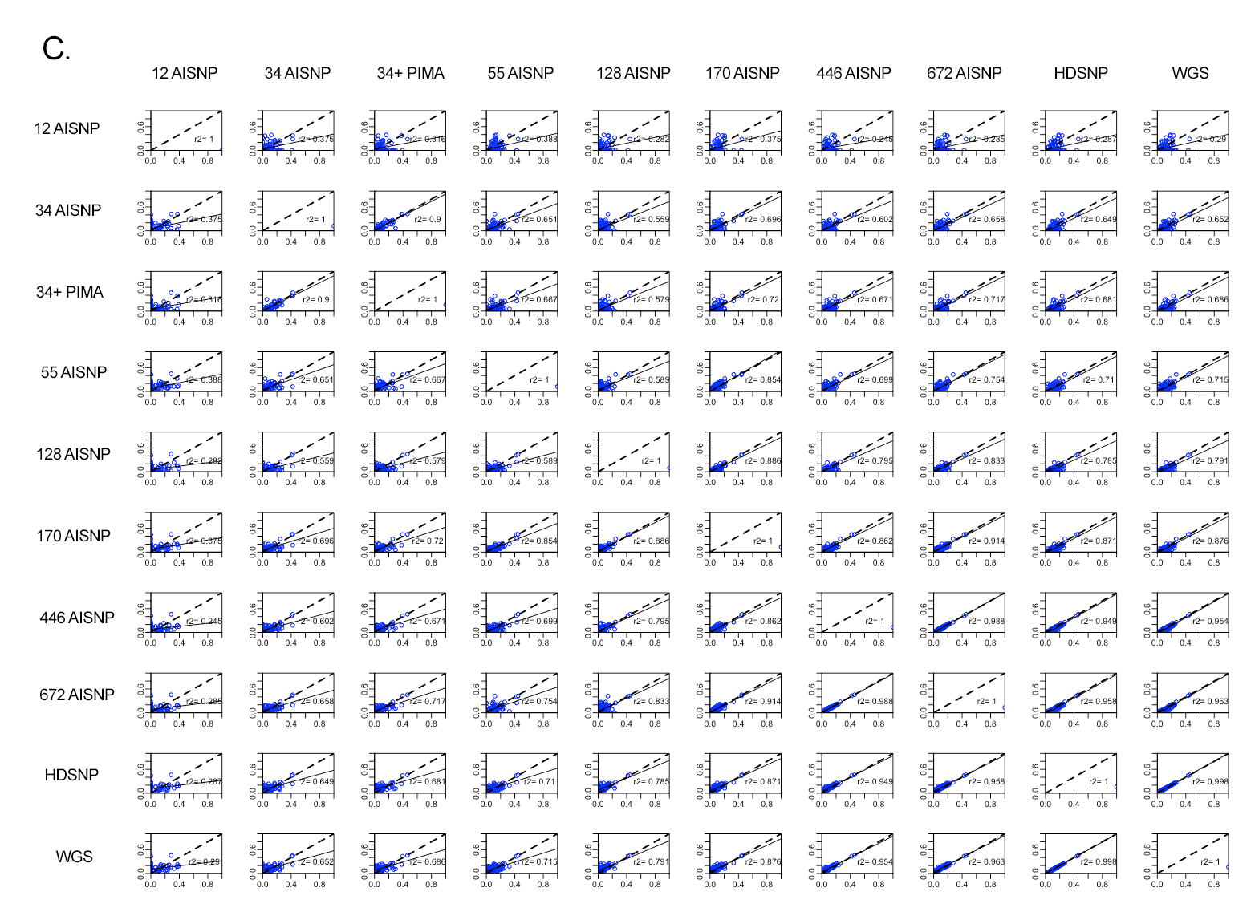
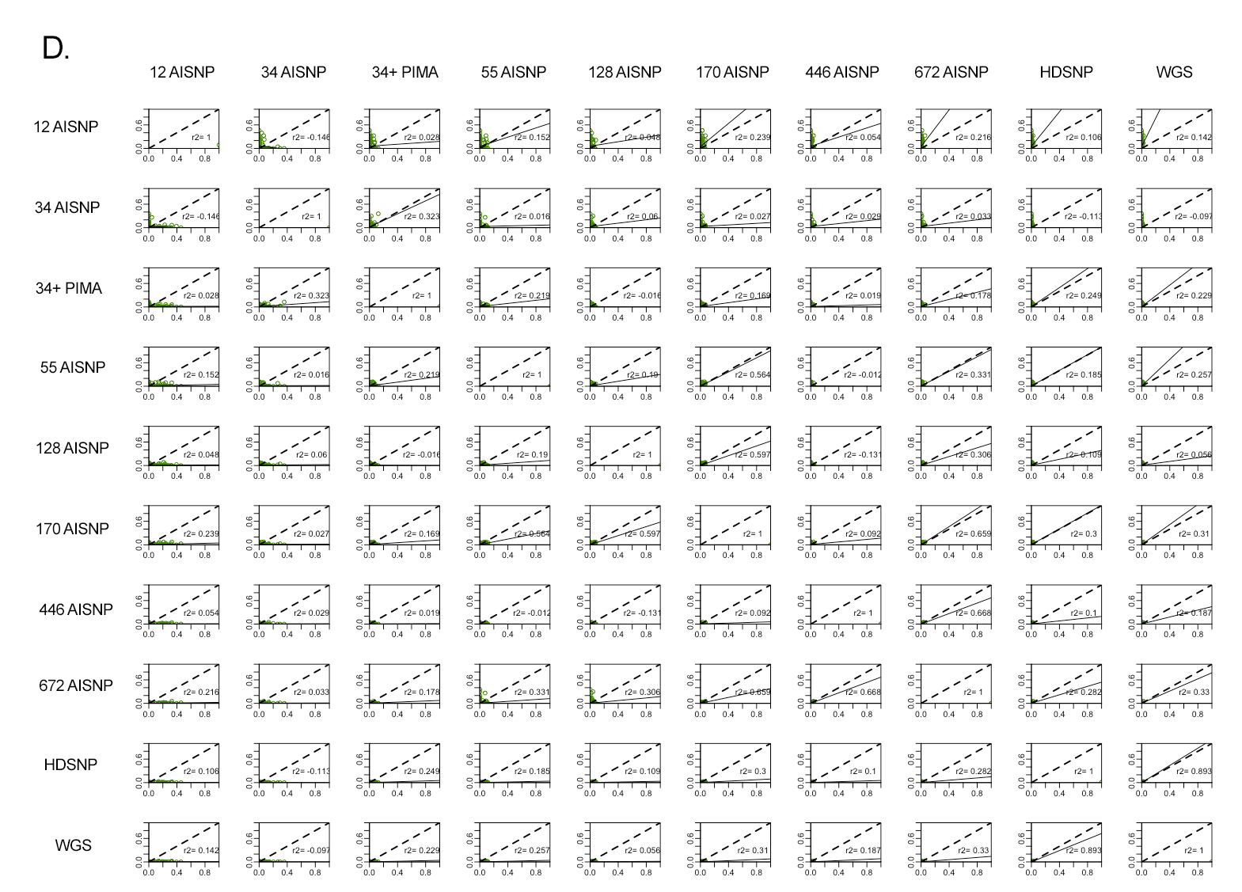

Figure S5. Pairwise comparison of ancestry inferences for the African Caribean samples with the 10 panel sets evaluated (12 AISNP; 34 AISNP ; 34 AISNP +PIMA; 55 AISNP; 128 AISNP; 170 AISNP; 446 AISNP; 672 AISNP; HDSNP, WGS). In the figure, r2 corresponds to the correlation coefficient, the black dashed line represents the trendency, and the solid black line the perfect agreement between two panels. (A) corresponds to African ancestry component (red), (B) East Asian ancestry component (orange); (C) European ancestry component (blue) and (D) Native American ancestry component (green).

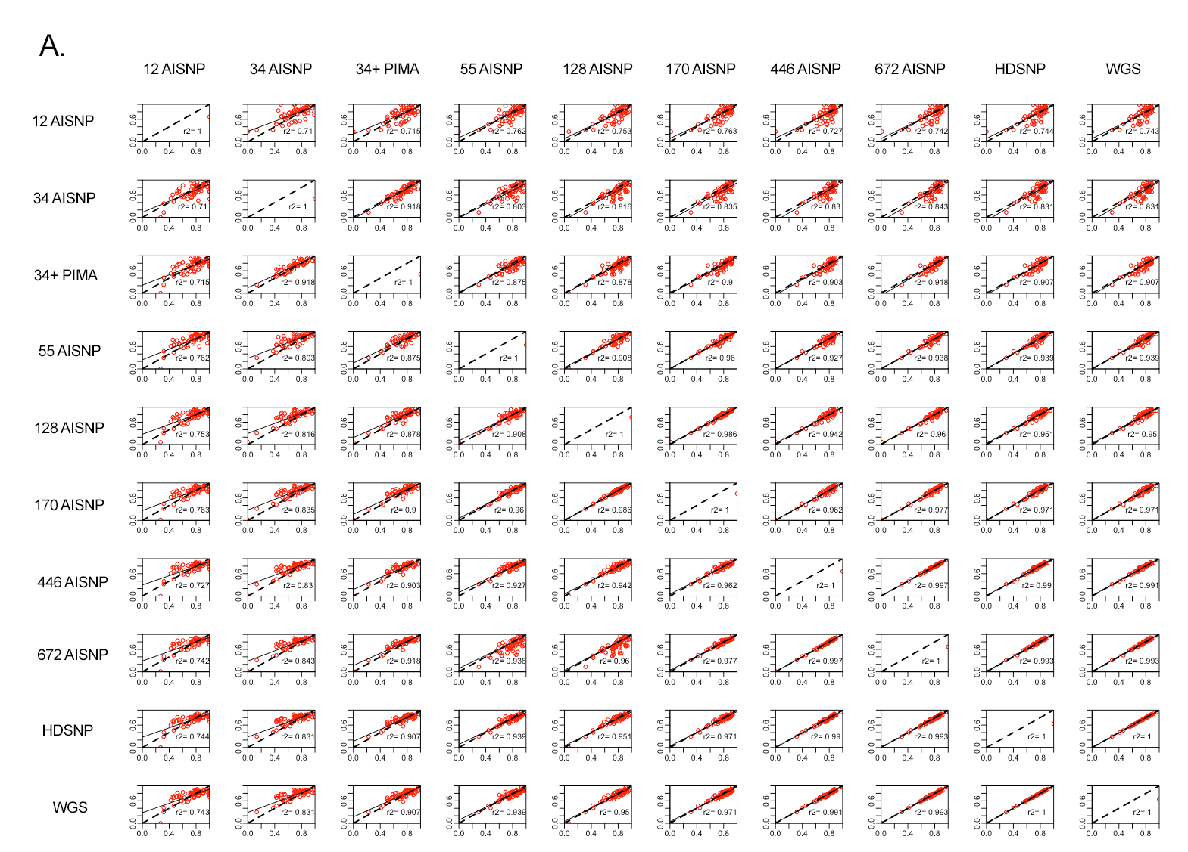
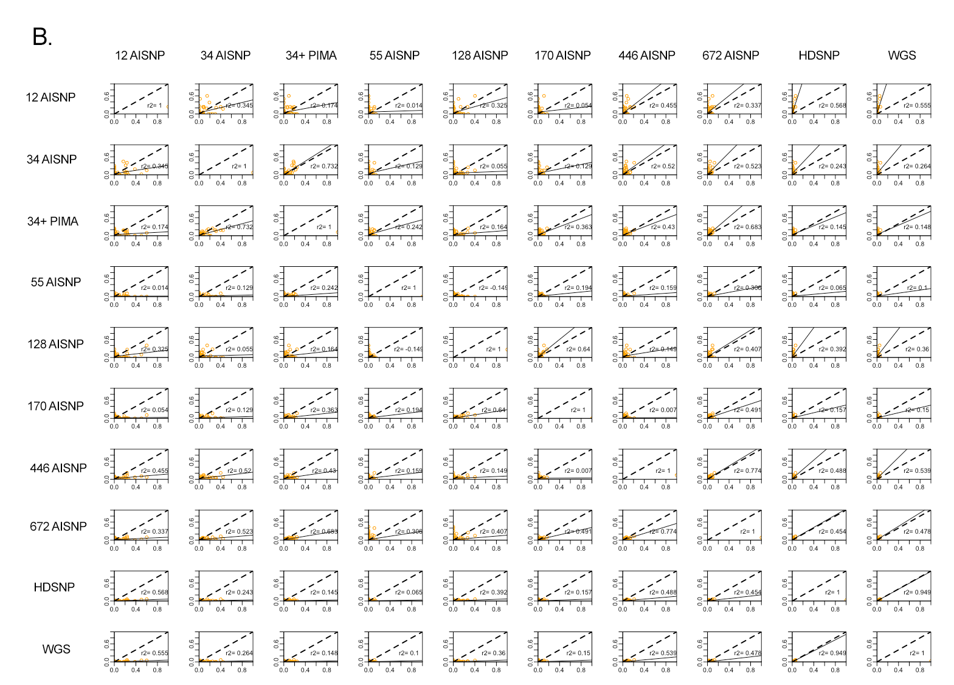
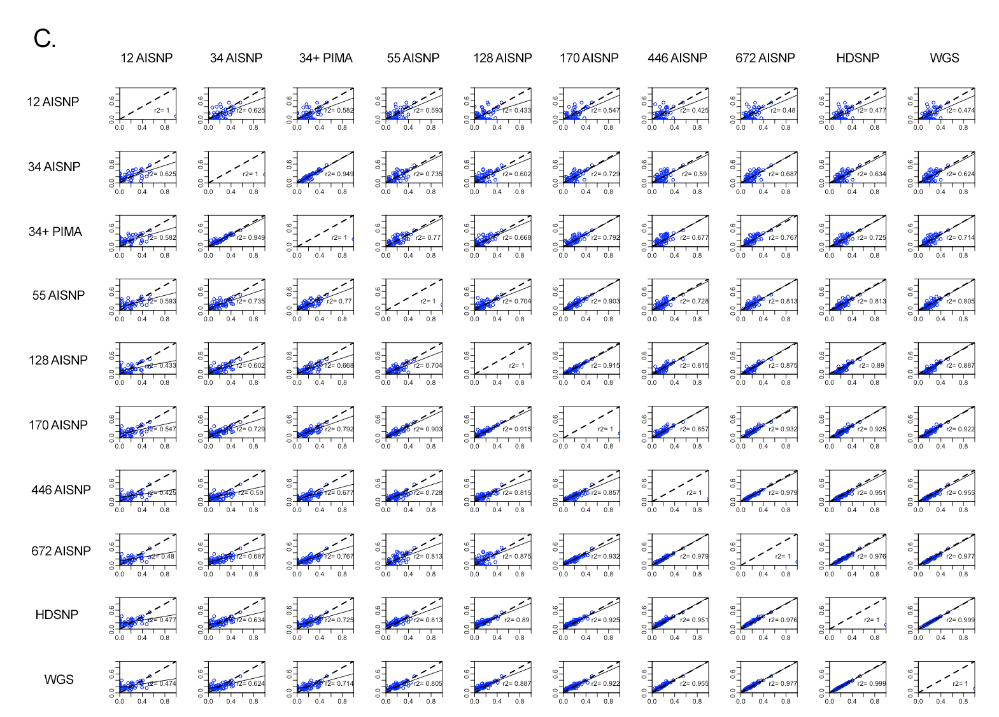
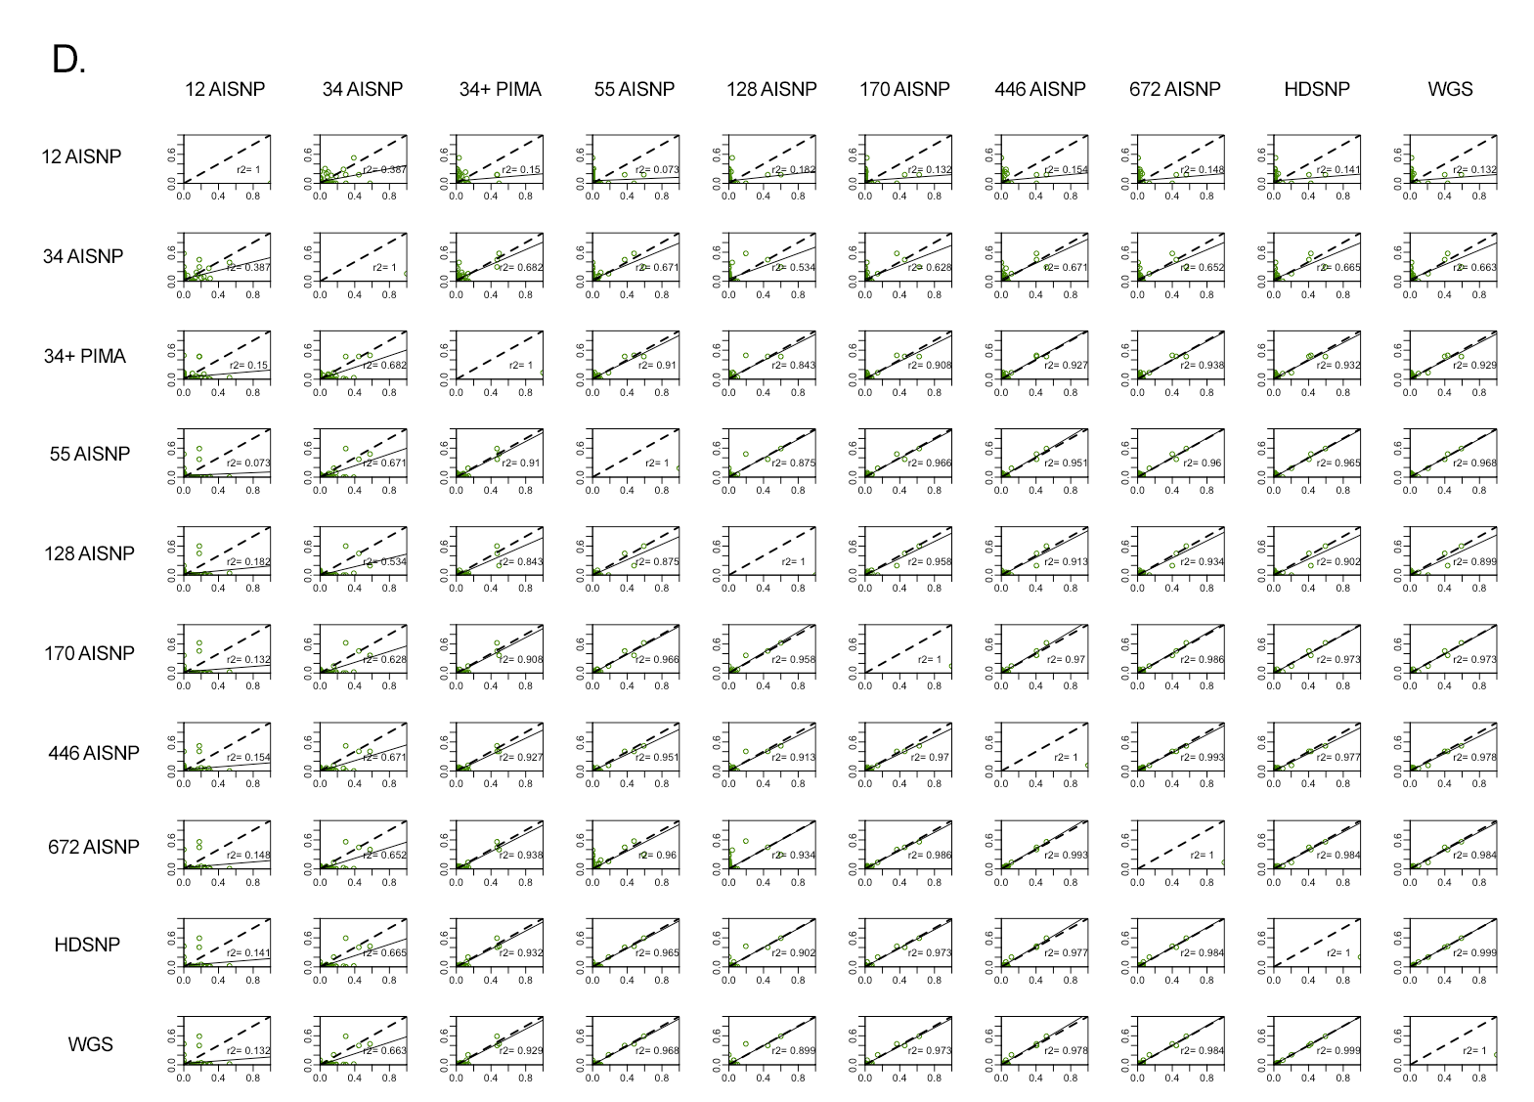
Figure S6. Pairwise comparison of ancestry inferences for the African American samples with the 10 panel sets evaluated (12 AISNP; 34 AISNP ; 34 AISNP +PIMA; 55 AISNP; 128 AISNP; 170 AISNP; 446 AISNP; 672 AISNP; HDSNP, WGS). In the figure, r2 corresponds to the correlation coefficient, the black dashed line represents the trendency, and the solid black line the perfect agreement between two panels. (A) corresponds to African ancestry component (red), (B) East Asian ancestry component (orange); (C) European ancestry component (blue) and (D) Native American ancestry component (green).

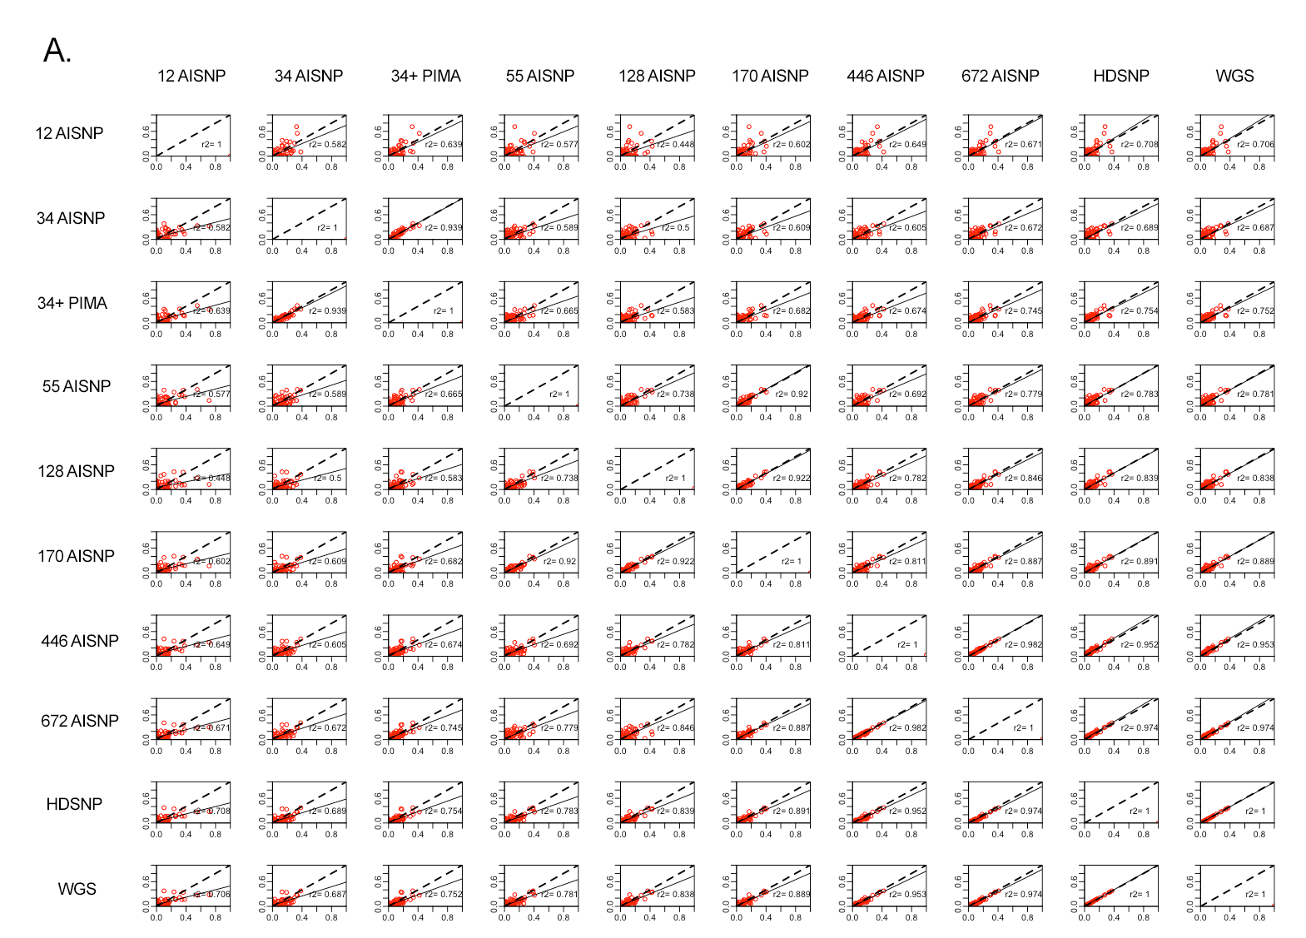
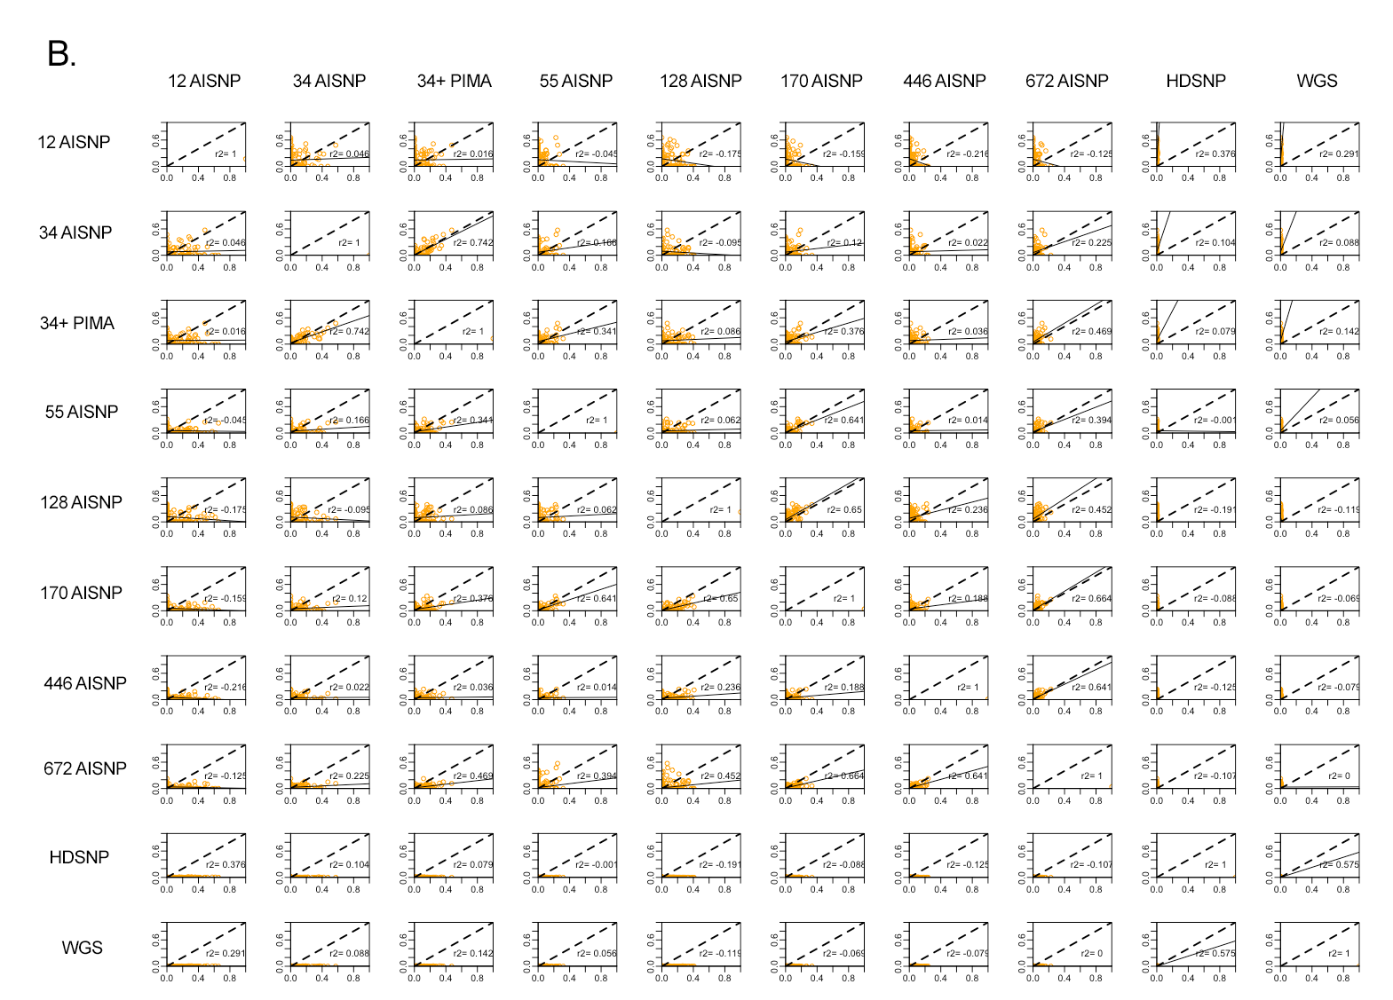
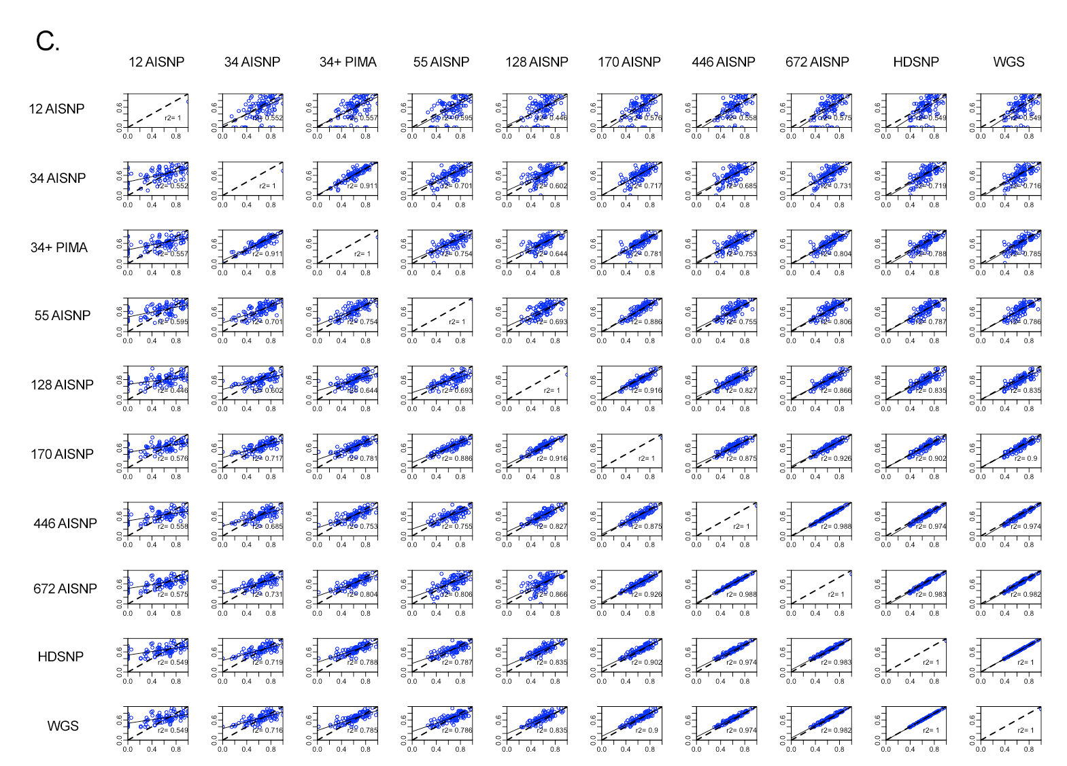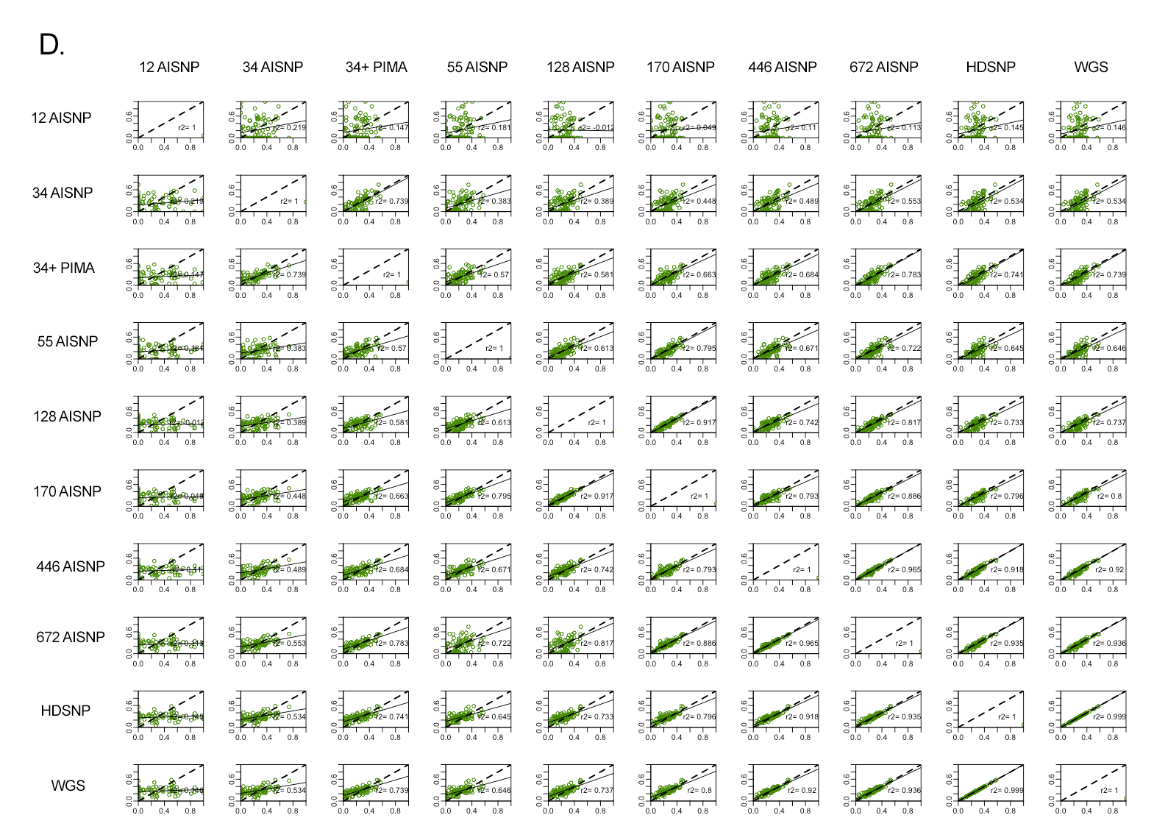Figure S7. Pairwise comparison of ancestry inferences for the Colombian samples with the 10 panel sets evaluated (12 AISNP; 34 AISNP ; 34 AISNP +PIMA; 55 AISNP; 128 AISNP; 170 AISNP; 446 AISNP; 672 AISNP; HDSNP, WGS). In the figure, r2 corresponds to the correlation coefficient, the black dashed line represents the trendency, and the solid black line the perfect agreement between two panels. (A) corresponds to African ancestry component (red), (B) East Asian ancestry component (orange); (C) European ancestry component (blue) and (D) Native American ancestry component (green).

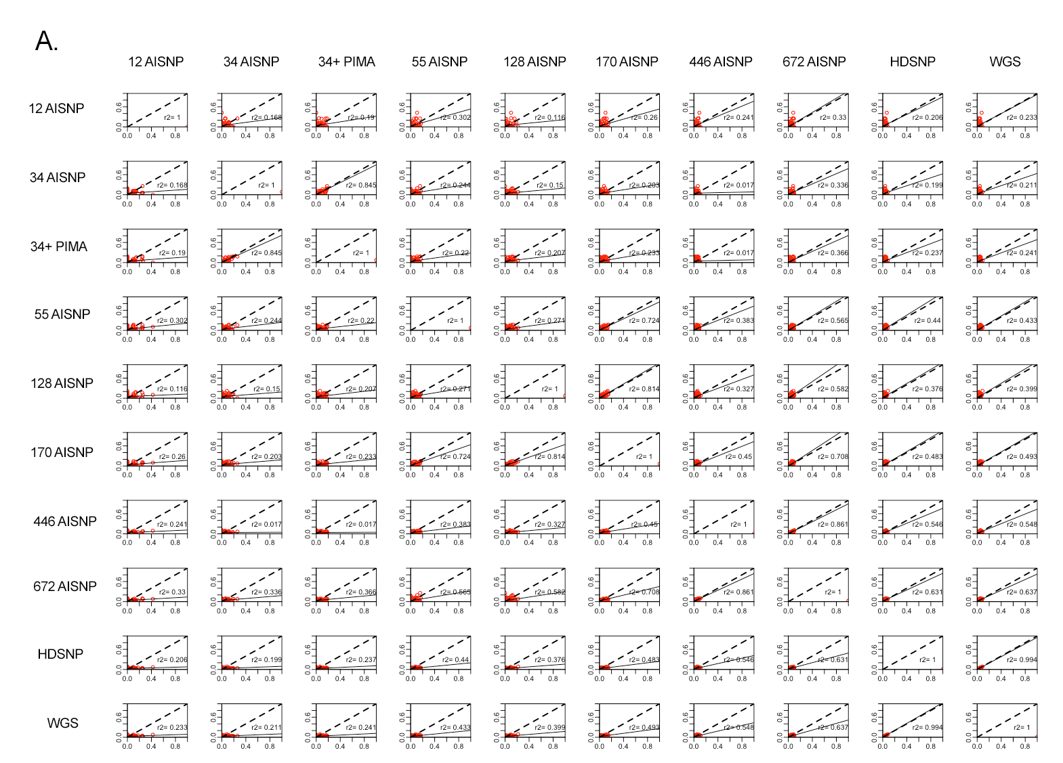
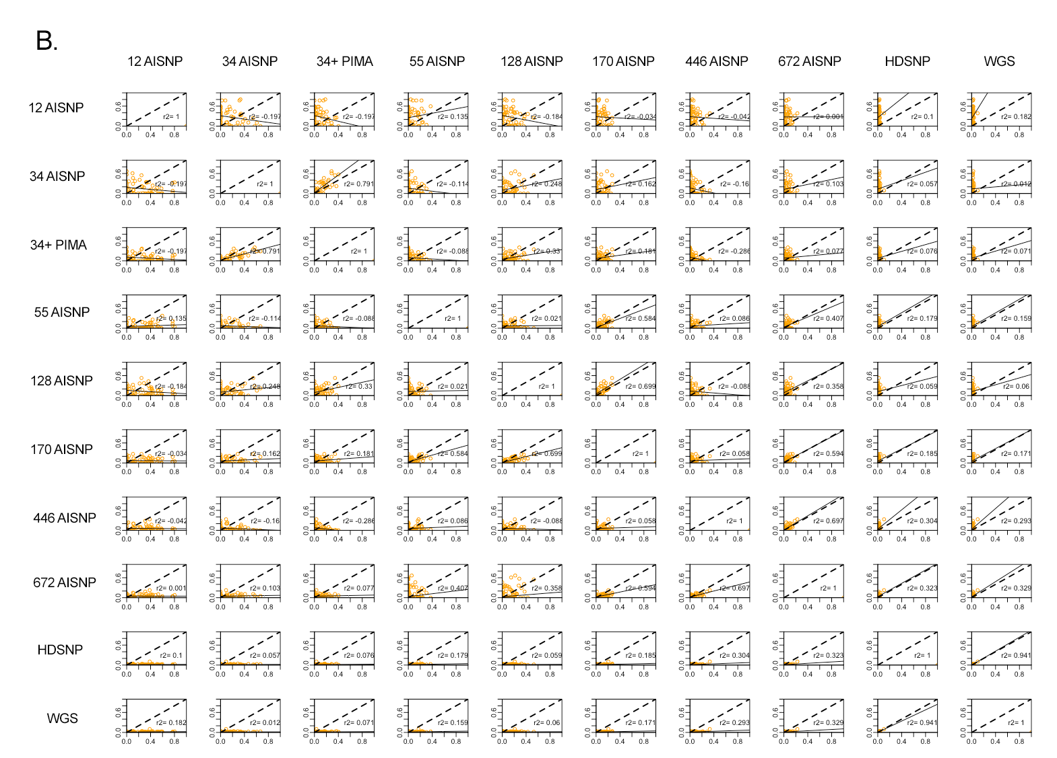
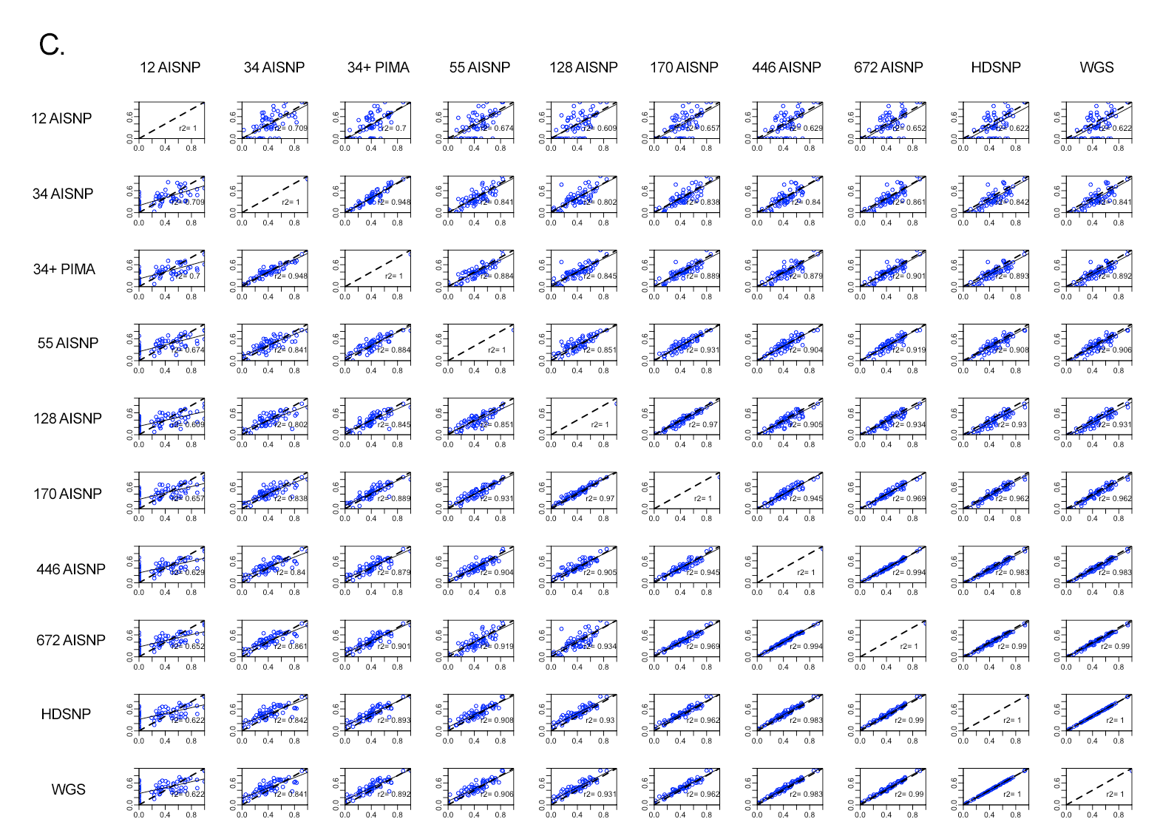
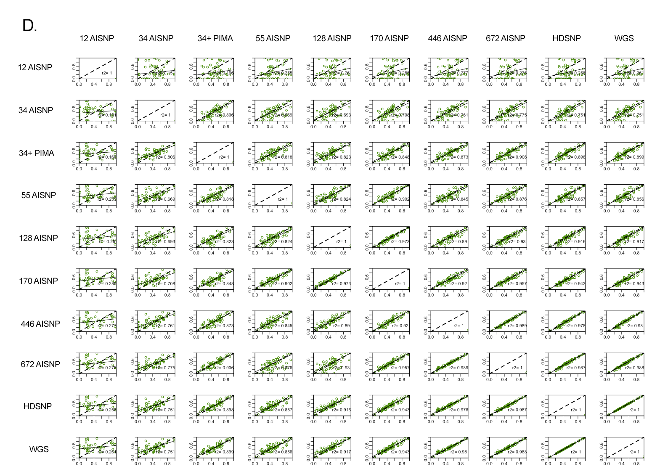

Figure S8. Pairwise comparison of ancestry inferences for the Mexican samples with the 10 panel sets evaluated (12 AISNP; 34 AISNP ; 34 AISNP +PIMA; 55 AISNP; 128 AISNP; 170 AISNP; 446 AISNP; 672 AISNP; HDSNP, WGS). In the figure, r2 corresponds to the correlation coefficient, the black dashed line represents the trendency, and the solid black line the perfect agreement between two panels. (A) corresponds to African ancestry component (red), (B) East Asian ancestry component (orange); (C) European ancestry component (blue) and (D) Native American ancestry component (green).

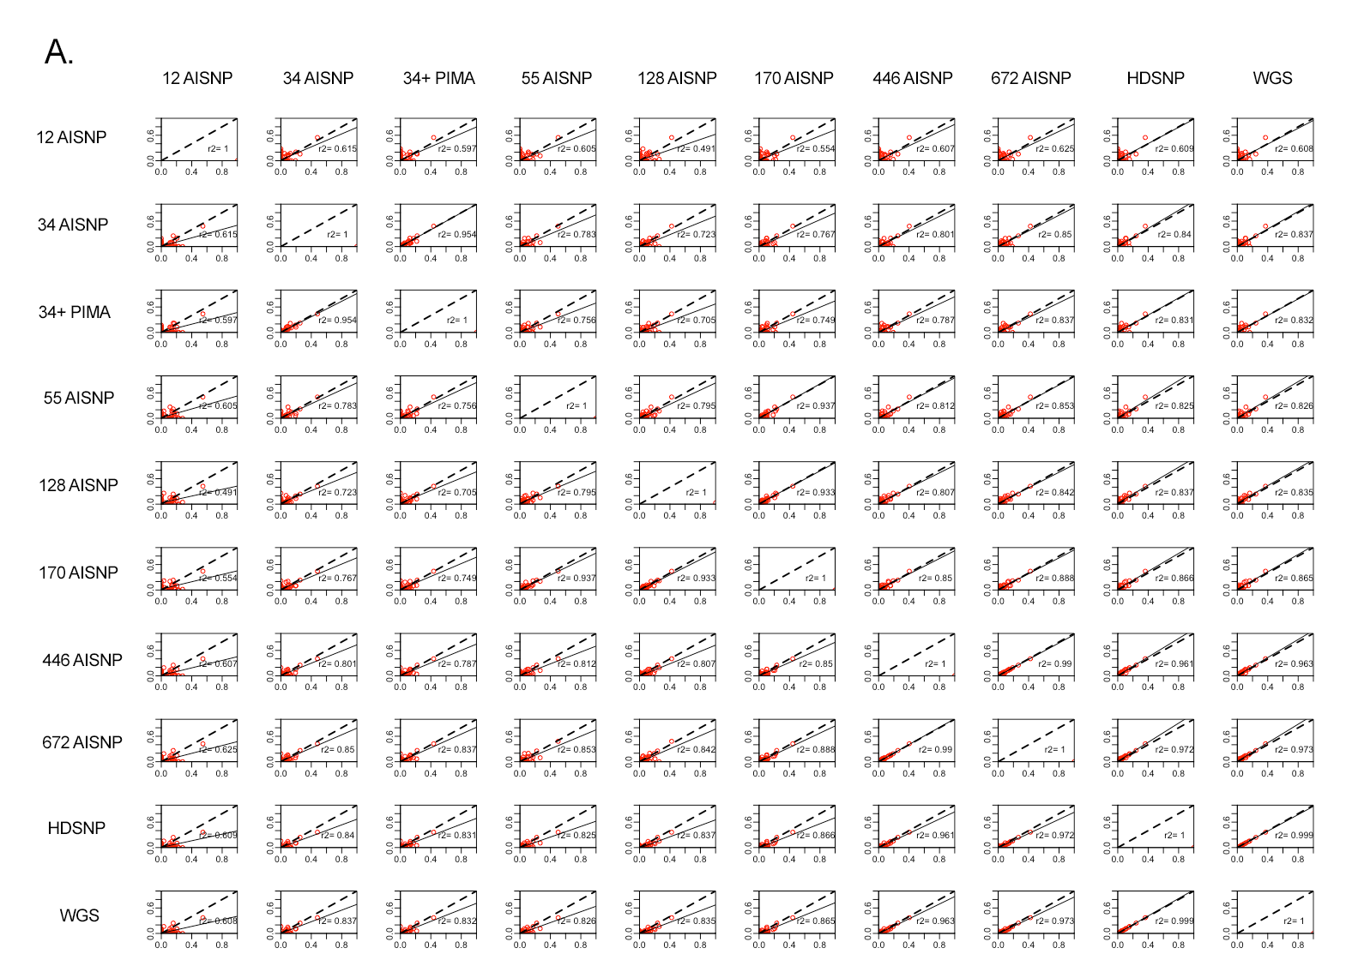
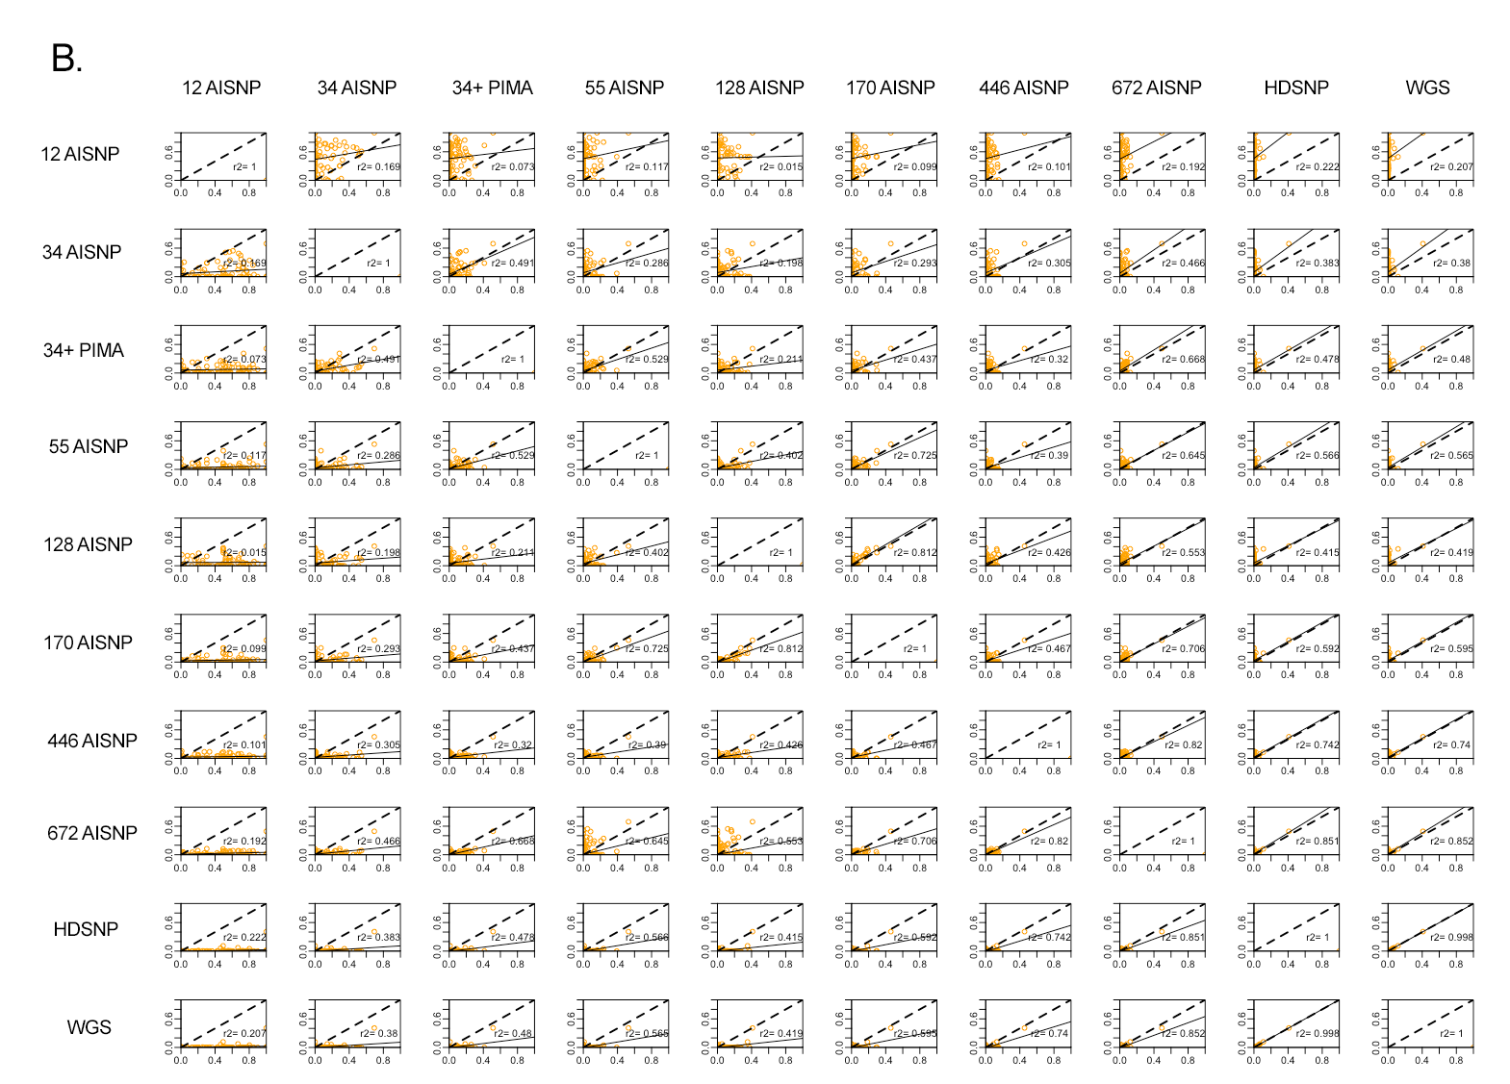
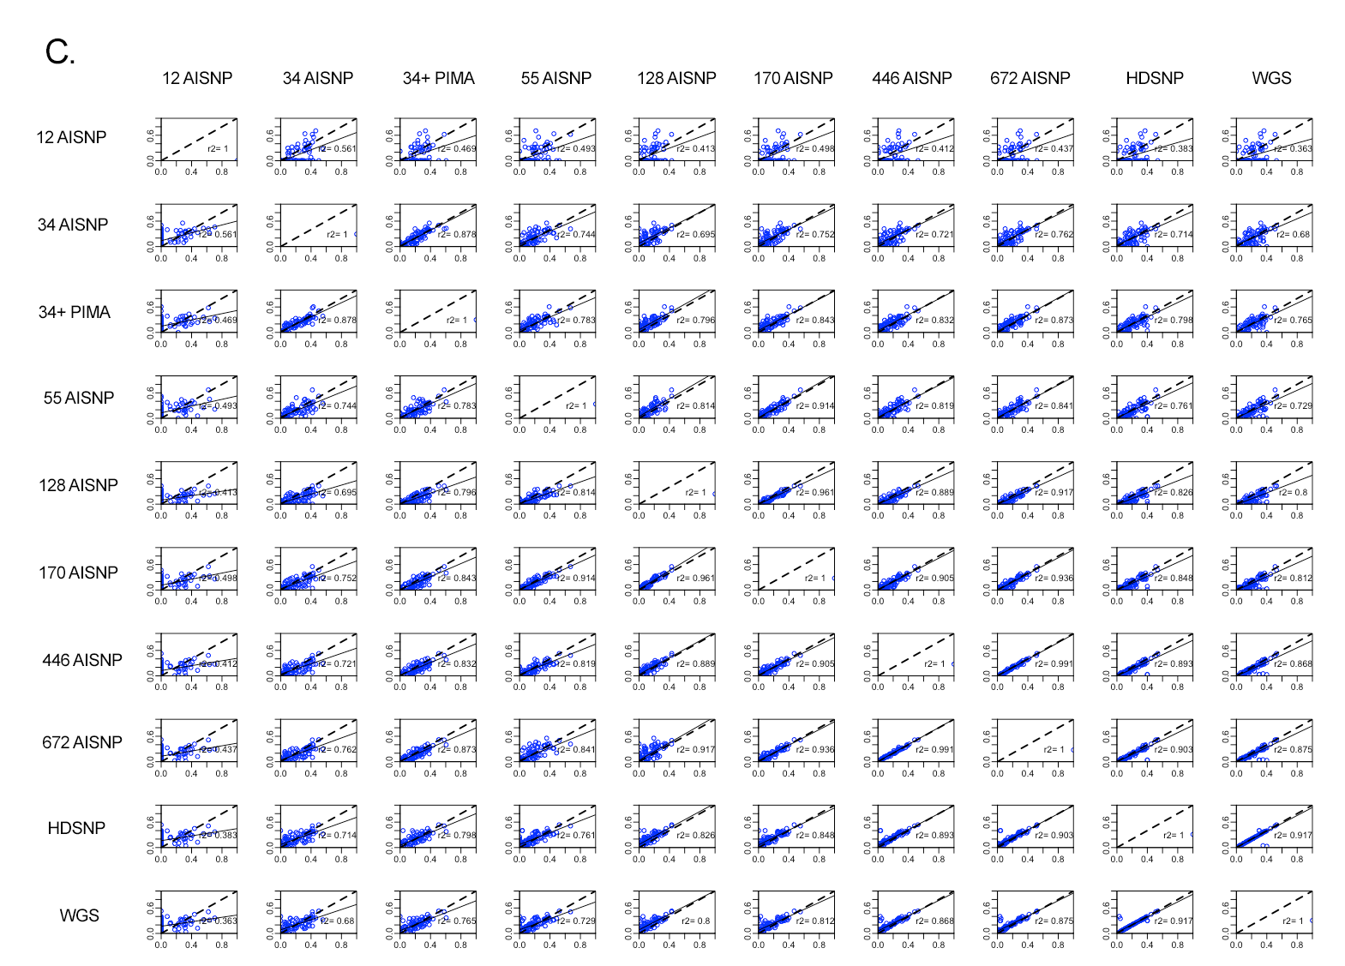
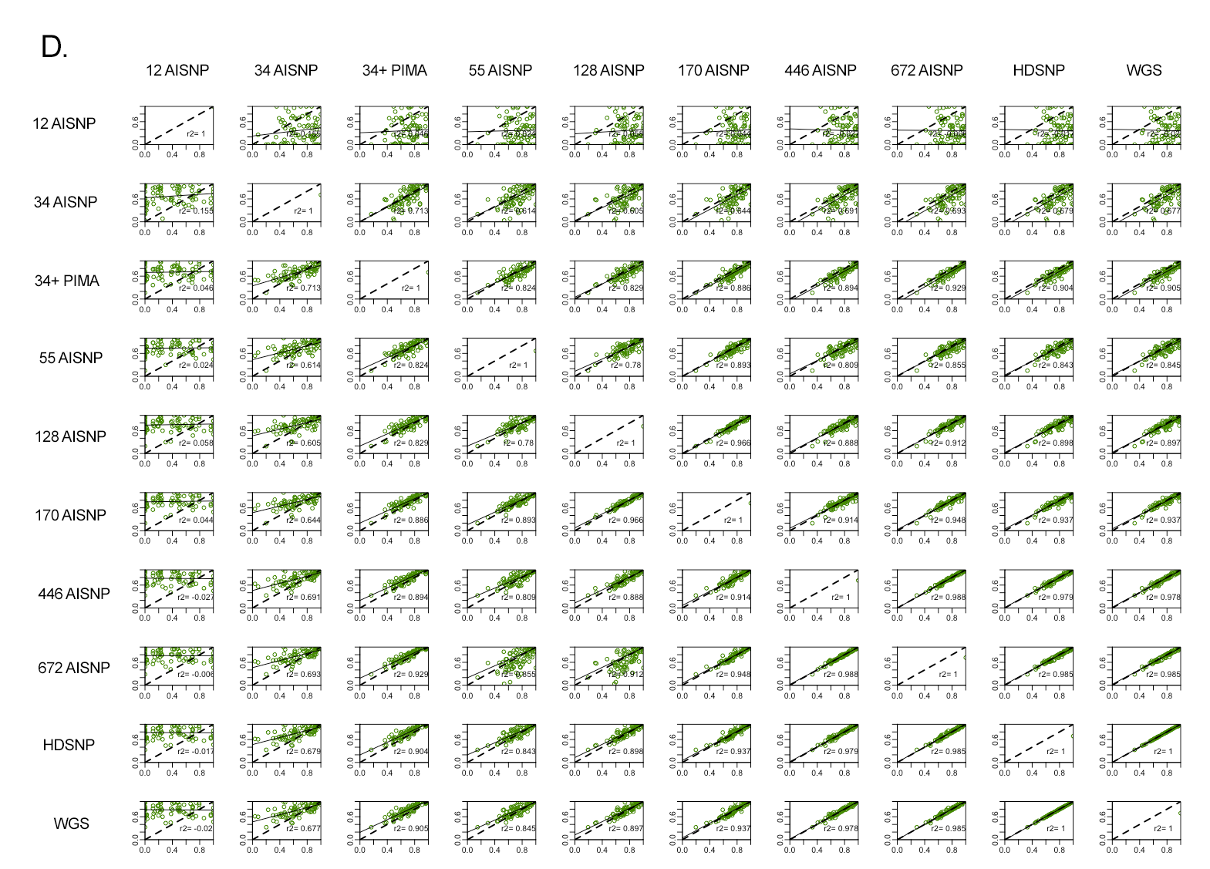Figure S9. Pairwise comparison of ancestry inferences for the Peruvian samples with the 10 panel sets evaluated (12 AISNP; 34 AISNP ; 34 AISNP +PIMA; 55 AISNP; 128 AISNP; 170 AISNP; 446 AISNP; 672 AISNP; HDSNP, WGS). In the figure, r2 corresponds to the correlation coefficient, the black dashed line represents the trendency, and the solid black line the perfect agreement between two panels. (A) corresponds to African ancestry component (red), (B) East Asian ancestry component (orange); (C) European ancestry component (blue) and (D) Native American ancestry component (green).

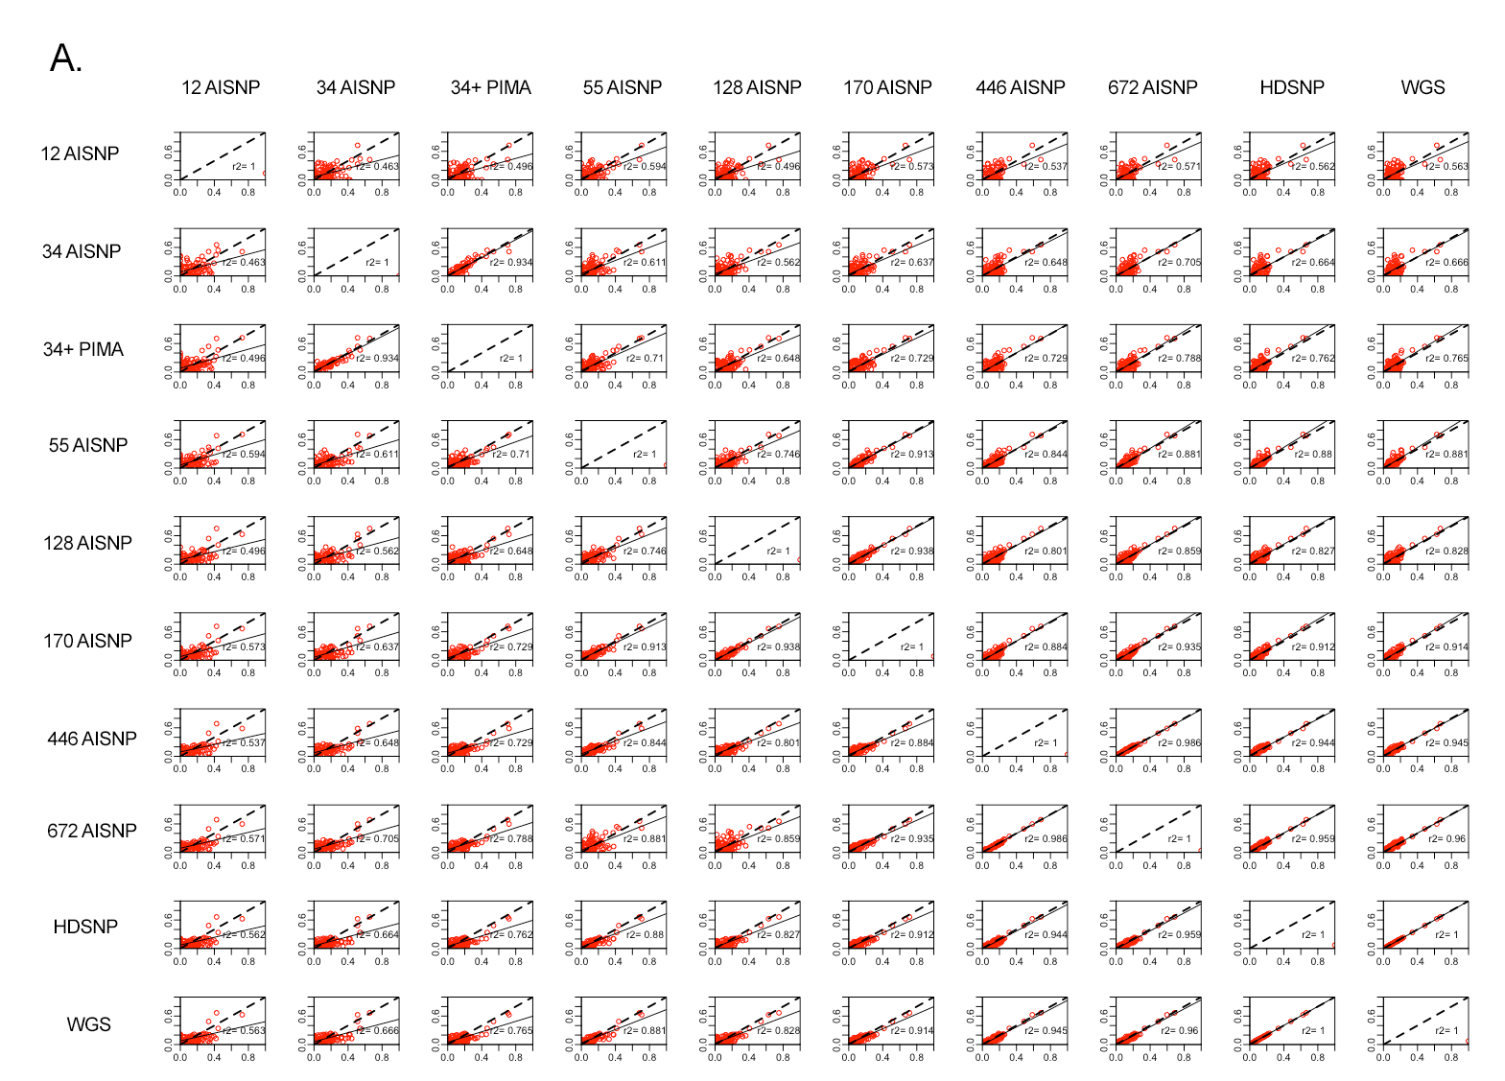
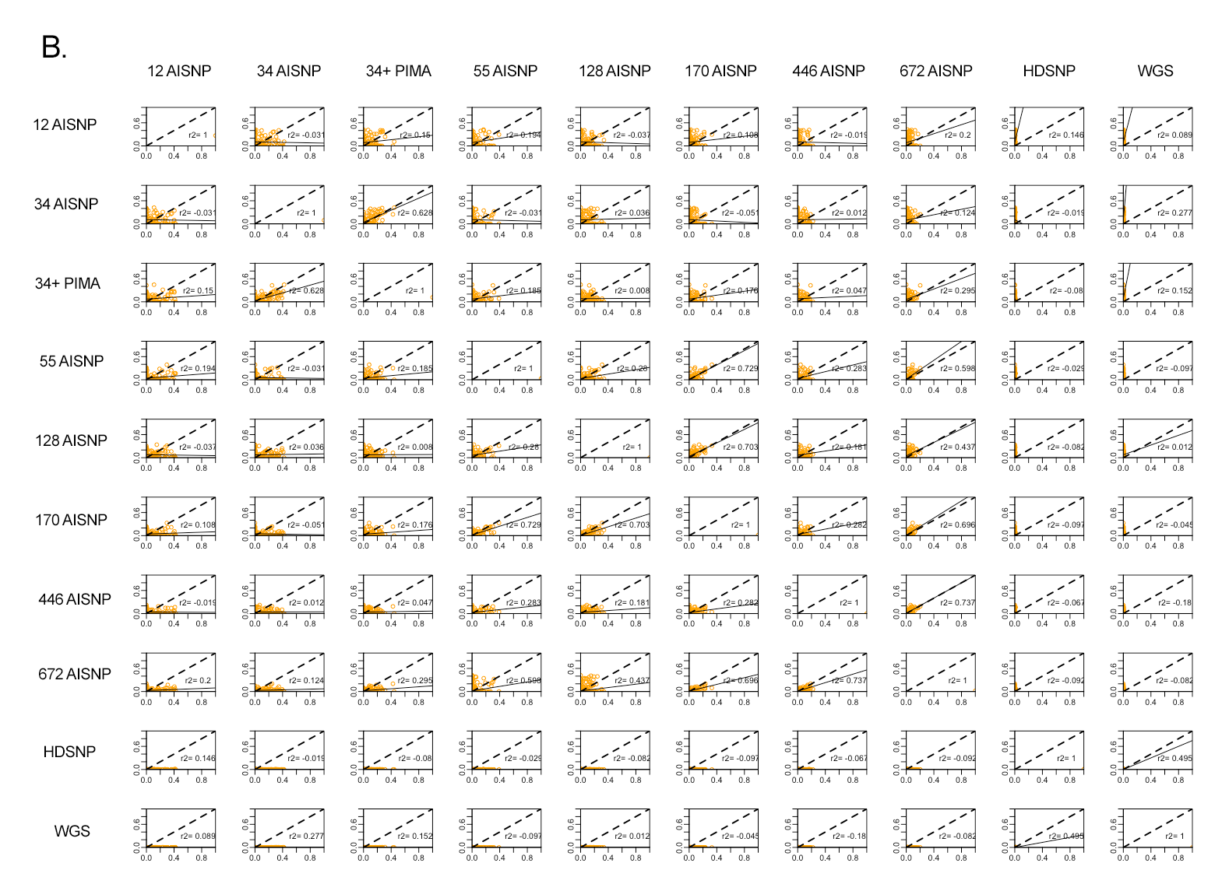
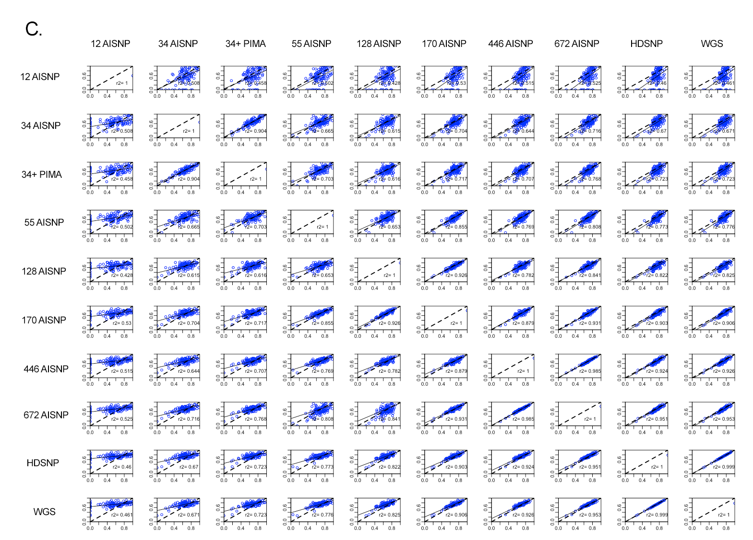
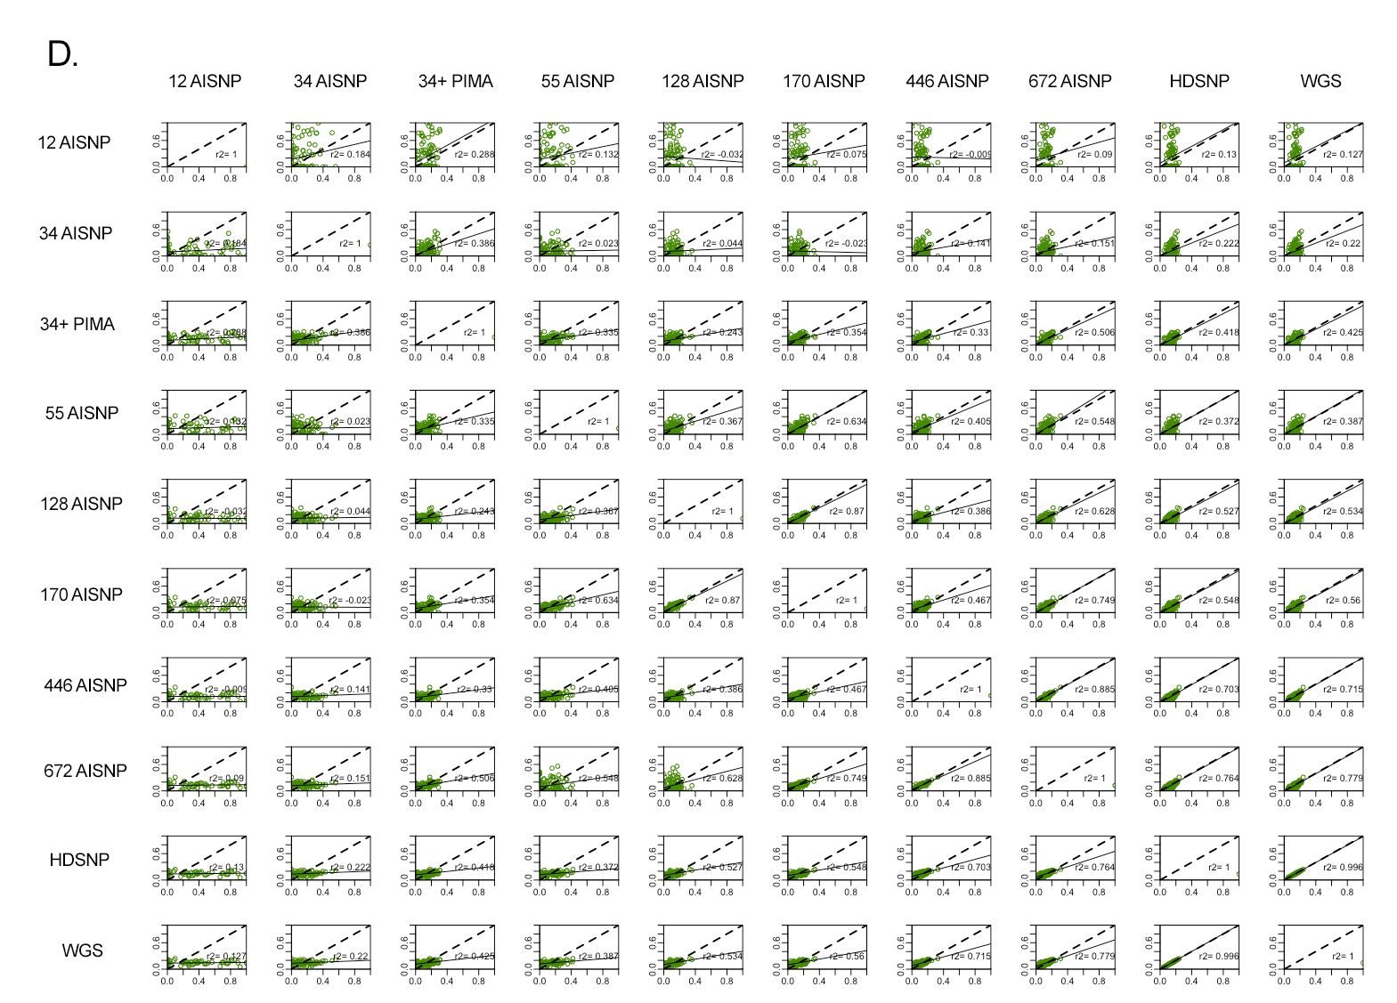Figure S10. Pairwise comparison of ancestry inferences for the Puerto Rican samples with the 10 panel sets evaluated (12 AISNP; 34 AISNP ; 34 AISNP +PIMA; 55 AISNP; 128 AISNP; 170 AISNP; 446 AISNP; 672 AISNP; HDSNP, WGS). In the figure, r2 corresponds to the correlation coefficient, the black dashed line represents the trendency, and the solid black line the perfect agreement between two panels. (A) corresponds to African ancestry component (red), (B) East Asian ancestry component (orange); (C) European ancestry component (blue) and (D) Native American ancestry component (green).
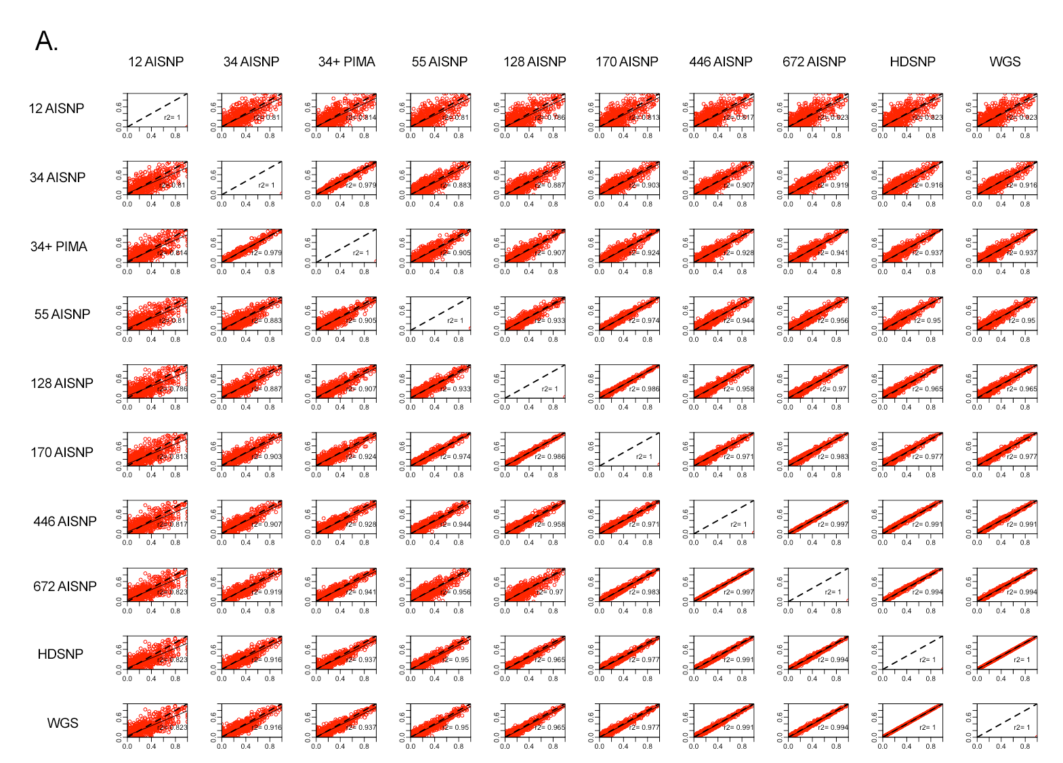
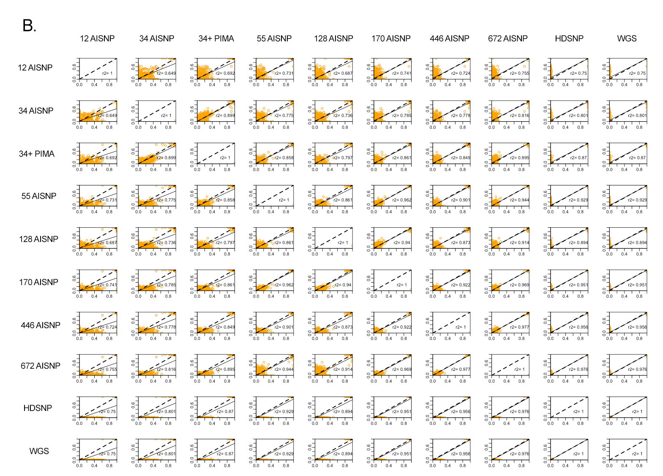
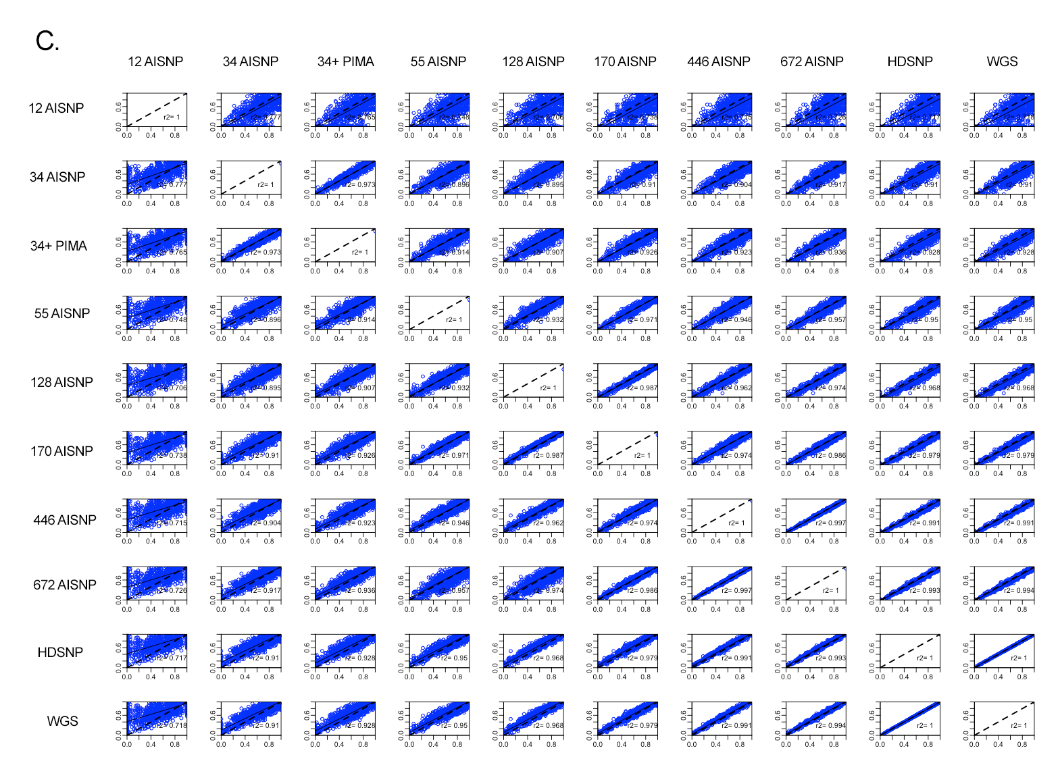
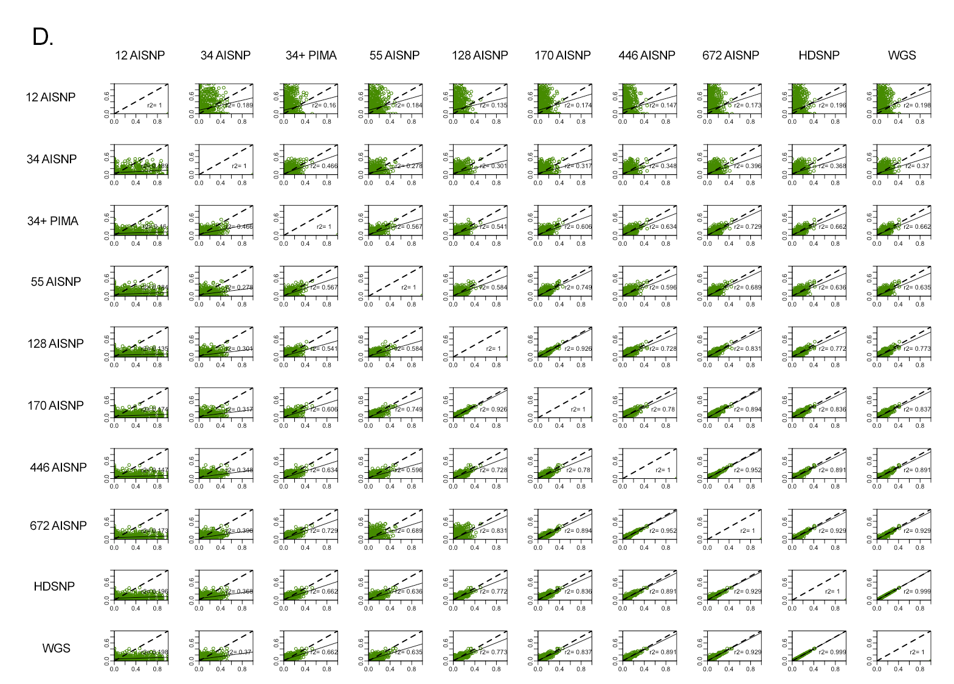Figure S11. Pairwise comparison of ancestry inferences for the Brazilian samples with the 10 panel sets evaluated (12 AISNP; 34 AISNP ; 34 AISNP +PIMA; 55 AISNP; 128 AISNP; 170 AISNP; 446 AISNP; 672 AISNP; HDSNP, WGS). In the figure, r2 corresponds to the correlation coefficient, the black dashed line represents the trendency, and the solid black line the perfect agreement between two panels. (A) corresponds to African ancestry component (red), (B) East Asian ancestry component (orange); (C) European ancestry component (blue) and (D) Native American ancestry component (green).

