Appendix I:
CDH f-ECHO based management Protocol
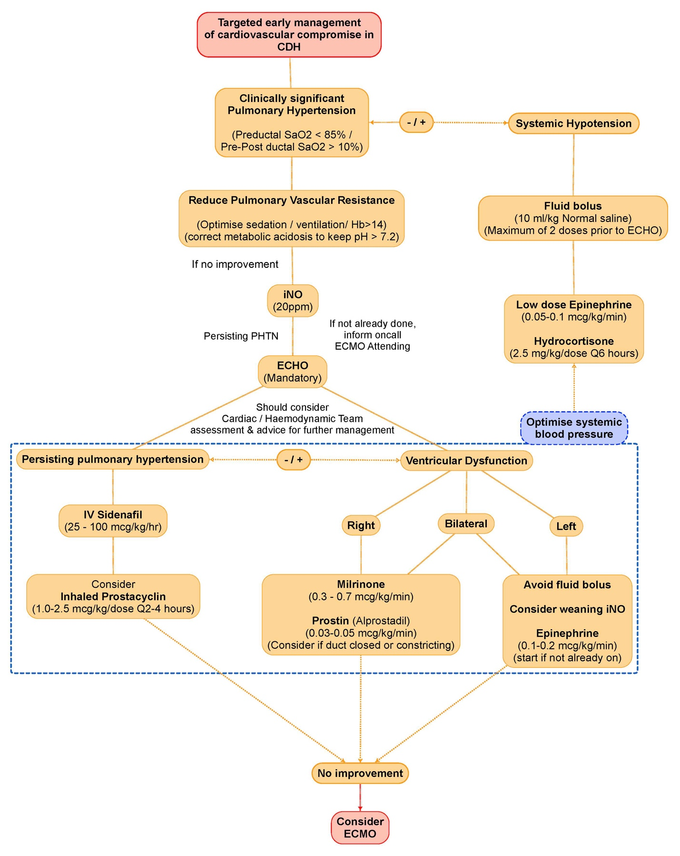
Protocol adopted from CODINOS trial²⁷ and Glasgow CDH protocol with permission from Dr Neil Patel

