Supplementary materials
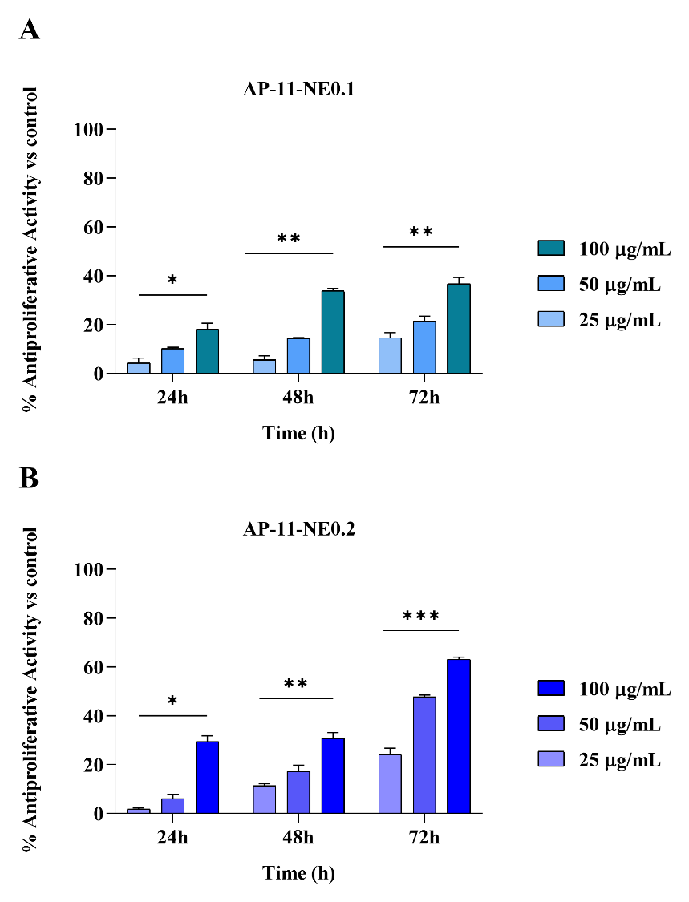
Fig. S1 Anti-proliferative activity of nanocomposites on HaCaT cells, at different concentrations (25-50-100 µg/mL, after 24, 48, and 72 hours of treatment. Panel A:AP-1-NE0.1 Panel B: AP-11-NE0.2. Data are expressed as mean ± S.E.M. Mercaptopurine (1 µM) was used as a positive control. ***, ** and * denote P<0.001, P<0.01 and P<0.05 respectively formulations vs control

