Supplementary Materials

Models eliminating bias in treatment effect via inverse probability weighting (IPW)

The effect estimation follows two steps as detailed in the following. Let $L$ be the set of identified confounding factors and $X_{0}$ be the set of baseline prognostic factors.

- We estimate the stabilised IP weight for each individual in the study population by fitting logistic models for the probability $Pr⁡(A=1)$ of treatment (e.g., quitting smoking, taking BPLM or LLM) and the conditional probability $Pr⁡(A=1|L)$ given the variables in $L$
$$\begin{aligned}logit\operatorname{Pr}{(A=1)}=γ_{0} \#(1) \\ logit\operatorname{Pr}\left(A=1 | L\right)=α_{0}+α_{1}l_{1}+α_{2}l_{2}+⋯+α_{d}l_{d}.\#(2)\end{aligned}$$
The estimated stabilised IP weight is then $W^{A}= \operatorname{Pr}\left(A=1\right)/\operatorname{Pr}\left(A=1|L\right)$ for the treated and $(1-Pr\left(A=1\right))/(1-\operatorname{Pr}\left(A=1|L\right))$ for the untreated.

There exists selection bias due to administrative censoring and loss of follow-up (including competing events). This will be adjusted for by conceptualizing the censoring as a time-varying treatment $C_{1}, …, C_{K}$, where $C_{k}$ is an indicator that takes value 0 if the individual remains uncensored at time $k$ and takes value 1 otherwise; by definition $C_{0}=0$ for all individuals in the study. A pseudo-population if no individuals had been lost to follow-up can be created using the stabilized IP weights
$$\begin{aligned}W^{C}=\prod_{k=1}^{K}{\frac{\text{Pr}\left(C_{k}=0 | C_{k-1}=0, A\right)}{\text{Pr}\left(C_{k}=0 | C_{k-1}=0, A,L,X_{0}\right)}, } \#\left(3\right)\end{aligned}$$
where the numerator and denominator of weights are estimated via two separate pooled logistic models, respectively, as follows
$$\begin{aligned}logit\operatorname{Pr}\left(C_{k}=0 | C_{k-1}=0, A\right)=γ_{0}^{*}+γ_{1}^{*}a +γ_{2}^{*}k.\#(4) \\ logit\operatorname{Pr}\left(C_{k}=0 | C_{k-1}=0, A, L,X_{0}\right)=γ_{0}++γ_{01}a +γ_{02}k+ \\ γ_{1}l_{1}+⋯+γ_{d}l_{d}+ γ_{d+1}x_{1}+⋯+γ_{d+s}x_{s}.\#(5)\end{aligned}$$

Note here we include baseline measurements $X_{0}$ which are associated with both censoring and the outcome in the predictive model for denominator. The effects can then be estimated with IP weighting $W^{A}×W^{C}$ as in Step 2.
- We fit a hazards model with individuals that are weighted by their estimated stabilised IP weights using each person-year prior to either a CVD event, censoring, or end of 5-year follow-up (which ever occurred first) as an observation. Let $D_{k}$ indicate CVD status at time $k$ (months of follow-up). This IP weighted pooled logistic model estimates the parameters of the marginal structural logistic model
$$\begin{aligned} logit\operatorname{Pr}\left(D_{k+1}^{a}=1 | D_{k}^{a}=0\right)=β_{0}+β_{1}k+β_{2}a+ β_{3}a×k.\#(6)\end{aligned}$$

One minus the estimates of $\operatorname{Pr}\left(D_{k+1}^{a}=1 | D_{k}^{a}=0\right)$ from the IP weighted hazards model can then be multiplied overtime to obtained an estimate of the survival $\operatorname{Pr}{(D_{k+1}^{a}=0)}$ that would have been observed under treatment and under no treatment.

Identify confounders in IPW approaches
There are two general approaches to selecting variables in order to control confounding in estimating causal effects with observational data (1): (a) use of background knowledge and causal graph theory, and (b) empirical approaches that select variables on the basis of statistical associations. A graphical analysis of the structural basis for evaluating confounding is known to be the most robust approach to selecting variables for adjustment; however, construction of a relevant causal structure that is comprehensive and accurate for us to use here is beyond the scope of this paper. We therefore adopt more practical variable selection approaches based on background knowledge when the causal structure is only partially known, as recommended in (1). These strategies include: (a) adjusting for all observed pre-treatment variables that have some connection to the outcome (2), (b) all known risk factors for the outcome (3,4), and (c) all direct causes of the treatment or the outcome (5). We adopted strategy (a) to firstly include for adjustment all pre-treatment covariates that all possible risk factors for the outcome, a strategy often used with propensity score methods. We then used the (partially) know causal structures to exclude, e.g. strong instruments and colliders, as otherwise biases can result (5,6). For IPW approach b1 where only baseline data were used to determine sample treatment status, $X_{0}$ in Table 2 are likely to be partly mediators. For example, baseline TC/HDL-C is not included in $L$ for adjustment in IPW approach b1 as blood pressure lowering medication is reported to affect lipid profiles (7) and therefore TC/HDL-C represents an effect mediator of blood pressure lowering medication. Similarly, baseline SBP is not included in $L$ for adjustment in IPW approach 1 as lipid-lowering medication is reported to lower BP (8), and therefore SBP represents an effect mediator of lipid-lowering medication.

Adjusting for selection bias in IPW approach (b2)
Bias from pre-selecting individuals who followed up within 2 years following their first assessment visit was corrected in the analysis by inverse probability weighting. This was based on assigning a weight $W^{C^{'}}$ to each selected individual ($C^{'}=0$), which was the inverse of the probability of their selection $\operatorname{Pr}{{(C}^{'}}=0|X^{'})$. We used all mandatory variables required for the CVD risk assessment as variables in $X^{'}$ for estimating the probability, all measured at their first assessment visit: sex, age, ethnicity, socioeconomic status, and family history of CVD, smoking status, diabetes, atrial fibrillation, SBP, TC/HDL-C, ATM, LLM, BPLM. For treatment effect estimation using IPW approach (b2), the IP weighted hazards model was applied using the computed weight $W^{C^{'}}$together with the treatment and censoring weights $W^{A}×W^{C}$.

Supplementary Tables

Table E1: Beta coefficients from refitted CPM and current PREDICT model.
NZDep=New Zealand Index of Socioeconomic Deprivation. SBP=systolic blood pressure. TC/HDL-C=total cholesterol to HDL cholesterol ratio. OBPLM=on blood pressure-lowering medications. OLLM=on lipid-lowering medications. OATM=on antithrombotic medications.

 | PREDICT  (female) | refitted PREDICT  (female) | PREDICT  (male) | refitted PREDICT (male)
Age | 0.0756412 | 0.072087754 | 0.0675532 | 0.0676234
Maori | 0.3910183 | 0.465883913 | 0.2899054 | 0.35781349
Pacific | 0.2010224 | 0.314346777 | 0.1774195 | 0.31043198
Indian | 0.1183427 | 0.095860408 | 0.2902049 | 0.18276439
Asian | -0.28551 | -0.33859176 | -0.3975687 | -0.4127755
NZDep quintile | 0.1080795 | 0.113142957 | 0.0794903 | 0.07044576
Ex-smoker | 0.087476 | 0.127872115 | 0.0753246 | 0.0872162
Current-smoker | 0.6226384 | 0.647034588 | 0.5058041 | 0.51977242
Family history of CVD | 0.0445534 | 0.066267029 | 0.1326587 | 0.13616994
Atrial fibrillation | 0.8927126 | 0.894545374 | 0.5880131 | 0.5637951
Diabetes | 0.5447632 | 0.500767257 | 0.5597023 | 0.49456508
SBP per 1 mmHg | 0.0136606 | 0.018439897 | 0.0163778 | 0.01897567
TC/HDL-C | 0.1226753 | 0.135519996 | 0.1283758 | 0.13732456
OBPLM | 0.339925 | 0.381825062 | 0.2947634 | 0.31370106
OLLM | -0.0593798 | -0.06155674 | -0.0537314 | -0.0180492
OATM | 0.1172496 | 0.164681863 | 0.0934141 | 0.0677013
Age x Diabetes | -0.0222549 | -0.016455946 | -0.020235 | -0.0159106
Age x SBP | -0.0004425 | -0.000538926 | -0.0004184 | -0.0005784
OBPLM x SBP | -0.004313 | -0.007287935 | -0.0053077 | -0.0045176
Baseline survival function (at 5 years) | 0.983169213 | 0.985567573 | 0.974755526 | 0.97765173

Table E2: Estimated relative risks estimated by IPW Approach b2 where data from the 1st follow-up after baseline were used to estimate treatment effects.
*Intermediate model: using the same confounder set as in baseline only model (see Methods);
 | IPW effects with post-baseline data
 | Intermediate  model* | Full model
(I) Smoking cessation | 0.73 (0.39–1.06) | 0.73 (0.38–1.07)
(IIa) Lowering SBP | 0.96 (0.69–1.22) | 0.99 (0.70–1.29)
(IIb) BP lowering medication | 1.19 (0.88–1.49) | 1.16 (0.69–1.62)
(IIIa) Lowering TC/HDL-C | 0.92 (0.60–1.24) | 0.95 (0.53–1.36)
(IIIb) Lipid lowering medication | 1.17 (0.72–1.62) | 1.13 (0.61–1.65)

Table E3: Absolute risk changes (ARC): median and lower and upper quartiles (LQ, UQ) across the target population, estimated from different approaches. ARC = risk without intervention – risk under intervention.
*Intermediate model: using the same confounder set as in baseline only model (see Methods).
 | Non-causal approach using refitted PREDICT:  ARR median (LQ, UQ) | IPW: ARR median (LQ, UQ) |  |  | Effects from external sources: ARR median (LQ, UQ)
 |  | With baseline data only | With post-baseline data |  | Effects from external sources: ARR median (LQ, UQ)
 |  | With baseline data only | Intermediate model* | Full model | Effects from external sources: ARR median (LQ, UQ)
(I) Smoking cessation | 1.42% (0.85%, 2.56%) | 1.44% (0.85%, 2.63%) | 1.09% (0.64%, 1.99%) | 1.17% (0.69%, 2.13%) | 1.05% (0.62%, 1.92%)
(IIa) Lowering SBP | 0.90% (0.55%, 1.55%) | 1.76% (1.07%, 2.86%) | 0.49% (0.30%, 0.80%) | 0.34% (0.21%, 0.56%) | 1.71% (1.04%, 2.78%)
(IIb) BP lowering medication | -0.18% (-0.60%, 0.19%) | -0.43% (-0.68%, -0.27%) | -0.94% (-1.49%, -0.59%) | -0.62% (-0.99%, -0.40%) | 1.05% (0.67%, 1.67%)
(IIIa) Lowering TC/HDL-C | 0.78% (0.43%, 1.49%) | 1.19% (0.68%, 2.22%) | 0.31% (0.17%, 0.57%) | 0.27% (0.16%, 0.51%) | 0.76% (0.44%, 1.42%)
(IIIb) Lipid lowering medication | 0.77% (0.44%, 1.42%) | 0.39% (0.23%, 0.70%) | -0.39% (-0.70%, -0.23%) | 0.06% (-0.10%, -0.03%) | 0.70% (0.41%, 1.26%)

Supplementary Figures

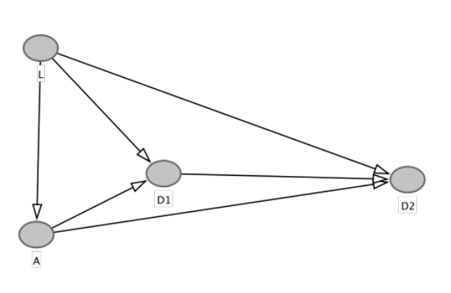
Fig. E1 Causal diagram for IPW approaches. $D_{k}$ indicates CVD status at time k (months of follow-up).

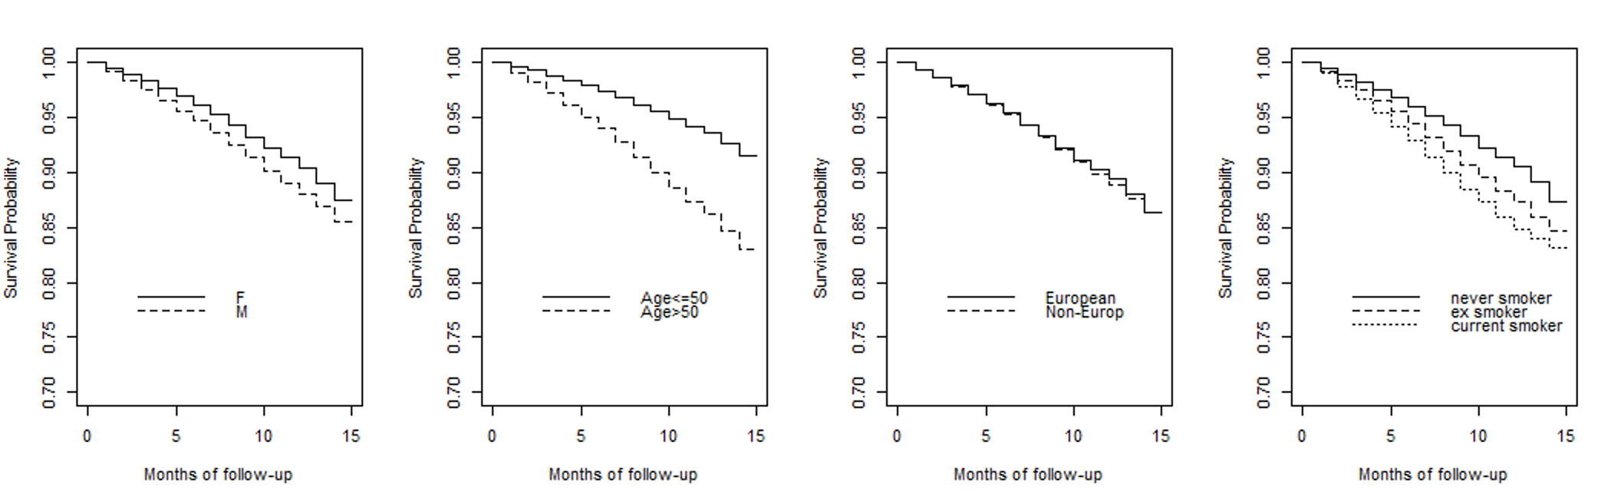

Fig. E2 Kaplan-Meier plots of survival probability in different patient groups.

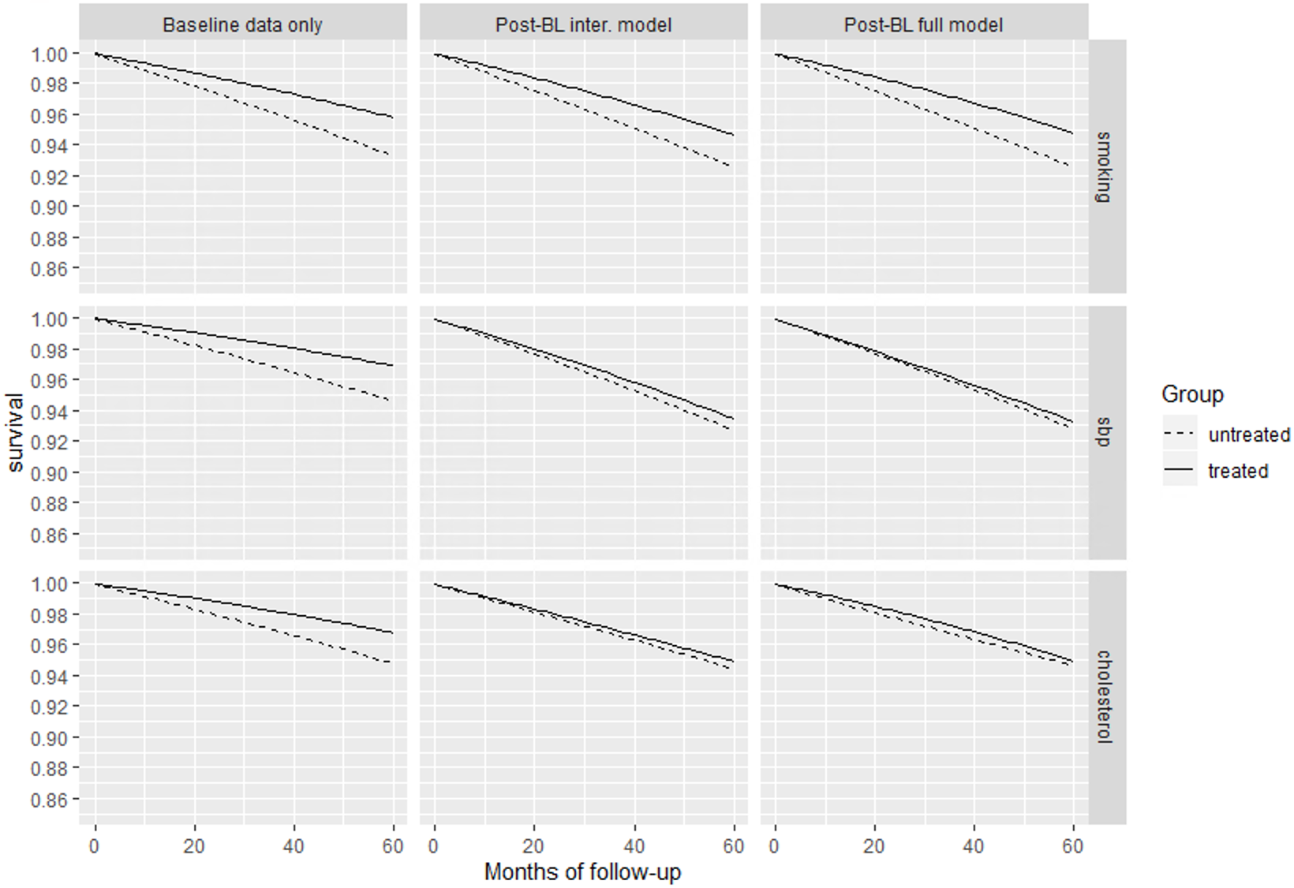

Fig. E3 Survival probability from an IP weighted hazards model: (I) smoking cessation, (IIa) lowering SBP, (IIIa) lowering TC/HDL-C. The solid curves represent the treated group and the dotted is for untreated group.

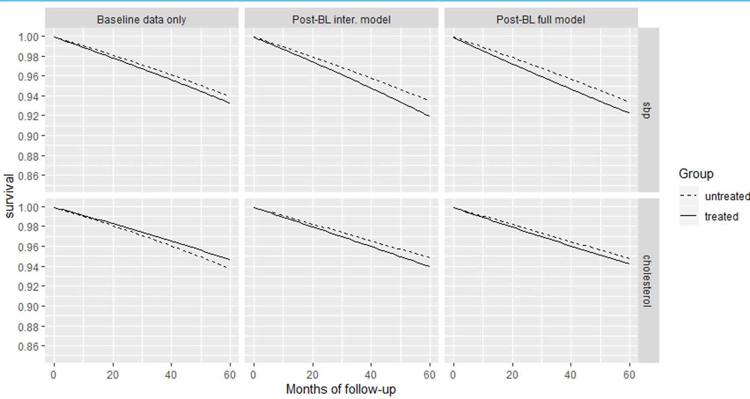
Fig. E4 Survival probability from an IP weighted hazards model: (IIb) BP lowering medication and (IIIb) lipid lowering medication. The solid curves represent the treated group and the dotted is for untreated group.

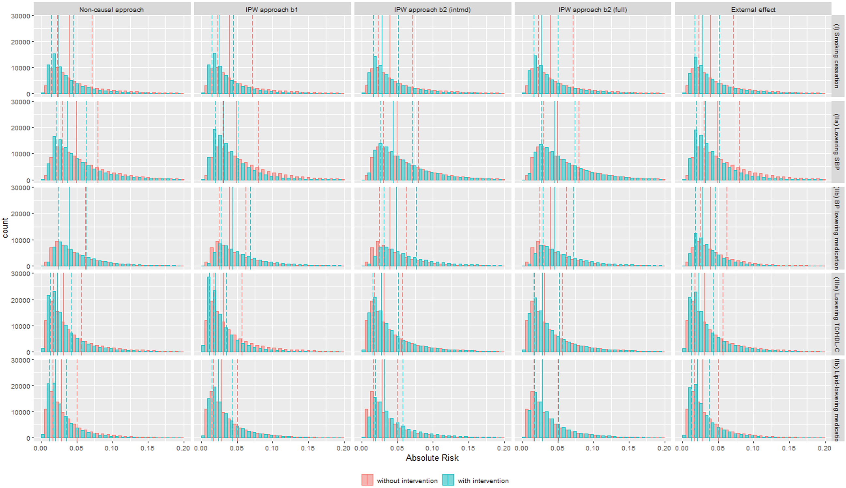
Fig E5 Distribution of absolute risk estimated from different approaches in different scenarios: (I) Smoking cessation, (IIa) Lowering SBP, (IIb) BP lowering medication, (IIIa) Lowering TC/HDL-C, and (IIIb) Lipid lowering medication. Dashed line represents corresponding mean. Blue, with interventions; Red, without interventions; Dashed lines: lower and upper quartiles; Solid lines: median
Reference:
1. Velentgas P, Dreyer NA, Nourjah P, Smith SR, Torchia MM, editors. Developing a Protocol for Observational Comparative Effectiveness Research: A User’s Guide [Internet]. Rockville (MD): Agency for Healthcare Research and Quality (US); 2013 [cited 2022 Mar 11]. (AHRQ Methods for Effective Health Care). Available from: http://www.ncbi.nlm.nih.gov/books/NBK126190/
2. Rubin DB. The design versus the analysis of observational studies for causal effects: parallels with the design of randomized trials. Stat Med. 2007 Jan 15;26(1):20–36.
3. Brookhart MA, Schneeweiss S, Rothman KJ, Glynn RJ, Avorn J, Stürmer T. Variable selection for propensity score models. Am J Epidemiol. 2006 Jun 15;163(12):1149–56.
4. Myers JA, Rassen JA, Gagne JJ, Huybrechts KF, Schneeweiss S, Rothman KJ, et al. Effects of Adjusting for Instrumental Variables on Bias and Precision of Effect Estimates. Am J Epidemiol. 2011 Dec 1;174(11):1213–22.
5. VanderWeele TJ, Shpitser I. A new criterion for confounder selection. Biometrics. 2011 Dec;67(4):1406–13.
6. Pearl J. Remarks on the method of propensity score. Stat Med. 2009 Apr 30;28(9):1415–6; author reply 1420-1423.
7. Ames RP. Antihypertensive drugs and lipid profiles. Am J Hypertens. 1988 Oct;1(4 Pt 1):421–7.
8. Strazzullo P, Kerry SM, Barbato A, Versiero M, D’Elia L, Cappuccio FP. Do statins reduce blood pressure? A meta-analysis of randomized, controlled trials. Hypertension. 2007 Apr 1;49(4):792–8.
9. Schultz WM, Kelli HM, Lisko JC, Varghese T, Shen J, Sandesara P, et al. Socioeconomic Status and Cardiovascular Outcomes. Circulation. 2018 May 15;137(20):2166–78.
10. Vitale C, Mendelsohn ME, Rosano GMC. Gender differences in the cardiovascular effect of sex hormones. Nat Rev Cardiol. 2009 Aug;6(8):532–42.
11. Lüscher TF. Prevention: further insights on age and lipids. Eur Heart J. 2017 May 21;38(20):1525–9.
12. B.o A, J.h B, D C, M.e G, F S, G.d S, et al. Causal associations of tobacco smoking with cardiovascular risk factors: A Mendelian randomization analysis of the HUNT study in Norway. Int J Epidemiol. 1464th–3685th ed. 2014 Aug;43(5):1458–70.
13. M.g L, D K, T.l A, M.s F, E I, J L, et al. Genetics of Smoking and Risk of Atherosclerotic Cardiovascular Diseases: A Mendelian Randomization Study. JAMA Netw Open. 2574th–3805th ed. 2020;no pagination.
14. Lakier JB. Smoking and cardiovascular disease. Am J Med. 1992 Jul 15;93(1, Supplement 1):S8–12.
15. Qazi MU, Malik S. Diabetes and Cardiovascular Disease: Insights from the Framingham Heart Study. Glob Heart. 2013 Mar 1;8(1):43–8.
16. Larsson SC, Scott RA, Traylor M, Langenberg CC, Hindy G, Melander O, et al. Type 2 diabetes, glucose, insulin, BMI, and ischemic stroke subtypes. Neurology. 2017 Aug 1;89(5):454–60.
17. Odutayo A, Wong CX, Hsiao AJ, Hopewell S, Altman DG, Emdin CA. Atrial fibrillation and risks of cardiovascular disease, renal disease, and death: systematic review and meta-analysis. BMJ. 2016 Sep 6;354:i4482.
18. Nauffal V, Weng L-C, Treu T, Gunn S, Morrill VN, Galloway A, et al. Abstract 10816: Causal Effect of Atrial Fibrillation on Cardiovascular Diseases - A Mendelian Randomization Analysis in the Million Veteran Program. Circulation. 2021 Nov 16;144(Suppl_1):A10816–A10816.
19. Fuchs FD, Whelton PK. High Blood Pressure and Cardiovascular Disease. Hypertension. 2020 Feb;75(2):285–92.
20. Burgess S, Harshfield E. Mendelian randomization to assess causal effects of blood lipids on coronary heart disease: lessons from the past and applications to the future. Curr Opin Endocrinol Diabetes Obes. 2016 Apr;23(2):124–30.
21. Haire-Joshu D, Glasgow RE, Tibbs TL. Smoking and diabetes. Diabetes Care. 1999 Nov 1;22(11):1887–98.
22. Larsson SC, Mason AM, Bäck M, Klarin D, Damrauer SM, Million Veteran Program, et al. Genetic predisposition to smoking in relation to 14 cardiovascular diseases. Eur Heart J. 2020 Sep 14;41(35):3304–10.
23. High blood pressure (hypertension). https://www.nhs.uk/conditions/high-blood-pressure-hypertension/No Title [Internet]. Available from: https://www.nhs.uk/conditions/high-blood-pressure-hypertension

