Supplementary Information

Biodiversity–stability relationships strengthen over time in a long-term grassland experiment

Cameron Wagg*, Christiane Roscher, Alexandra Weigelt, Anja Vogel, Anne Ebeling, Enrica de Luca, Anna Roeder, Clemens Kleinspehn, Vicky M. Temperton, Elisabeth Marquard, Sebastian T. Meyer, Michael Scherer-Lorenzen, Nina Buchmann, Markus Fischer, Wolfgang W. Weisser, Nico Eisenhauer, Bernhard Schmid

*Corresponding author: (cameron.wagg@agr.gc.ca)

Table S1. Plant species and their functional group (FG) identities.
Species name | FG | Species name | FG
Alopecurus pratensis | Grass | Glechoma hederacea | Short herb
Anthoxanthum odoratum | Grass | Leontodon autumnalis | Short herb
Arrhenatherum elatius | Grass | Leontodon hispidus | Short herb
Avenula pubescens | Grass | Plantago lanceolata | Short herb
Bromus erectus | Grass | Plantago media | Short herb
Bromus hordeaceus | Grass | Primula veris | Short herb
Cynosurus cristatus | Grass | Prunella vulgaris | Short herb
Dactylis glomerata | Grass | Ranunculus repens | Short herb
Festuca pratensis | Grass | Taraxacum officinale | Short herb
Festuca rubra | Grass | Veronica chamaedrys | Short herb
Holcus lanatus | Grass | Achillea millefolium | Tall herb
Luzula campestris | Grass | Anthriscus sylvestris | Tall herb
Phleum pratense | Grass | Campanula patula | Tall herb
Poa pratensis | Grass | Cardamine pratensis | Tall herb
Poa trivialis | Grass | Carum carvi | Tall herb
Trisetum flavescens | Grass | Centaurea jacea | Tall herb
Lathyrus pratensis | Legume | Cirsium oleraceum | Tall herb
Lotus corniculatus | Legume | Crepis biennis | Tall herb
Medicago lupulina | Legume | Daucus carota | Tall herb
Medicago varia | Legume | Galium mollugo | Tall herb
Onobrychis viciifolia | Legume | Geranium pratense | Tall herb
Trifolium campestre | Legume | Heracleum sphondylium | Tall herb
Trifolium dubium | Legume | Knautia arvensis | Tall herb
Trifolium fragiferum | Legume | Leucanthemum vulgare | Tall herb
Trifolium hybridum | Legume | Pastinaca sativa | Tall herb
Trifolium pratense | Legume | Pimpinella major | Tall herb
Trifolium repens | Legume | Ranunculus acris | Tall herb
Vicia cracca | Legume | Rumex acetosa | Tall herb
Ajuga reptans | Short herb | Sanguisorba officinalis | Tall herb
Bellis perennis | Short herb | Tragopogon pratensis | Tall herb

Table S2. Experimental design where numbers indicate the number of plots per plant functional group richness (FGR) and sown plant species richness (SR) levels.
 | FGR
SR | 1 | 2 | 3 | 4 | Total
1 | 16 |  |  |  | 16
2 | 8 | 8 |  |  | 16
4 | 4 | 4 | 4 | 4 | 16
8 | 4 | 4 | 4 | 4 | 16
16 | 2 | 4 | 4 | 4 | 14
Total | 34 | 20 | 12 | 12 | 78

Table S3. Mixed-model ANOVA results for assessing the changes in the species richness–community productivity (square-root transformed) and the species richness–relative yield (log-transformed) relationship (see also Fig. 1a and b). Species richness was always log-transformed (SR_{log}) and the change in the effect of richness was assessed using year as a linear term (Y_{linear}) followed by year as a factor with 17 levels (Y_{factor}).
 |  | Productivity |  |  | Relative yield
Fixed | DF | DF_{den} | F | P | DF_{den} | F | P
SR_{log} | 1 | 71.3 | 69.45 | < 0.001 | 71.2 | 80.62 | < 0.001
Y_{linear} | 1 | 440.0 | 354.30 | < 0.001 | 437.1 | 65.96 | 0.076
Y_{factor} | 15 | 1074.8 | 18.08 | < 0.001 | 1072.1 | 6.55 | < 0.001
SR_{log} × Y_{linear} | 1 | 329.9 | 8.34 | 0.004 | 331.1 | 44.29 | < 0.001
SR_{log} × Y_{factor} | 15 | 1074.8 | 1.40 | 0.138 | 1072.1 | 2.11 | 0.008
Random |  | Var. | SE |  | Var (10⁻³) | SE (10⁻³)
Block |  | 0.39 | 0.84 |  | 2.23 | 4.32
Plot |  | 8.97 | 2.07 |  | 43.22 | 9.79
Residual |  | 20.17 | 1.18 |  | 93.76 | 5.37
Year ρ_{AR1} |  | 0.51 | 0.03 |  | 0.490 | 0.028

Table S4. Slopes and standard errors (SE) for the slope along with the significance (P) for a difference from 0 (no relationship) are provided along with the intercept (Inter.) for the relationship between log-transformed sown species richness and a) the square-root transformed community productivity and b) the log-transformed relative yield. The relationships are shown on the original scale in Fig. 1a.
 | - Community productivity |  |  |  | - Relative yield
Year | Inter. | Slope | SE | P | Inter. | Slope | SE | P
2003 | 21.76 | 2.48 | 0.65 | < 0.001 | 0.642 | 0.105 | 0.045 | 0.018
2004 | 21.91 | 1.79 | 0.65 | 0.006 | 0.603 | 0.072 | 0.044 | 0.104
2005 | 15.26 | 2.39 | 0.65 | < 0.001 | 0.577 | 0.131 | 0.045 | 0.003
2006 | 15.33 | 3.56 | 0.65 | < 0.001 | 0.614 | 0.200 | 0.045 | < 0.001
2007 | 16.91 | 3.86 | 0.65 | < 0.001 | 0.652 | 0.208 | 0.045 | < 0.001
2008 | 11.26 | 3.79 | 0.64 | < 0.001 | 0.628 | 0.288 | 0.045 | < 0.001
2009 | 12.70 | 3.85 | 0.65 | < 0.001 | 0.550 | 0.244 | 0.045 | < 0.001
2010 | 11.16 | 3.21 | 0.64 | < 0.001 | 0.673 | 0.258 | 0.045 | < 0.001
2011 | 13.18 | 2.58 | 0.64 | < 0.001 | 0.702 | 0.183 | 0.045 | < 0.001
2012 | 11.60 | 3.77 | 0.65 | < 0.001 | 0.534 | 0.250 | 0.045 | < 0.001
2013 | 11.62 | 3.17 | 0.64 | < 0.001 | 0.717 | 0.256 | 0.045 | < 0.001
2014 | 11.29 | 3.91 | 0.64 | < 0.001 | 0.675 | 0.290 | 0.045 | < 0.001
2015 | 9.80 | 3.66 | 0.64 | < 0.001 | 0.673 | 0.322 | 0.045 | < 0.001
2016 | 7.58 | 3.74 | 0.64 | < 0.001 | 0.566 | 0.359 | 0.045 | < 0.001
2017 | 9.05 | 4.33 | 0.64 | < 0.001 | 0.592 | 0.361 | 0.045 | < 0.001
2018 | 7.77 | 4.06 | 0.66 | < 0.001 | 0.531 | 0.373 | 0.046 | < 0.001
2019 | 6.41 | 4.88 | 0.65 | < 0.001 | 0.488 | 0.459 | 0.045 | < 0.001

Table S5. Mixed-model ANOVA results for the change in community productivity relative to community productivity in year 1 (2003) (see also Fig. 1d). Richness is a factor (SR_{factor}) and year is linear (Y_{linear}). The model was fit with the intercept fixed at 0 (log(1)) hence the degrees of freedom for richness is 5.
Fixed | DF | DF_{den} | F | P
SR_{factor} | 5 | 30.7 | 17.64 | < 0.001
Y_{linear} | 1 | 244.3 | 211.9 | < 0.001
SR_{factor} × Y_{linear} | 4 | 244.3 | 13.79 | < 0.001
Random |  | Var. | SE
Block |  | 0.041 | 0.046
Plot |  | 0.191 | 0.051
Residual |  | 0.629 | 0.036
Year ρ_{AR1} |  | 0.498 | 0.028

Table S6. Mixed-model ANOVA results for assessing the changes in the species richness–yearly biodiversity effects and the species richness–relative yield total (log-transformed) relationships (see also Fig. 2a–d). Species richness was always log-transformed (SR_{log}) and the change in the effect of richness was assessed using year as a linear term (Y_{linear}) followed by year as a factor with 17 levels (Y_{factor}).
 | Relative Yield Total (RYT) |  |  |  | Net effect
Fixed | DF | DF_{den} | F | P | DF | DF_{den} | F | P
SR_{log} | 1 | 57.8 | 50.49 | <0.001 | 1 | 57.3 | 40.91 | <0.001
Y_{linear} | 1 | 588.9 | 8.32 | 0.958 | 1 | 474.1 | 28.91 | 0.493
Y_{factor} | 14 | 732.5 | 2.57 | 0.001 | 15 | 872.5 | 10.17 | <0.001
SR_{log} × Y_{linear} | 1 | 495.2 | 7.33 | 0.007 | 1 | 290.1 | 1.00 | 0.318
SR_{log} × Y_{factor} | 14 | 738.2 | 0.55 | 0.901 | 15 | 872.8 | 1.41 | 0.135
Random |  | Var. 10³ | SE 10³ |  |  | Var. 10⁻³ | SE 10⁻³
Block |  | 9.46 | 15.35 |  |  | 0.59 | 0.99
Plot |  | 97.84 | 26.93 |  |  | 4.97 | 1.88
Residual |  | 529.67 | 27.14 |  |  | 33.55 | 1.99
Year ρ_{AR1} |  | 0.120 | 0.039 |  |  | 0.44 | 0.03
 | Complementarity effect |  |  |  | Selection effect
Fixed | DF | DF_{den} | F | P | DF | DF_{den} | F | P
SR_{log} | 1 | 57.4 | 39.87 | <0.001 | 1 | 61.3 | 22.04 | <0.001
Y_{linear} | 1 | 623.1 | 4.02 | 0.449 | 1 | 606.1 | 1.05 | 0.673
Y_{factor} | 14 | 746.6 | 1.42 | 0.140 | 14 | 677.4 | 0.92 | 0.540
SR_{log} × Y_{linear} | 1 | 417.7 | 0.01 | 0.932 | 1 | 397.7 | 0.00 | 0.975
SR_{log} × Y_{factor} | 14 | 750.5 | 0.91 | 0.545 | 14 | 685.8 | 0.95 | 0.500
Random |  | Var. 10⁻⁴ | SE 10⁻⁴ |  |  | Var. 10⁻⁴ | SE 10⁻⁴
Block |  | -0.48 | 0.53 |  |  | <0.01 | <0.01
Plot |  | 10.33 | 3.17 |  |  | 9.52 | 2.69
Residual |  | 79.04 | 3.98 |  |  | 59.81 | 3.14
Year ρ_{AR1} |  | 0.09 | 0.04 |  |  | 0.06 | 0.04

Table S7. Mixed-model ANOVA results of the analysis of the community stability, population stability and asynchrony. The log of species richness is a linear term (SR_{log}) along a five-year rolling window (13 consecutive 5-year windows) as linear (W_{linear}) to assess components of stability changed through time followed by window as a factor (W_{factor}) to assess whether effects varied among the five-year windows (see also Fig. 3). Community and population stability was log-transformed prior to analyses.
 |  | Community stability (CV_{net}⁻¹)
Fixed | DF | DF_{den} | F | P
SR_{log} | 1 | 74 | 44.99 | <0.001
W_{linear} | 1 | 888.0 | 0.13 | 0.008
W_{factor} | 11 | 888.0 | 2.66 | 0.002
SR_{log} × W_{linear} | 1 | 888.0 | 14.23 | <0.001
SR_{log} × W_{factor} | 11 | 888.0 | 0.46 | 0.929
Random |  | Var 10³ | SE 10³
Block |  | <0.01 | <0.01
Plot |  | 89.94 | 16.68
Residual |  | 149.20 | 7.08
 |  | Population stability (CV_{pop}⁻¹)
Fixed | DF | DF_{den} | F | P
SR_{log} | 1 | 74.0 | 4.97 | 0.029
W_{linear} | 1 | 888.0 | 0.83 | 0.019
W_{factor} | 11 | 888.0 | 0.89 | 0.553
SR_{log} × W_{linear} | 1 | 888.0 | 17.43 | <0.001
SR_{log} × W_{factor} | 11 | 888.0 | 0.48 | 0.917
Random |  | Var 10⁻³ | SE 10⁻³
Block |  | 0.00 | 0.00
Plot |  | 70.02 | 12.79
Residual |  | 100.86 | 4.79
 |  | Asynchrony (1-$θ$)
Fixed | DF | DF_{den} | F | P
SR_{log} | 1 | 71.2 | 260.70 | <0.001
W_{linear} | 1 | 888.0 | 0.86 | 0.272
W_{factor} | 11 | 888.0 | 2.11 | 0.017
SR_{log} × W_{linear} | 1 | 888.0 | 0.29 | 0.591
SR_{log} × W_{factor} | 11 | 888.0 | 1.49 | 0.129
Random |  | Var 10⁻³ | SE 10⁻³
Block |  | 0.49 | 0.87
Plot |  | 9.61 | 1.84
Residual |  | 17.70 | 0.84

Table S7. Fit statistics (R²) for the endogenous variables in the structural equation models shown in Fig. 4.
 | Window
R² | 2003-2007 | 2009-2013 | 2015-2019
CV_{net}⁻¹ | 0.921 | 0.930 | 0.948
ANP | 0.445 | 0.301 | 0.232
CVpop⁻¹ | 0.628 | 0.496 | 0.643
Async | 0.237 | 0.353 | 0.323
CE | 0.179 | 0.248 | 0.403
SE | 0.078 | 0.074 | 0.140

Table S8. Mixed-model ANOVA results assessing the effects of asynchrony (1- $θ$) on the Net, Complementarity and Selection biodiversity effects and the relative yield total (RYT) along the five-year rolling window (13 consecutive 5-year windows) as linear (W_{linear}) to assess components of stability changed through time followed by window as a factor (W_{factor}) to assess whether effects varied among the five-year windows (see Fig. 5). Population stability was log-transformed prior to analyses.
 |  | RYT |  |  | Net
 | DF | DF_{den} | F | P | DF_{den} | F | P
Async. | 1 | 694.7 | 3.97 | 0.053 | 715.8 | 1.49 | 0.085
W_{linear} | 1 | 645.1 | 391.10 | <0.001 | 677.7 | 6.37 | 0.265
W_{factor} | 11 | 636.3 | 2.34 | 0.007 | 674.0 | 11.24 | <0.001
Async. × W_{linear} | 1 | 648.9 | 12.29 | <0.001 | 679.5 | 0.73 | 0.394
Async. × W_{factor} | 11 | 639.3 | 1.23 | 0.263 | 675.1 | 0.48 | 0.917
Random |  | Var 10⁻² | SE 10⁻² |  | Var 10⁴ | SE 10⁴
Block |  | <0.01 | <0.01 |  | 0.46 | 2.78
Plot |  | 12.22 | 2.43 |  | 43.84 | 8.44
Residual |  | 12.94 | 0.73 |  | 17.21 | 0.94
 |  | Complementarity |  |  | Selection
 | DF | DF_{den} | F | P | DF_{den} | F | P
Async. | 1 | 646.4 | 0.87 | 0.358 | 632.2 | 19.81 | <0.001
W_{linear} | 1 | 660.6 | 85.27 | 0.048 | 639.5 | 98.83 | 0.244
W_{factor} | 11 | 645.3 | 1.27 | 0.212 | 624.6 | 1.49 | 0.117
Async. × W_{linear} | 1 | 665.6 | 5.67 | 0.018 | 645.9 | 18.47 | <0.001
Async. × W_{factor} | 11 | 650.6 | 0.43 | 0.944 | 629.6 | 0.71 | 0.732
Random |  | Var 10⁵ | SE 10⁵ |  | Var 10⁵ | SE 10⁵
Block |  | -5.72 | 2.96 |  | -1.14 | 1.58
Plot |  | 116.37 | 25.39 |  | 39.74 | 8.77
Residual |  | 219.49 | 12.24 |  | 77.50 | 4.40

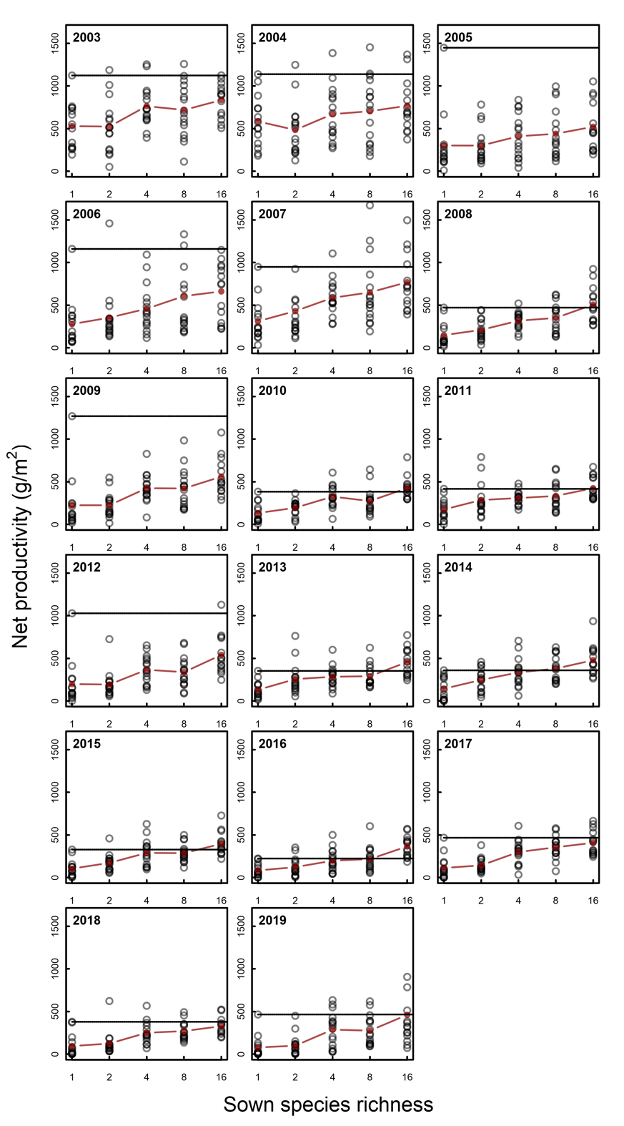
Fig S1. Scatterplots of the raw biomass data for each plot (points) are shown for each of the 17 years where community productivity was collected. The red line highlights the trend between consecutive sown species richness means. The dashed line highlights the most productive monoculture.

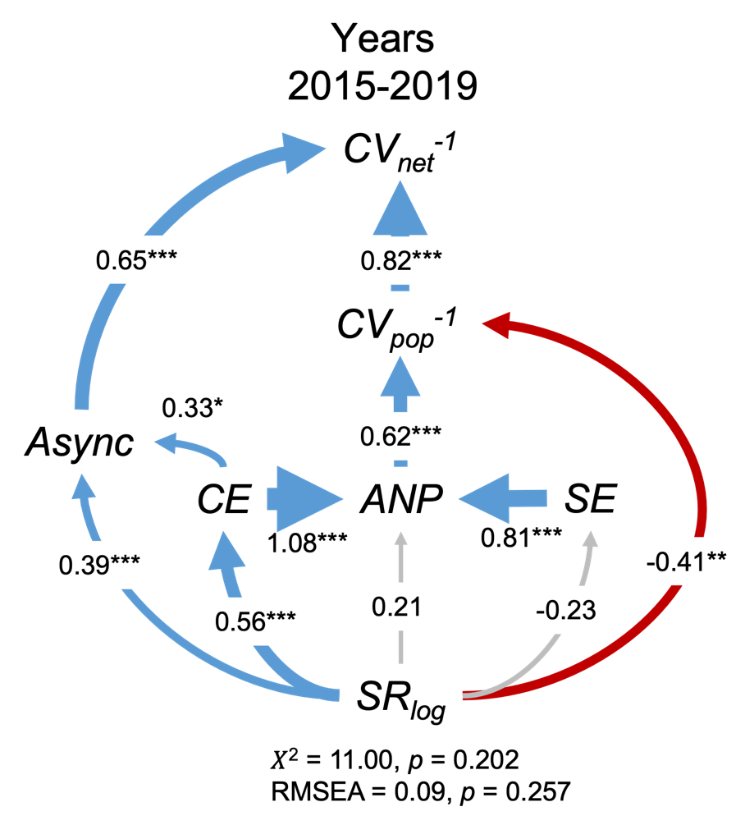
Figure S2. Alternative structural equation model for the 20015-2019 five-year window linking temporal changes in biodiversity effects with stability. Here the complementarity effect (CE) affects asynchrony whereas in Fig. 4c asynchrony affected the complementarity and selection effects. The structural equation model shows the log-transformed species richness (SR_{log}) effects on the five-year productivity (ANP) directly and indirectly through the complementarity (CE) and selection (SE) effects that all together affect species the population stability (CV_{pop}⁻¹). The population stability and species asynchrony (Async), which is indirectly determined by species richness, together determine the community stability (CV_{net}⁻¹). Standardized path coefficients are indicated by arrows with positive effects highlighted in blue and negative highlighted in red with significance indicated by *P < 0.05, **P < 0.01 and ***P < 0.001. The Async and CV_{pop}⁻¹ were allowed to covary as well as the CE and SE in all models. Fit statistics for the structural equation models are provided below each (The R² values of endogenous variables: CV⁻¹ = 0.95, CV_{pop}⁻¹ = 0.24, ANP = 0.64, Async = 0.40, CE = 0.31, SE = 0.05).

