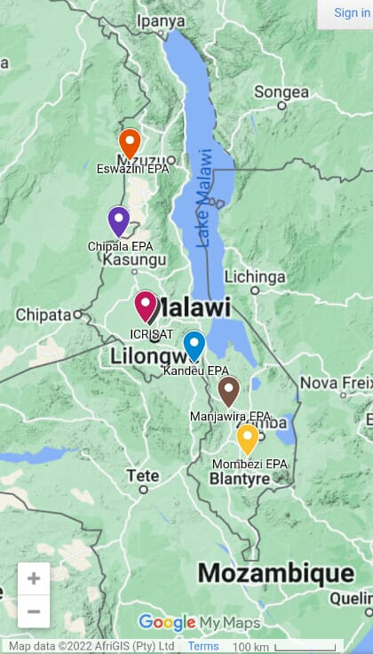
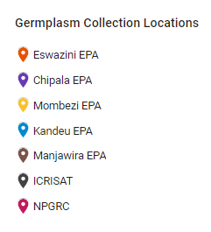

Fig S1: Germplasm collections sites

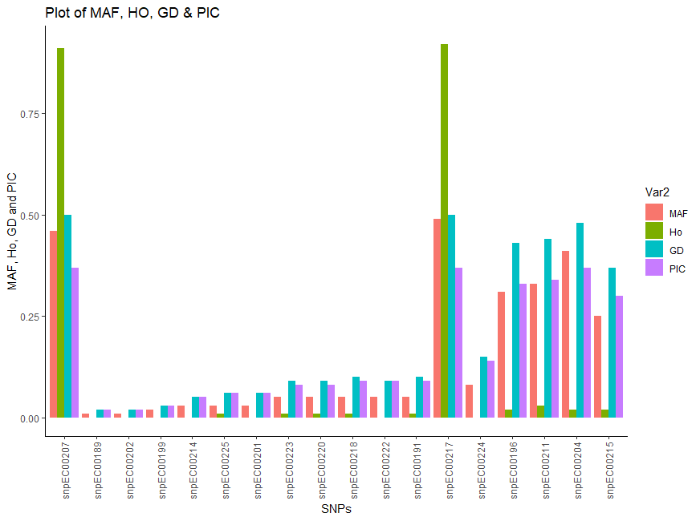
Fig S2: Attribute of the used Single nucleotide polymorphic (SNP)

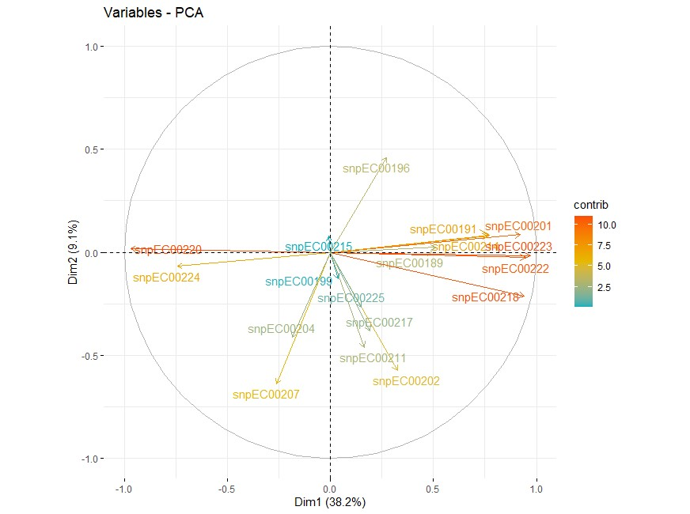
Fig S3: Principal component biplot analysis of finger millet germplasm showing relative contributions of SNPs to principal component

