Supplementary Information
Elastic interfacial layer enabled the high-temperature performance of lithium-ion batteries
via utilization of synthetic fluorosulfate additive

Hyeongyu Moon¹, Huibeom Nam⁴, Min Pyeong Kim^{2,3}, Seung Min Lee³, Hyeongjun Kim³,
Min Ho Jeon^{2,3}, Yoon-Sung Lee⁴, Koeun Kim⁴, Joong-Hyun Chun⁵, Sang Kyu Kwak^{3,}*,
Sung You Hong^{2,}* & Nam-Soon Choi^{1,}*

¹Department of Chemical and Biomolecular Engineering, Korea Advanced Institute of Science and Technology (KAIST), 291 Daehak-ro, Yuseong-gu, Dajeon 34141, Republic of Korea
²Department of Chemistry, Ulsan National Institute of Science and Technology (UNIST),
50 UNIST-gil, Ulsan 44919, Republic of Korea
³School of Energy and Chemical Engineering, Ulsan National Institute of Science and Technology (UNIST), 50 UNIST-gil, Ulsan 44919, Republic of Korea
⁴Research & Development Division, Hyundai Motor Company, 150, Hyundaiyeonguso-ro, Namyang-eup, Hwaseong-si, Gyeonggi-do 18280, Republic of Korea
⁵Department of Nuclear Medicine, Yonsei University College of Medicine, 50-1 Yonsei-ro, Sinchon-dong, Seodaemun-gu, Seoul 03722, Republic of Korea

*Corresponding authors
E-mail: skkwak@unist.ac.kr; syhong@unist.ac.kr; nschoi@kaist.ac.kr
Supplementary methods
Characterization
To investigate the thermal stability of the cathode–electrolyte interface (CEI) layer formed by 4-(allyloxy)phenyl fluorosulfate (APFS), the transition metal ion (Ni, Co, and Mn) dissolution of the cathode was measured by inductively coupled plasma-optical emission spectroscopy (ICP-OES, 700-ES, Varian). The fully charged cathodes were recovered and rinsed with dimethyl carbonate to remove the residual electrolyte and then stored in the same amount (2 mL) of electrolyte. The sample was sealed in a polyethylene vial and stored in an oven at 60 °C for three days. Differential scanning calorimetry (DSC 1 STAR^{e} System, Mettler Toledo) analysis was conducted to examine the thermal behaviors of the delithiated cathodes with the electrolyte. The samples were scanned at a heating rate of 5 °C min⁻¹ from 30 °C to 350 °C under a nitrogen atmosphere. The electrodes retrieved from fully charged NCM811/SiC-graphite (SiG-C) full cells up to 4.2 V versus Li/Li⁺ were used for DSC analysis. The additive-free electrolyte (1 M LiPF₆ in ethylene carbonate, ethyl methyl carbonate, and diethyl carbonate (EC/EMC/DEC, 25/45/30 vol%)) was used to understand the effect of CEI on the thermal stability of NCM811 cathodes. The amount of electrolyte and electrode sample in a single DSC cell was 0.7 mg and 1.4 mg, respectively. X-ray powder diffraction (XRD, D/MAX2500V/PC, Rigaku) measurement was conducted to analyze the changes in the cathode structures. The X-ray radiation source scanned the sample in the range of 10° to 80° at a rate of 1° min⁻¹.

Computational details
Density functional theory calculations were performed to investigate the orbital energy levels, deformation energies, F dissociation energies, and reaction mechanisms. Beck’s three-parameter hybrid functional combined with the Lee–Yang–Parr correlation (B3LYP) functional was employed for deriving the exchange-correlation energy^{1,2}. Spin-polarized calculations were conducted, and the Tkatchenko–Scheffler method was used to apply a van der Waals correction³. All relativistic core treatments and the DNP 4.4 basis set were utilized to describe the core electrons and atomic orbital basis set, respectively. The self-consistent field tolerance was set to 1.0 × 10⁻⁶ Ha. The convergence criteria for geometry optimization were 1.0 × 10⁻⁵ Ha for energy, 0.002 Ha/Ǻ for force, and 0.005 Ǻ for displacement.
It should be noted that the dielectric constant (ɛ_{mix}) of the mixture was obtained from a mixing rule defined by Looyenga⁴ as equation (1):
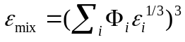 (1)
where Φ_{i} and ɛ_{i} are the volume fraction and dielectric constant of component i, respectively. Dielectric constants of each electrolyte component were 95.3, 2.82, and 2.9 for EC, DEC, and EMC, respectively⁵. The deformation energies (ΔE_{deformation}) of the oxidized and reduced electrolyte components were calculated according to equation (2):
ΔE_{deformation} = E_{oxi/red} – E_{neutral} (2)
where E_{oxi/red} is a total energy of a molecule deformed by oxidation and reduction, respectively, and E_{neutral} is a total energy of a neutral molecule. F dissociation energies (E_{dissociation}) of fluoroethylene carbonate (FEC) and APFS were calculated according to equation (3):
ΔE_{dissociation} = E_{Add-F} + E_{F} – E_{Add} (3)
where E_{Add}, E_{F}, and E_{Add-F} are the total energies of the additive, F radical, and the remaining part without F, respectively.
For the investigation of reaction mechanisms, the generalized gradient approximation (GGA) with the Perdew–Burke–Ernzerhof (PBE) functional was used for the exchange-correlation energy⁶. Complete single linear synchronous transit (LST) and quadratic synchronous transit (QST) methods were used to calculate transition states^{7,8}. The root mean square (RMS) convergence force of the atoms was set to 0.01 Ha/Ǻ.

Supplementary Table 1. The amount of transition metal ions dissolved from NCM811 cathodes after storing for 3 days at 60 °C
Amount of transition metal dissolution (ppm)
 | Ni | Co | Mn
VC | 13.3 | 1.3 | 0.7
VC+APFS | 6.7 | 0.5 | 0.6

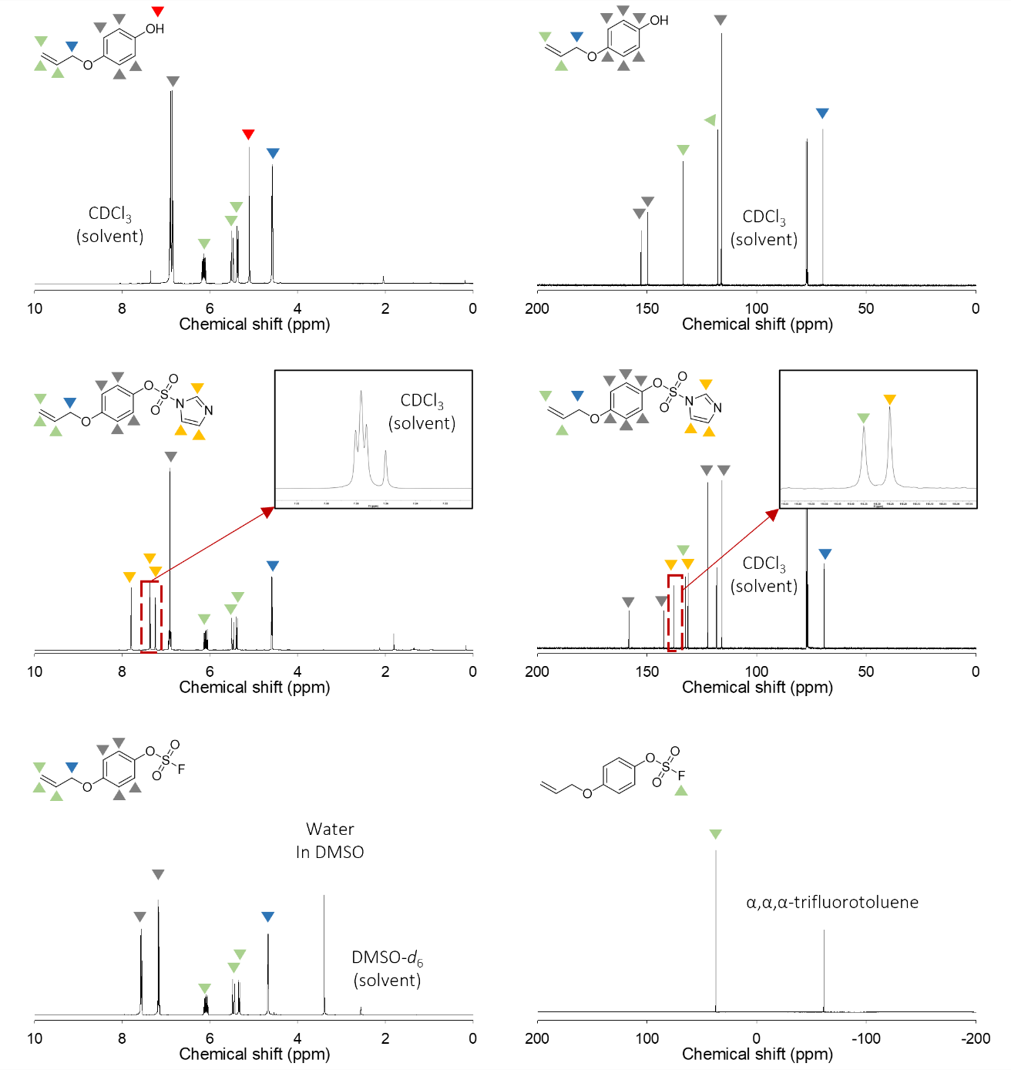
Supplementary Fig. 1. ¹H, ¹³C, and ¹⁹F NMR spectra of 4-(allyloxy)phenol, 4-(allyloxy)phenyl 1H-imidazole-1-sulfonate, and 4-(allyloxy)phenyl fluorosulfate (APFS).

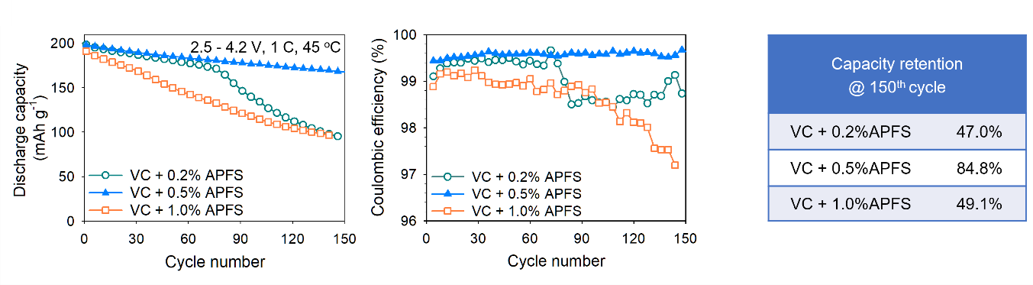
Supplementary Fig. 2. Cycle performance of NCM811/SiG-C full cells with 0.2%, 0.5%, and 1.0% AFPS at 45 °C.
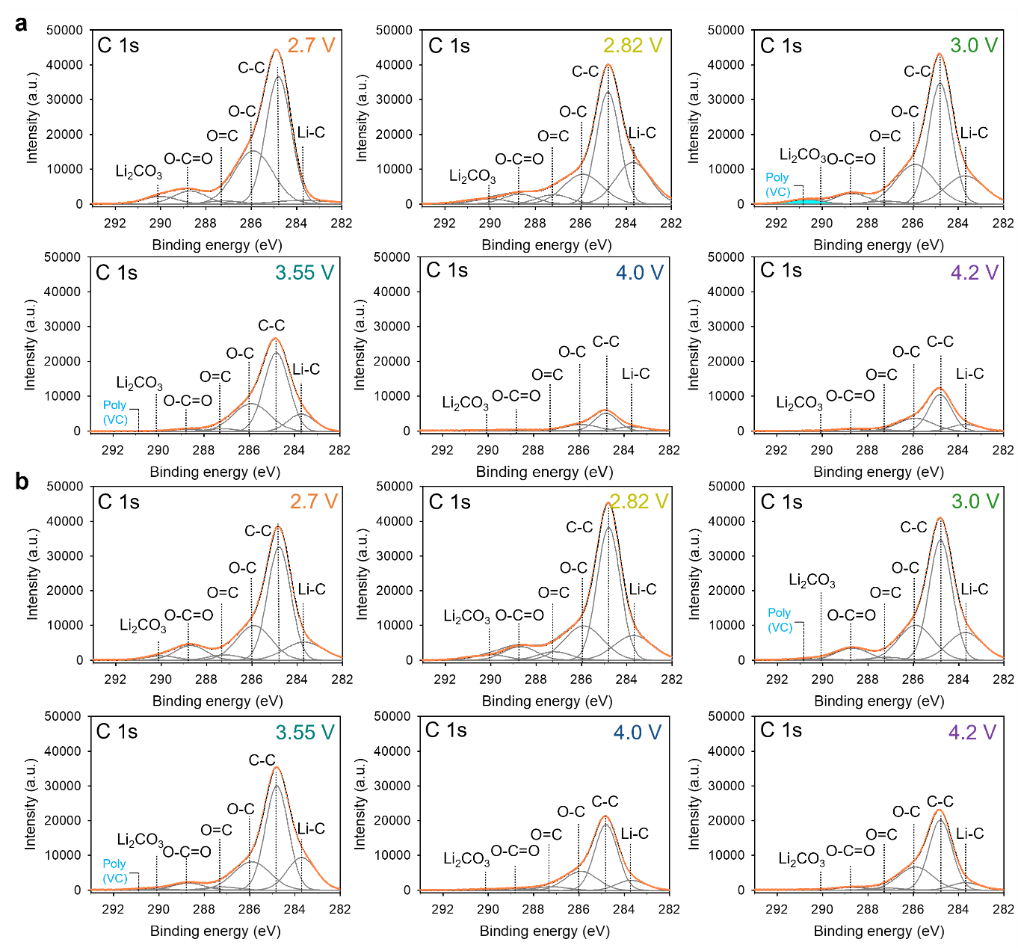
Supplementary Fig. 3. C 1s XPS spectra of SiG-C anodes with a) VC and b) VC+APFS electrolytes.
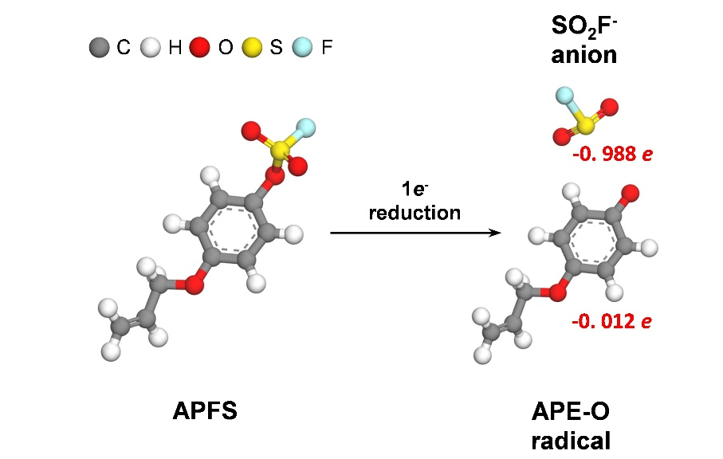
Supplementary Fig. 4. Optimized structure of APFS by one-electron reduction. Distributed charges of the APE–O radical and SO₂F⁻ anion are indicated with red color.

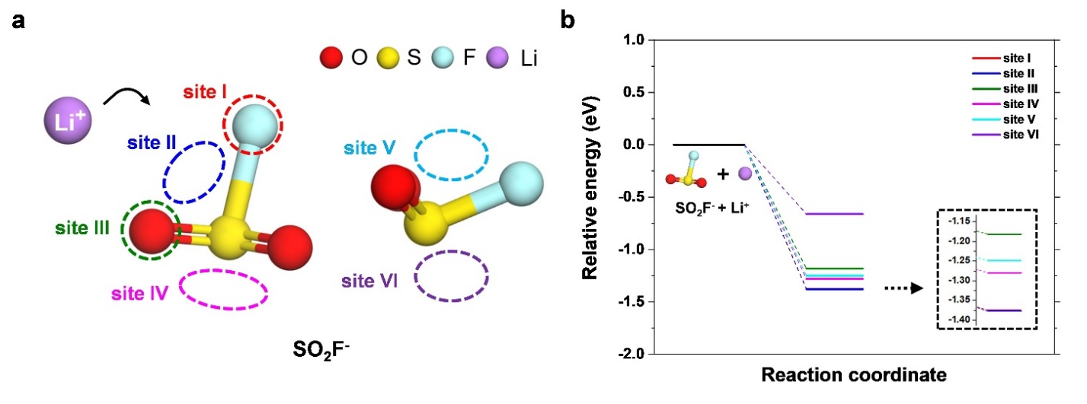
Supplementary Fig. 5. a) Possible Li⁺ ion adsorption sites on the SO₂F⁻ anion. b) Relative energy diagram for the Li⁺-ion adsorption on the SO₂F⁻ anion according to various adsorption sites.
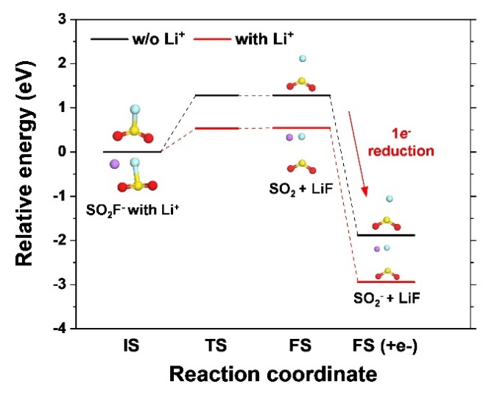
Supplementary Fig. 6. Reaction paths for the LiF formation by decomposition of the SO₂F⁻ anion.

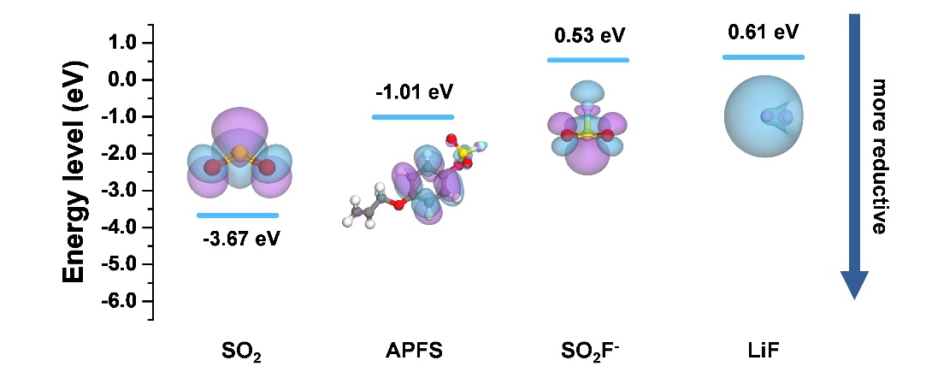
Supplementary Fig. 7. LUMO energy levels of SO₂, APFS, SO₂F⁻ anion, and LiF. It should be noted that the isovalue of each orbital is 0.02 e/Ǻ³.

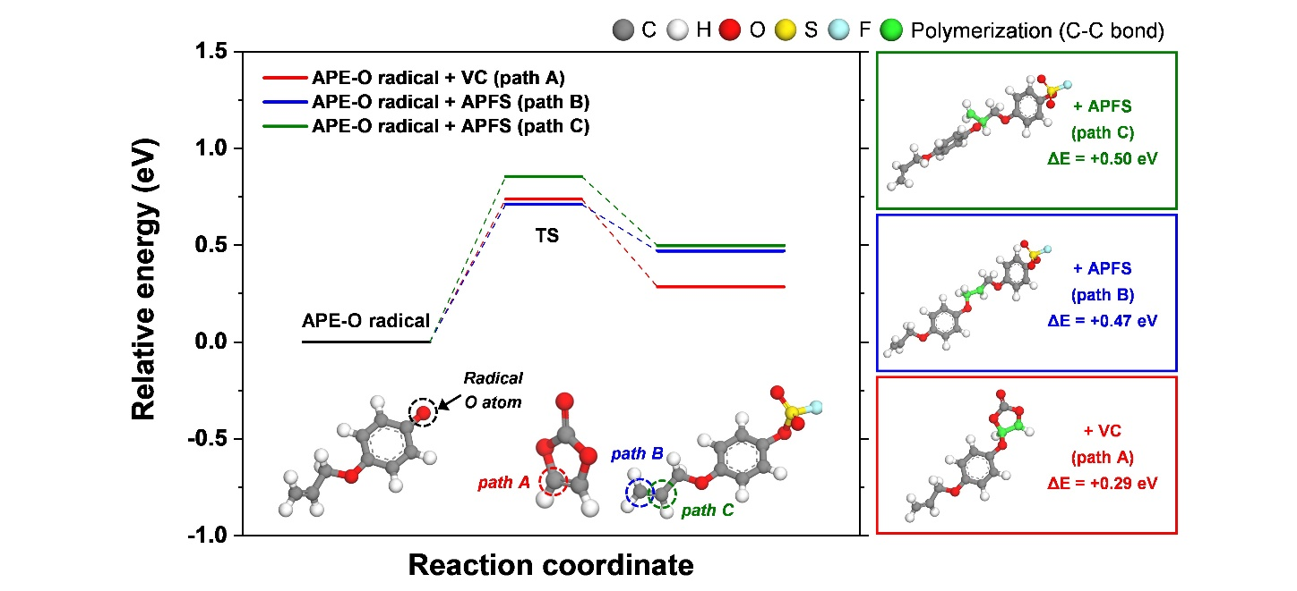
Supplementary Fig. 8. Relative energy diagram of polymerization by the APE–O radical with VC and APFS. The radical O atom and reaction sites of VC and APFS are represented by black, red, blue, and green dotted circles.

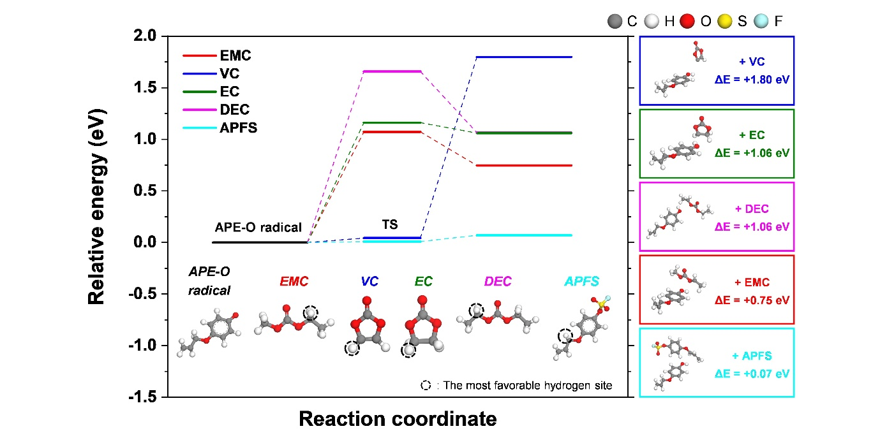
Supplementary Fig. 9. Relative energy diagram of hydrogen atom transfer (HAT) reaction by the APE–O radical with EMC, VC, EC, DEC, and APFS. Reaction sites, which showed the most favorable reaction among the various hydrogen sites, are indicated by a black dotted circle
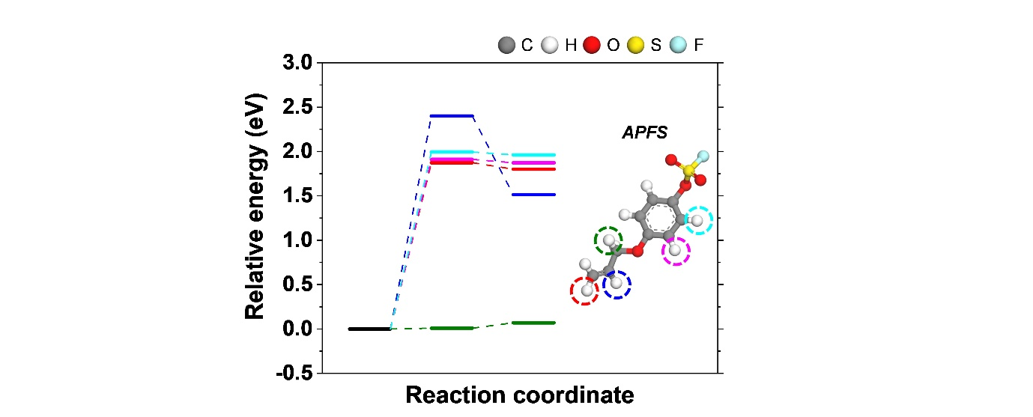
Supplementary Fig. 10. Relative energy diagram of the HAT reaction by the APE–O radical with APFS. Possible reaction sites of APFS are indicated by a colored dotted circle.

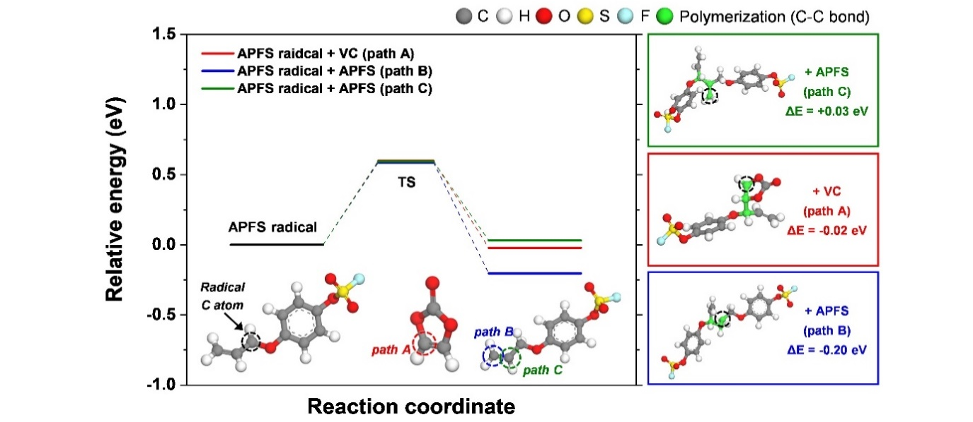
Supplementary Fig. 11. Relative energy diagram of polymerization by the APFS radical with VC and APFS. The radical C atom and reaction sites of VC and APFS are indicated by black, red, blue and green dotted circles.

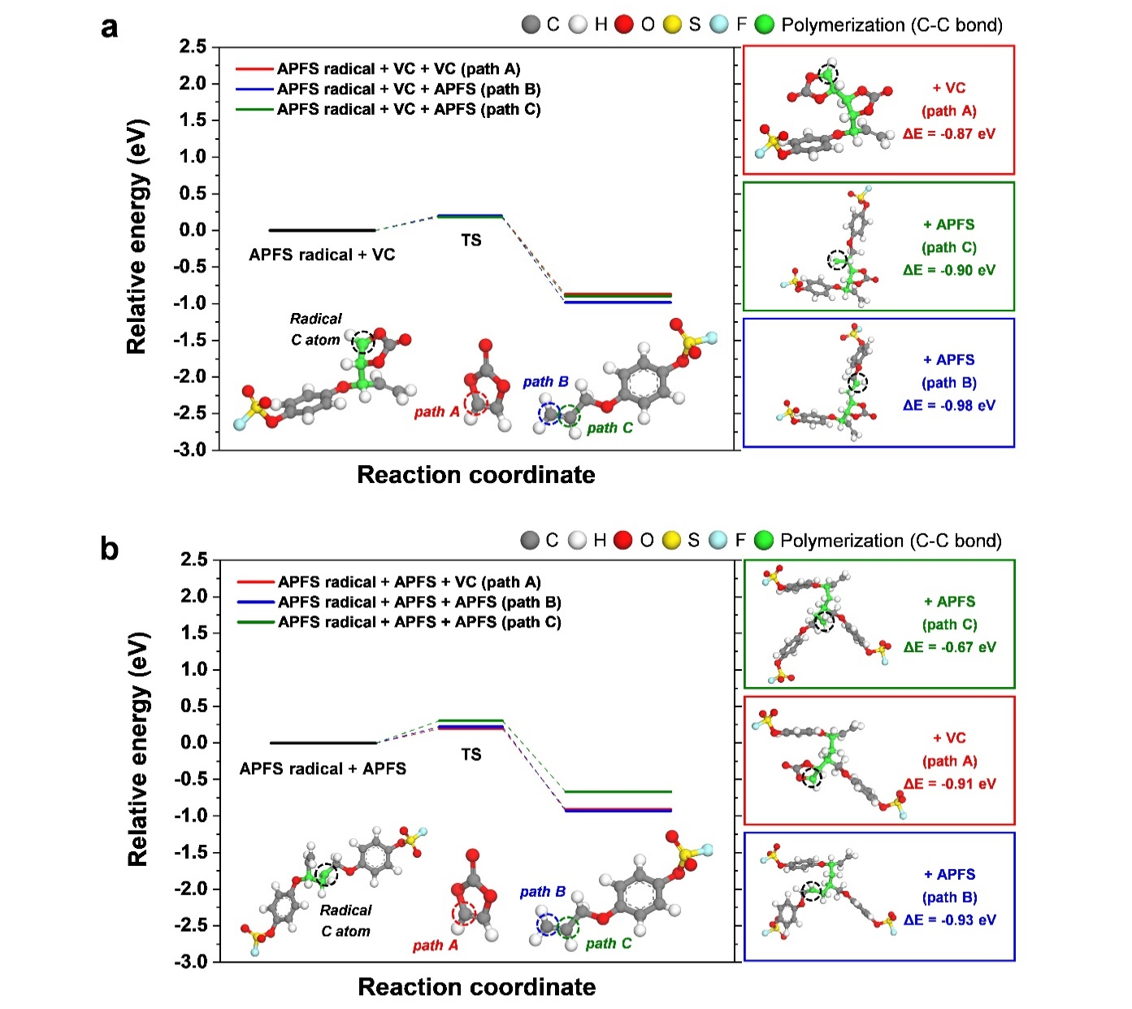
Supplementary Fig. 12. Relative energy diagram of successive polymerization of a) the APFS radical + VC and b) the APFS radical + APFS. Radical C atoms and reaction sites of VC and APFS are indicated by black, red, blue, and green dotted circles.

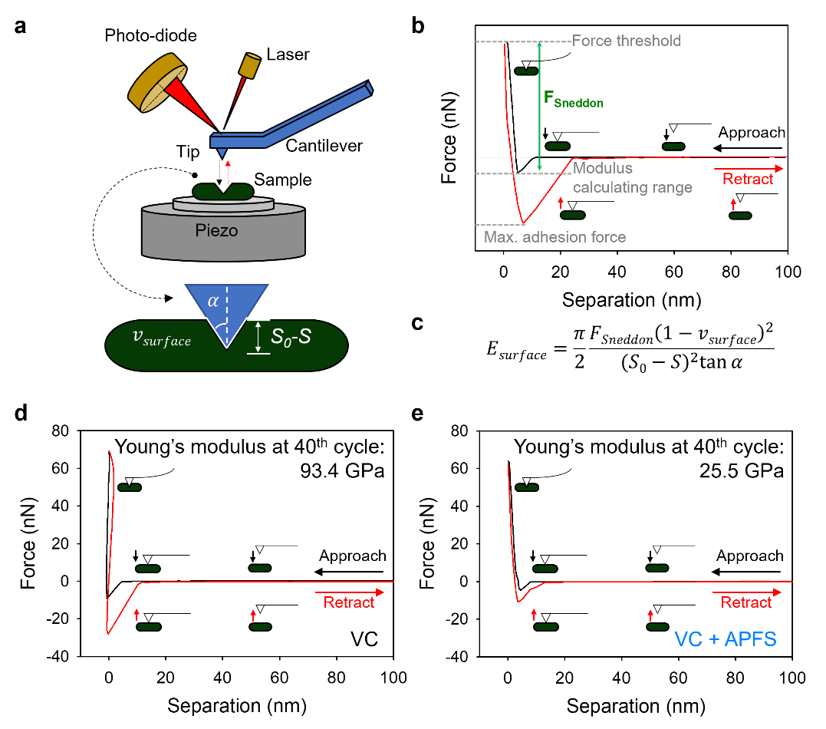
Supplementary Fig. 13. a) A schematic illustration of atomic force microscopy (AFM) indentation. b) Illustration of the force–distance curve of AFM nanoindentation experiment when the tip approaches the sample (black) and retracts from the sample (red). c) Galin–Sneddon solution for conical indentation is stated where v_{surface} is the Poisson’s ratio of sample, α is half-angle of AFM tip, and E is the elastic Young’s modulus⁹⁻¹¹. The load (F_{sneddon}) is applied with a tip to the sample in indentation depth, (S₀ – S). The force–indentation curves obtained from the SiG-C anode cycled with the d) VC or e) VC+APFS electrolyte at the 40th cycles at high temperature.

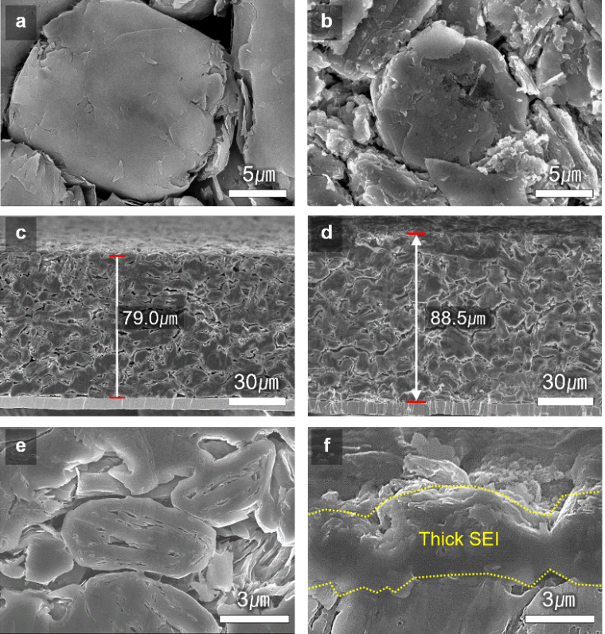
Supplementary Fig. 14. a) Surface and c), e) cross-sectional morphologies of pristine SiG-C anodes. b) Surface and d), f) cross-sectional morphologies of SiG-C anodes retrieved from the NCM811/SiG-C full cell with VC+FEC electrolyte after 100 cycles at 1C rate and 45 °C.

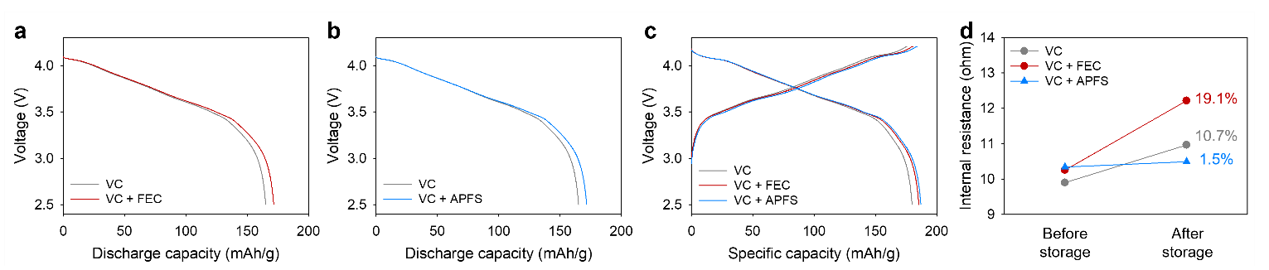
Supplementary Fig. 15. a), b) Discharge capacity and c) recovery capacity of NCM811/SiG-C full cells with VC, VC+FEC, or VC+APFS electrolyte after storing at 60 °C. d) Cell resistance measured by direct current internal resistance at 50% state of charge before and after the storage at 60 °C.

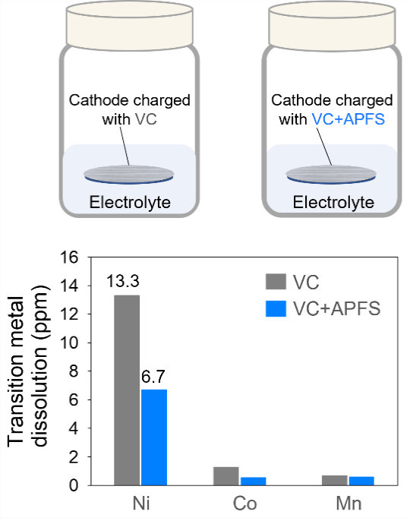
Supplementary Fig. 16. The inductively coupled plasma-optical emission spectroscopy result of transition metal dissolution from NCM811 cathodes retrieved from NCM811/SiG-C full cells after charging. A fully delithiated cathode charged up to 4.2 V was stored with a baseline electrolyte for 3 days at 60 °C.

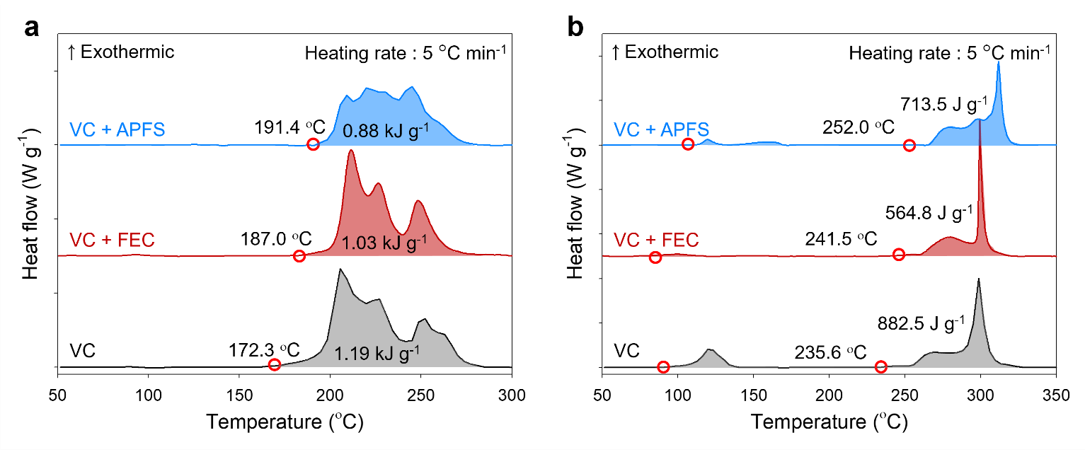
Supplementary Fig. 17. Differential scanning calorimetry heating curves of a) fully delithiated cathode and b) fully lithiated anode with the bare electrolyte. Each electrode was cycled with VC, VC+FEC, or VC+APFS electrolyte and was retrieved from NCM811/SiG-C full cells charged up to 4.2 V at a C/10 rate after precycle.
Supplementary Fig.18. Cross-sectional morphologies of a), b) the pristine NCM811 cathode and c), d) the cathode with the VC+FEC electrolyte after 100 cycles at 1C rate and 45 °C.
Supplementary Fig.19. a) Scanning transmission electron microscopy (STEM) and fast Fourier transform images of the NCM811 cathode cycled with the VC+FEC electrolyte. b) Magnified STEM images of NCM811 cathodes cycled with different electrolytes. c) A series of electron energy loss spectroscopy (EELS) O K-, Co L-, Ni L-edge spectra of the cycled cathode with the VC+FEC electrolyte. d) ,e) ΔE of the O K-edge and the intensity ratio of Ni L₃/L₂ peaks deduced from the EELS spectra of the cycled NCM811 cathodes.

Supplementary Fig.20. a) A schematic representation for the suppressed structural deterioration of the NCM811 cathode by cathode–electrolyte interface (CEI) modification. X-ray diffraction patterns of NCM811 cathodes after 100 cycles at 45 °C b) in the range of 55º to 70º and c) in the full range.

Supplementary NMR data
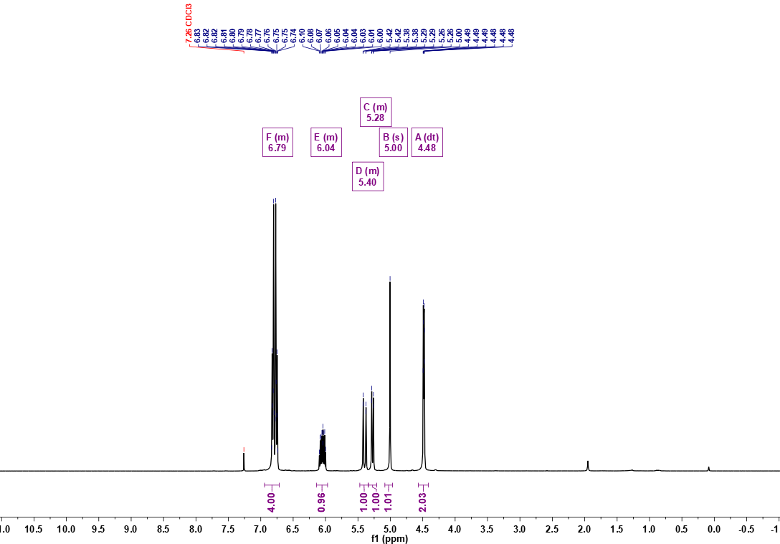
¹H NMR (400 MHz, CDCl₃) of 4-(allyloxy)phenol
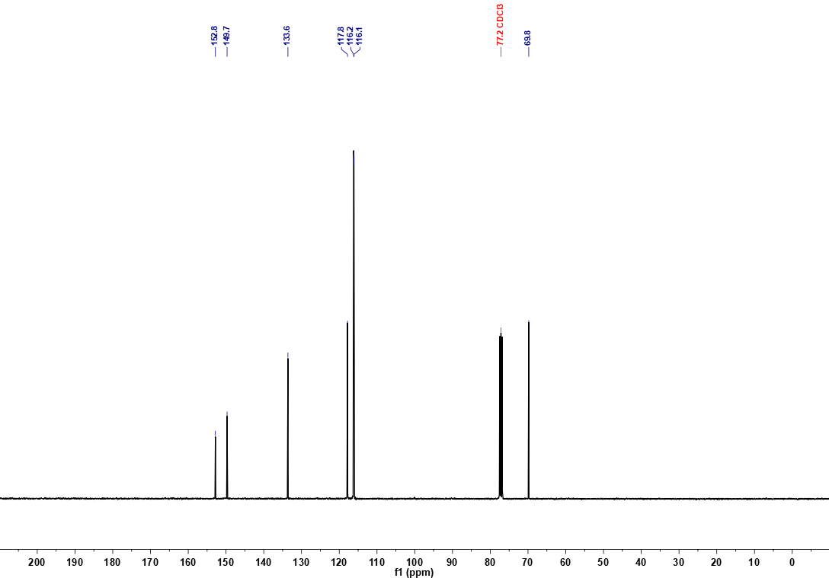
¹³C NMR (101 MHz, CDCl₃) of 4-(allyloxy)phenol
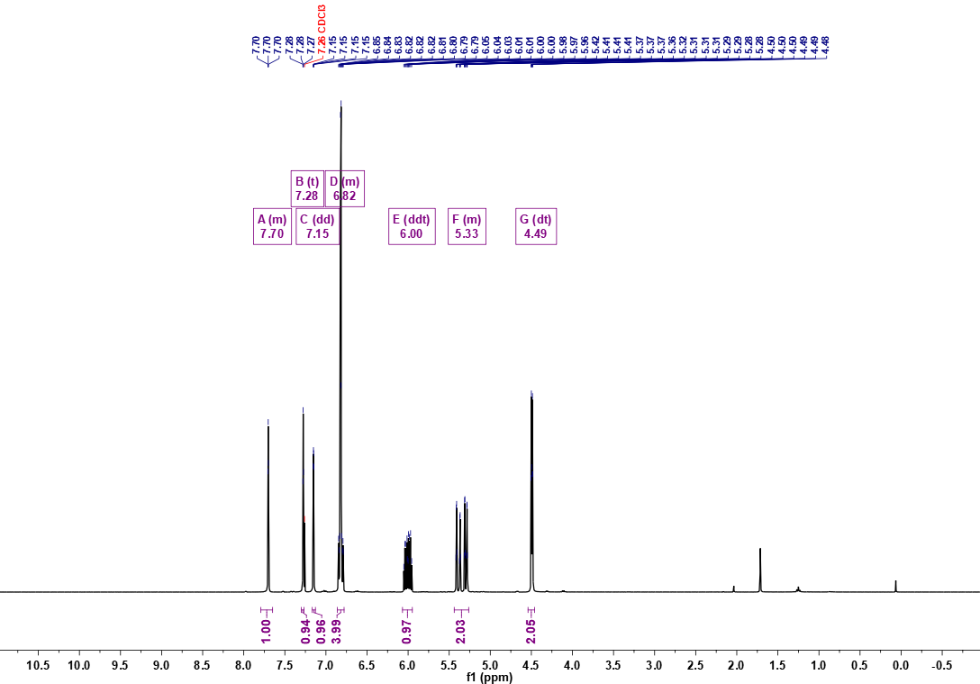
¹H NMR (400 MHz, CDCl₃) of 4-(allyloxy)phenyl 1H-imidazole-1-sulfonate
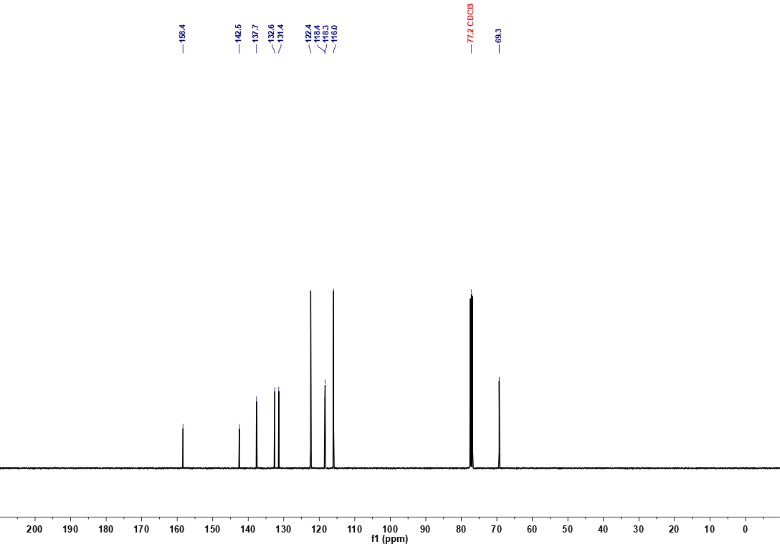
¹³C NMR (101 MHz, CDCl₃) of 4-(allyloxy)phenyl 1H-imidazole-1-sulfonate

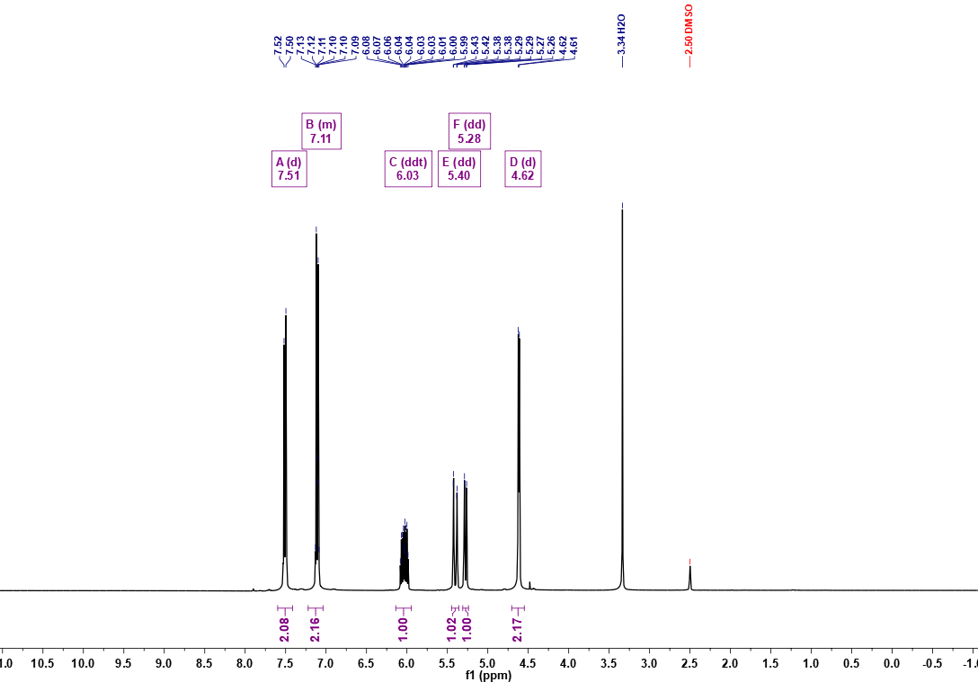
¹H NMR (400 MHz, DMSO-d₆) of 4-(allyloxy)phenyl fluorosulfate
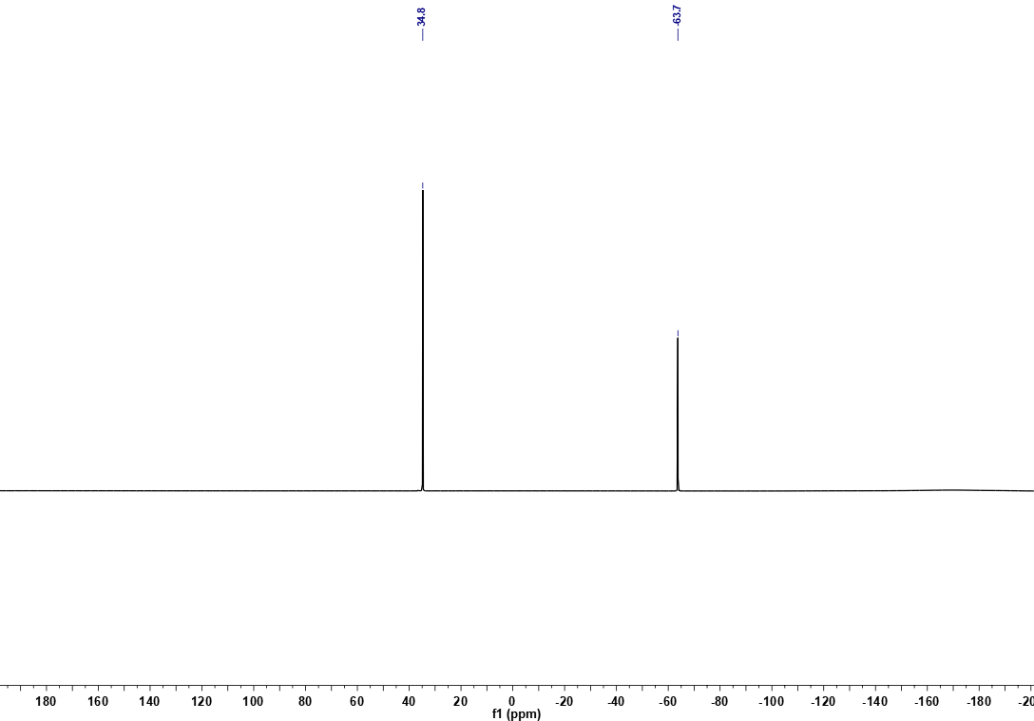
¹⁹F NMR (376 MHz, DMSO-d₆) of 4-(allyloxy)phenyl fluorosulfate

Supplementary References
1. Becke, A. D. Density-functional thermochemistry. III. The role of exact exchange. J. Chem. Phys. 98, 5648–5652 (1993).
2. Stephens, P. J., Devlin, F. J., Chabalowski, C. F. & Frisch, M. J. Ab Initio calculation of vibrational absorption and circular dichroism spectra using density functional force fields. J. Phys. Chem. 98, 11623–11627 (1994).
3. Tkatchenko, A. & Scheffler, M. Accurate molecular van der Waals interactions from ground-state electron density and free-atom reference data. Phys. Rev. Lett. 102, 073005 (2009).
4. Looyenga, H. Dielectric constants of homogeneous mixture. Mol. Phys. 9, 501–511 (1965).
5. Hall, D. S., Self, J. & Dahn, J. R. Dielectric constants for quantum chemistry and Li-ion batteries: solvent blends of ethylene carbonate and ethyl methyl carbonate. J. Phys. Chem. C 119, 22322–22330 (2015).
6. Perdew, J. P., Burke, K. & Ernzerhof, M. Generalized gradient approximation made simple. Phys. Rev. Lett. 77, 3865–3868 (1996).
7. Halgren, T. A. & Lipscomb, W. N. The synchronous-transit method for determining reaction pathways and locating molecular transition states. Chem. Phys. Lett. 49, 225–232 (1977).
8. Govind, N., Petersen, M., Fitzgerald, G., King-Smith, D. & Andzelm, J. A generalized synchronous transit method for transition state location. Computational Materials Science 28, 250–258 (2003).
9. Galin, L. A. Moss, H. Sneddon, I. N. Contact problems in the theory of elasticity. Ph.D. thesis, Dept. Math. Sch. Phys. Sci. Appl. Math. North Carolina State Coll. Raleigh, NC (1961).
10. Sneddon, I. N. The relation between load and penetration in the axisymmetric boussinesq problem for a punch of arbitrary profile. Int. J. Eng. Sci. 3, 47–57 (1965).
11. Allen, R. G., Little, D. N., Bhasin, A. & Lytton, R. L. Identification of the composite relaxation modulus of asphalt binder using AFM nanoindentation. J. Mater. Civ. Eng. 25, 530–539 (2013).

