Characterization of a sex-determining locus and development of early molecular assays in Telfairia occidentalis, a dioecious cucurbit, Metry A (University of Fribourg, adrian.metry@unifr.ch), Adeyemo OA (University of Lagos), Grünig S (University of Fribourg), Parisod C (University of Fribourg)

Supplementary Information 1
Table S1: Three ddRADseq libraries. The compilation of the libraries was random. Each box represents a 96 well plate. The upper numbers and letters are the sample IDs (A = Anambra, C = Cross River, E = Ekiti, Ib = Oyo, L = Lagos). The lower letters and numbers represent the well number. The replicates were A16r (B4, library3), C_I_38r (G6, library 3), E20’r (C1, library 3), Ib_II_56r (B3, library 3) and L_I_75r (E1, library 3)

Library 1
C_I_34  A1 | C_I_36  A2 | E35v  A3 | A100  A4 | C_I_96  A5 | Ib_I_50  A6
L_I_80  B1 | E39'  B2 | A90  B3 | L_I_77'  B4 | E14'  B5 | E28v  B6
L_I_81  C1 | A11  C2 | E40v  C3 | C_I_98  C4 | C_I_39  C5 | L_I_72  C6
Ib_II_60  D1 | A19  D2 | A89  D3 | Ib_I_52  D4 | E8v  D5 | L_I_70'  D6
L_I_75  E1 | E36  E2 | E24'  E3 | Ib_III_64  E4 | E20'  E5 | E3  E6
E18  F1 | L_I_69v  F2 | C_II_47  F3 | Ib_II_56  F4 | Ib_I_51  F5 | E13v  F6
E45  G1 | E19  G2 | Ib_I_49  G3 | C_I_32  G4 | A21  G5 | Ib_II_61  G6
E44'  H1 | A20  H2 | L_II_104  H3 | C_I_31  H4 | C_I_46  H5 | L_I_76  H6

Library 2
E32  A1 | E48v  A2 | L_I_73  A3 | E29'  A4 | L_II_84  A5 | L_I_78v  A6
L_II_87  B1 | E10v  B2 | C_I_27  B3 | E2  B4 | E21  B5 | A16  B6
L_III_108  C1 | E30'  C2 | E26  C3 | Ib_II_97  C4 | C_I_28  C5 | E9v  C6
A25  D1 | E7v  D2 | L_I_79  D3 | A12  D4 | E43  D5 | E15v  D6
E27  E1 | L_I_65v  E2 | E17  E3 | E46  E4 | A15  E5 | C_II_48  E6
A17  F1 | E11  F2 | C_I_38  F3 | L_II_86  F4 | Ib_II_58  F5 | A18  F6
E34  G1 | L_III_107  G2 | E37v  G3 | A93  G4 | C_I_40  G5 | L_I_74  G6
L_I_67  H1 | L_I_68  H2 | L_II_105  H3 | C_I_30  H4 | L_II_101  H5 | A94v  H6

Library 3
E41  A1 | C_I_45  A2 | E12'  A3 | A95  A4 | C_I_43  A5 | E38  A6
L_II_102  B1 | E47v  B2 | Ib_II_56r  B3 | A16r  B4 | A2  B5 | E42  B6
E20'r  C1 | E5  C2 | C_I_41  C3 | L_I_66  C4 | A5  C5 | Ib_II_57  C6
E23  D1 | A22  D2 | E31  D3 | L_I_71  D4 | E16v  D5 | E25  D6
L_I_75r  E1 | L_III_106  E2 | E1  E3 | A6  E4 | A24  E5 | C_I_35  E6
Ib_II_99  F1 | A26  F2 | Ib_II_59  F3 | C_I_29  F4 | C_I_42  F5 | A91  F6
E4  G1 | L_II_85  G2 | E33  G3 | A88  G4 | C_I_44  G5 | C_I_38r  G6
A14  H1 | E22  H2 | A92  H3 | L_I_83  H4 | Ib_I_53  H5 | C_I_33  H6

EcoR1 | Idx 6 | Sample ID
GCATG | GCCAAT | E32
AACCA | GCCAAT | L_II_87
CGATC | GCCAAT | L_III_108
TCGAT | GCCAAT | A25
TGCAT | GCCAAT | E27
CAACC | GCCAAT | A17
GGTTG | GCCAAT | E34
AAGGA | GCCAAT | L_I_67
AGCTA | GCCAAT | E48v
ACACA | GCCAAT | E10v
AATTA | GCCAAT | E30'
ACGGT | GCCAAT | E7v
ACTGG | GCCAAT | L_I_65v
ACTTC | GCCAAT | E11
ATACG | GCCAAT | L_III_107
ATGAG | GCCAAT | L_I_68
ATTAC | GCCAAT | L_I_73
CATAT | GCCAAT | C_I_27
CGAAT | GCCAAT | E26
CGGCT | GCCAAT | L_I_79
CGGTA | GCCAAT | E17
CGTAC | GCCAAT | C_I_38
CGTCG | GCCAAT | E37v
CTGAT | GCCAAT | L_II_105
CTGCG | GCCAAT | E29'
CTGTC | GCCAAT | E2
CTTGG | GCCAAT | Ib_II_97
GACAC | GCCAAT | A12
GAGAT | GCCAAT | E46
GAGTC | GCCAAT | L_II_86
GCCGT | GCCAAT | A93
GCTGA | GCCAAT | C_I_30
GGATA | GCCAAT | L_II_84
GGCCA | GCCAAT | E21
GGCTC | GCCAAT | C_I_28
GTAGT | GCCAAT | E43
GTCCG | GCCAAT | A15
GTCGA | GCCAAT | Ib_II_58
TACCG | GCCAAT | C_I_40
TACGT | GCCAAT | L_II_101
TAGTA | GCCAAT | L_I_78v
TATAC | GCCAAT | A16
TCACG | GCCAAT | E9v
TCAGT | GCCAAT | E15v
TCCGG | GCCAAT | C_II_48
TCTGC | GCCAAT | A18
TGGAA | GCCAAT | L_I_74
TTACC | GCCAAT | A94v
Table S2: EcoR1 barcodes, indexes (Mfe1 adapter) and sample identification
EcoR1 | Idx 5 | Sample ID
GCATG | ACAGTG | C_I_34
AACCA | ACAGTG | L_I_80
CGATC | ACAGTG | L_I_81
TCGAT | ACAGTG | Ib_II_60
TGCAT | ACAGTG | L_I_75
CAACC | ACAGTG | E18
GGTTG | ACAGTG | E45
AAGGA | ACAGTG | E44'
AGCTA | ACAGTG | C_I_36
ACACA | ACAGTG | E39'
AATTA | ACAGTG | A11
ACGGT | ACAGTG | A19
ACTGG | ACAGTG | E36
ACTTC | ACAGTG | L_I_69v
ATACG | ACAGTG | E19
ATGAG | ACAGTG | A20
ATTAC | ACAGTG | E35v
CATAT | ACAGTG | A90
CGAAT | ACAGTG | E40v
CGGCT | ACAGTG | A89
CGGTA | ACAGTG | E24'
CGTAC | ACAGTG | C_II_47
CGTCG | ACAGTG | Ib_I_49
CTGAT | ACAGTG | L_II_104
CTGCG | ACAGTG | A100
CTGTC | ACAGTG | L_I_77'
CTTGG | ACAGTG | C_I_98
GACAC | ACAGTG | Ib_I_52
GAGAT | ACAGTG | Ib_III_64
GAGTC | ACAGTG | Ib_II_56
GCCGT | ACAGTG | C_I_32
GCTGA | ACAGTG | C_I_31
GGATA | ACAGTG | C_I_96
GGCCA | ACAGTG | E14'
GGCTC | ACAGTG | C_I_39
GTAGT | ACAGTG | E8v
GTCCG | ACAGTG | E20'
GTCGA | ACAGTG | Ib_I_51
TACCG | ACAGTG | A21
TACGT | ACAGTG | C_I_46
TAGTA | ACAGTG | Ib_I_50
TATAC | ACAGTG | E28v
TCACG | ACAGTG | L_I_72
TCAGT | ACAGTG | L_I_70'
TCCGG | ACAGTG | E3
TCTGC | ACAGTG | E13v
TGGAA | ACAGTG | Ib_II_61
TTACC | ACAGTG | L_I_76

EcoR1 | Idx 12 | Sample ID
GCATG | CTTGTA | E41
AACCA | CTTGTA | L_II_102
CGATC | CTTGTA | E20'r
TCGAT | CTTGTA | E23
TGCAT | CTTGTA | L_I_75r
CAACC | CTTGTA | Ib_II_99
GGTTG | CTTGTA | E4
AAGGA | CTTGTA | A14
AGCTA | CTTGTA | C_I_45
ACACA | CTTGTA | E47v
AATTA | CTTGTA | E5
ACGGT | CTTGTA | A22
ACTGG | CTTGTA | L_III_106
ACTTC | CTTGTA | A26
ATACG | CTTGTA | L_II_85
ATGAG | CTTGTA | E22
ATTAC | CTTGTA | E12'
CATAT | CTTGTA | Ib_II_56r
CGAAT | CTTGTA | C_I_41
CGGCT | CTTGTA | E31
CGGTA | CTTGTA | E1
CGTAC | CTTGTA | Ib_II_59
CGTCG | CTTGTA | E33
CTGAT | CTTGTA | A92
CTGCG | CTTGTA | A95
CTGTC | CTTGTA | A16r
CTTGG | CTTGTA | L_I_66
GACAC | CTTGTA | L_I_71
GAGAT | CTTGTA | A6
GAGTC | CTTGTA | C_I_29
GCCGT | CTTGTA | A88
GCTGA | CTTGTA | L_I_83
GGATA | CTTGTA | C_I_43
GGCCA | CTTGTA | A2
GGCTC | CTTGTA | A5
GTAGT | CTTGTA | E16v
GTCCG | CTTGTA | A24
GTCGA | CTTGTA | C_I_42
TACCG | CTTGTA | C_I_44
TACGT | CTTGTA | Ib_I_53
TAGTA | CTTGTA | E38
TATAC | CTTGTA | E42
TCACG | CTTGTA | Ib_II_57
TCAGT | CTTGTA | E25
TCCGG | CTTGTA | C_I_35
TCTGC | CTTGTA | A91
TGGAA | CTTGTA | C_I_38r
TTACC | CTTGTA | C_I_33

Table S3: Measured concentrations, fragment sizes and calculated Molarity of each ddRAD library

 | Concentrations (ng/μl) | Fragment sizes (bp) | nano Molarity
ddRAD library 1 | 1.22 | 536 | 3.45
ddRAD library 2 | 3.56 | 539 | 10.01
ddRAD library 3 | 1.34 | 526 | 3.86

Table S4: The three catalogues and their number of contigs, cluster values and average quality scores. The pipeline continued with the second de novo catalogue (0.85) because it showed the highest average value after dividing the aligned reads that passed a quality threshold with aligned reads without meeting the quality score
 | Cluster values | Number of contigs | Average quality score
Catalogue 1 | 80 % | 8518 | 0.54
Catalogue 2 | 85 % | 8657 | 0.55
Catalogue 3 | 90 % | 8700 | 0.54

Table S5: The ddRAD sequencing error rates estimated for four technical replicates
Landraces | Number of allelic differences between replicates and originals | Error rate %
Cross River | 1753 | 4.74
Oyo | 1898 | 5.13
Lagos | 1470 | 3.97
Ekiti | 1436 | 3.88
Average | 1639.25 | 4.43

Table S6: Summary statistics of genetic variation in Telferia occidentalis. a Expected heterozygosity of the SNPs on contig 4813. m = male, f = female, s.d. = standard deviation, Tot. Het. = total heterozygosity b F-statistics of the SNPs on contig 4813.

a
SNP number | Cross River m | Cross River f | Ekiti m | Ekiti f | Oyo m | Oyo f | Lagos m | Lagos f | Mean | s.d. | Tot. Het.
9434 | 0.52 | 0.14 | 0.51 | 0.00 | 0.57 | 0.23 | 0.52 | 0.00 | 0.31 | 0.25 | 0.37
9435 | 0.52 | 0.07 | 0.51 | 0.00 | 0.57 | 0.23 | 0.52 | 0.00 | 0.30 | 0.25 | 0.36
9436 | 0.52 | 0.07 | 0.51 | 0.00 | 0.57 | 0.23 | 0.52 | 0.00 | 0.30 | 0.25 | 0.36
9437 | 0.37 | 0.00 | 0.48 | 0.00 | 0.25 | 0.00 | 0.34 | 0.00 | 0.18 | 0.20 | 0.22
9438 | 0.52 | 0.14 | 0.51 | 0.00 | 0.57 | 0.23 | 0.52 | 0.00 | 0.31 | 0.25 | 0.37
9439 | 0.52 | 0.07 | 0.51 | 0.00 | 0.57 | 0.23 | 0.52 | 0.00 | 0.30 | 0.25 | 0.36
9440 | 0.00 | 0.07 | 0.00 | 0.00 | 0.00 | 0.13 | 0.00 | 0.00 | 0.02 | 0.05 | 0.02
9441 | 0.52 | 0.07 | 0.51 | 0.00 | 0.57 | 0.23 | 0.52 | 0.00 | 0.30 | 0.25 | 0.37
9442 | 0.00 | 0.00 | 0.00 | 0.00 | 0.00 | 0.13 | 0.00 | 0.00 | 0.02 | 0.04 | 0.01
9443 | 0.52 | 0.07 | 0.51 | 0.00 | 0.57 | 0.23 | 0.52 | 0.00 | 0.30 | 0.25 | 0.37
9444 | 0.52 | 0.07 | 0.51 | 0.00 | 0.57 | 0.23 | 0.52 | 0.00 | 0.30 | 0.25 | 0.37
9445 | 0.52 | 0.07 | 0.51 | 0.00 | 0.57 | 0.23 | 0.52 | 0.00 | 0.30 | 0.25 | 0.37
9446 | 0.52 | 0.07 | 0.51 | 0.00 | 0.57 | 0.23 | 0.52 | 0.00 | 0.30 | 0.25 | 0.37

b
SNP number | FIS | P-value | FSC | P-value | FCT | P-value | FIT | P-value
9434 | -0.67 | 1.00 | 0.45 | 0.00 | -0.30 | 0.99 | -0.21 | 0.99
9435 | -0.69 | 1.00 | 0.46 | 0.00 | -0.31 | 1.00 | -0.20 | 0.99
9436 | -0.69 | 1.00 | 0.46 | 0.00 | -0.31 | 1.00 | -0.20 | 1.00
9437 | -0.41 | 1.00 | 0.31 | 0.00 | -0.17 | 0.98 | -0.13 | 1.00
9438 | -0.67 | 1.00 | 0.45 | 0.00 | -0.30 | 0.99 | -0.21 | 0.99
9439 | -0.69 | 1.00 | 0.46 | 0.00 | -0.31 | 1.00 | -0.20 | 0.99
9440 | -0.01 | 1.00 | -0.01 | 1.00 | 0.01 | 0.19 | 0.00 | 1.00
9441 | -0.66 | 1.00 | 0.48 | 0.00 | -0.33 | 1.00 | -0.15 | 0.96
9442 | -0.03 | 1.00 | 0.00 | 1.00 | 0.03 | 0.03 | 0.01 | 1.00
9443 | -0.73 | 1.00 | 0.47 | 0.00 | -0.32 | 1.00 | -0.21 | 1.00
9444 | -0.73 | 1.00 | 0.47 | 0.00 | -0.32 | 1.00 | -0.21 | 0.99
9445 | -0.73 | 1.00 | 0.47 | 0.00 | -0.32 | 1.00 | -0.21 | 0.99
9446 | -0.73 | 1.00 | 0.47 | 0.00 | -0.32 | 1.00 | -0.21 | 0.99

Figure S1: Detailed PCA plot (first and second axis) of the PCA plot from figure 2. A = Anambra, C = Cross River, E = Ekiti, Ib = Oyo, L = Lagos. Note that the sample A100 (Anambra) is on top of the cluster mostly composed by Cross River, Oyo and Lagos. PC1 explains 8.3% and PC2 5.6% of variation.

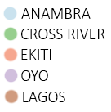
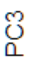
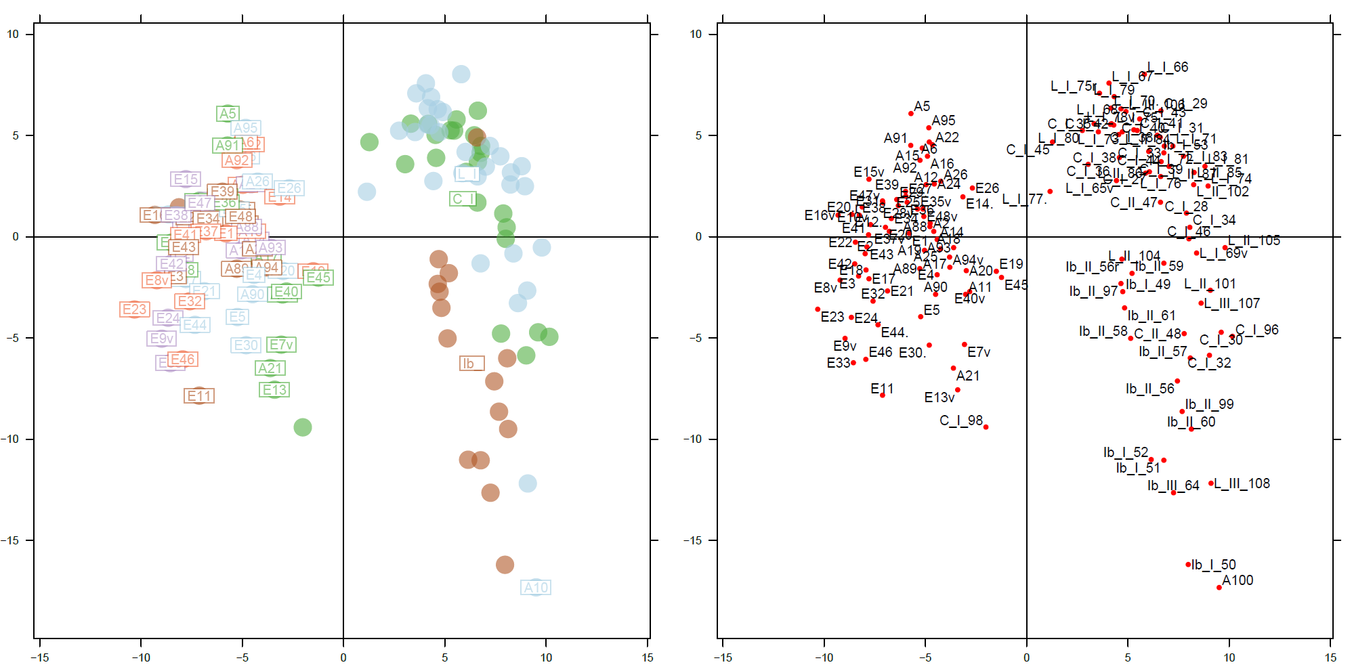
a

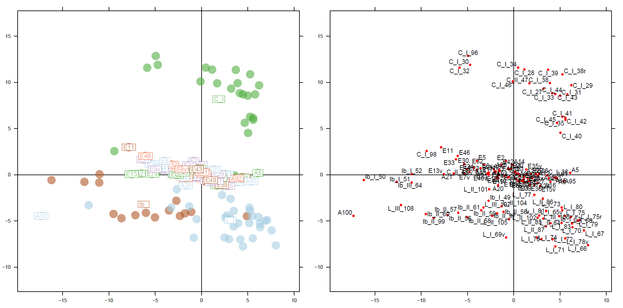
b

Figure S2: PCA plot of the ddRADseq genetic data on (a) the second (X) and third (Y) axis (5.6% and 3.2% of the total variance, respectively), and (b) the third (X) and fourth (Y) axis (3.2% and 2.9% of the total variance, respectively). Notice that Cross River (C), Oyo (Ib) and Lagos (L) cluster together and distinguish themselves from Anambra (A) and Ekiti (E). The proportion of variation explained by the second axis is for the third axis.

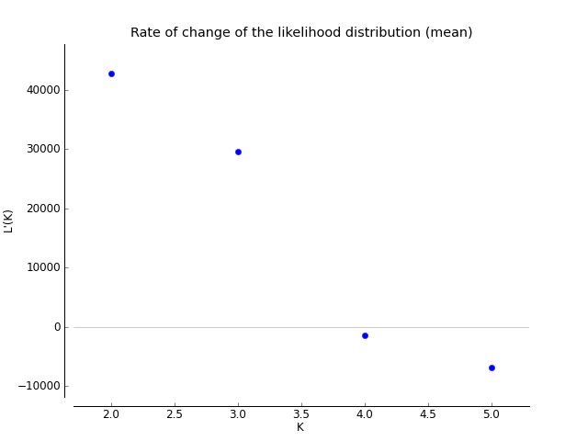
a

b
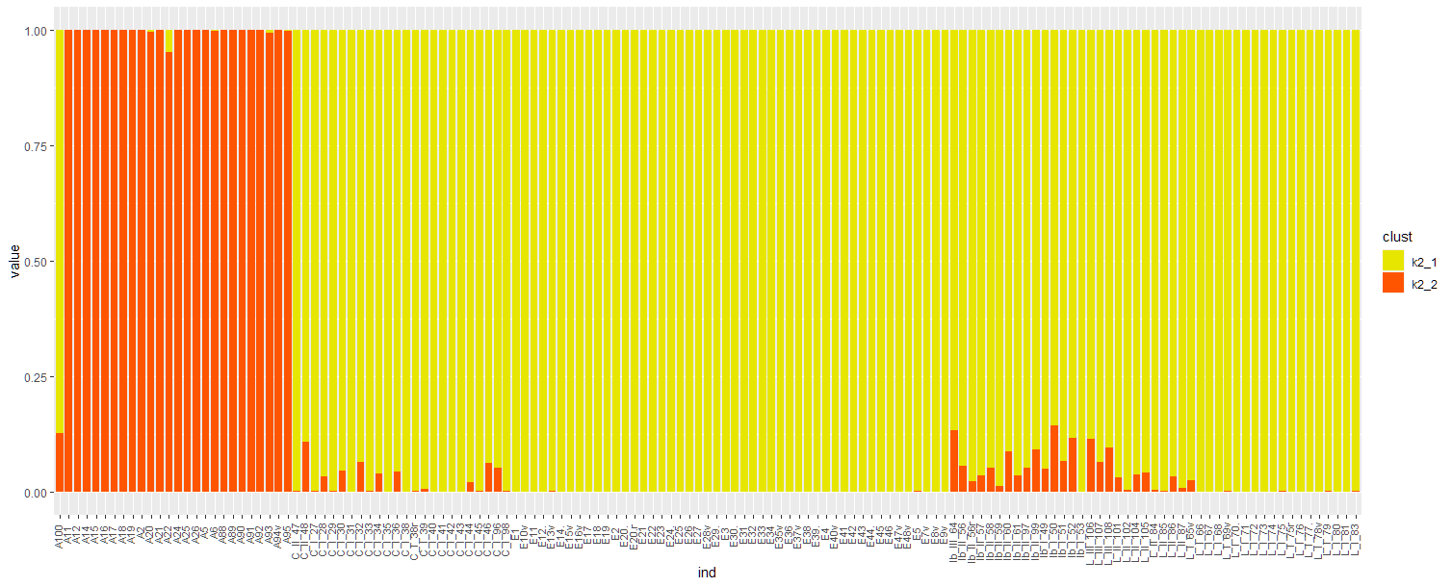
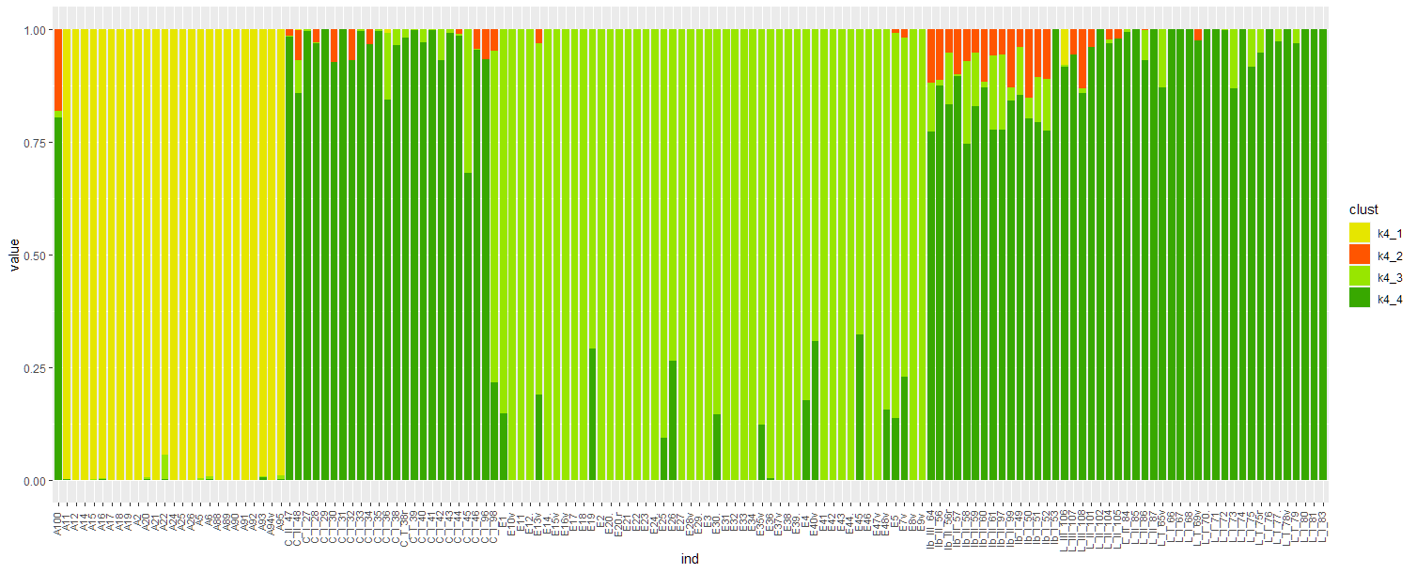
c

Figure S3: STRUCTURE results. Each K-value had 10 iterations. a Rate of change of the likelihood distribution (mean). It is calculated as follows: L′(K) = L(K) – L(K – 1). b and c Bar plots made out of the STRUCTURE data. b K = 2. c K = 4. We see that although panel c assumes four clusters, the majority of clusters are three (three dominant colours).

