Supplementary Material
Toughening modification of polylactic acid by long-chain hyperbranched polymers containing polycaprolactone end groups
Rui Tie¹, Yansong Huang^{1,2}, Yujuan Jin^{1,2*}, Jianjian Sun^{1,2}, Huafeng Tian^{1,2**}, Xiao Lei¹, Gongcheng Li¹, Shuang Men^{2,3}

1 School of Chemistry and Materials Engineering, Beijing Technology and Business University, Beijing, P. R. China, 100048

2 Beijing Key Laboratory of Quality Evaluation Technology for Hygiene and Safety of Plastics, Beijing Technology, and Business University, Beijing, P. R. China,100048

3 Institute of Cosmetic Regulatory Science, Beijing Technology and Business University, Beijing, P. R. China,100048

*To whom correspondence should be addressed.
Email: jinyujuan@th.btbu.edu.cn (Y Jin) or tianhuafeng@th.btbu.edu.cn (H Tian)
Tel: +86-10-68985531
Fax: +86-10-68985380
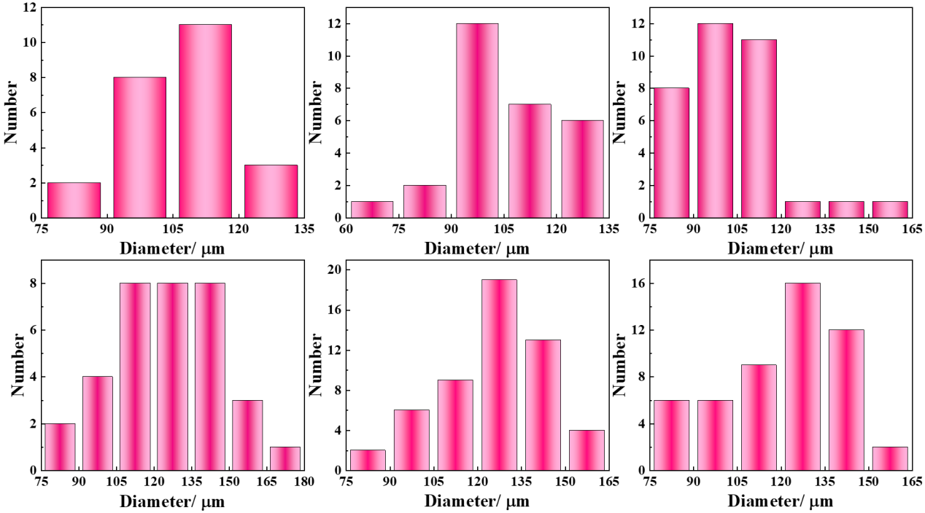
Fig. S1 Statistics of polylactic acid spherulite diameter.

