Supplementary information
Supplementary Table S1. Participant demographics of three datasets
Name of dataset | Keio University | Mie National Hospital | JSDT
Area | Tokyo  (capital city) | Mie  (rural area, west Japan) | Tokyo  (capital city)
Affiliation | Healthcare workers | Healthcare  workers | HD patients | Patients with underlying diseases  (Not on HD)
Number | 673 | 165 | 193 | 100
Median age, years  (IQR) | 45 (35 – 53) | 41 (32-53) | 68 (74-53) | 67 (72-57)
Male participants (%) | 196 (29.1) | 40 (24.2) | 123 (63.7) | 61 (61.0)
Female participants (%) | 477 (70.9) | 125 (75.8) | 70 (36.3) | 39 (39.0)
History of COVID-19 (%) | 10 (1.5) | 0(0) | 0 (0) | 0 (0)
Immunosuppressant* use (%) | 18 (2.7) | -† | 0 (0) | 0 (0)
Diabetes (%) | 4 (0.6) | -† | 92 (47.4) | 17 (17.0)
Abbreviations; JSDT, Japanese Society for Dialysis Therapy; HD, hemodialysis; IQR, interquartile range
*Systemic use of steroids and other medications suppress cellular immunity.
†Data about immunosuppressant use and history of diabetes were not obtained from the healthcare workers of Mie National Hospital

Supplementary Figure S1. Prediction results from Mie National Hospital data.
Prediction results from fitting the best-fit model to three selected Mie National Hospital participants. The area to the right of the vertical reference line shows the predicted results. (1 & 2) Data and predicted results of antibody titers for a participant whose antibody titer increased to about 10,000 (A), 20,000 (B), and 30,000 (C) after two vaccinations. (2) Semi-logarithmic scales. Time points are shown when the lower limit of the 95% prediction interval and median value fell below the ≥ 50 AU/mL threshold for classification as a positive sample (A-2, B-2, and C-2).
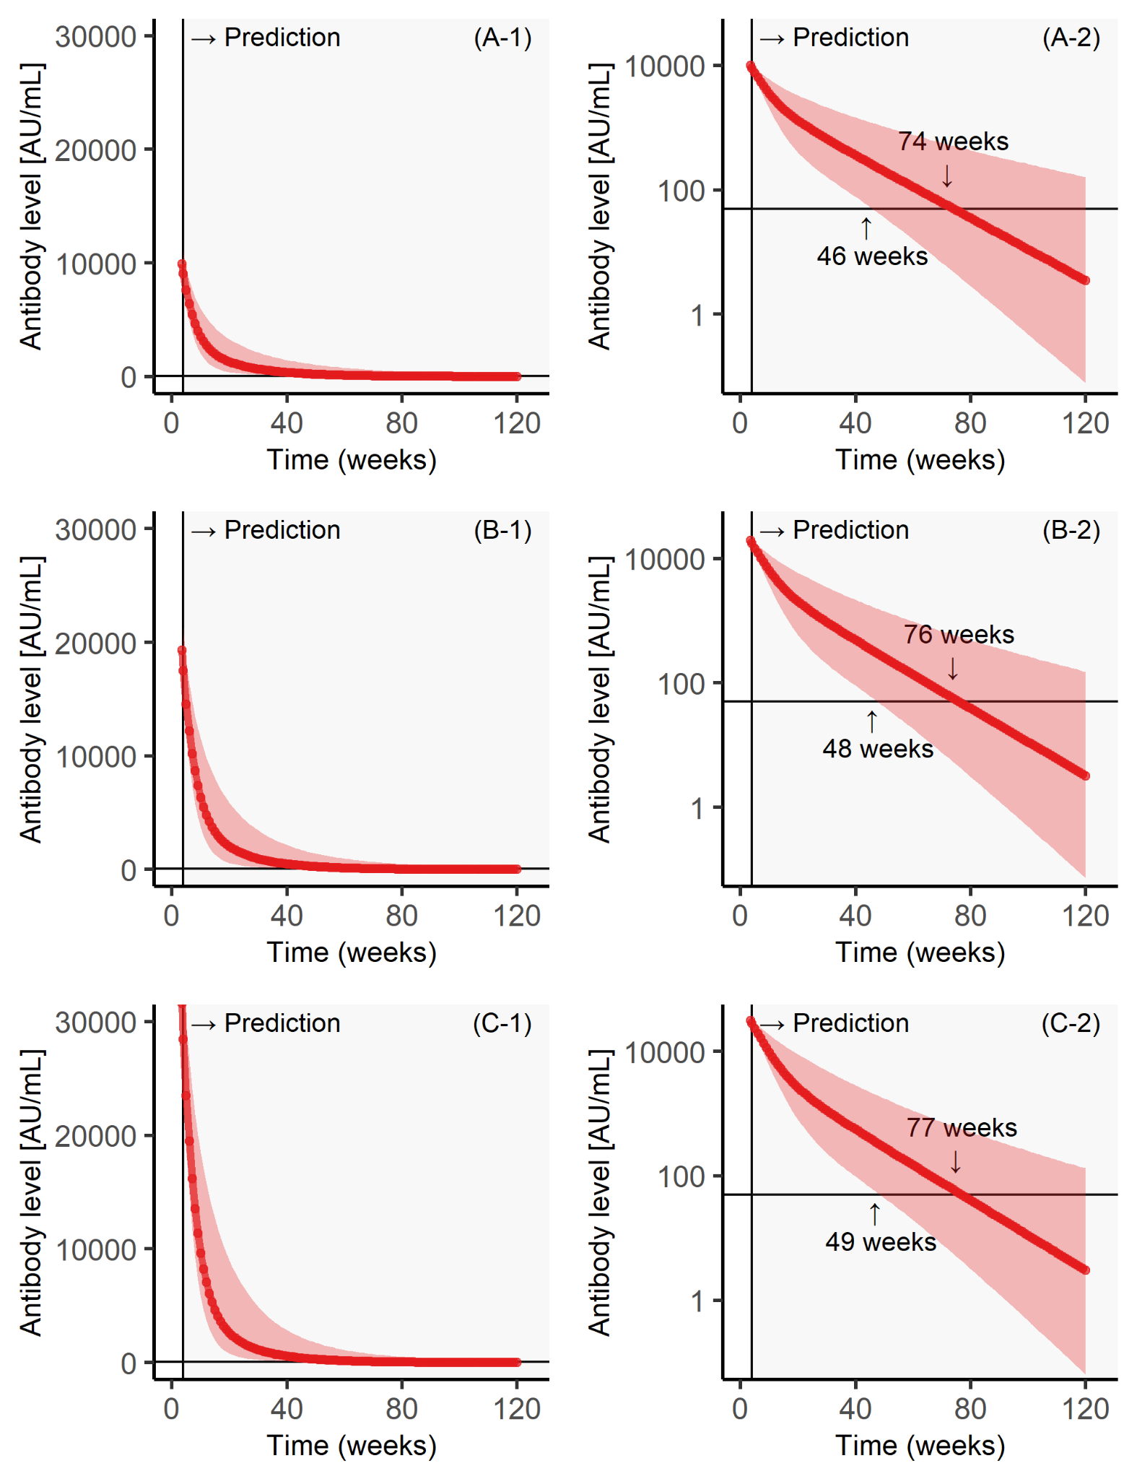
Supplementary Figure S2. Prediction results from the Japanese Society for Dialysis Therapy (JSDT) data: dialysis patients.
Prediction results from fitting the best-fit model to three selected JSDT dialysis patients. The area to the right of the vertical reference line shows the predicted results. (1 & 2) Data and predicted results of antibody titers for a participant whose antibody titer increased to about 10,000 (A), 20,000 (B), and 30,000 (C) after two vaccinations. (2) Semi-logarithmic scales. Time points are shown when the lower limit of the 95% prediction interval and median value fell below the ≥ 50 AU/mL threshold for classification as a positive sample (A-2, B-2, and C-2).

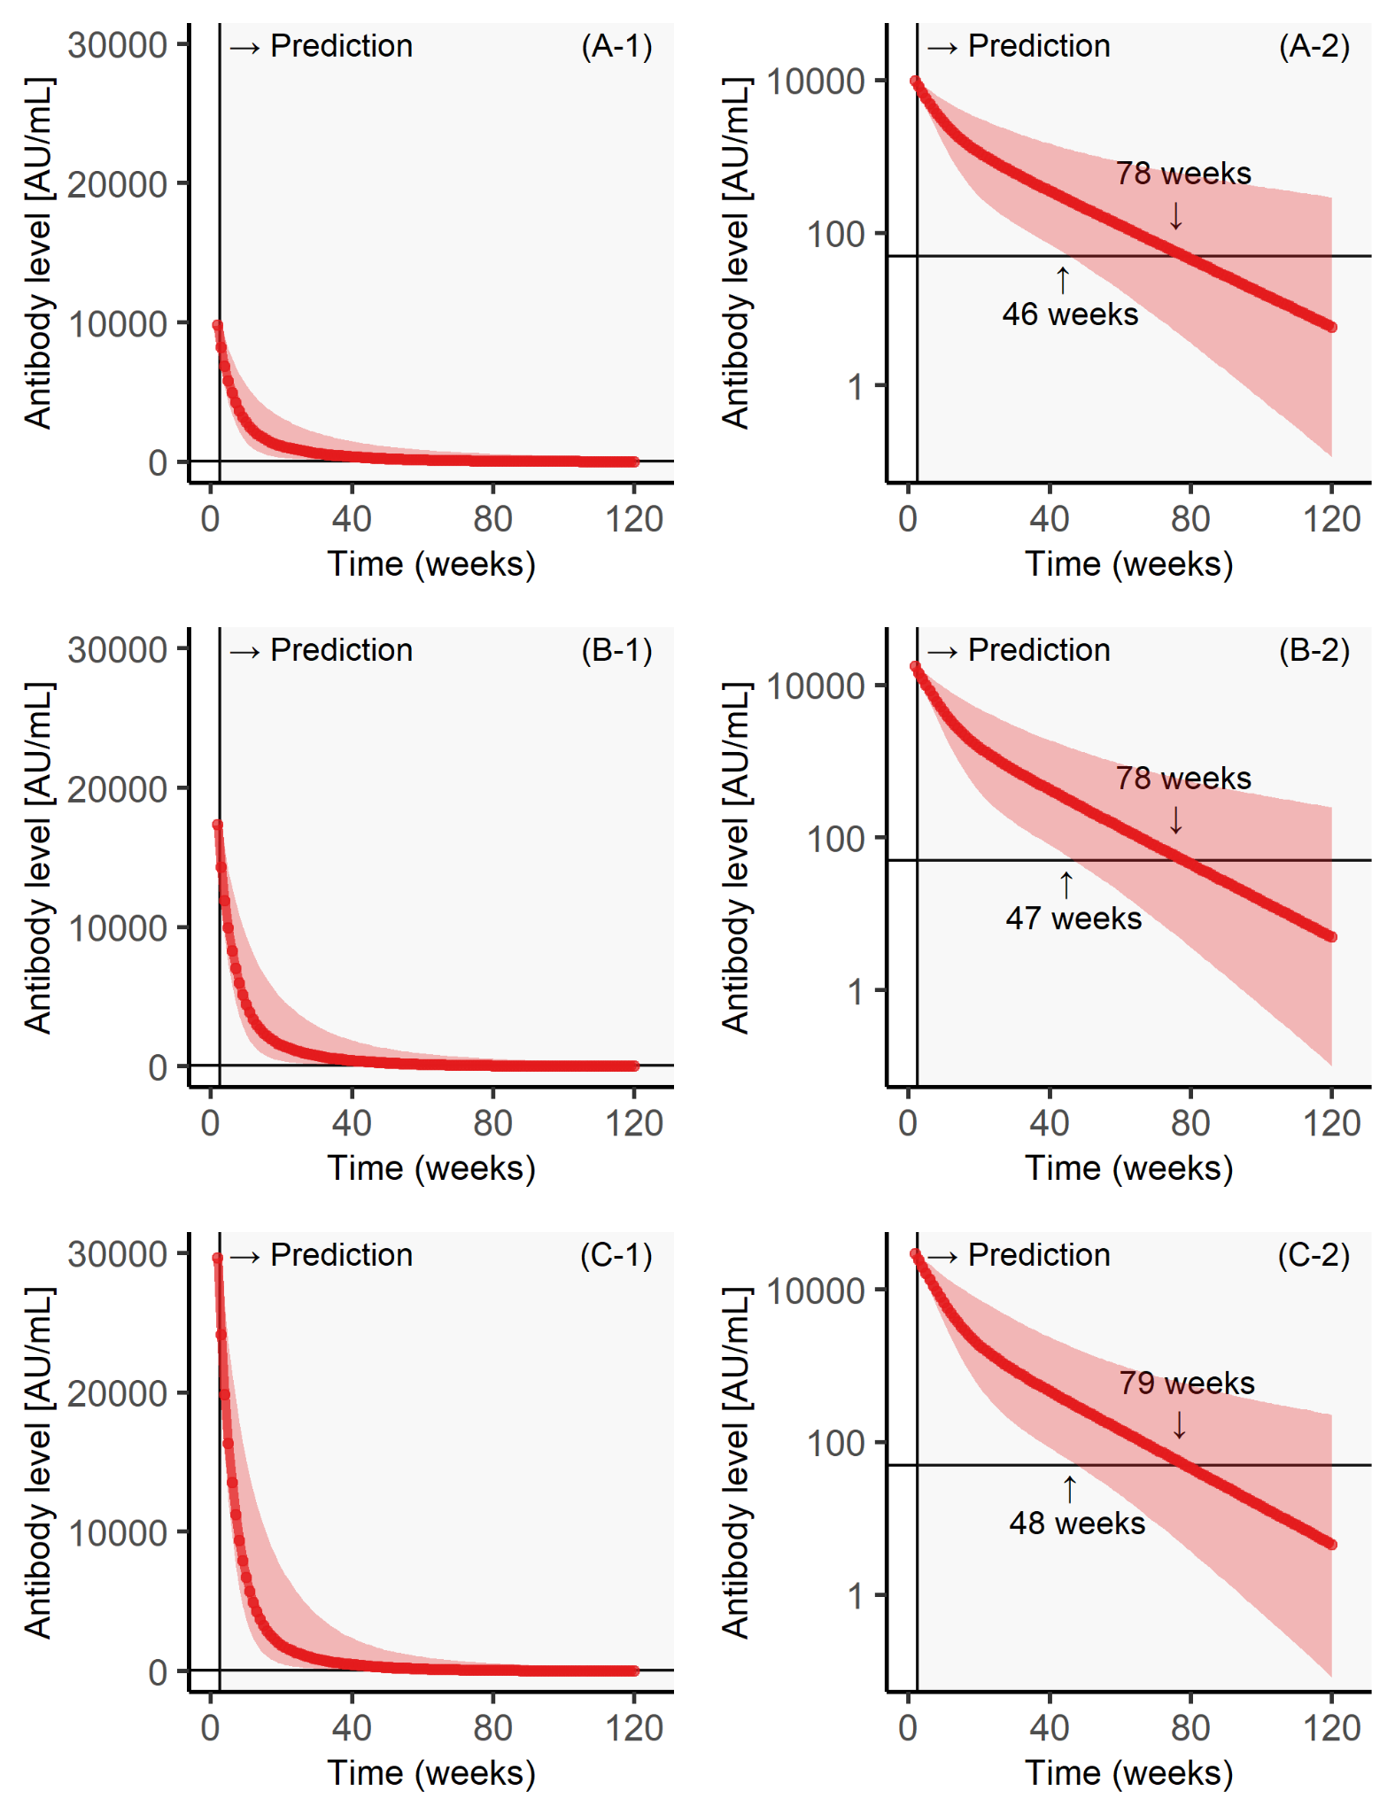
Supplementary Figure S3. Prediction results from the Japanese Society for Dialysis Therapy (JSDT) data: healthy elderly people.
Prediction results from fitting the best-fit model to three selected JSDT healthy elderly participants. The area to the right of the vertical reference line shows the predicted results. (1 & 2) Data and predicted results of antibody titers for a participant whose antibody titer increased to about 10,000 (A), 20,000 (B), and 30,000 (C) after two vaccinations. (2) Semi-logarithmic scales. Time points are shown when the lower limit of the 95% prediction interval and median value fell below the ≥ 50 AU/mL threshold for classification as a positive sample (A-2, B-2, and C-2).
