Supplementary information

The G9a/CHCHD2/Sirt1 regulatory module acts on RNase H1 to control R-loop formation at rDNA sites
Le Li＃, Yequn Wu＃, Kui Dai, Qing Wang, Shiqi Ye, Qipeng Shi, Zhenfei Chen, Yi-Chun Huang, Weiwei Zhao, Lijia Li*
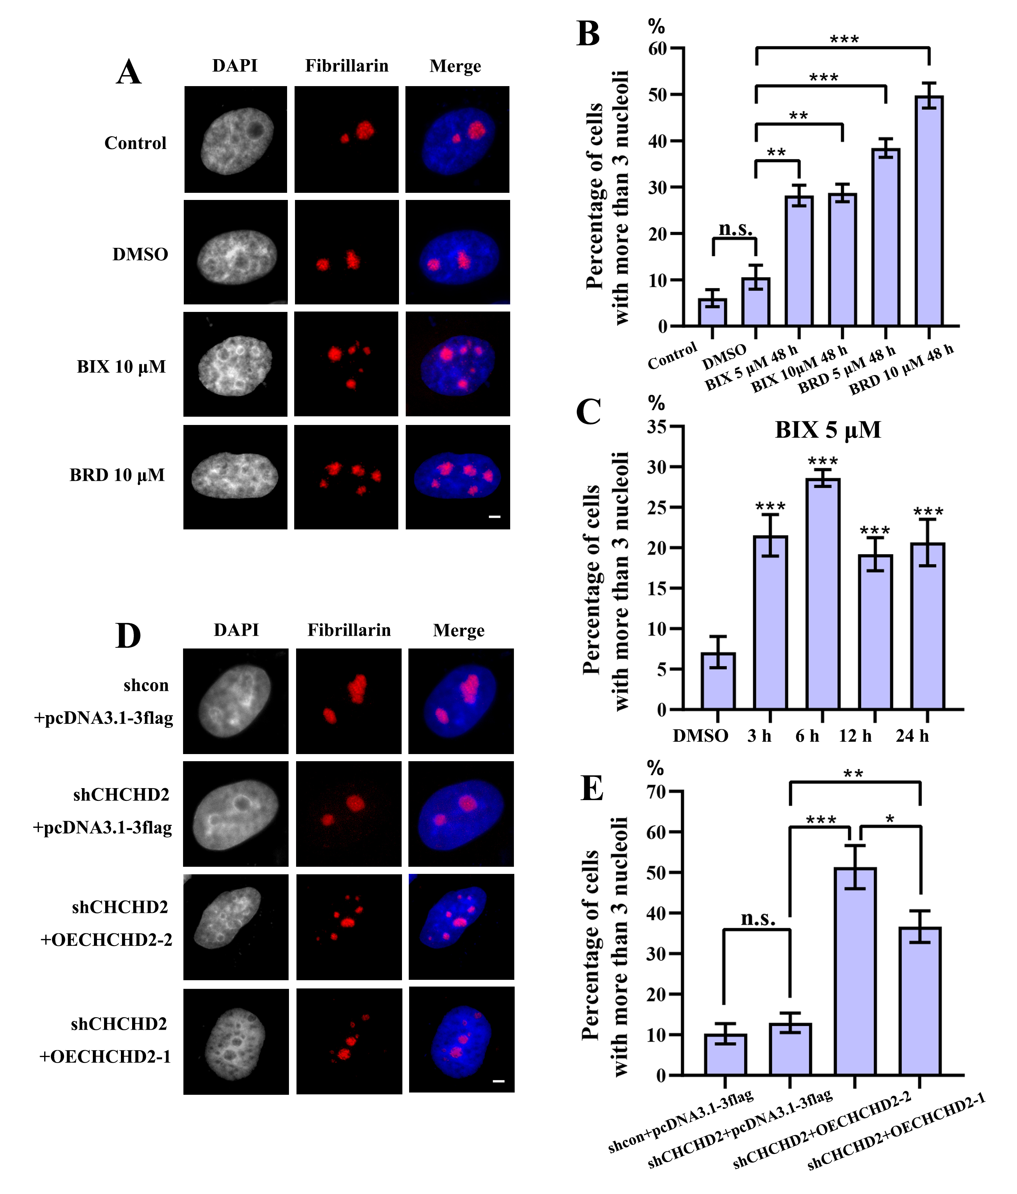
Supplementary Figure 1
(A) Fragmented nucleoli were detected by indirect immunofluorescence staining with an antibody against fibrillarin. The normal cells showed one-three brightly stained nucleoli in a nucleus. More than three fragmented nucleoli were observed in a cell treated with 5 μM BIX (data not shown), 10 μM BIX, 5 μM BRD (data not shown) or 10 μM BRD for 48 h, respectively. The same proportion of DMSO as the 10μM BIX group was used as a solvent control. Bar = 3 μm. (B) Percentages of interphase nuclei with more than three fragmented nucleoli after treatment with 5 μM BIX, 10 μM BIX, 5 μM BRD or 10 μM BRD for 48 h, respectively. (C) Percentages of interphase nuclei with more than three fragmented nucleoli after treatment with 5 μM BIX for 3h, 6h, 12h and 24h. The treatment of DMSO for 24 h with same concentration was used as the control group. (D) The stable shCHCHD2 HeLa cells after transfection with pcDNA3.1-3flag-CHCHD2-isoform1(OECHCHD2-1) and pcDNA3.1-3flag-CHCHD2-isoform2 (OECHCHD2-2) for 48 h and then indirect immunofluorescence staining with the anti-fibrillarin antibody was used to detect the nucleoli. The pcDNA3.1-3flag empty vector was used as the negative control and was added to maintain equal amounts of total transfected DNA in shcon HeLa cells and stable shCHCHD2 HeLa cells. Bar = 3 μm. (E) Percentages of interphase nuclei with more than three fragmented nucleoli after transfection with OECHCHD2-1 and OECHCHD2-2 for 48 h. The number of evaluated nuclei in each group was 500. All results are expressed as * P < 0.05, ** P < 0.01, *** P < 0.001, and n. s. means no significance, measured by the t-test.
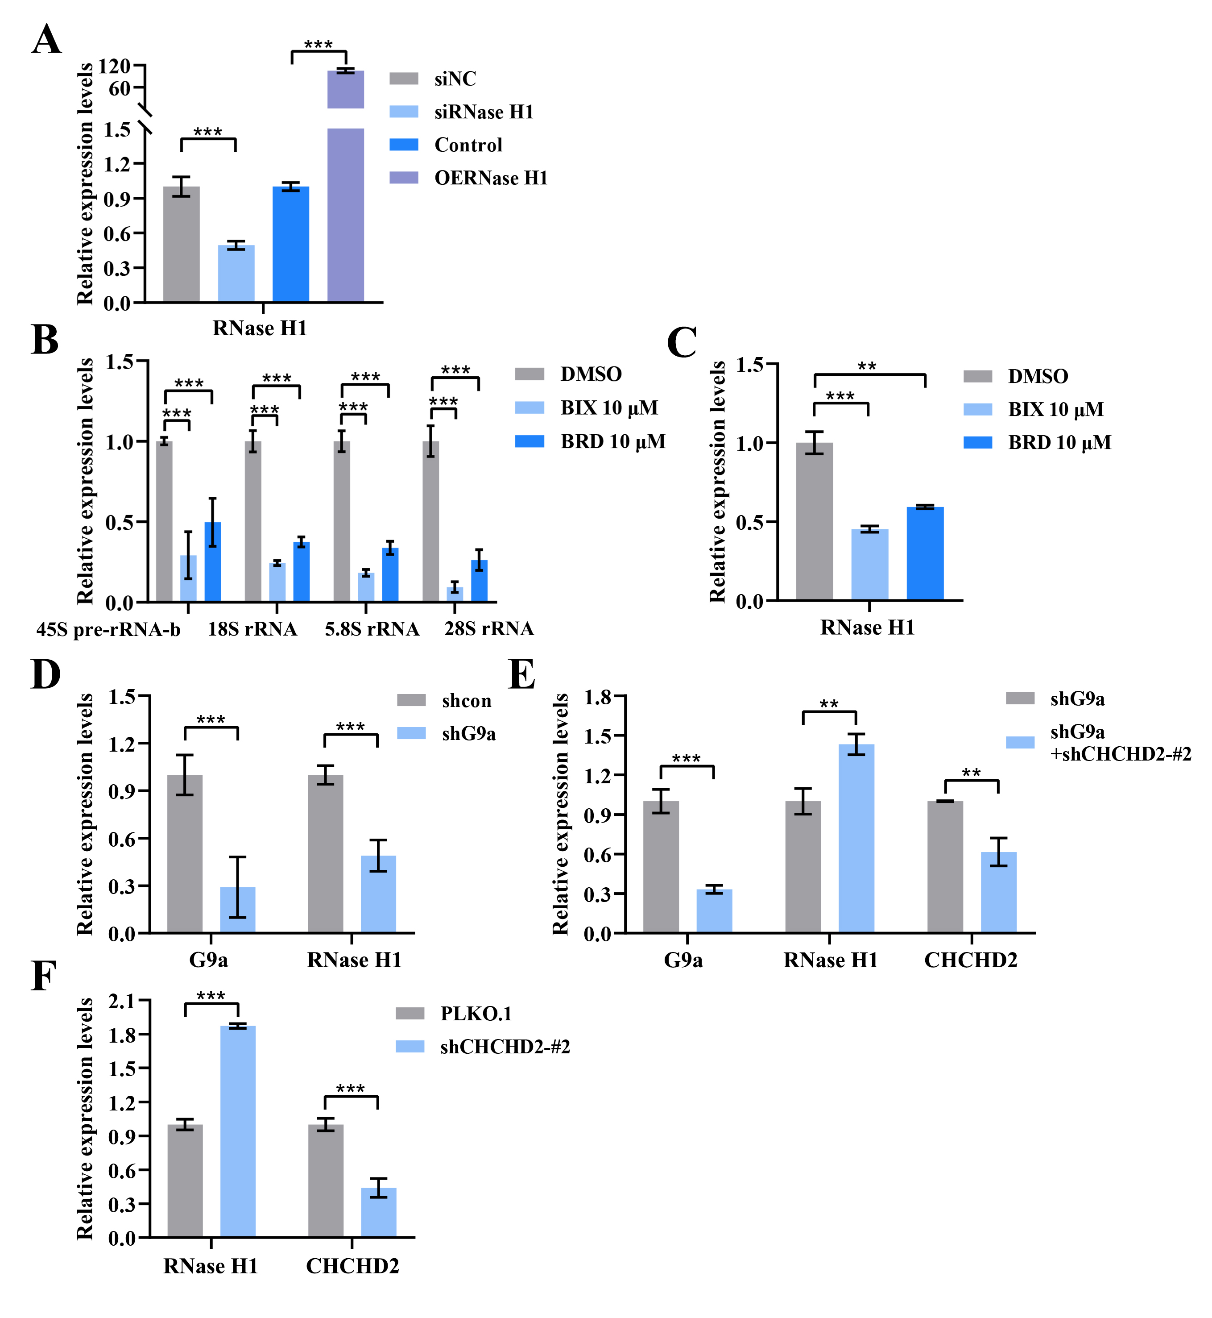
Supplementary Figure 2
(A) Real-time quantitative PCR (RT-qPCR) was used to detect the RNase H1 expression in HeLa cells after transfection with RNase H1 short-interfering RNA (siRNase H1) and pcDNA3.1-3flag-RNase H1 (OERNase H1) for 48 h. The HeLa cells were used as the control group after transfection with negative control RNA oligo (NC) and the pcDNA3.1-3flag empty vector. (B) RT-qPCR was used to detect the incomplete 5'ETS transcripts (45S-pre-rRNA-b) and the mature rRNA expressions (18S, 5.8S and 28S) in HeLa cells after treated with 10 μM BIX and 10 μM BRD for 48 h. In the above inhibitor treatment, DMSO was used as the solvent. The same proportion of DMSO as the 10 μM BIX group was used as a solvent control. (C) RT-qPCR was used to detect the RNase H1 expression in HeLa cells after the same treatment as shown in Supplementary Figure 2B. (D) RT-qPCR was used to detect the RNase H1 and G9a expression in HeLa cells after transfection with shG9a-#1 for 48 h. The pLKO.1 empty vector was used as the negative control and was added to maintain equal amounts of total transfected DNA. (E) RT-qPCR was used to detect the RNase H1, CHCHD2 and G9a expression in stable shG9a HeLa cells after transfection with shCHCHD2-#2 for 48 h. The pLKO.1 empty vector was used as the negative control and was added to maintain equal amounts of total transfected DNA. (F) RT-qPCR was used to detect the RNase H1 and CHCHD2 expression in HeLa cells after transfection with shCHCHD2-#2 for 48 h. The pLKO.1 empty vector was used as the negative control and was added to maintain equal amounts of total transfected DNA. Expression values were normalized to the gene GAPDH. The relative expression ratio of each sample was compared with untreated cells, expression value of which was assigned as 1. The error bars represent 2 ^{−ΔΔCT} ± the SD of three independent experiments and each experiment was repeated three times. The above results are expressed as * P < 0.05, ** P < 0.01, *** P < 0.001, and n. s. means no significance, measured by the t-test.
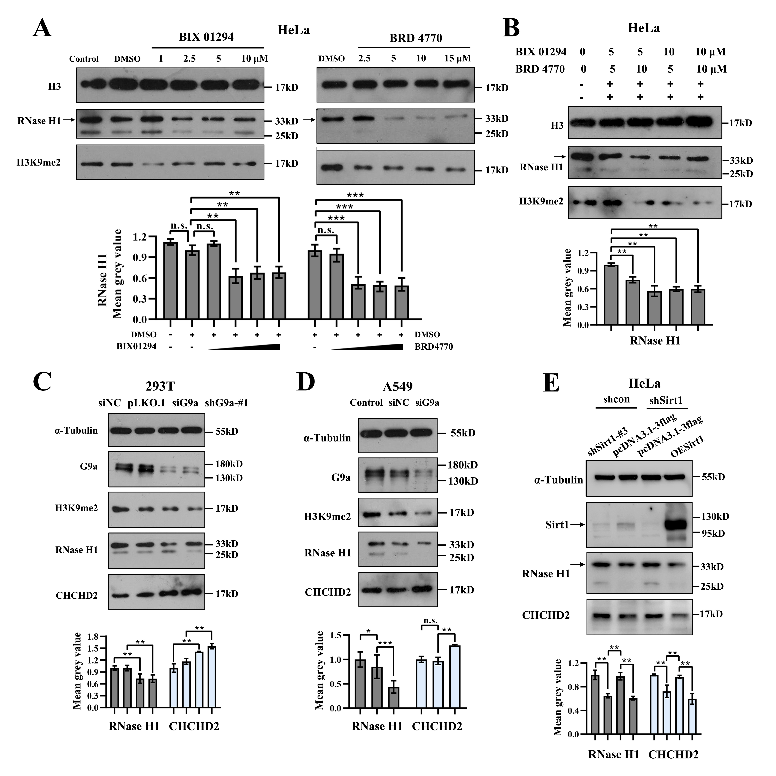
Supplementary Figure 3
(A) Left panel: Western blot analysis of RNase H1 expression and H3K9me2 levels in BIX-treated (48 h) HeLa cells. Right panel: Western blot analysis of RNase H1 expression and H3K9me2 levels in BRD-treated (48 h) HeLa cells. RNase H1 expression and H3K9me2 levels were quantified to the level of H3. (B) Western blot analysis of RNase H1 expression in HeLa cells after BIX-BRD combined treatment. In the above inhibitor treatment, DMSO was used as the solvent. The same proportion of DMSO as the 10 μM BIX and the 15 μM BRD group was used as a solvent control. RNase H1 levels were quantified to the level of H3. In the above groups, the relative mean gray value of RNase H1 were shown in the lower panel. (C) Western blot analysis of RNase H1, CHCHD2, G9a and H3K9me2 expression in 293T cells after transfection with G9a short-interfering RNA (siG9a) and shG9a-#1 for 48 h. The 293T cells were used as the control group after transfection with negative control RNA oligo (NC) and the pLKO.1 empty vector. RNase H1, CHCHD2, H3K9me2 and G9a levels were quantified to the level of α-tubulin. (D) Western blot analysis of RNase H1, CHCHD2, G9a and H3K9me2 expression in A549 cells after transfection with siG9a for 48 h. The A549 cells after transfection with NC were used as the negative control group. RNase H1, CHCHD2, H3K9me2 and G9a levels were quantified to the level of α-tubulin. (E) Western blot analyses showed the relative expression levels of RNase H1, CHCHD2 and Sirt1 in Sirt1 knockdown and Sirt1 rescued HeLa cells. The pcDNA3.1-3flag and the pLKO.1 (figure not shown) empty vector were used as the negative control and were added to maintain equal amounts of total transfected DNA. Expression levels of RNase H1, CHCHD2 and Sirt1 were quantified to α-tubulin. In the above groups, the relative mean gray value of RNase H1 and CHCHD2 were shown in the lower panel. Each experiment was repeated three times, and the average value and SD are shown. Data are expressed as * P < 0.05, ** P < 0.01, *** P < 0.001, and n. s. means no significance, measured by the t-test.

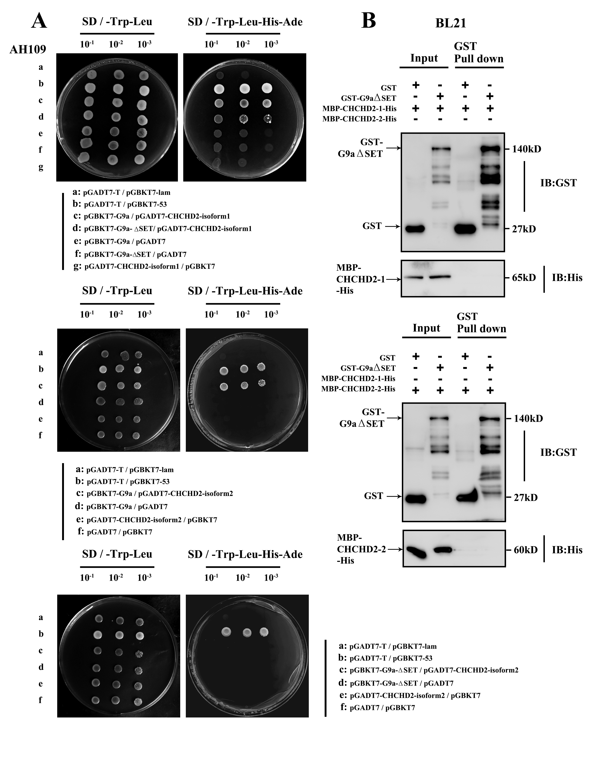
Supplementary Figure 4
Interaction between G9a and CHCHD2.
(A) Detection of the CHCHD2-isoform1 / G9a, CHCHD2-isoform1 / G9aΔSET, CHCHD2-isoform2 / G9a and CHCHD2-isoform2 / G9aΔSET interactions in a yeast two-hybrid assay. The pGADT7-T and pGBKT7-53 combination was used as a positive control. The pGADT7-T and pGBKT7-lam combination was used as the negative control. (B) GST pull-down assay showing the interaction of purified MBP-CHCHD2-His and GST-G9aΔSET from BL21. GST-G9aΔSET pull-down products were analyzed by western blotting analysis with anti-His antibody.
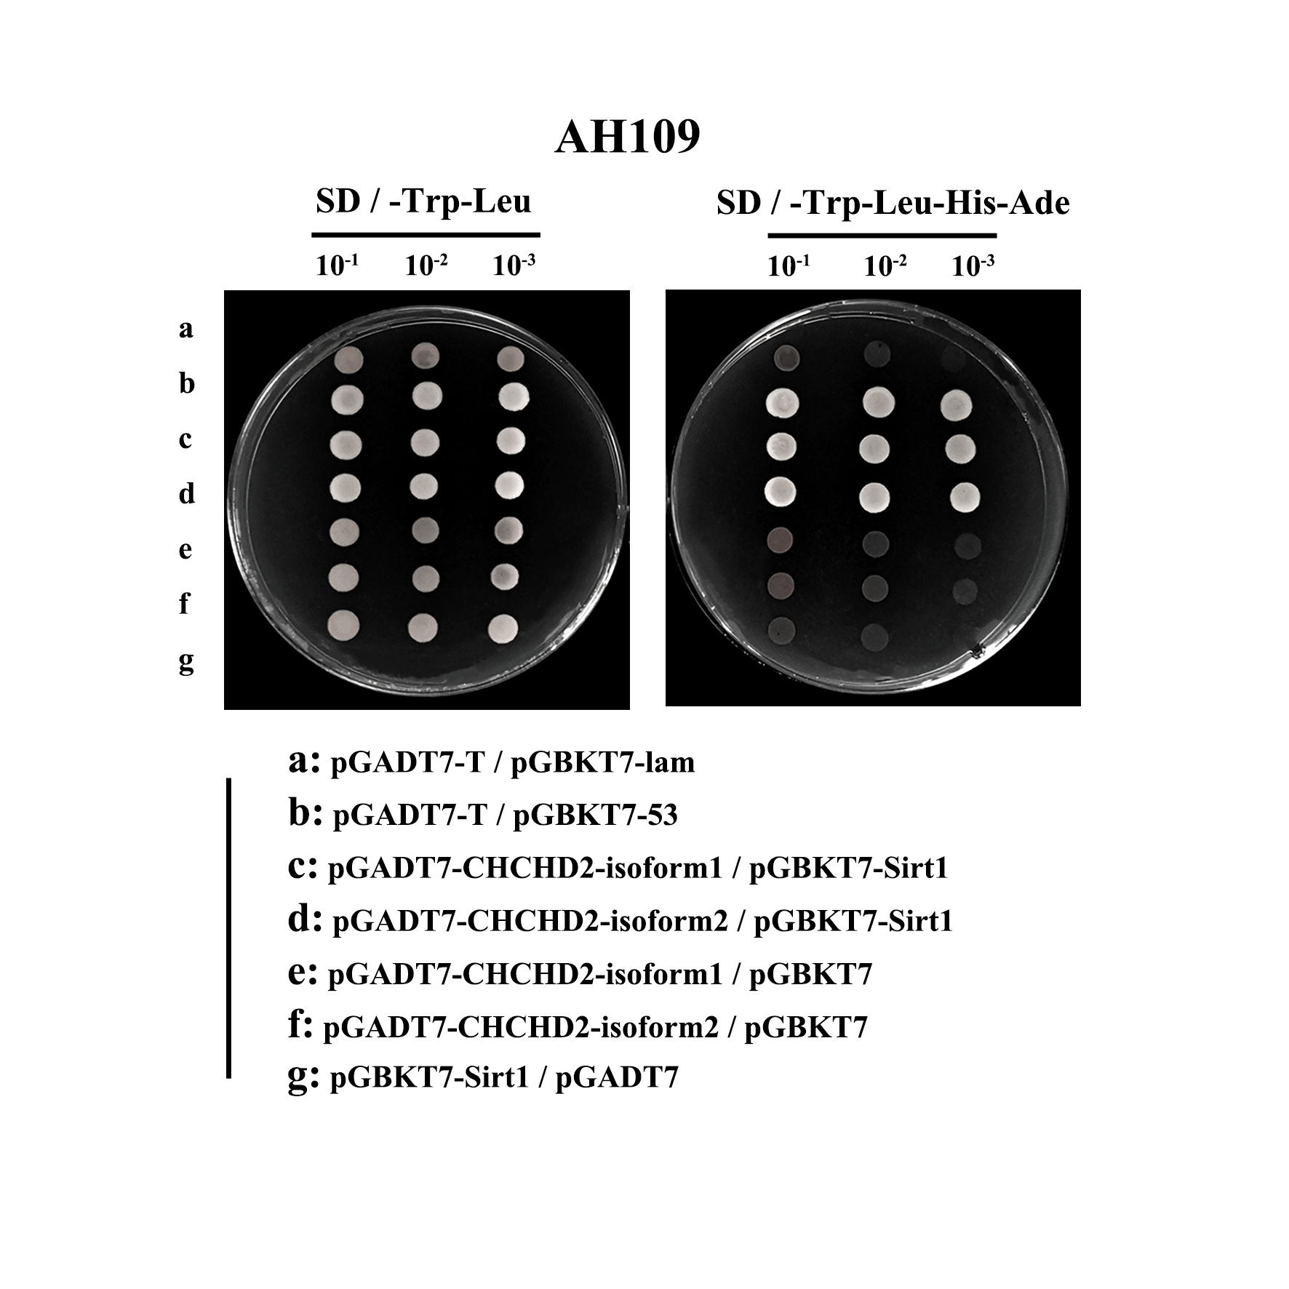
Supplementary Figure 5
Interaction between Sirt1 and CHCHD2.
(A) Detection of the CHCHD2-isoform1 / Sirt1 and CHCHD2-isoform2 / Sirt1 interactions in a yeast two-hybrid assay. The pGADT7-T and pGBKT7-53 combination was used as a positive control. The pGADT7-T and pGBKT7-lam combination was used as the negative control.
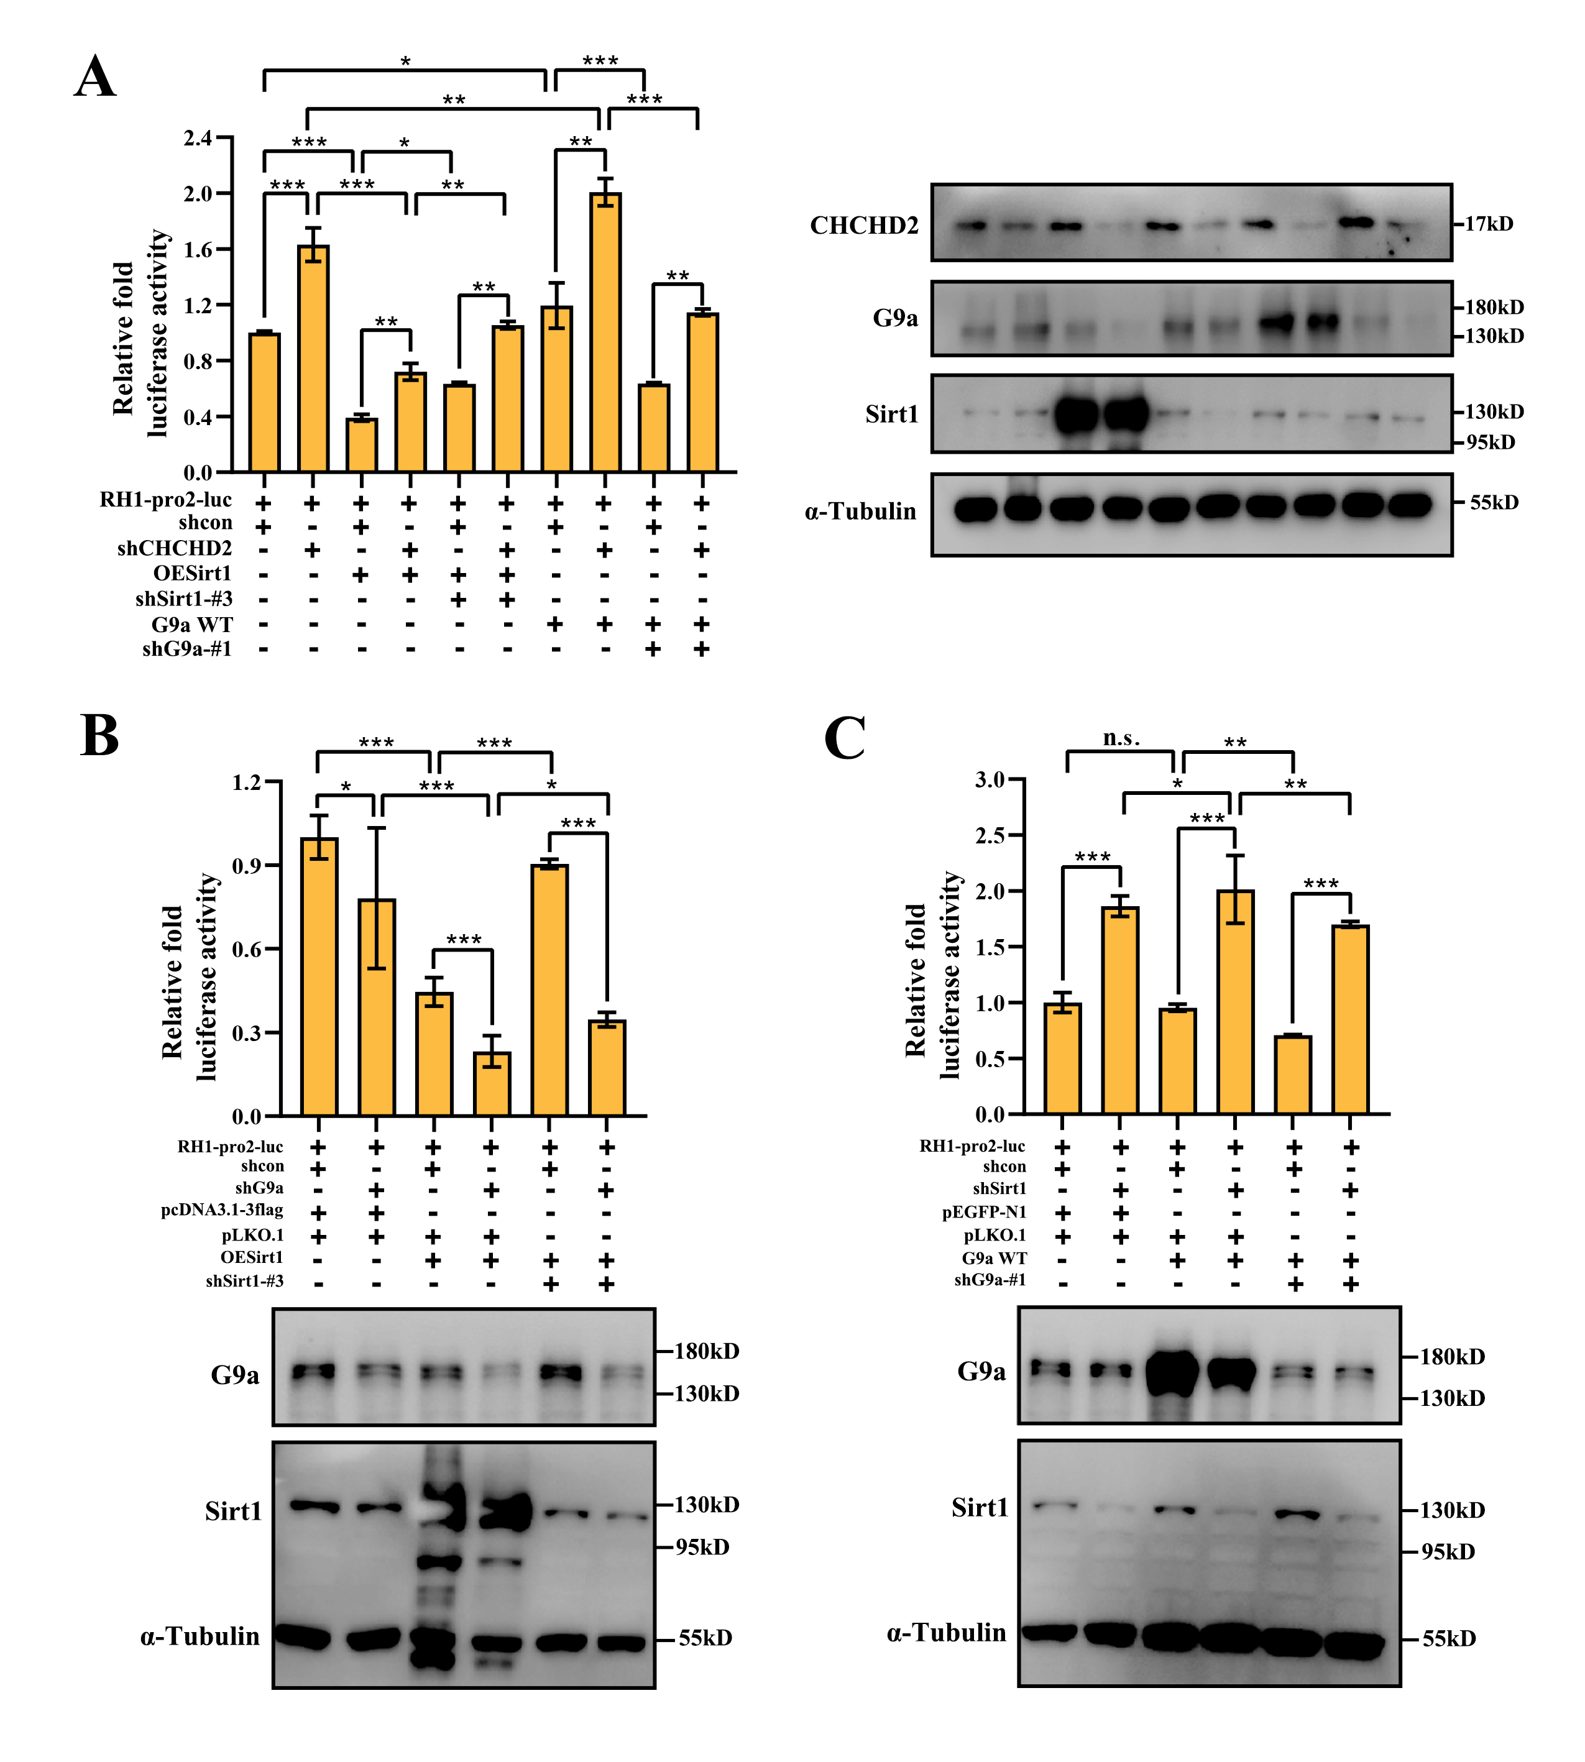
Supplementary Figure 6
CHCHD2, G9a and Sirt1 function with each other and precisely regulate the expression of RNase H1.
(A) Stable shCHCHD2 HeLa cells and shcon HeLa cells were co- transfected with the pGL3- RNase H1 promoter, pcDNA3.1-3flag-Sirt1(OESirt1), pEGFP-G9a (G9A WT) and phRL-TK. Twenty-four hours after transfection, these cells were transfected with pLKO.1-shSirt1-#3 (shSirt1-#3) and pLKO.1-shG9a-#1 (shG9a-#1) for 24 h. The pcDNA3.1-3flag, pLKO.1 and pEGFP-N1 empty vector were used as the negative control and were added to maintain equal amounts of total transfected DNA. Following transfection, cells were grown for 48 h, and cell extracts were assayed for luciferase activity. Firefly luciferase activity levels were normalized to those of the Renilla luciferases. Expression of the transfected constructs is shown in the immunoblot analysis. Each P-value represents the mean of three replicates from a single assay. All data are representative of at least three independent experiments and are presented as means ±SD. t-test is performed, * P < 0.05, ** P < 0.01 and *** P < 0.001, n. s. means not significant. (B) Stable shG9a HeLa cells and shcon HeLa cells were co-transfected with the pGL3- RNase H1 promoter, OESirt1 and phRL-TK. Twenty-four hours after transfection, these cells were transfected with shSirt1-#3 for 24 h. The pcDNA3.1-3flag and pLKO.1 empty vector were used as the negative control and were added to maintain equal amounts of total transfected DNA. Cells were grown for 48 h, and cell extracts were assayed for luciferase activity. Expression of the transfected constructs is shown in the immunoblot analysis. (C) Stable shSirt1 HeLa cells and shcon HeLa cells were co-transfected with the pGL3- RNase H1 promoter, G9A WT and phRL-TK. Twenty-four hours after transfection, these cells were transfected with shG9a-#1 for 24 h. The pEGFP-N1 and pLKO.1 empty vector were used as the negative control and were added to maintain equal amounts of total transfected DNA. Luciferase activity was measured 48 h after transfection. Firefly luciferase activity levels were normalized to those of the Renilla luciferases. Overexpression and knockdown of Sirt1or G9a are shown in the immunoblot analysis. Each P-value represents the mean of three replicates from a single assay. All data are representative of at least three independent experiments and are presented as means ±SD. t-test is performed, * P < 0.05, ** P < 0.01 and *** P < 0.001, n. s. means not significant.
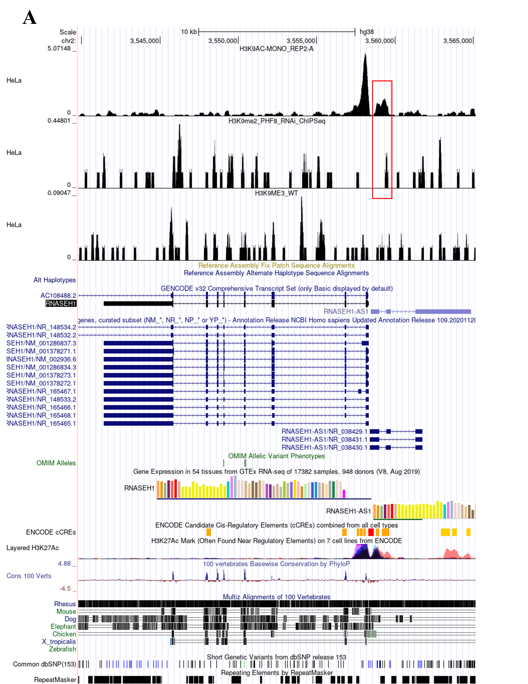
Supplementary Figure 7
ChIP-seq data mining of histone H3K9 modification in the promoter region of RNase H1 in HeLa cell line.
(A) The red box shows the main enrichment peak of H3K9ac and H3K9me2 in the RNaseH1 promoter region in the HeLa cell from the ChIP-seq public database Cistrome Data Browser

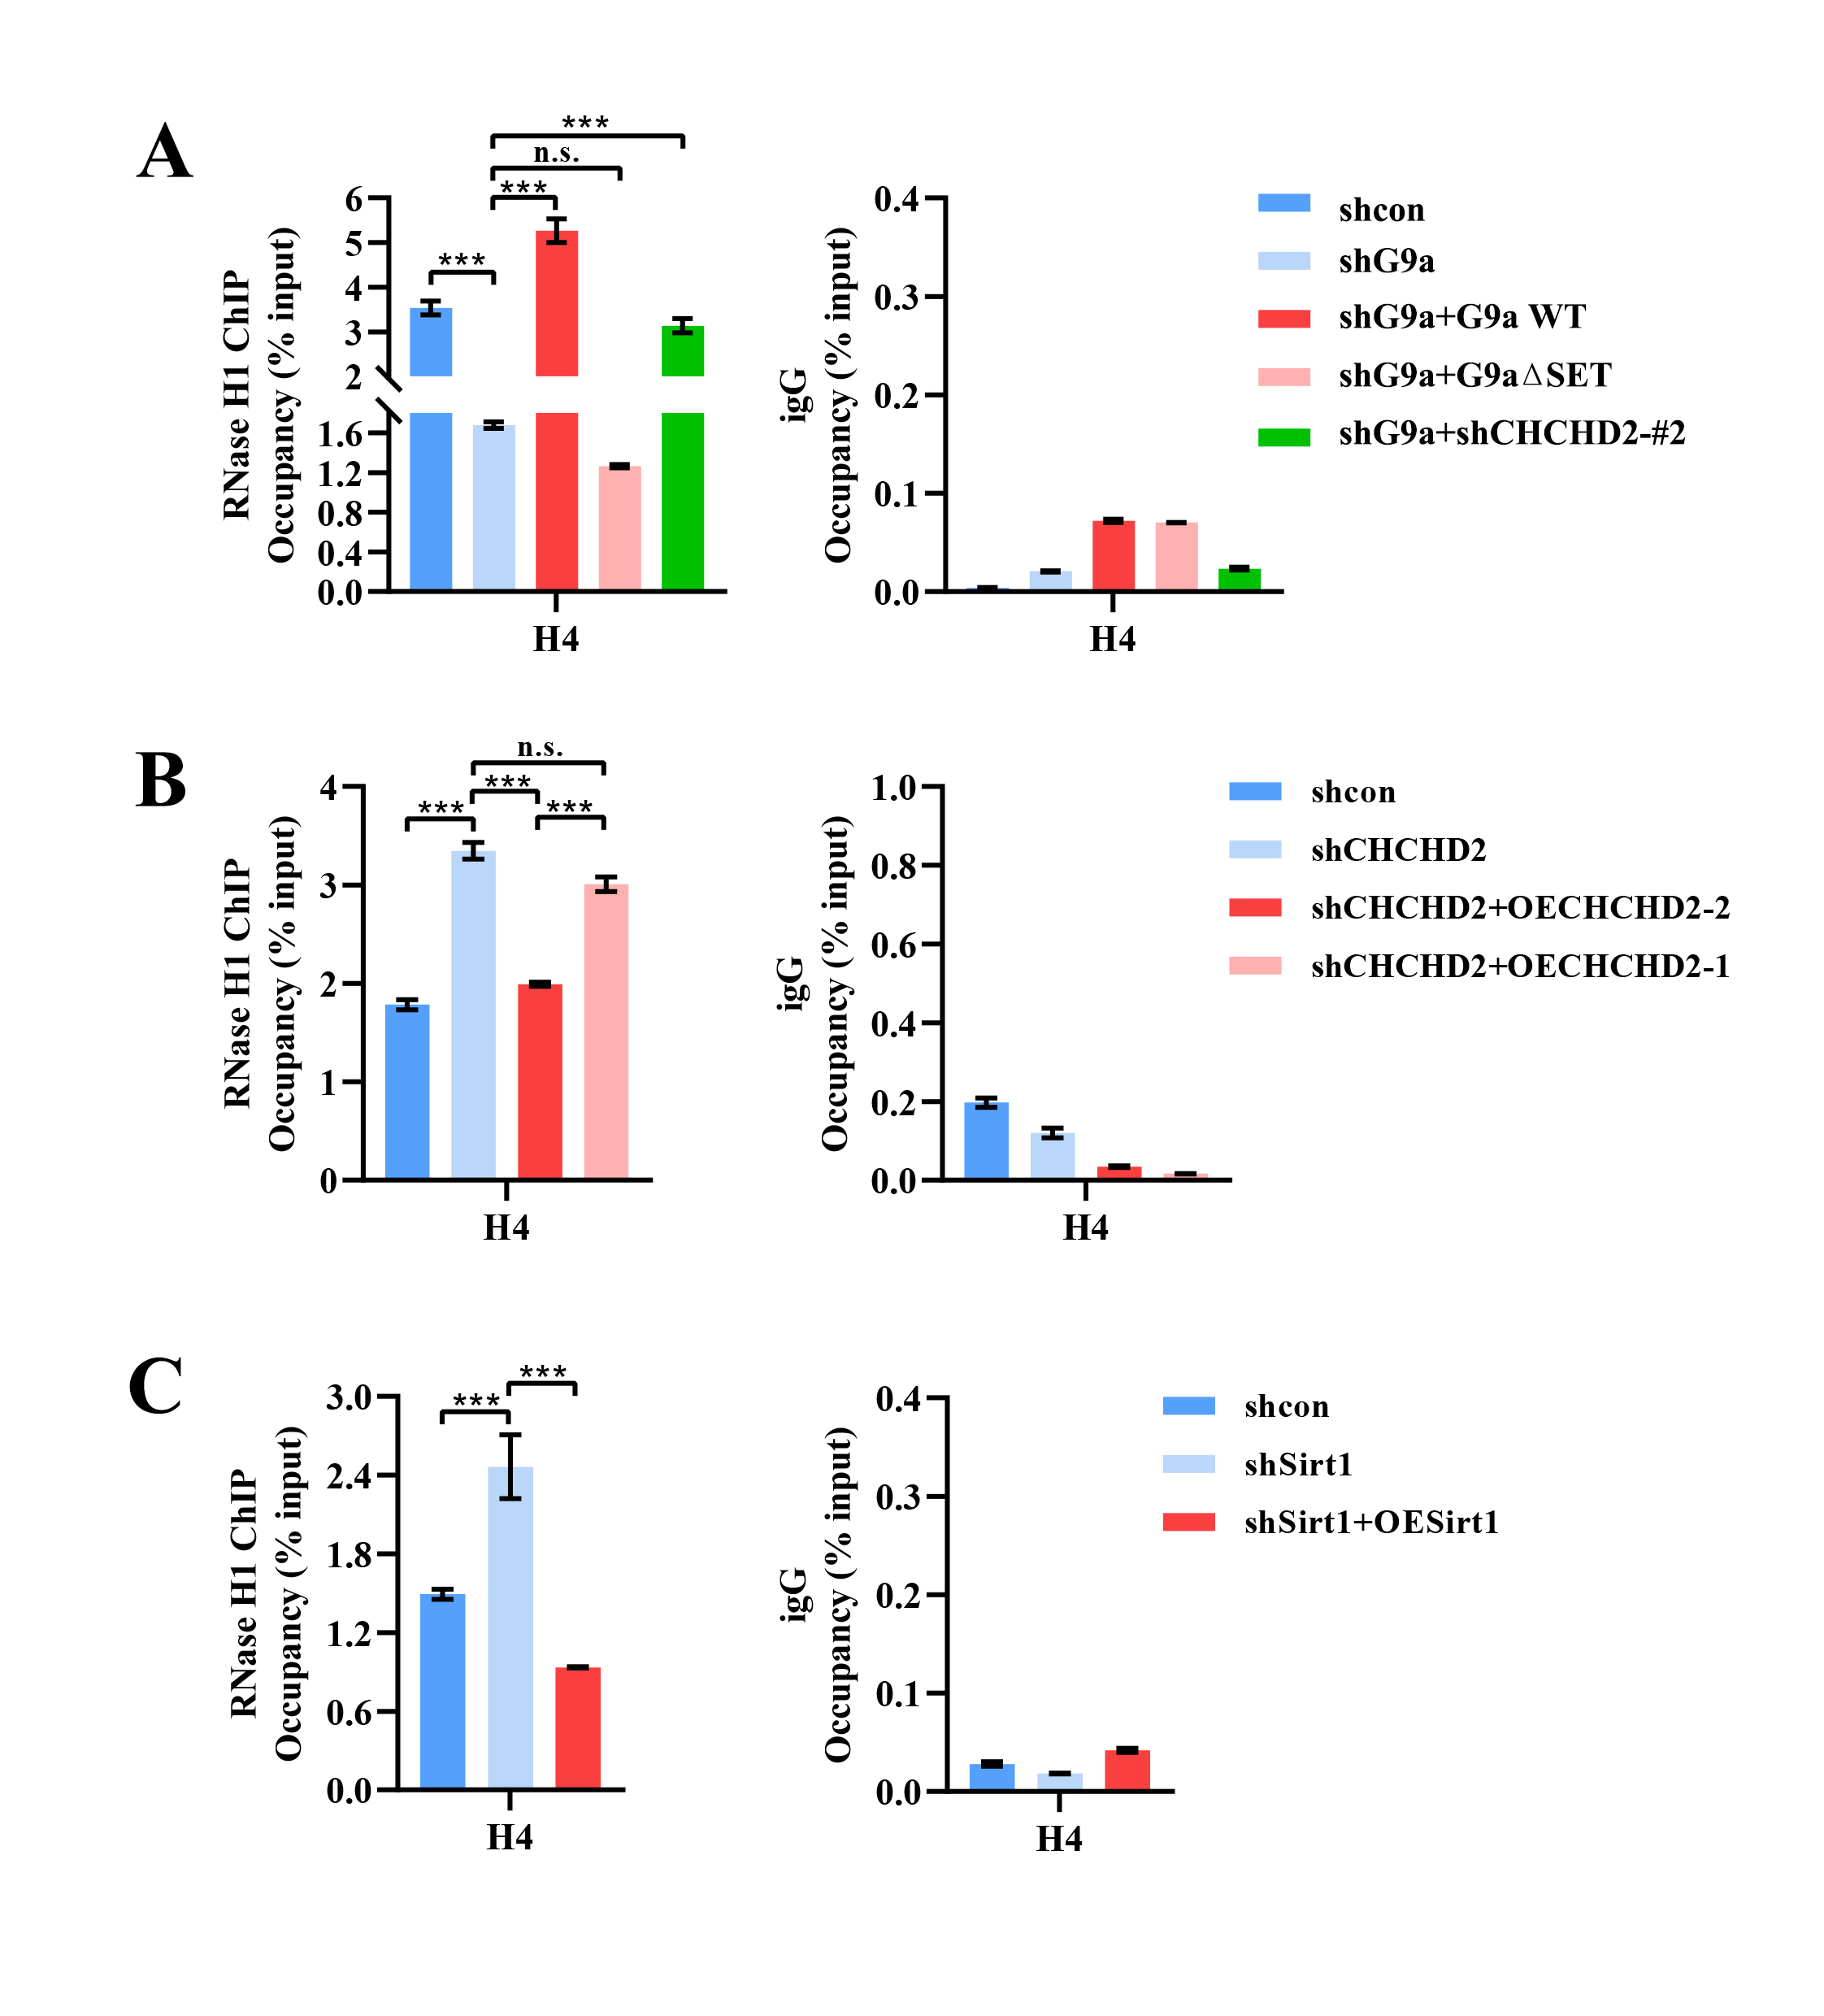
Supplementary Figure 8
G9a, CHCHD2 and Sirt1 influence the recruitment of RNase H1 at the rDNA locus H4
(A) Endogenous RNase H1 ChIP were used to detect the RNase H1 occupancy at rDNA locus H4 in stable shG9a HeLa cells after transfection with pEGFP-G9a (G9a WT), pEGFP-G9a-ΔSET (G9a ΔSET) or pLKO.1-shCHCHD2-#2 (shCHCHD2-#2) for 48 h. The pEGFP-N1 and the pLKO.1 empty vector was used as the negative control and was added respectively to maintain equal amounts of total transfected DNA. (B) Endogenous RNase H1 ChIP were used to detect the RNase H1 occupancy at rDNA locus H4 in stable shCHCHD2 HeLa cells after transfection with pcDNA3.1-3flag-CHCHD2-isoform1(OECHCHD2-1) or pcDNA3.1-3flag-CHCHD2-isoform2 (OECHCHD2-2) for 48 h. The pcDNA3.1-3flag empty vector was used as the negative control and was added to maintain equal amounts of total transfected DNA. (C) Endogenous RNase H1 ChIP were used to detect the RNase H1 occupancy at rDNA locus H4 in stable shSirt1 HeLa cells after transfection with pcDNA3.1-3flag-Sirt1 (OESirt1) for 48 h. The pcDNA3.1-3flag empty vector was used as the negative control and was added to maintain equal amounts of total transfected DNA. Relative values were normalized to the input. The x-axis indicated the region H4 of rDNA amplicons. The result represents at least three independent experiments (±SD). * P < 0.05, ** P < 0.01, *** P < 0.001, n. s. means not significant, measured by the t-test.
Supplementary Table 1: Sequences for siRNA and shRNA oligonucleotide (Abdelmohsen et al., 2007; Cheng et al., 2019; Kim et al., 2015; Ruhanen et al., 2011)
Gene name | sequence
siRNaseH1  sense | CUGGAUGGAGAUGGACAUGAATT
siRNaseH1 antisense | UUCAUGUCCAUCUCCAUCCAGTT
siG9a  sense | CACACAUUCCUGACCAGAGAUTT
siG9a  antisense | AUCUCUGGUCAGGAAUGUGUGTT
Negative control sense | UUCUCCGAACGUGUCACGUTT
Negative control antisense | ACGUGACACGUUCGGAGAATT
shCHCHD2-#1  top strand | CCGGGGGCACACATTGGGTCACGCCATTACTCGAGTAATGGCGTGACCCAATGTGTGCCC TTTTTG
shCHCHD2-#1 bottom strand | AATTCAAAAAGGGCACACATTGGGTCACGCCATTACTCGAGTAATGGCGTGACCCAATGTGTGCCC
shCHCHD2-#2  top strand | CCGGGGTGACATCAAGCTCTGTGAGGGTTCTCGAGAACCCTCACAGAGCTTGATGTCACCTTTTTG
shCHCHD2-#2 bottom strand | AATTCAAAAAGGTGACATCAAGCTCTGTGAGGGTTCTCGAGAACCCTCACAGAGCTTGATGTCACC
shsirt1-#3  top strand | CCGGGAAGTTGACCTCCTCATTGTCTCGAGACAATGAGGAGGTCAACTTCTTTTTG
shsirt1-#3  bottom strand | AATTCAAAAAGAAGTTGACCTCCTCATTGTCTCGAGACAATGAGGAGGTCAACTTC
sh(human) G9a-#1 top strand | CCGGCACACATTCCTGACCAGAGATCTCGAGATCTCTGGTCAGGAATGTGTGTTTTTG
sh(human) G9a-#1 bottom strand | AATTCAAAAACACACATTCCTGACCAGAGATCTCGAGATCTCTGGTCAGGAATGTGTG

Supplementary Table 2: Primer sequences for genomic DNA amplification (reporter gene assay)
CHCHD2-pro1-luc Forward | 5’-CTTTGGGGGGAACAGGTGGT-3’
CHCHD2-pro2-luc Forward | 5’-ACCCACCTAGCACATCCC-3’
CHCHD2-pro3-luc Forward | 5’-GTTGACCGCGAAGGACGAG-3’
CHCHD2-pro-luc Reverse | 5’-AGATCTCGGCCTCCCTCTGCGT-3’
RH1-pro1-luc Forward | 5’-CCTTGTGATACAGGACCAGC-3’
RH1-pro2-luc Forward | 5’-GGTTGCAGTGAGCCCCAATC-3’
RH1-pro3-luc Forward | 5’-GTAGAGACAGGGTTTCATCA-3’
RH1-pro-luc Reverse | 5’-GCACCGGGAAGCATTTCGAC-3’

Supplementary Table 3: Primers for DNA fragment amplification (chromatin immunoprecipitation assay) (Cong et al., 2012; Grandori et al., 2005; Murayama et al., 2008)
primer name | sequence(sense/antisense)
H0 | 5’-GGTATATCTTTCGCTCCGAG-3’
H0 | 5’-GACGACAGGTCGCCAGAGGA-3’
H1 | 5′- GGCGGTTTGAGTGAGACGAGA -3′
H1 | 5′- ACGTGCGCTCACCGAGAGCAG -3′
H4 | 5’- CGACGACCCATTCGAACGTCT -3’
H4 | 5’- CTCTCCGGAATCGAACCCTGA -3’
H4- | 5’- GGATGCGTGCATTTATCAGA -3’
H4- | 5’- GATCGGCCCGAGGTTATCTA -3’
H8 | 5’-AGTCGGGTTGCTTGGGAATGC-3’
H8 | 5’-CCCTTACGGTACTTGTTGACT-3’
H13 | 5’-ACCTGGCGCTAAACCATTCGT-3’
H13 | 5’-GGACAAACCCTTGTGTCGAGG-3’
H18 | 5’-GTTGACGTACAGGGTGGACTG -3’
H18 | 5’- GGAAGTTGTCTTCACGCCTGA-3’
H23 | 5’-CCTTCCACGAGAGTGAGAAGC-3’
H23 | 5’-TCGACCTCCCGAAATCGTACA-3’
RH proA | 5’-CCAATGTACGCGTCGCTTTT-3’
RH proA | 5’-AGGCAGAACAAGCTGTTGGA-3’
RH proB | 5’-TCGATCTCCTGACCTGGTGA-3’
RH proB | 5’-AGGGGATATCCAGTGCCTCA-3’
RH proC | 5’-CATCTCGACCTTCCTCTGCC-3’
RH proC | 5’-GAAGATGACGCACGTCTGGG-3’

Supplementary Table 4: Primers for cDNA fragment amplification (RT-qPCR) assay
(Cong et al., 2012; Murayama et al., 2008; Uemura et al., 2012; Wei et al., 2018)
primer name | sequence(sense/antisense)
45S pre-rRNA-a | 5’-CGACCTGTCGTCGGAGAG-3’
45S pre-rRNA-a | 5’-GGTCACCGTGAGGCCAGA-3’
45S pre-rRNA-b | 5’-GAACGGTGGTGTGTCGTTC-3’
45S pre-rRNA-b | 5’-GCGTCTCGTCTCGTCTCACT-3’
45S pre-rRNA-c | 5’-ATGGACGAGAATCACGAGCG-3’
45S pre-rRNA-c | 5’-CAGCCACGAACCCGACAC-3’
45S pre-rRNA-d | 5’-GAAGCGTCGCGGGTCT-3’
45S pre-rRNA-d | 5’-CACGCGACACGACCAC-3’
18Sr RNA | 5’-GATGGTAGTCGCCGTGCC-3’
18Sr RNA | 5’-GCCTGCTGCCTTCCTTGG-3’
5.8Sr RNA | 5’-ACTCGGCTCGTGCGTC-3’
5.8Sr RNA | 5’-GCGACGCTCAGACAGG-3’
28Sr RNA | 5’-AGAGGTAAACGGGTGGGGTC-3’
28Sr RNA | 5’-GGGGTCGGGAGGAACGG-3’
GAPDH | 5’-TCCACCACCCTGTTGCTGTA-3’
GAPDH | 5’-ACCACAGTCCATGCCATCAC-3’
β-actin | 5’-ATCGTCCACCGCAAATGCTTCTA-3’
β-actin | 5’-AGCCATGCCAATCTCATCTTGTT-3’
RNaseH1 | 5’-CTGGGTTCAAGGTTGGAAGA-3’
RNaseH1 | 5’-CATGCATCCACTGAATGTCC-3’
G9a | 5’-GCCAGGCCGGGAGGCCCTGGAA-3’
G9a | 5’-CTCCAGCCTGCAGCAGCACATG-3’
CHCHD2 | 5’-ACATTGGGTCACGCCATTACT-3’
CHCHD2 | 5’-TCCCTGAGGCTCCTGGTAAG-3’
Sirt1 | 5’-TCAGTGTCATGGTTCCTTTGC-3’
Sirt1 | 5’-AATCTGCTCCTTTGCCACTCT-3’

Reference
Abdelmohsen, K., Pullmann, J.R., Lal, A., Kim, H.H., Galban, S., Yang, X., Blethrow, J.D., Walker, M., Shubert, J., Gillespie, D.A., et al. (2007). Phosphorylation of HuR by Chk2 Regulates SIRT1 Expression. Molecular Cell 25, 543-557.
Cheng, Q., Qu, D., Lu, Z., and Zhang, L. (2019). Knockdown of CHCHD2 inhibits migration and angiogenesis of human renal cell carcinoma: A potential molecular marker for treatment of RCC. Oncology Letters 17, 765-772.
Cong, R., Das, S., Ugrinova, I., Kumar, S., Mongelard, F., Wong, J., and Bouvet, P. (2012). Interaction of nucleolin with ribosomal RNA genes and its role in RNA polymerase I transcription. Nucleic acids research 40, 9441-9454.
Grandori, C., Gomez-Roman, N., Felton-Edkins, Z.A., Ngouenet, C., Galloway, D.A., Eisenman, R.N., and White, R.J. (2005). c-Myc binds to human ribosomal DNA and stimulates transcription of rRNA genes by RNA polymerase I. Nature Cell Biology 7, 311-318.
Kim, K.-B., Son, H.-J., Choi, S., Hahm, J.Y., Jung, H., Baek, H.J., Kook, H., Hahn, Y., Kook, H., and Seo, S.-B. (2015). H3K9 methyltransferase G9a negatively regulates UHRF1 transcription during leukemia cell differentiation. Nucleic acids research 43, 3509-3523.
Murayama, A., Ohmori, K., Fujimura, A., Minami, H., Yasuzawa-Tanaka, K., Kuroda, T., Oie, S., Daitoku, H., Okuwaki, M., Nagata, K., et al. (2008). Epigenetic Control of rDNA Loci in Response to Intracellular Energy Status. Cell 133, 627-639.
Ruhanen, H., Ushakov, K., and Yasukawa, T. (2011). Involvement of DNA ligase III and ribonuclease H1 in mitochondrial DNA replication in cultured human cells. BBA - Molecular Cell Research 1813, 2000-2007.
Uemura, M., Zheng, Q., Koh, C.M., Nelson, W.G., De Marzo, A.M., and Yegnasubramanian, S. (2012). Overexpression of ribosomal RNA in prostate cancer is common but not linked to rDNA promoter hypomethylation. Oncogene 31, 1254-1263.
Wei, T., Najmi, S.M., Liu, H., Peltonen, K., Kucerova, A., Schneider, D.A., and Laiho, M. (2018). Small-Molecule Targeting of RNA Polymerase I Activates a Conserved Transcription Elongation Checkpoint. Cell Reports 23, 404-414.

