Supplementary Information
Article title: Iron (hydr)oxide formation in Andosols under extreme climate conditions

Authors: Björn Klaes^{1,2*}, Sören Thiele-Bruhn², Gerhard Wörner³, Carmen Höschen⁴, Carsten W. Mueller^{4,5}, Philipp Marx², Helge Wolfgang Arz⁶, Sonja Breuer⁷, Rolf Kilian^{1,8†}
¹Geology Department, Trier University, Campus II (Geozentrum), Behringstraße 21, 54296 Trier, Germany; klaesb@uni-trier.de
²Soil Science Department, Trier University, Campus II (Geozentrum), Behringstraße 21, 54296 Trier, Germany; thiele@uni-trier.de, phipmarx@kabelmail.de
³Division of Geochemistry and Isotope Geology, GZG, Georg-August-University Göttingen, Goldschmidtstraße 1, 37077 Göttingen, Germany; gwoerne@gwdg.de
⁴Soil Science, Research Department Life Science Systems, TUM School of Life Sciences, Technical University of Munich, Emil-Ramann-Straße 2, 85354 Freising-Weihenstephan, Germany; carmen.hoeschen@tum.de
⁵Department for Geosciences and Environmental Management, University of Copenhagen, Øster Voldgade 10, 1350 København K, Denmark; cm@ign.ku.dk
⁶Marine Geology Section, Leibniz Institute for Baltic Sea Research Warnemünde (IOW), Seestraße 15, 18119 Rostock, Germany; helge.arz@io-warnemuende.de
⁷Federal Institute for Geosciences and Natural Resources (BGR), Stilleweg 2, 30655 Hannover, Germany; sonja.breuer@bgr.de
⁸University of Magallanes, Avenida Bulnes 01855, Punta Arenas, Chile

* = corresponding author (B. Klaes);
† = deceased
Table S1: Compilation of published wavenumbers of diagnostic bands of secondary Fe-minerals used for phase identification with Raman spectroscopy in this study.
Mineral phase | Diagnostic Raman bands [cm⁻¹] |  |  |  |  |  |  |  |  |  |  |  |  |  | Reference
Goethite |  | 244 | 299 | 385 |  | 480 | 548 |  | 681 |  |  |  |  |  | Hanesch¹
Goethite |  | 243 | 299 | 385 |  | 479 | 550 |  | 685 | 993 | 1120 | 1255 |  |  | de Faria et al.²
Goethite | 205 | 247 | 300 | 386 | 418 | 481 | 549 |  |  |  |  |  |  |  | Oh et al.³and references therein
Goethite |  | 245 | 300 | 390 | 420 | 480 | 550 |  | 685 |  |  |  |  |  | Oh et al.³and references therein
Goethite |  | 248 | 303 | 397 |  | 485 | 554 |  | 680 | 1002 | 1120 |  |  |  | Oh et al.³and references therein
Goethite |  | 245 | 300 | 390 |  | 485 | 550 |  |  |  |  |  |  |  | Oh et al.³and references therein
Goethite | 205 | 245 | 300 | 390 | 415 | 480 | 550 |  | 685 | 1005 | 1300 |  |  |  | Bridges et a⁴
Goethite | 162 | 243 | 297 | 384 |  | 477 | 545 |  | 655 |  |  |  |  |  | Das & Hendry⁵
Goethite |  |  | 298 | 397 | 414 | 474 | 550 |  |  |  |  |  |  |  | Thibeau et al.⁶
Goethite |  | 225 | 297 | 393 |  | 482 | 565 |  | 676 |  |  |  |  |  | Legodi & de Waal⁷
Goethite |  | 243 | 297 | 392 | 477 | 546 |  | 610 | 682 | 993 | 1113 | 1209 | 1292 |  | Froment et al.⁸ and references therein
Goethite |  | 243 | 299 | 385 | 479 | 550 |  |  | 685 | 993 | 1120 | 1255 |  |  | Froment et al.⁸ and references therein
Hematite | 225 |  | 245 | 290-300 | 412 |  |  |  |  |  |  |  |  |  | Hanesch¹
Hematite | 219-226 |  | 236-245 | 282-292; 295-299 | 395-410 | 492-497 | 596-612 |  |  |  |  |  |  |  | de Faria et al.²
Hematite | 225 |  | 245 | 291-292 | 411 | 497-500 | 611-612 |  |  |  |  | 1321 |  |  | Oh et al.³
Hematite | 225 |  | 245 | 290 | 405 | 495 | 605 |  |  |  |  | 1310 |  |  | Bridges et al⁴
Hematite | 222 | 230 | 290 |  | 408 | 490 | 607 |  |  |  |  |  |  |  | Das & Hendry⁵
Hematite | 227 |  | 245 | 293-298 | 414 | 501 | 612 |  |  |  |  |  |  |  | Thibeau et al.⁶
Hematite | 223 |  | 245 | 291 | 407 | 495 | 608 |  |  |  |  |  |  |  | Legodi & de Waal⁷
Hematite | 224 |  | 243 | 290 | 406 | 494 | 607 | 655 | 813 | 1055 | 1100 | 1310 |  |  | Froment et al.⁸and references therein
Hematite | 225 |  | 247 | 293 | 412 | 498 | 613 |  |  |  |  | 1320 |  |  | Froment et al.⁸ and references therein
Hematite | 225 |  | 247 | 292 | 411 | 496 | 610 |  |  |  |  | 1318 |  |  | Chourpa et al.⁹
Maghemite |  |  | 350 |  |  | 512 |  |  | 664-665 | 726-730 |  |  |  |  | Hanesch³; Jacintho et al.¹⁰
Maghemite |  |  | 350 |  |  | 500 |  |  |  | 700 |  | 1320 |  | 1560 | de Faria et al.²; Mazzetti & Thistlethwaite¹¹
Maghemite |  |  |  | 381 | 486 |  |  |  | 670 | 718 |  |  |  |  | Oh et al.³and references therein
Maghemite | 265 | 300 | 345 | 395 |  | 515 |  | 645 | 670 | 715 |  |  | 1440 |  | Oh et al.³and references therein
Maghemite |  |  | 350 |  |  | 505 |  |  | 660 | 710 |  |  | 1425 |  | Oh et al.³and references therein
Maghemite |  |  |  | 380 | 460 | 510 |  |  | 670 | 720 | 1160 |  | 1400 |  | Bridges et al⁶
Maghemite | 290 | 339 |  | 378 | 479 | 507 | 575 | 630 | 657 | 723 | 1172 |  | 1417 |  | Froment et al.⁸
Maghemite |  | 330 |  | 380 | 482 | 502 |  |  | 652 | 703 |  |  |  |  | Chourpa et al.⁹
Magnetite |  |  |  | 310 |  |  |  |  | 540; (532-530) |  |  | 670; (661-676) |  |  | Hanesch¹
Magnetite |  |  |  | 302 |  |  |  | 513 | 534 |  |  | 663 |  |  | de Faria et al.² and references therein
Magnetite |  |  |  |  |  |  |  |  |  |  | 616 | 663 |  |  | de Faria et al.² and references therein
Magnetite |  |  |  |  |  |  |  |  |  | 550 |  | 670 |  |  | de Faria et al.² and references therein
Magnetite |  |  |  | 298 | 320 | 420 |  |  |  | 550 |  | 676 |  |  | de Faria et al.² and references therein
Magnetite |  |  |  | 300 | 320 | 420 |  |  |  | 560 |  | 680 |  |  | de Faria et al.² and references therein
Magnetite |  |  |  | 298 | 319 | 418 |  |  |  | 550 |  | 676 | 1322 |  | de Faria et al.² and references therein
Magnetite |  |  |  |  |  |  |  |  | 540 |  |  | 665 |  |  | de Faria et al.² and references therein
Magnetite |  |  |  |  |  |  |  |  |  | 550 |  | 670 |  |  | de Faria et al.² and references therein
Magnetite |  |  |  |  |  |  |  |  | 532 |  |  | 667 |  |  | Oh et al.³and references therein
Magnetite |  |  |  |  |  |  |  |  |  |  | 616 | 663 |  |  | Oh et al.³and references therein
Magnetite |  |  |  | 298 | 319 | 418 |  |  |  | 550 |  | 676 | 1322 |  | Oh et al.³and references therein
Magnetite |  |  |  | 295 |  |  |  |  | 521 |  |  | 662 |  |  | Bridges et al⁴
Magnetite |  |  |  |  |  |  |  |  | 536 |  |  | 667 | 1337 |  | Das & Hendry⁵
Magnetite |  |  |  |  |  |  |  |  |  |  | 616 | 663 |  |  | Thibeau et al.⁶
Magnetite |  |  |  | 307 |  |  |  |  | 532 |  |  | 667 |  |  | Legodi & de Waal⁷
Magnetite |  |  |  | 292 |  |  |  |  | 524 |  |  | 665 |  |  | Froment et al.⁸ and references therein
Magnetite |  |  |  | 300 |  |  |  |  | 532 |  |  | 661 |  |  | Froment et al.⁸ and references therein
Magnetite | 194 | 258 | 276 | 303 | 327 |  | 456 | 508 | 528 |  |  | 662 |  |  | Chourpa et al.⁹
Siderite | 184 |  | 287 |  |  |  |  |  |  |  |  | 731 | 1090 |  | Hanesch¹
Siderite | 180 |  | 282 |  |  |  |  |  |  |  |  | 722 | 1082 |  | Das & Hendry⁵

Table S2: Applied laser powers and configuration (accumulated quantity x duration of individual measurements) of the analyses performed with Raman spectroscopy. Abbreviations: Goe – goethite; Hem – hematite; Mgn – magnetite; Mgh – maghemite; Sid – siderite.
 | Granite thin sections |  |  | Soil aggregates
Mineral phase | Laser power [mW] | Configuration/  acquisition time | Figure | Laser power [mW] | Configuration/  acquisition time | Figure
Goe | 0.7 | 20 × 2 s | Fig. S5 | - | - | -
 | 0.7 | 20 × 0.5 s | Fig. S5 | - | - | -
 | 1 | 10 × 0.5 s | Fig. S5 | - | - | -
Hem-Mgn- | - | - | - | 0.7 | 20 × 2 s | Fig. 2
Mgh | - | - | - | 1 | 10 × 5 s | Fig. 2
Mgh | - | - | - | 1 | 20 × 5 s | Fig. 3
 | - | - | - | 0.5 | 20 × 5 s | Fig. 3
 | - | - | - | 0.2 | 10 × 10 s | Fig. 3
 | - | - | - | 0.7 | 20 × 2 s | Fig. 3
 | - | - | - | 1 | 10 × 5 s | Fig. 3
Hem | 0.7 | 20 × 0.5 s | Fig. S5 | 0.1 | 20 × 2 s | Fig. 4
 | - | - | - | 0.1 | 20 × 2 s | Fig. 4
 | - | - | - | 0.1 | 20 × 5 s | Fig. 4
 | - | - | - | 0.1 | 1 × 60 s | Fig. 4
Sid |  |  |  | 1 | 1 × 300 s | Fig. S6

Fig. S1:
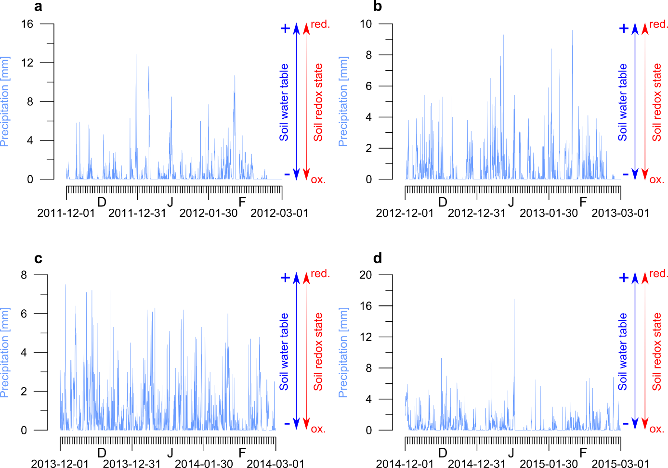
Variations in daily precipitation during austral summer recorded by automatic weather station Arévalo¹². December, January and February (DJF) precipitation data are displayed for the years a 2011/2012, b 2012/2013, c 2013/2014 and d 2014/2015. The rainfall-driven control on soil water-level fluctuations, and thus, the suggested changes in the soil redox state¹³, is indicated.
Fig. S2:
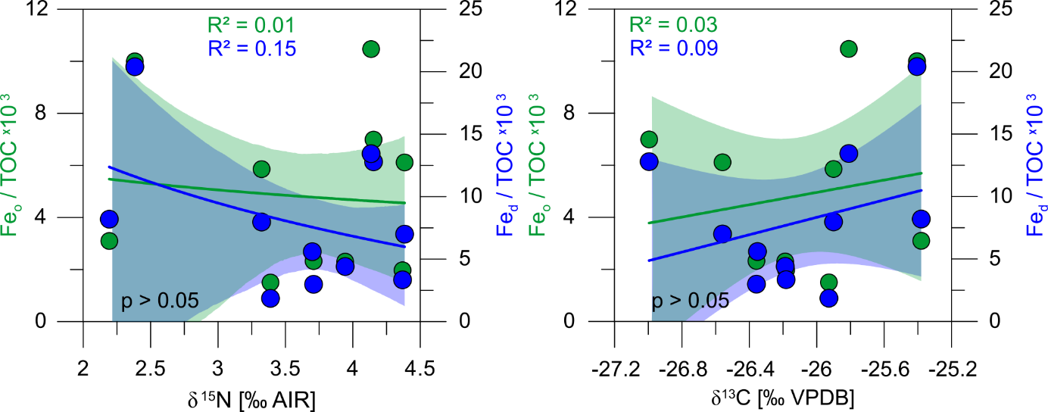
Wet-chemical extractions of iron from topsoils and their relation to organic matter turnover. Fe_{o} and Fe_{d} concentrations plotted versus δ¹³C and δ¹⁵N values indicate the relationships between noncrystalline/total Fe-(hydr)oxide content and organic matter turnover. Subscripts refer to the treatments used for wet-chemical extraction (citrate bicarbonate dithionite – Fe_{d}, ammonium oxalate – Fe_{o}). Shaded fields represent 95% confidence intervals.

Fig. S3:
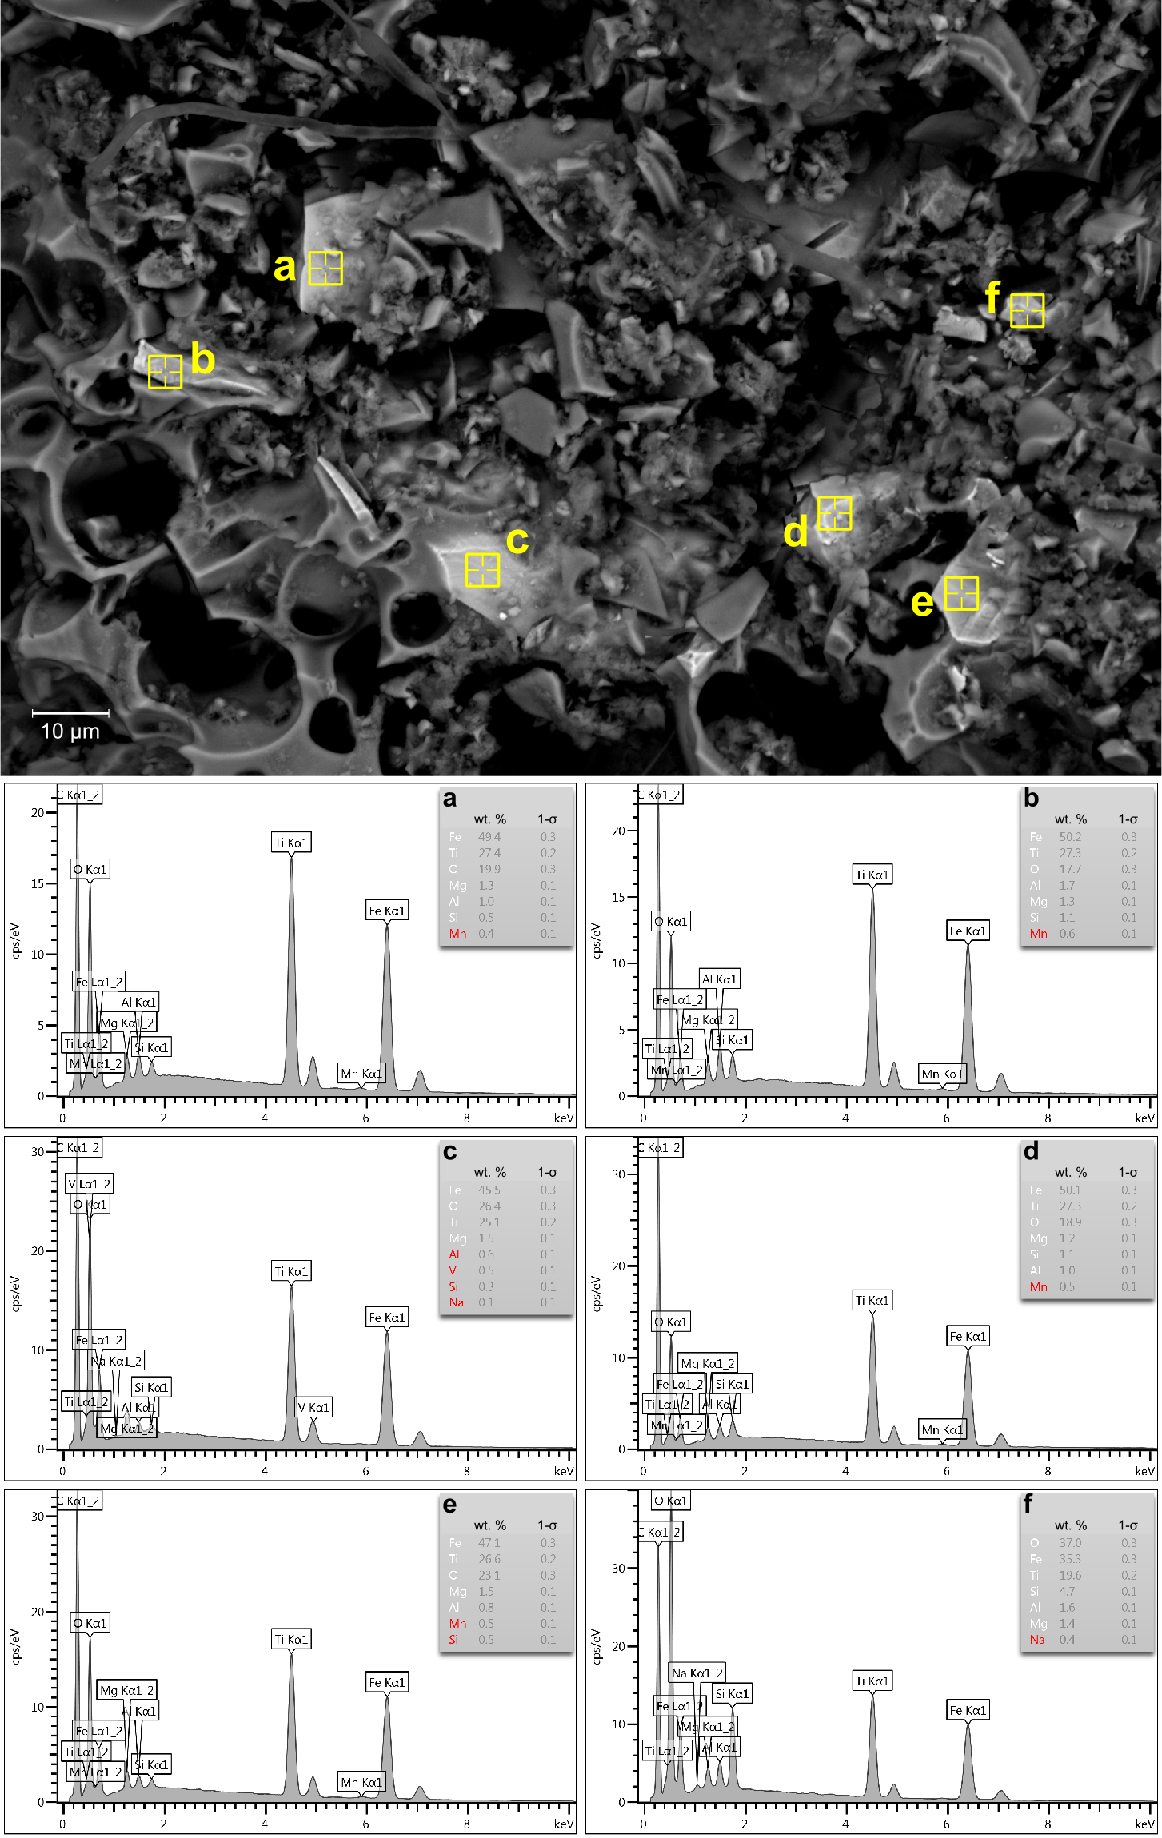
Chemical compositions of titanomagnetite phenocrysts in MB₂ tephra. SEM micrograph showing an excerpt of a pumice particle from an MB₂ tephra layer and SEM-EDS single-point measurements of titanomagnetite phenocrysts (a-f). Yellow markings indicate the localizations of the measurements.

Fig. S4:
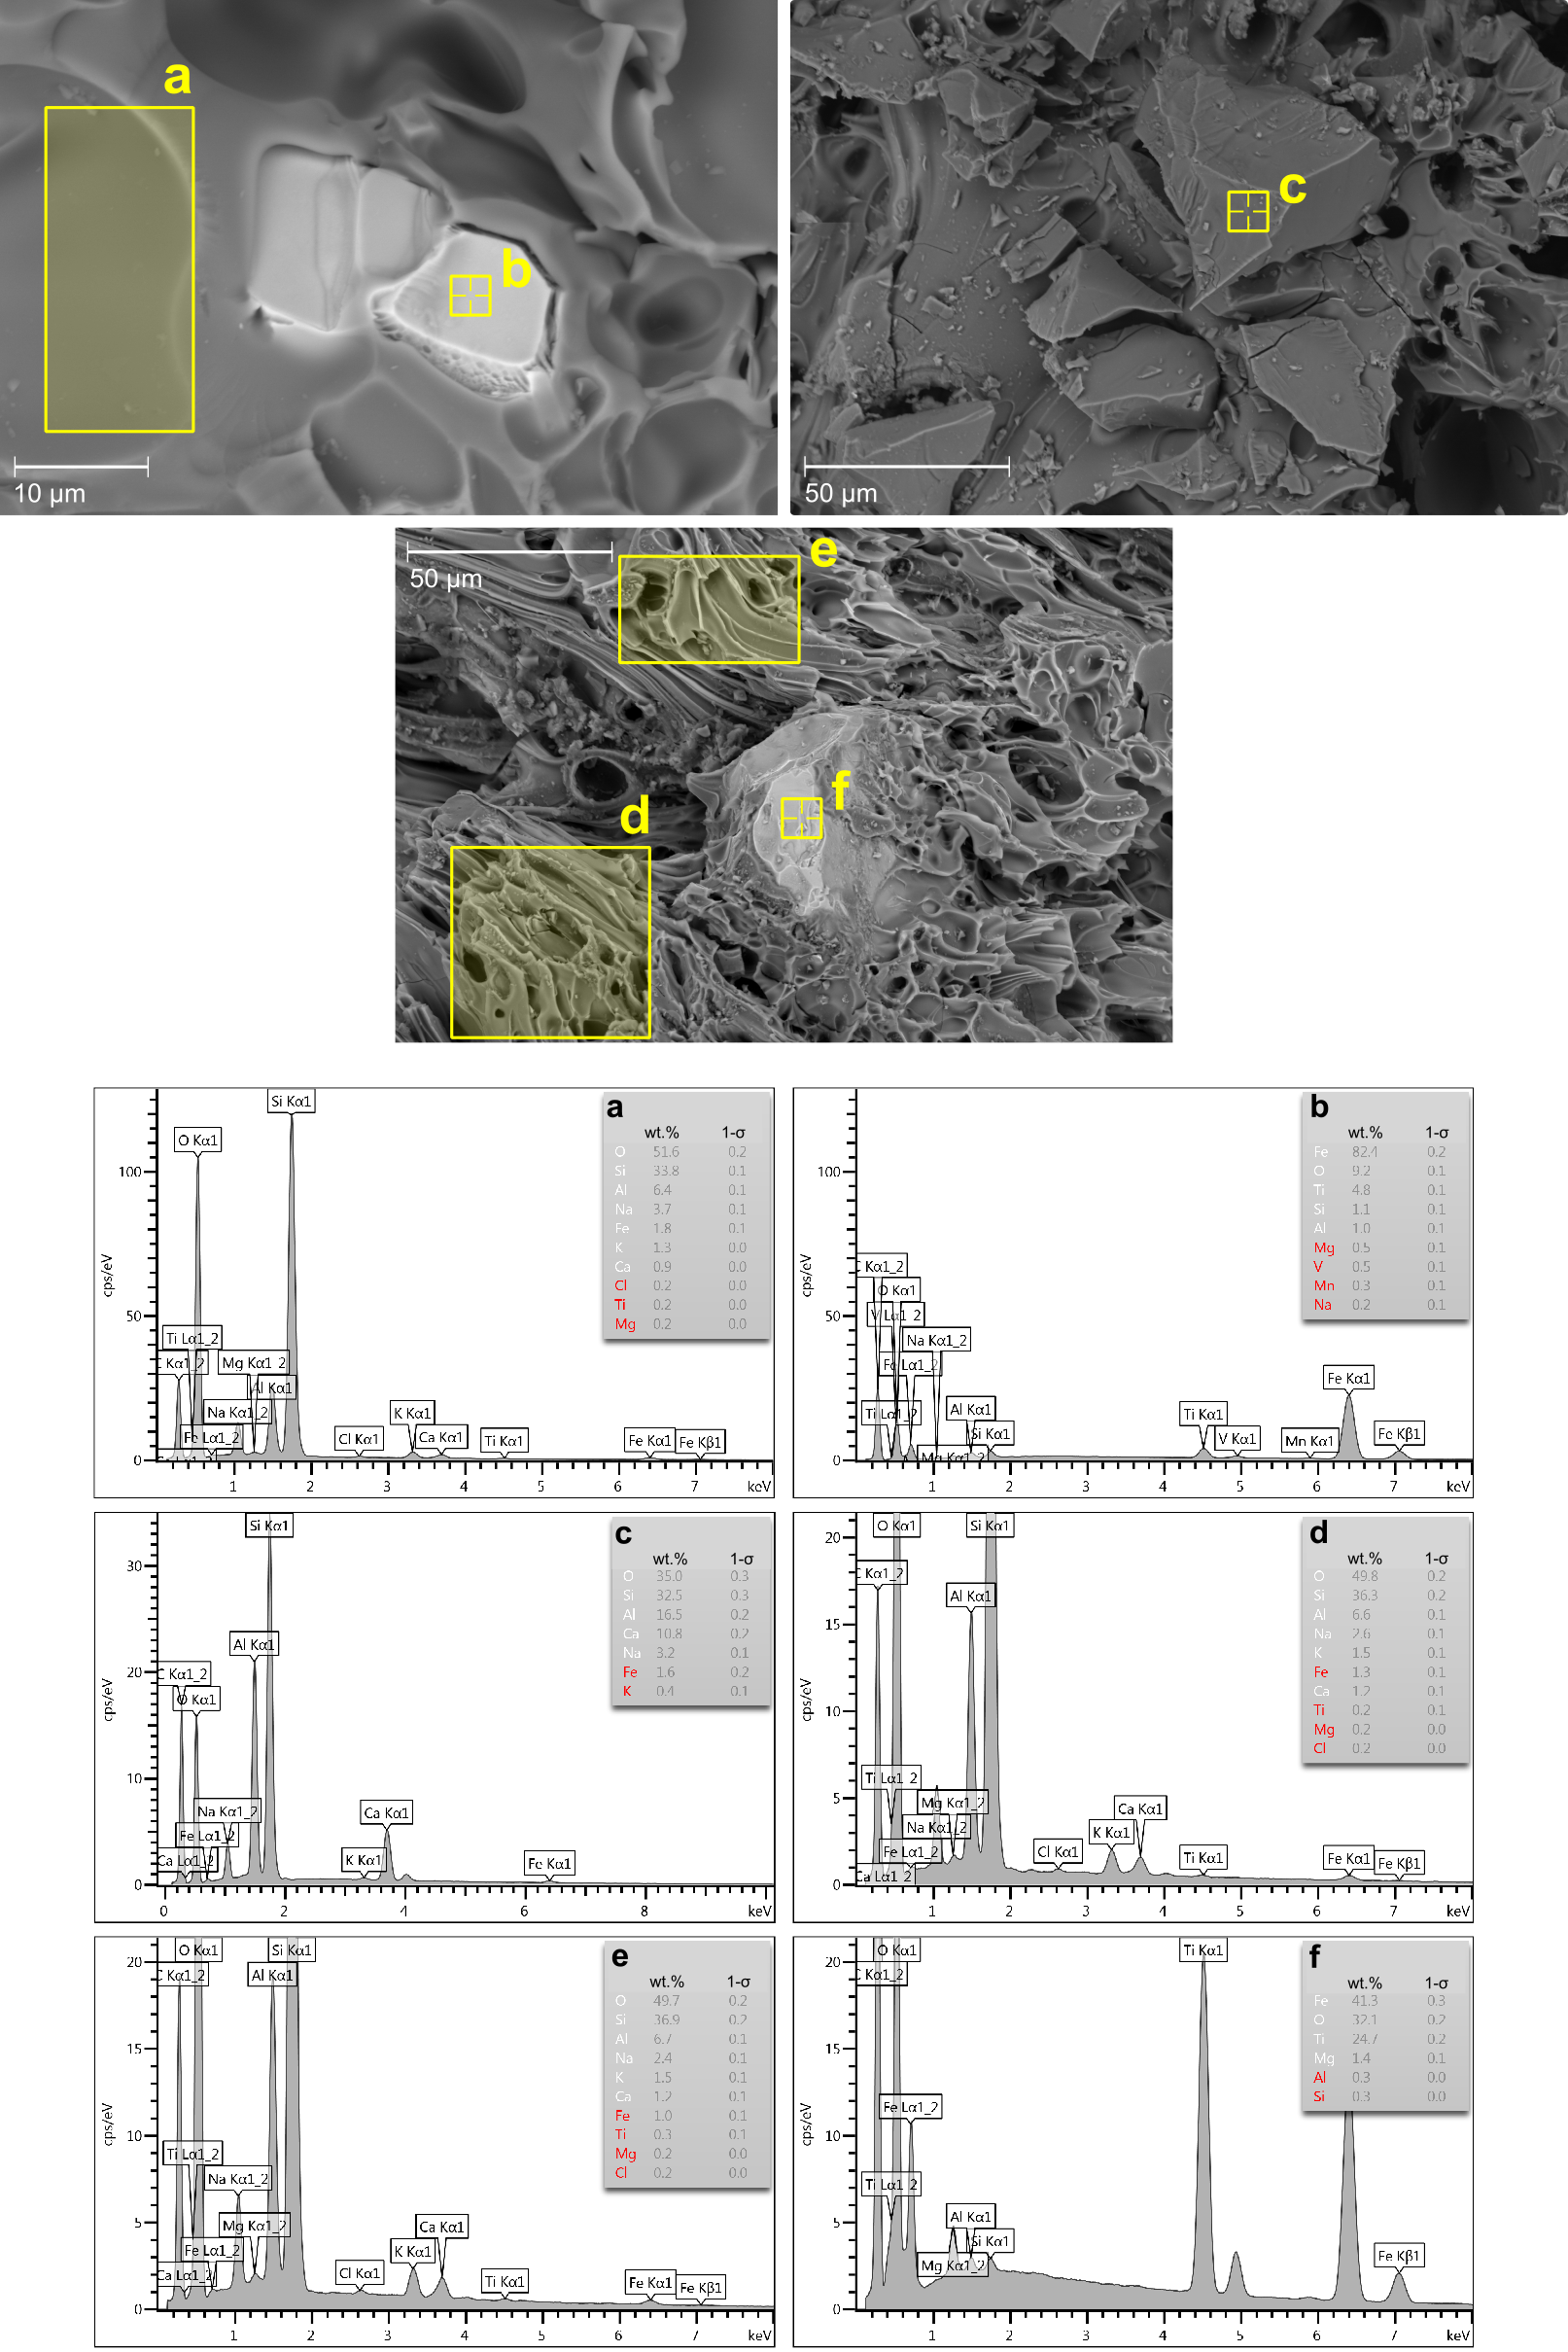
Chemical compositions of MB₂ glass and embedded titanomagnetite phenocrysts. SEM micrographs showing excerpts of pumice particles from an MB₂ tephra layer. The yellow points and areas highlight the localizations of the measurements. SEM-EDS single-point and area measurements on volcanic glass (a,c-e) and titanomagnetite phenocrysts (b,f).

Fig. S5:
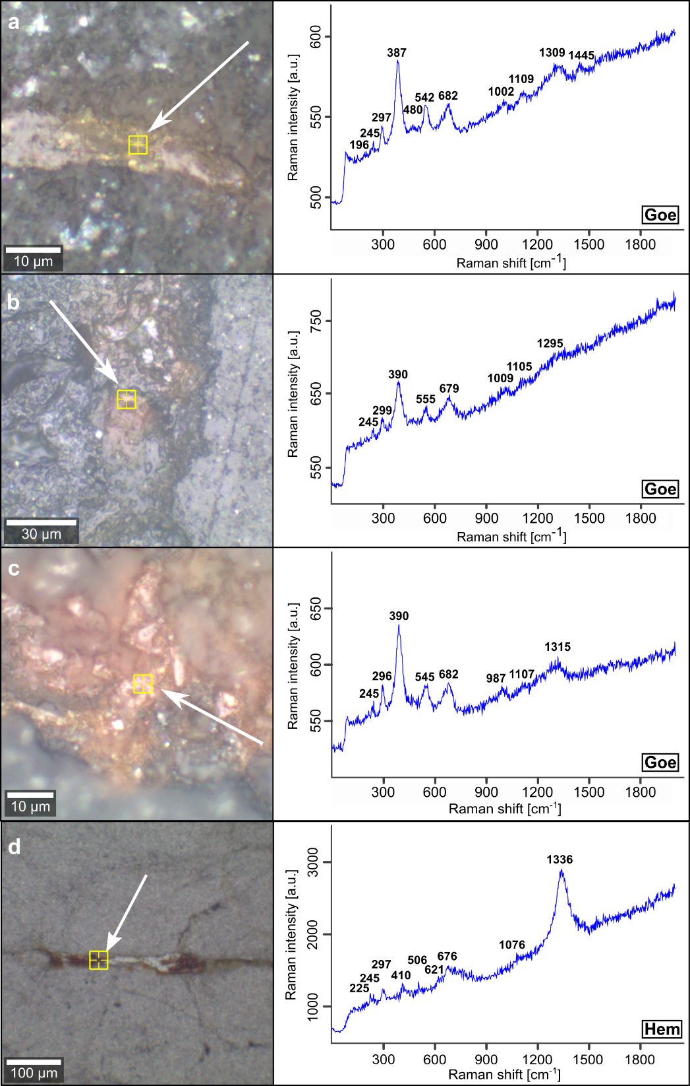
Raman spectra of hematite and goethite deduced from alteration rims of weathered granite. a-d Reflected light microphotographs in combination with Raman spectra of hematite and goethite. Bold numbers represent the wavenumbers of diagnostic Raman bands. Yellow markings indicate the localizations of the respective measurements. Goethite precipitates have been observed in cracks forming single crystals to crusts, depending on crack-width (a-c). Hematite fillings covering an extended crack network (d).

Fig. S6:
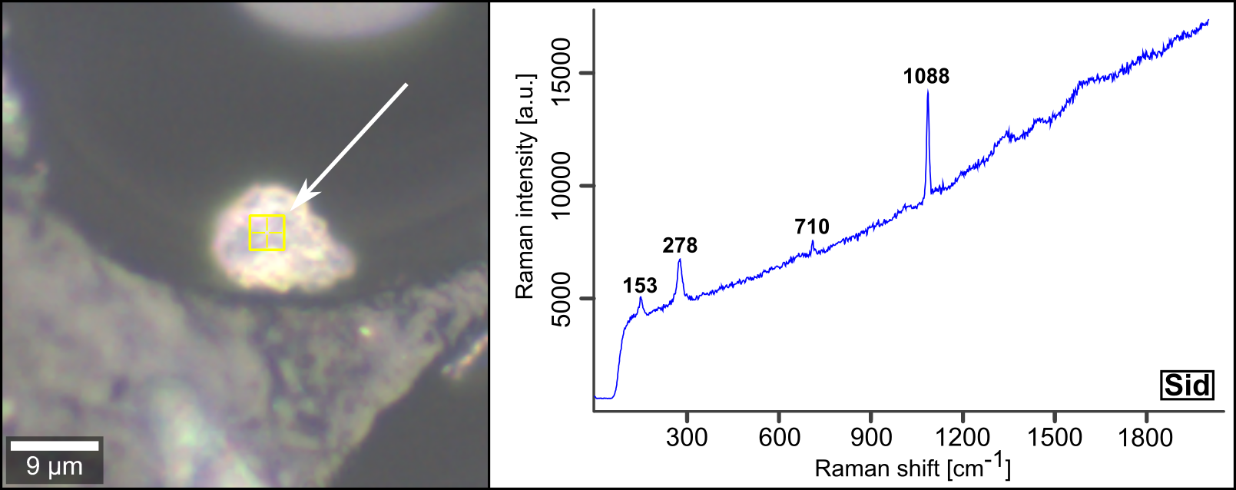
Raman spectra of siderite deduced from micrometer-scale crystals embedded in soil aggregates. Reflected light microphotograph combined with a Raman spectrum of siderite obtained from a crystal situated next to silicate glass. Bold numbers represent the wavenumbers of diagnostic Raman bands. The localizations of the measurement is marked in yellow.

Fig. S7:
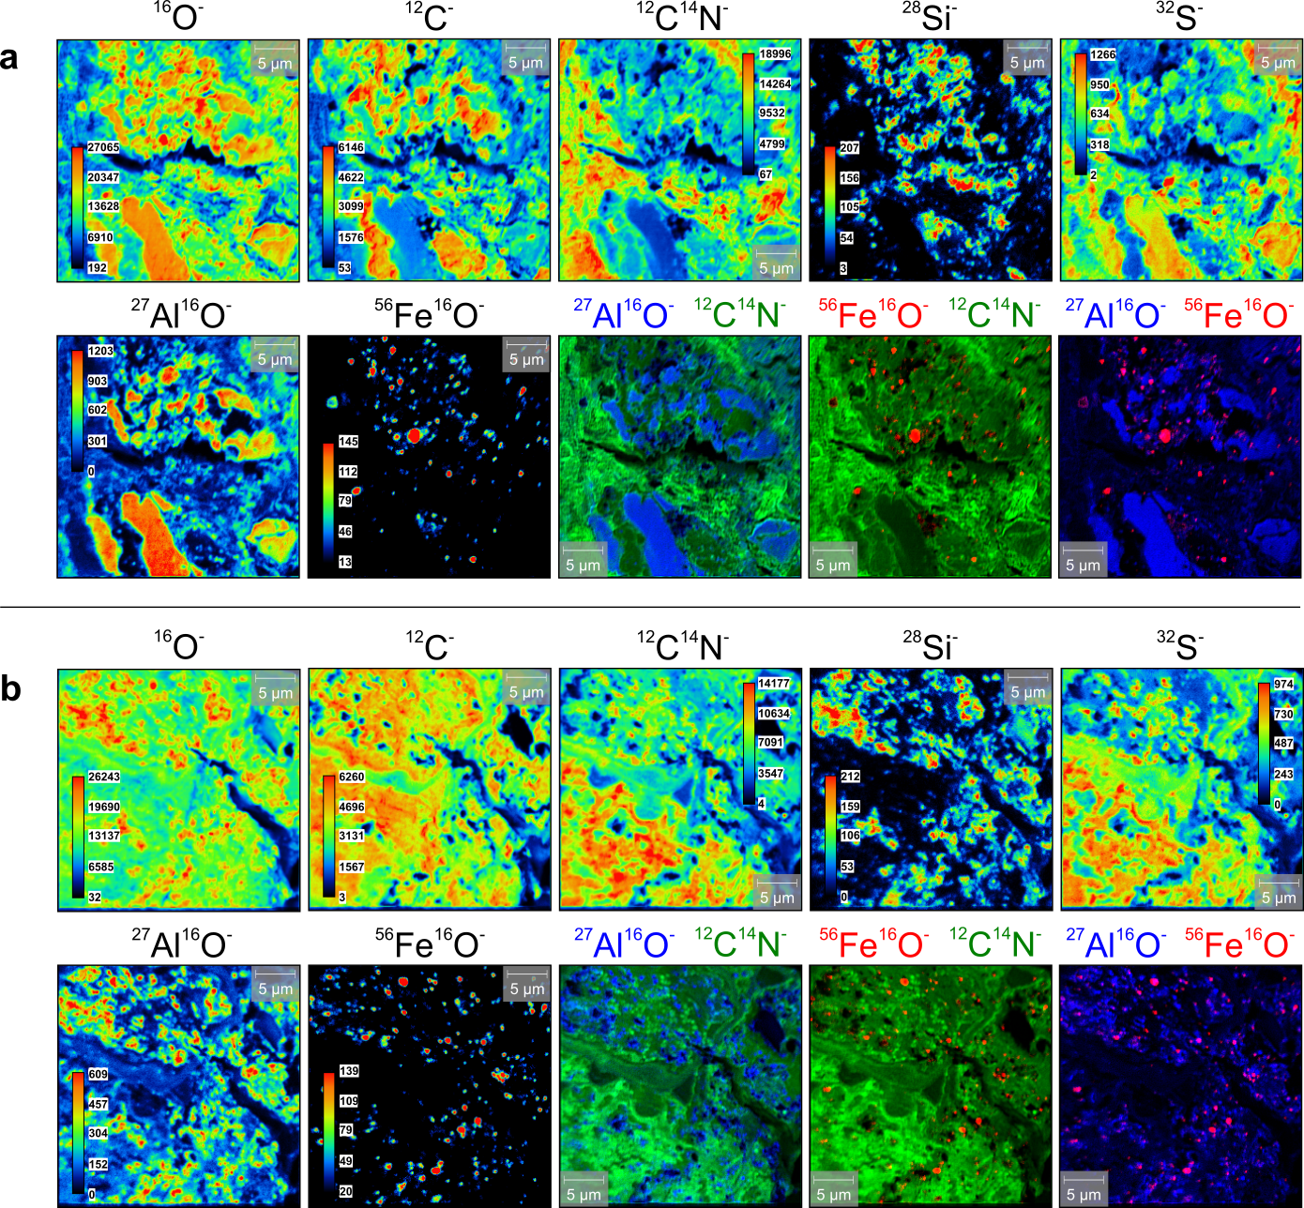
Additional NanoSIMS secondary ion mappings of to micrometer-scale intra-aggregate components. a,b Spatial distribution of ¹⁶O⁻, ¹²C⁻, ¹²C¹⁴N⁻, ²⁸Si⁻, ³²S⁻, ²⁷Al¹⁶O⁻, and ⁵⁶Fe¹⁶O⁻ secondary ions measured on 30 × 30 μm surfaces within the organic-rich matrix of the soil aggregates. In addition, composite images calculated from ¹²C¹⁴N⁻, ²⁷Al¹⁶O⁻ and ⁵⁶Fe¹⁶O⁻ secondary ion data are shown.

Fig. S8:
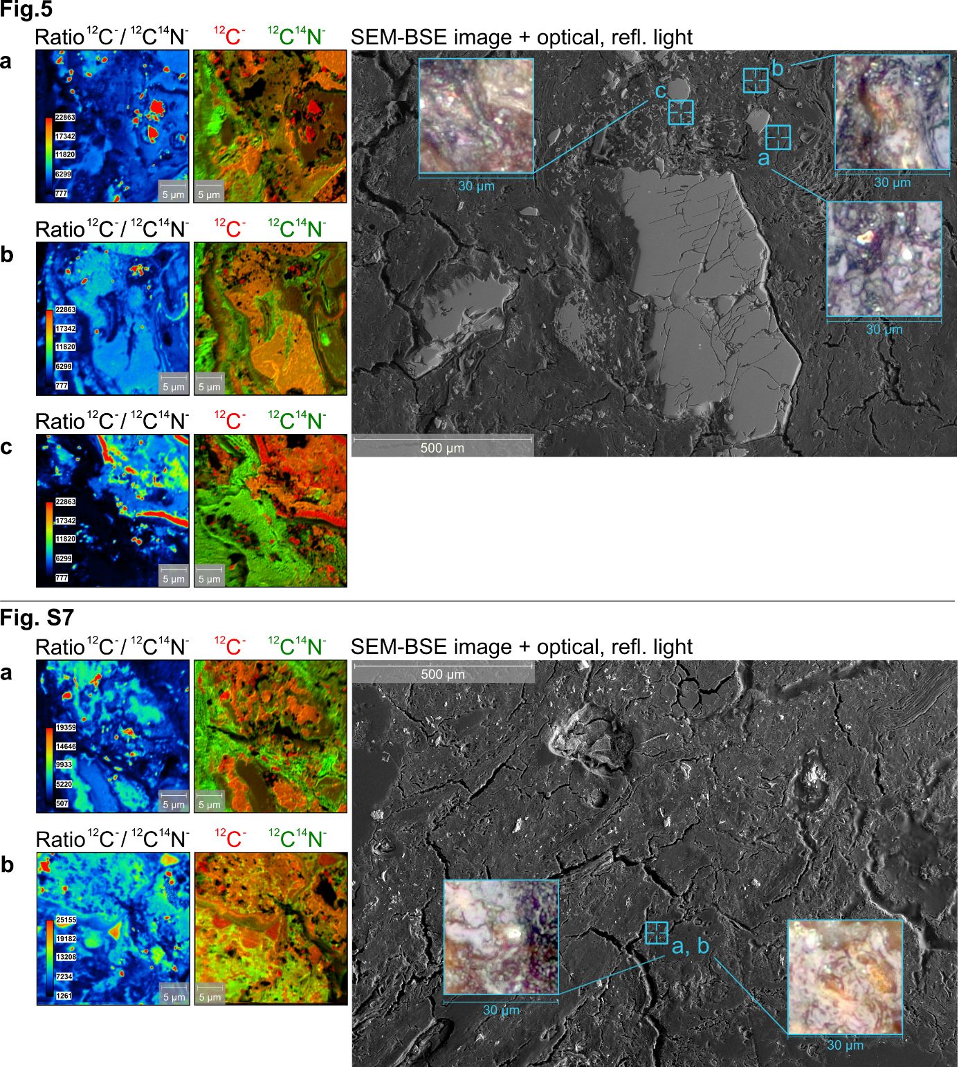
Documentation of NanoSIMS operations of intra-aggregate components shown in Figs. 5 and S7. Reflected light microphotographs inserted in SEM micrographs document the selected localities for NanoSIMS operations. In addition, composite images and mass ratios calculated from¹²C⁻and ¹²C¹⁴N⁻ secondary ion data are shown. Composite images and mass ratios were applied to identify areas with abundant resin used for the preparation process of the samples (Figs. S9 and S10). The indicated panel designations refer to them in Figs. 5 and S7.

Fig. S9:
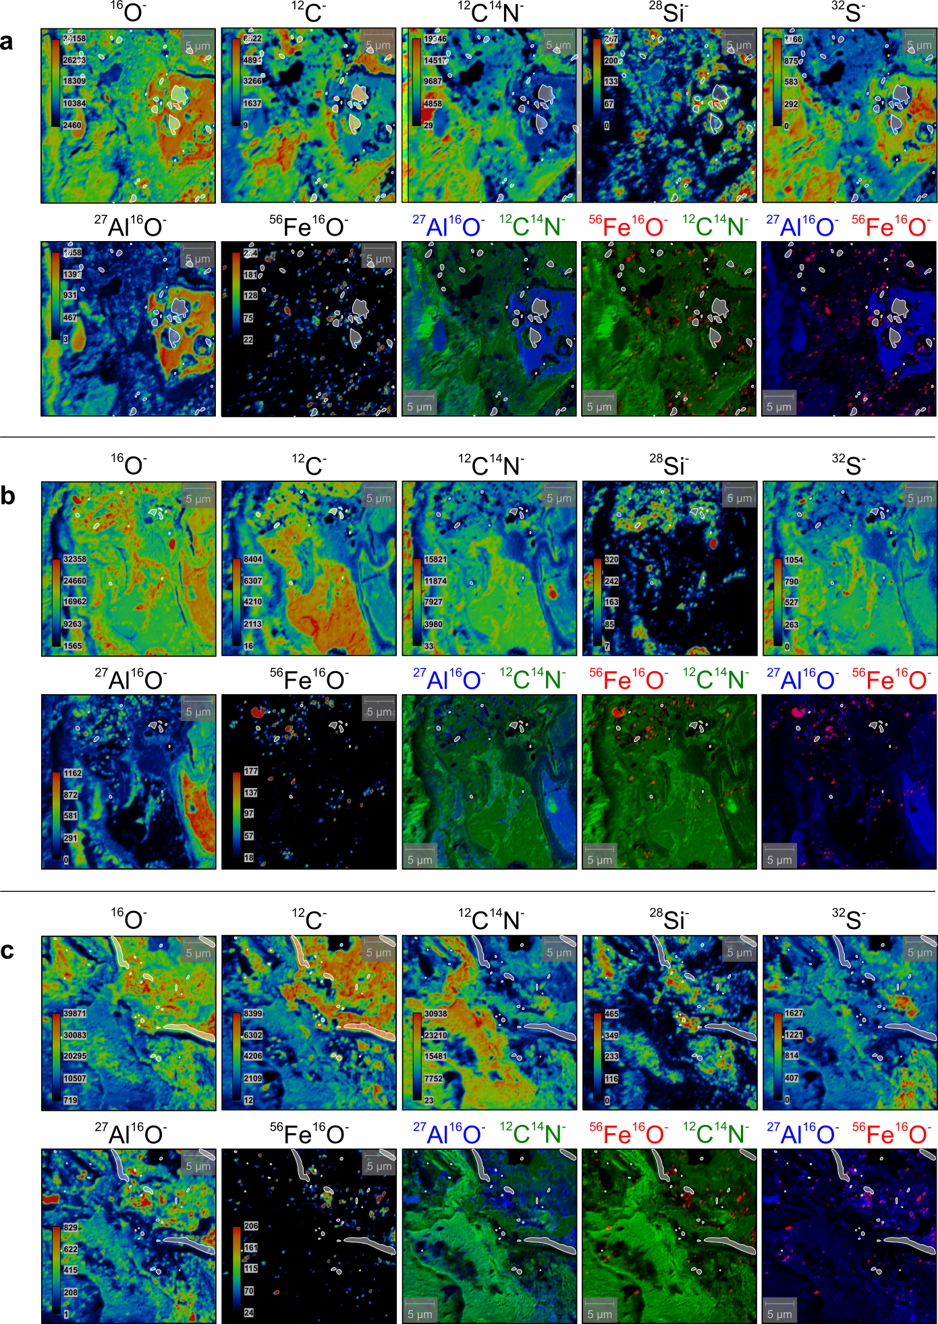
Visualization of the areas containing resin (NanoSIMS secondary ion mappings in Fig. 5) Identified resin is highlighted by white fields on the distribution maps of ¹⁶O⁻, ¹²C⁻, ¹²C¹⁴N⁻, ²⁸Si⁻, ³²S⁻, ²⁷Al¹⁶O⁻, and ⁵⁶Fe¹⁶O⁻ secondary ions and ¹²C¹⁴N⁻, ²⁷Al¹⁶O⁻ and ⁵⁶Fe¹⁶O⁻ composite images. The indicated panel designations refer to them in Fig. 5.
Fig. S10:
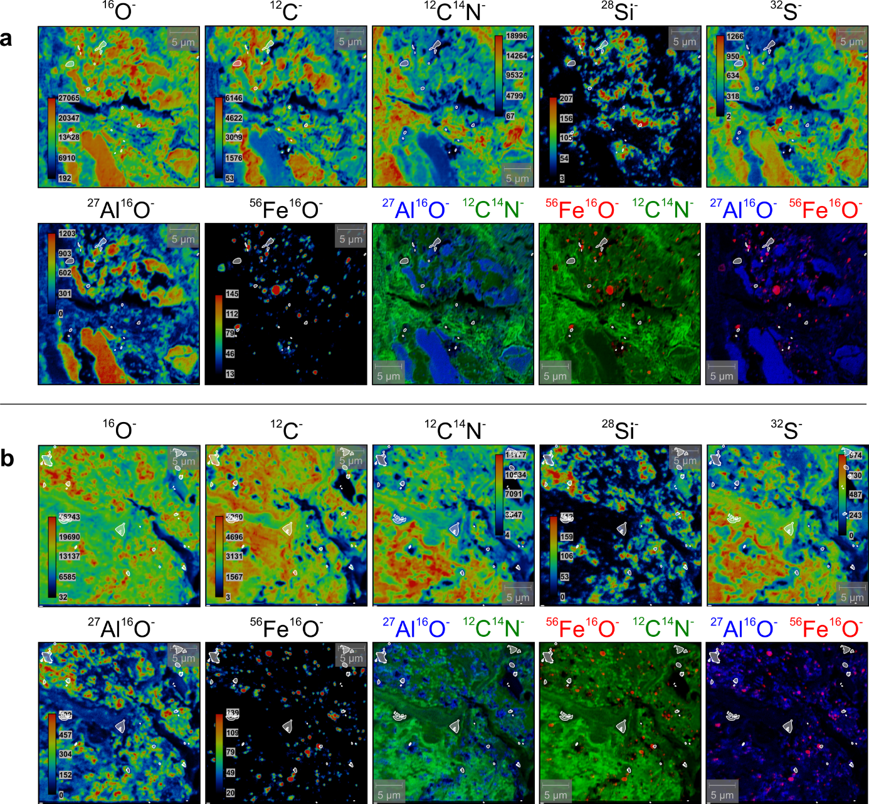
Visualization of the areas containing resin (NanoSIMS secondary ion mappings in Fig. S7) Identified resin is highlighted by white fields on the distribution maps of ¹⁶O⁻, ¹²C⁻, ¹²C¹⁴N⁻, ²⁸Si⁻, ³²S⁻, ²⁷Al¹⁶O⁻, and ⁵⁶Fe¹⁶O⁻ secondary ions and ¹²C¹⁴N⁻, ²⁷Al¹⁶O⁻ and ⁵⁶Fe¹⁶O⁻ composite images. The indicated panel designations refer to them in Fig. S7.

References – Supplementary information
- Hanesch, M. Raman spectroscopy of iron oxides and (oxy)hydroxides at low laser power and possible applications in environmental magnetic studies. Geophys. J. Int. 177, 941-948 (2009).
- de Faria, D. L: A., Venacio Silva, S., de Oliveira, M.T. Raman microspectroscopy of some iron oxides and oxyhydroxides. J. Raman Spectrosc. 28, 873-878 (1997).
- Oh, S. J., Cook, D. C., Townsend, H. E. Characterization of iron oxides commonly formed as corrosion products on steel. Hyperfine Interact. 112, 59-65 (1998).
- Bridges, J. C. et al. Iron oxides in comet 81P/Wild 2. Meteorit. Planet. Sci. 45, 55-72 (2010).
- Das, S. Hendry M. J. Application of Raman spectroscopy to identify iron minerals commonly found in mine wastes. Chem. Geol. 290, 101-108 (2011).
- Thibeau, R. J., Brown, C. W., Heidersbach, R. H. Raman spectra of possible corrosion products of iron. Appl. Spectrosc. 32, 532-535 (1978).
- Legodi, M. A., de Waal, D. Raman spectroscopic study of ancient South African domestic clay pottery. Spetrochim. Acta A. Mol. Biomol. Spectrosc. 66 (1), 135-142 (2007).
- Froment, F., Tournié, A., Colomban, P. Raman identification of natural red to yellow pigments: ochre and iron containing ores. J. Raman Spectrosc. 39´, 560-568 (2008).
- Chourpa, I. et al. Molecular composition of iron oxide nanoparticles, precursors for magnetic drug targeting, as characterized by confocal Raman microspectroscopy. Analyst 130, 1395-1403 (2005).
- Jacintho, G. V. M., Corio, P., Rubim, J. C. Surface-enhanced Raman spectra of magnetic nanoparticles adsorbed on a silver electrode. J. Electroanal. Chem. 603, 27-34 (2007).
- Mazzetti, L., Thistlethwaite, P. J. Raman spectra and thermal transformations of ferrihydrite and schwertmannite. J. Raman Spectrosc. 33 (2), 104-111 (2002).
- Weidemann, S. et al. A 17 year record of meteorological observations across the Gran Campo Nevado Ice Cap in Southernmost Patagonia. Frontiers Earth Sci. 6 (53), 10.3389/feart.2018.00053 (2018).
- Peiffer, S. et al. A biogeochemical-hydrological framework for the role of redox-active compounds in aquatic systems. Nat. Geosci. 14, 264-272 (2021).

