Supplemental Information

Molecular hydrogen promotes wound healing by inducing early extracellular matrix deposition and epidermal stem cell proliferation
Pengxiang Zhao^{1,2,3}, Zheng Dang^{1,2,3}, Mengyu Liu^{1,2,3}, Dazhi Guo⁴, Ruiliu Luo^{1,2,3}, Yao Mawulikplimi Adzavon^{1,2,3}, Mingzi Zhang⁵, Fei Xie^{1,2,3}, Xujuan Zhang^{1,2,3}, Youbin Wang⁵, Shuyi Pan⁴, and Xuemei Ma^{1,2,3}*
Affiliations:
¹ Faculty of Environment and Life Science, Beijing University of Technology, Beijing 100124, P. R. China;
² Beijing molecular hydrogen research center, Beijing 100124, P. R. China;
³ Beijing International Science and Technology Cooperation Base of Antivirus Drug, Beijing 100124, P. R. China;
⁴ Department of Hyperbaric Oxygen, Sixth Medical Center of PLA General Hospital, Beijing 100048, P. R. China;
⁵ Department of Plastic Surgery, Peking Union Medical College Hospital (Dongdan campus), No.1 Shuaifuyuan Wangfujing Dongcheng District, Beijing 100730, P.R. China.
*To whom correspondence should be addressed: xmma@bjut.edu.cn, Telephone number: +8613661188049.

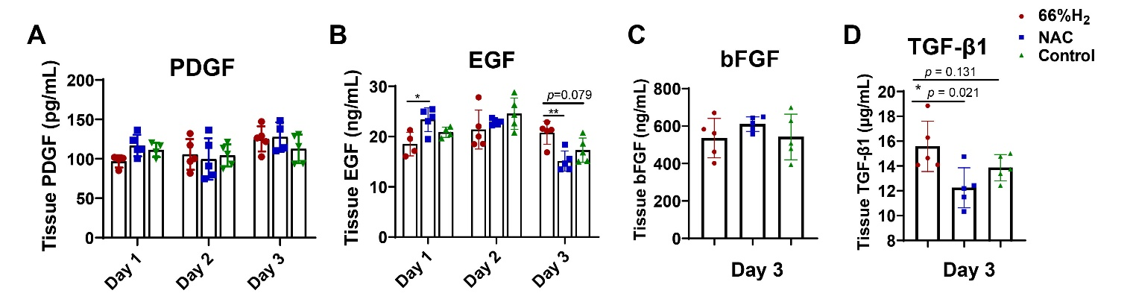
Supplemental Figure 1. H₂ slightly increases growth factors concentration at wound sites at day 1-3 after wounding.
A, B. Profiles of tissue growth factors PDGF and EGF among the three groups at time points of day 1, day 2 and day 3 post-wounding. C, D. Concentrations of tissue growth factors bFGF and TGFβ-1 among all three groups at day 3. Data in A and B processed Two-way ANOVA test, and data in C and D processed unpaired t test. All data were plotted as Mean±SEM. * P-value < 0.05; ** P-value <0.01; *** P-value < 0.001; no stars for P-value > 0.05

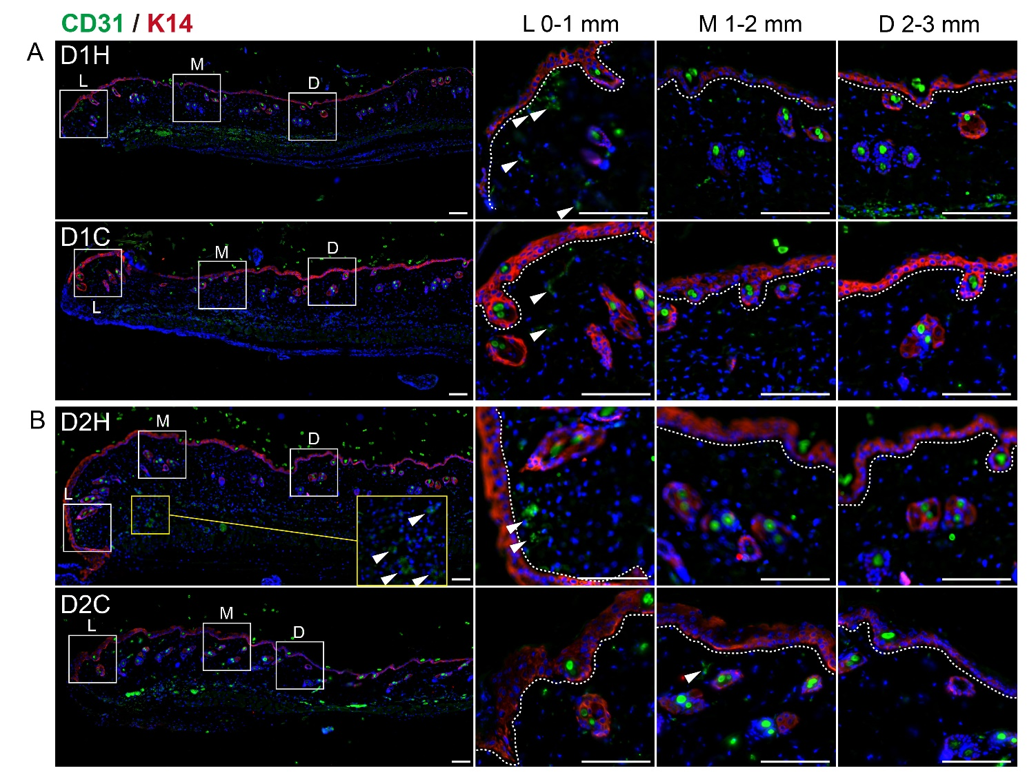
Supplemental Figure 2. Whole-mount scanning showing H₂ promoted early tube formation at the first 2 days after wounding.
A and B. Panoramic scanning of wound edge and the representative immunoﬂuorescence images of CD31 (green) and k14 (red) expression in the leading edge (L, 0-1 mm from wound edge), mid-end (M, 1-2 mm from wound edge) and distal (D, 2-3 mm from wound edge) of the wound at day 1 and day 2 post wounding respectively. White dotted line indicates the boundary between the epithelium and dermis. White arrowhead indicates Scale bar = 100 μM.

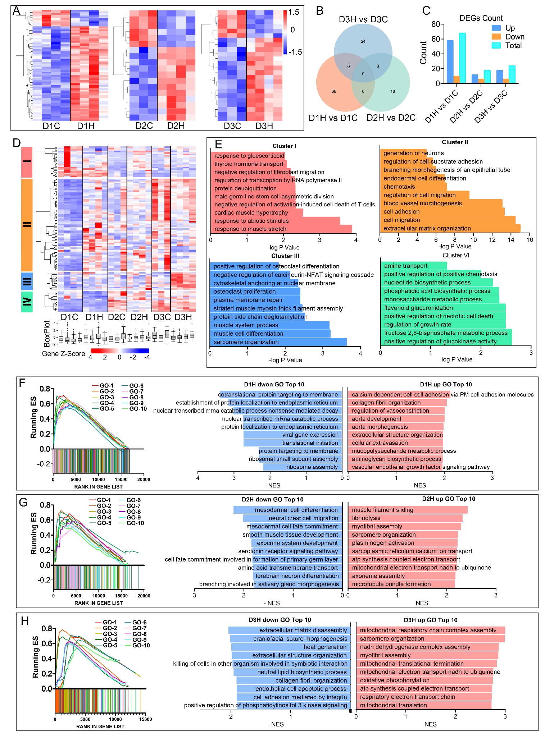
Supplemental Figure 3. Comprehensive gene set function enrichment analysis of differential gene expression induced by 66% H₂ treatment at the first 3 days post wounding
A. Heat map showing the differentially expressed genes (DEGs) among the three time points (D1H vs D1C, D2H vs D2C, D3H vs D3C). B. Venn diagrams showing the overlapping number of DEGs among the comparative data of three time points. C. Counting of total, up- and down-regulated DEGs among the comparative data of three time points. D. Heat map showing four clusters identified from all the DEGs. E. GO-BP analysis in each individual cluster, the GO terms for genes related with extracellular matrix organization and muscle cell differentiation were significantly enriched in D1H and D3H, separately. F. Top 10 enriched up and down GO-BP in D1H by GSEA. G. Top 10 enriched up and down GO-BP in D2H by GSEA. H. Top 10 enriched up and down GO-BP in D1H by GSEA.
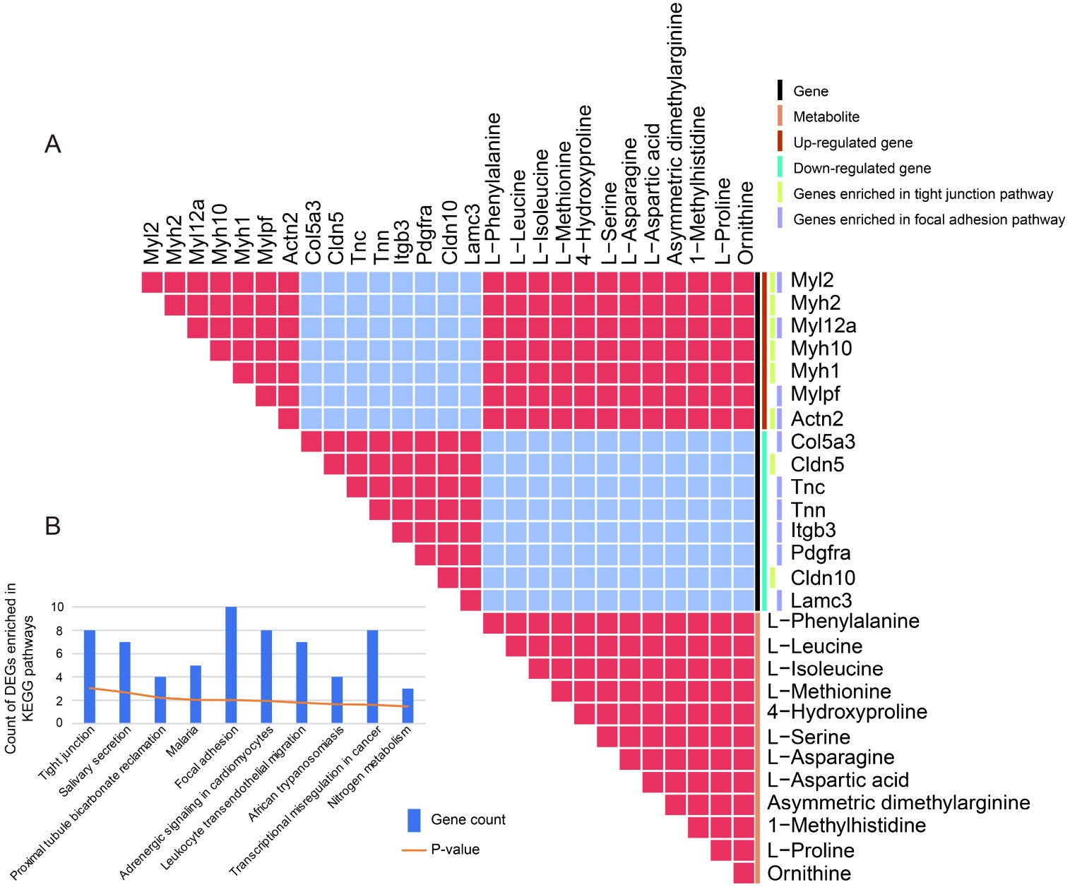
Supplemental Figure 4. Transcriptomics and metabolomics correlation analysis reveal that differential genes and metabolites of the D3H group are enriched in tight junction and focal adhesion pathways.
A. Correlation plot of DEGs and differential metabolites between D3H and D3C. B. Count of D3H vs D3C DEGs enriched in KEGG pathways.

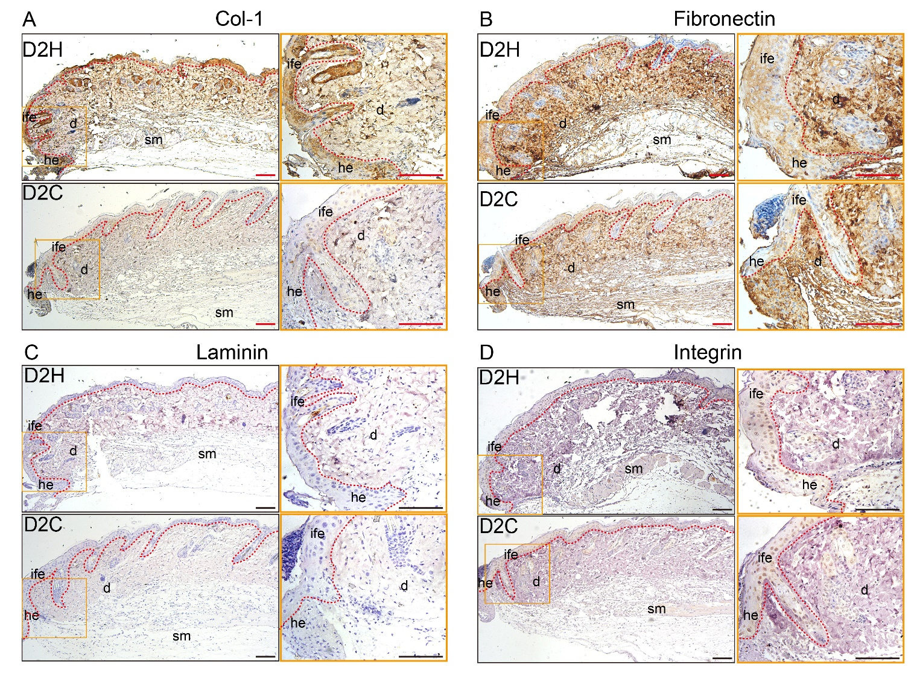
Supplemental Figure 5. ECM components col-I, fibronectin, laminin, and integrin deposition 2 days after wounding are increased in the H₂ group especially in the proximal wound edge.
IHC staining showing the difference between D2H and D2C in ECM deposit of day 2 post wounding. A-D indicated Col-1, fibronectin, laminin and integrin expression in D2H and D2H, separately. Scale bar = 100 μm.

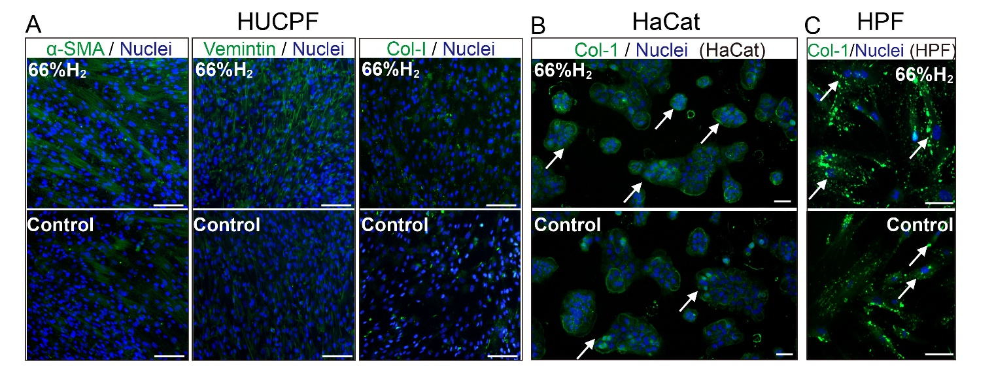
Supplemental Figure 6. H₂ conditioned medium promotes collagen deposition in vitro in fibroblasts and keratinocytes
A. α-SMA, Vimintin, and Col-1 expression in the HUCPF (fibroblast) between 66% H₂ and control groups 24 h after treatment. B and C. Col-1 deposit in the HaCat (keratinocyte) and HPF (fibroblast) cells between 66% H₂ and control groups 24 h after treatment.

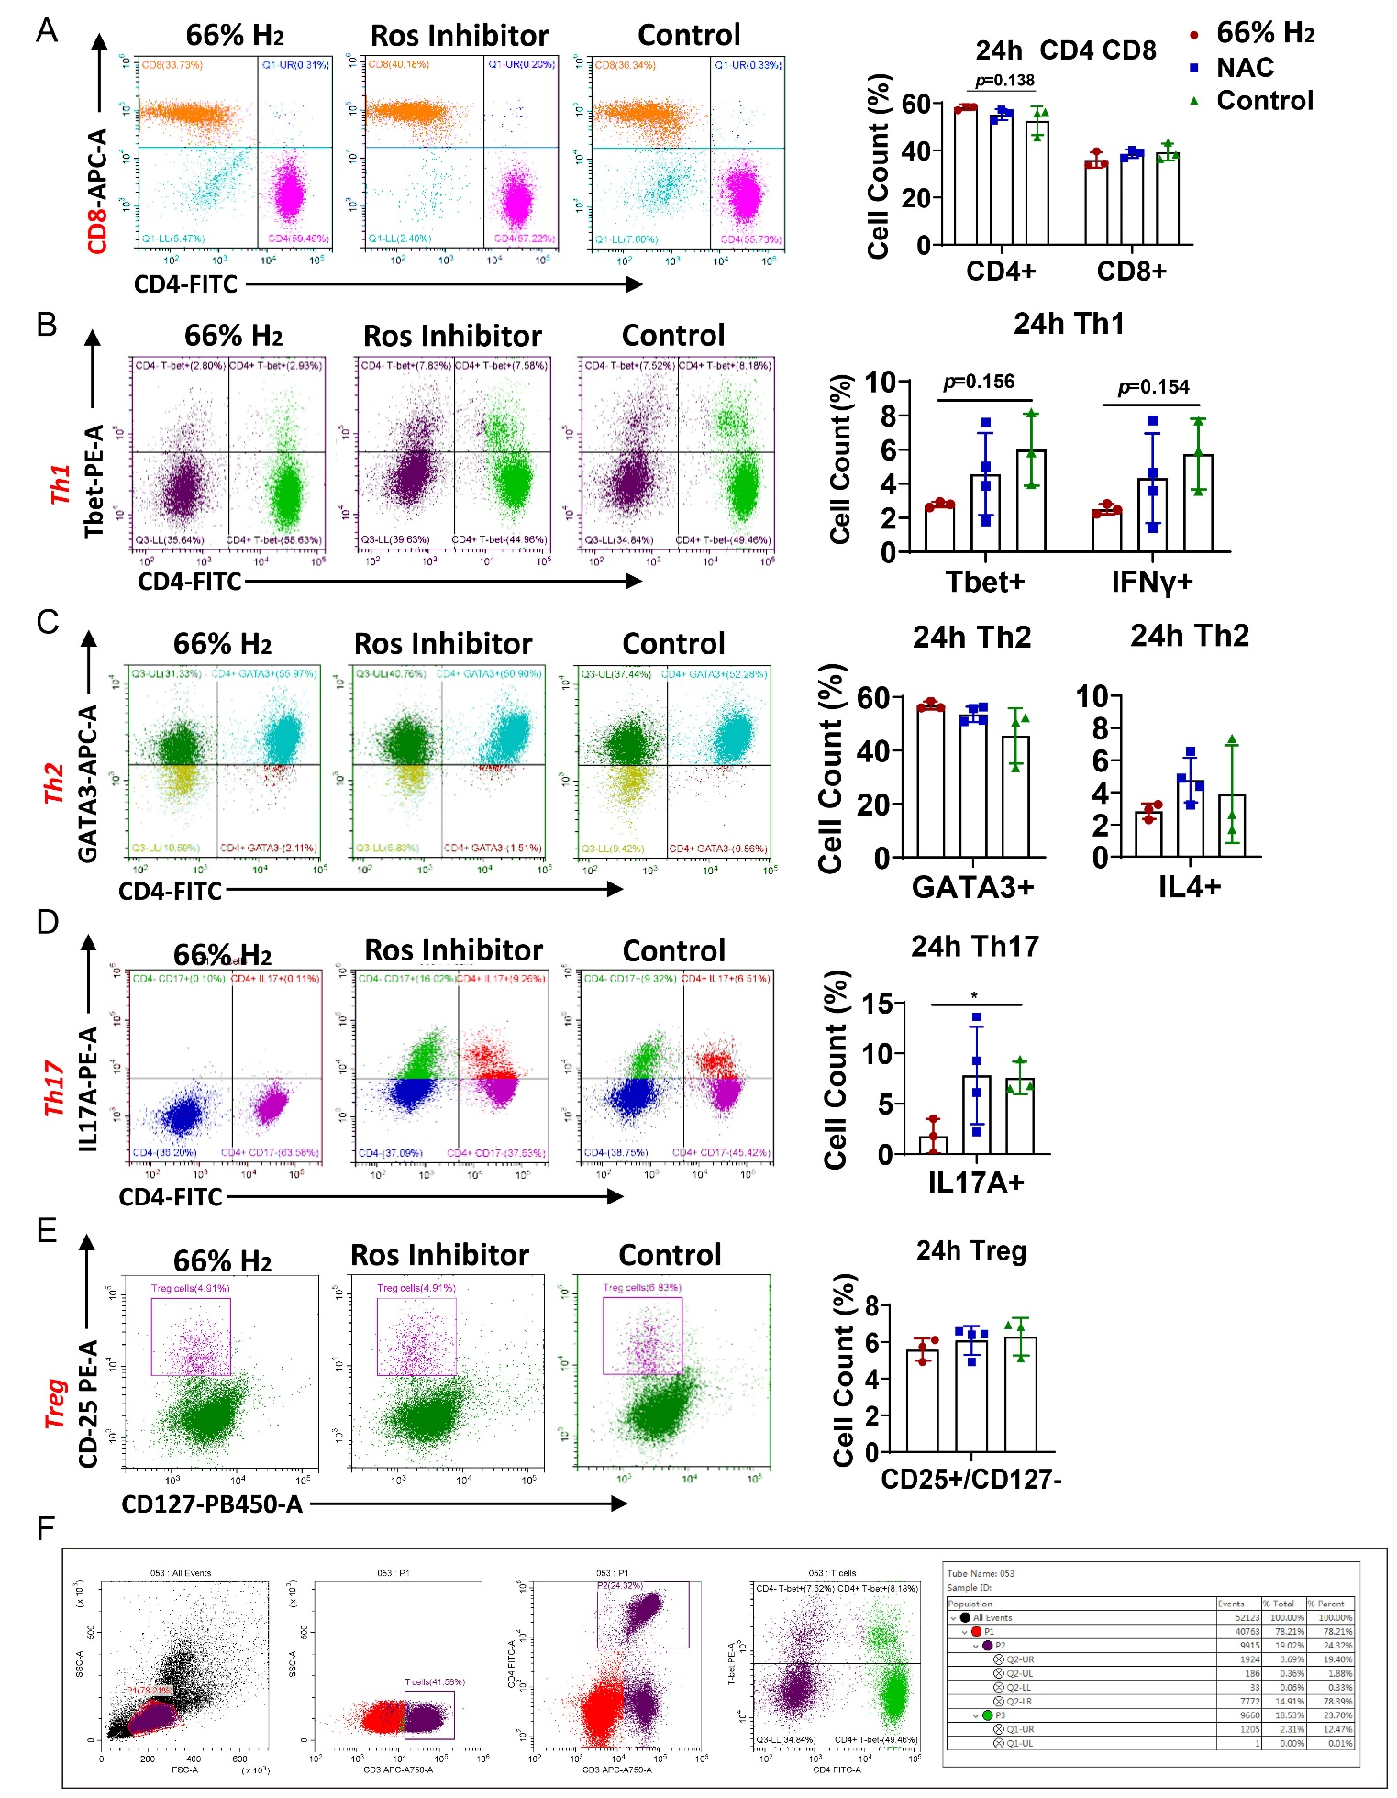

Supplemental Figure 7. Four-color Flow CytoMetry (FCM) of different targets showing quantification of CD3⁺, CD4⁺, and CD8⁺ T cells, as well as of Th₁, Th₂, Th₁₇ and Treg subgroups.
A. FCM quantification of CD4⁺ and CD8⁺ cell distribution in all three groups. B. T-bet⁺/CD4⁺ T-cell distribution, double checked against IFN-γ⁺/CD4⁺ T-cell distribution. C. GATA3⁺/CD4⁺ T-cell distribution, double-checked against IL-4⁺/CD4⁺ T-cell distribution. D. IL-17A⁺/CD4⁺ T-cell distribution. E. CD25^{high}/CD127^{low} T-cell distribution. F. Example figures of gating strategy used in cytometry flow test, and the first four plots showed procedure of gating strategy from one of the typical samples in Th₁ subgroup cells analysis, the form showed the cell abundance during the gating strategy. Data in A-C processed Two-way ANOVA test, and data in D and E processed unpaired t test. All data were plotted as Mean±SEM. * P-value < 0.05; ** P-value <0.01; *** P-value < 0.001; no stars for P-value > 0.05.

Table. S1. List of primary and secondary antibodies used in experiments. IHC indicates immunochemistry, IF indicates immunofluorescence; FC indicates flow cytometry.
A. Primary antibody list
Antigen | Host Species | Type | Conjugates | Dillution | Supplier | Reference
CD31 | Rabbit IgG | polyclonal | unconjugated | 1:50-IF | Abcam | ab28364
VEGFA | Rabbit IgG | monoclonal | unconjugated | 1:500-IF | Abcam | ab52917
CD34 | Rabbit IgG | monoclonal | unconjugated | 1:200-IF | Abcam | ab81289
Cytokeratin 14 | Rabbit IgG | monoclonal | unconjugated | 1:1000-IF | Abcam | ab181595
a-SMA | Rabbit IgG | monoclonal | unconjugated | 1:500-IF | Abcam | ab32575
Collagen I | Rabbit IgG | polyclonal | unconjugated | 1:500-IF,  1:200-IHC | Abcam | Ab254113
Collagen III | Rabbit IgG | polyclonal | unconjugated | 1:1000 IHC | proteintech | 22734-1-AP
Ki67 | Rabbit IgG | polyclonal | unconjugated | 1:500-IF,  1:200-IHC | Abcam | ab15580
Cytokeratin 15 | Rabbit IgG | polyclonal | unconjugated | 1:100-IHC | Biodragon | BD-PT1263
P63 | Rabbit IgG | polyclonal | unconjugated | 1:100-IHC | Biodragon | BD-PT3547
Lgr6 | Rabbit IgG | monoclonal | unconjugated | 1:100-IHC | Abcam | ab126747
Fibronectin | Rabbit IgG | polyclonal | unconjugated | 1:200-IHC | Abcam | ab2413
Laminin beta 1 | Rabbit IgG | polyclonal | unconjugated | 1:100-IHC | proteintech | 23498-1-AP
Integrin-β1 | Rabbit IgG | polyclonal | unconjugated | 1:200-IHC | proteintech | 12594-1-AP
Collagen XVII | Rabbit IgG | monoclonal | unconjugated | 1:100-IHC | proteintech | ab184996
CD16/32  (For Blocking) | Rat | monoclonal | unconjugated | 1:50-FC | Biolegend | 101319
CD3 | Rat IgG2b,κ | monoclonal | APC/Cyanine7 | 1:80-FC | Biolegend | 100222
CD4 | Rat IgG2a,κ | monoclonal | Alexa Fluor® 488 | 1:900-FC | Biolegend | 100529
CD8a | Rat IgG2a,κ | monoclonal | Alexa Fluor® 647 | 1:250-FC | Biolegend | 100724
T-bet | Mouse IgG1, κ | monoclonal | PE | 1:20-FC | Biolegend | 644810
IFN-γ | Rat IgG1, κ | monoclonal | Alexa Fluor® 647 | 1:200-FC | Biolegend | 505814
GATA3 | Mouse IgG2b, κ | monoclonal | Alexa Fluor® 647 | 1:25-FC | Biolegend | 653810
IL-4 | Rat IgG1, κ | monoclonal | PE | 1:80-FC | Biolegend | 504104
IL-17A | Rat IgG1, κ | monoclonal | PE | 1:80-FC | Biolegend | 506904
CD25 | Rat IgG2b,κ | monoclonal | PE | 1:20-FC | Biolegend | 101904
CD127 | Rat IgG2a,κ | monoclonal | Brilliant Violet 421™ | 1:20-FC | Biolegend | 135024

B. Secondary antibody list
Antigen | Host Species | Type | Conjugates | Dillution | Supplier | Reference
Rabbit IgG(H+L) , | Goat | F(ab')2  Fragment | Alexa Fluor ® 488 | 1:1000-IF | Cell Signaling | #4412
Rat IgG | Goat | Polyclonal | Alexa Fluor® 594) | 1:1000-IF | Abcam | ab150160
Mouse and Rabbit IgG | Goat | Polyclonal | HRP | 1:1-IHC | ZSGB-BIO | PV-9000

Table S2. Gradient conditions for reversed phase C18 separation

Time (min) | A (v%) | B (v%)
0 | 100 | 0
2 | 70 | 30
9 | 30 | 70
11 | 5 | 95
12 | 0 | 100
14 | 0 | 100
14.1 | 100 | 0
16 | 100 | 0

Table S3. Gradient conditions for HILIC separation of polar metabolites

Time (min) | A (v%) | B (v%)
0 | 95 | 5
1 | 95 | 5
7 | 50 | 50
12 | 50 | 50
12.1 | 95 | 5

Table S10. Top 20 significant pathways discovered by nontargeted metabolomic analysis between the D3H and D3C groups

Pathway Name | -log(p) | Impact
Aminoacyl-tRNA biosynthesis | 22.02 | 0.11268
Cyanoamino acid metabolism | 9.8804 | 0
Arginine and proline metabolism | 7.8377 | 0.30285
Nitrogen metabolism | 7.1529 | 0.0083
Cysteine and methionine metabolism | 6.0914 | 0.05003
Alanine, aspartate, and glutamate metabolism | 5.1297 | 0.31054
Valine, leucine, and isoleucine biosynthesis | 4.8976 | 0.0265
Valine, leucine, and isoleucine degradation | 4.1352 | 0.02232
Histidine metabolism | 3.9533 | 0.0056
Glycine, serine, and threonine metabolism | 3.7884 | 0.13604
D-arginine and D-ornithine metabolism | 3.2378 | 0
Sulfur metabolism | 2.4496 | 0
Sphingolipid metabolism | 2.137 | 0
Pantothenate and CoA biosynthesis | 2.0645 | 0
Phenylalanine, tyrosine, and tryptophan biosynthesis | 2.0645 | 0.00062
beta-alanine metabolism | 2.0304 | 0
Lysine biosynthesis | 1.9059 | 0
Methane metabolism | 1.8498 | 0.01751
Glutathione metabolism | 1.7476 | 0
Nicotinate and nicotinamide metabolism | 1.6144 | 0

Legends for Movies S1&S2

Movie S1. Live cell imaging of HPF cells under H₂ medium condition within 24 h. HPF cells stained by actin-GFP images were taken every one hour, and 0, 4, 8, 12, 16, 20 and 24 h images were collected to build the video. Bar indicates 1000 μ.
Movie S2. Live cell imaging of HPF cells under normal condition within 24 h. HPF cells stained by actin-GFP images were taken every one hour, and 0, 4, 8, 12, 16, 20 and 24 h images were collected to build the video. Bar indicates 1000 μM.

