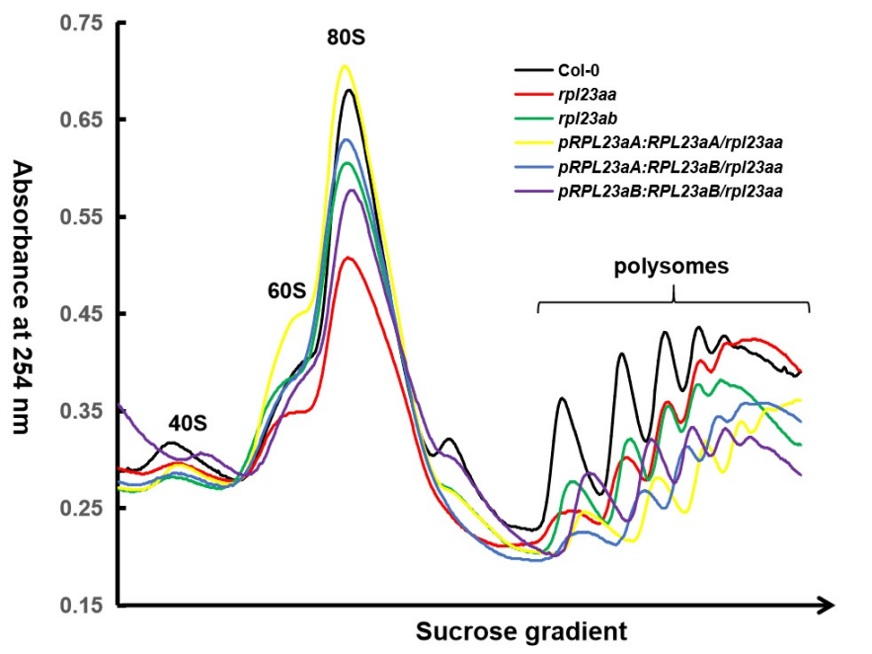
Figure S7. Polysome profiles of Col-0 (black), rpl23aa (red), rpl23ab (green), pRPL23aA:RPL23aA/rpl23aa (yellow), pRPL23aA:RPL23aB/rpl23aa (blue), and pRPL23aB:RPL23aB/rpl23aa (purple). Polysomes were extracted from 14-day-old seedlings. The absorbance peaks at 254 nm representing the 40S small subunits, 60S large subunits, 80S monosomes, and polysomes are labeled above the peaks.

