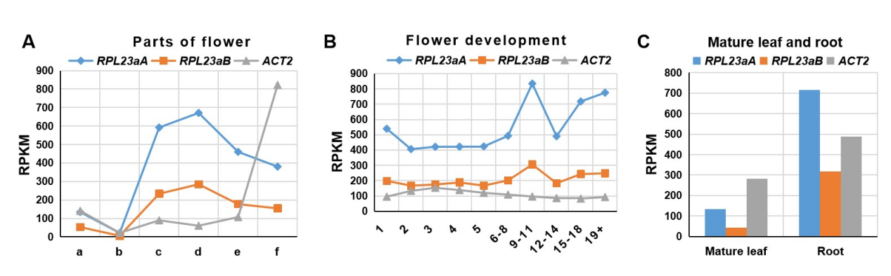
Figure S6. Transcript profiles of RPL23aA and RPL23aB in different organs. Y axis: the average RPKM (Reads Per Kilobase per Million mapped reads) value of two biological replicates. (A) parts of flower. (B) different flowers in the inflorescence, with the first flower at the moment of anthesis. a, sepals; b, anthers; c, carpels; d, ovules from carpels; e, stigmatic tissue; f, stamen filaments of mature flowers. (C) mature leaf and root.

