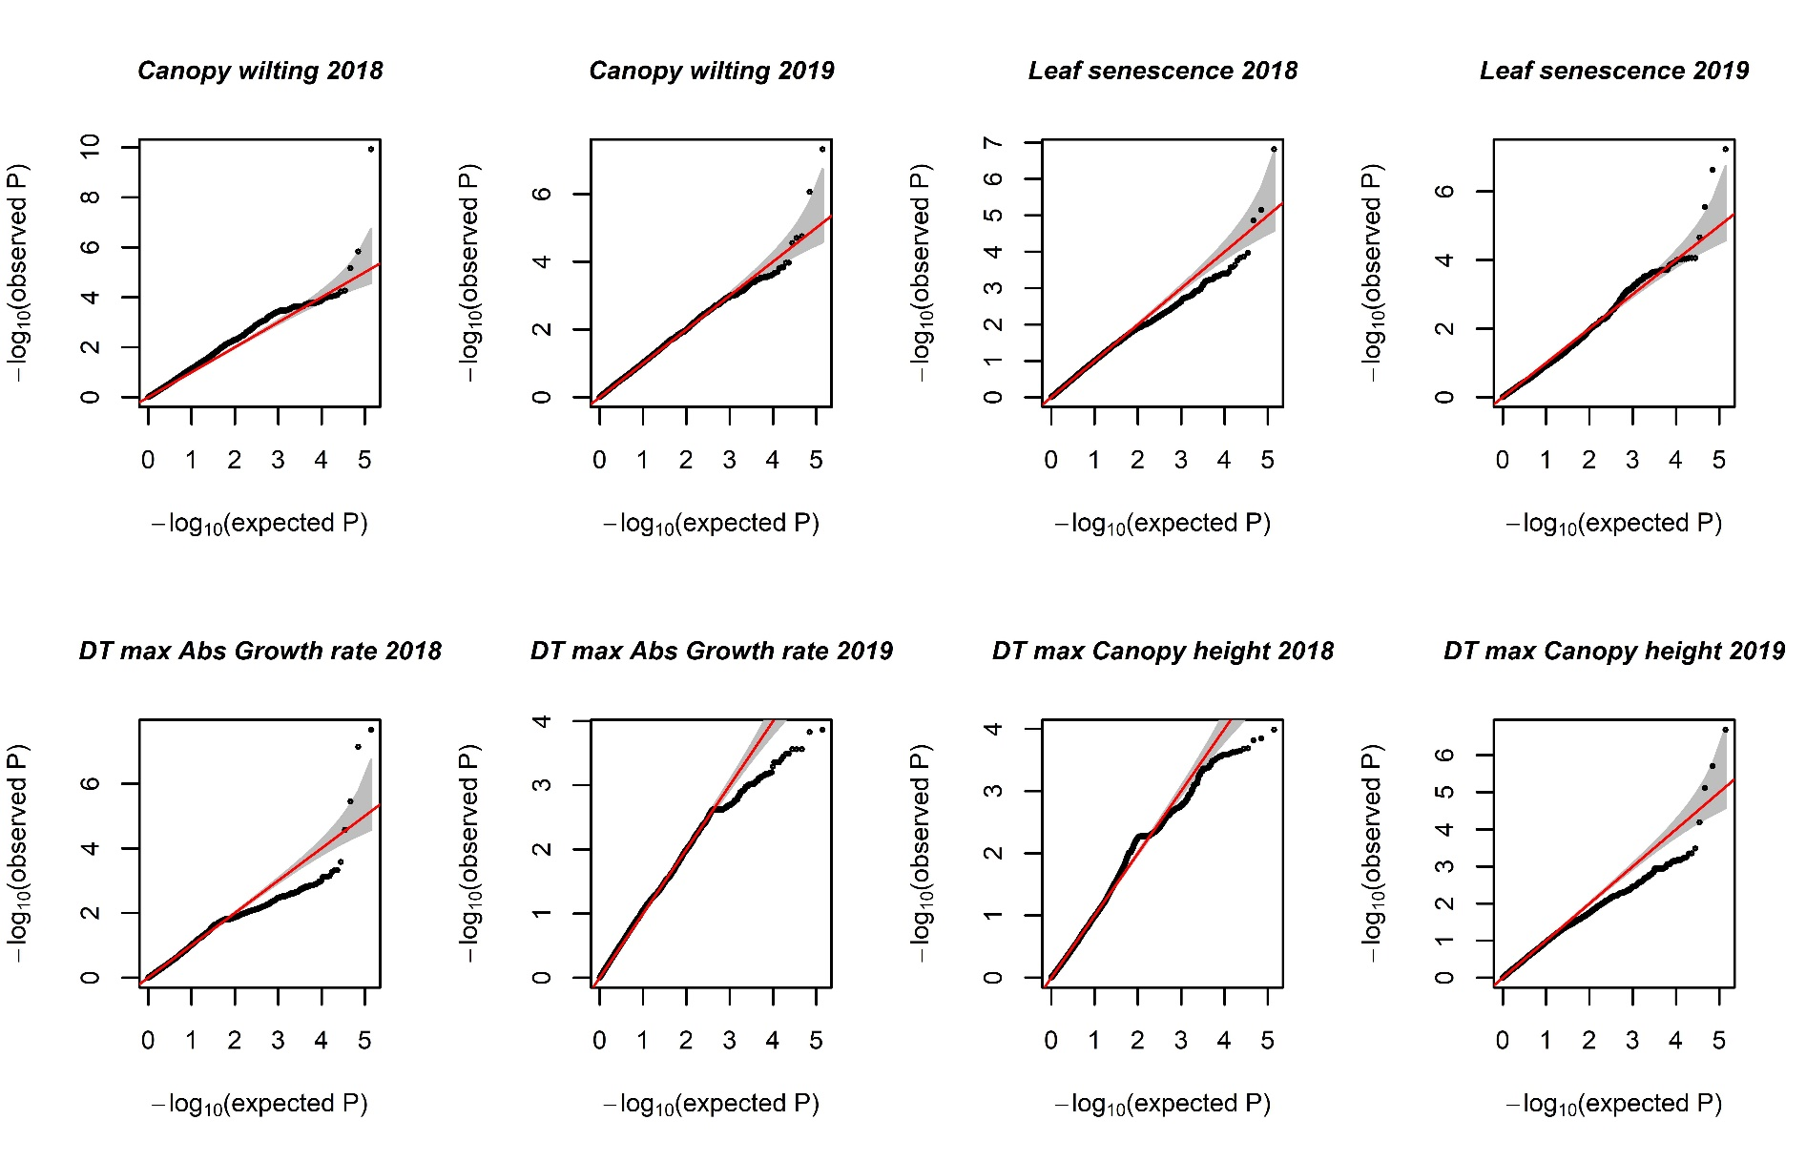
Additional file 2: Q-Q plots of GWAS analysis using the BLINK model.

