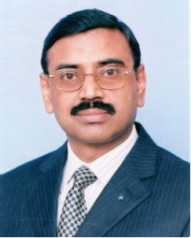 Prof. Dr. B.S. Chowdhry is a Distinguished National Professor and the former Dean Faculty of Electrical Electronics and Computer Engineering at Mehran University of Engineering & Technology, Jamshoro, Pakistan. His list of research publications crosses to over 60 in national and international journals, IEEE and ACM proceedings in the area of Intelligent Instrumentation, WSN, Embedded systems, simulation & Modelling, Internet Technologies, Smart Civil Structures. He is member of various professional bodies including: immediate past Chairman IEEE Karachi Section, Region10 Asia/Pacific, Fellow IEP, Fellow IEEEP, Senior Member IEEE Inc. (USA), SM ACM Inc. (USA). He organized several International Conferences including “IMTIC08”, “IMTIC12”, “IMTIC13”, “IMTIC15”, “IMTIC18”, “WSN4DC13”, “IEEE SCONEST”, “IEEE PSGWC13”, and track chair in “Global Wireless Summit (GWS 2014), and Chief Organizer and Co-Chair GCWOC’16, GCWOC’17 in Malaga Spain. In 2015, he also organized two weeks ICTP/UNESCO Regional workshop on “FPGA Based Instrumentation Systems”, fully funded by The Abdus Salam ICTP/ UNESCO first time in Pakistan in which scientist from 27 regional countries were invited for participation.
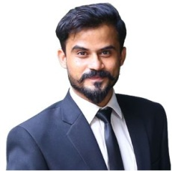 Engr. Salman ul Mouzam received his Bachelor of Engineering degree in Biomedical Engineering from Mehran University of Engineering and Technology, Jamshoro in 2013. Currently, he is working as a Research Assistant at the Institute of Information and Communication Technologies, MUET, Jamshoro. He has been part of many technical societies and community engagement programs. In 2020, he was among the few youngsters from Pakistan who were trained and later on awarded by UNICEF for community engagement.
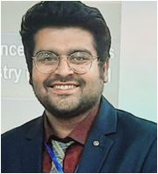 Engr. Ali Akbar Shah is currently a PhD Scholar in Electronics Engineering and is doing research on railway track condition monitoring for almost 3 years now. He has done ME in Mechatronics Engineering and BE in Electronics Engineering from Mehran University of Engineering and Technology, Jamshoro. He is currently working as a Research Associate/Design Engineer at National Center for Robotics and Automation-Condition Monitoring Systems Lab in Mehran University of Engineering and Technology, Jamshoro. He is also working as Member of UIC’s Harmotrack Project to implement standards of international railway association in Pakistan, a member of European Union’s Central Project and Student Advisor of IEEE Instrumentation and Measurement Society Student Branch. He has represented Pakistan and Mehran University at several national and international platforms. Besides that, he has already worked as a lecturer in Computer Science Department of SZABIST, Hyderabad. He has over 22 publications and 9 of those publications are related to railway track condition monitoring. With his latest publication published in 9.95 Impact Factor IEEE’s Journal of Internet of Things. His specializations are railway track surface monitoring, rolling stock condition monitoring, road condition monitoring, CAD designing, Robotics and Automation, and bridge condition monitoring. He has currently is in process of filing 2 patents in his domain of specialization.
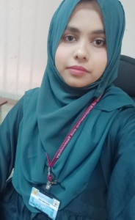 Engr. Ghulam Fiza Mirza is working as a Lecturer at Department of Telecommunications Engineering, NED University of Engineering and Technology, Karachi. She did joint Masters from Mehran UET and University of Malaga, Spain. She has worked as Research Assistant in National Center of Robotics and Automation (Condition Monitoring Systems Lab-MUET) for 2 years. Her research interests focus in the field of Wireless Sensor Networks (WSN), Body Sensor Networks, Vehicular Networks, Internet of Things (IoT), Road Condition Monitoring, and Artificial Intelligence.
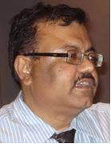Prof. Dr. Mohammad Aslam Uqaili is meritorious Professor and former Vice Chancellor of Mehran University of Engineering \& Technology, Jamshoro, Pakistan. He has earned bachelors, masters and doctoral degrees in electrical engineering and masters in economics. He has supervised more than dozen doctoral students. Prof Uqaili has written 13 chapters in international books, 75 research papers in national and international research journals, and presented 56 research papers in national and international conferences. Dr Uqaili has also edited four international books. Prof Uqaili is currently working as vice chancellor, MUET. Previously, he held positions of pro vice chancellor, registrar and dean, Quality Enhancement Cell (QEC), MUET, Jamshoro. He is a member on editorial board of several research journals. He has held other positions in the different statutory forums of MUET, Jamshoro. Prof. Uqaili facilitated the linkage of Mehran University with national and international public and private institutions, including universities in USA, UK, China, Japan, Malaysia and Turkey. Recognizing the contribution to higher education, he has been nominated on several academic forums in the country. He is recognized as a leading academician in Pakistan and abroad. During his tenure, MUET has ranked by HEC, Islamabad, as second best public engineering university of the country and number one public sector engineering university of the province (2015). Prof. Uqaili is involved in community services and he is on the board/trust of several nonprofit organizations, working on health, education, water, agriculture, community physical infrastructure etc.
From undergrad to doctoral level he has been awarded with several distinctions and honours, which includes, nomination by president of Pakistan as Member, Pakistan Science Foundation, Chairman, Board of Directors, Hyderabad Electric Supply Company (HESCO), elected as Member Governing Body of Pakistan Engineering Council (PEC) 2012-2014 and 2015-18, Best Teacher Award from Higher Education Commission of Pakistan (2005), awarded scholarship through countrywide open competition to pursue postgraduate studies abroad, by the Ministry of Science and Technology, Government of Pakistan,1990. He has an exposure at country and world levels. He has visited UK, USA, Australia, Germany, Malaysia, Italy, China, Singapore, Netherlands, France, Saudi Arabia, Belgium, Luxembourg, Thailand, UAE and Turkey.

