Supplementary Information

Observation of higher-order non-Hermitian skin effect
Xiujuan Zhang¹, Yuan Tian¹, Jian-Hua Jiang^{2,†}, Ming-Hui Lu^{1,3,†} and Yan-Feng Chen^{1,3,†}
¹National Laboratory of Solid State Microstructures and Department of Materials Science and Engineering, Nanjing University, Nanjing 210093, China
² School of Physical Science and Technology, and Collaborative Innovation Center of Suzhou Nano Science and Technology, Soochow University, 1 Shizi Street, Suzhou 215006, China
³Collaborative Innovation Center of Advanced Microstructures, Nanjing University, Nanjing 210093, China
†Correspondence and requests for materials should be addressed to joejhjiang@hotmail.com (JHJ), luminghui@nju.edu.cn (MHL) or yfchen@nju.edu.cn (YFC).
- Theoretical model
In this section, we derive the theoretical model to characterize the designed sonic crystal (SC) and the observed non-Hermitian skin effect in the main text. Our SC is an acoustic analog of the spinful 2D Su-Schrieffer-Heeger (SSH) model, as shown in Fig. S1a, where the spin-up and spin-down modes are emulated by the anti-clockwise and clockwise resonant modes. For simplicity, here, we only study the model with clockwise modes. The case with anti-clockwise modes can be analyzed following the same derivations. When the clockwise modes are considered, the biased loss in Fig. 1a of the main text can be modeled by the anisotropic intra-cell coupling strengths, i.e., $t_{1}$ and $t_{1}+χ$. The inter-cell coupling strengths are isotropic, denoted as $t_{2}$. The Hamiltonian in momentum space for such an SSH-like lattice can be written as
$H=\left(\begin{matrix}\begin{matrix}0 & t_{1}+t_{2}e^{ik_{x}} \\ t_{1}+χ+t_{2}e^{-ik_{x}} & 0\end{matrix} & \begin{matrix}t_{1}+χ+t_{2}e^{-ik_{y}} & 0 \\ 0 & t_{1}+χ+t_{2}e^{-ik_{y}}\end{matrix} \\ \begin{matrix}t_{1}+t_{2}e^{ik_{y}} & 0 \\ 0 & t_{1}+t_{2}e^{ik_{y}}\end{matrix} & \begin{matrix}0 & t_{1}+t_{2}e^{ik_{x}} \\ t_{1}+χ+t_{2}e^{-ik_{x}} & 0\end{matrix}\end{matrix}\right)$. (S1)
Here, on-site energy is taken as zero and only the nearest-neighbor coupling is considered. The eigen-values and eigen-vectors of Eq. (S1) give the dispersions and wavefunctions of the lattice, respectively. In the Hermitian regime ($χ=0$), the staggered coupling parameters, i.e., $t_{1}≠t_{2}$, open band gaps, as demonstrated in Fig. S1b, where the energy dispersions for three cases, $t_{1}=3, t_{2}=1$, $t_{1}= t_{2}=1$, and $t_{1}=1, t_{2}=3$, are successively presented. These dispersions are similar to those shown in Fig. 1b of the main text, suggesting that our system can indeed be described by the 2D SSH-like tight-binding lattice. Note that in Fig. S1b, the middle two energy bands are degenerate along the high symmetric line $ΓM$, while in Fig. 1b of the main text, such a degeneracy is lifted. This discrepancy is presumably due to the spin-degeneracy (i.e., the interferences between the clockwise and anti-clockwise modes) and the weak next-nearest-neighbor couplings in the SC. Nevertheless, Fig. S1b still captures the typical dispersion features of the SC.
Based on the analyses in the main text, the staggered coupling parameters bring forward distinct bulk topology, which is accompanied with parity inversion, as demonstrated in Fig. 1b. Such a parity inversion leads to non-trivial bulk polarizations. Here, we further calculate the bulk polarizations of the tight-binding lattice, which show consistency with the SC. In a 2D system, the bulk polarization is defined in terms of the Berry phase vector potential $A$, as
$P_{i}=-\frac{1}{{\left(2π\right)}^{2}}\int_{BZ}{d^{2}k \text{Tr}\left[A_{i}\right]}, i=x,y$ (S2)
where ${\left(A_{i}\right)}_{mn}\left(k\right)=i〈u_{m}\left(k\right)|∂_{k_{i}}|u_{n}\left(k\right)〉$, with $i$ denoting the directions of the two lattice vectors and $m$ and $n$ running over the bands below the considered band gap. $|\left.u_{m,n}\left(k\right)\right\rangle$ is the periodic part of the wavefunctions of the $m$th (or $n$th) order band with wave vector $k$. BZ refers to the Brillouin zone. In the numerical calculation, where the Brillouin zone is discretized, Eq. (S2) can be further reduced to
$P_{i}=\frac{1}{2π}\int_{L}{dν_{i,k_{j}} }, i=x,y, j=y,x$ (S3)
Here, $L$ denotes the projection length of the BZ along $k_{j}$ direction. $ν_{i,k_{j}}$ is the Berry phase along the loop $k_{i}$ for a fixed $k_{j}$. Figure S1c presents the calculated $ν_{x}$ ($ν_{y}$=$ν_{x}$ restricted by the inversion symmetry) for the two gapped cases in Fig. S1b (the lowest band is studied). Accordingly, the bulk polarizations are obtained as $P=\left(0, 0\right)$ for $t_{1}>t_{2}$ and $P=\left(\frac{1}{2}, \frac{1}{2}\right)$ for $t_{1}<t_{2}$, corresponding to the topological trivial and non-trivial cases, respectively. This is consistent with the parity inversion analyses in the main text.
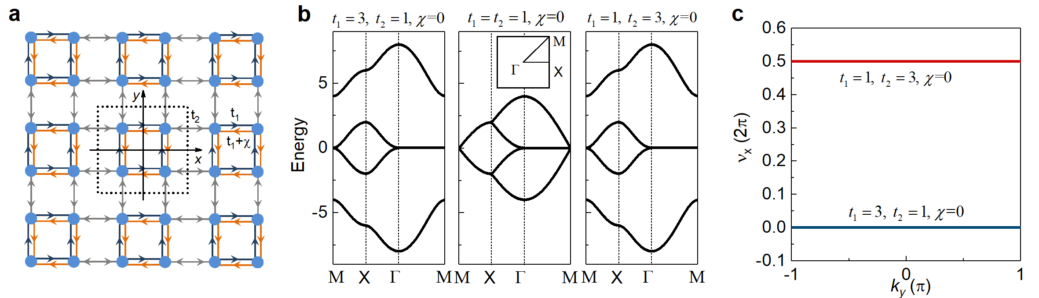
Figure S1 | Theoretical tight-binding model. a, The tight-binding lattice that models the SC proposed in the main text. The dotted box encloses a unit-cell. b, Energy dispersions of the lattice in a, with coupling parameters taken as $t_{1}=3, t_{2}=1$, $t_{1}= t_{2}=1$, and $t_{1}=1, t_{2}=3$, successively from left to right. The common parameter $χ=0$. c, Calculated Berry phase $ν_{x}$ as functions of $k_{y}$ for the two gapped cases in b. The bulk polarization is accordingly obtained by integration of $ν_{x}$ over $k_{y}$.
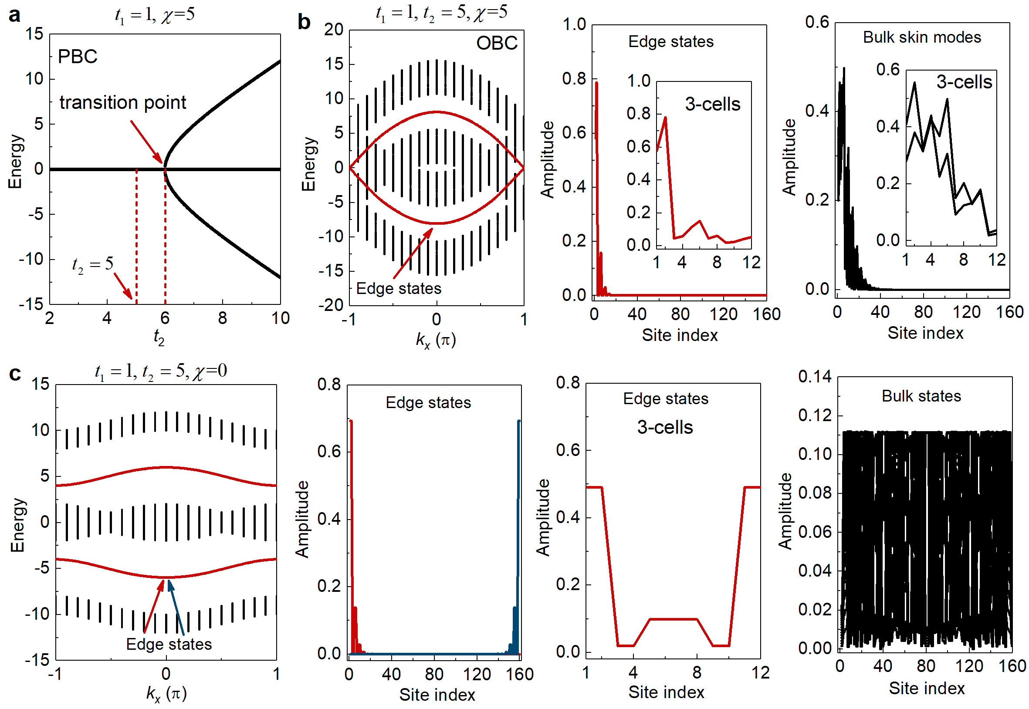
Figure S2 | Non-Hermitian skin effect in the tight-binding model. a, The topological phase diagram under the PBC, with $t_{1}=1$ and $χ=5$ indicating a non-Hermitian system. b, Energy dispersions of a supercell with 40 unit-cells, subject to the OBC along the y direction and PBC along the x direction. Edge states are found, indicating a topological non-trivial phase at $t_{2}=5$, which shows an inconsistency with the prediction under PBC. The wavefunctions of the edge states (the middle panel) and the bulk states (the right panel) show wave localization toward the upper boundaries (with smaller site indices), as manifestations of the non-Hermitian skin effect. The results for the supercell with 3 unit-cells are also presented. c, The same as b, but with $χ=0$ indicating a Hermitian case. The wavefunctions of the edge states are localized around both the upper and lower boundaries. Meanwhile, the bulk states are no longer localized but become extended.
When non-Hermiticity is introduced, i.e., $χ≠0$, the conventional bulk-boundary correspondence breaks down, signified by the different energy spectra between the lattices with periodic boundary condition (PBC) and with open boundary condition (OBC). In the main text, we numerically show this difference in Fig. 1c. Here, we study a specific case with $χ=5$ for an additional illustration. Figure S2a presents the eigen-energy (the real parts) for the four eigen-states at the M point subject to the PBC as a function of $t_{2}$, where $t_{1}=1$ and $χ=5$ are fixed. It is seen that for a non-zero $χ$, the topological phase transition takes place at $t_{1}+χ=6$, where the degeneracy of the upper and lower bands is lifted and band gaps are opened. Surprisingly, if we take $t_{2}=5$ (corresponding to a gapless phase under PBC) to compute the dispersions of a supercell subject to OBC along the y direction and PBC along the x direction, as shown in Fig. S2b (left panel), we find that edge states emerge (the red curves), indicating a topological non-trivial phase. Such an inconsistent topological phase transition subject to PBC and OBC suggests a non-Hermitian skin effect. As shown by the wavefunctions in the middle panel for the edge states (i.e., the two degenerate edge states with negative eigen-energy at $k_{x}=0$, indicated by the red arrow) and in the right panel for the bulk states (i.e., the lowest 39 states at $k_{x}=0$), indeed all the states are localized toward the upper boundary (with smaller site indices). Here, 40 unit-cells are taken in the calculations. We also present the wavefunctions for a case with 3 unit-cells (see the insets), which also show the interesting localization effects, for both the edge states and the skin modes. For comparison, the same studies are conducted in the Hermitian case with $χ=0$. The results are presented in Fig. S2c, which exhibit strikingly different behaviors from the non-Hermitian case. In particular, the edge states are no longer localized toward the upper boundary, but have preferences to both the upper and lower boundaries. Additionally, the bulk states become extended. These results are consistent with those reported in the main text for the real metamaterial and provide additional evidence to the non-Hermitian skin effect.
- Parity inversion at the high symmetric point X
In the main text, Fig. 1b presents the bulk topological transition, which is signaled by the parity inversion at the X point. To further confirm this, we provide the acoustic wavefunctions of the eigen-states on the lowest two bulk bands (at both the $Γ$ and X points) below the concerned band gap in Fig. S3. It is shown that the parity at the X point indeed flips during the process of band gap closing and re-opening.
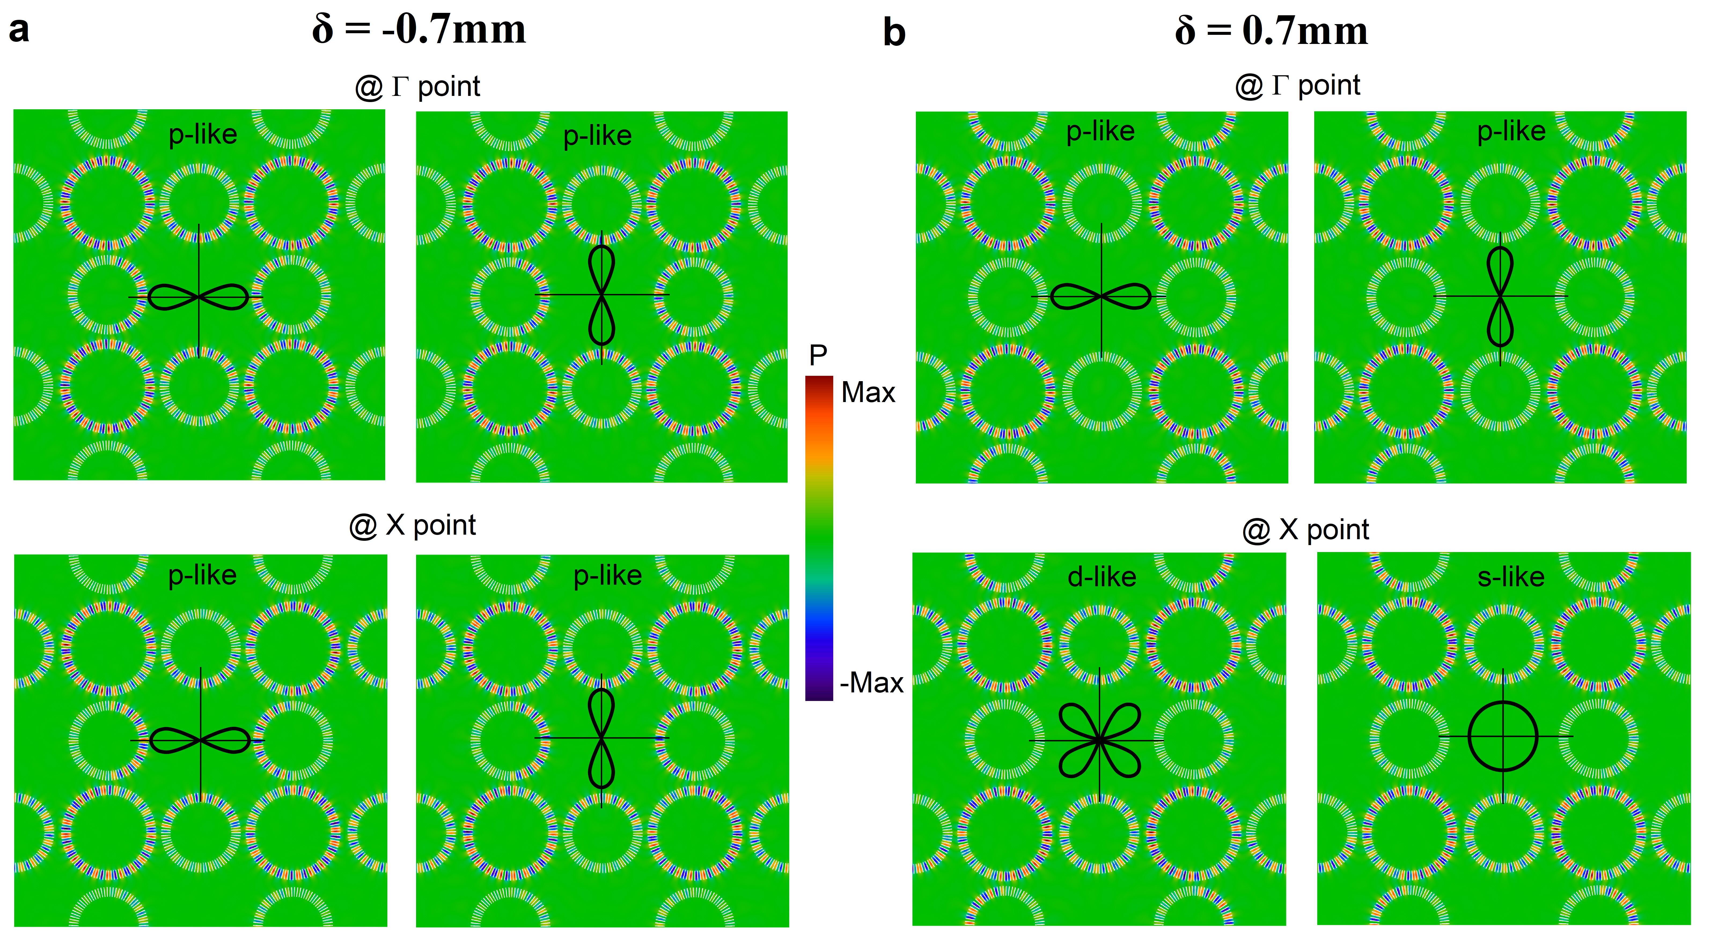
Figure S3 | Parity properties of the bulk states at the $Γ$ and X points. a, Acoustic wavefunctions for the four bulk states located below the band gap at the $Γ$ and X points, for the case with $δ=-0.7$ mm. It is observed that the states at both the $Γ$ and X points have the p-like wave distributions. b, The same as a, only for the case with $δ=0.7$ mm. Note that now the states at the X point become $s$-/$d$-like while their counterparts at the $Γ$ point are still $p$-like, indicating a clear signature of parity inversion.
- The degenerate topological edge states
Figure 2a of the main text presents the projected band structure of a ribbon-like supercell, which gives the in-gap edge states. We show here in Fig. S4 the frequencies of the eigen-states at $k_{x}=\frac{π}{a}$ as functions of the solution number and find that there are four nearly degenerate states emerging in the gap of the bulk states. Further simulations on the acoustic wavefunctions confirm that these degenerate states are indeed edge states.
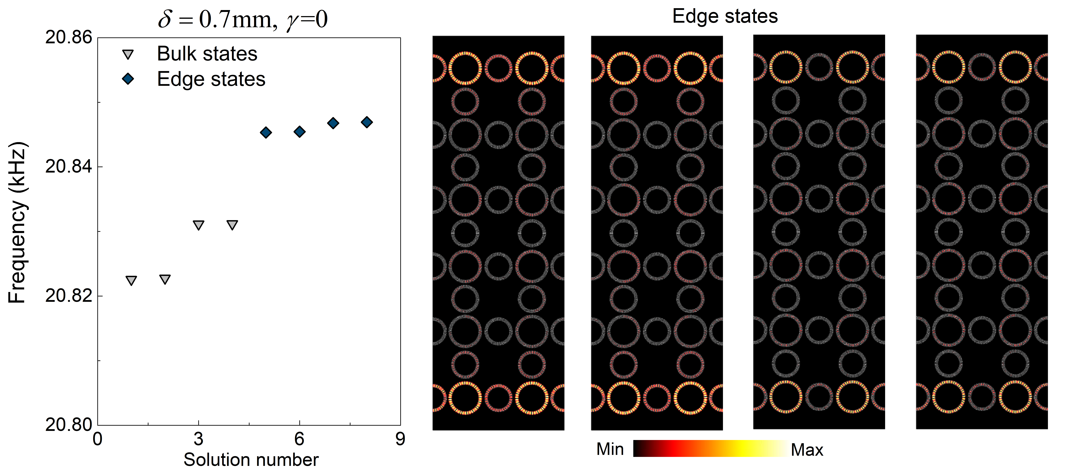
Figure S4 | Degenerate topological edge states. Frequencies of the eigen-states at $k_{x}=\frac{π}{a}$, calculated for the ribbon-like supercell (the same as that in Fig. 2a of the main text), as functions of the solution number are plotted. Four in-gap, nearly degenerate states (dark blue) are observed. The corresponding acoustic wavefunctions indicate that they are topological edge states.

- Sample photos and experimental set-ups
In this section, we illustrate the fabricated sample photos and elaborate the experimental set-ups for the measurements in Figs. 2-3 of the main text. Two samples are fabricated, including an edge sample and a corner sample. The former consists of 12 by 11 ring resonators (i.e., 3 by 3 unit-cells), with open boundaries along the y direction (see Fig. S5a for the sample photo). The latter consists of 7 by 11 ring resonators (i.e., 2 by 3 unit-cells), with open boundaries in both the x and y directions (see Fig. S5b for the sample photo). An enlarged image of the site and link rings is also shown. To induce non-Hermiticity, dissipative materials (i.e., the porous sponge) are added to the intra-cell link rings, forming a biased configuration, as illustrated in Fig. S5c for one unit-cell.
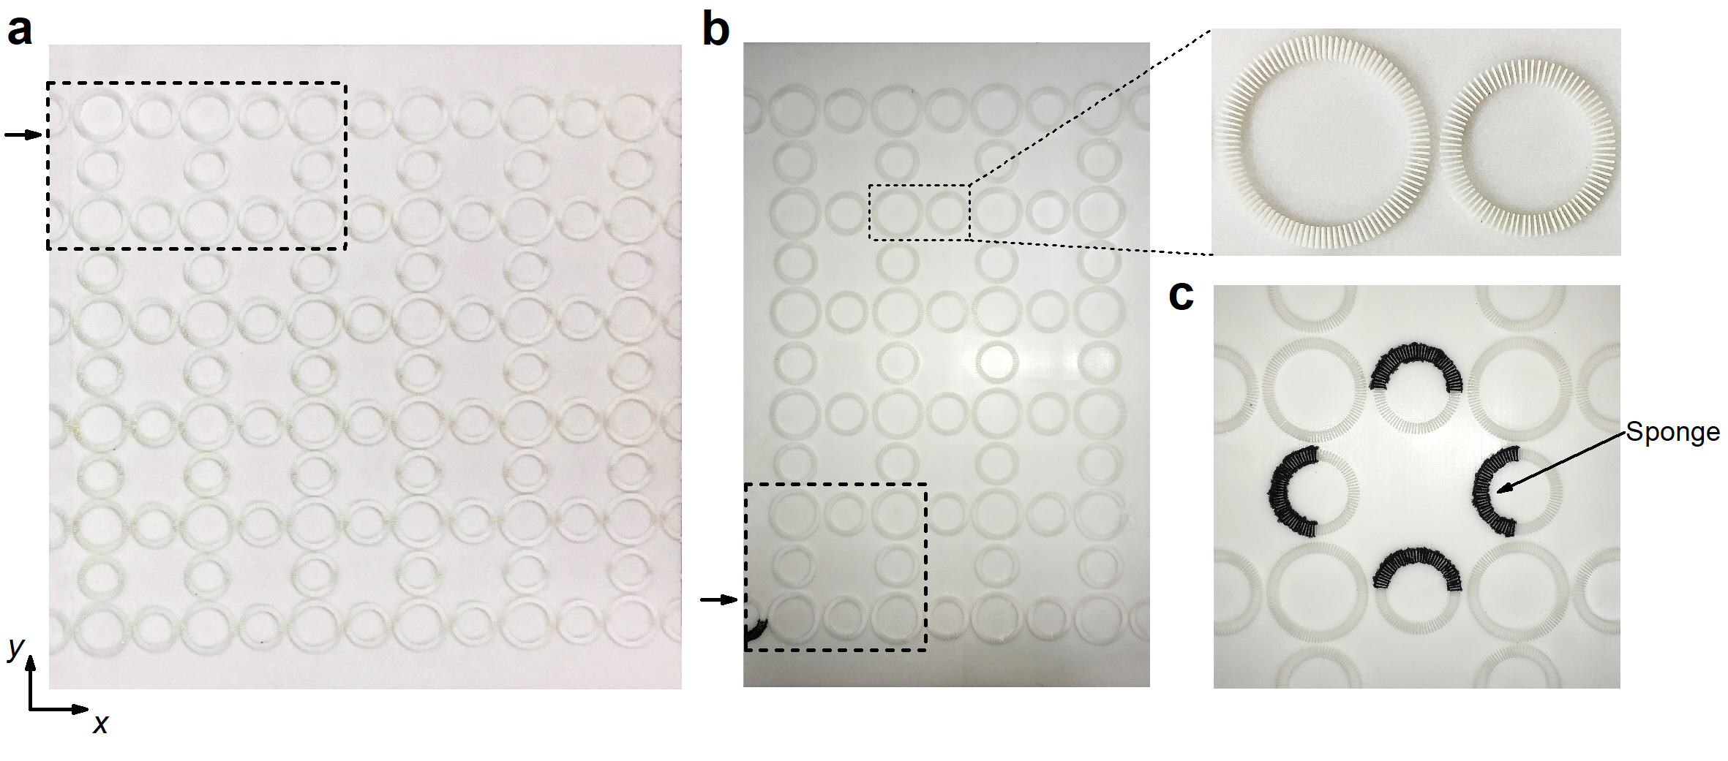
Figure S5 | Fabricated samples. a, The edge sample with 12 by 11 ring resonators. b, The corner sample with 7 by 11 ring resonators. An image of the enlarged site and link rings is inserted. The thick dotted boxes in a and b mark the scanning domains in the measurements and the arrows indicate the input plane-wave-like signals. c, The biased loss configuration, formed by adding porous sponge to the air slits of the intra-cell link rings. Note that for clarification, here we only show the loss domains in one unit-cell (in experiments, every unit-cell has the same loss configuration).
To conduct the measurements, an acoustically rigid plate is placed on top of the samples to form a waveguide. The plate is perforated with open channels in order to probe the acoustic fields. For each ring, there are 18 open channels forming the same ring-shape as the resonators (see Fig. S6a). During measurements, the detector is manually moved in a channel-by-channel fashion to scan the concerned domains. When one channel is probed, all the other channels are sealed by acoustically rigid plugs to avoid sound leakage (see Fig. S6a, lower panel). The obtained data are post-processed to generate the pump-probe transmission spectra and the acoustic field maps, as shown in Fig. 2c-d and Fig. 3c-e of the main text. It is pointed out that the transmission spectra for the bulk and edge probes in the edge samples (with and without biased loss) are obtained respectively by averaging the measurements on Rings 1-5 in the bulk region and by averaging Rings 6-9 on the edge. These ring indices are marked in Fig. S6b. For the corner samples (with and without biased loss), the transmission spectra for the bulk, edge and corner probes are respectively the averaging over Ring 1, 2 and 3 (the indices are marked in Fig. S6c).
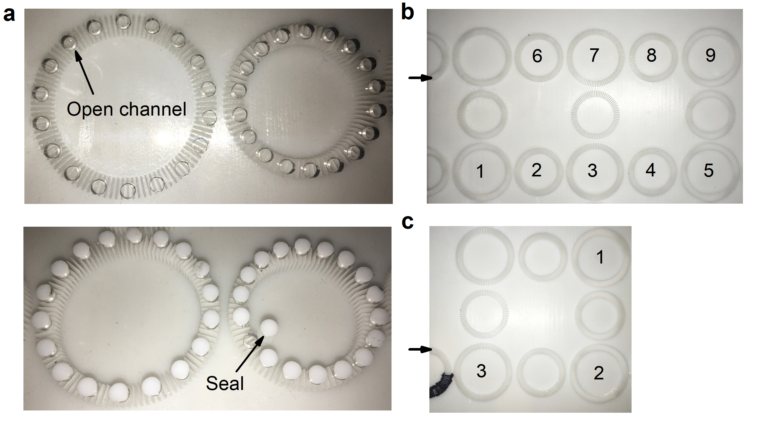
Figure S6 | Measurement set-ups. a, Images of a partial upper board with open channels (covering the regions of a site ring and a link ring), as indicated by the upper panel. For each ring, there are 18 channels. During the measurements, the channels are either opened for detection or sealed to avoid sound leakage (see the lower panel for the seals). b and c, Respectively the scanned domains for the edge and corner samples, where the transmission spectra are obtained by averaging over the marked rings.
- Broadband non-Hermitian skin effect
In this section, we argue that due to the existence of an extensive number of skin modes, the non-Hermitian skin effect is a broadband effect. As demonstrated in both the main text for the real metamaterial and the above Section 1 for the tight-binding model, when non-Hermiticity is introduced, all the states become skin modes. These states occupy finite frequency regimes and are experimentally detectable. In Fig. S7, we present the simulated transmission spectra for the edge and corner samples without ($γ=0$) and with ($γ=0.02$) the designed loss. The set-ups are the same as the experiments, where a plane wave source is injected into the samples and the numerical probes are conducted in the bulk, edge and corner regions (using the same averaging as described in Fig. S6b-c) to obtain the transmission spectra. The results indicate that the non-Hermitian skin effect is salient in broadband frequency regimes. The acoustic field maps at the same excitation frequencies as the experiments are also presented, which show high agreements with those presented in Figs. 2c-d and 3c-d of the main text, suggesting that our experimental results can indeed reflect the non-Hermitian skin effect.
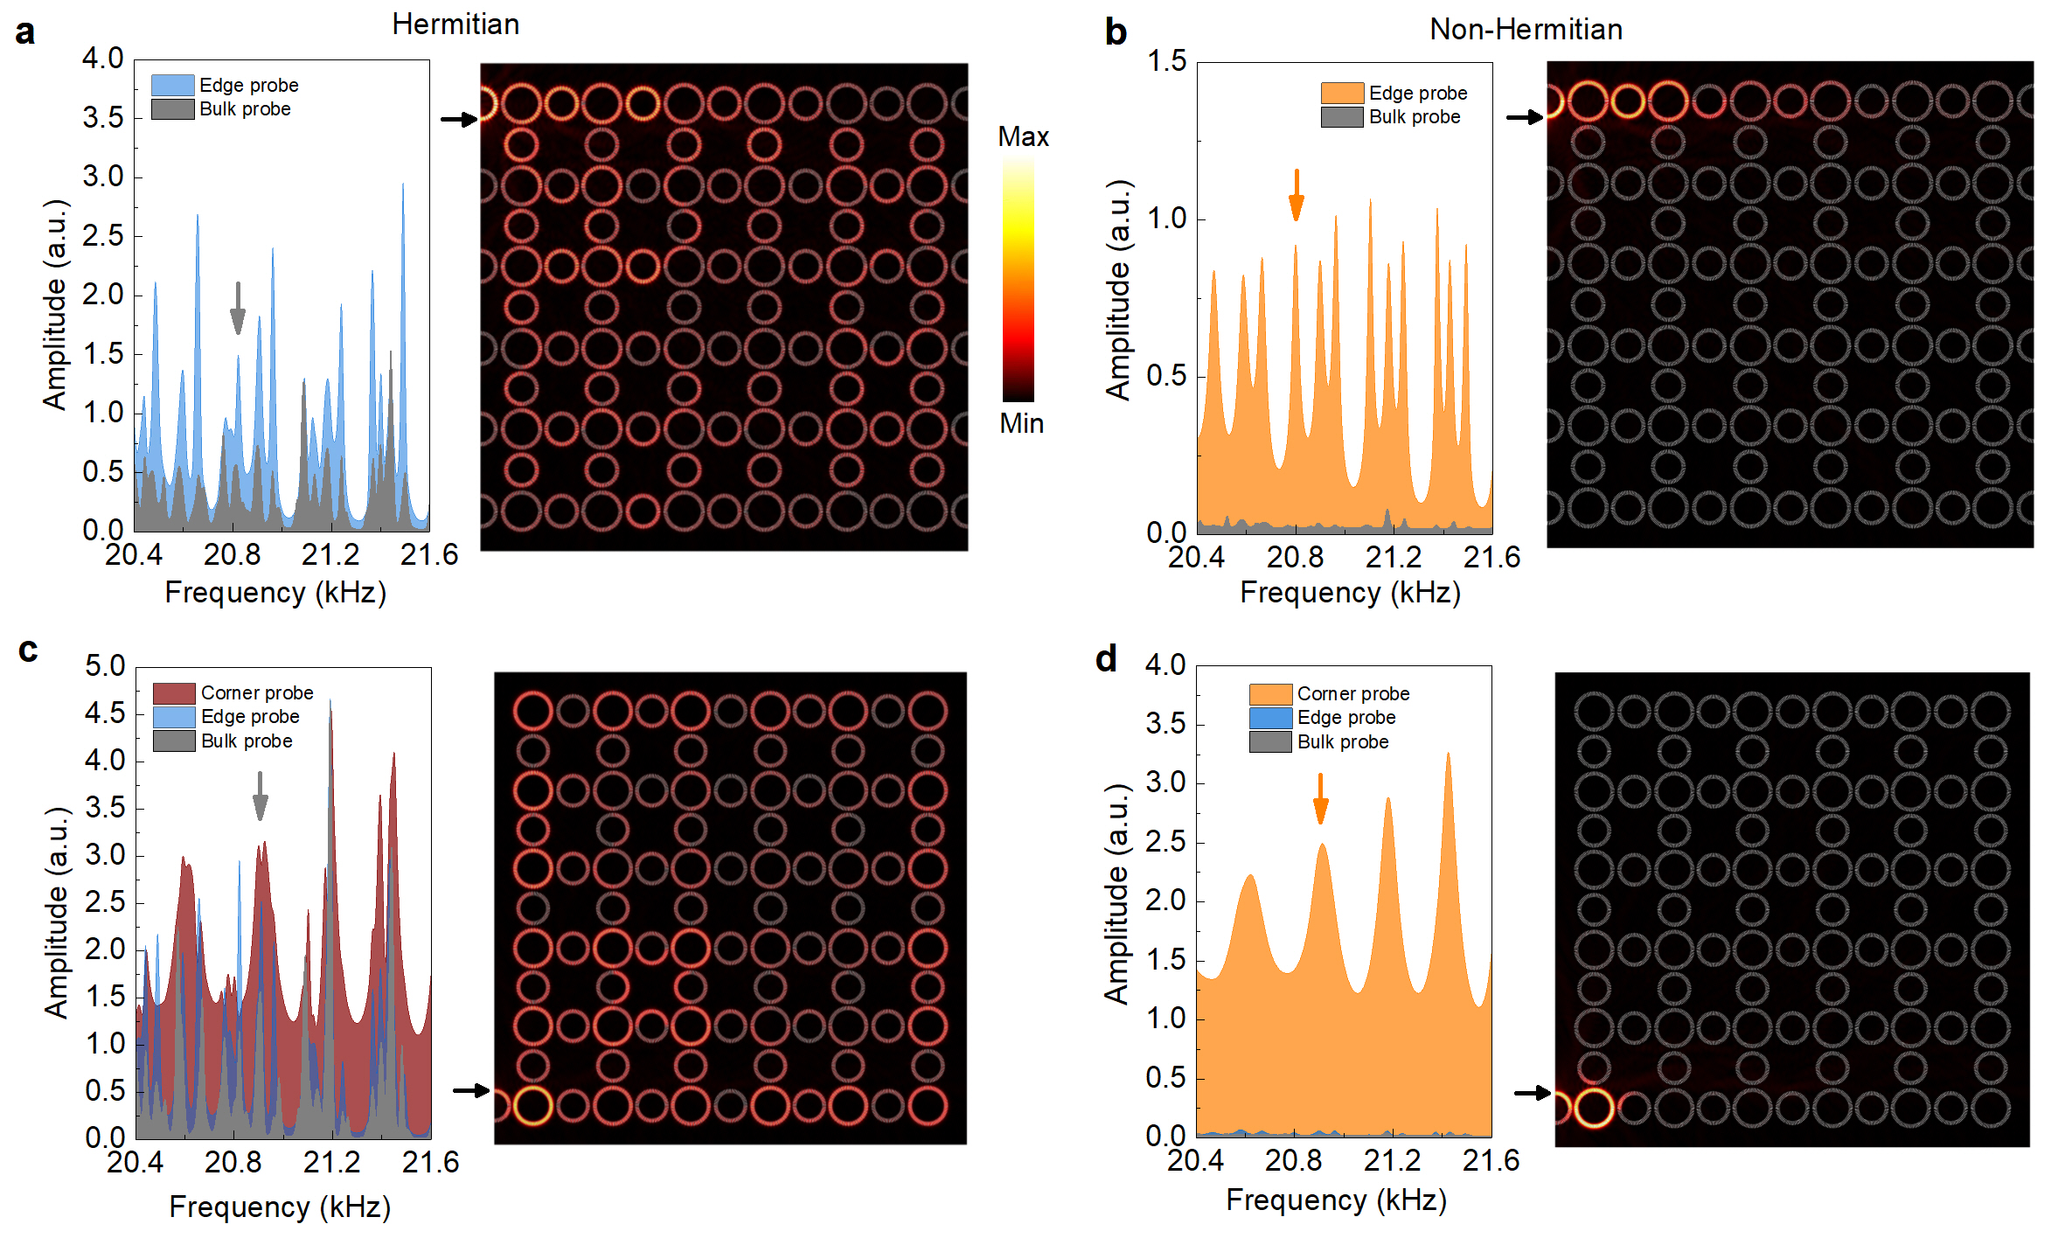
Figure S7 | Simulated pump-probe transmission spectra. a and b, Respectively the same as that in Figs. 2c and 2d in the main text, but for simulations. It is clearly seen that the non-Hermitian skin effect exhibits a broadband behavior, consistent with the experimental measurements. Note that due to the background air loss, the peak spectral features in the simulations are flattened in the experiments. The acoustic field distributions for two excited states (with the same excitation frequencies as the experiments) also demonstrate the consistency with the experiments, i.e., after introducing the designed loss, all the states, including the bulk and edge states, become edge-like skin modes. c and d, Respectively the same as that in Figs. 3c and 3d in the main text, but for simulations. Again, clear features of the broadband higher-order non-Hermitian skin effect is observed when the extended states become localized corner-like skin modes after introducing the designed loss.

