Supplementary Figure S1. Species accumulation curves of plants.
Figure S2-(I) represents species accumulation curves of plants based on the 15 plots in the tropical area, Figure S2-(II) represents species accumulation curves of plants based on the 15 plots in the subtropical area.
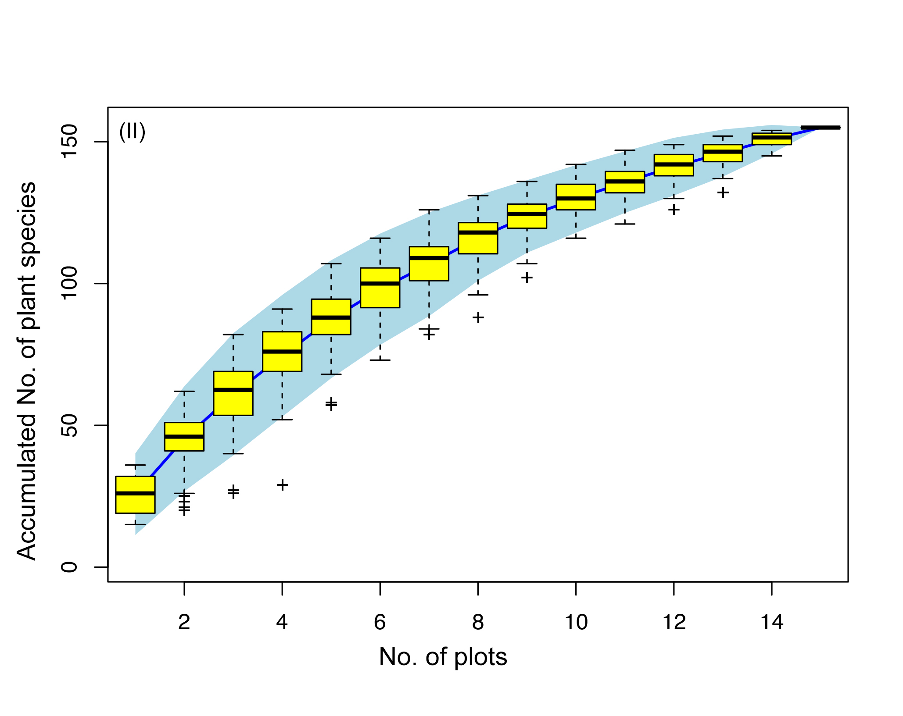
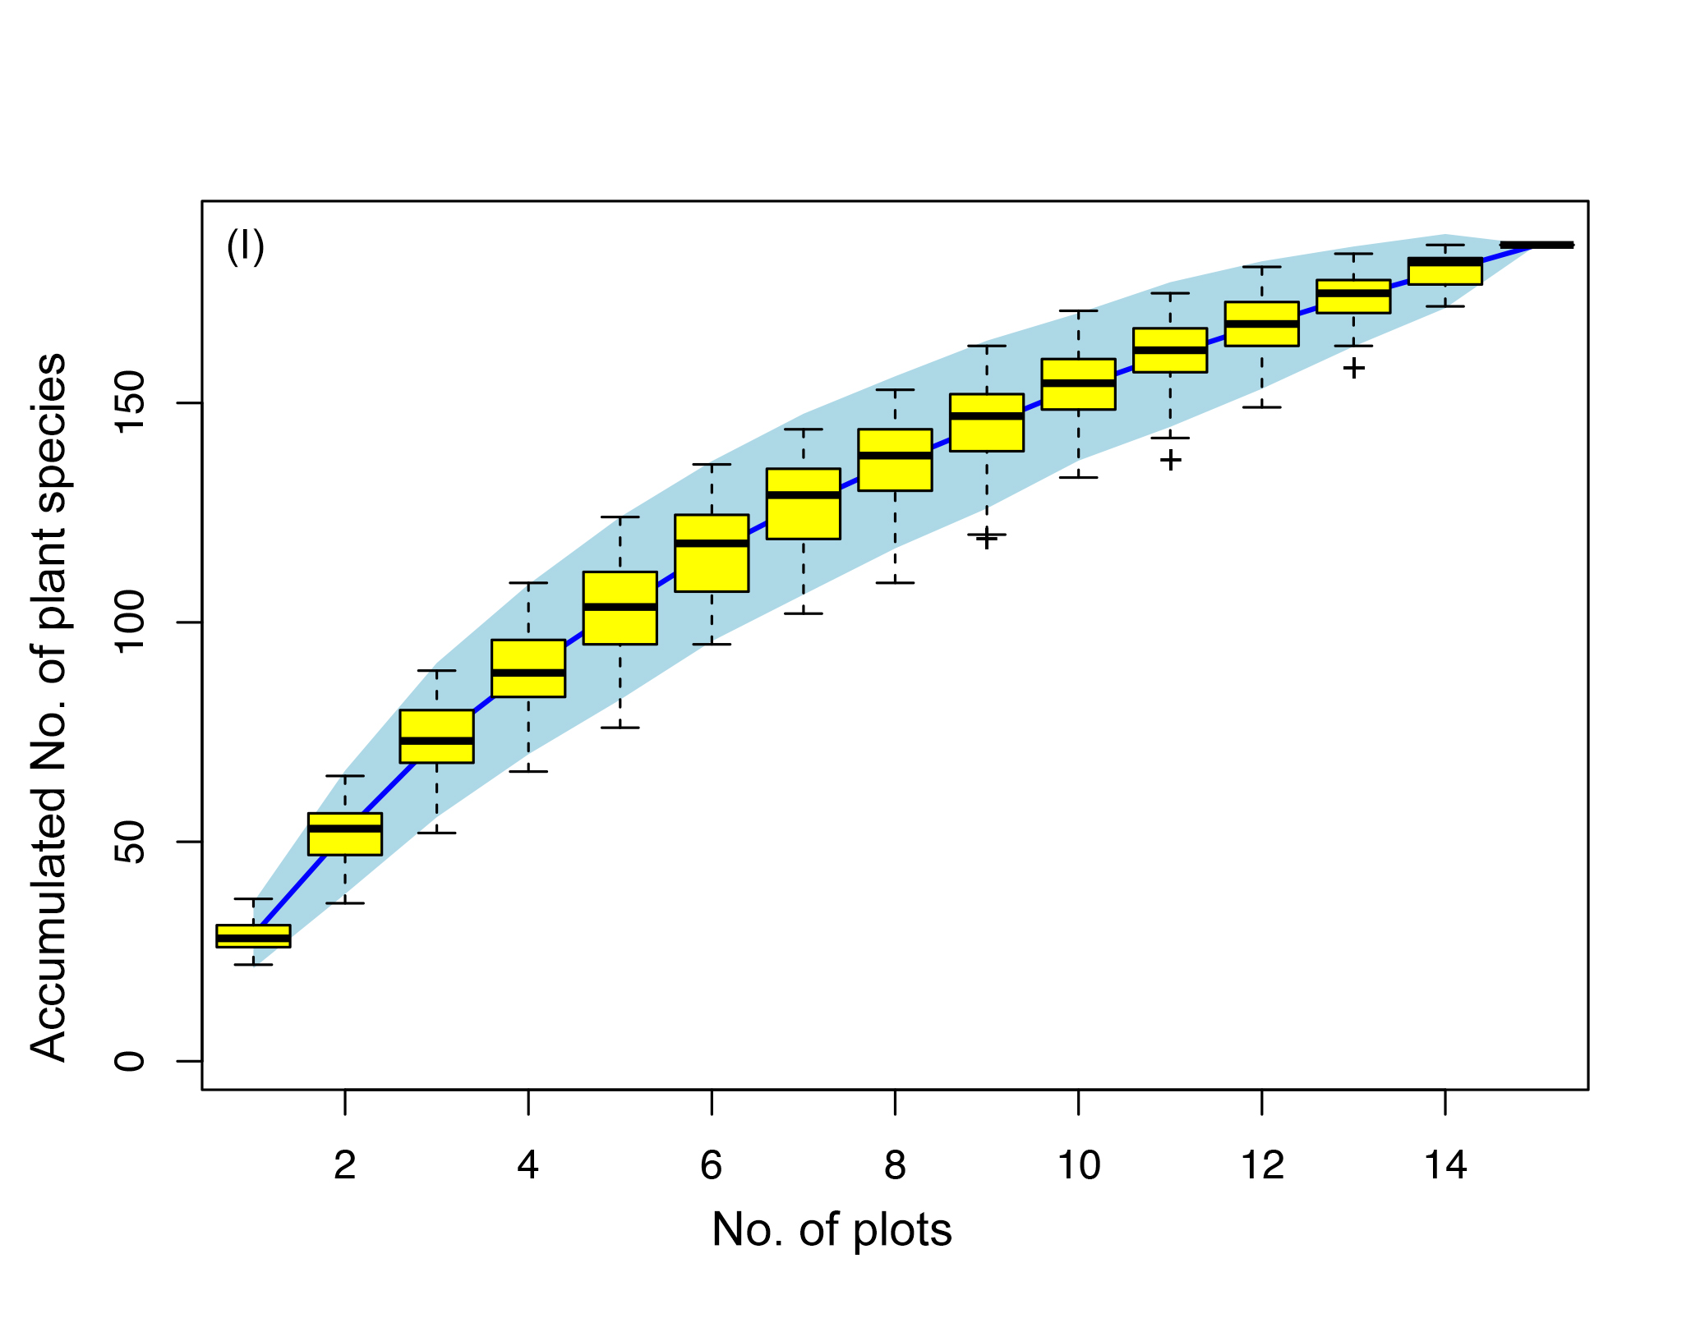

Supplementary Figure S2. Non-metric multidimensional scaling (NMDS) ordinations for beetle assemblages and plant assemblages.
Fig. 2-I represents Non-metric multidimensional scaling (NMDS) ordinations for beetle assemblages in different sampling plots. Fig. 2-II represents Non-metric multidimensional scaling (NMDS) ordinations for plant assemblages in different sampling plots. The red points are sampling plots, different numbers in the squares represent different transects (1: Ailaoshan; 2: Dajianshan; 3: Laoqinshan; 4: Bubeng; 5: Lvshuihe; 6: Gulingqin), the coloured ellipses are 95% confidence intervals of species centroids for each treatment level. Two convergent solutions were found after 20 iterations with a stress value of 0.05793 for plants and 0.08923 for beetles using Bray-Curtis distance.
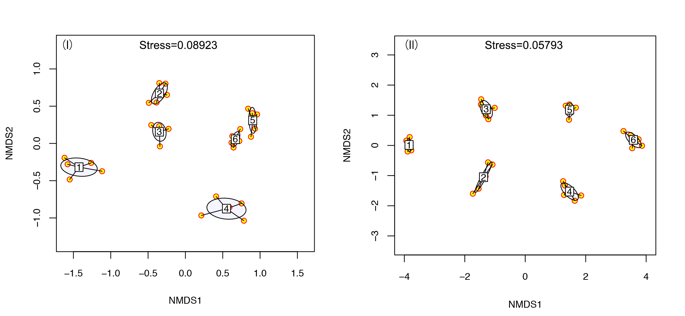

Supplementary Figure S3. The proportion of the five most abundant longhorn beetle species.
The proportion of the five most abundant longhorn beetle species within two different climatic zones (tropical and subtropical habitats) of Yunnan province, Southwest China.
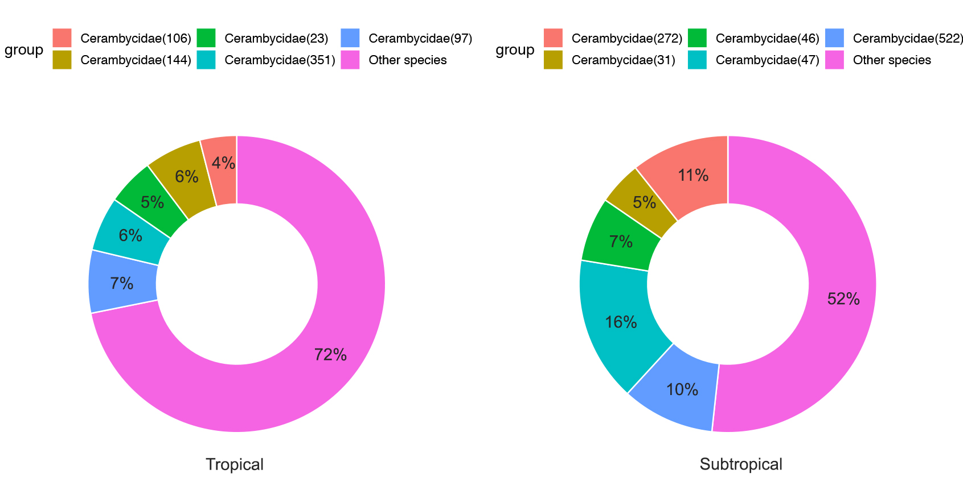

Supplementary Table S1.2 Results of redundancy analysis.
Results of redundancy analysis testing the influence of plant species composition and plant phylogeny on wood-boring longhorn beetle species composition in tropical and subtropical areas in Yunnan province, SW China. Pla, plant species; PlaPhy, plant phylogeny; Spa, spatial distance. F statistics to test the significance of variables were calculated using the iterative ‘anova.cca’ in ‘vegan’ using R. Significance. codes: 0 ‘***’ 0.001 ‘**’ 0.01 ‘*’ 0.05 ‘.’ 0.1 ‘ ’ 1
 |  |  | Number of plant species/phylogeny PC axes included |  | P
Tropics |  | Pla | 5/15 (2,3,4,7,15) |  | 0.02 (*)
 |  | Spa | 3/4 (1,3) |  | 0.03 (*)
 |  | PlaPhy | 6/15 (1,2,4,5,6,7) |  | 0.04 (*)
Subtropics |  | Pla  Spa | 3/15(2,4,15)  2/3 (1,3) |  | 0.045 (*)  0.02 (*)
 |  | PlaPhy | 1/15 (2) |  | 0.005 (**)

