Supporting information

Synthesis, biological evaluation and molecular docking studies of a new series of bis-chalcones
Zahra Khazaei_Poul,ª Nosrat Ollah Mahmoodi *^{,a} Hossein Taherpour Nahzomi ^{b}

ª Department of Chemistry, Faculty of Sciences, University of Guilan, PO Box 41335-1914, Rasht, I.R. Iran
Corresponding author email: mahmoodi@guilan.ac.ir
^{b} Department of Chemistry, Payame Noor University, PO BOX 19395-3697 Tehran, Iran.
* E-mail: mahmoodi@guilan.ac.ir
Tell: 09113335909

This file is containing the information about
- FT-IR, ¹H NMR and ¹³C NMR Spectra of Compounds 4a-h.
- 2D ligand-receptor interaction with 1SA0 enzyme.
- The binding mode of compounds with the colchicine binding site (PDB ID: 1SA0).

1. FT-IR, 1H NMR and 13C NMR Spectra of Compounds 4a-h
1.1. (2E,2'E)-3,3'-(2-hydroxy-5-methyl-1,3-phenylene)bis(1-(naphthalen-2-yl)prop-2-en-1-one) (4a)
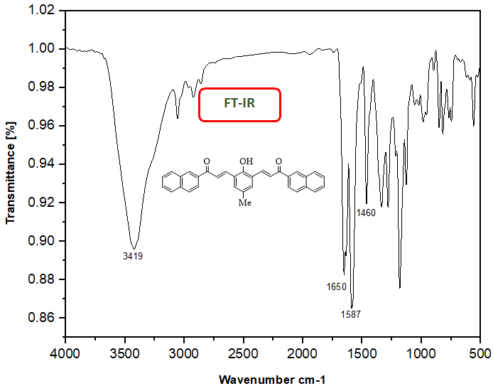

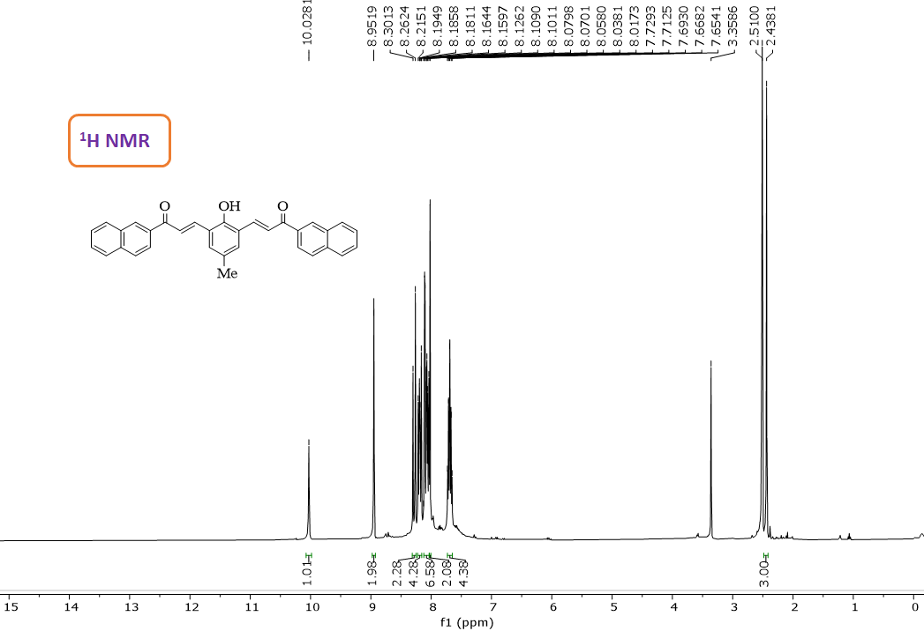
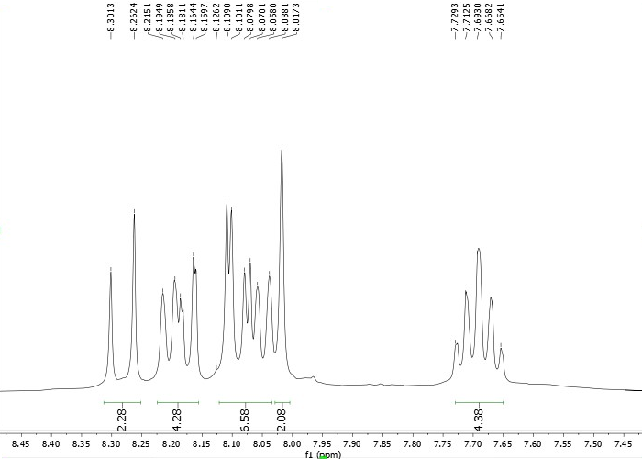

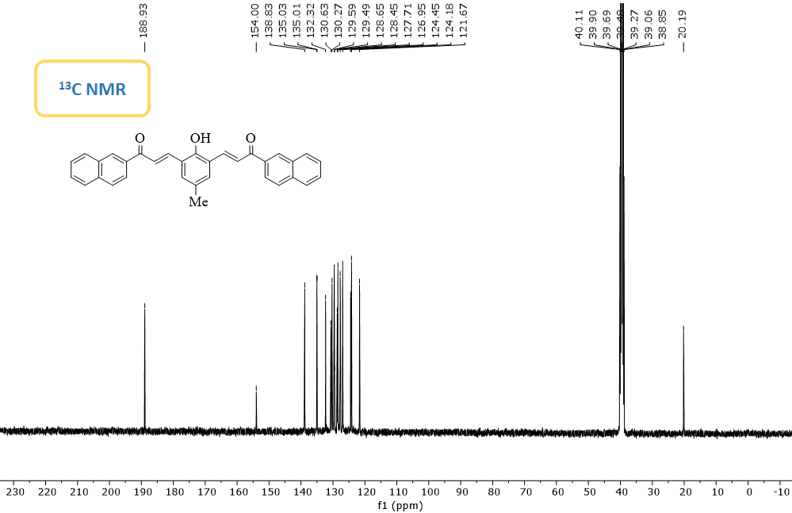
1.2. (2E,2'E)-3,3'-(2-hydroxy-5-methoxy-1,3-phenylene)bis(1-(naphthalen-2-yl)prop-2-en-1-one) (4b)
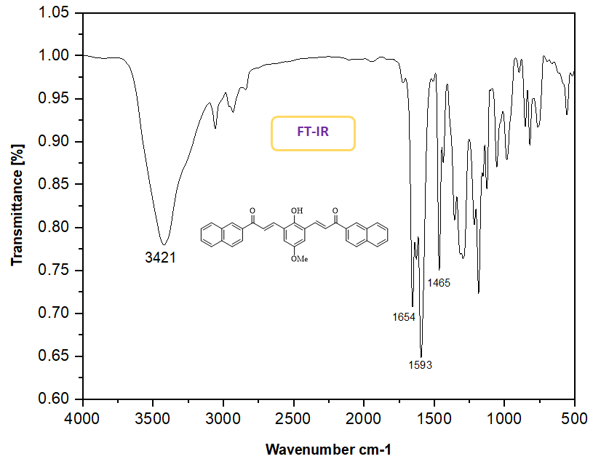
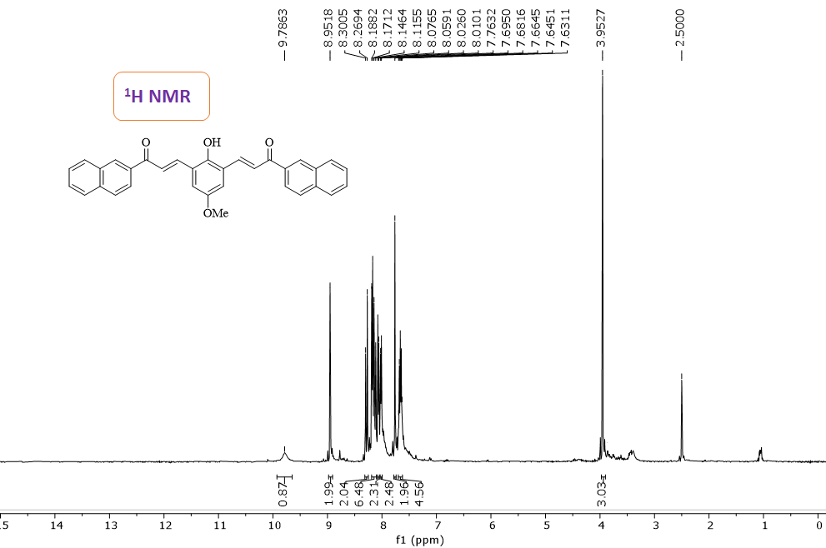

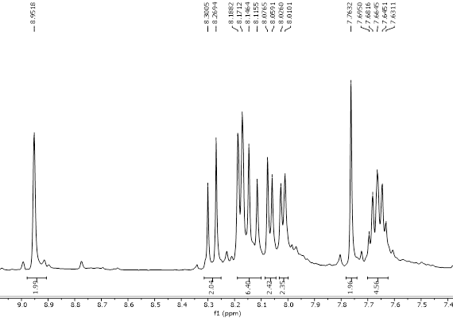
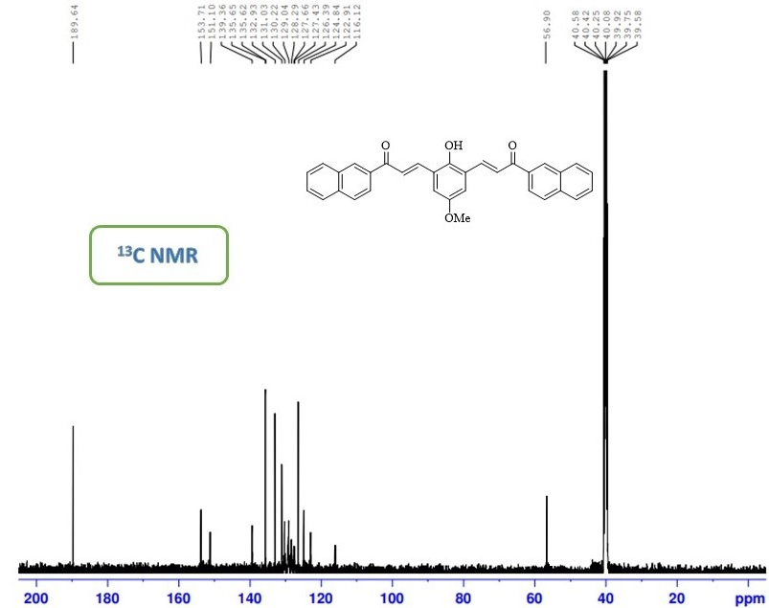
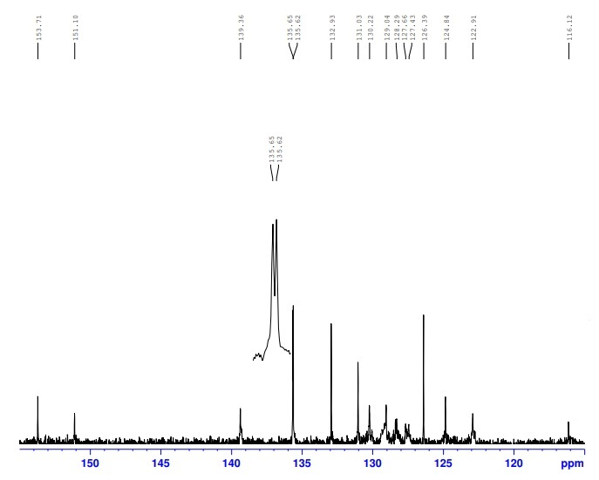
1.3. (2E,2'E)-3,3'-(2-hydroxy-5-methyl-1,3-phenylene)bis(1-(furan-2-yl)prop-2-en-1-one) (4c)
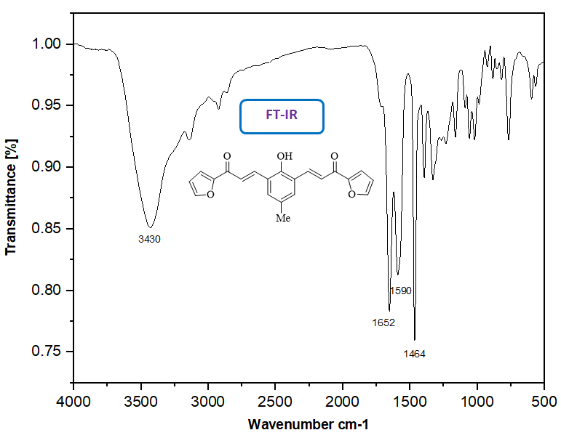

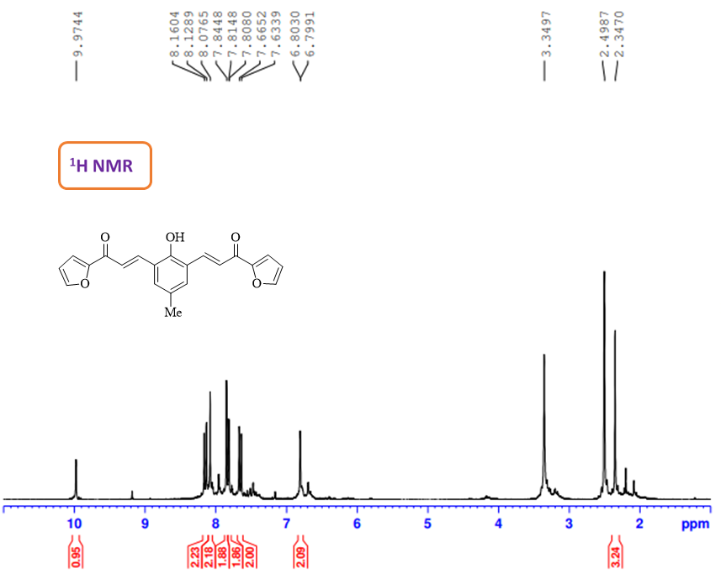
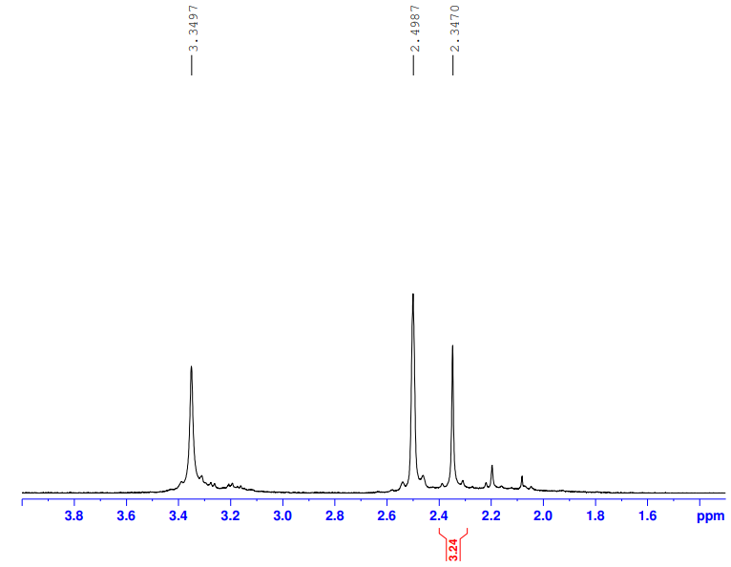
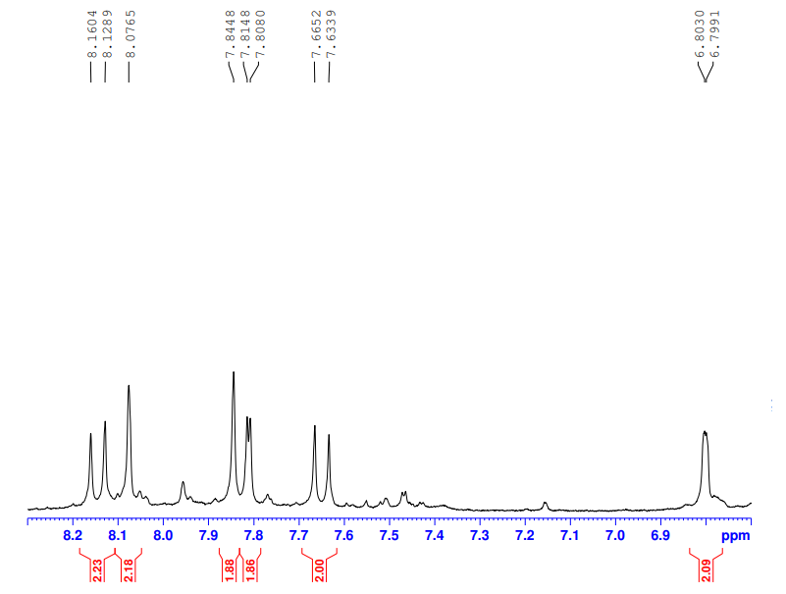
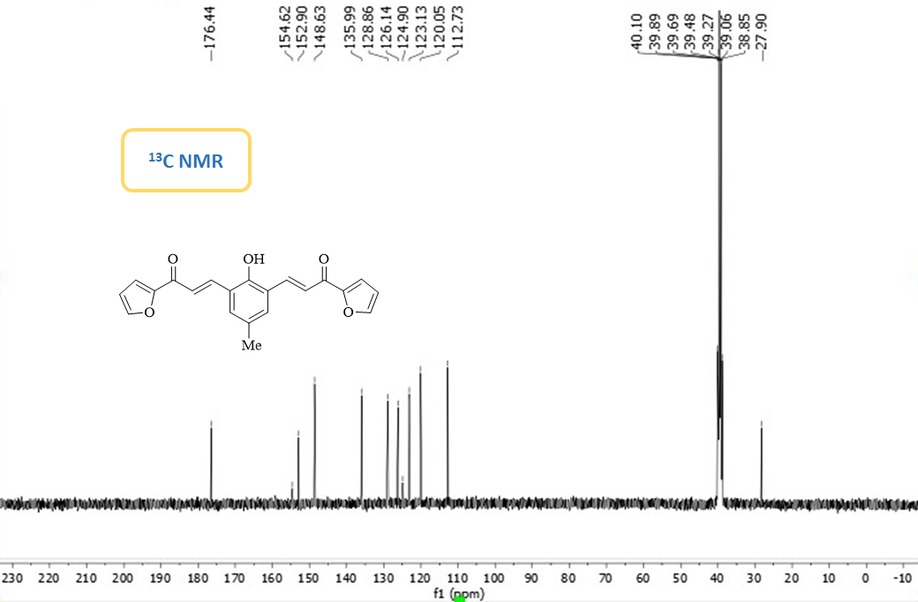
1.4. (2E,2'E)-3,3'-(2-hydroxy-5-methoxy-1,3-phenylene)bis(1-(furan-2-yl)prop-2-en-1-one) (4d)

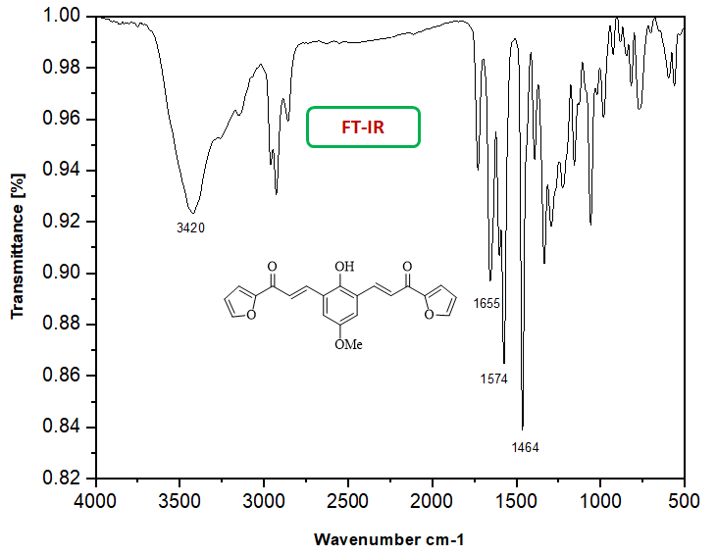

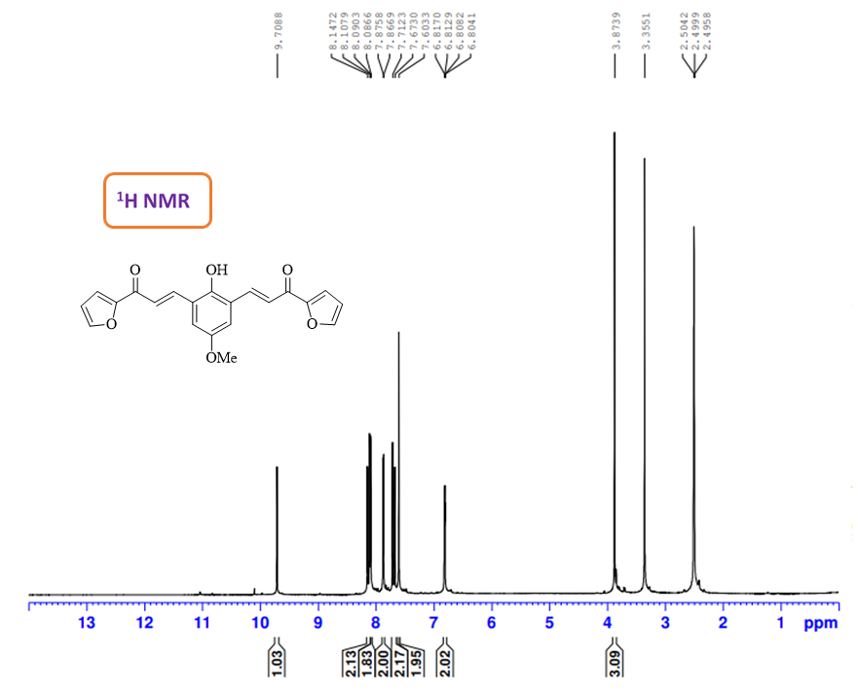
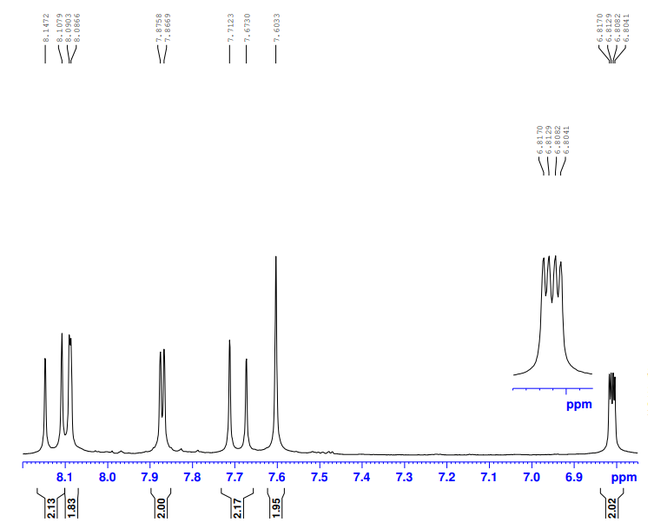
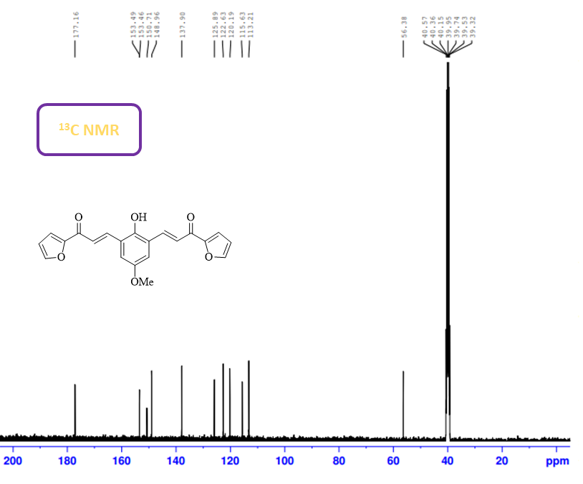
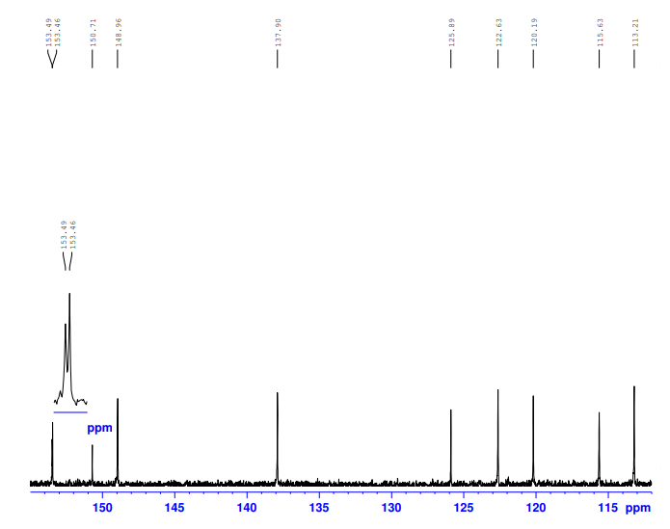
1.5. (2E,2'E)-3,3'-(2-hydroxy-5-methyl-1,3-phenylene)bis(1-(4-methoxyphenyl)prop-2-en-1-one) (4e)
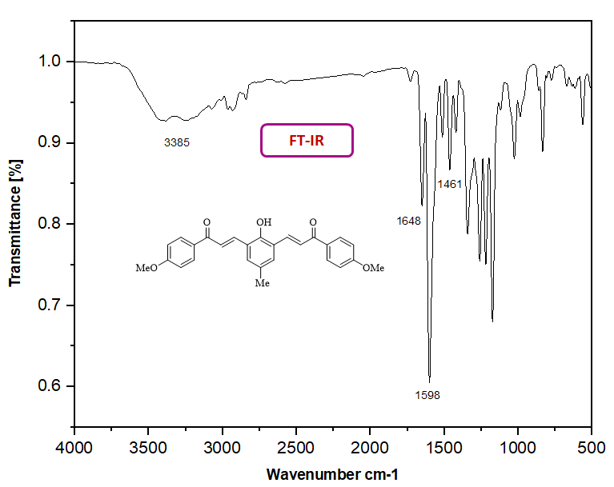
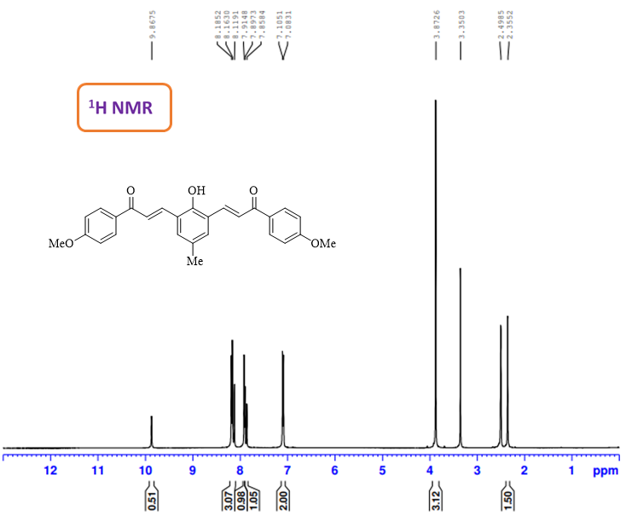
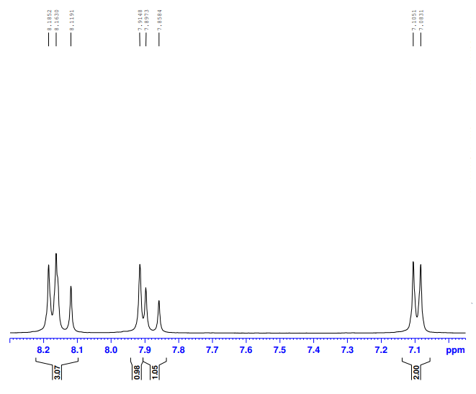
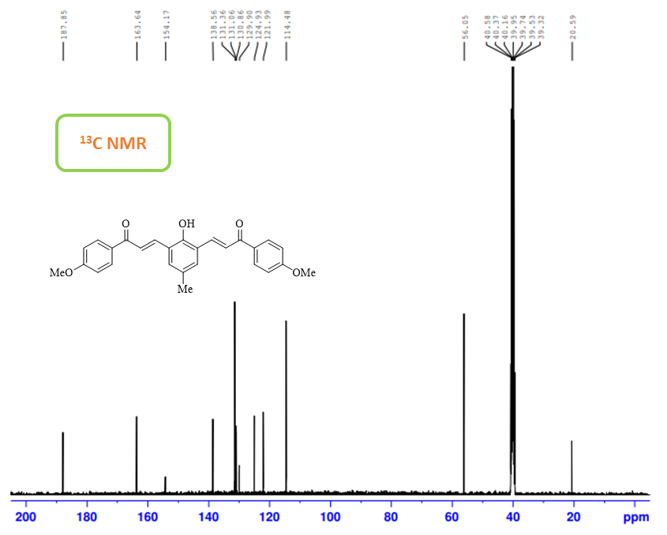
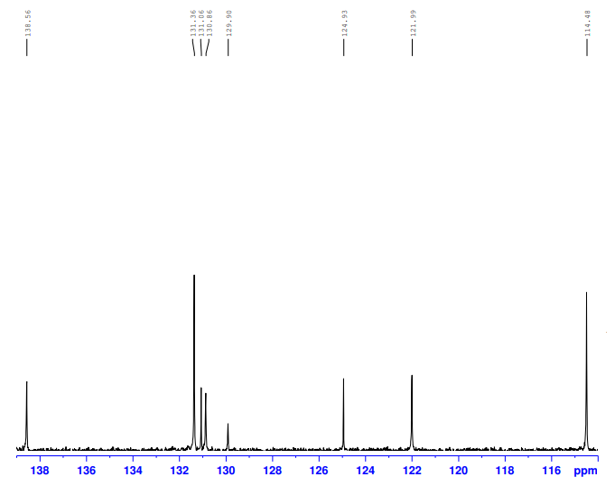

1.6. (2E,2'E)-2,2'-((2-hydroxy-5-methyl-1,3-phenylene)bis(methaneylylidene))bis(2,3-dihydro-1H-inden-1-one) (4f)
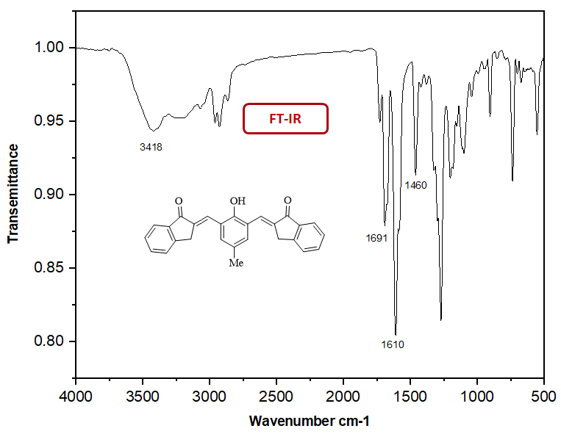

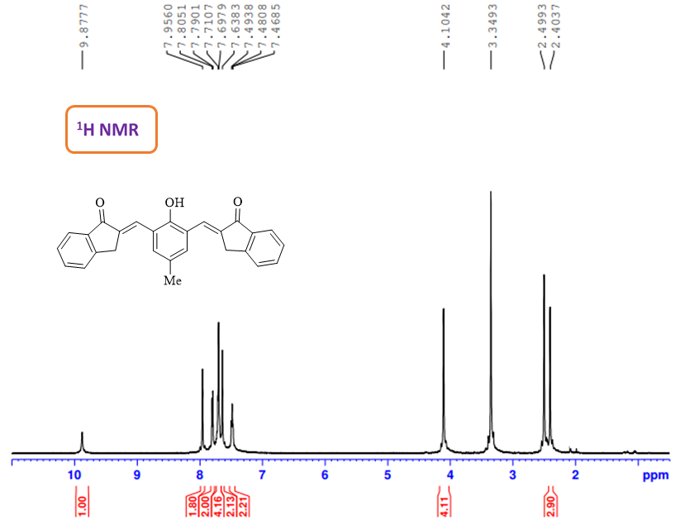

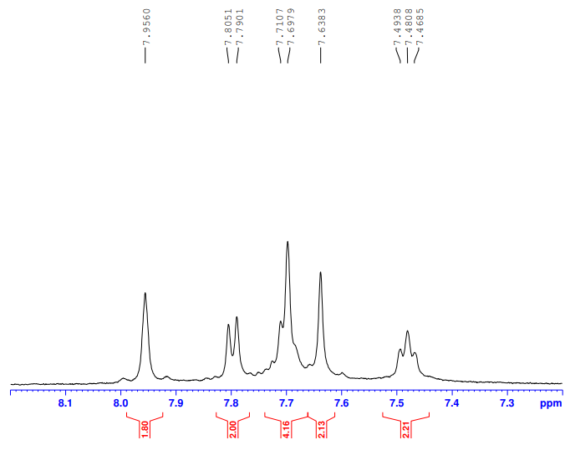

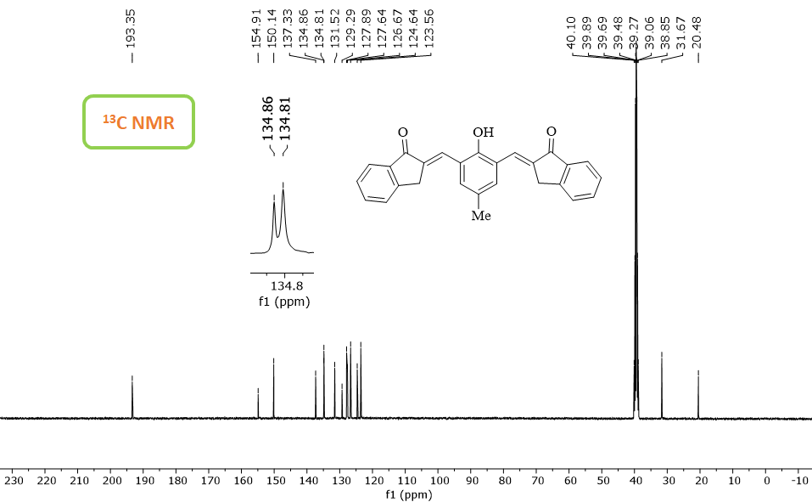
1.7. (2E,2'E)-2,2'-((2-hydroxy-5-methoxy-1,3-phenylene)bis(methaneylylidene))bis(2,3-dihydro-1H-inden-1-one) (4g)
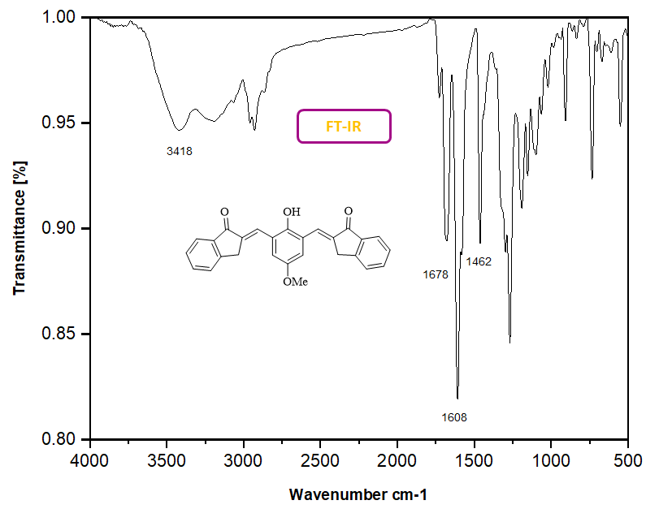

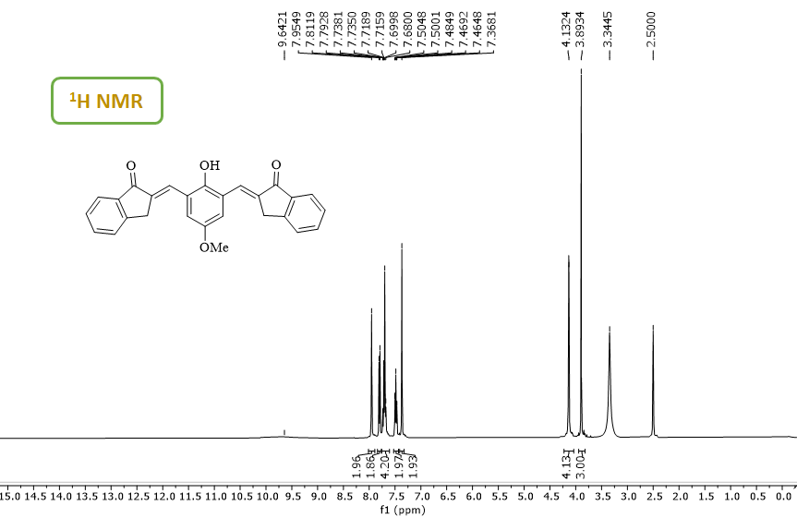
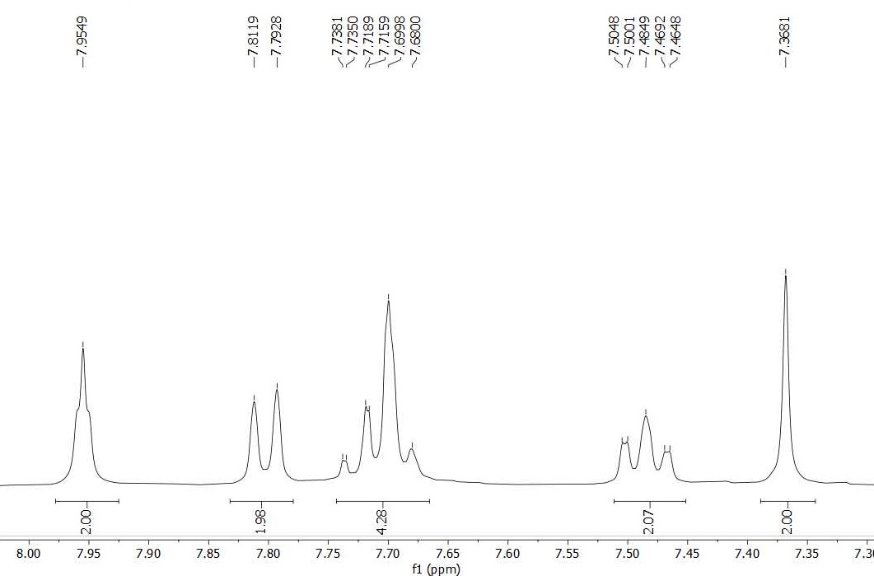

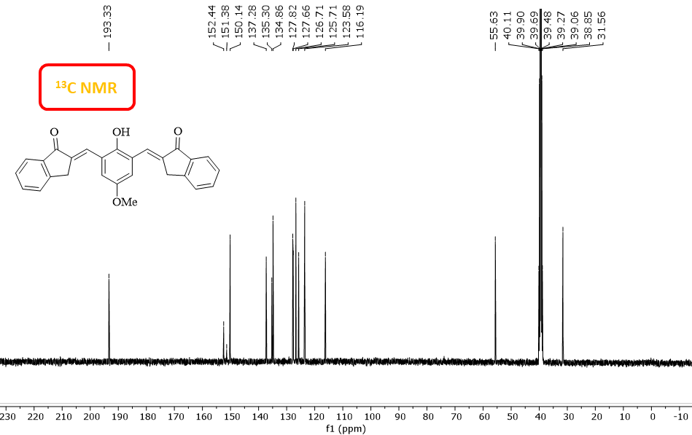

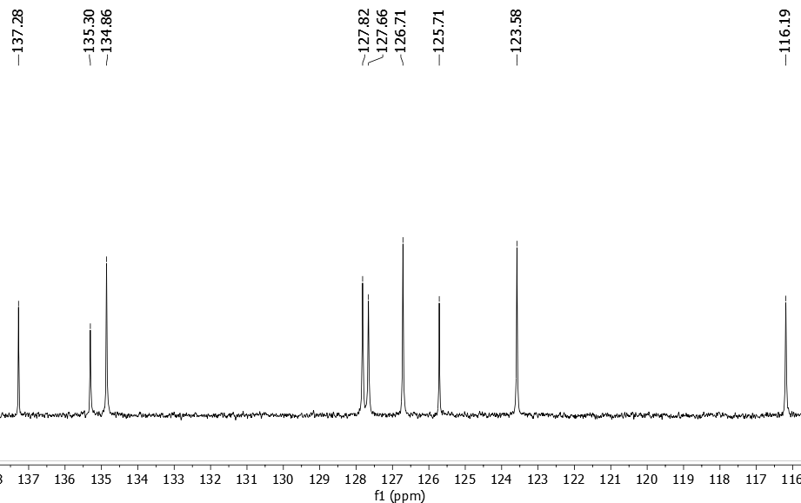
1.8. (2E,2'E)-2,2'-((2-hydroxy-5-methoxy-1,3-phenylene)bis(methaneylylidene))bis(3,4-dihydronaphthalen-1(2H)-one) (4h)
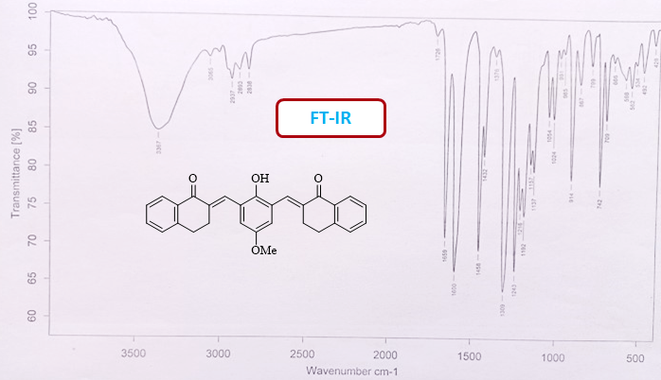
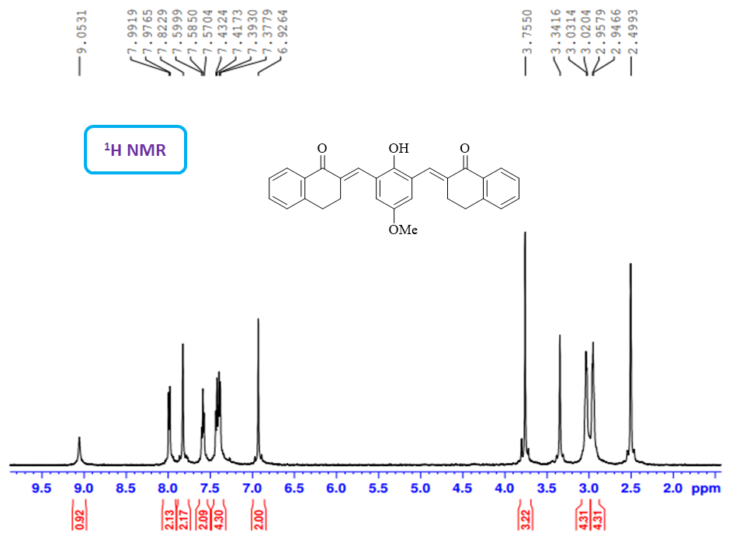
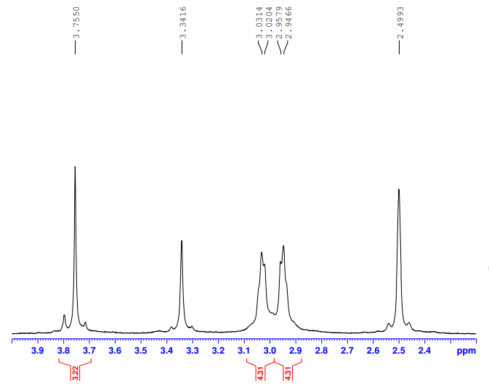
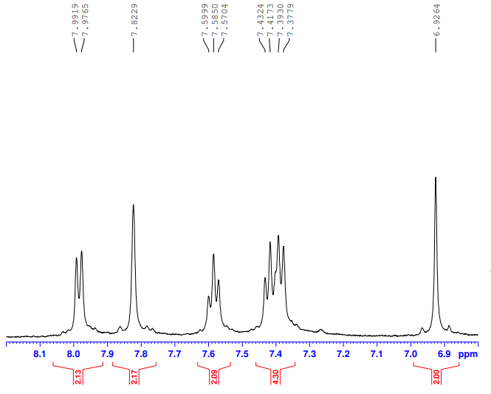
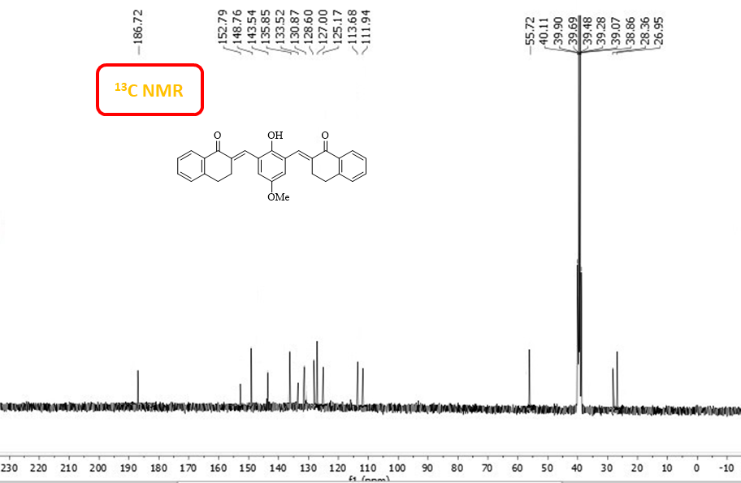

2. Figure of 2D ligand-receptor interaction with 7AIX enzyme

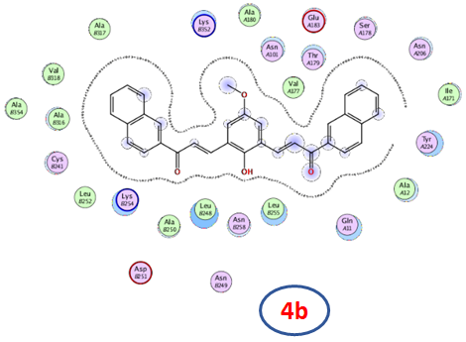
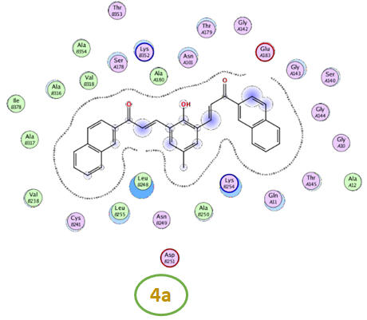

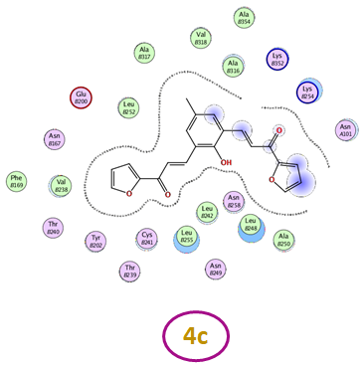
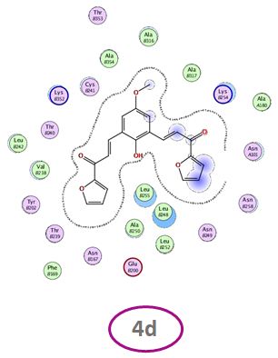

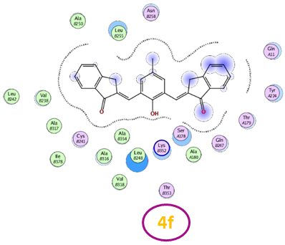
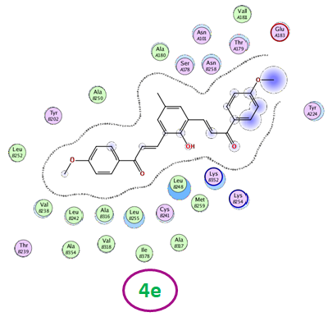

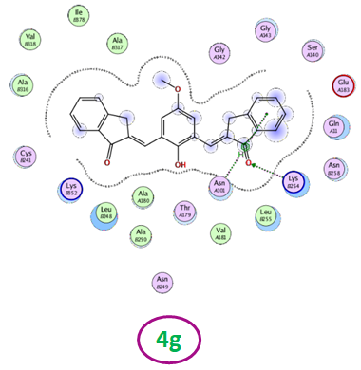
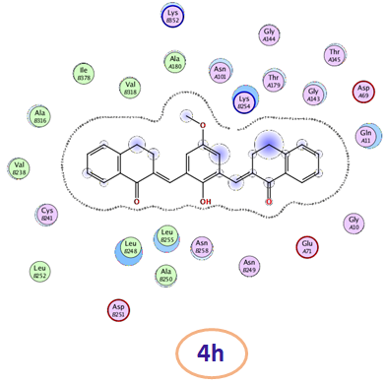

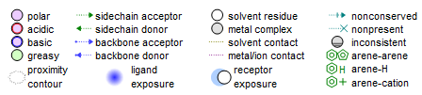

3. Figure of the binding mode of compounds with the colchicine binding site (PDB ID: 1SA0)

