The wheat stem rust resistance gene Sr43 encodes an unusual protein kinase

Yu et al.

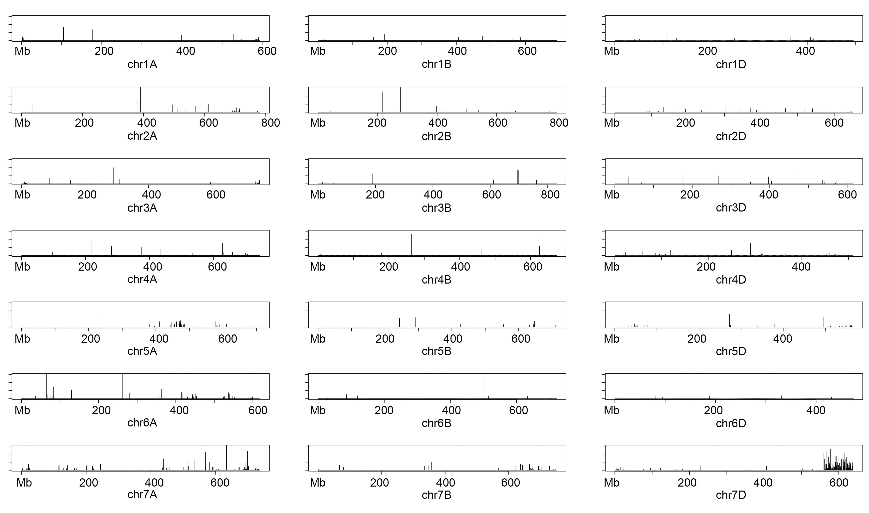
Supplementary Fig. 1: Genotyping-by-sequencing (GBS) plot of the Sr43 wheat-Th. elongatum introgression wild type line. The SNP frequency was plotted in 10 Mb bins along the length of each chromosome relative to wheat cv. Chinese Spring.
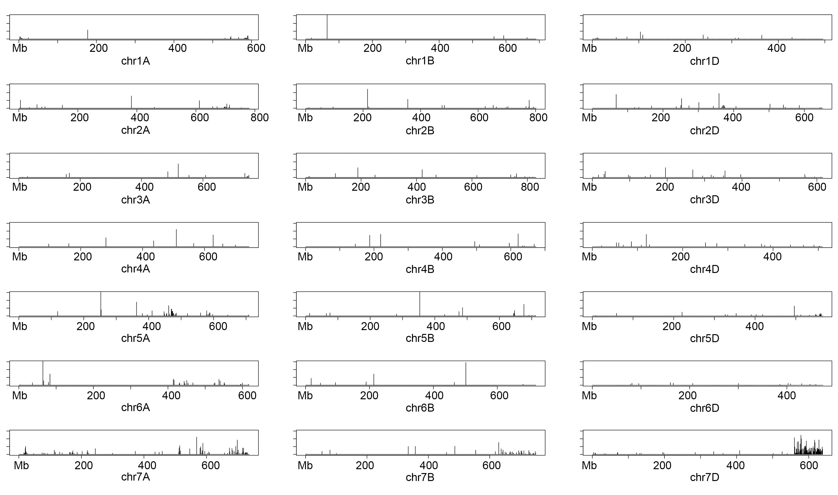 Supplementary Fig. 2: GBS plot of the Sr43 wheat-Th. elongatum introgression EMS mutant 31b.

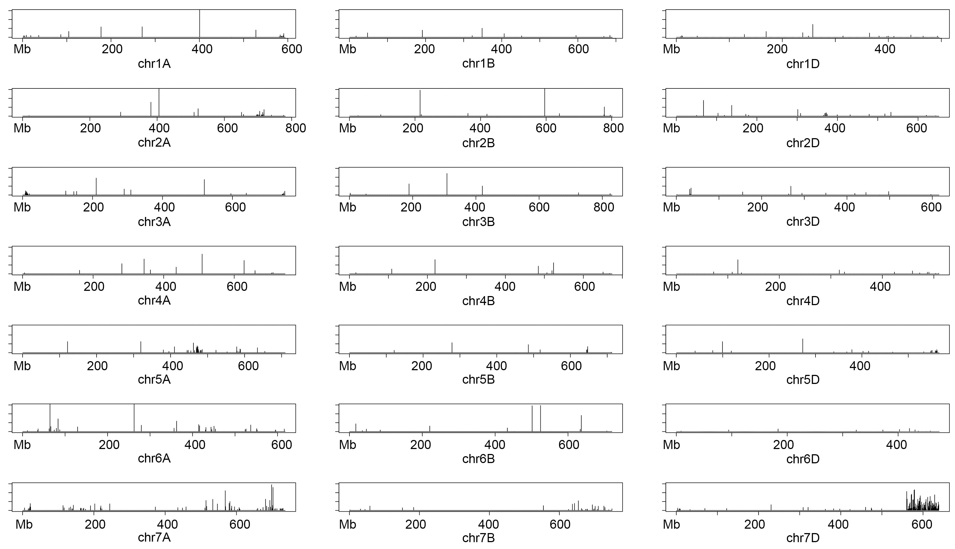
Supplementary Fig. 3: GBS plot of the Sr43 wheat-Th. elongatum introgression EMS mutant 187g.
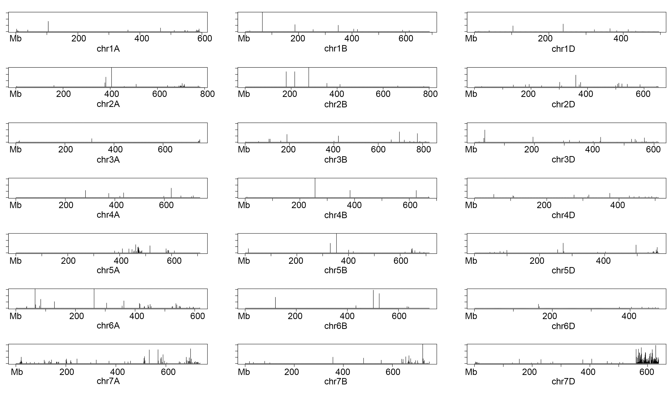
Supplementary Fig. 4: GBS plot of the Sr43 wheat-Th. elongatum introgression EMS mutant 276b.

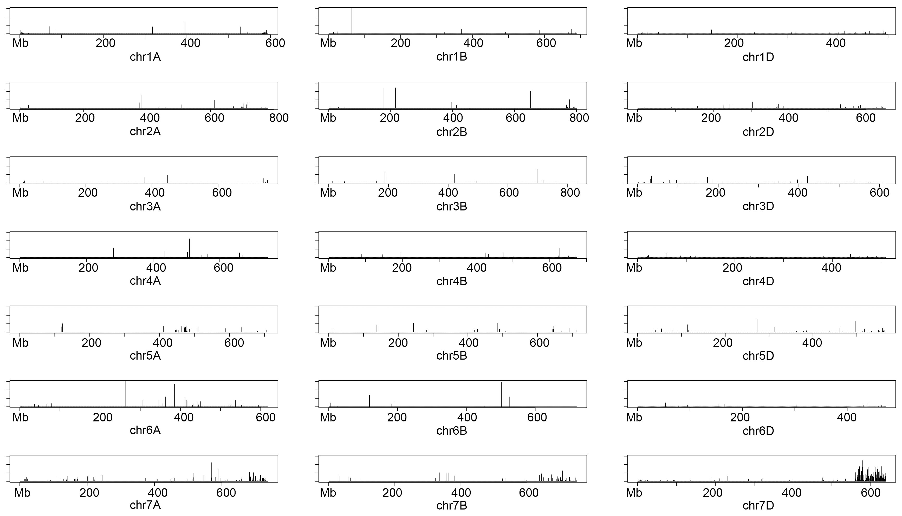
Supplementary Fig. 5: GBS plot of the Sr43 wheat-Th. elongatum introgression EMS mutant 450b.

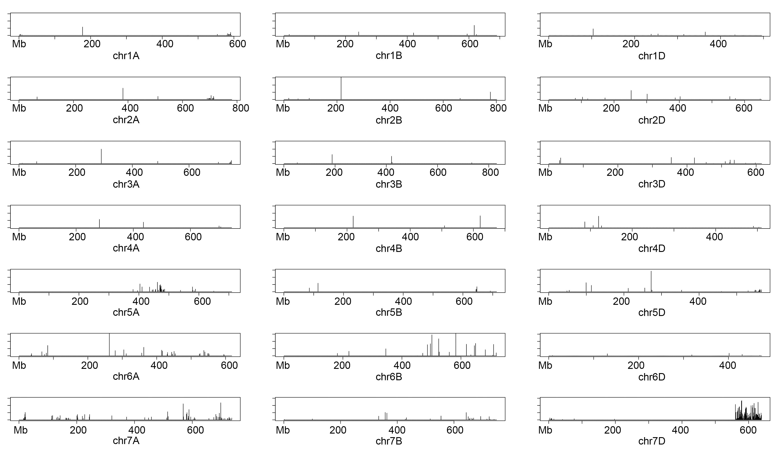
Supplementary Fig. 6: GBS plot of the Sr43 wheat-Th. elongatum introgression EMS mutant 706f.
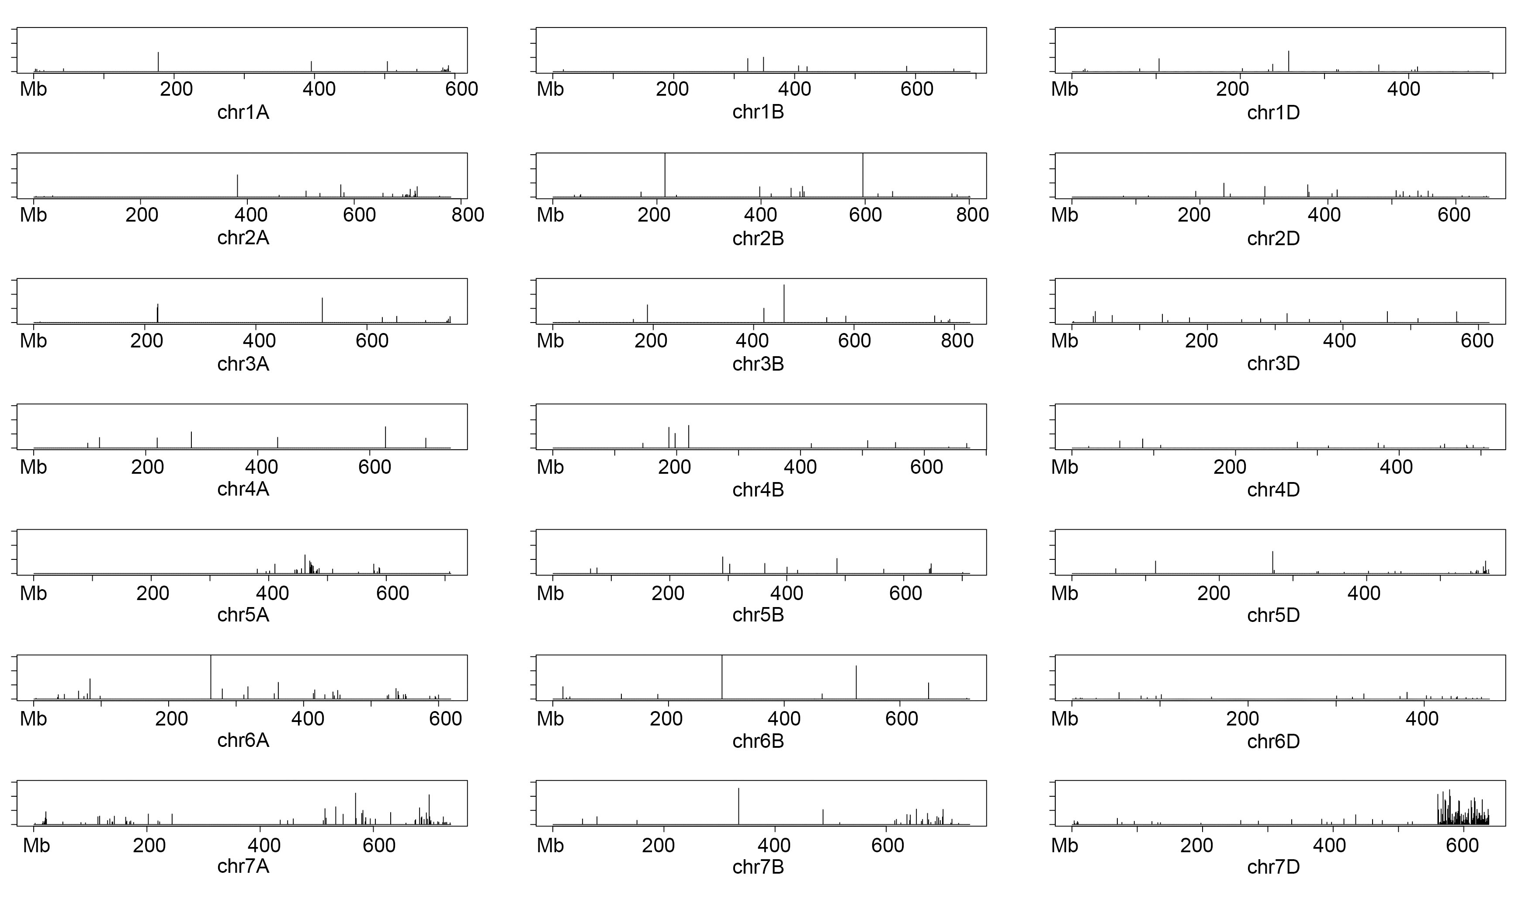
Supplementary Fig. 7: GBS plot of the Sr43 wheat-Th. elongatum introgression EMS mutant 1013a.
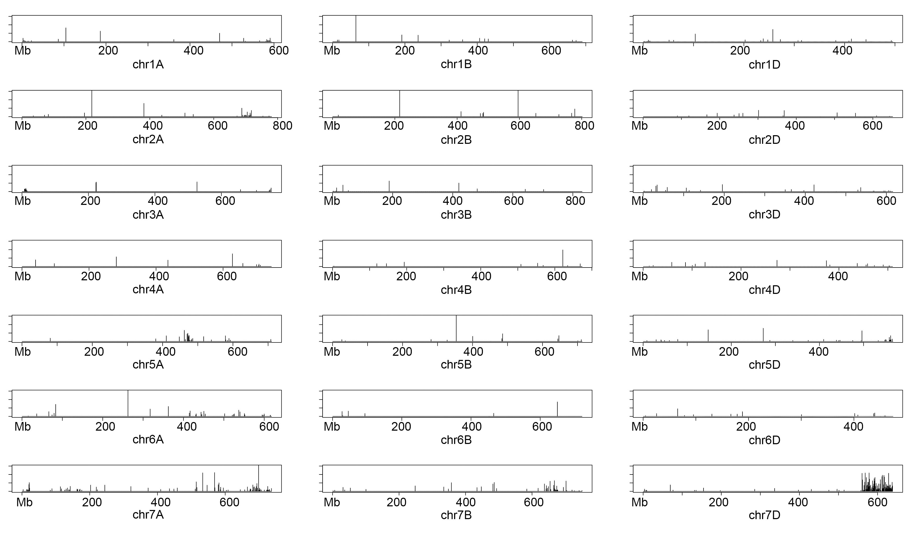
Supplementary Fig. 8: GBS plot of the Sr43 wheat-Th. elongatum introgression EMS mutant 1102h.
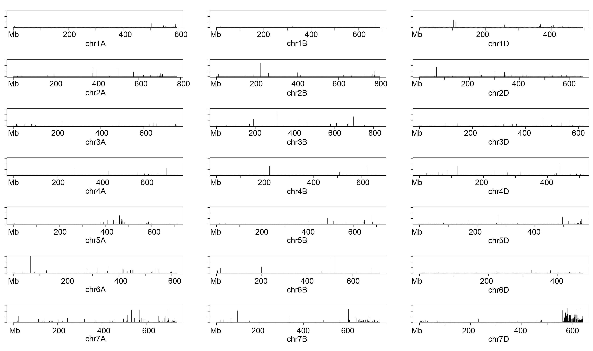
Supplementary Fig. 9: GBS plot of the Sr43 wheat-Th. elongatum introgression EMS mutant 1298g.
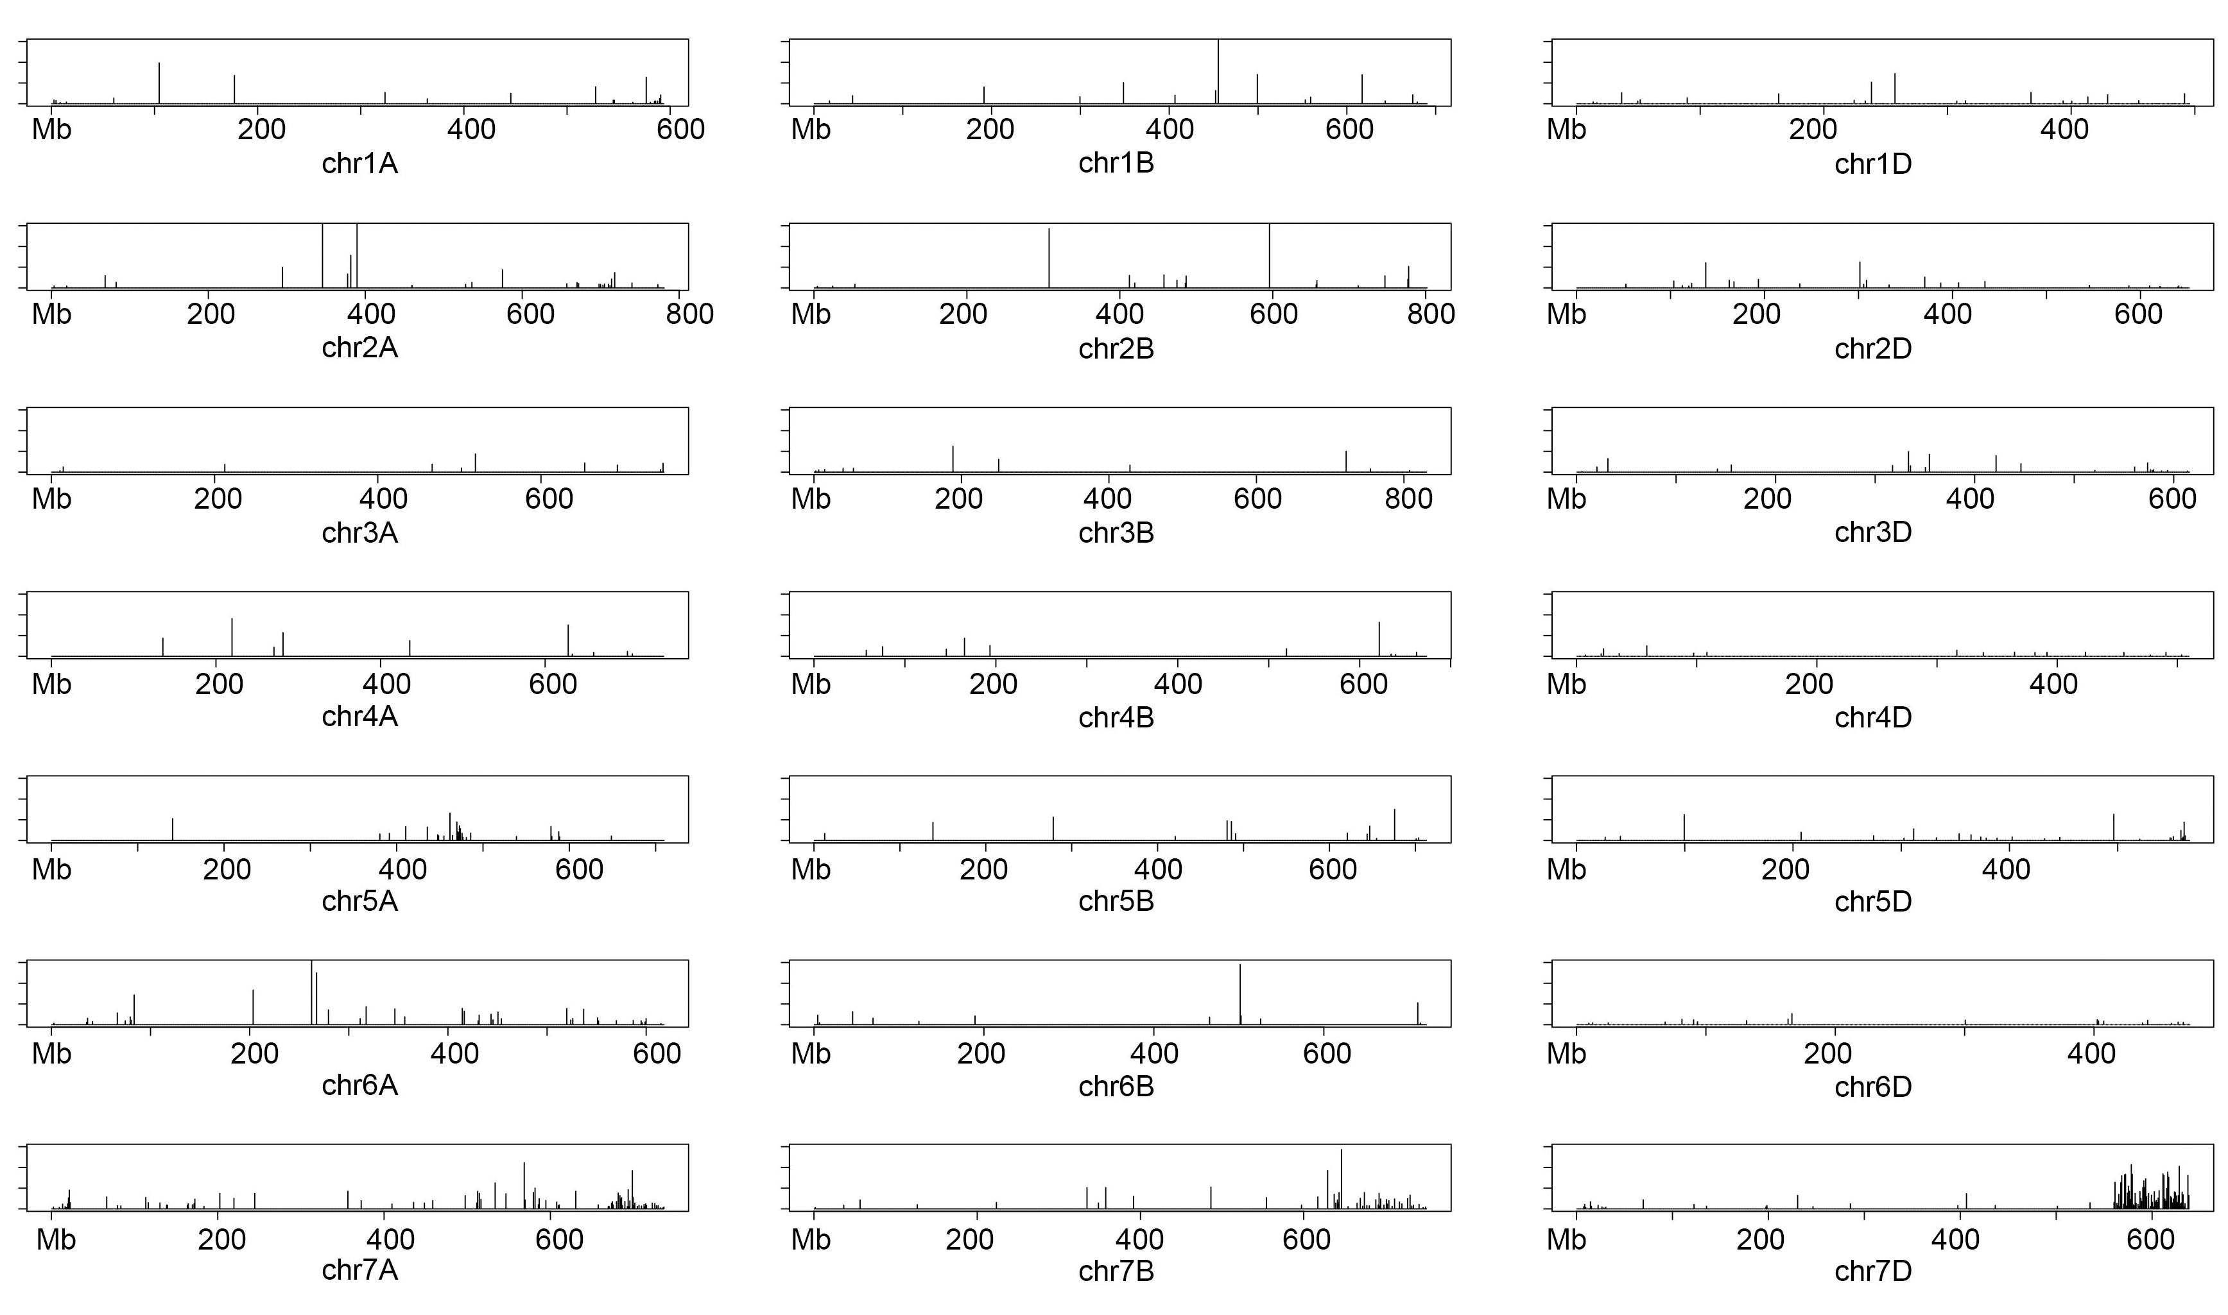
Supplementary Fig. 10: GBS plot of the Sr43 wheat-Th. elongatum introgression EMS mutant 1513d.
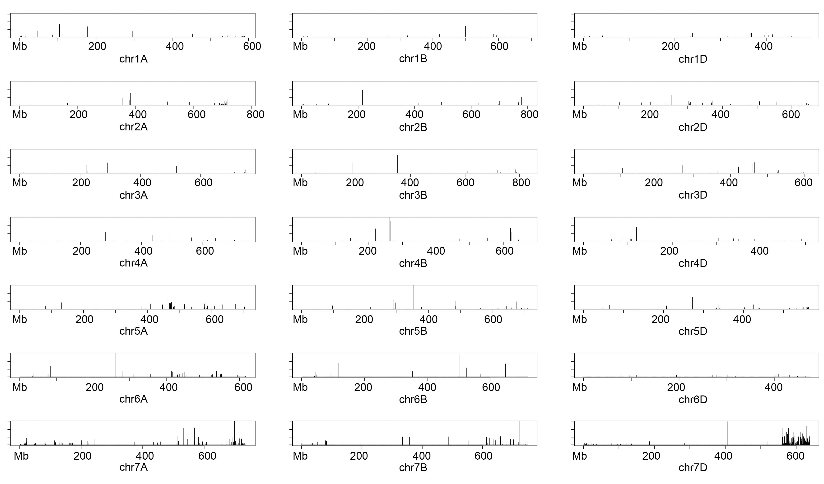
Supplementary Fig. 11: GBS plot of the Sr43 wheat-Th. elongatum introgression EMS mutant 1671a.

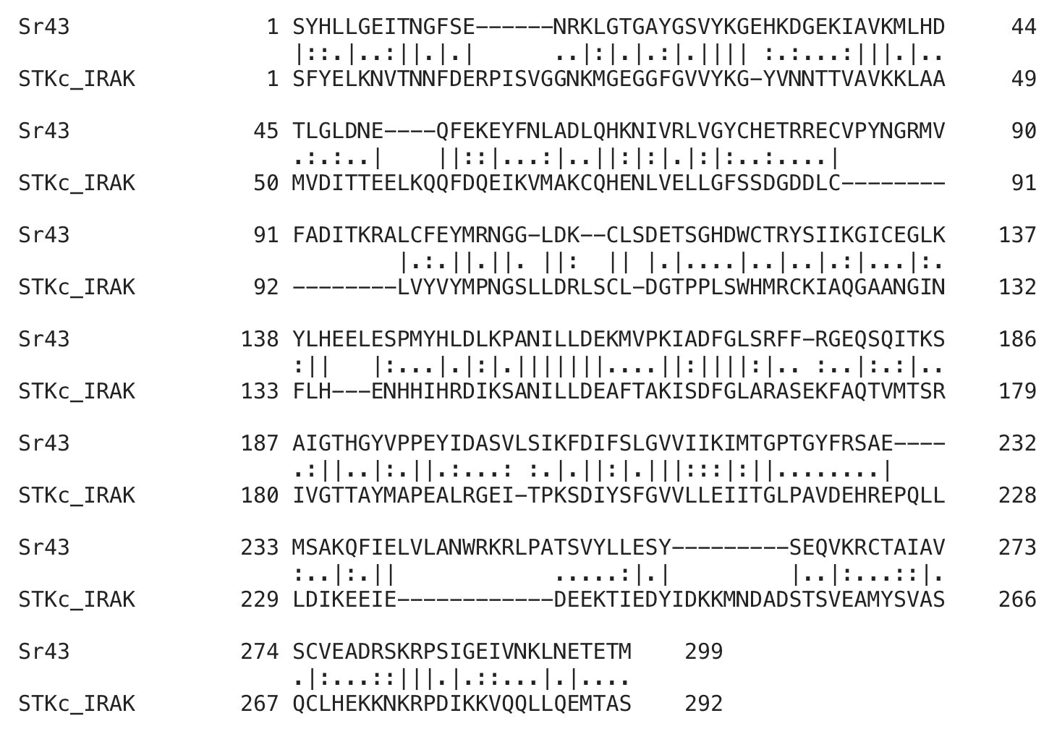

Supplementary Fig. 12: Amino acid alignment between Sr43 and STKc IRAK. The identity is 30.4%, and the e-value is 2.06e-60.

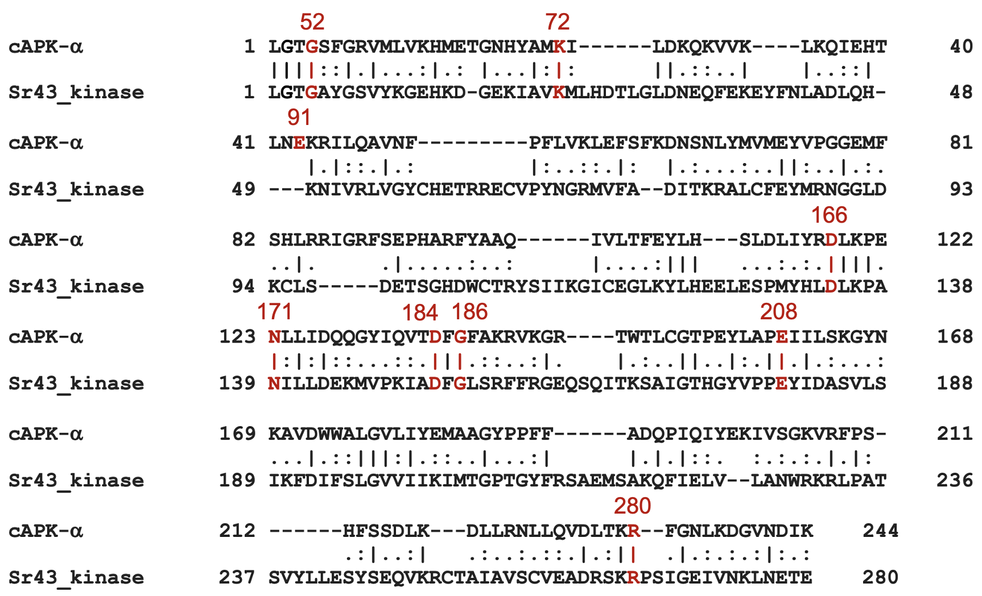
Supplementary Fig. 13: Amino acid alignment between Sr43 and cAPK-α (Hanks, et al. 1988, DOI: 10.1126/science.3291115). Eight out of nine key amino acids are conserved in the Sr43 kinase. The numbers in red are the positions of nine key conserved amino acids of cAPK-α.

