The wheat stem rust resistance gene Sr43 encodes an unusual protein kinase

Yu et al.

Extended Data Figures 1-8.

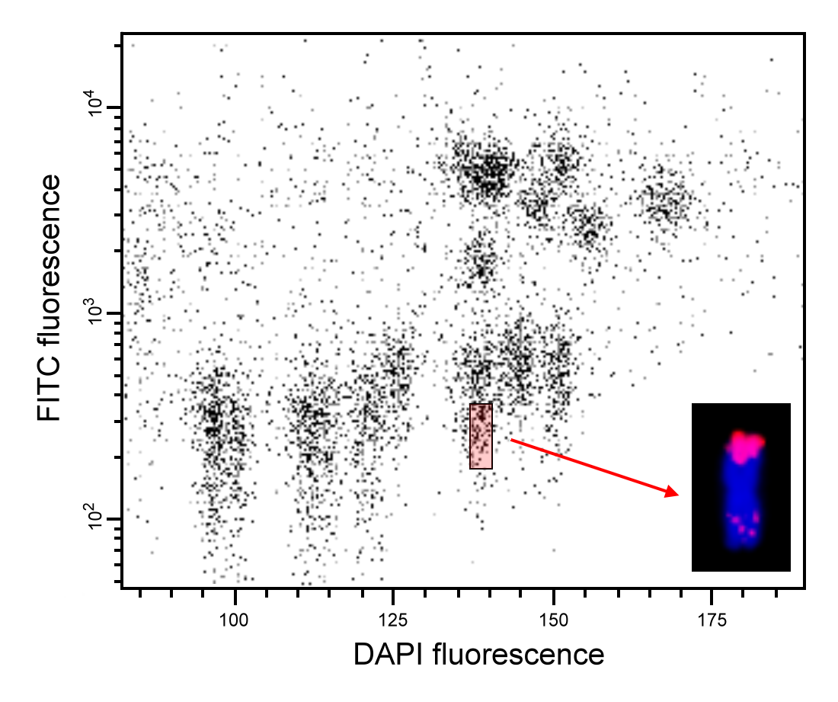
Extended Data Fig. 1: Bivariate flow karyotype of mitotic metaphase chromosomes isolated from the wheat-Th. elongatum 7D/7el2 translocation line carrying the Sr43 resistance gene. DAPI (x-axis) vs. FITC (y-axis) dot plot was obtained after the analysis of DAPI-stained chromosome suspensions labeled by FISHIS with FITC-conjugated probes for GAA and ACG microsatellites. The 7D/7el2 translocation chromosomes were sorted from the sorting window shown as red rectangle at purities of 60–65%. Inset: 7D/7el2 translocation chromosome after FISH with probes for pSc119.2 repeat (green), Afa family repeat (red) and 45S rDNA (yellow) that was used to identify chromosomes in the sorted fraction. Chromosomes were counterstained by DAPI (blue).
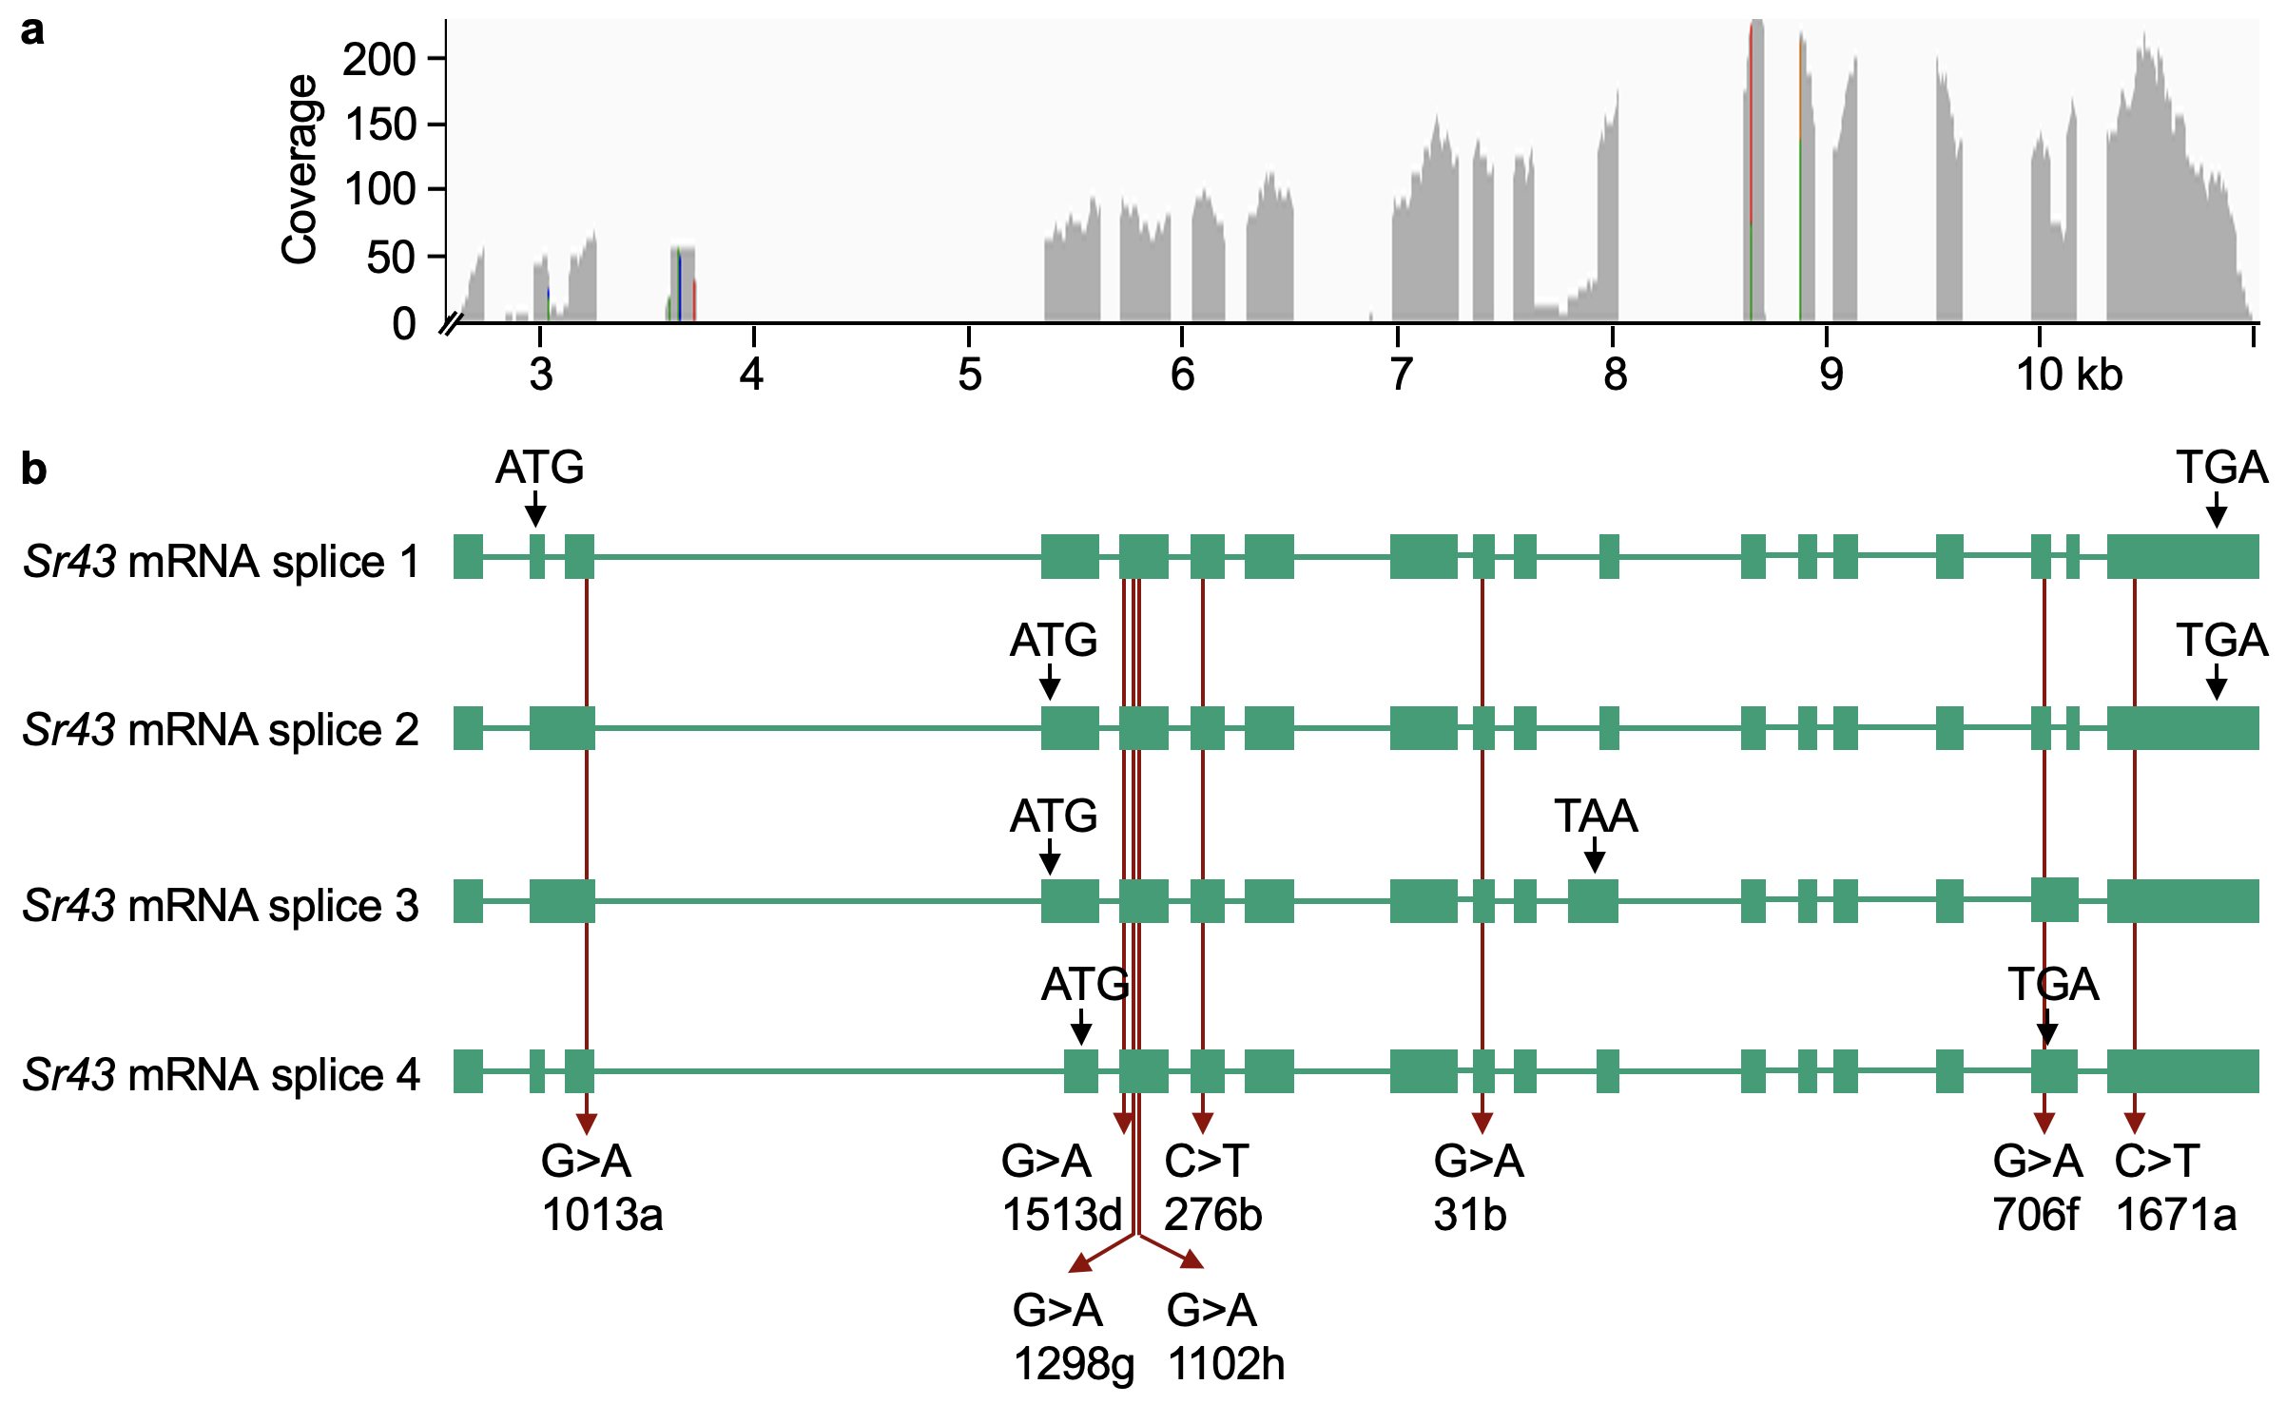

Extended Data Fig. 2: Sr43 transcript and alternative splicing. a, Mapping of RNA-seq reads from the leaf transcriptome onto the Sr43 locus. b, mRNA splice variants identified by sequencing full-length cDNA clones. Introns and exons are represented by lines and boxes, respectively. Splice variants 1, 2, 3 and 4 have 8, 7, 5 and 6 EMS-induced mutations in the coding sequence, respectively.

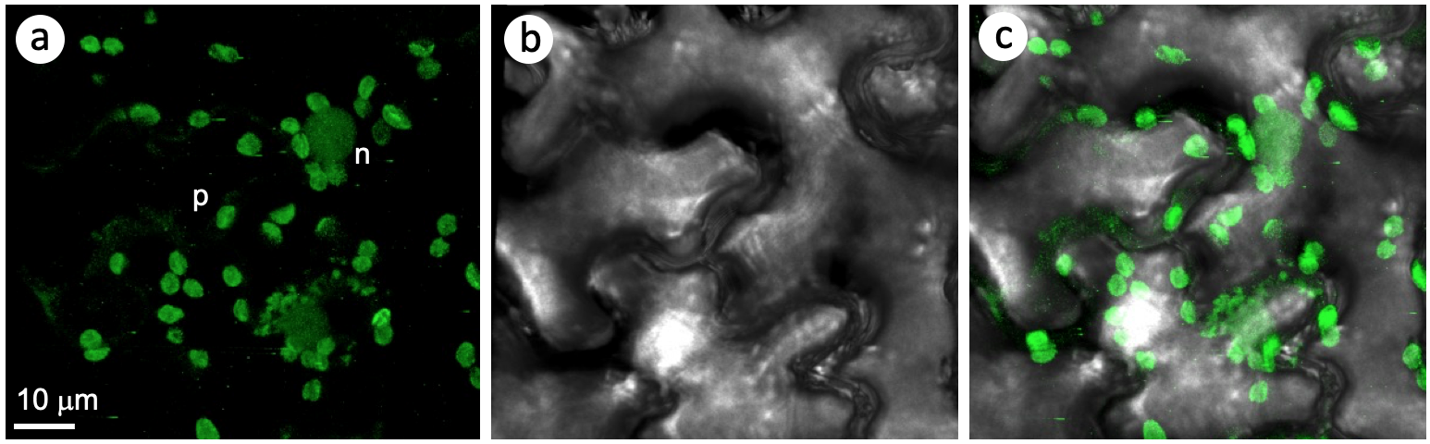
Extended Data Fig. 3: Sr43 localizes to the nucleus and plastids. Agrobacterium-mediated transient expression of an Sr43-GFP fusion construct driven by the cauliflower mosaic virus (CaMV) 35S promoter in Nicotiana benthamiana. a, GFP fluorescence in epidermal cells was recorded at 3 days post infiltration by confocal laser scanning microscopy. b, Bright-field channel. c, merge.
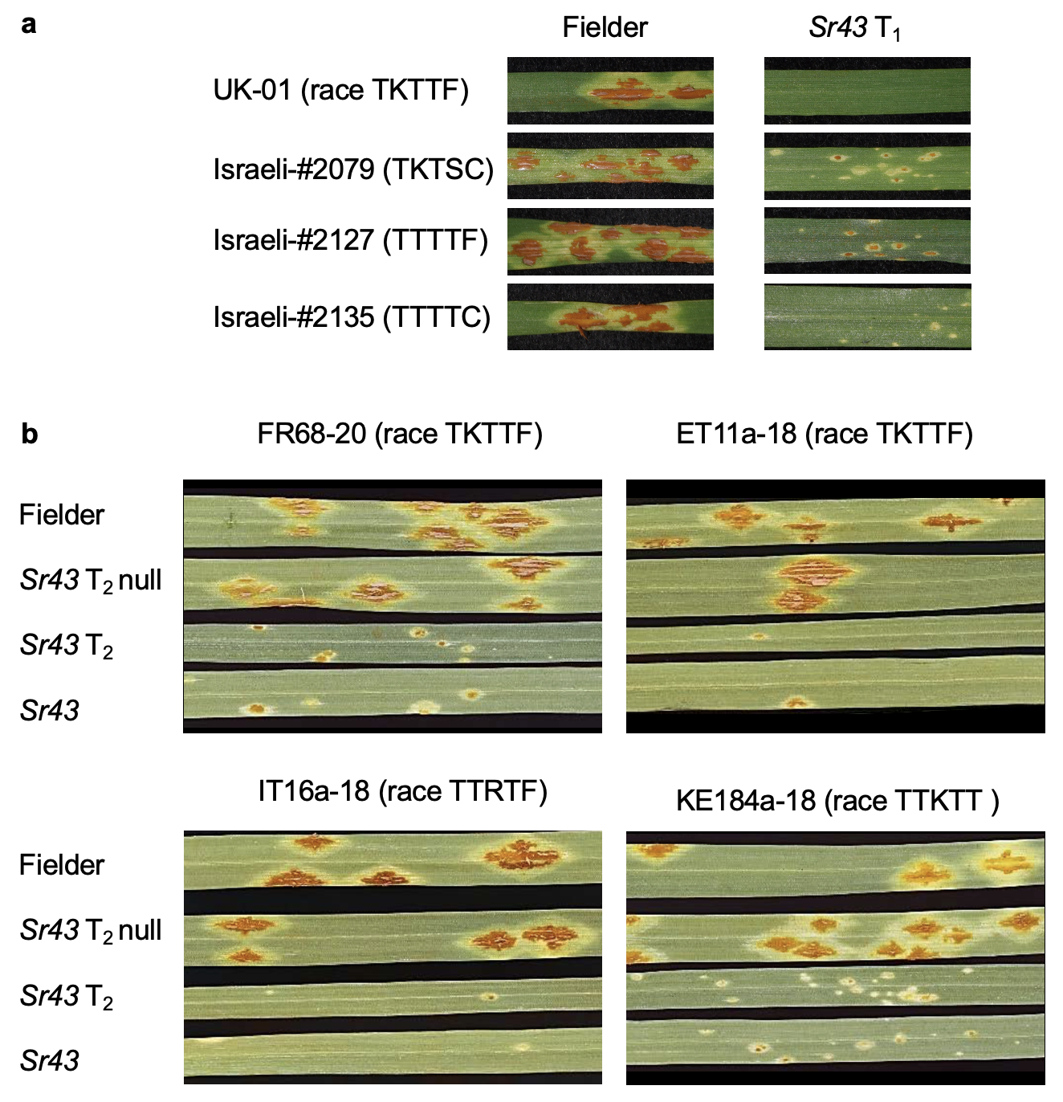
Extended Data Fig. 4: Reactions of Sr43 transgenic plants and controls to seven races/isolates of the fungal agent causing stem rust. a, homozygous transgenic lines from generation T₁ alongside the non-transgenic parent cultivar Fielder. b, Homozygous transgenic lines and null segregants from generation T₂.

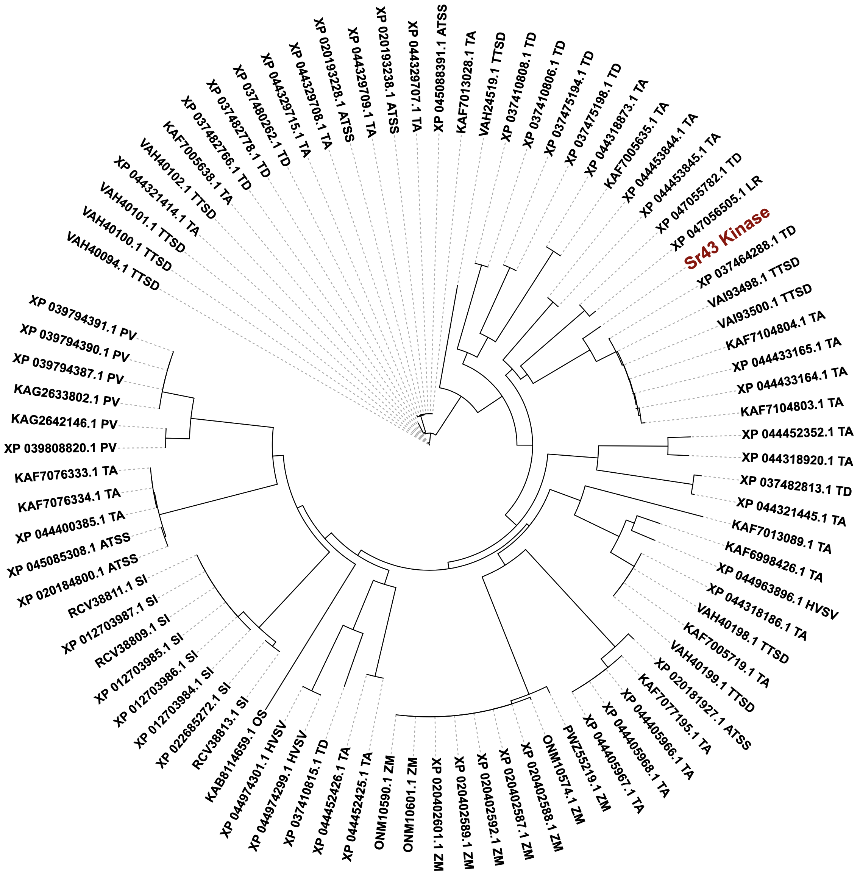

Extended Data Fig. 5: Phylogenetic tree of the Sr43 kinase domain with best hits from the NCBI protein database. A minimum threshold of 94% coverage and an identity of ≥60% were applied. ATSS, Aegilops tauschii subsp. strangulata; HVSV, Hordeum vulgare subsp. vulgare; LR, Lolium rigidum; OS, Oryza sativa; PV, Panicum virgatum; SI, Setaria italica; TA, Triticum aestivum; TD, Triticum dicoccoides; TTSD, Triticum turgidum subsp. durum; ZM, Zea mays.
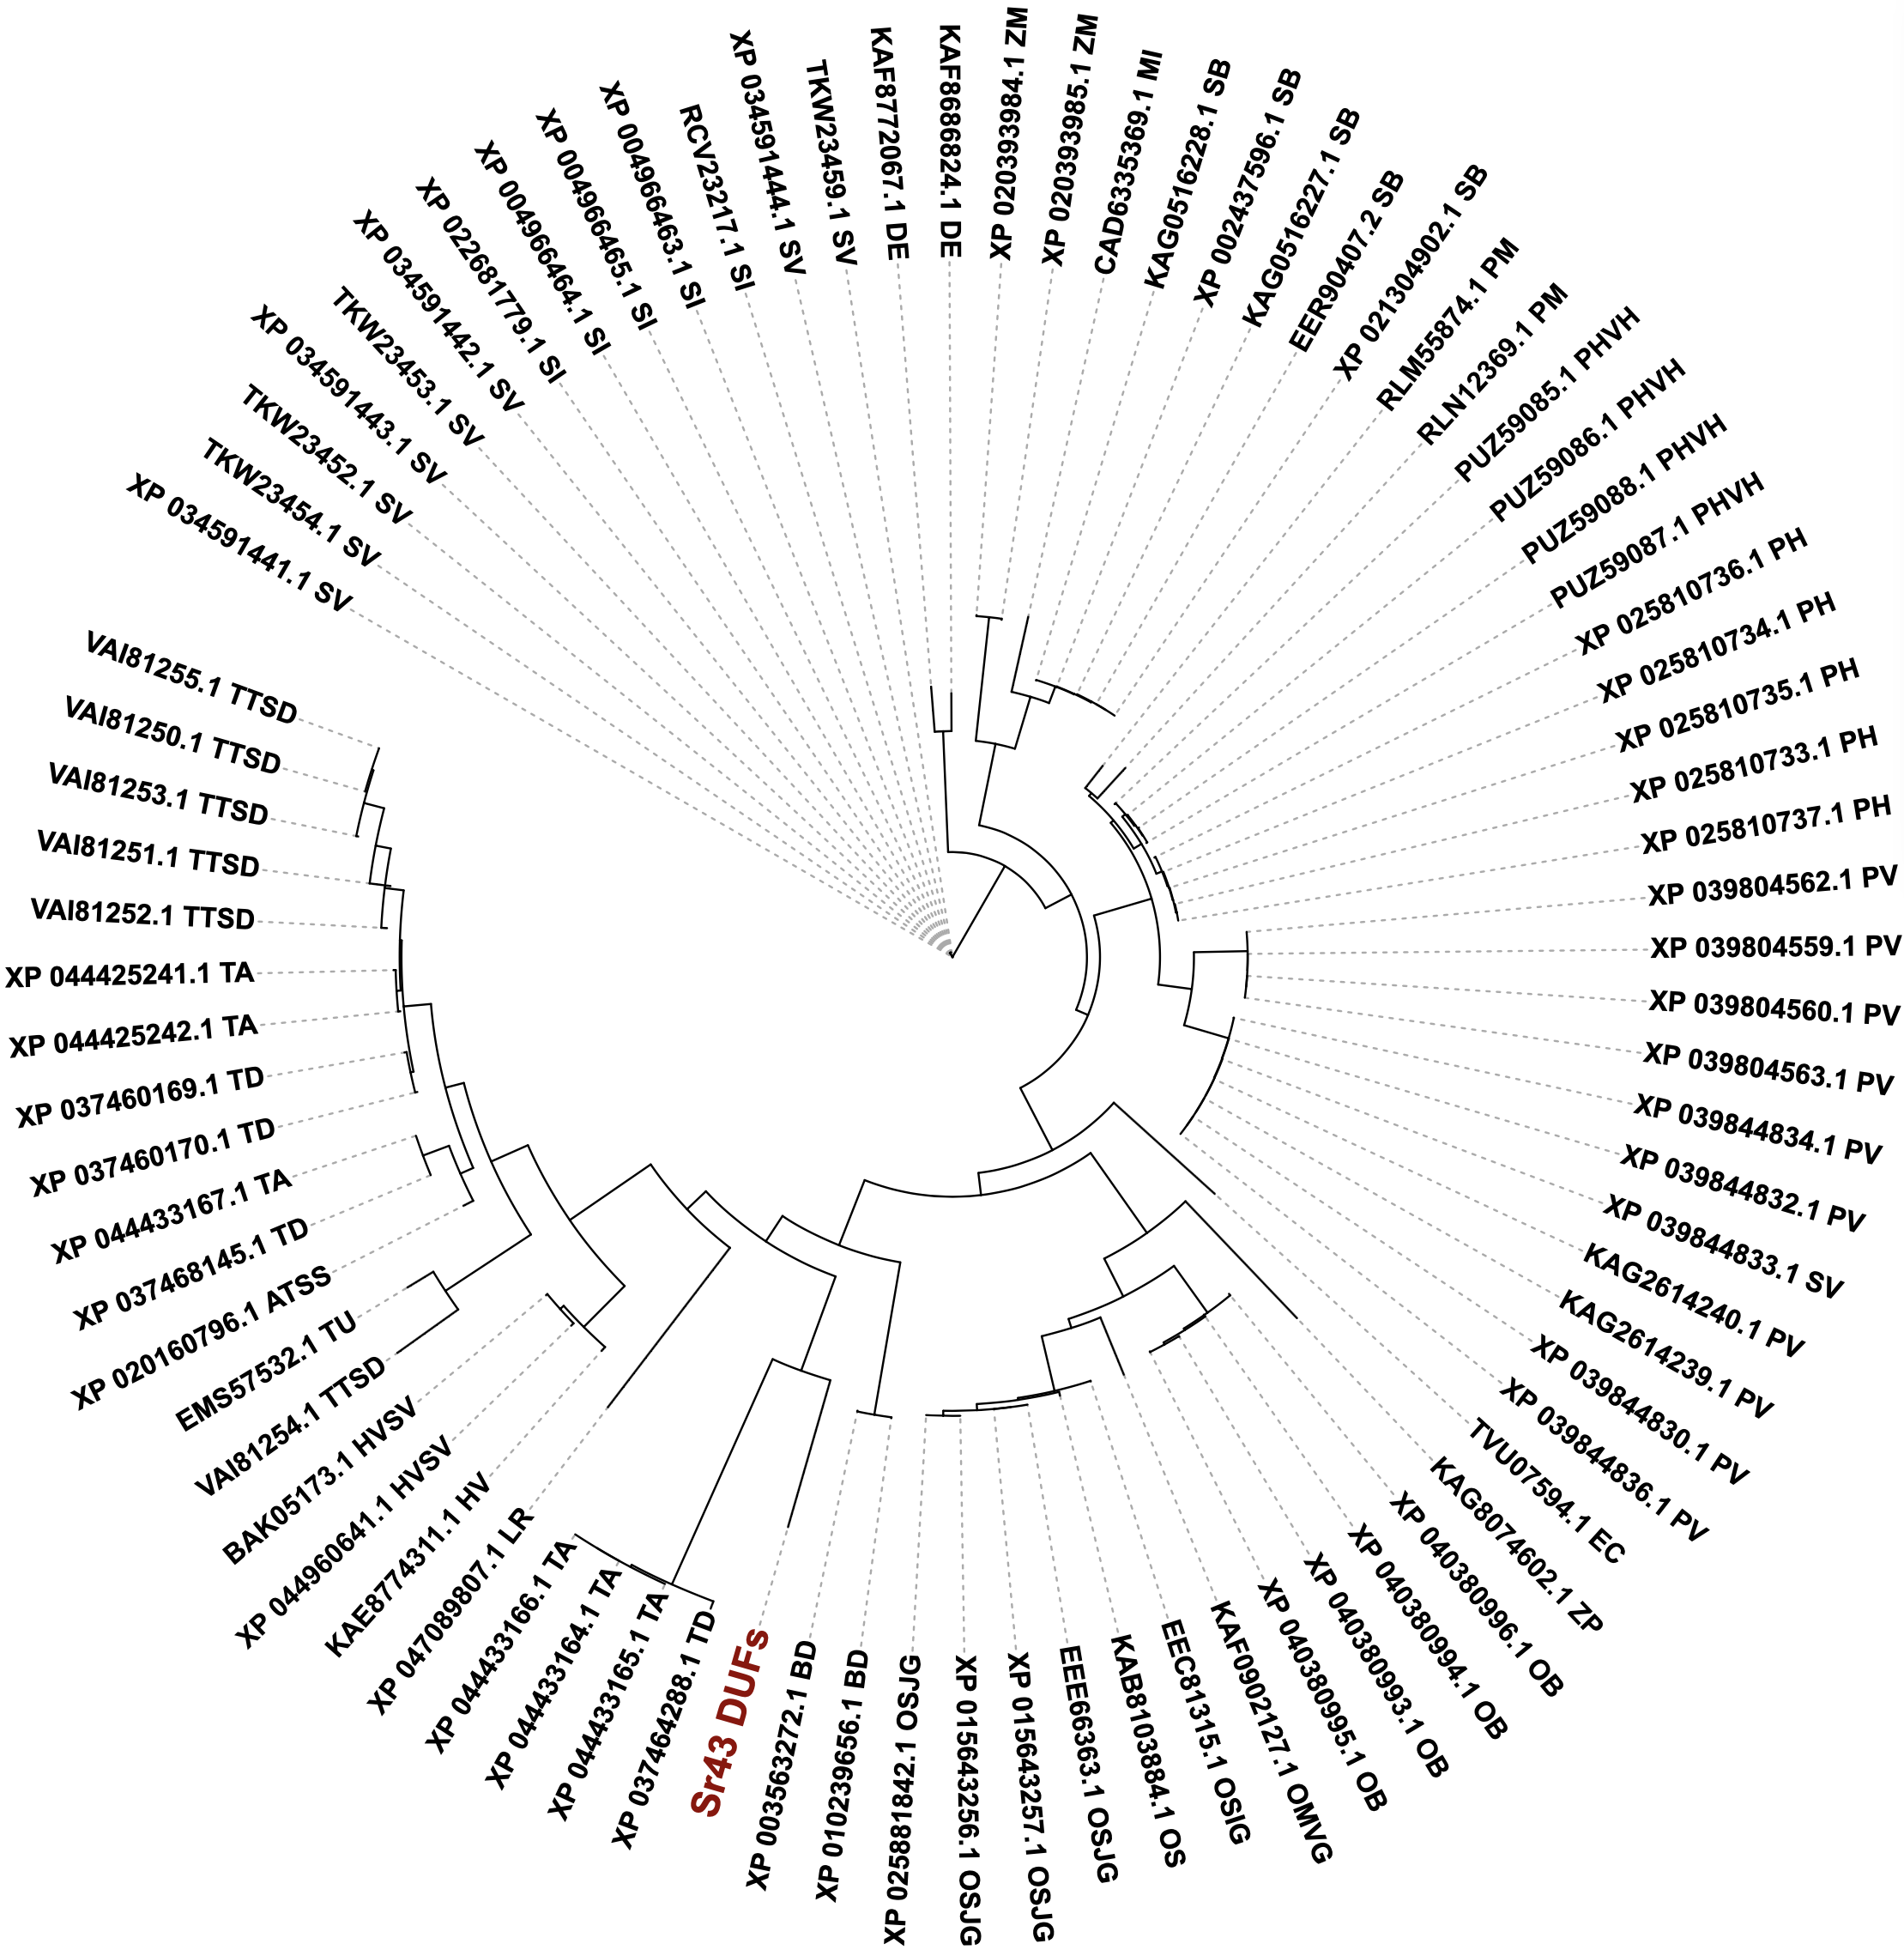

Extended Data Fig. 6: Phylogenetic tree of the Sr43 DUF region with best hits from the NCBI protein database. A minimum threshold of ≥99% coverage and an identity of ≥70% were applied. ATSS, Aegilops tauschii subsp. strangulata; BD, Brachypodium distachyon; DE, Digitaria exilis; EC, Eragrostis curvula; HV, Hordeum vulgare; HVSV, Hordeum vulgare subsp. vulgare; LR, Lolium rigidum; ML, Miscanthus lutarioriparius; OB, Oryza brachyantha; OMVG, Oryza meyeriana var. granulata; OS, Oryza sativa; OSIG, Oryza sativa Indica Group; OSJG, Oryza sativa Japonica Group; PH, Panicum hallii; PHVH, Panicum hallii var. hallii; PM, Panicum miliaceum; PV, Panicum virgatum; SI, Setaria italica; SV, Setaria viridis; SB, Sorghum bicolor; TA, Triticum aestivum; TD, Triticum dicoccoides; TTSD, Triticum turgidum subsp. durum; TU, Triticum urartu; ZM, Zea mays; ZP, Zizania palustris.

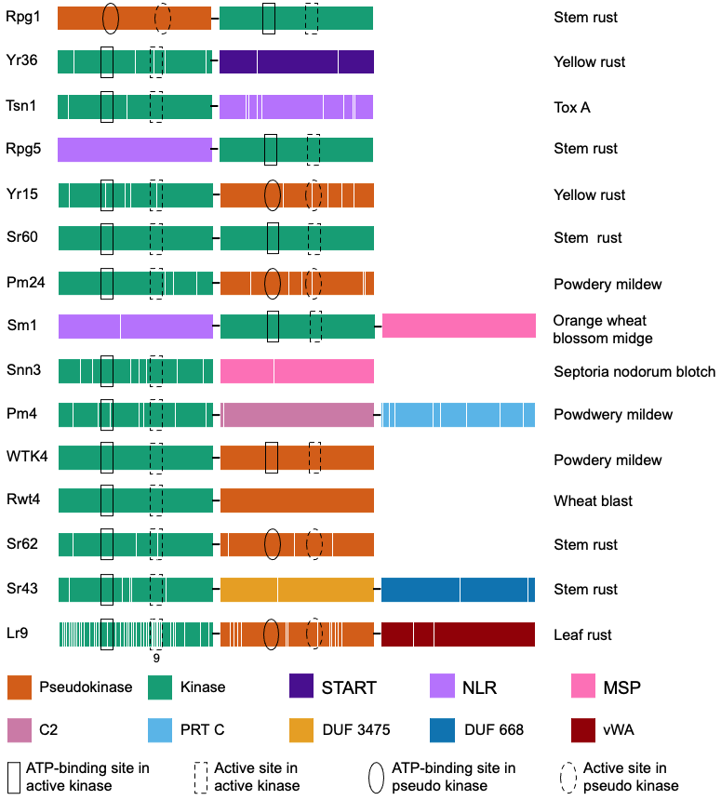

Extended Data Fig. 7: Schematic diagrams of Triticeae kinase fusion proteins with disease resistance function. The ATP-binding and active sites of the kinases are indicated by boxes and circles in the active and pseudo kinases, respectively, as determined by Interpro scanning, homology searching in AlphaFold-derived 3D models, and/or BLAST. White bars indicate loss-of-function missense mutations obtained from EMS mutant screens. For the figure, the mutations were spaced evenly in each region of the domains. Eight mutations in the linker domains are not shown. The proteins are organized from top to bottom by date of publication: Rpg1, Yr36, Tsn1, Rpg5, Yr15, Sr60, Pm24, Sm1, Snn3, Pm4 (encoded by splice version 2), WTK4, Rwt4, Sr62 (refs. 7,14,17,18,8,9,11,19,16,15,12,13,10), Sr43 (this study) and Lr9 (ref. ²⁰). START, Steroidogenic Acute Regulatory Protein-related Lipid Transfer; NLR, nucleotide-binding and leucine-rich repeat; MSP, major sperm protein; C2, C2 domain; PRT C, phosphoribosyl transferase C-terminal domain; DUF, domain of unknown function; vWA, von Willebrand factor type A domain. White bars indicate the position of EMS-derived loss-of-function mutations (excluding early stop codon mutations) where they are available. The number 9 underneath the active site in the active kinase of Lr9 indicates the presence of nine mutations.

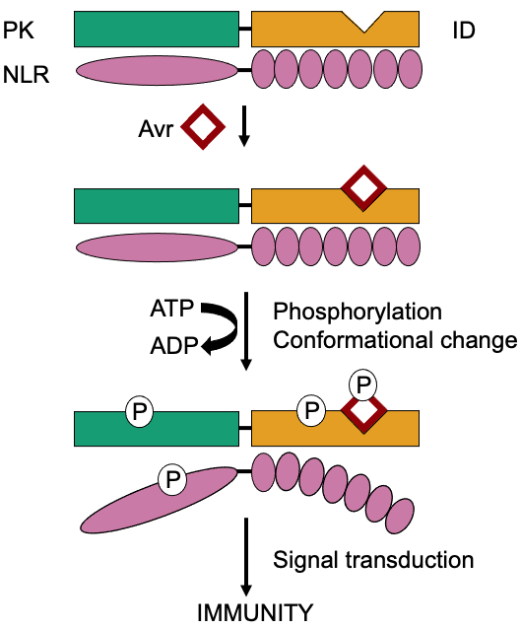

Extended Data Fig. 8: Mechanistic model of protein kinase fusion proteins in plant disease resistance. The protein kinase (PK) fusion protein contains an integrated decoy (ID) that traps the avirulence (Avr) effector protein (red square). This triggers an autophosphorylation of either the protein kinase or decoy, the effector, or the nucleotide binding leucine-rich repeat (NLR) guard. This results in a conformational change which in turn triggers a signal cascade leading to downstream defense responses and immunity.

