Additional file 1: Patient preparatory tool
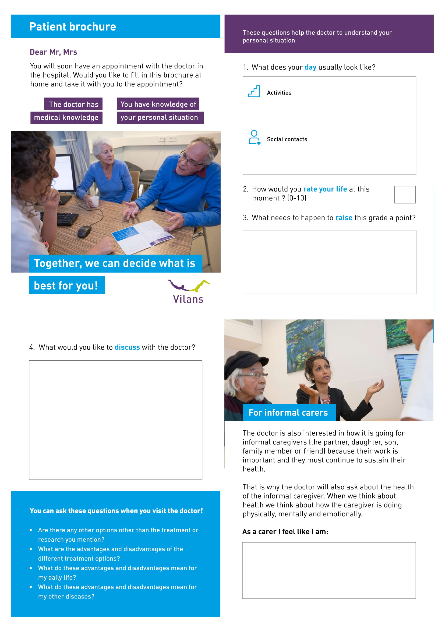
https://www.vilans.org/app/uploads/2019/07/patient-brochure.pdf

