[Climate Dynamics]
Supplementary materials for
[Cumulative positive contributions of propagating MJO to the quick low-level atmospheric response during El Niño developing years]

[Haibo Hu^{#, *, 2} Rongrong Wang* Fei Liu^{3,4} William Perrie⁵ Jiabei Fang* Haokun Bai*]

*CMA-NJU Joint Laboratory for Climate Prediction Studies, Instituted for Climate and Global Change Research, School of Atmospheric Science, Nanjing University, Nanjing 210093, China
²Key Laboratory of Meteorological Disaster of Ministry of Education, Nanjing University of Information Science and Technology, Nanjing 210044, China
³School of Atmospheric Sciences and Guangdong Province Key Laboratory for Climate Change and Natural Disaster Studies, Sun Yat-sen University, Zhuhai 519082, China
⁴Southern Marine Science and Engineering Guangdong Laboratory (Zhuhai), Zhuhai 519082, China
⁵ Bedford Institute of Oceanography, Fisheries and Oceans Canada, Dartmouth, Nova Scotia Canada

Contents of this file
Figure S1 to S11
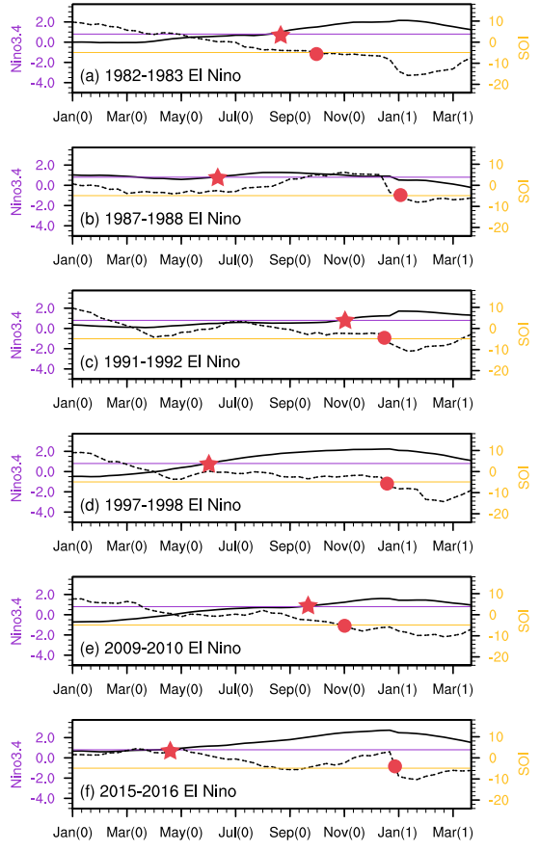
Figure S1. The evolution of dekadly Niño3.4 (black solid line) and SOI (black dashed line) in six El Niño events during 1982–2016. The atmospheric threshold of steady El Niño (SOI =-4.9, yellow line) and the oceanic threshold of steady El Niño (Niño3.4=-0.8, purple line) are showed too. The red star and red solid circle represent the time when Niño3.4 exceeds the oceanic threshold and the SOI exceeds the atmospheric threshold, respectively. This atmospheric threshold (SOI=-4.9) is the averaged SOI, which the period is when the monthly Niño3.4 reaches the El Niño condition.
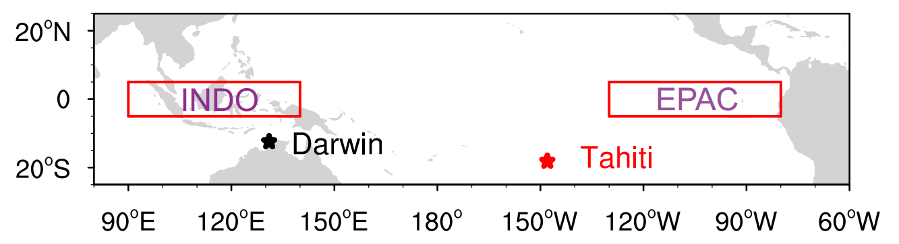
Figure S2. The ESOI is a standardized index according to the averaged SLPA differences between eastern Pacific (EPAC, 80°W-130°W, 5°S-5°N, red rectangle on the right) and Indonesia (INDO, 90°E~140°E, 5°S~5°N, red rectangle on the left). The SOI is a standardized SLPA differences between Tahiti station (148°05'W, 17°53'S, eastern Pacific, red star symbol) and Darwin station (130°59'E, 12°20'S, Australia, black star symbol).
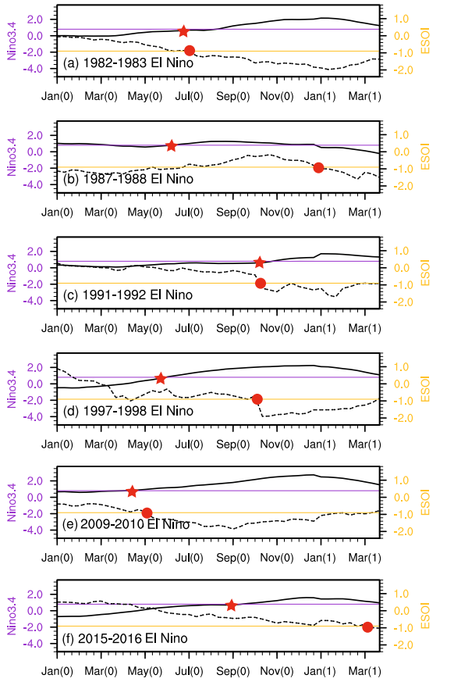
Figure S3. The evolution of dekadly Niño3.4 (black solid line) and ESOI (black dashed line) in six El Niño events during 1982–2016. The atmospheric threshold of steady El Niño (ESOI =-0.9, yellow line) and the oceanic threshold of steady El Niño (Niño3.4=+0.8, purple line) are showed too. The red star and red solid circle represent the time when Niño3.4 exceeds the oceanic threshold and the ESOI exceeds the atmospheric threshold. This atmospheric threshold (ESOI=-0.9) is the averaged ESOI, which the period is when the monthly Niño3.4 reaches the El Niño condition.
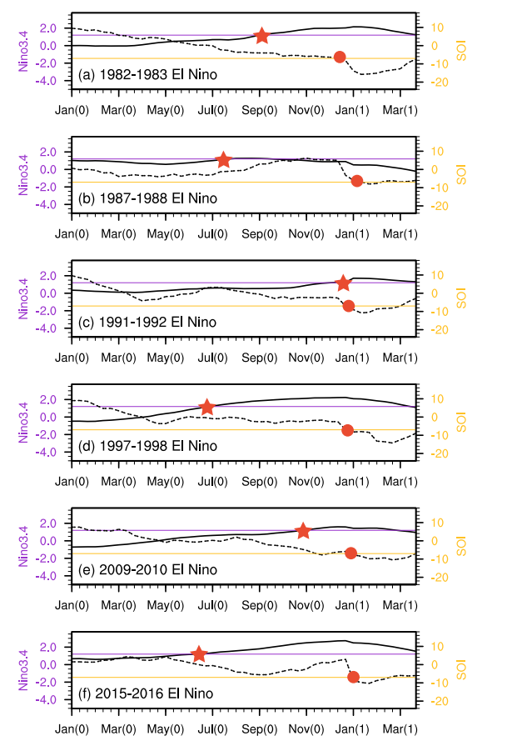
Figure S4. The evolution of dekadly Niño3.4 (black solid line) and SOI (black dashed line) in six El Niño events during 1982-2016. The atmospheric threshold of steady El Niño (SOI =-7, yellow line) and the oceanic threshold of steady El Niño (Niño3.4=+1.2, purple line) are showed too. The red star and red solid circle represent the time when Niño3.4 exceeds the oceanic threshold and the SOI exceeds the atmospheric threshold. This oceanic threshold (Niño3.4=+1.2) is the averaged Niño3.4, which the period is when the monthly SOI reaches the El Niño condition.
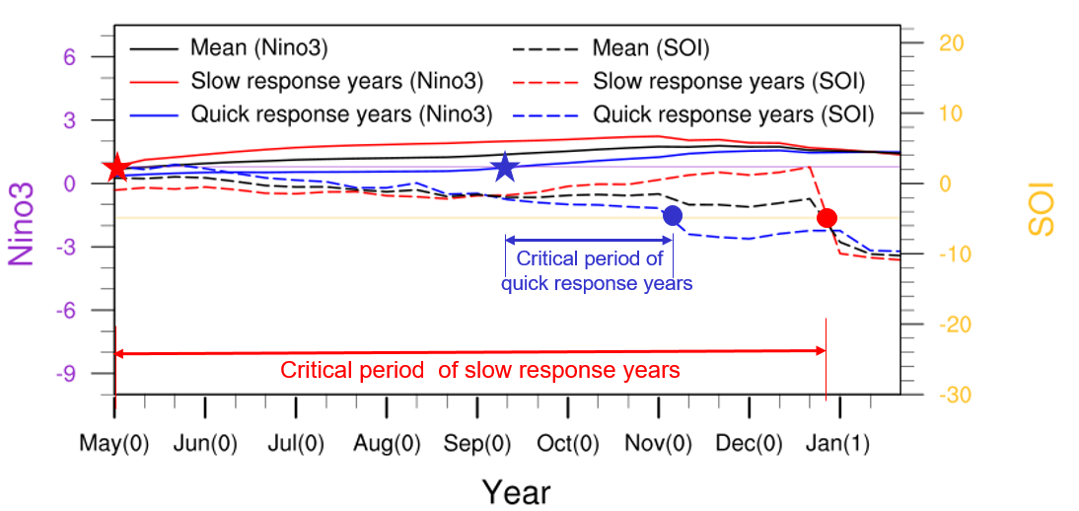
Figure S5. The composite evolution of dekadly SOI and Niño3. X-axis represents the El Niño developing year (0) and El Niño developed year (1). The blue line, red line, and black line represent the quick response years, the slow response years and the average of the all the El Niño years, respectively. The dashed lines are the values of SOI, and the solid lines represent the Niño3. The atmospheric threshold of steady El Niño (SOI =-4.9, yellow line) and the oceanic threshold of steady El Niño (Niño3=0.8, purple line) are showed too. The star and circle represent the time when Niño3 exceeds the oceanic threshold (red star) and the SOI exceeds the atmospheric threshold (red solid circle) in the slow response years; and in the quick response years when the Niño3 exceeds the oceanic threshold (blue star) and the SOI exceeds the atmospheric threshold (blue solid circle). The critical period is defined as the time interval between the red (blue) star and red (blue) solid circle in the slow (quick) response years.
Figure S6. The simulations considering the different MJO initial disturbances of (a) quick and (b) slow response years. The other forcings (SSTA, PBL feedback, U200-U850) are the mean states of all El Niño events for both quick and slow response years. Precipitation rate (shadings; unit: mm/day) and 850hPa geopotential anomalies of subseasonal timescales (dashed black contours, from -200 to 100 every 15, unit: m2s-2) are plotted. Positive (negative) values are denoted by solid (dashed) lines.
Figure S7. Similar to Figure S6. Different vertical shear of zonal wind is used to force the model. The others forcings (initial disturbance, SSTA, PBL feedback) are the mean states.

Figure S8. Similar to Figure S6. Different SSTA pattern are used to force the model. The others forcings (initial disturbance, U200-U850, PBL feedback) are the mean states.

Figure S9. Similar to Figure S6. Different moisture feedback within PBL are used to force the model. The others forcings (initial disturbance, U200-U850, SSTA) are the mean states.
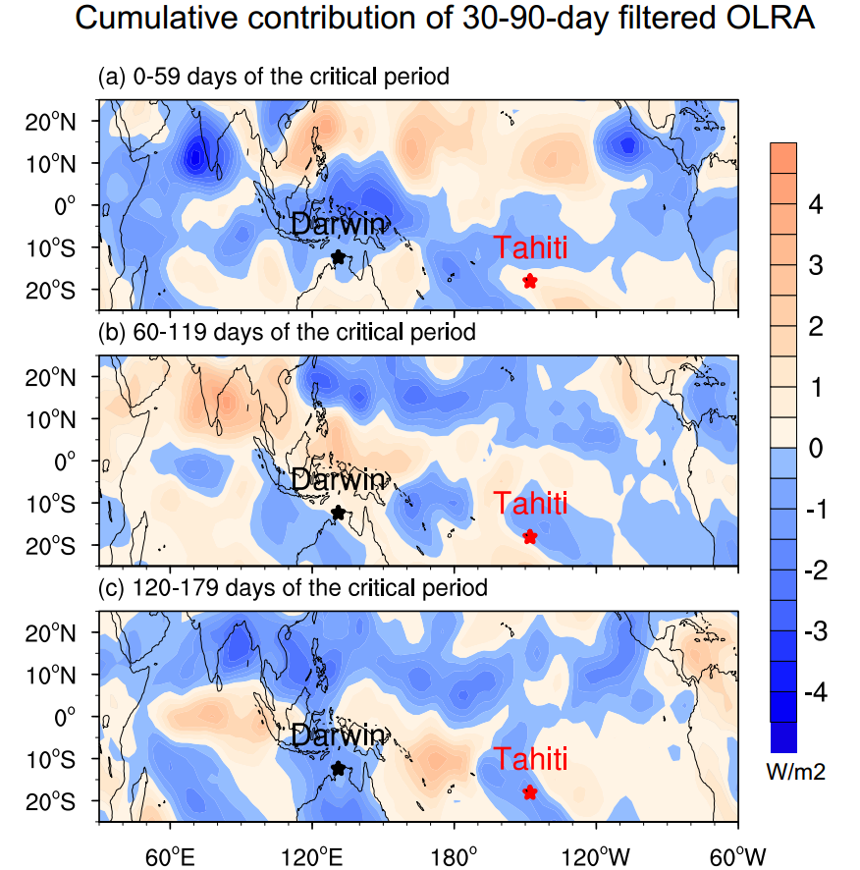
Figure S10. Cumulative contributions of 30–90-day filtered OLRA (contours, units: W/m2) of the critical period in the slow response years. (a) 0–59 days of the critical period of slow response years; (b) 60–119 days; (c) 120–170 days.
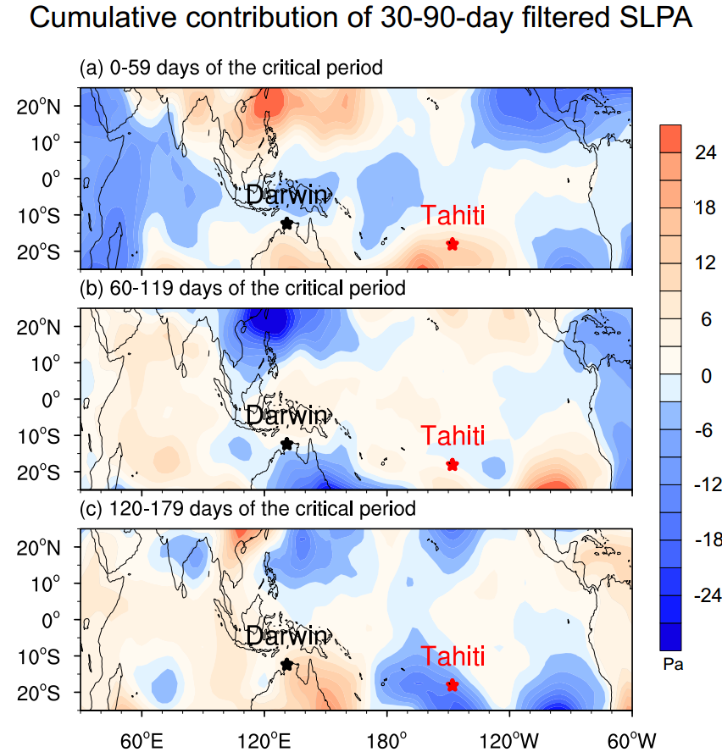

Figure S11. Cumulative contributions of 30–90-day filtered SLPA (contours, units: W/m2) of the critical period in the slow response years. (a) 0–59 days of the critical period of slow response years; (b) 60–119 days; (c) 120–170 days.

