Supplementary Information

Strain tuning of negative capacitance in ferroelectric KNbO₃ thin films

Yongjian Luo¹, Deyang Chen^{1,*}, Zhen Wang^{2,3}, Yu Chen², Minghui Qin¹, Zhen Fan¹, Min Zeng¹, Guofu Zhou⁴, Xubing Lu¹, Xingsen Gao¹, Jun-Ming Liu^{1,5}
¹Institute for Advanced Materials and Guangdong Provincial Key Laboratory of Optical Information Materials and Technology, South China Academy of Advanced Optoelectronics, South China Normal University, Guangzhou 510006, China
²Institute of High Energy Physics, Chinese Academy of Sciences, Beijing 100049, China
³University of Chinese Academy of Sciences, Beijing 100049, China
⁴National Center for International Research on Green Optoelectronics, South China Normal University, Guangzhou 510006, China
⁵Laboratory of Solid State Microstructures and Innovation Center of Advanced Microstructures, Nanjing University, Nanjing 210093, China

*correspondence: deyangchen@m.scnu.edu.cn

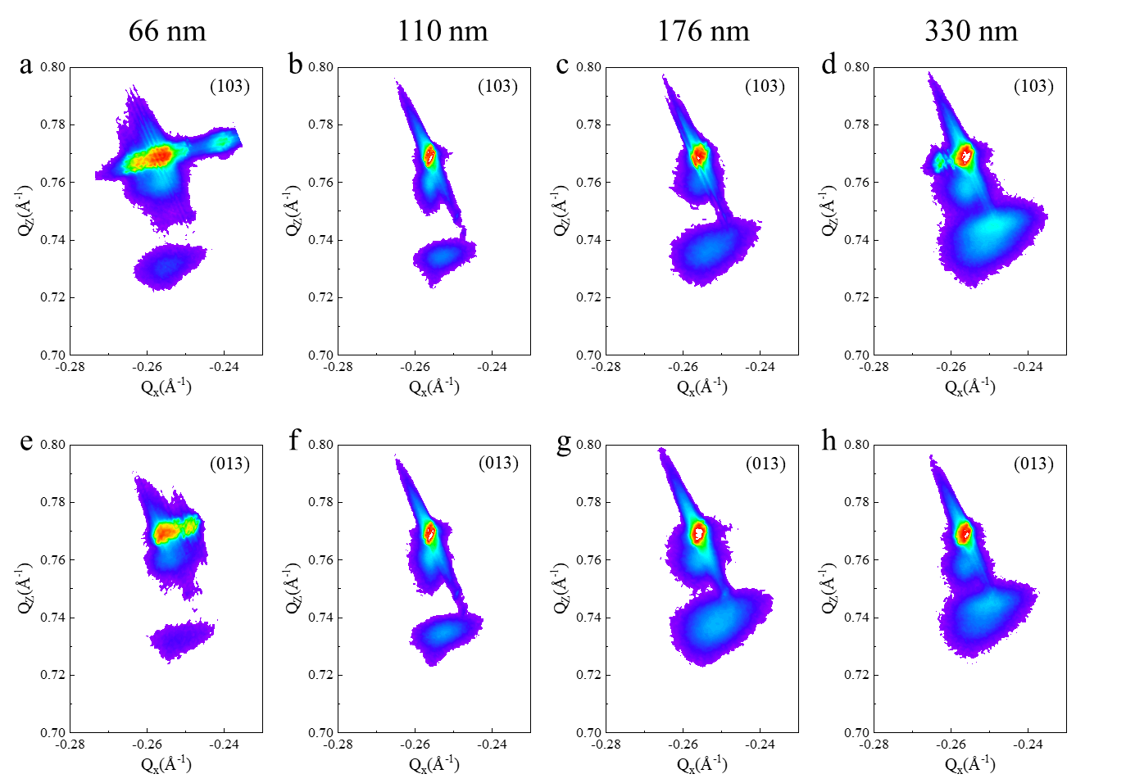
Fig. S1 RSM data around STO (103) and STO (013) for a, e 66 nm, b, f 110 nm, c, g 176 nm and d,h 330 nm, repectively.

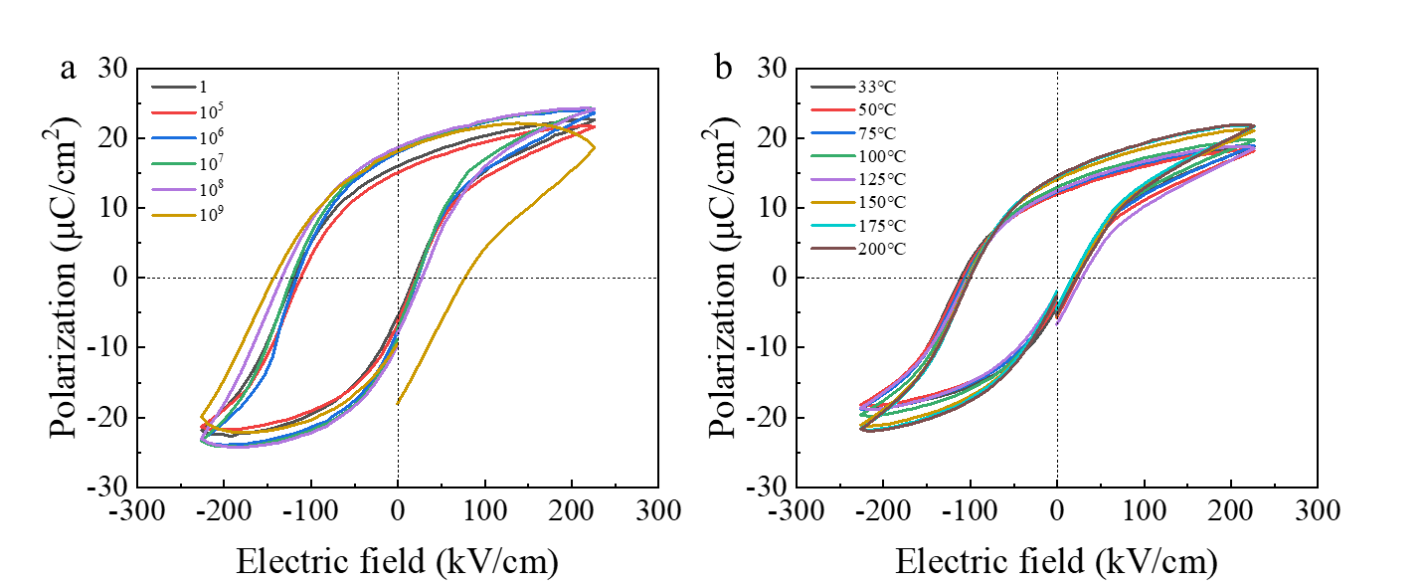
Fig. S2 P-E loops a upon electric flied cycling and b at different temperature in the 176 nm-thick KNO film.

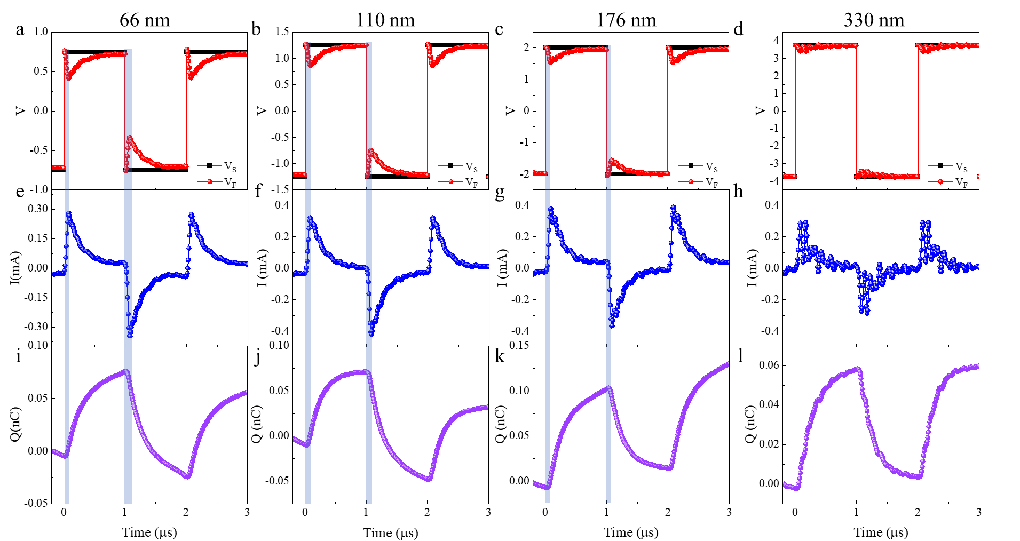
Fig. S3 Transients corresponding of the source voltage V_{S} (black line) and the ferroelectric voltage V_{F} (red line) a-d, current I through the circuit e-h and Charge Q on the application i-l in KNO thin films with thicknesses of 66 nm, 110 nm, 176 nm and 330 nm, respectively.

Ferroelectric phenomenological theory in strained KNbO₃
In the phenomenological Landau–Ginzburg–Devonshire (LGD) theory, the spontaneous polarization P = (P₁, P₂, P₃) is chosen as the order parameters. In this work, an eighth-order polynomial is used to describe the thermodynamic potential of KNO single crystal, which given as:
$f_{LGD}=α_{1}\left(P_{1}^{2}+P_{2}^{2}+P_{3}^{2}\right)+α_{11}\left(P_{1}^{4}+P_{2}^{4}+P_{3}^{4}\right)+α_{12}\left(P_{1}^{2}P_{2}^{2}+P_{2}^{2}P_{3}^{2}+P_{1}^{2}P_{3}^{2}\right)+α_{111}\left(P_{1}^{6}+P_{2}^{6}+P_{3}^{6}\right)+α_{112}\left[P_{1}^{4}\left(P_{2}^{2}+P_{3}^{2}\right)+P_{2}^{4}\left(P_{1}^{2}+P_{3}^{2}\right)+P_{3}^{4}\left(P_{1}^{2}+P_{2}^{2}\right)\right]+α_{123}P_{1}^{2}P_{2}^{2}P_{3}^{2}+α_{1111}\left(P_{1}^{8}+P_{2}^{8}+P_{3}^{8}\right)+α_{1112}\left[P_{1}^{6}\left(P_{2}^{2}+P_{3}^{2}\right)+P_{2}^{6}\left(P_{1}^{2}+P_{3}^{2}\right)+P_{3}^{6}\left(P_{1}^{2}+P_{2}^{2}\right)\right]+α_{1122}\left(P_{1}^{4}P_{2}^{4}+P_{2}^{4}P_{3}^{4}+P_{1}^{4}P_{3}^{4}\right)+α_{1123}\left({ P}_{1}^{4}P_{2}^{2}P_{3}^{2}+{ P}_{2}^{4}P_{1}^{2}P_{3}^{2}+{ P}_{3}^{4}P_{1}^{2}P_{2}^{2}\right)$ (S1)
where $α$ with subscript index represents energy expansion coefficient and are shown in Table S1. All of these coefficients are assumed to be temperature independent except $α_{1}$. To perform the thermodynamic analysis, polarization is assumed to be P = (P₁, 0, P₁) for the orthorhombic phase. The mechanical boundary conditions are given by $ε$₁ = $ε$₂ = $ε$, where u_{m} is the misfit strain along the in-plane direction. Consequently, the thermodynamic potential of KNO thin films becomes a function of polarization P₁, misfit strain $ε$ and applied electric field E_{F}:
${G=(α}_{1}^{*}+α_{3}^{*}{)P}_{1}^{2}+{(α}_{11}^{*}+α_{33}^{*}{+α_{13}^{*})P}_{1}^{4}+{(2α}_{111}+2α_{112})P_{1}^{6}+\left(2α_{1111}+{2α}_{1112}+α_{1122}\right)P_{1}^{8}-E_{F}P_{1}+\frac{ε^{2}}{S_{11}+S_{22}}$ (S2)
where $α_{1}^{*}= α_{1}-\frac{Q_{11}+Q_{12}}{s_{11}+s_{12}}ε$ (S3)
$α_{3}^{*}= α_{1}-\frac{2Q_{12}}{s_{11}+s_{12}}ε$ (S4)
$α_{11}^{*}= α_{11}+\frac{1}{2}\frac{\left[\left(Q_{11}^{2}+Q_{12}^{2}\right)s_{11}\right]-2Q_{11}Q_{12}s_{12}}{s_{11}^{2}-s_{12}^{2}}$ (S5)
$α_{33}^{*}= α_{11}+\frac{Q_{12}^{2}}{s_{11}+s_{12}}$ (S6)
$α_{13}^{*}= α_{12}+\frac{Q_{12}\left(Q_{11}+Q_{12}\right)}{s_{11}+s_{12}}$ (S7)
Here, $α_{i}^{*}$ and $α_{i.j}^{*}$ are the renormalized dielectric stiffness coefficients and the calculated results are shown in Table S2. The free energy profiles of G – P₁ when the E_{F} =0 is showed in Fig. 5a. Minimizing G with respect to P₁ yielded the expression for the electric field:

${E_{F}=2(α}_{1}^{*}+α_{3}^{*})P_{1}+{4(α}_{11}^{*}+α_{33}^{*}{+α_{13}^{*})P}_{1}^{3}+{6(2α}_{111}+2α_{112})P_{1}^{5}+8\left(2α_{1111}+{2α}_{1112}+α_{1122}\right)P_{1}^{7}$ (S8)
which have an “S”-shape as shown in Fig. 5b. The inverse of the permittivity obtained by differentiating E_{F} with respect to P_{s} as:
${ε^{-1}=2(α}_{1}^{*}+α_{3}^{*})+{12(α}_{11}^{*}+α_{33}^{*}{+α_{13}^{*})P}_{1}^{2}+{30(2α}_{111}+2α_{112})P_{1}^{4}+56\left(2α_{1111}+{2α}_{1112}+α_{1122}\right)P_{1}^{6}$ (S9)
which was plotted at Figure S4. The negative curvature in free energy-polarization landscape, negative slope in polarization – electric field curves and negative permittivity revealed the NC effect which can be modulated by misfit strain.

Table S1. Parameters used for thermodynamic potential calculation of KNO films¹
Coefficient | This | Unit
$$α_{1}$$ | 4.273×10⁵×(T-377) | C⁻²m²N
$$α_{11}$$ | -6.36×10⁸ | C⁻⁴m⁶N
$$α_{12}$$ | 9.66×10⁸ | C⁻⁴m⁶N
$$α_{111}$$ | 2.81×10⁹ | C⁻⁶m¹⁰N
$$α_{112}$$ | -1.99×10⁹ | C⁻⁶m¹⁰N
$$α_{123}$$ | 6.03×10⁹ | C⁻⁶m¹⁰N
$$α_{1111}$$ | 1.74×10¹⁰ | C⁻⁸m¹⁴N
$$α_{1112}$$ | 5.99×10⁹ | C⁻⁸m¹⁴N
$$α_{1122}$$ | 2.50×10¹⁰ | C⁻⁸m¹⁴N
$$α_{1123}$$ | -1.17×10¹⁰ | C⁻⁸m¹⁴N
$$Q_{11}$$ | 0.12 | m⁴C²
$$Q_{12}$$ | -0.053 | m⁴C²
$$Q_{44}$$ | 0.052 | m⁴C²
$$s_{11}$$ | 4.6×10⁻¹² | m²N
$$s_{12}$$ | -1.1×10⁻¹² | m²N
$$s_{44}$$ | 11.1×10⁻¹² | m²N

Table S2. Renormalized dielectric stiffness coefficients used for thermodynamic potential calculation of KNO films
$$ε$$ | 1% | 0 | -1% | -2%
$α_{1}^{*}$ (C⁻²m²N) | -2.26×10⁸ | -3.42×10⁷ | 1.57×10⁸ | 3.49×10⁸
$α_{3}^{*}$ (C⁻²m²N) | 2.69×10⁸ | -3.42×10⁷ | -3.37×10⁸ | -6.40×10⁸
$α_{11}^{*}$ (C⁻⁴m⁶N) | -5.55×10⁸
$α_{33}^{*}$ (C⁻⁴m⁶N) | 1.67×10⁸
$α_{13}^{*}$ (C⁻⁴m⁶N) | -4.86×10⁷

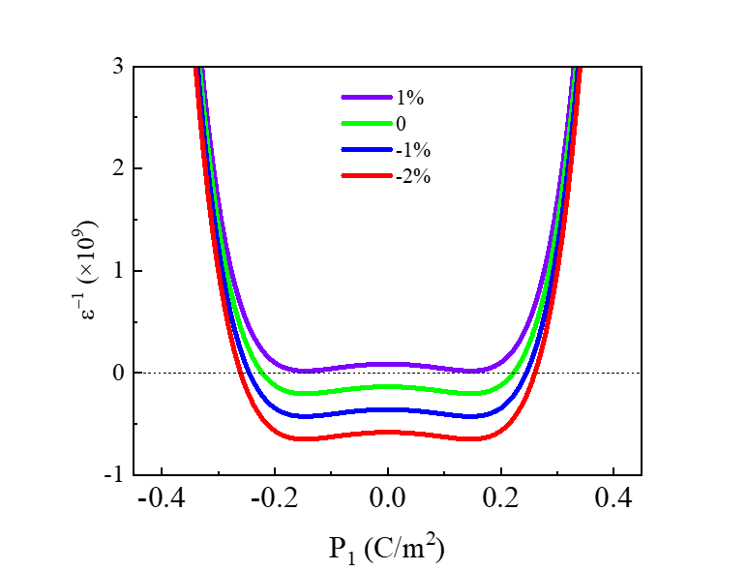
Fig. S4 Inverse of ε as a function of polarization derived from Equation (S9).

Simulation of the time-dependence ferroelectric switching dynamics under variant strain.
The Landau-Khalatnikov model (L-K model) was adopted to predict the temporal evolution of polarization in ferroelectric capacitor:
$ρ\frac{dQ_{F}}{dt}=-\frac{dU}{dQ_{F}}$ (S10)
where ρ was the internal resistance and U was the energy density given by
${U=(α}_{1}^{*}+α_{3}^{*}{)Q}_{F}^{2}+{(α}_{11}^{*}+α_{33}^{*}{+α_{13}^{*})Q}_{F}^{4}+{(2α}_{111}+2α_{112})Q_{F}^{6}+\left(2α_{1111}+{2α}_{1112}+α_{1122}\right)Q_{F}^{8}-VQ_{F}$ (S11)
We assumed the thickness and surface area of the KNO thin films are 100 nm and 200 μm², the external and internal resistor are 1200 Ω and 10 kΩ, respectively. The experimental setup can be equivalent to Figure S5(a)^{2,3}. We denoted V_{int} as the internal ferroelectric node voltage, which eliminated the parasitic capacitance of internal resistance. Equation (S10) lead to an expression for the voltage and current across the ferroelectric capacitor:
$V_{F}\left(t\right)=2{(α}_{1}^{*}+α_{3}^{*})Q_{F}\left(t\right)+{4(α}_{11}^{*}+α_{33}^{*}+α_{13}^{*}{)Q}_{F}{\left(t\right)}^{3}+12{(α}_{111}+α_{112})Q_{F}{\left(t\right)}^{5}+8\left(2α_{1111}+{2α}_{1112}+α_{1122}\right)Q_{F}^{7}+ρ\frac{{dQ}_{F}(t)}{dt}$ (S12)
$V_{S}\left(t\right)=i\left(t\right)*R+V_{F}\left(t\right)=i\left(t\right)*\left(ρ+R\right)+V_{int}$ (S13)
$i\left(t\right)=\frac{dQ_{F}(t)}{dt}$ (S14)
By solving equation (S12-S14), the transient charge, current and voltage of KNO thin films with different strain states in the circuit were simulated and showed in Fig. S6. Figure S7a-c summarized the transient voltage, demonstrated that compressive strain increased the magnitude of the voltage reduction. Figure S7d, e showed the P-V_{F} and P-V_{int} curve of KNO thin films under different strain states. It is obvious that compressive strain increased the negative slope.

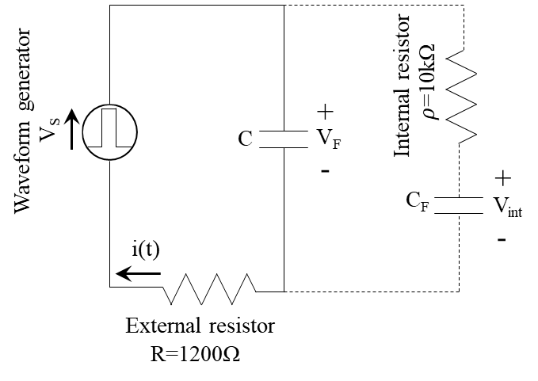
Fig. S5 Equivalent circuit diagram of the simulation. The full line was experimental setup and the dash line was equivalent circuit.

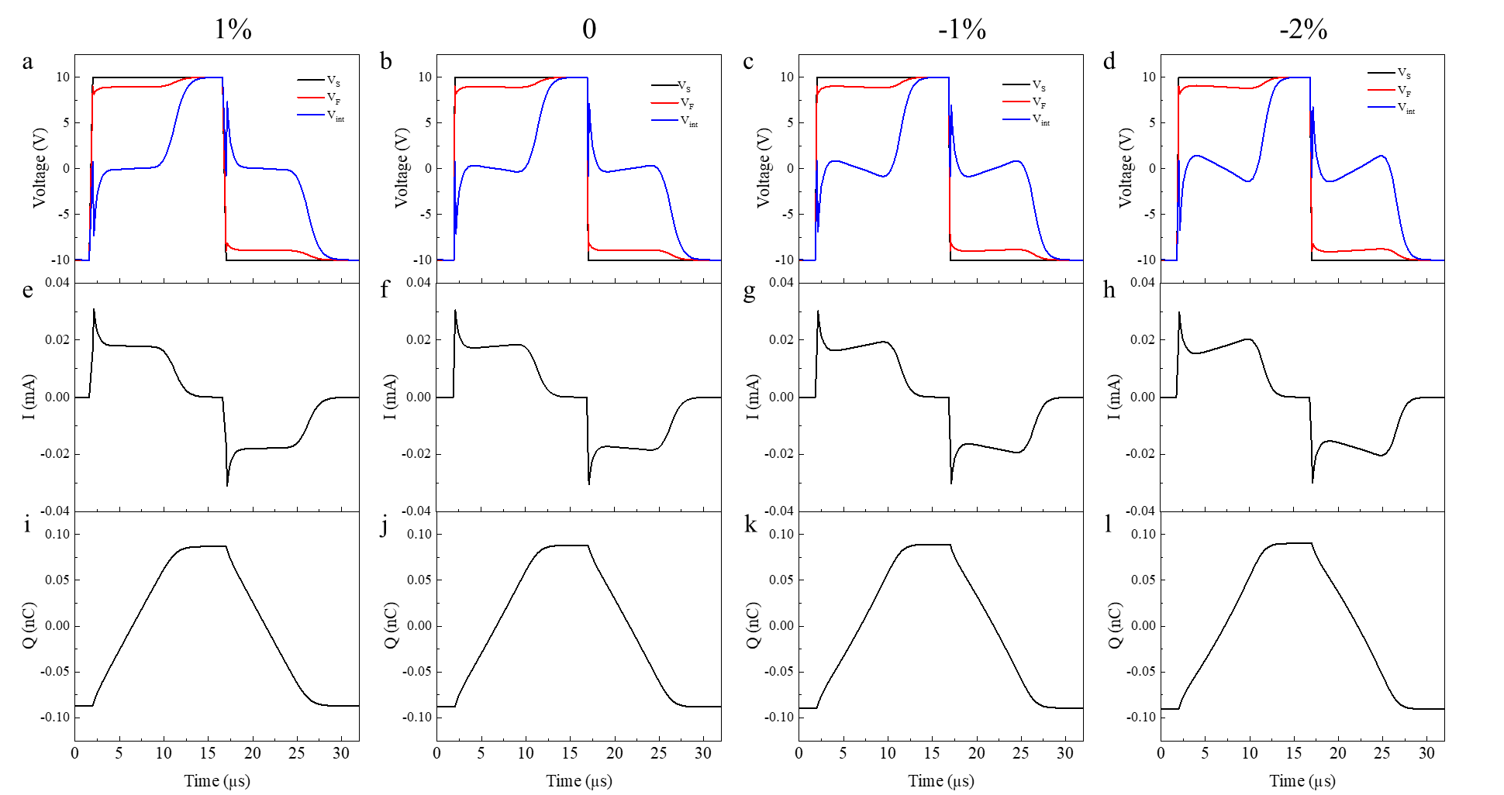
Fig. S6 The simulation of transient a-d voltage (V_{S}, V_{F} and V_{int}), e-h current and i-l charge of KNO thin films with different strain state.

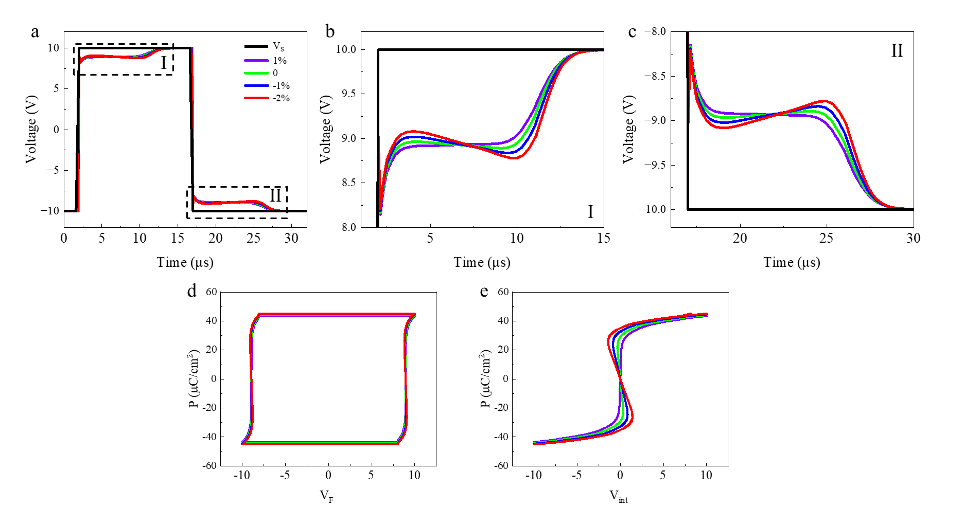
Fig. S7 a Summary of transient voltage V_{F} of KNO thin films under different strain. The NC regions Ⅰ and Ⅱ in a are magnified in b and c, respectively. d P-V_{F} curve and e P-V_{int} curve of KNO thin films under different strain state. The change of negative slope demonstrates the tunability of NC effect.

References
- Qiu, J. et al. Piezoelectric and pyroelectric properties of (001) oriented KNbO₃ film. Solid State Commun. 284, 1–4 (2018).
- Khan, A. I. et al. Negative capacitance in a ferroelectric capacitor. Nat. Mater. 14, 182–186 (2015).
- Liu, C. & Wang, J. Strain engineering of ferroelectric negative capacitance in PbZr_{(1-x)}Ti_{x}O₃ thin films. Acta Mater. 206, 116607 (2021).

