Supporting Information for
Deliverable Microparticles Coated With Nano-forest Like Structure
To Improve Dispersion and Biofouling Resistance

Chengduan Yang¹, Baoming Liang², Cheng Yang², Ziqi Liu², Xiangling Li²,Xi Xie^{1,2}, Fanmao Liu¹, Ji Wang^{1,*}, Hui-jiuan Chen^{2,}*

¹ The First Affiliated Hospital of Sun Yat-Sen University, Sun Yat-Sen University, Guangzhou, China
² State Key Laboratory of Optoelectronic Materials and Technologies, School of Electronics and Information Technology, Sun Yat-Sen University, Guangzhou, China

*To whom correspondence may be addressed. Corresponding to: Ji Wang, wangj683@mail.sysu.edu.cn; Hui-jiuan Chen, chenhuix5@mail.sysu.edu.cn

S1. Supporting information for the illustrating the fabrication procedure of the ‘liquid-like’ coating modified surfaces.

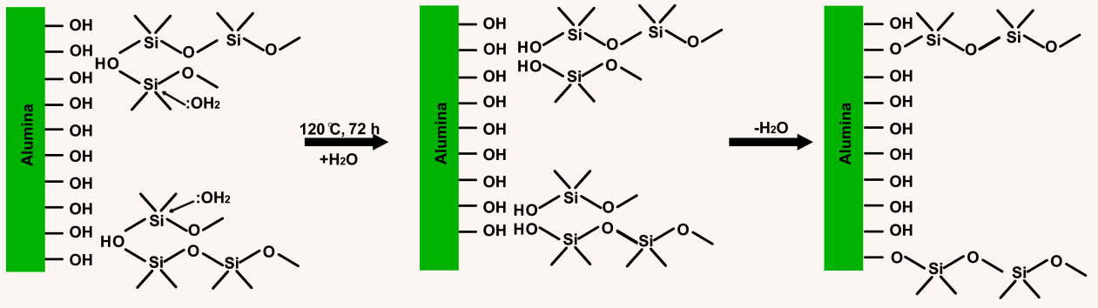
Figure S1. Illustration of the fabrication procedure of the ‘liquid-like’ coating modified surfaces. PDMS was hydrolyzed and grafted onto the alumina surface under thermally activated condition.¹ Through the hydrolysis reaction, the -Si-O-Si- bond in PDMS was broken, and only one end was grafted to thealumina surface.

- J.W. Krumpfer, et al. Langmuir 2011, 27, 11514-11519.

S2. Supporting information for the test of small molecule & protein adhesion.
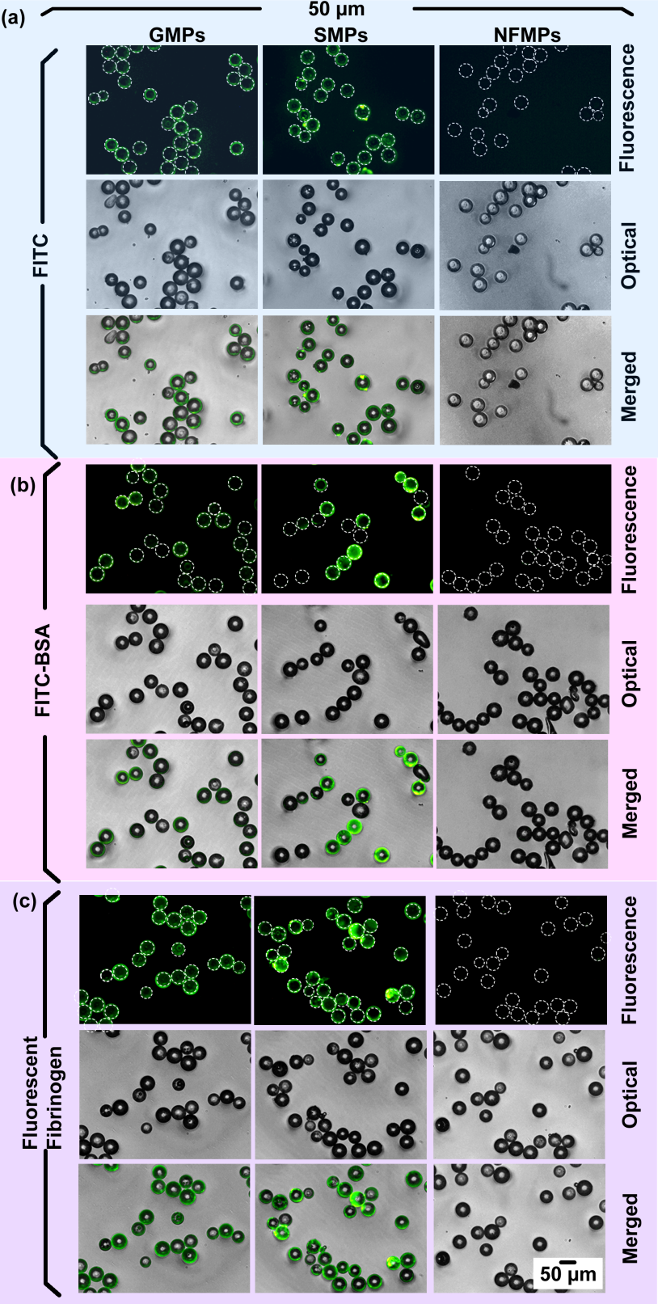
Figure S2.1. Optical, fluorescence and its merge images are showing the adhesion of small molecule (FITC, green fluorescence) and proteins (FITC-BSA and fluorescent fibrinogen, both with green fluorescence) on different microparticles surface with a diameter of 50 μm including GMPs, SMPs, and NFMPs after 24h incubation.
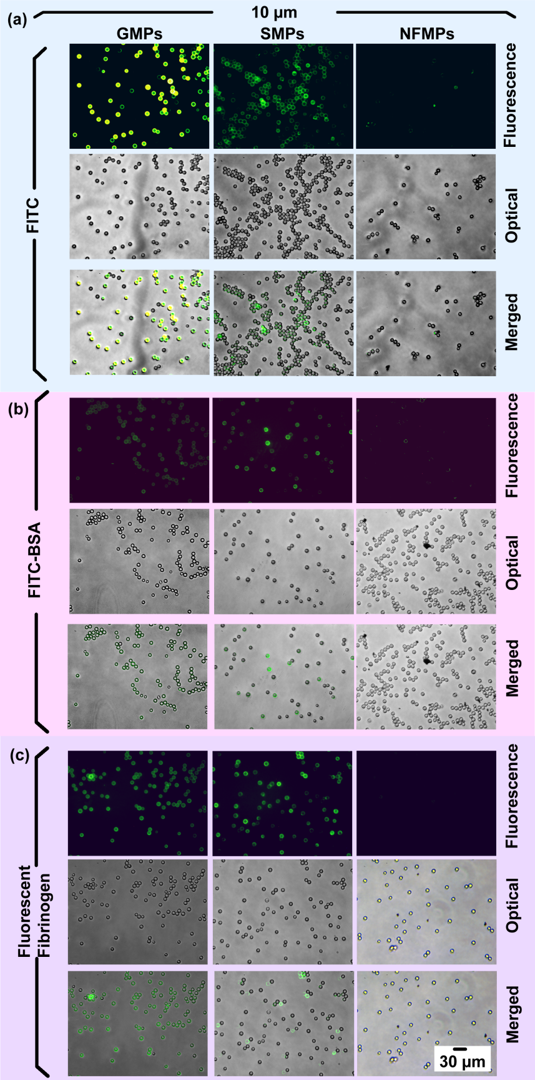
Figure S2.2. Optical, fluorescence and its merge images are showing the adhesion of small molecule (FITC, green fluorescence) and proteins (FITC-BSA and fluorescent fibrinogen, both with green fluorescence) on different microparticles surface with a diameter of 10 μm including GMPs, SMPs, and NFMPs after 24h incubation.
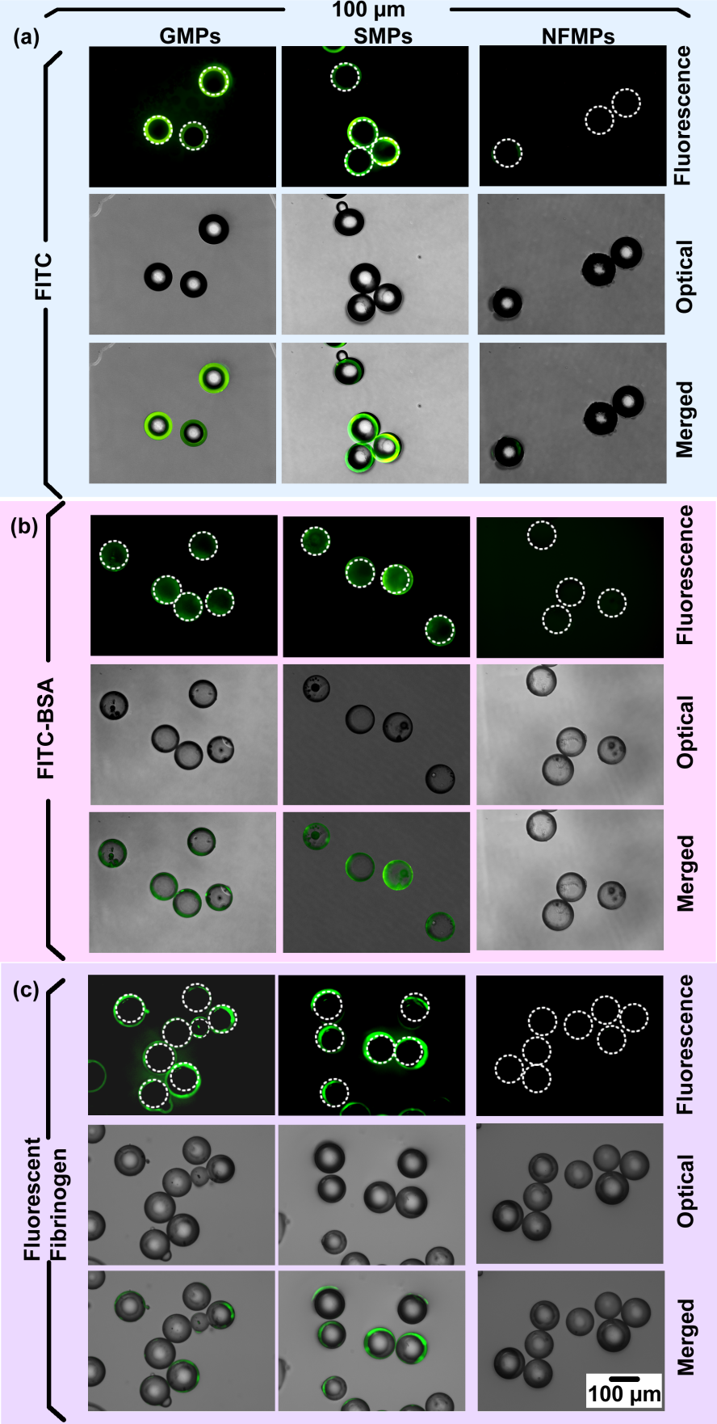
Figure S2.3. Optical, fluorescence and its merge images are showing the adhesion of small molecule (FITC, green fluorescence) and proteins (FITC-BSA and fluorescent fibrinogen, both with green fluorescence) on different microparticles surface with a diameter of 100 μm including GMPs, SMPs, and NFMPs after 24h incubation.
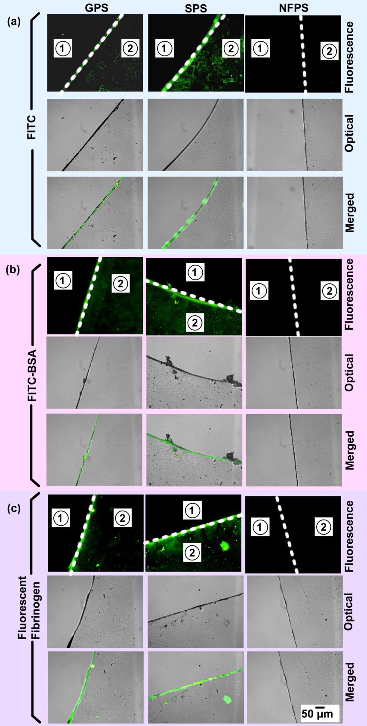
Figure S2.4. Optical, fluorescence and its merge images are showing the adhesion of small molecule (FITC, green fluorescence) and proteins (FITC-BSA and fluorescent fibrinogen, both with green fluorescence) on different on different substrates. The control clean glass substrate was indicated as the area “1”, and the sample substrate was indicated as the area “2”, and the substrate boundary highlighted with a dashed line.
S3. Supporting information for the test of bacteria adhesion.
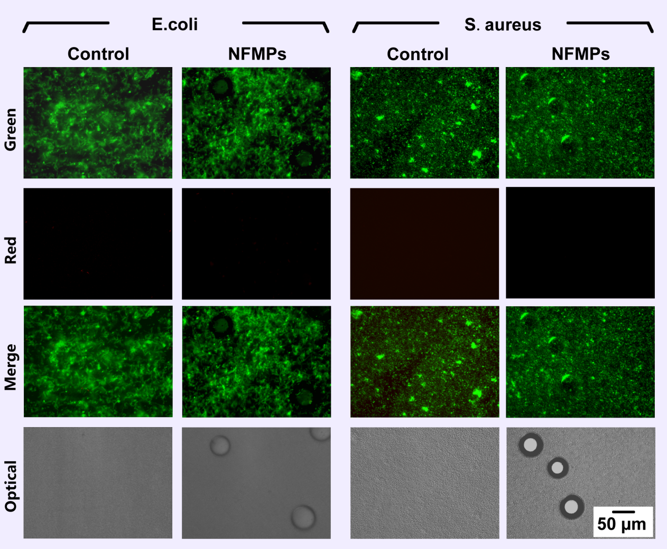
Figure S3.1. Test of bacterial toxicity. Fluorescence (Live bacteria were stained with green fluorescence, dead bacteria were stained with red fluorescence and its merge images) and optical images are showing the viabilities of E.coli. and S.aureus. incubated with media containing NFMPs for 24 h.

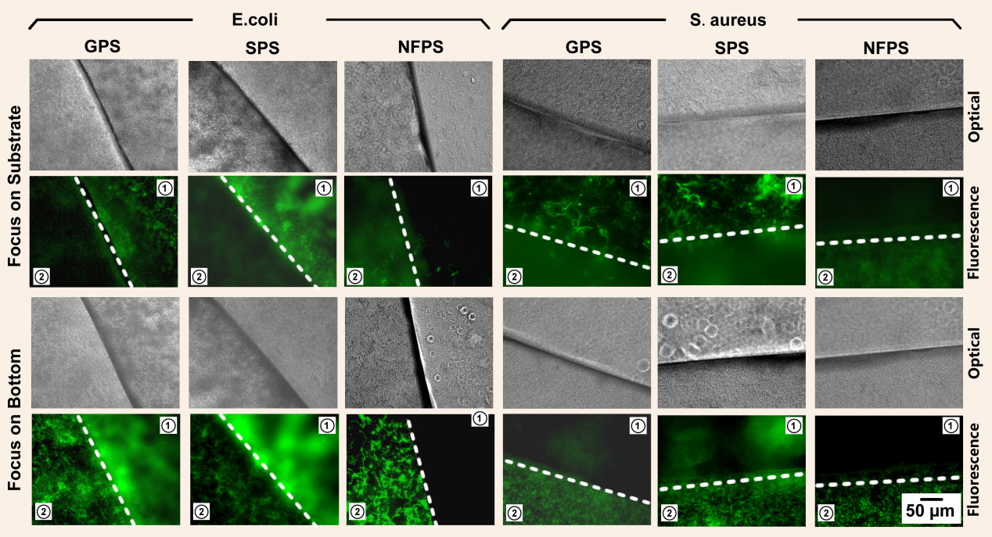
Figure S3.2. Fluorescence and optical images are showing the adhesion of E.coli. and S.aureus. (both stained with green fluorescence) on different substrates. The images was focused on the top surface of the substrate or the bottom surface of the well. The sample substrate was indicated as the area “1”, and the control well bottom was indicated as the area “2”, and the substrate boundary highlighted with a dashed line. The fluorescence image and optical microscopy image were separately shown.

S4. Supporting information for the test of cells adhesion.
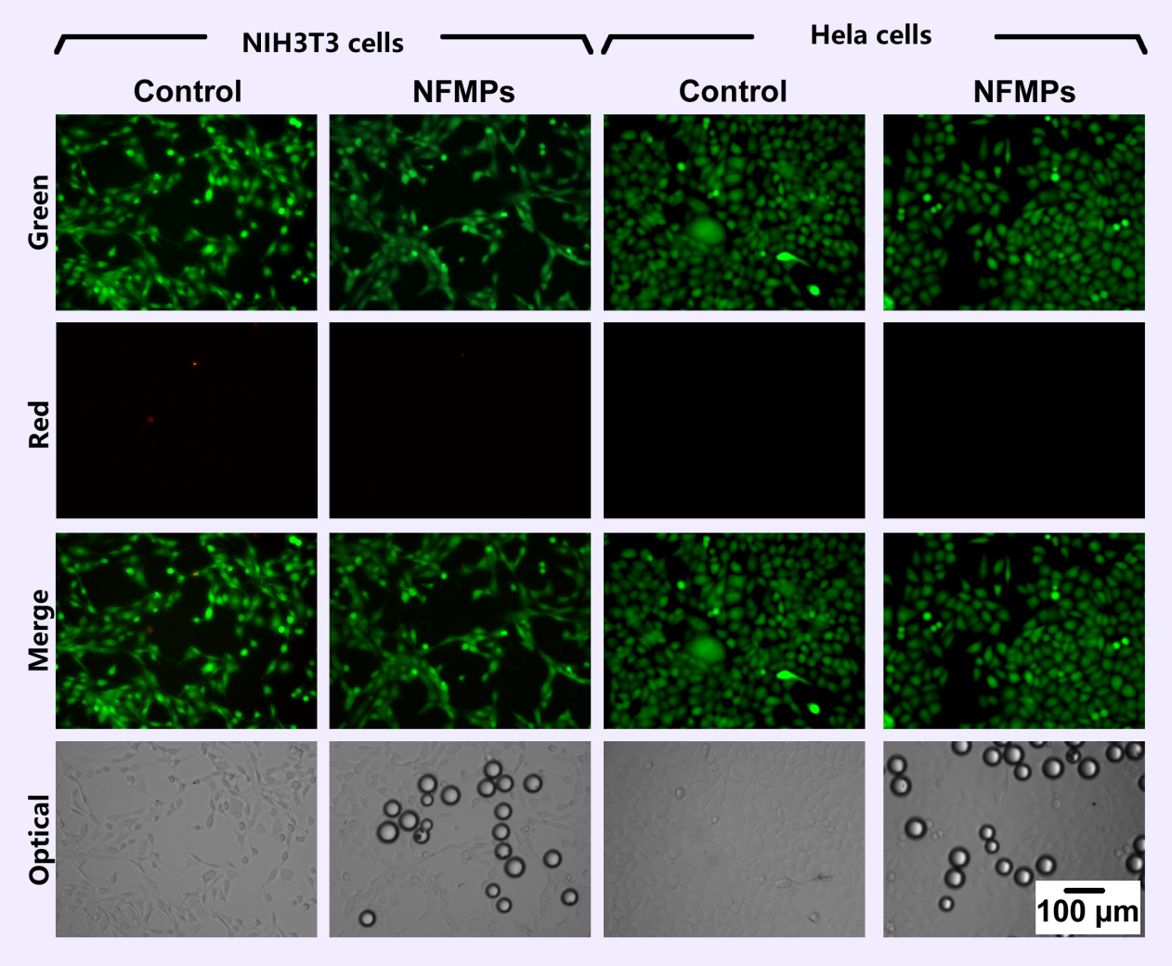
Figure S4.1. Test of cytotoxicity. Fluorescence (Live cells were stained with green fluorescence, dead cells were stained with red fluorescence and its merge images) and optical images are showing the viabilities of NIH/3T3 and HeLa cells incubated with media containing NFMPs for 24 h.

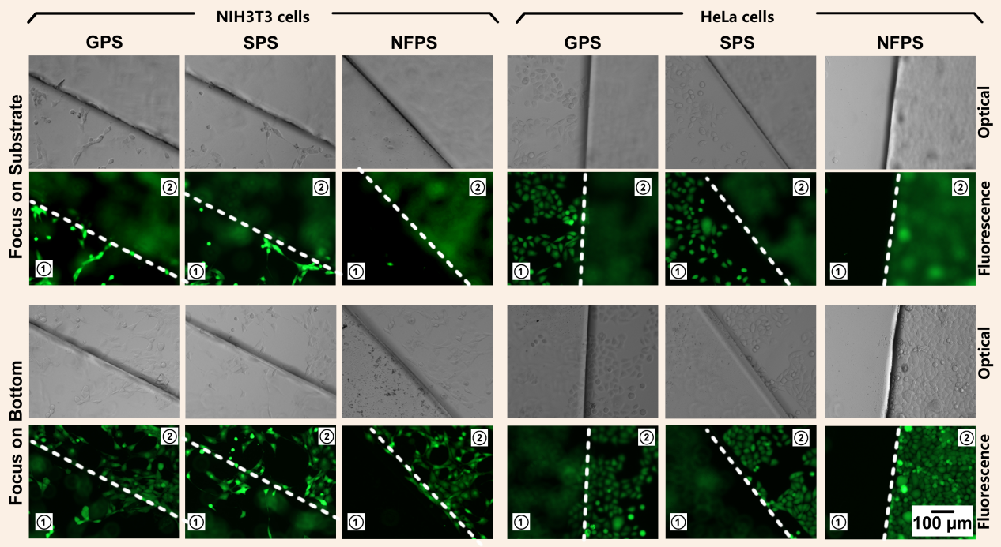
Figure S4.2. Fluorescence and optical images are showing the adhesion of NIH/3T3 cells and HeLa cells (both stained with green fluorescence) on different substrates. The images was focused on the top surface of the substrate or the bottom surface of the well. The sample substrate was indicated as the area “1”, and the control well bottom was indicated as the area “2”, and the substrate boundary highlighted with a dashed line. The fluorescence image and optical microscopy image were separately shown.

