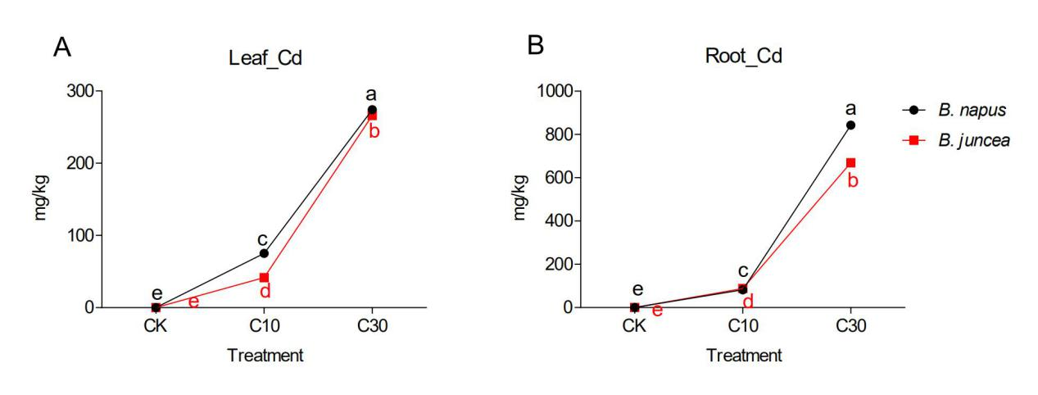
Figure S1 The accumulation of Cd in plant leaves (A) and roots (B). Error bars show standard deviation (n = 6). Means with different lowercase letters are significantly different at P < 0.05 based on one-way ANOVA.
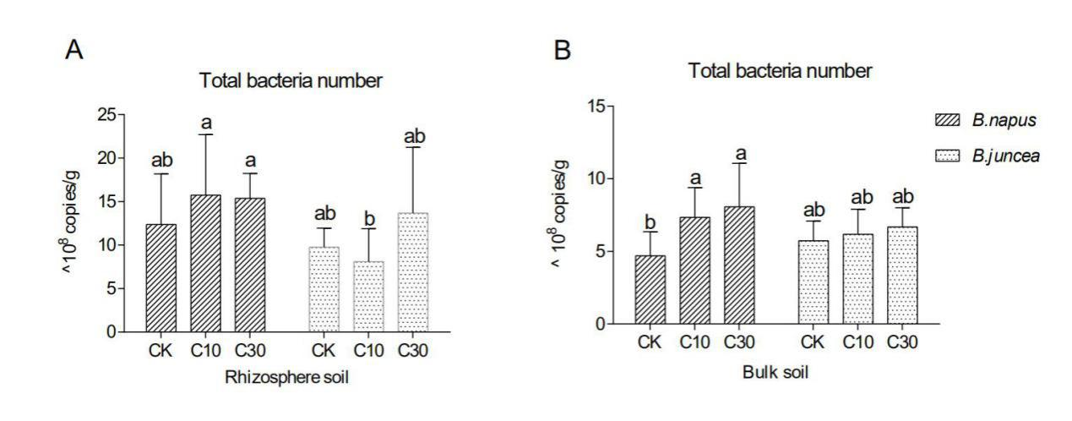
Figure S2 Variations of total bacteria copies in Cd contaminated soils of rhizosphere (A) and bulk soil (B). Error bars show standard deviation (n = 6). Means with different lowercase letters are significantly different at P < 0.05 based on one-way ANOVA.
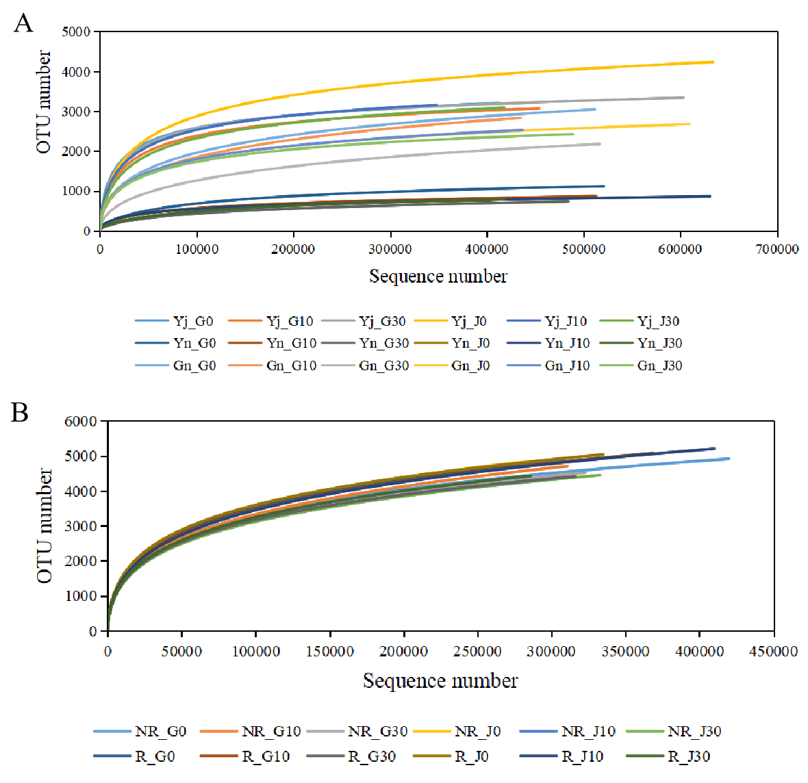
Figure S3 Rarefaction curve of the bacterial community in plants (A) and soils (B). Abbreviations: G0/J0, treatment with 0mg/kg Cd in B. napus /B. juncea; G10/J10, treatment with 10mg/kg Cd in B. napus /B. juncea; G30/J30, treatment with 30mg/kg Cd in B. napus /B. juncea ; Yj, phyllosphere samples from leaves; Yn, endophytes samples from leaves; Gn, endophytes samples from roots; R, rhizosphere soil samples; NR, bulk soil samples.
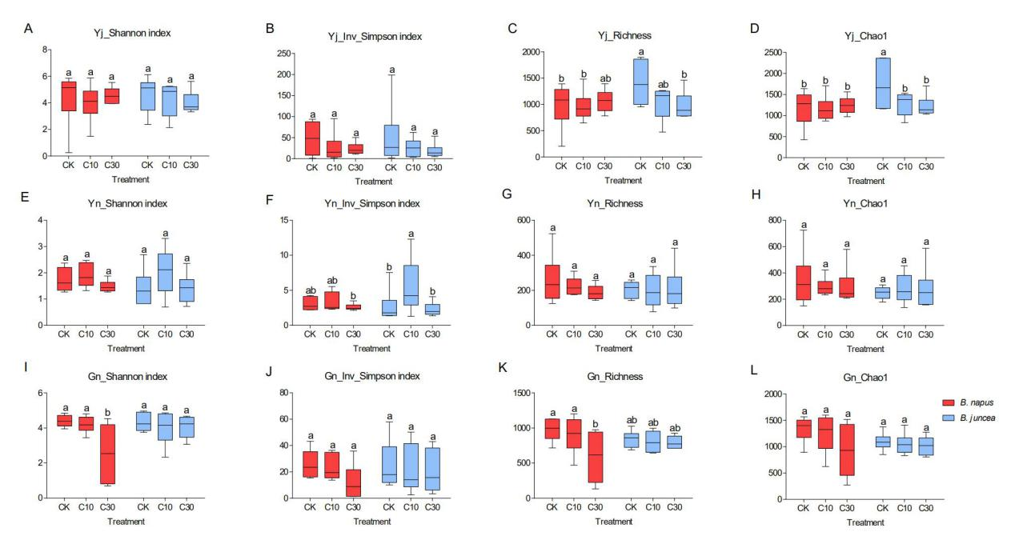
Figure S4 The effect of Cd on α-diversity of plant bacterial communities. Error bars show standard deviation (n = 6). Means with different lowercase letters are significantly different at P < 0.05 based on one-way ANOVA. Abbreviations: Yj, phyllosphere samples from leaves (A-D); Yn, endophytes samples from leaves (E-H); Gn, endophytes samples from roots (I-L).
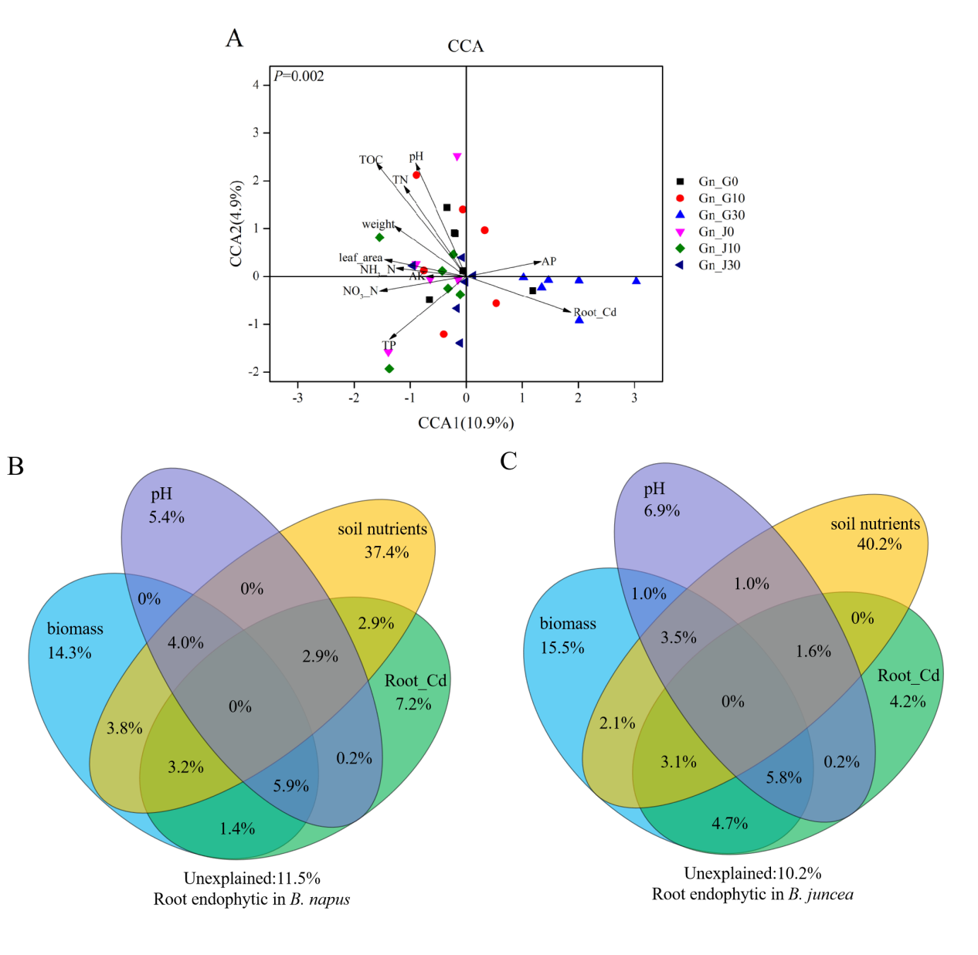
Figure S5 Canonical correspondence analysis (CCA) on root endophytic bacterial communities with the environmental variables (A) and CCA-based variation partitioning analysis (VPA) of bacterial communities explained by environmental variables (B&C). Abbreviations: G0/J0, treatment with 0mg/kg Cd in B. napus/B. juncea; G10/J10, treatment with 10mg/kg Cd in B. napus /B. juncea; G30/J30, treatment with 30mg/kg Cd in B. napus/B.juncea; Gn, endophytes samples from roots.
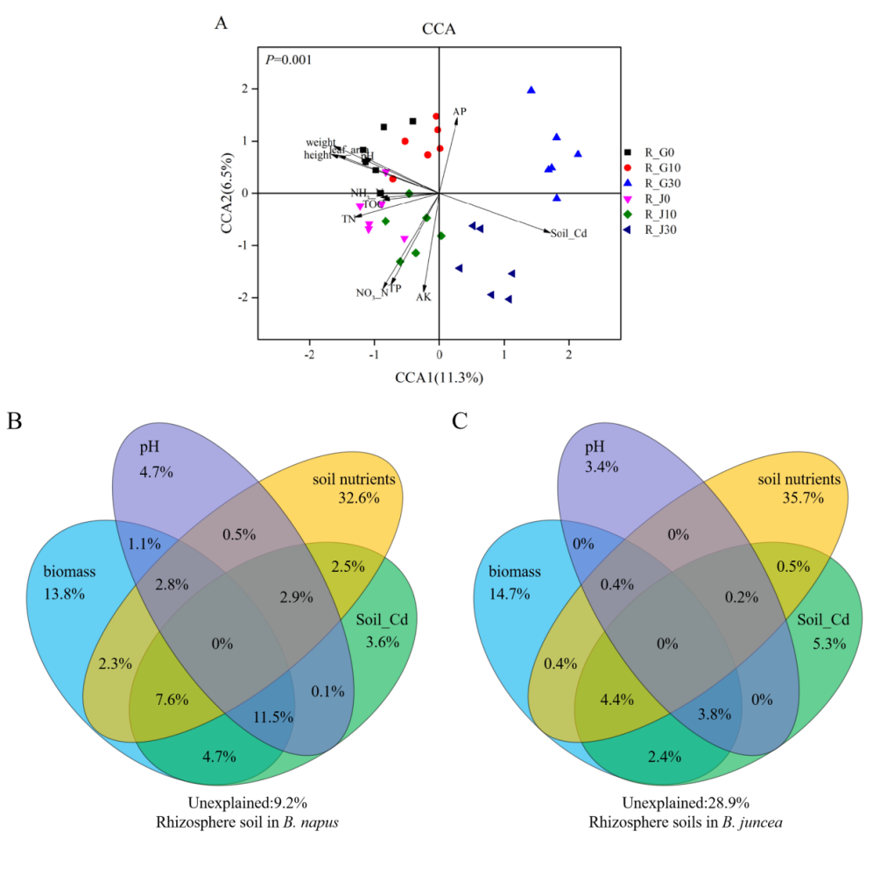
Figure S6 Canonical correspondence analysis (CCA) on rhizosphere soil bacterial communities with the environmental variables (A) and CCA-based variation partitioning analysis (VPA) of bacterial communities explained by environmental variables (B&C). Abbreviations: G0/J0, treatment with 0 mg/kg Cd in B. napus/B. juncea; G10/J10, treatment with 10 mg/kg Cd in B. napus/B. juncea; G30/J30, treatment with 30 mg/kg Cd in B. napus/B. juncea; R, rhizosphere soil samples.

