Supplementary Materials: Urban versus lake impacts on heat stress and its disparities in a shoreline city
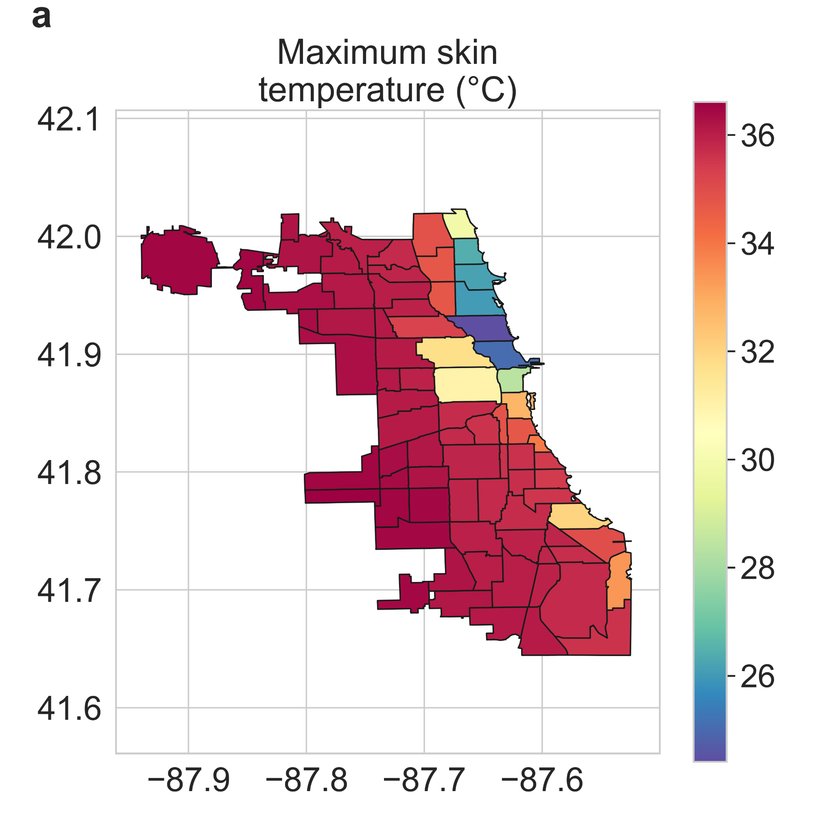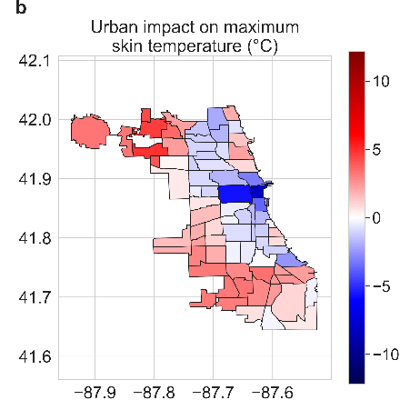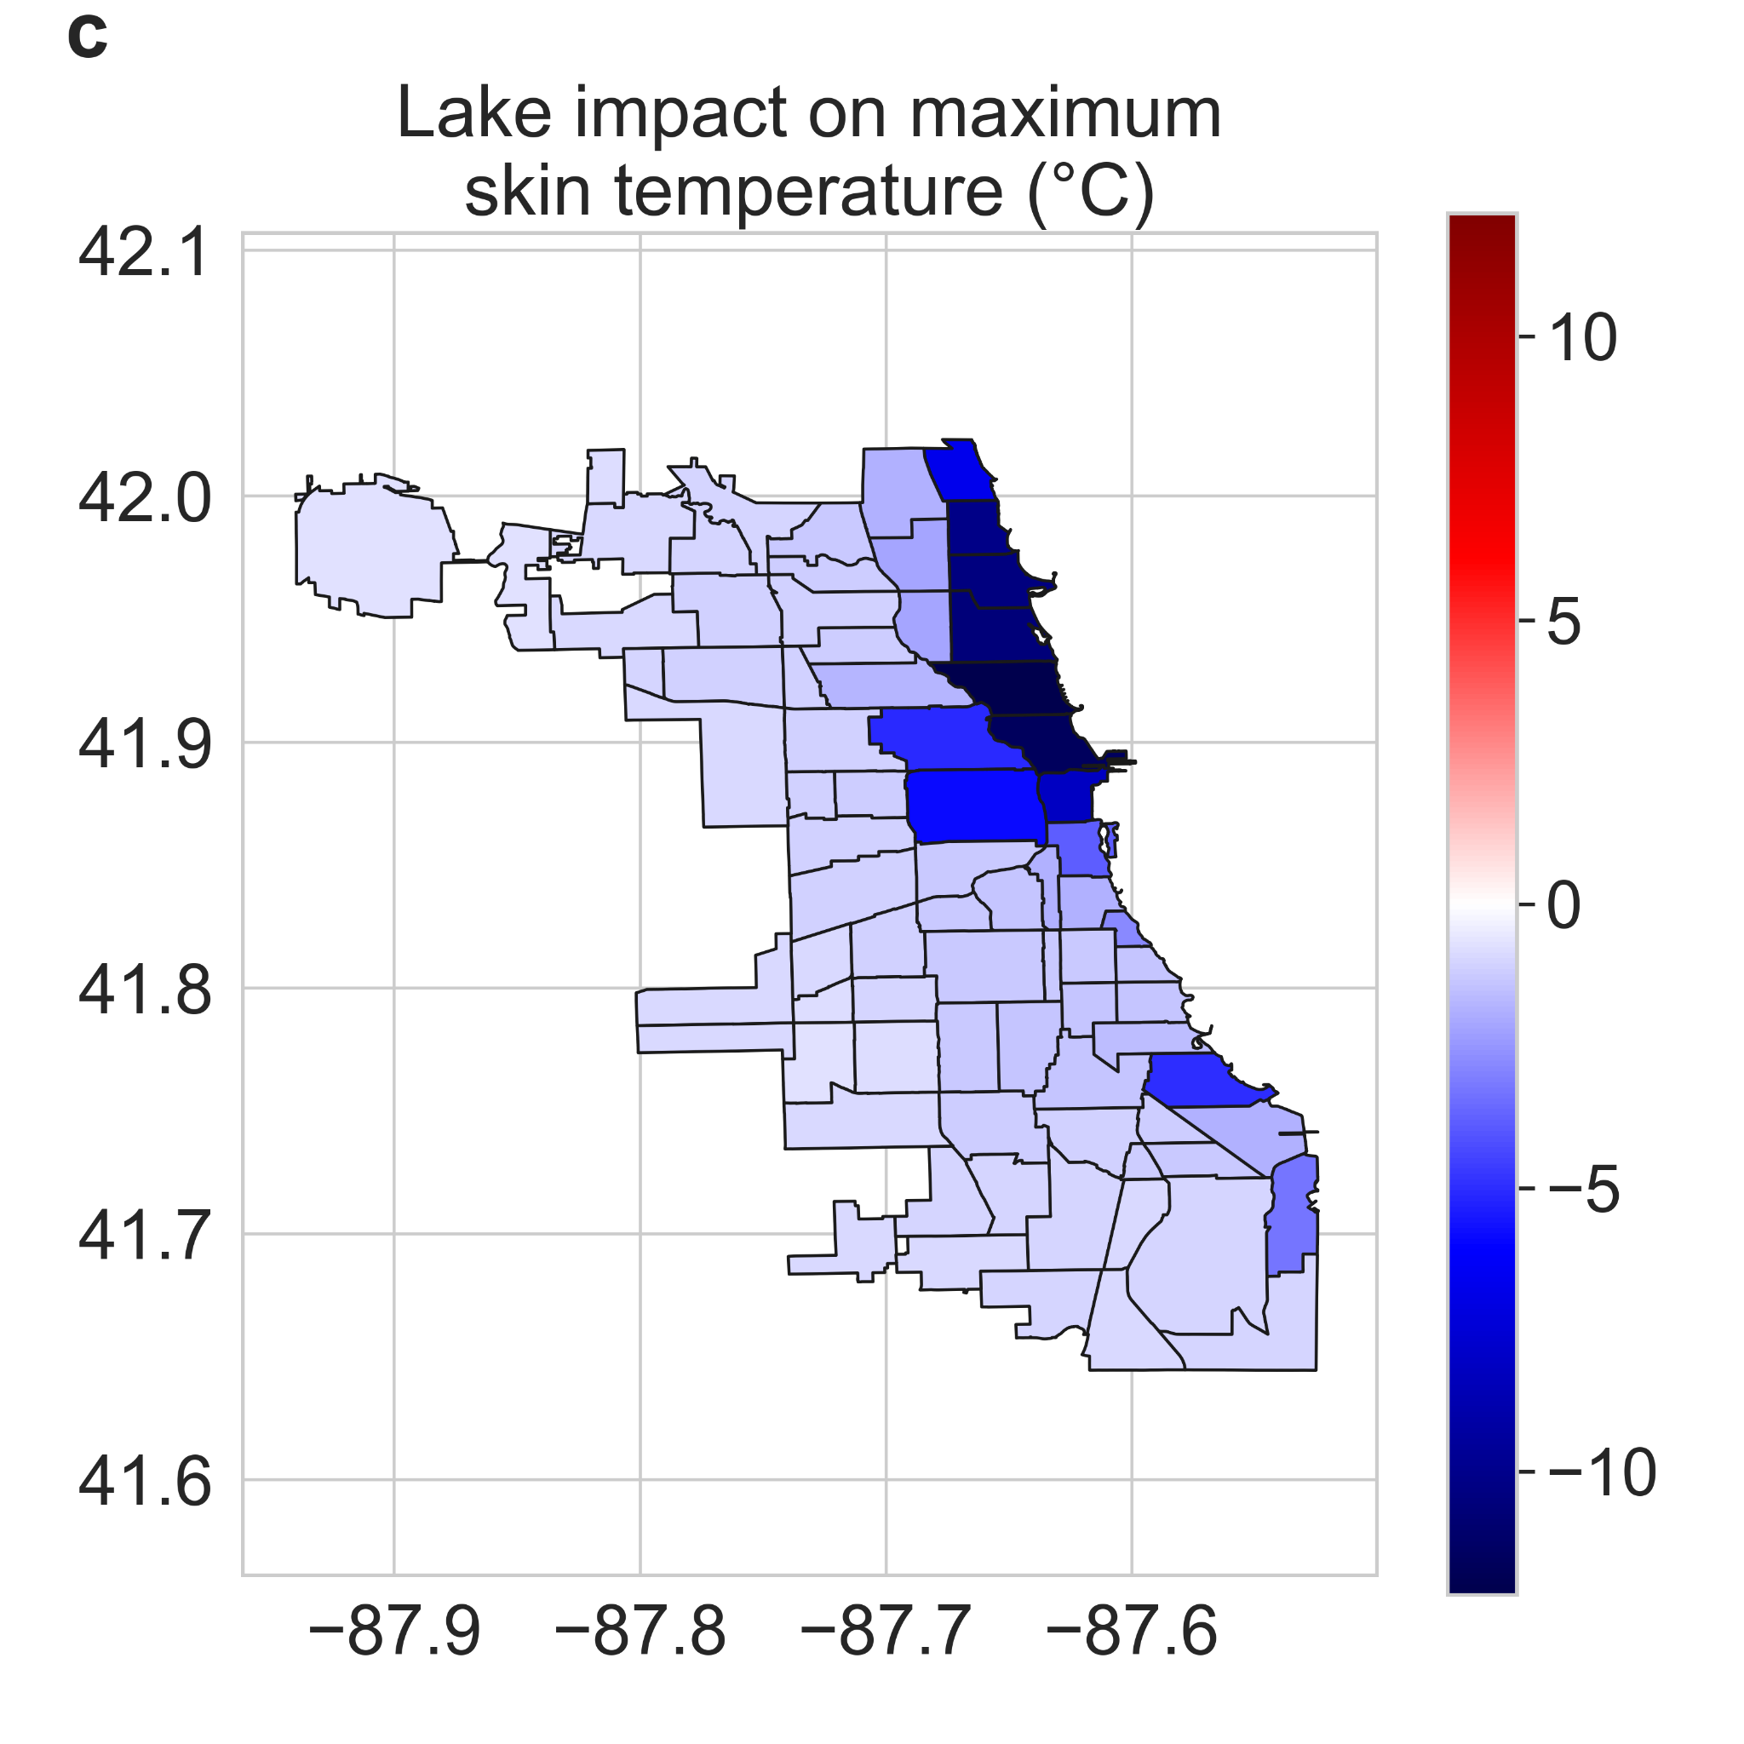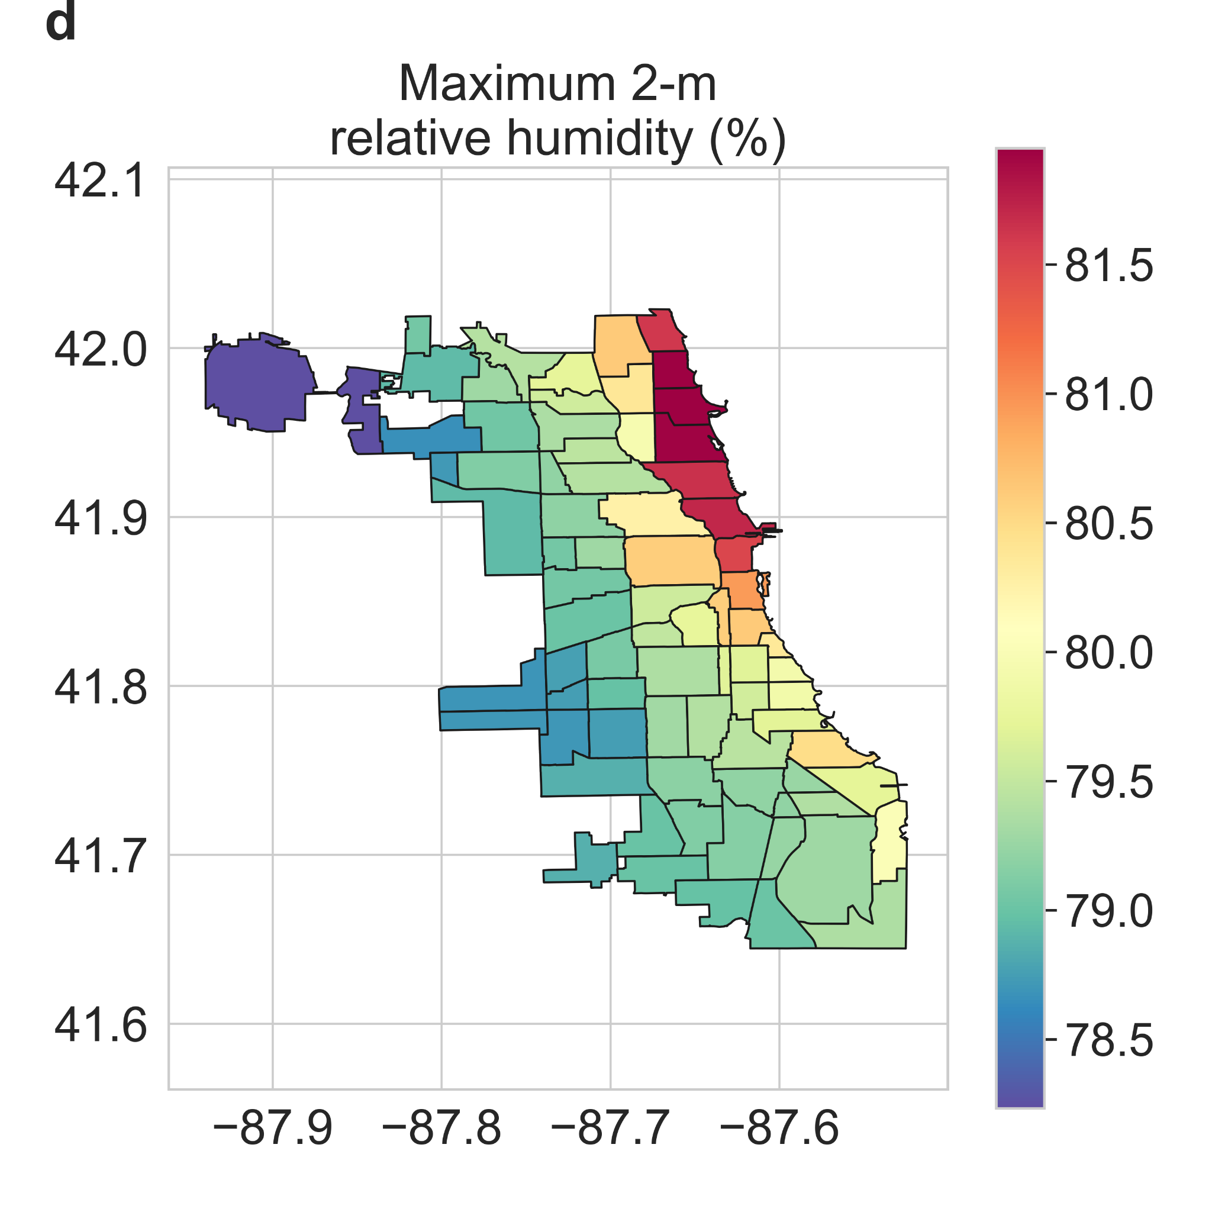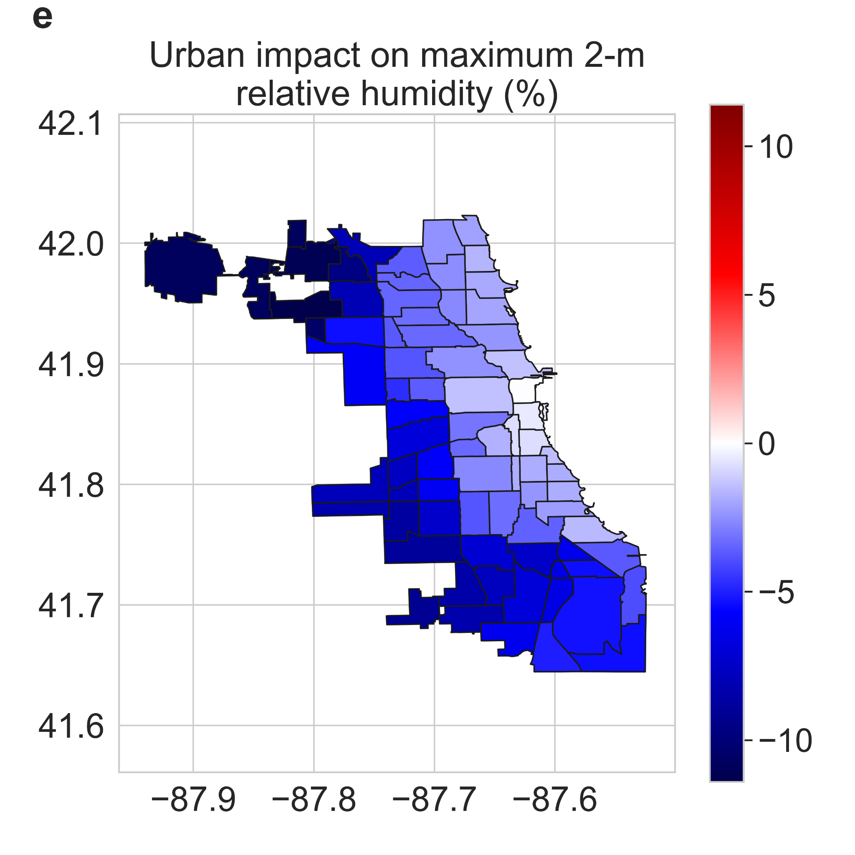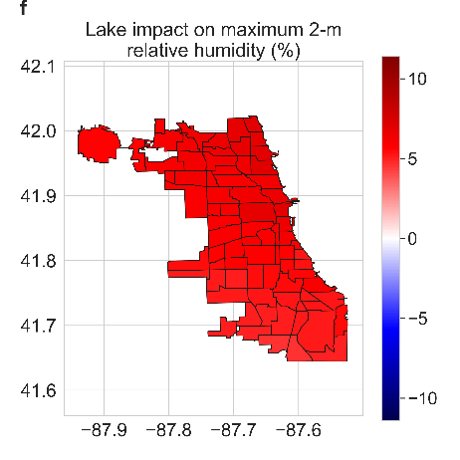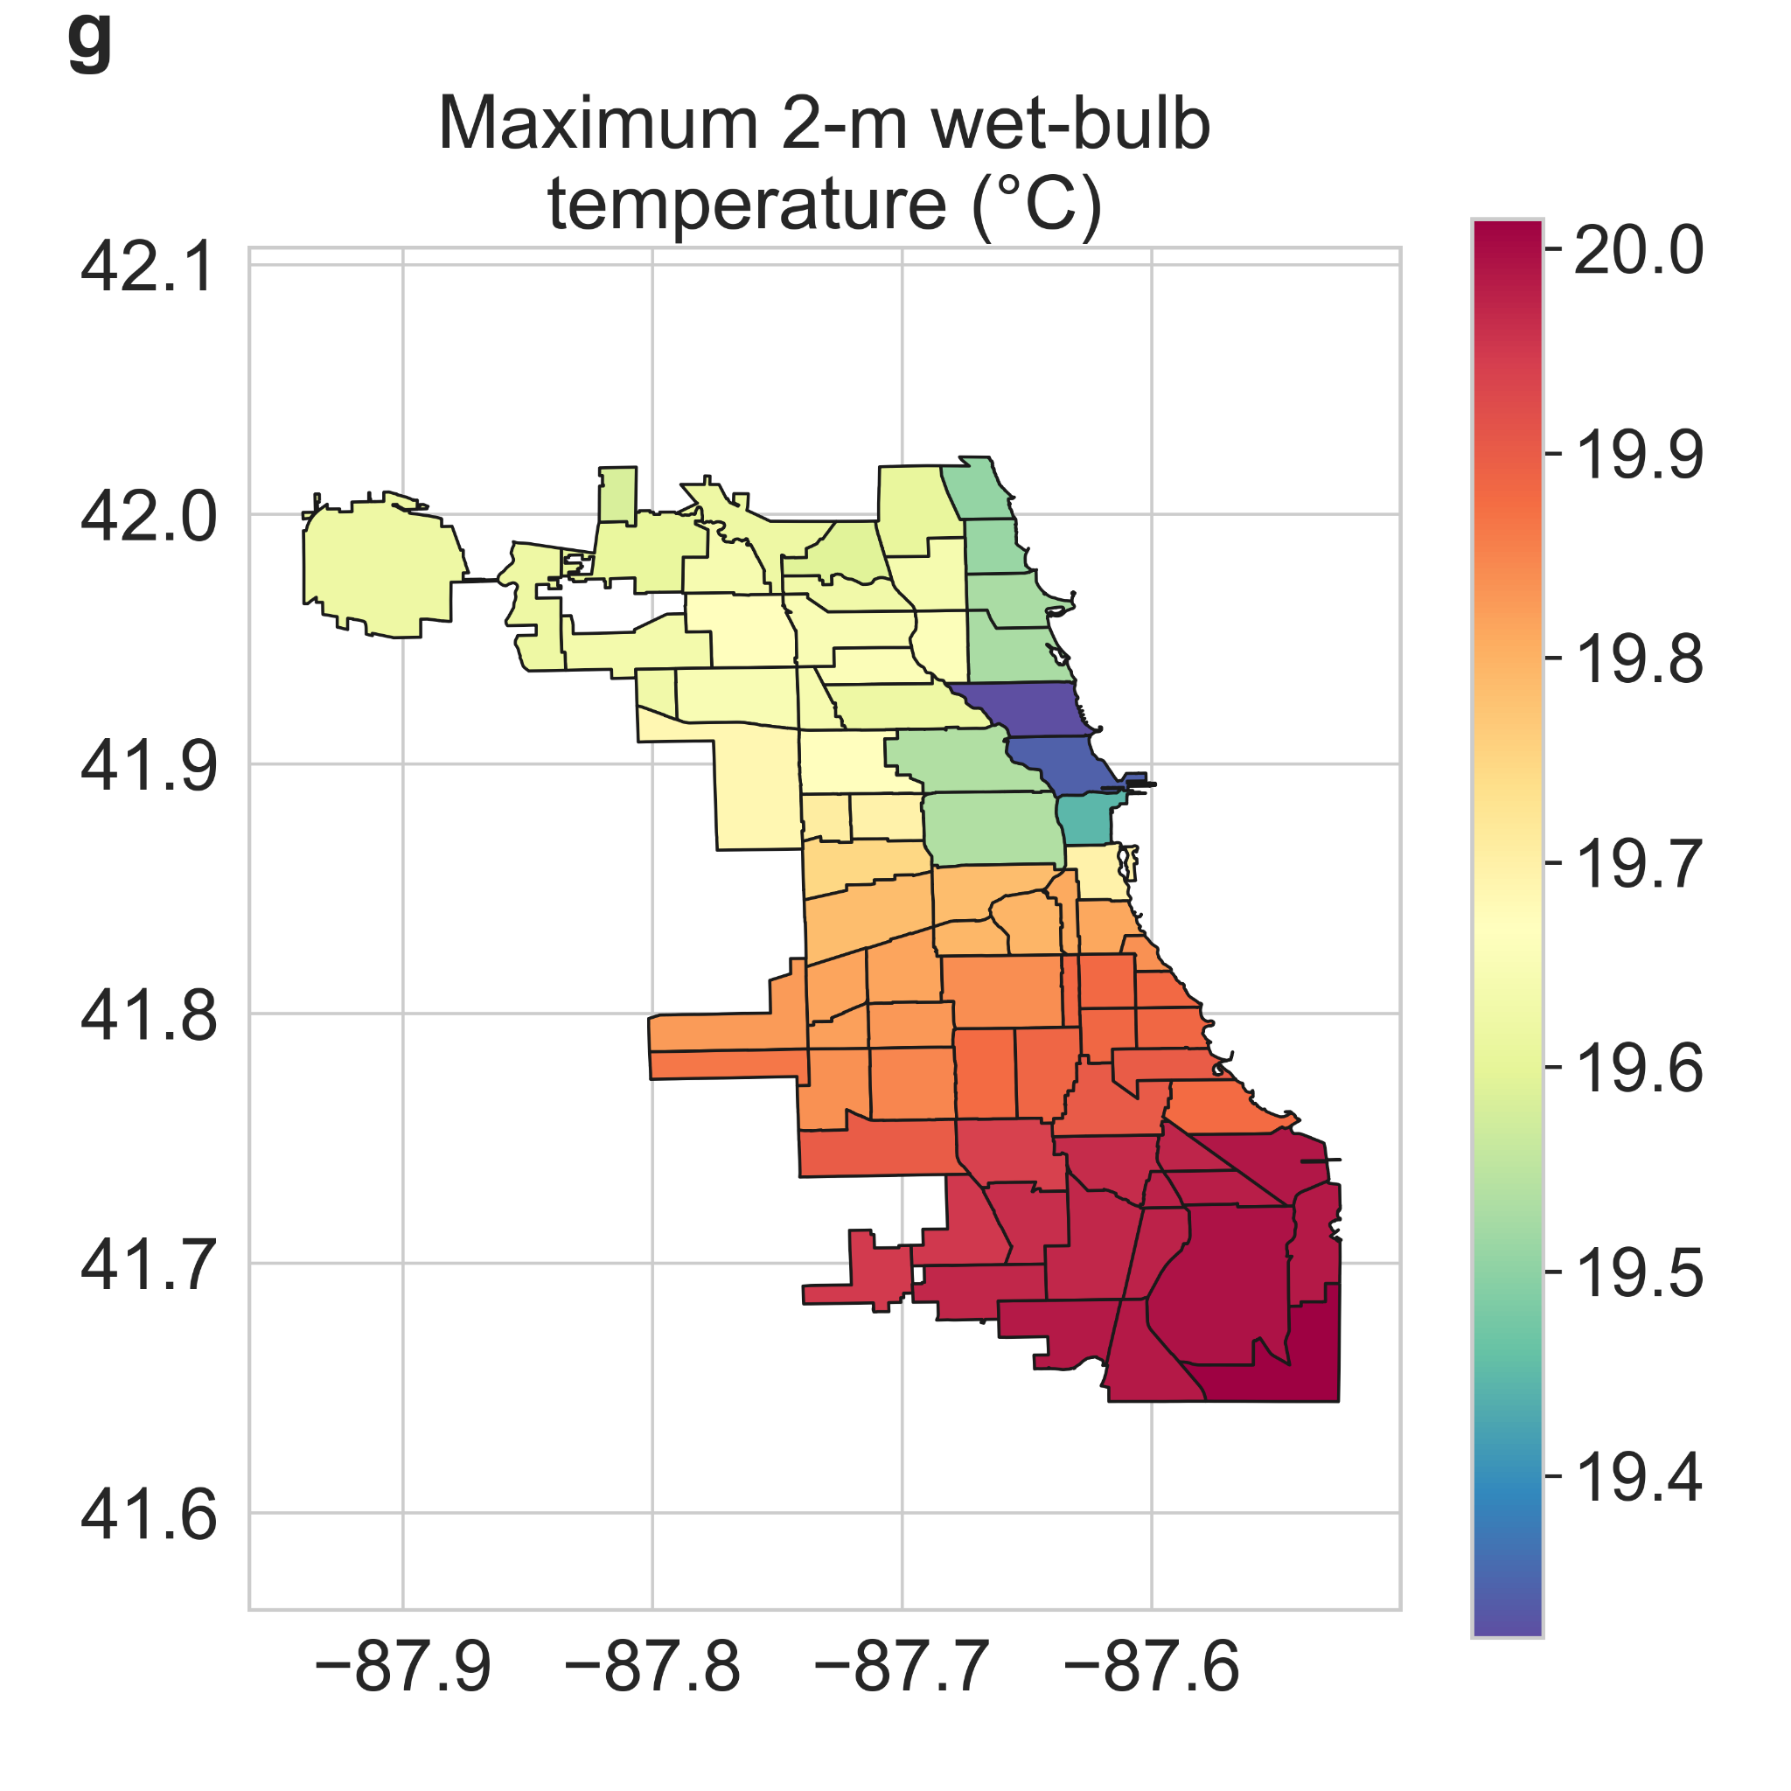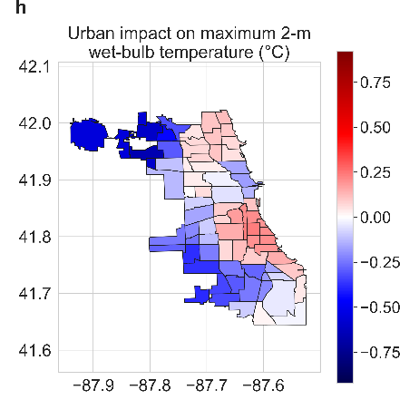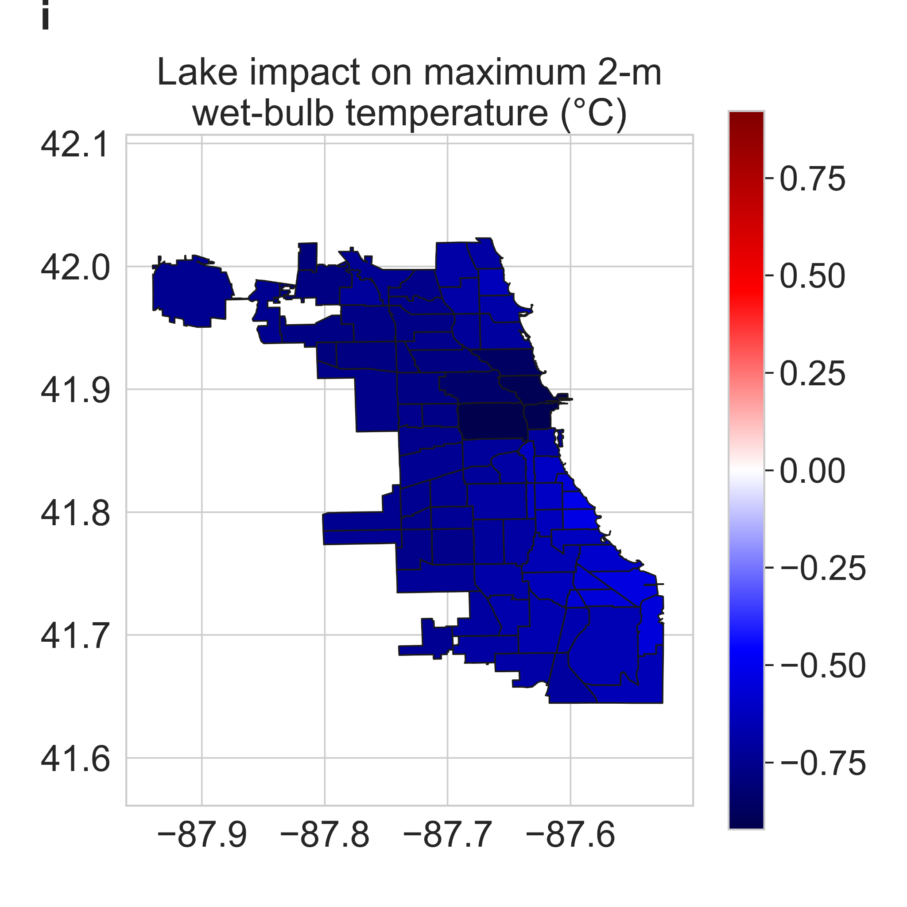
Fig S1 | Urban and lake impacts on other maximum exposure metrics | Neighborhood-scale summaries of WRF simulated maximum average a skin temperature, d relative humidity, and g wet-bulb temperature for summer 2018 in Chicago. b, e, h Urban impact on maximum average skin temperature, relative humidity, and wet-bulb temperature, respectively. c, f, i Lake impact on those variables.

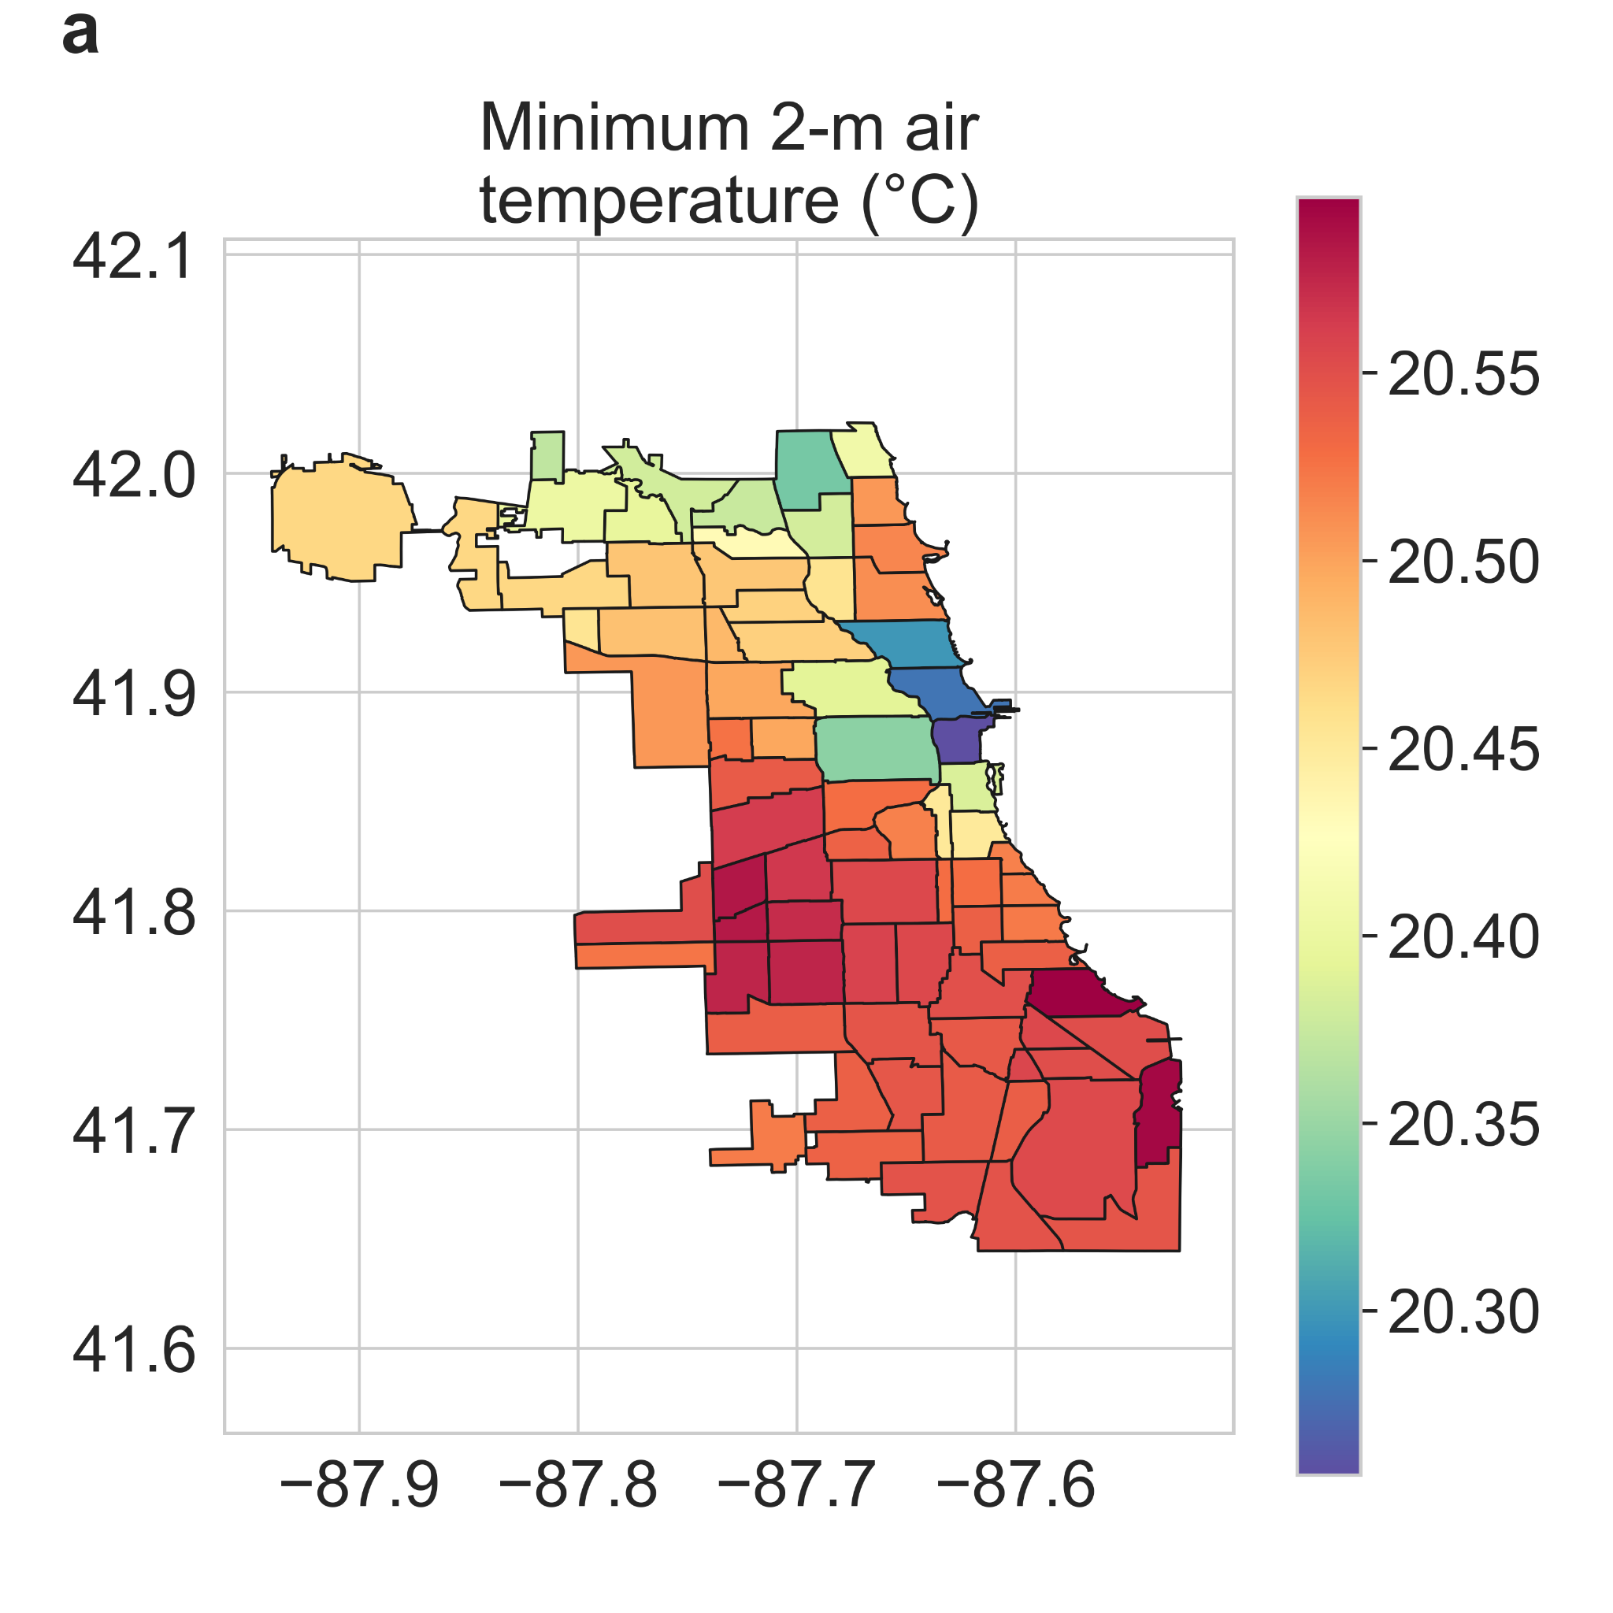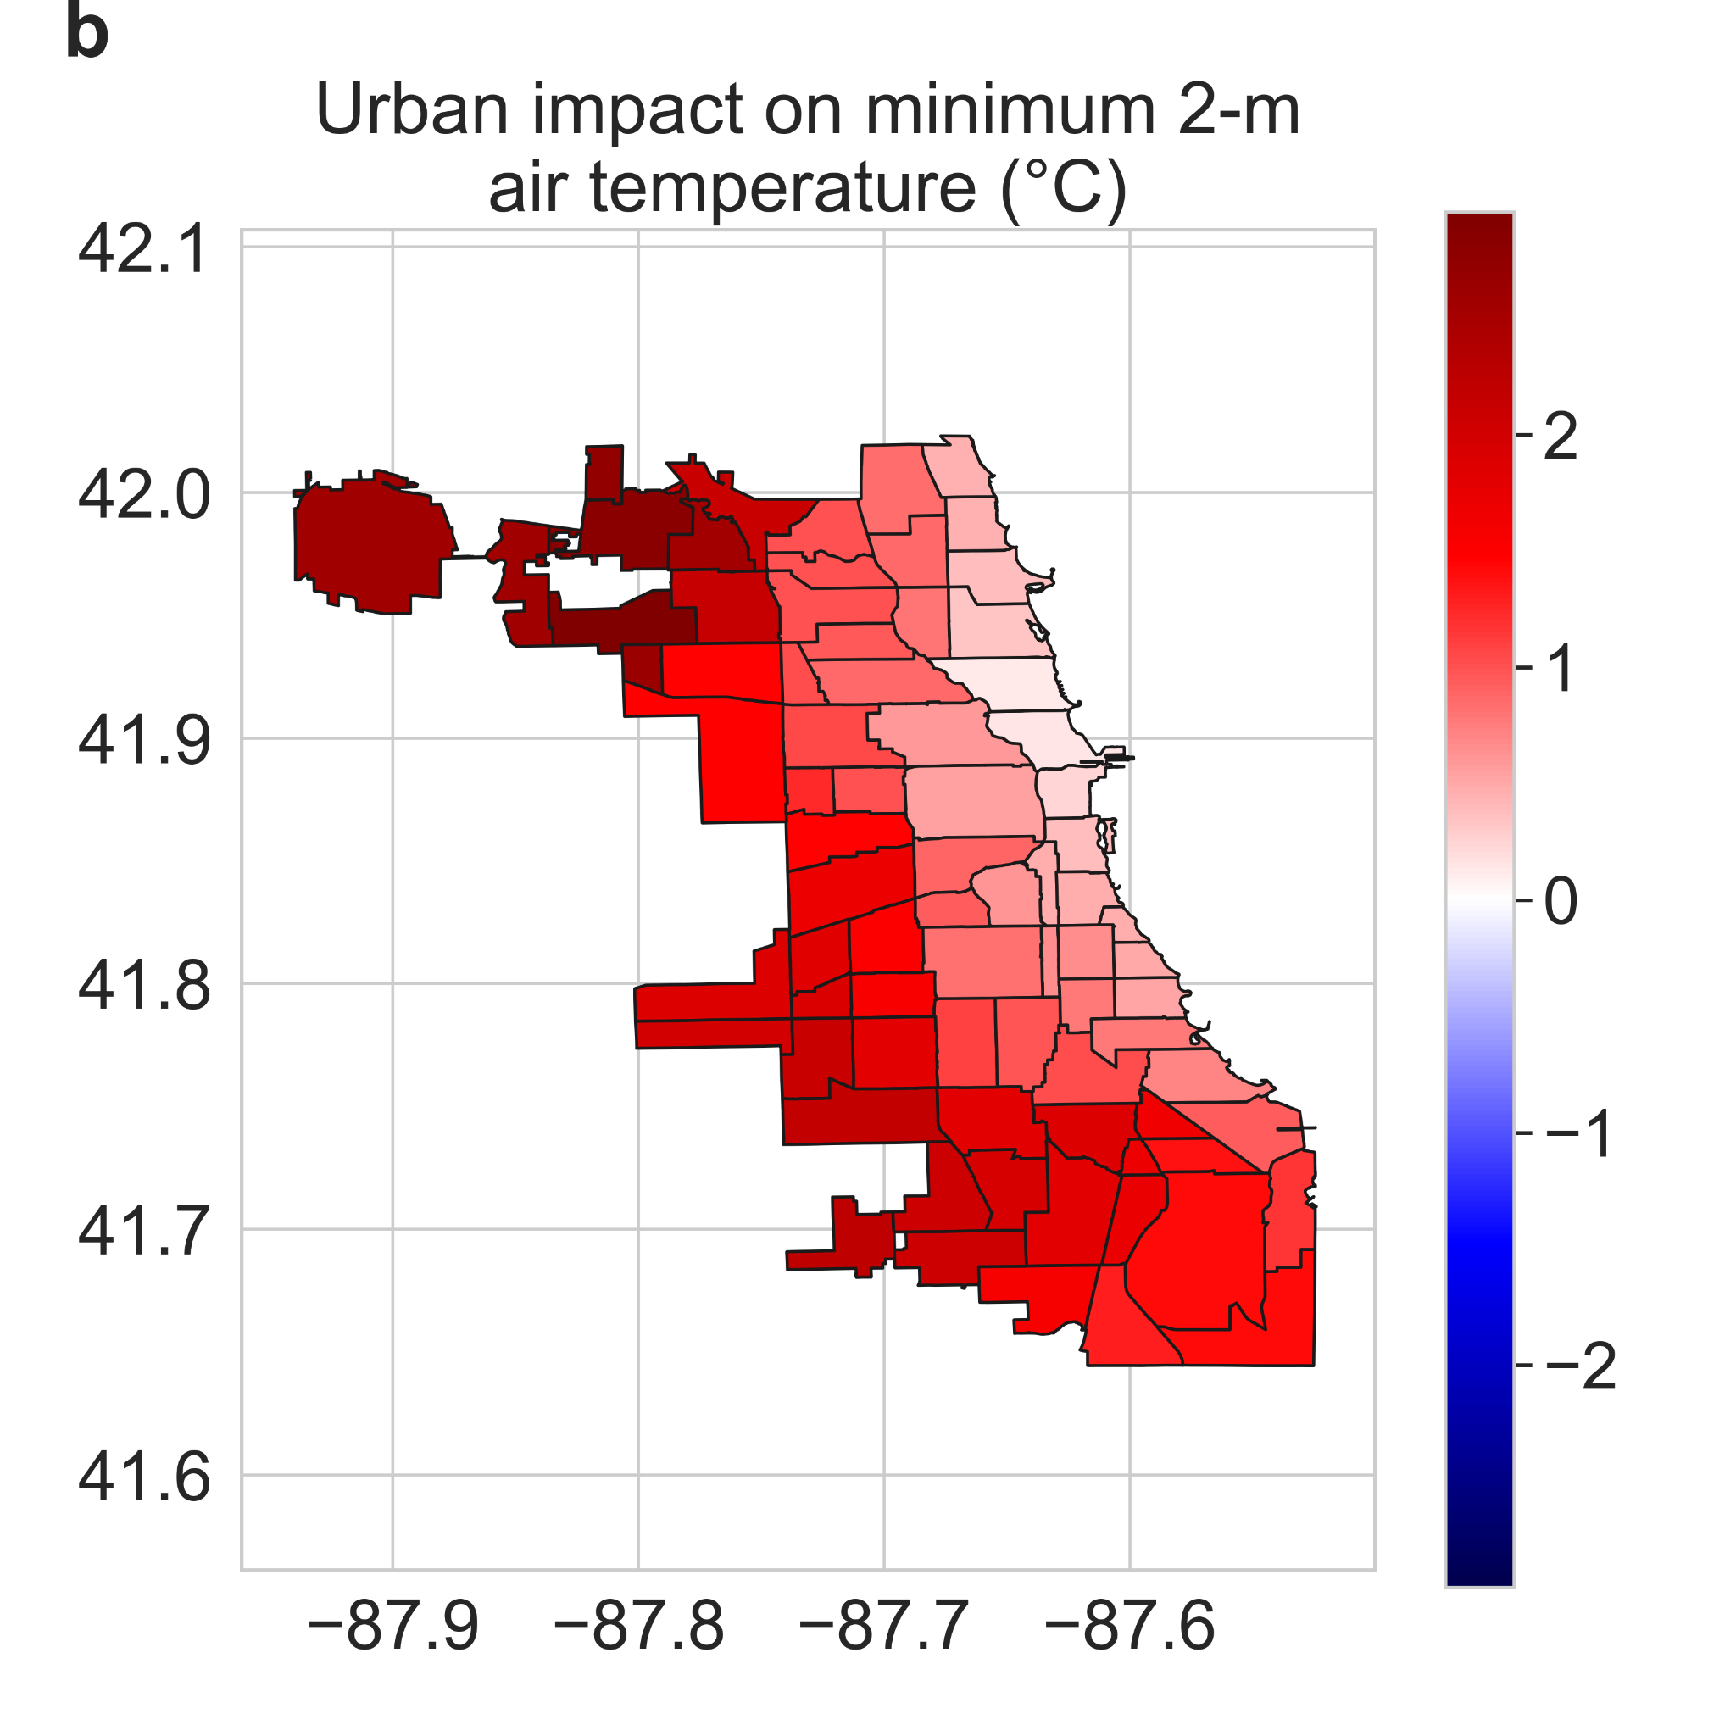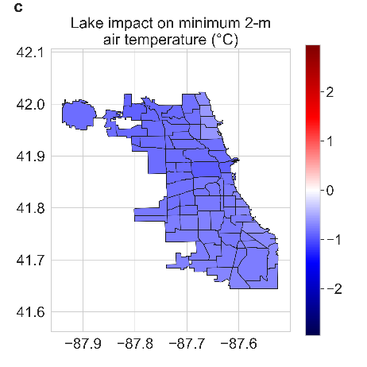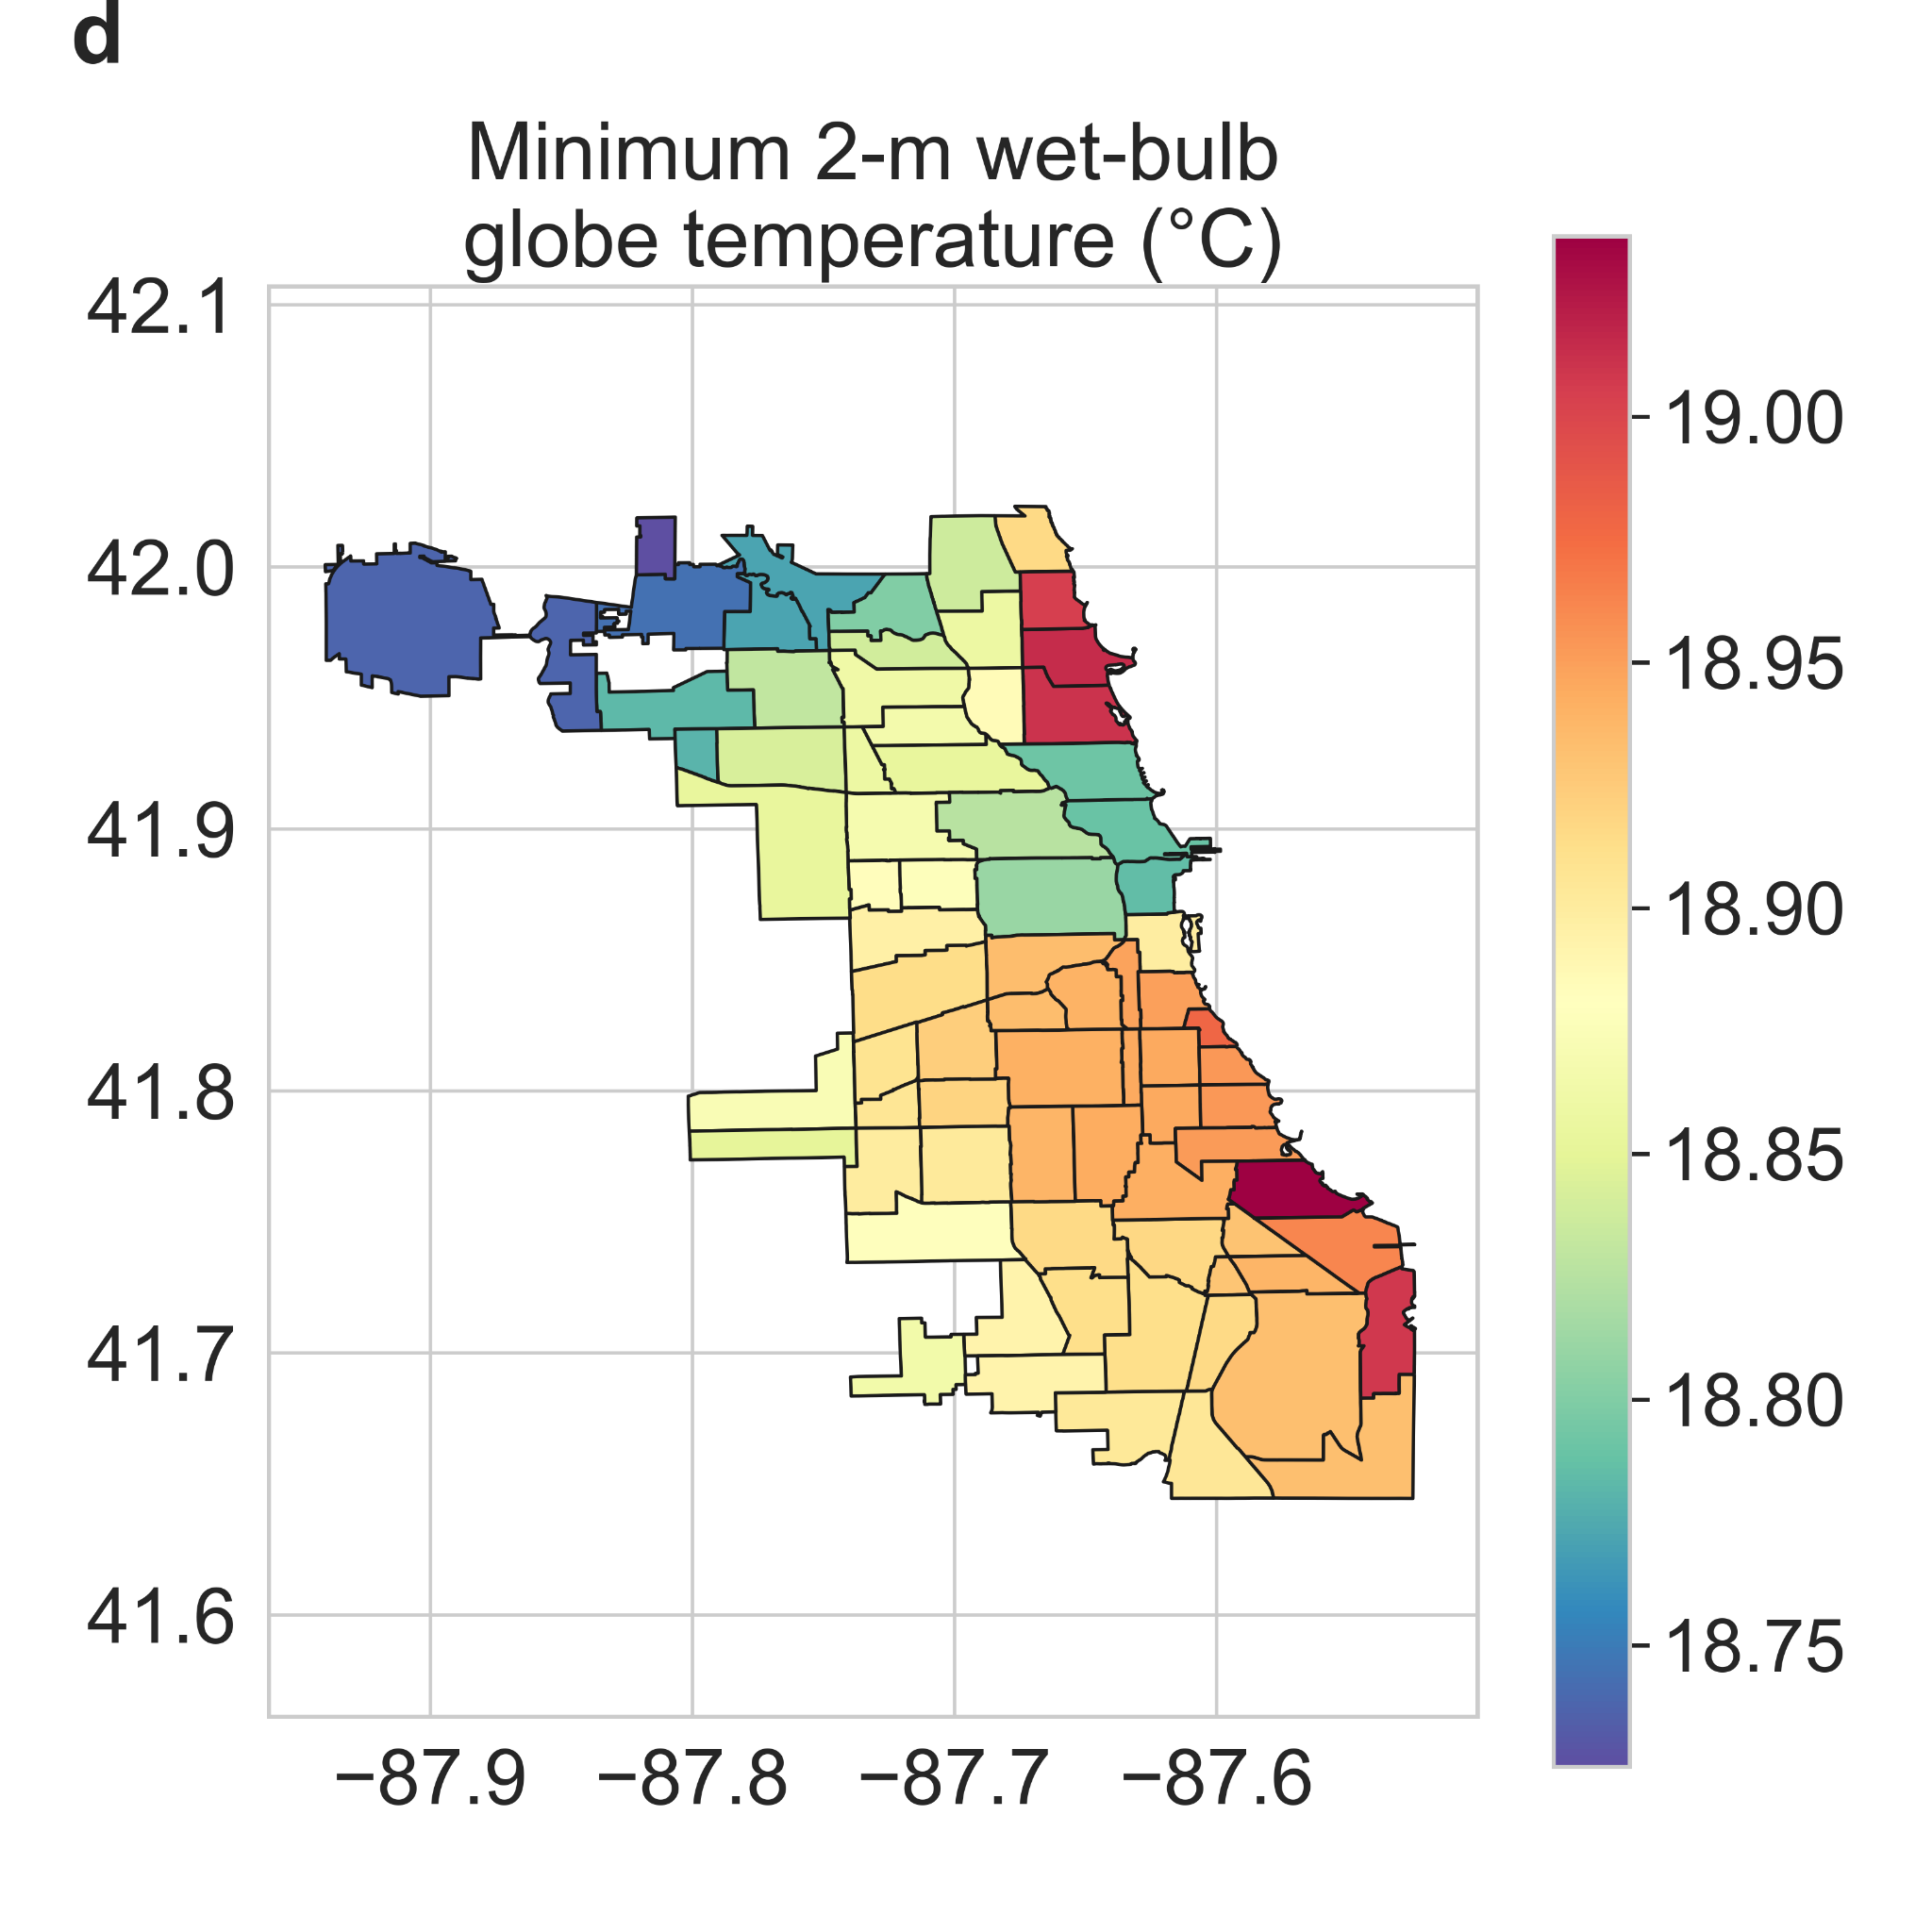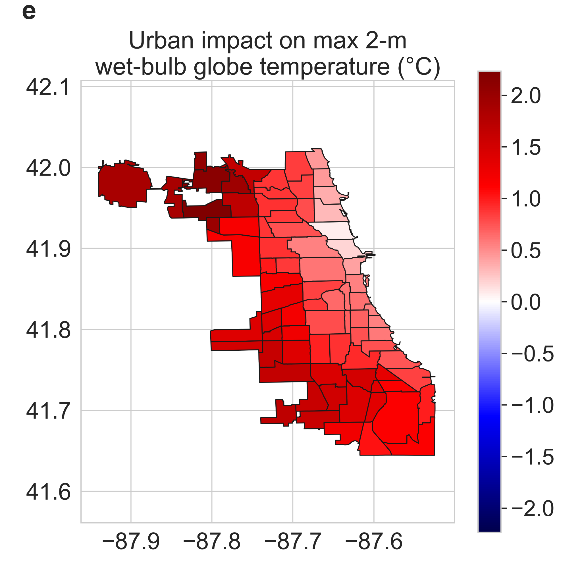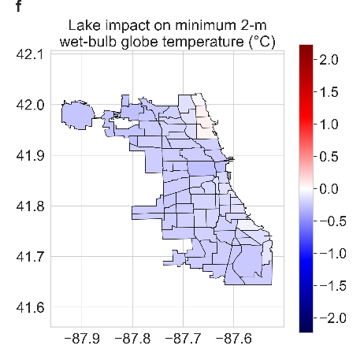
Fig S2 | Urban and lake impacts on minimum air and wet-bulb globe temperature | Neighborhood-scale summaries of WRF simulated minimum average a air temperature and d wet-bulb globe temperature for summer 2018 in Chicago. b, e Urban impact on minimum average air temperature and wet-bulb globe temperature, respectively. c, f Lake impact on those variables.
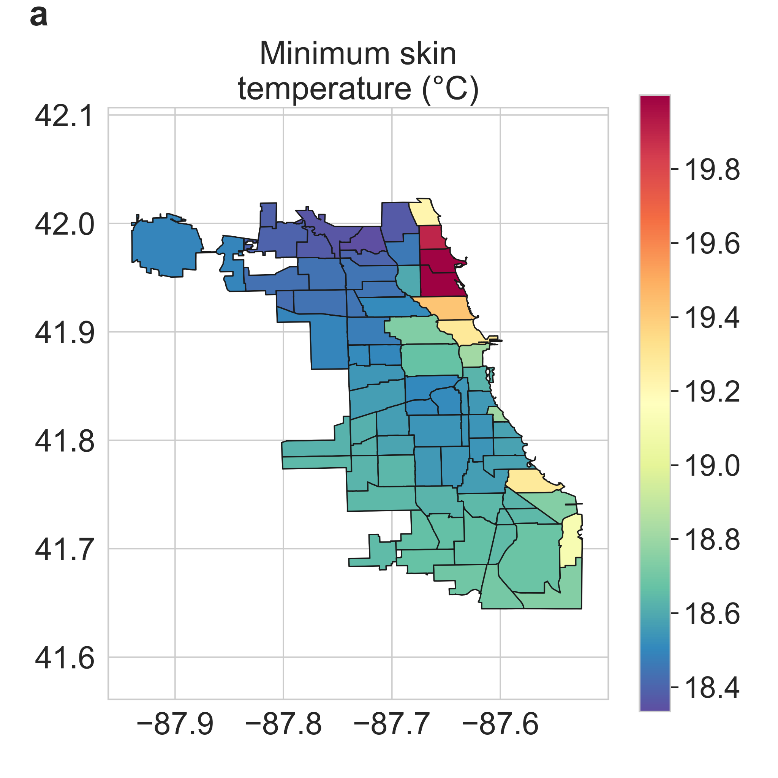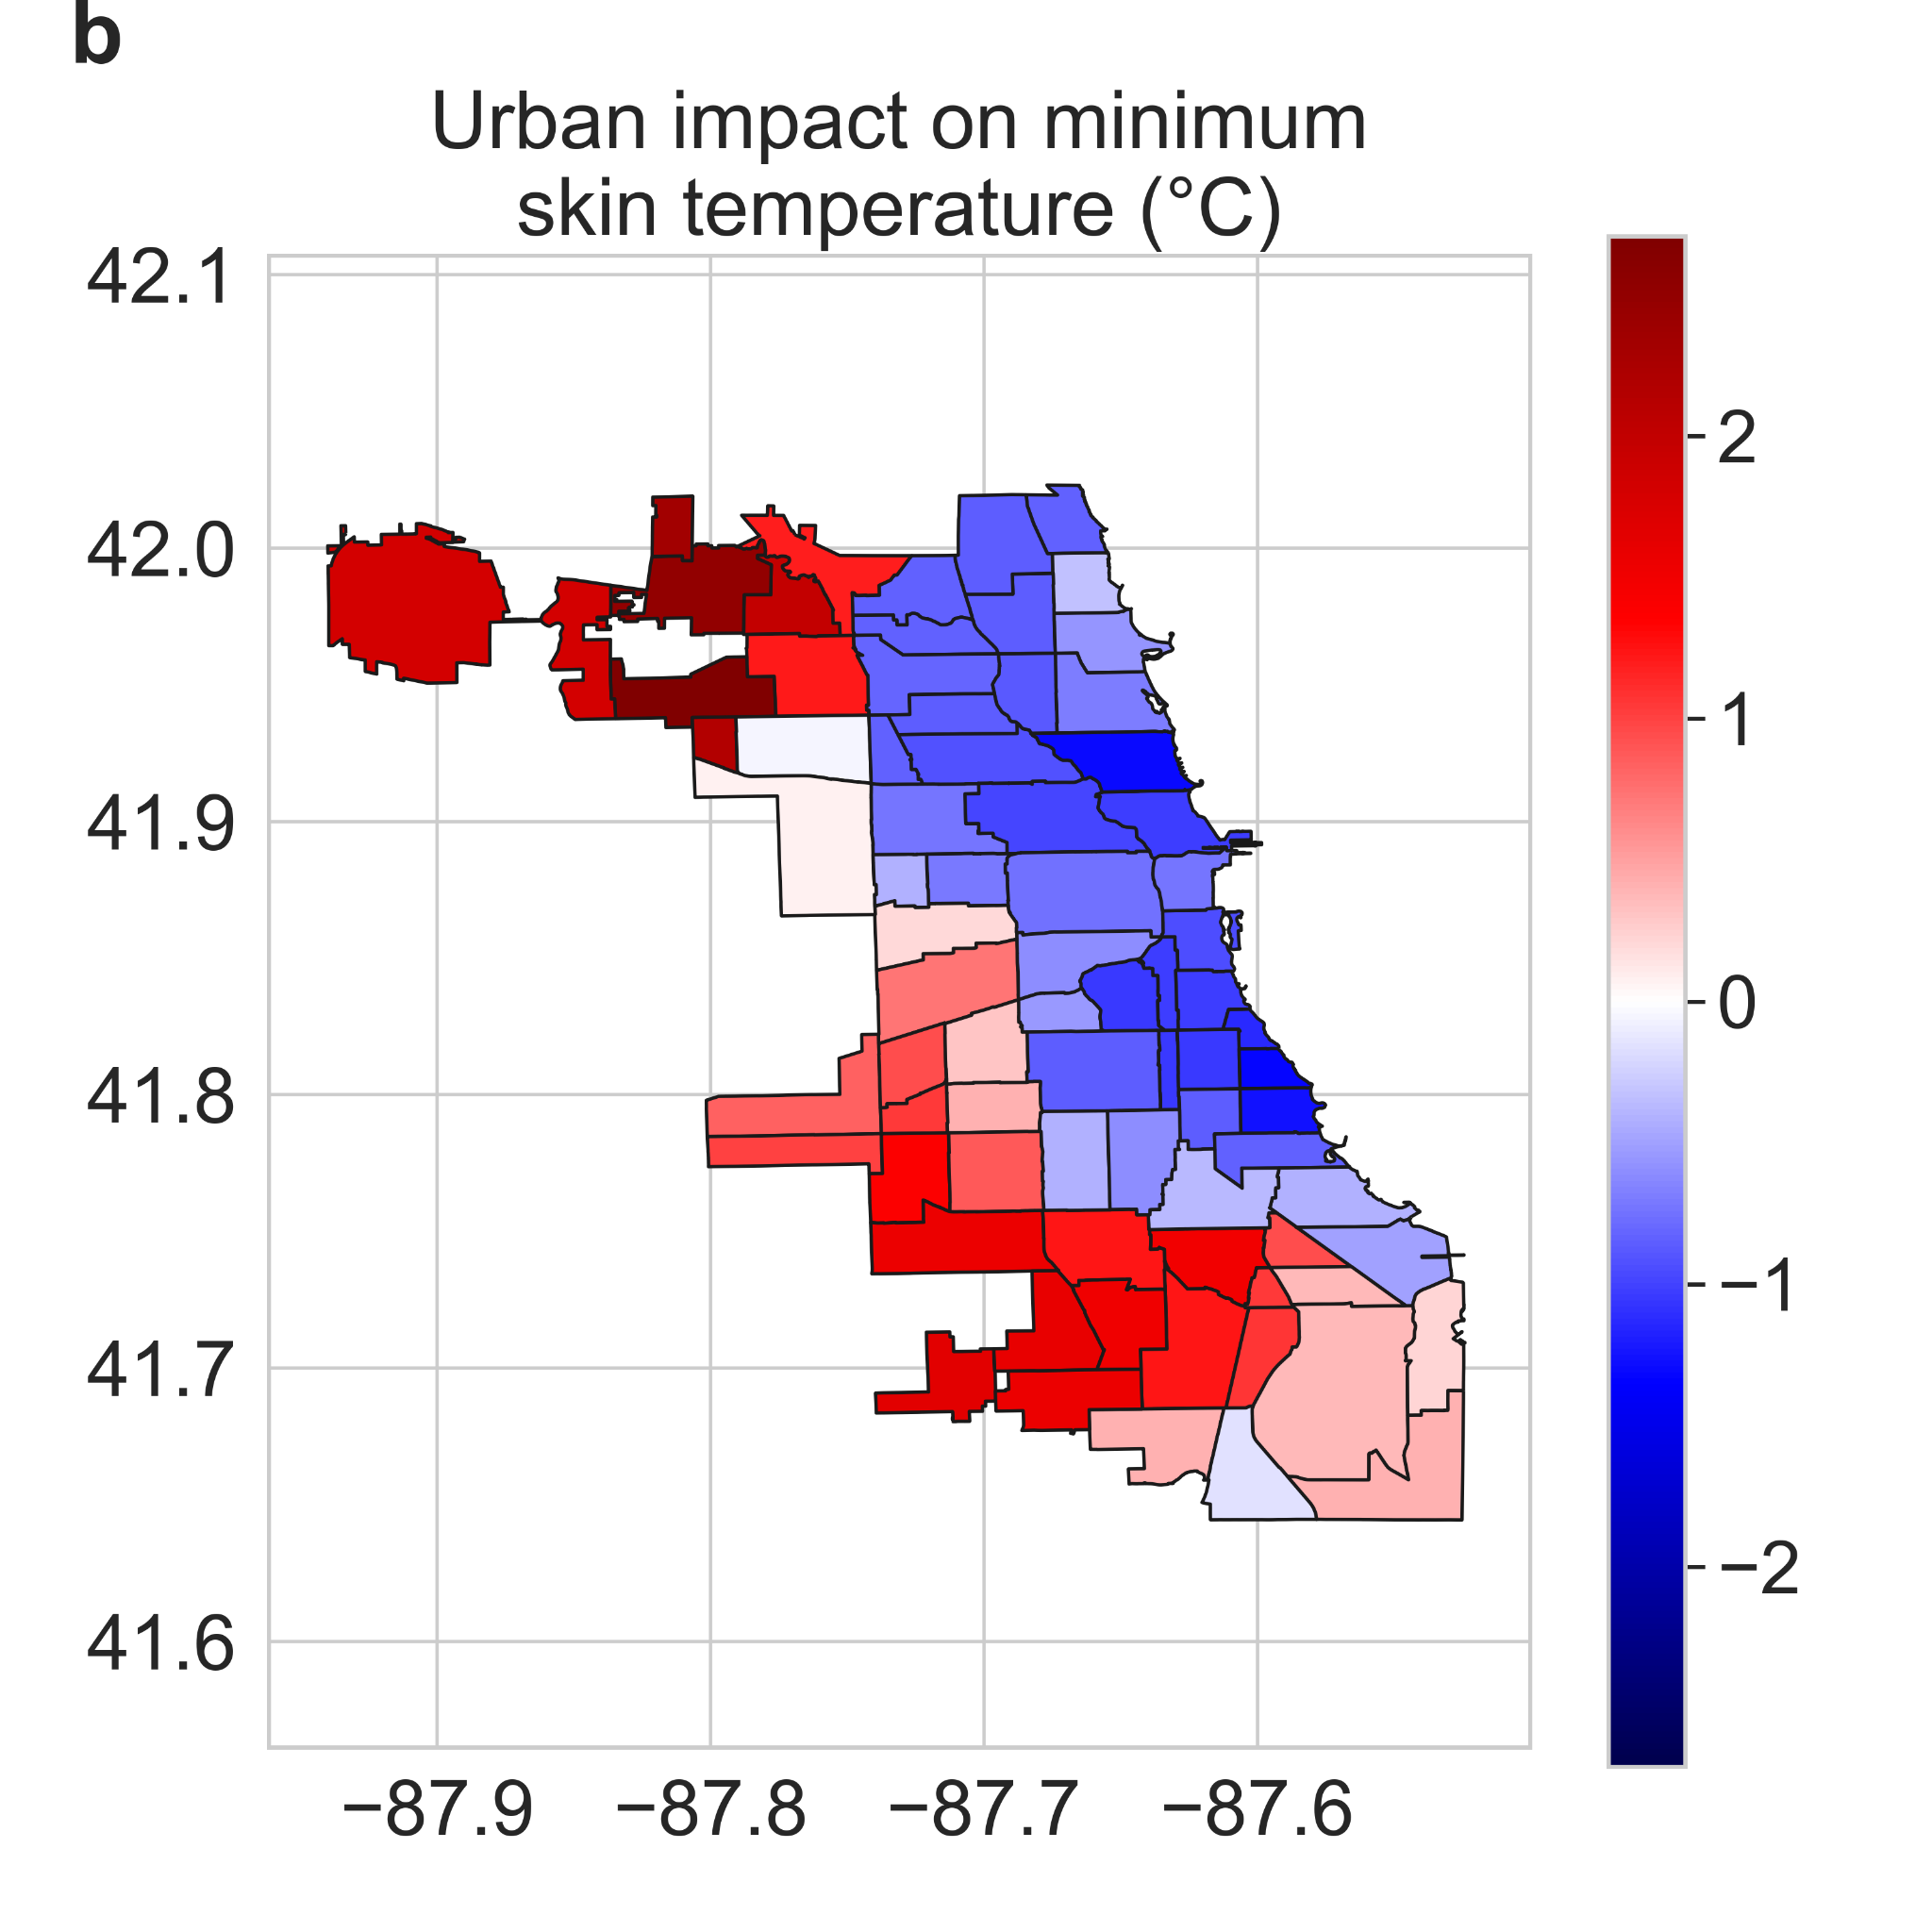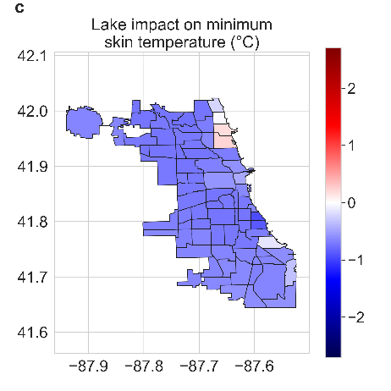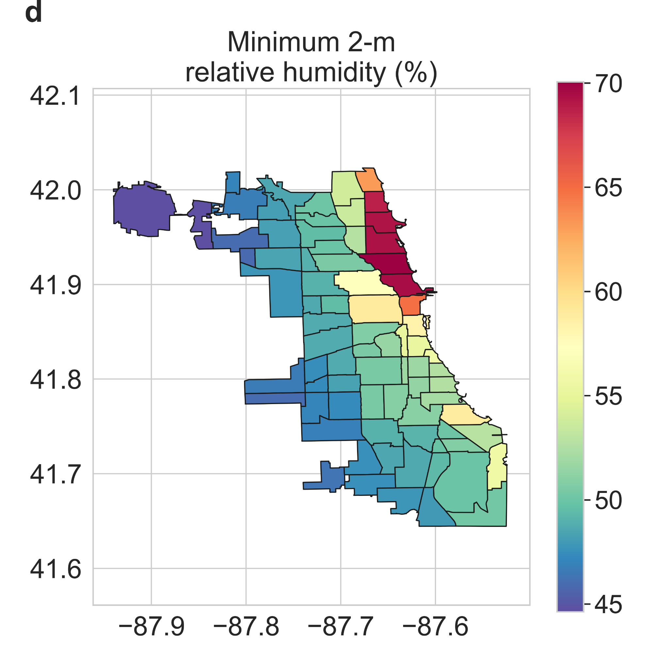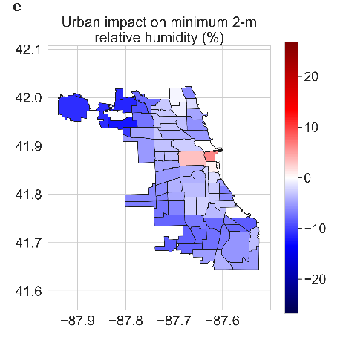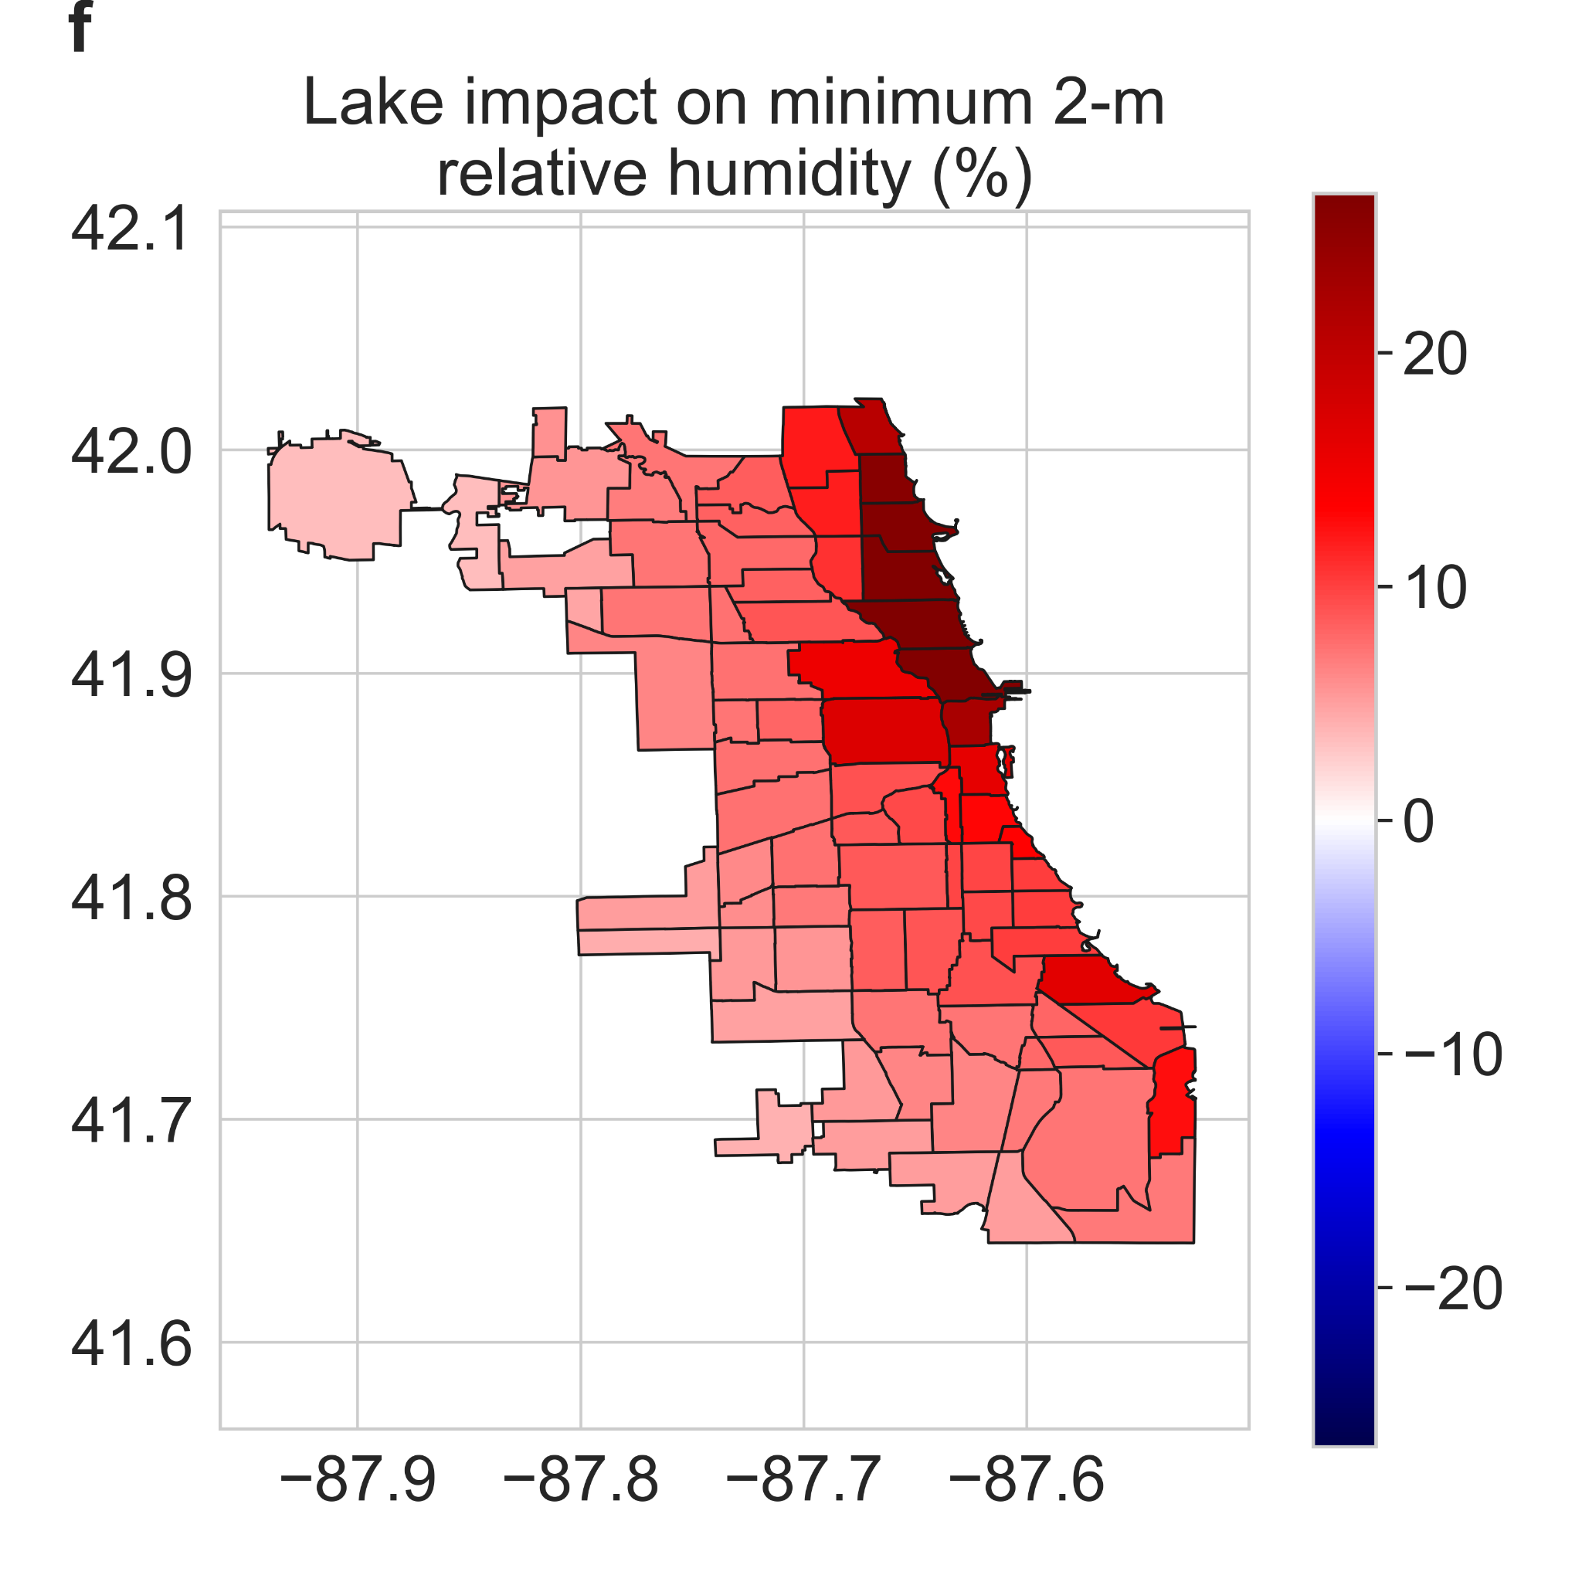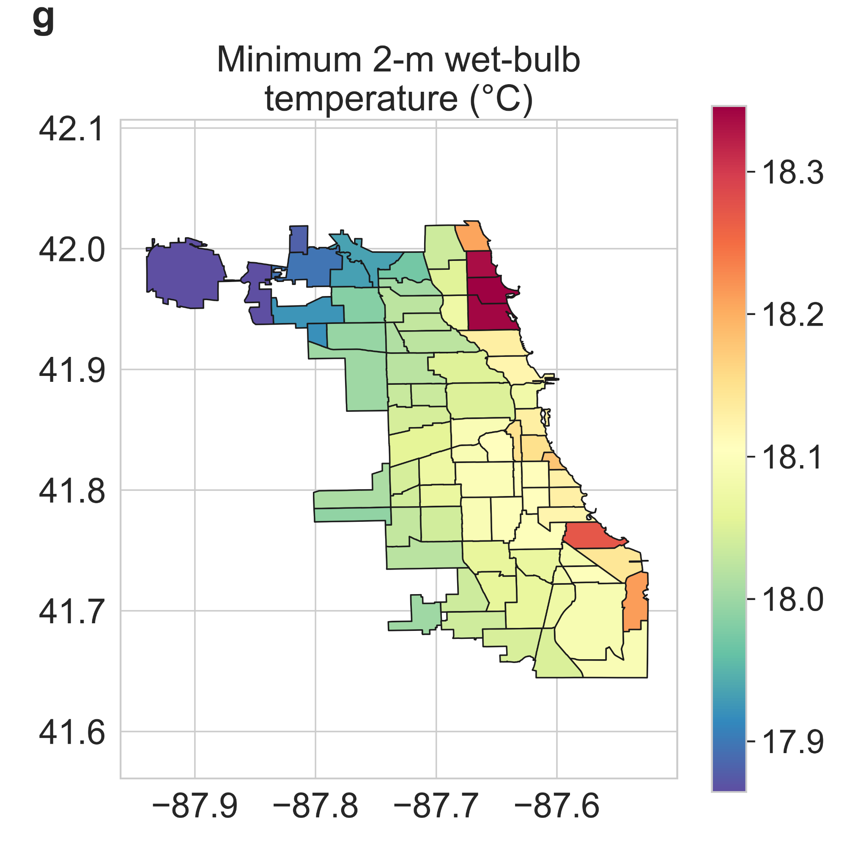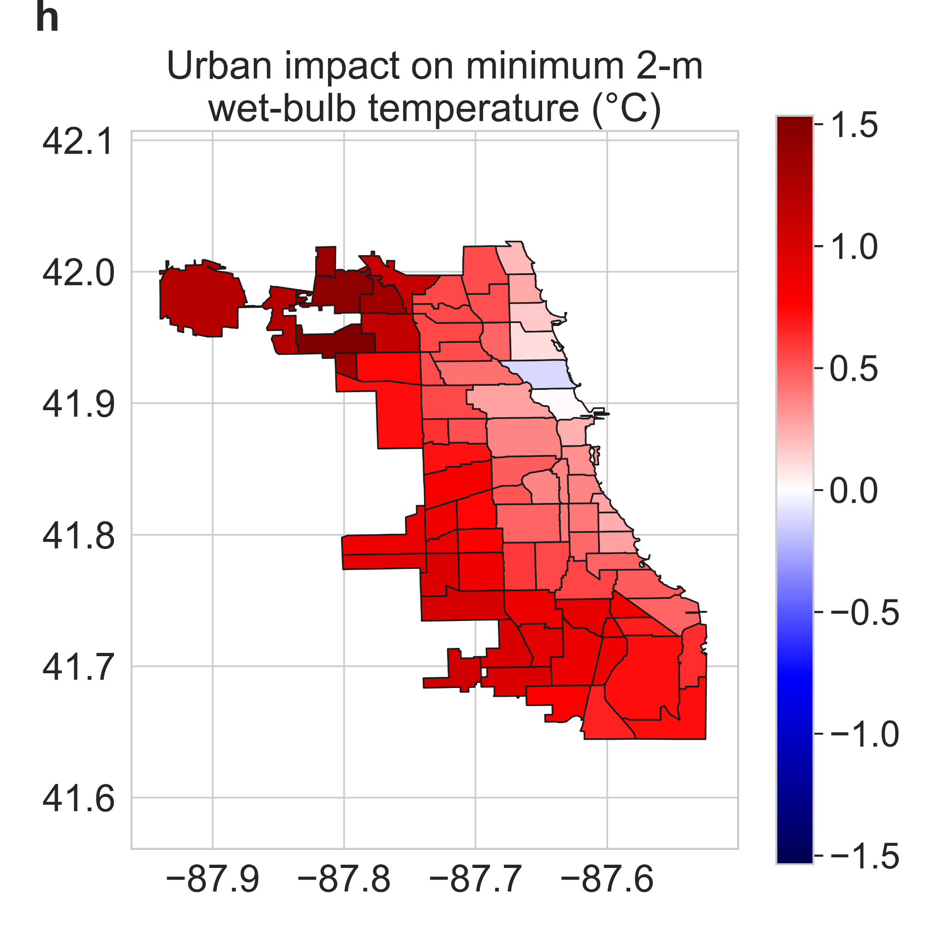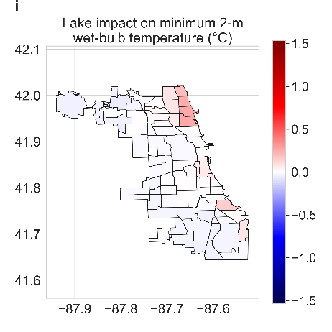
Fig S3 | Urban and lake impacts on other minimum exposure metrics | Neighborhood-scale summaries of WRF simulated minimum average a skin temperature, d relative humidity, and g wet-bulb temperature for summer 2018 in Chicago. b, e, h Urban impact on minimum average skin temperature, relative humidity, and wet-bulb temperature, respectively. c, f, i Lake impact on those variables.

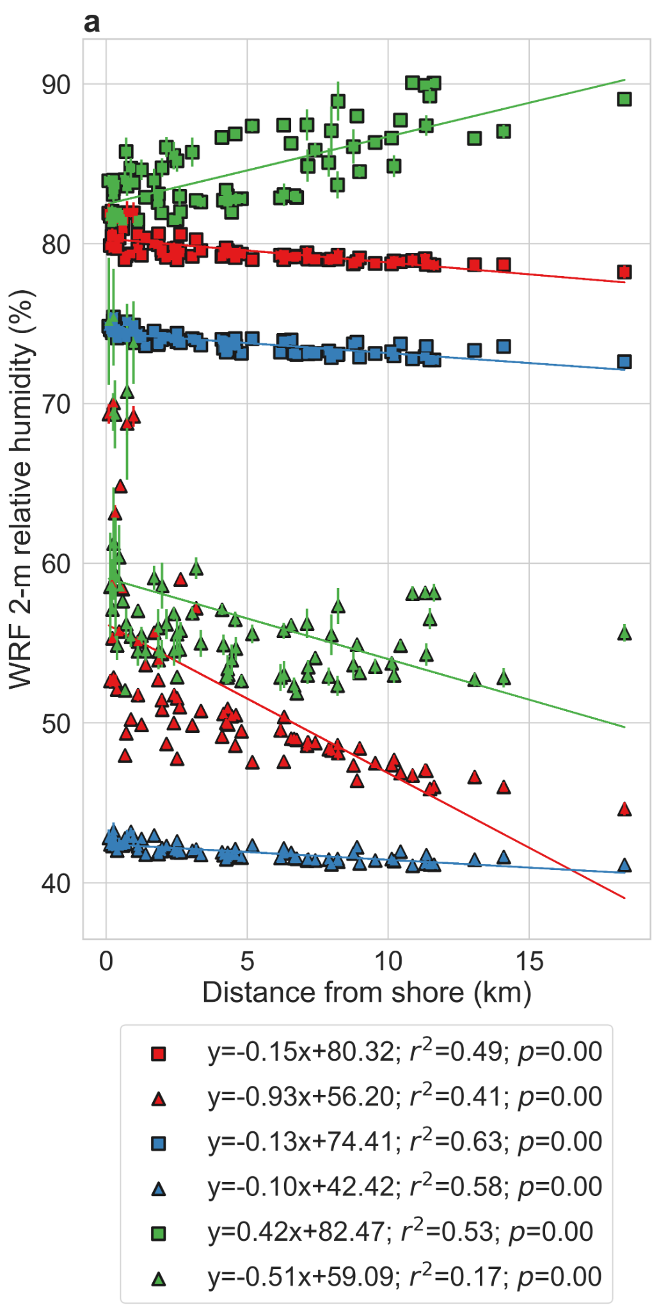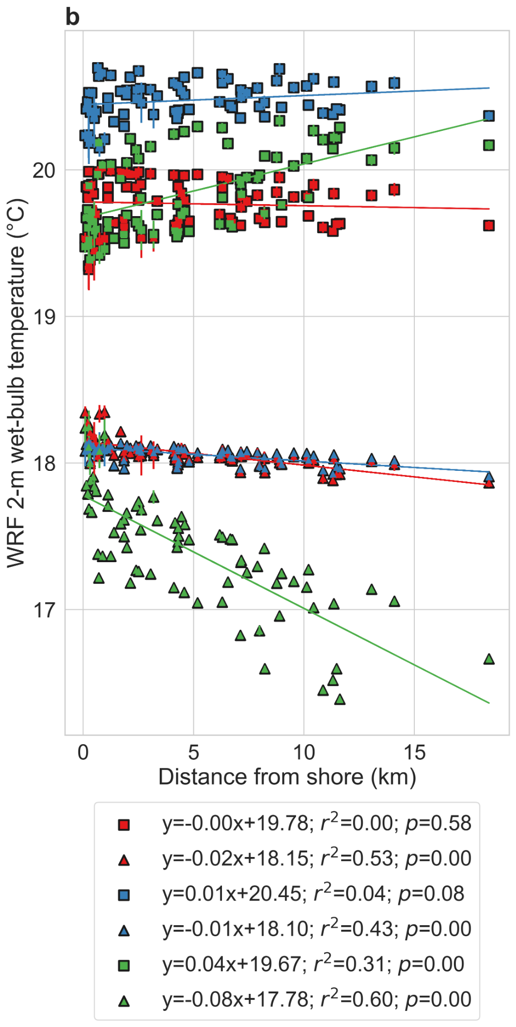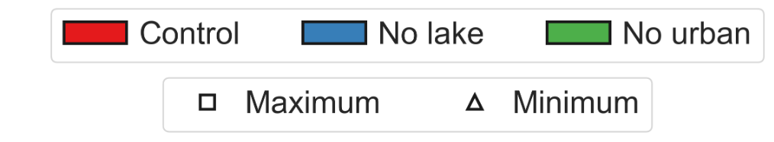
Fig S4 | Lake-to-land gradients of wet-bulb temperature and relative humidity | Associations between WRF simulated maximum and minimum average a relative humidity and b wet-bulb temperature in summer 2018 for Chicago neighborhoods and the corresponding distance of the centroid of each community area to the lake shore. The points represent the mean values from the five ensemble simulations and the error bars correspond to standard errors across the ensembles. The lines of best fit are shown and the associated equations, coefficients of determination, and p values are in the legend. The square symbols show the maximum averages and the triangles are for the minimum averages. The three colors (red, blue, and green) show the results for control, no lake, and no urban simulations, respectively.
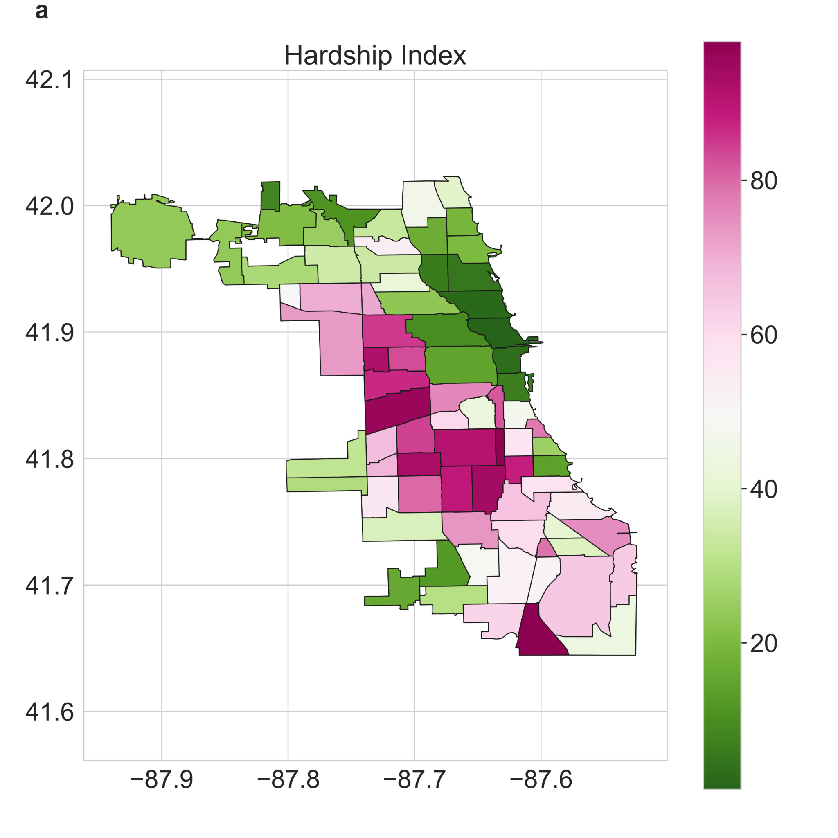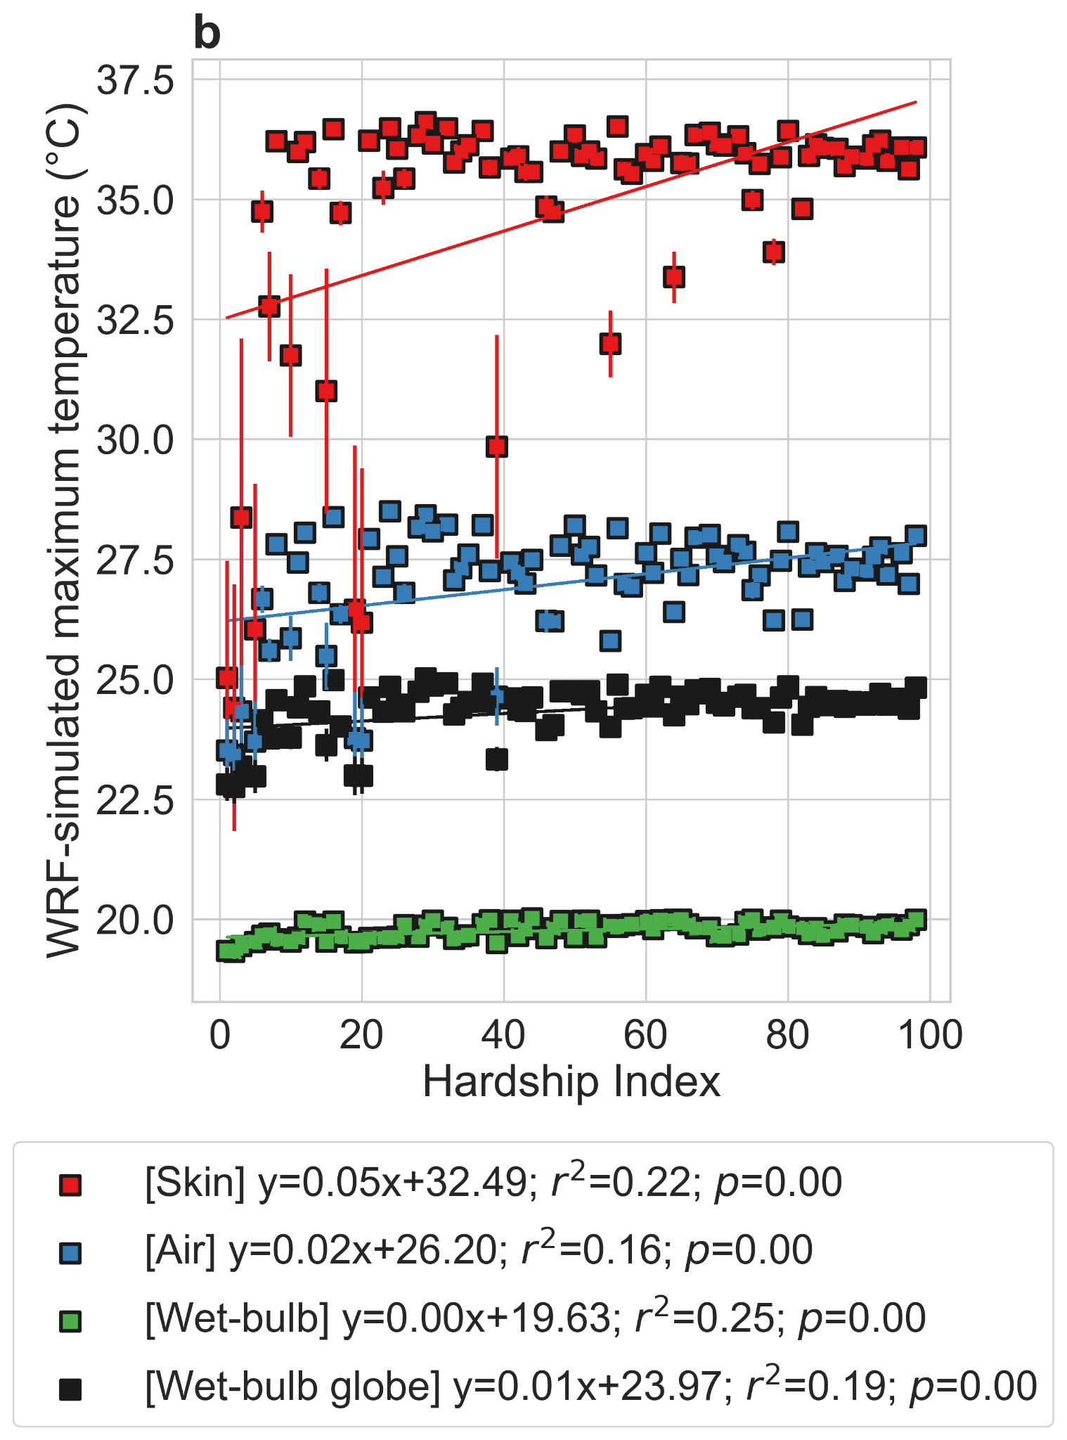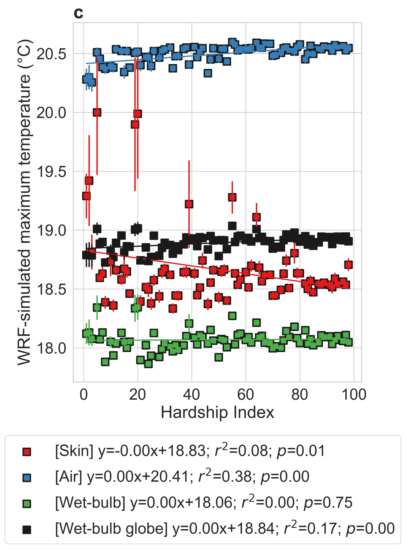
Fig S5 | Associations between simulated heat exposure metrics and Hardship index | a Neighborhood-scale summaries of Hardship index. b and c show associations between WRF simulated maximum and minimum average (respectively) skin temperature, air temperature, wet-bulb temperature, and wet-bulb globe temperature in summer 2018 for Chicago neighborhoods and the corresponding Hardship index. The points represent the mean values from the five ensemble simulations and the error bars correspond to standard errors across the ensembles. The lines of best fit are shown and the associated equations, coefficients of determination, and p values are in the legend.

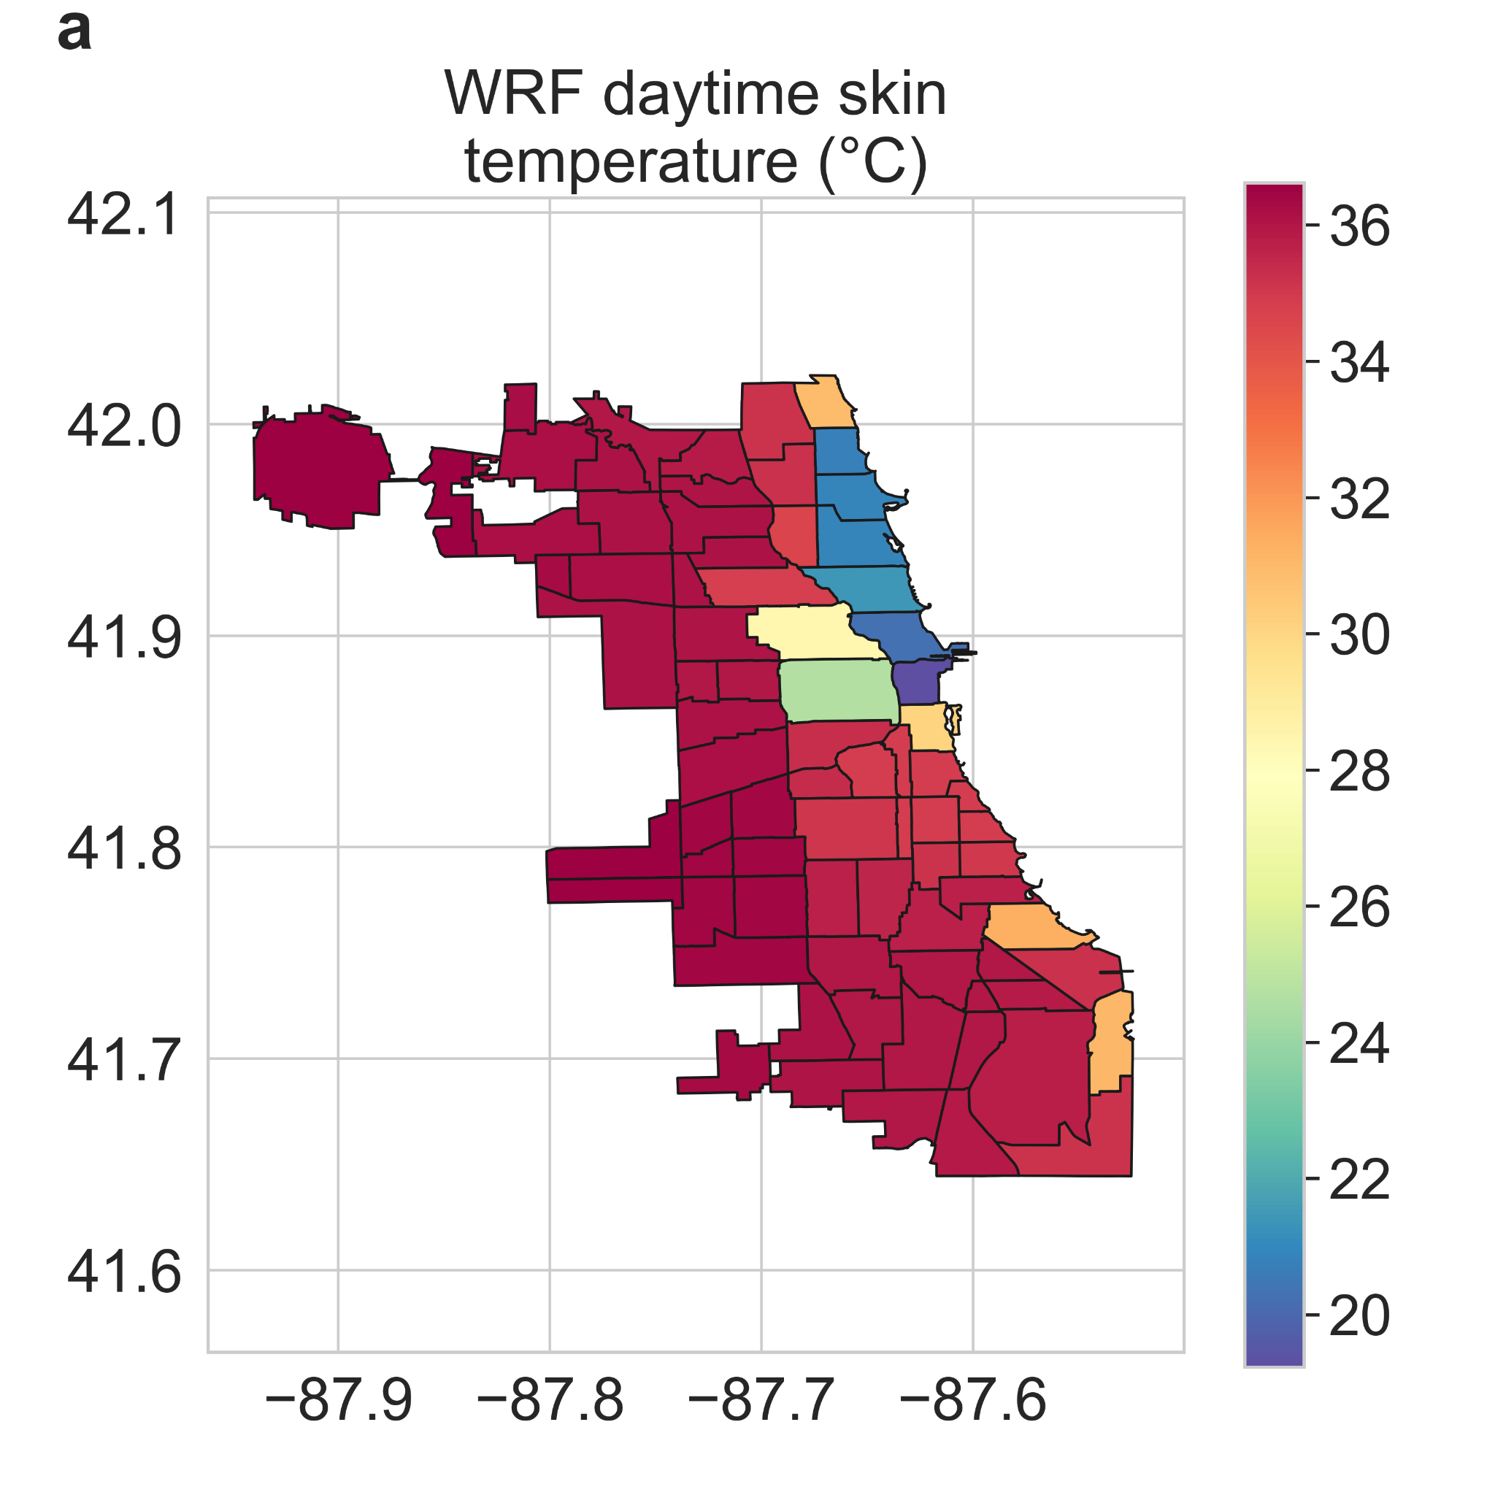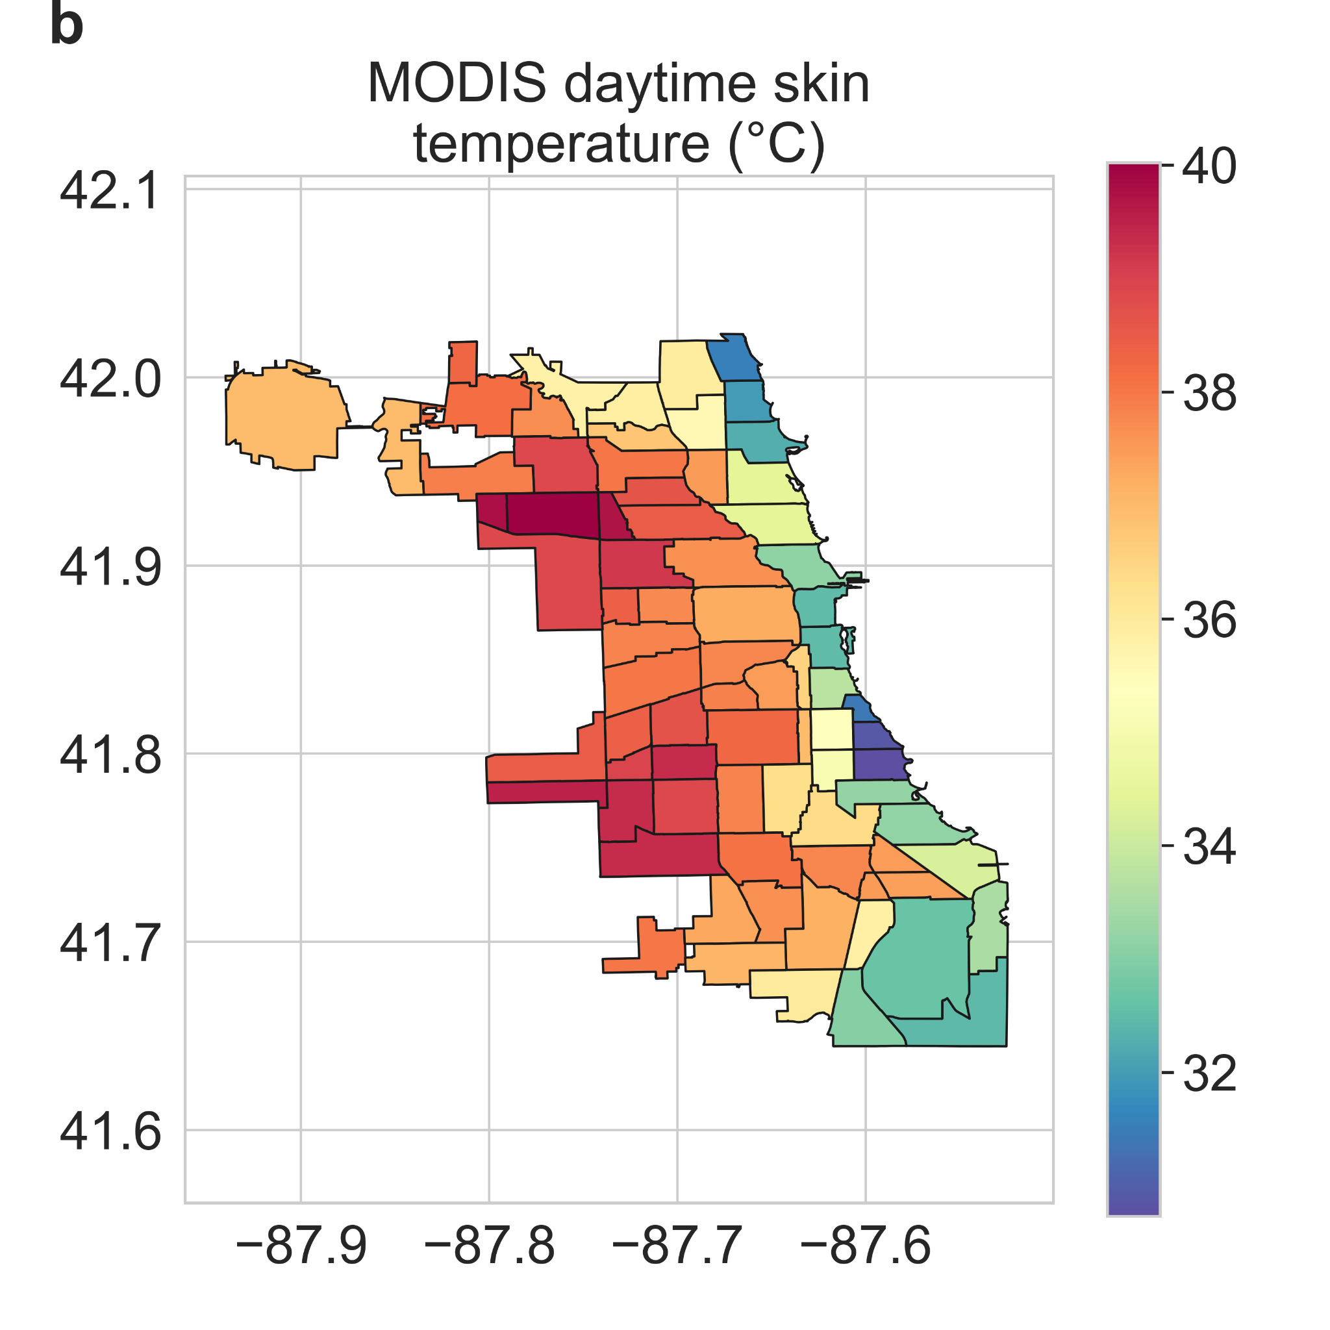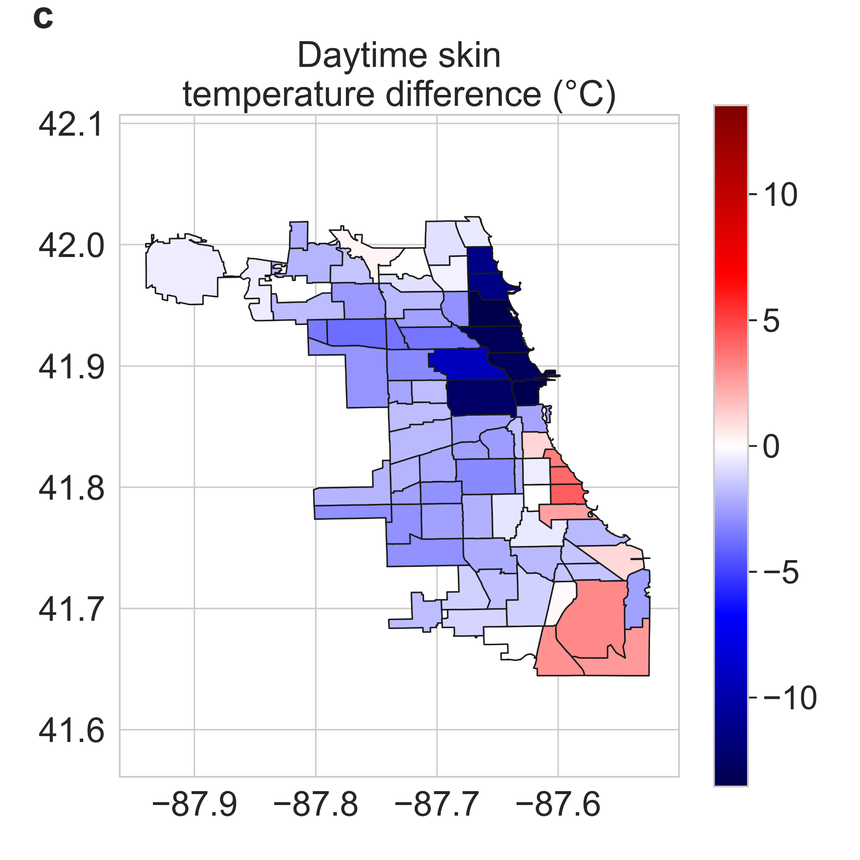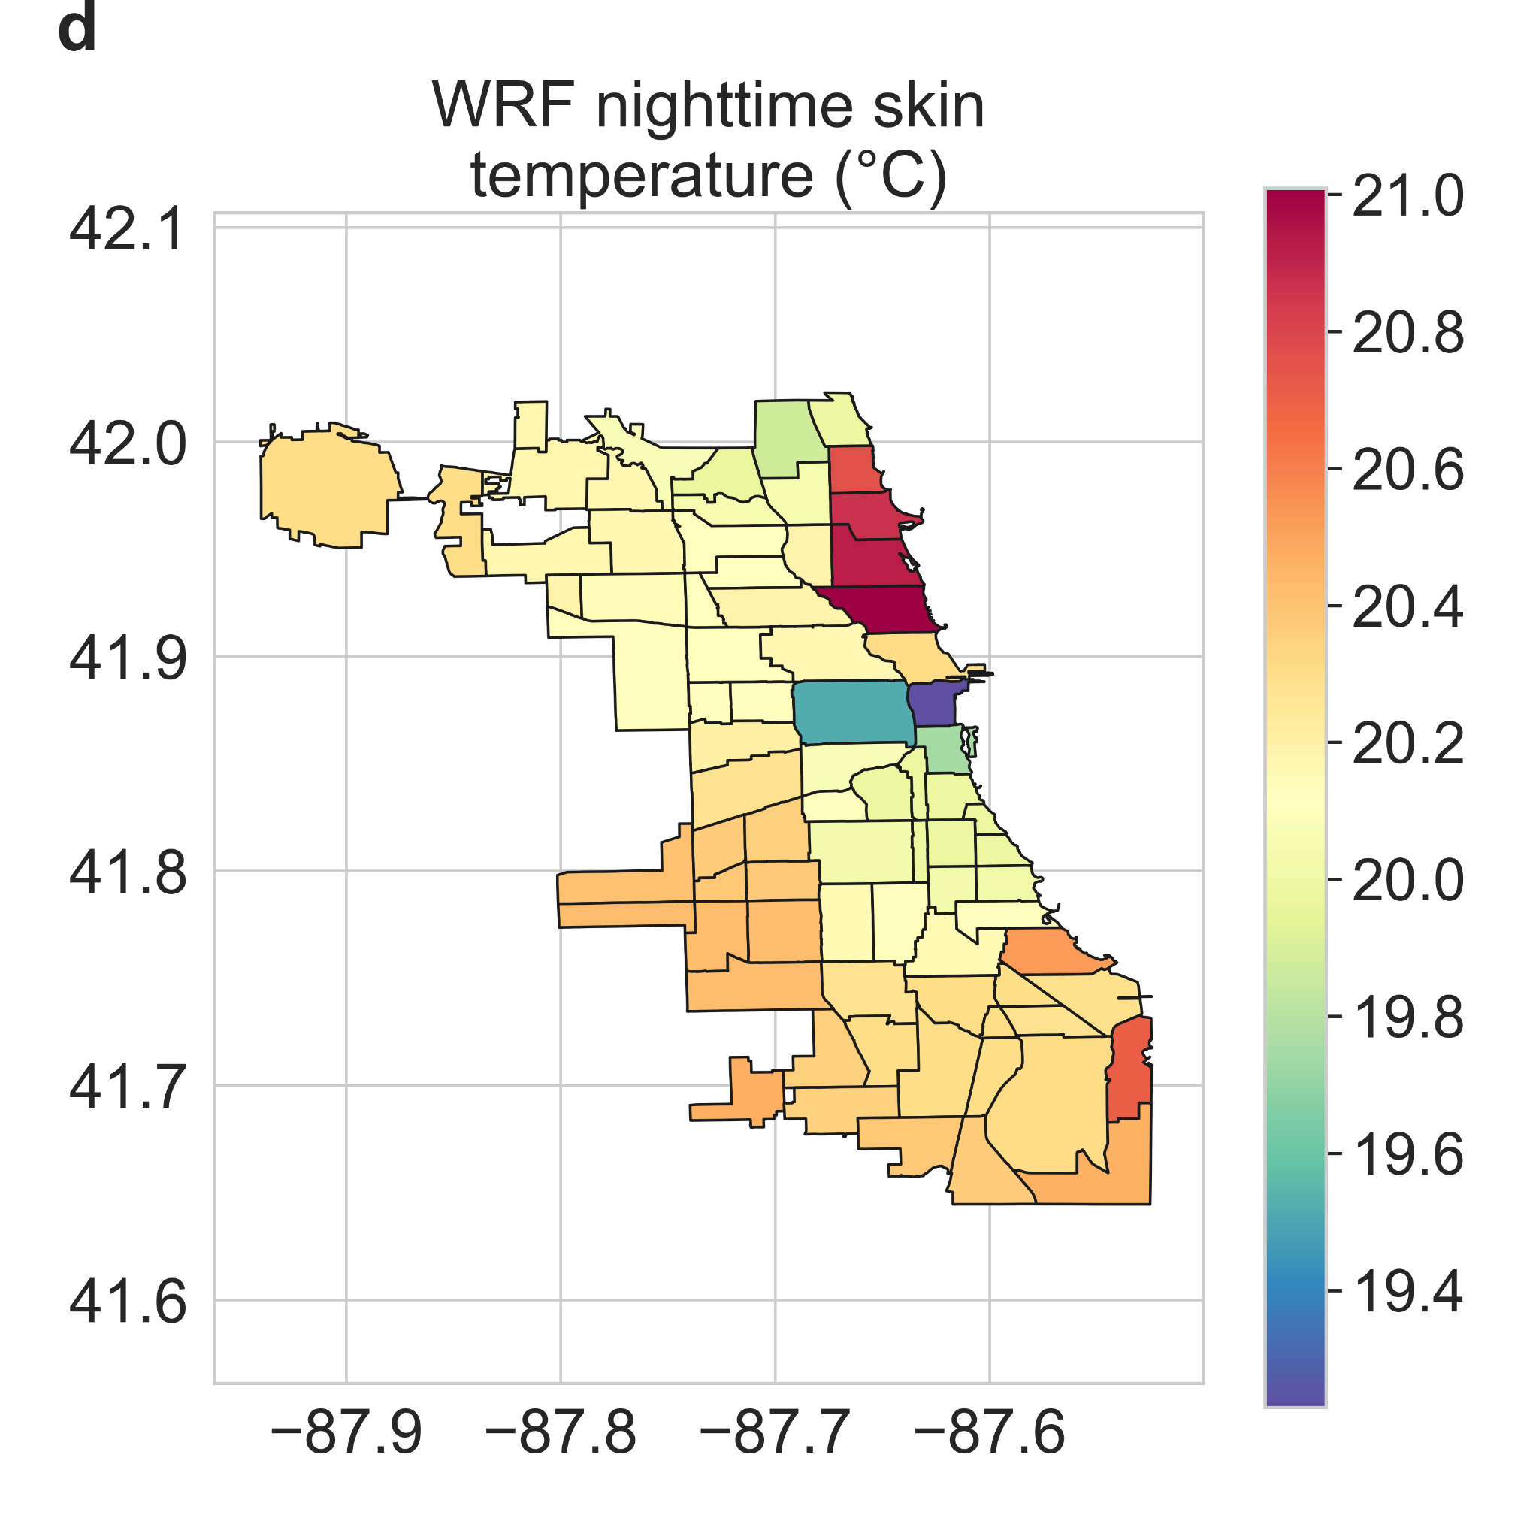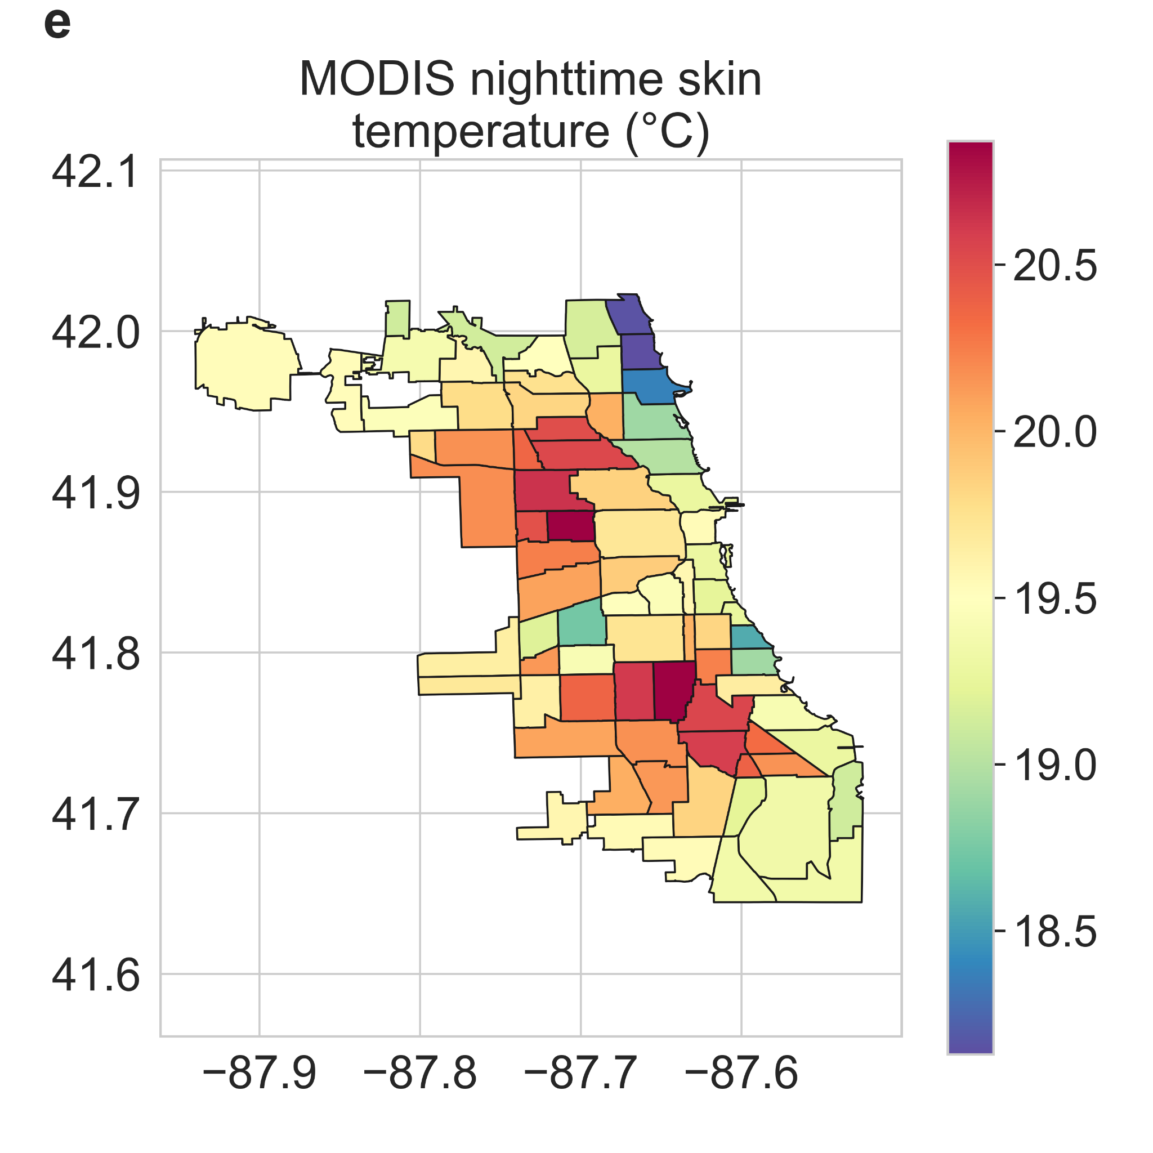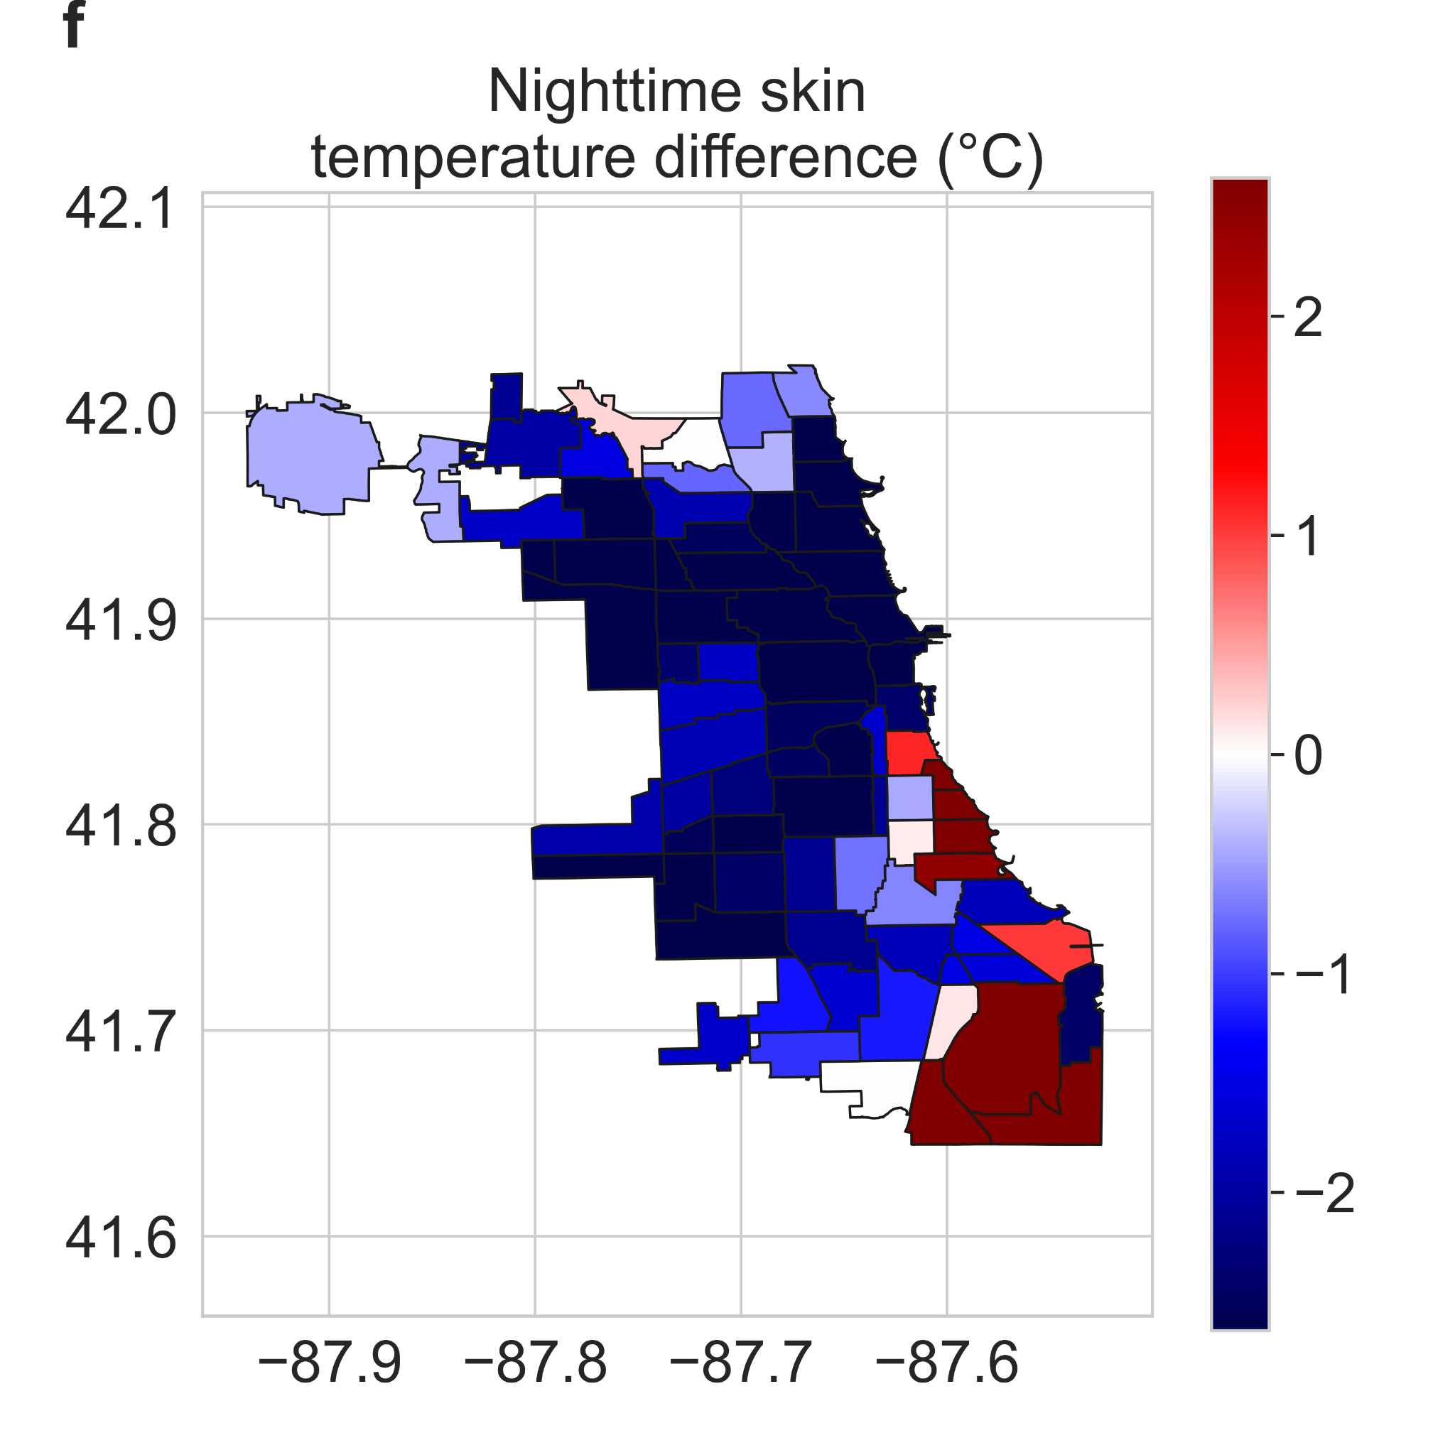Fig S6 | Spatial patterns of satellite-observed versus simulated skin temperature | Neighborhood-scale summaries of WRF simulated skin temperature corresponding to the MODIS Aqua a daytime (~1:30 pm local time) and d nighttime (~1:30 am local time) overpass and the MODIS observed daytime and nighttime skin temperature (b, e, respectively) for summer 2018 in Chicago. c, f Skin temperature differences between WRF and MODIS for the neighborhoods.

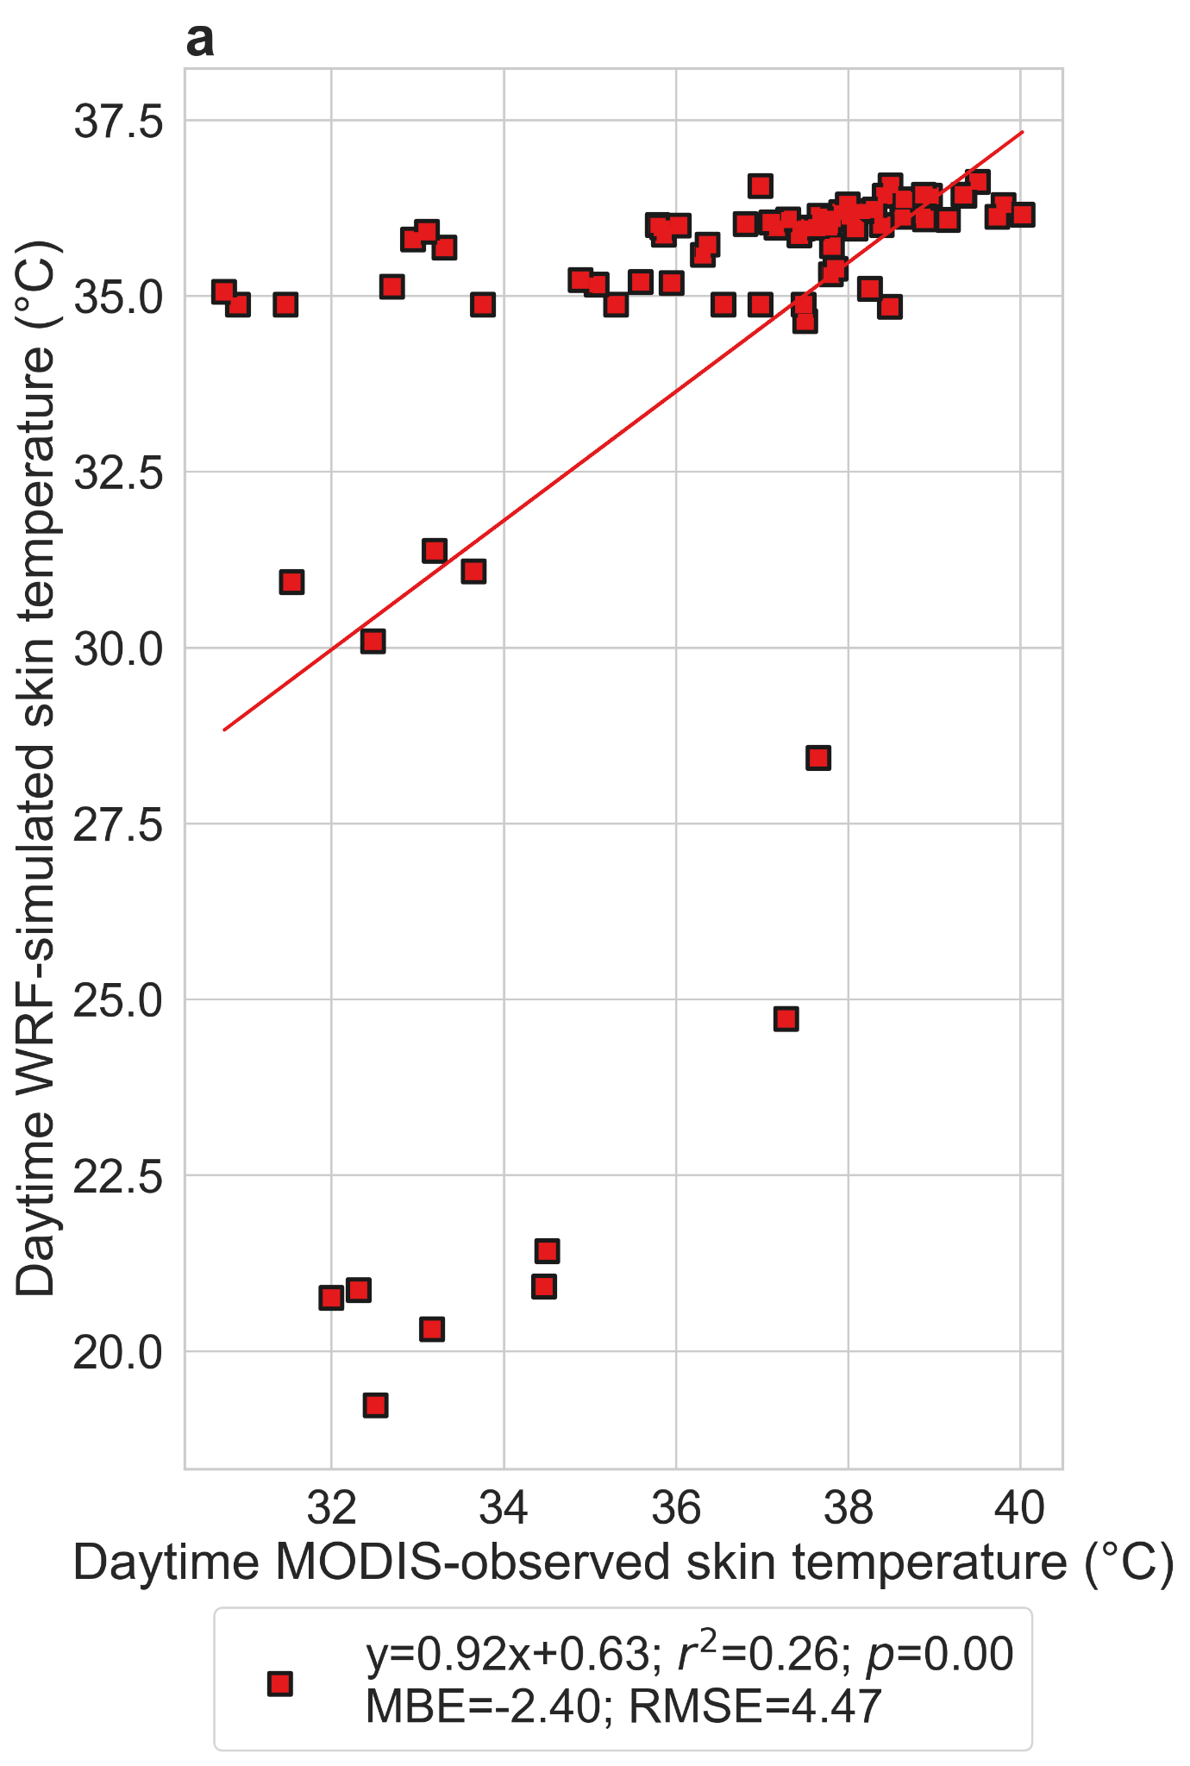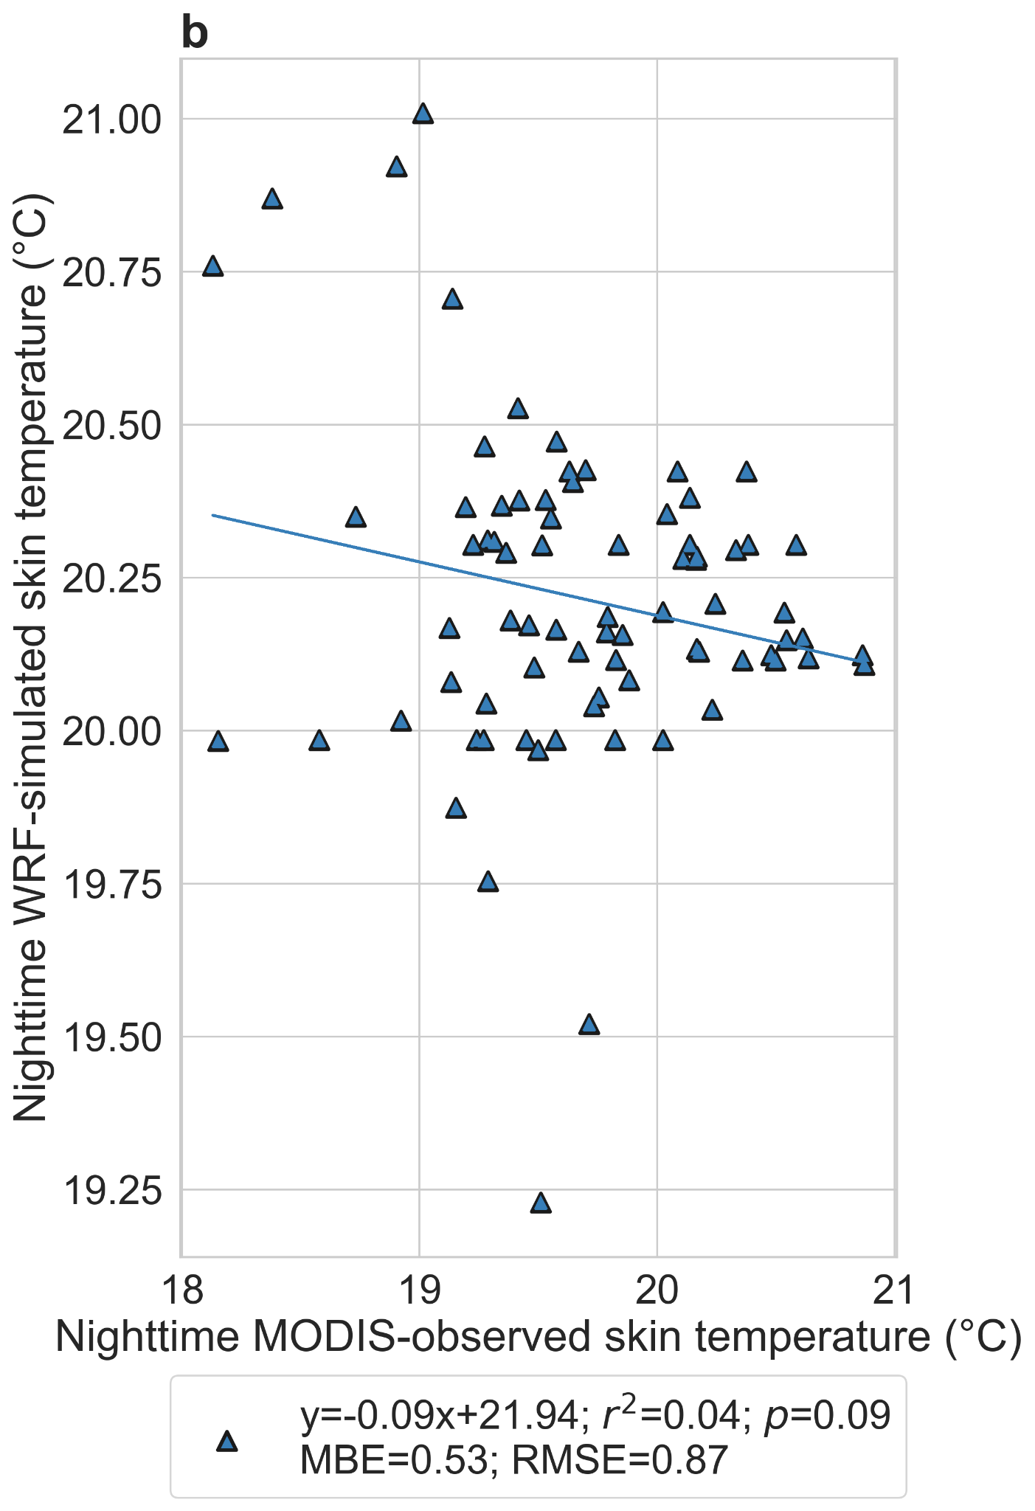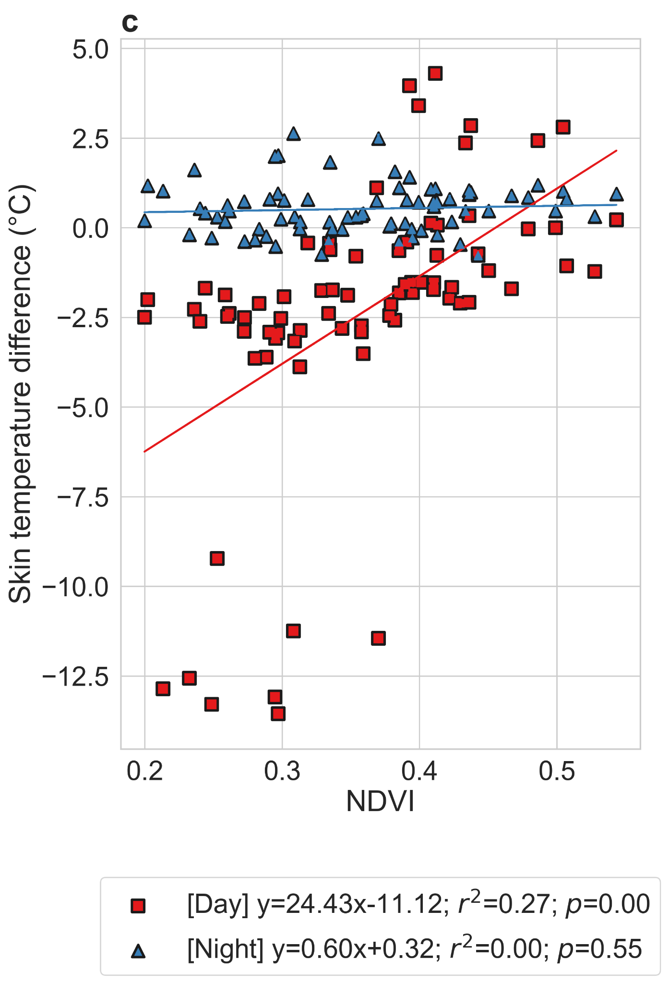
Fig S7 | Evaluating simulated skin temperature against satellite observations | Associations between WRF simulated and MODIS-observed a daytime (~1:30 pm local time) and b minimum (~1:30 am local time) skin temperature in summer 2018 for Chicago neighborhoods. c Difference between WRF and MODIS skin temperatures (daytime and nighttime) as a function of the summertime neighborhood-mean normalized difference vegetation index (NDVI). The points represent the mean values from the five ensemble simulations for the WRF simulations. The lines of best fit are shown and the associated equations, coefficients of determination, and p values are in the legend.

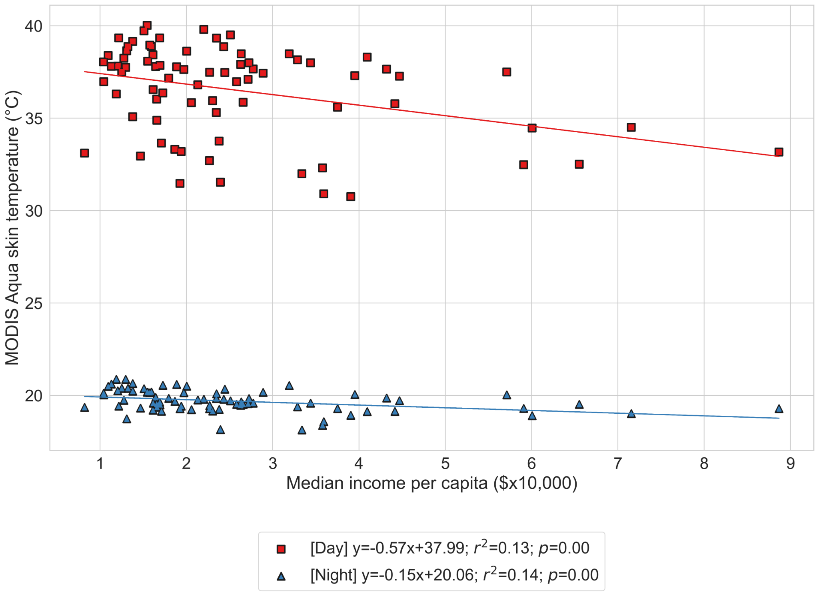
Fig S8 | Satellite-observed skin temperature versus neighborhood income | Associations between MODIS Aqua daytime and nighttime skin temperature for Chicago neighborhoods and the corresponding median income per capita for summer 2018. The lines of best fit are shown and the associated equations, coefficients of determination, and p values are in the legend.

