SUPPLEMENTARY MATERIALS to:
Physics of sliding on water predicts morphological and behavioral allometry in water striders
Woojoo Kim^{1&}, Jae Hong Lee^{2&}, Thai Hong Pham^{3,4}, Anh Duc Tran⁵, Jungmoon Ha¹, Sang Yun Bang¹, Piotr G. Jablonski^{1,6*}, Ho-Young Kim^{2*}, Sang-im Lee^{7*}

¹ Laboratory of Behavioral Ecology and Evolution, School of Biological Sciences, Seoul National University, Korea
² Department of Mechanical Engineering, Seoul National University, Seoul 08826, Korea
³ Mientrung Institute for Scientific Research (MISR), Vietnam Academy of Science and Technology (VAST), 321 Huynh Thuc Khang St, Hue, Vietnam
⁴ Graduate University of Science and Technology, VAST, 18 Hoang Quoc Viet, Cau Giay, Hanoi, Vietnam
⁵ Department of Applied Zoology, Faculty of Biology, University of Science, Vietnam National University, Hanoi, 334 Nguyen Trai, Thanh Xuan, Hanoi, Vietnam
⁶ Behavioral Ecology Group, Museum and Institute of Zoology, Polish Academy of Sciences, Warsaw, Poland
⁷ Laboratory of Integrative Animal Ecology, Department of New Biology, DGIST, Korea

Corresponding Authors:
PGJ: piotrjab@hotmail.com; HYK: hyk@snu.ac.kr, SIL: sangim@dgist.ac.kr
& these authors equally contributed to the work

Supplementary Materials (SM) are logically divided into several sections labeled as SMx, where x stands for the number.

SM1: Literature based view on variation in the “wetted leg geometry” in Gerridae (Fig. S1) 2
SM2: Supplementary Methods - Symbols used in the paper (Table S1) 3
SM3: Supplementary Methods - SM3: Additional mathematical explanations 5
SM4: Supplementary Results - Validation of the model (Fig. S2, S3) 6
SM5: Supplementary Results - Morphology and allometry in study subjects (Fig. S4, Table S1) 7
SM6: Supplementary Results - Comparison of thrust with the resistance (Fig. S5, S6) 8
SM7: Supplementary Results - Movie clip captions and results on body during observed striding (Fig.S7-S11) 9
SM8: Supplementary Results – Behavior of two smaller species (Fig. S12, Table S2-S5) 11
SM9: Supplementary Discussion – Allometry in water striders and preliminary investigation of the effect of body size on the “wetted leg geometry” (Fig. S13) 15

SM1: Literature based view on variation in “wetted leg geometry” in Gerridae
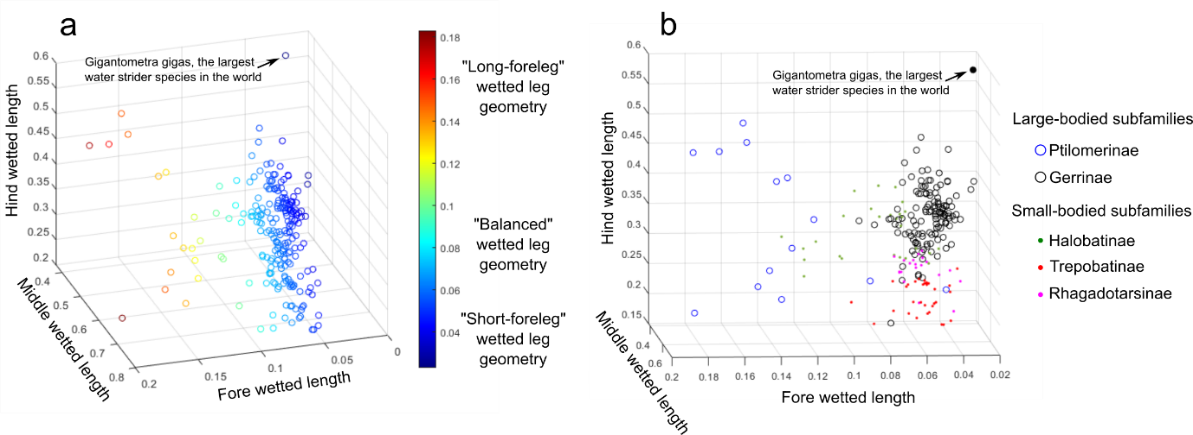
Fig. S1 Distribution of wetted leg geometries among Gerridae. (a) – 3D scattergram of proportions of wetted forelegs, midlegs and hindlegs (3 axes in the plot) in the total wetted leg length with data points color coded to highlight the differences among species in the proportion of wetted forelegs; (b) – 3D scattergram similar to (a) with data points marking different subfamilies (according to Matsuda 1960) and family-typical body size of a water strider (families with the typically larger size species are marked with color-coded unfilled circles and families with the typically smaller size species are marked with color-coded dots. Figure is based on Table 16 in Matsuda 1960. The concept of the “wetted leg geometry” is crucial in our theoretical model. The term refers to the relative proportions of wetted forelegs, wetted midlegs and wetted hindlegs in the total length of the wetted legs. The figure suggests that we can classify species into at least three types of “wetted leg geometry”: the “balanced” or “standard” observed in the frequently studied small and mid-size genera Gerris and Aquarius, (wetted forelegs comprise from ~4 to ~8% of the total wetted legs length), the “long-foreleg geometry” known in the marine small water striders, Halobatinae, and in the medium and large water striders from the subfamily Ptilomerinae (wetted forelegs comprise about 18% of the total wetted legs length), and the “short-foreleg geometry” (wetted forelegs comprise less than ~4% of the total wetted legs length) well documented in at least one large species, G. gigas, (Tseng and Rowe 1999), and present in some larger species of Gerrinae.

SM2: Supplementary Methods - Symbols used in the paper

Table S1 Explanations of the symbols in the model. The lists of symbols used in the mathematical model. The symbols below black solid line used only in supplementary materials. Values used in the model are shown for variables that do not change values among different simulations. The symbols are listed in the order in which they appear in the text.

Explanations of the symbols in the model
$$R$$ | Resistance force on a leg
$$F_{h}$$ | Hydrodynamic drag on a leg
$$F_{w}$$ | Wave drag on a leg
$$F_{s}$$ | Surface tension force on a leg
$$ρ$$ | Density of water, 997 kg/m³
$$U$$ | Velocity of sliding object on the water surface
$$D$$ | Diameter of a wetted leg
$$L$$ | Length of a wetted leg
$$A=πDL/2$$ | Wetted area assumed as a half of curved surface of a cylinder with a length, $L$, and diameter, $D$.
$$ν$$ | Kinematic viscosity of water, 1.003 mm²/s
$$C_{D}=1.328\sqrt{ν/(UL)}$$ | Drag coefficient on the flat plate
$$σ$$ | Surface tension coefficient of water, 0.0728 N/m
$$g$$ | Gravitational acceleration, 9.8 m/s²
$$c={\left(4gσ/ρ\right)}^{1/4}$$ | The theoretical minimum critical velocity of a floating object on the water surface, to produces capillary-gravity
$$N$$ | Normal force on a leg from the water
$${k=\left(k_{x}^{2}+k_{y}^{2}\right)}^{1/2}$$ | Wave number
$$Ψ$$ | Shape of wetted area; the shape of the wetted leg assumed as a line with length $L$ with the longitudinal movement
$$\hat{Ψ}=(1-e^{-iLk_{x}})/{ik}_{x}$$ | Fourier transform of $Ψ$
$$H(x)$$ | The Heaviside function
$$m$$ | Mass of a water strider
$$n$$ | The number of the anterior supporting legs
$$N_{a}$$ | Normal force (perpendicular to the water surface) on an anterior leg: a wetted foreleg for symmetrical sliding; a wetted midleg for asymmetrical sliding
$$N_{p}$$ | Normal force on a posterior leg, i.e., on the wetted hindleg
$$N_{aT}$$ | Normal anterior force on all anterior legs (total normal anterior force)
$R_{a}$ | Resistance force on an anterior leg: a wetted foreleg for symmetrical sliding; a wetted midleg for asymmetrical sliding.
$$R_{p}$$ | Resistance force on a posterior leg, i.e., on the wetted hindleg
$$h$$ | Height; the vertical distance between the center of the mass and the water surface
$$a$$ | Horizontal distance in the parallel axis to the moving direction from the center of the mass to the center of the wetted anterior supporting leg
$$b$$ | Horizontal distance in the parallel axis to the moving direction from the center of the mass to the center of the wetted posterior supporting leg
$$R_{T}$$ | Resistance on all legs (total resistance, $nR_{a}+2R_{p}$)
$$x$$ | Displacement of a water strider by sliding
$$\ddot{x}$$ | Acceleration/deceleration of a water strider
$$L_{a}$$ | A wetted length of all anterior leg(s) (total anterior wetted length)
$$L_{fw}$$ | Length of foreleg wetted length (tarsus)
$$L_{ft}$$ | Length of foreleg tibia
$$L_{ff}$$ | Length of foreleg femur
$$L_{mw}$$ | Length of midleg wetted length (tibia+tarsus)
$$L_{mf}$$ | Length of midleg femur
$$L_{hw}$$ | Length of hindleg wetted length (tibia+tarsus)
$$L_{hf}$$ | Length of hindleg femur
$$D_{hf}$$ | Distance from the head tip to the foreleg attachment
$$D_{hm}$$ | Distance from the head tip to the midleg attachment
$$D_{hh}$$ | Distance from the end tip of the abdomen to the hindleg attachment
$$Bl$$ | Body length
$$θ_{a}$$ | Angle between femur and tibia; tibia and tarsus (both angles were assumed the same) of the foreleg
$$θ_{p}$$ | Angle between body axis and femur; femur and posterior wetted leg (both angles were assumed the same) comprising tibia and tarsus assumed to form one straight section of hindleg
$$φ$$ | Velocity potential
$$B\left(k_{x},k_{y}\right)$$ | Amplitude of the waves of the disturbance
$$t$$ | Time
$$ζ$$ | Vertical displacement of liquid surface
$$P$$ | External pressure
$$δ$$ | The Dirac $δ$ function

SM3: Supplementary Methods - Additional mathematical explanations
(based on a large extent on Raphaël & De Gennes, 1996)-reference nr 45 in the main text

Velocity potential
The velocity potential of the liquid is determined by solving Laplace’s equation:
$$∇^{2}φ=0$$with the boundary condition, $∂φ/∂z→0$ for $z→-∞$. The formula of the velocity potential is
$$φ=\int_{-∞}^{∞}{\int_{-∞}^{∞}{\frac{1}{4π^{2}}B\left(k_{x},k_{y}\right)e^{i(k_{x}\left(x+Ut\right)+k_{y}y)}e^{kz}dk_{x}dk_{y} }}$$where $k={\left(k_{x}^{2}+k_{y}^{2}\right)}^{1/2}$ and $B\left(k_{x},k_{y}\right)$ is the constant. The coordinates at $t=0$ are represented in figure 1(d).
The vertical displacement of liquid surface, $ζ$, is obtained by $∂ζ/∂t={\left(∂φ/∂z\right)}_{z=0}$. The Fourier transform of the vertical displacement of liquid surface, $ζ$, is $\hat{ζ}$ and satisfies the following equation:
$$ζ\left(x, y, t\right)=\int_{-∞}^{∞}{\int_{-∞}^{∞}{\frac{1}{4π^{2}}\hat{ζ}\left(k_{x},k_{y}\right)e^{i(k_{x}\left(x+Ut\right)+k_{y}y)}dk_{x}dk_{y} }}$$Therefore the velocity potential is represented as
$φ=\int_{-∞}^{∞}{\int_{-∞}^{∞}{\frac{1}{4π^{2}}\frac{ik_{x}U}{k} \hat{ζ}\left(k_{x},k_{y}\right)e^{i(k_{x}\left(x+Ut\right)+k_{y}y)}e^{kz}dk_{x}dk_{y} }}$ (S1)
The relationship of $\hat{ζ}$ and $\hat{P}$ is determined from the Navier-Stokes equation and equation (S1):
$\left[ρgk+σk^{3}+ρ{\left(2νk^{2}-ik_{x}U\right)}^{2}-4ρν^{2}k^{3}\sqrt{k^{2}-\frac{ik_{x}U}{ν}}\right]\hat{ζ}=-k\hat{P}$ (S2)where $\hat{P}$ is the Fourier transform of the external pressure, $P\left(x,y\right)=N\left(H\left(x\right)-H\left(x-L\right)\right)δ\left(y\right)/L$ so $\hat{P}=N(1-e^{-iLk_{x}})/{ik}_{x}L$.

Wave drag
The wave drag is the total pressure per unit area of the liquid surface in the x-direction:
$F_{w}=-\int_{-∞}^{∞}{\int_{-∞}^{∞}{P\left(x,y\right)\left(\frac{d}{dx}ζ\left(x,y\right)\right)dxdy}}=-\int_{-∞}^{∞}{\int_{-∞}^{∞}{\frac{ik_{x}\hat{ζ}\hat{P}}{4π^{2}}dk_{x}dk_{y}}}$ (S3)
From equation (S2) and (S3) we obtain the wave drag:
$$F_{w}=R\left\{\int_{-∞}^{∞}{\int_{-∞}^{∞}{\frac{i{\hat{P}}^{2}k_{x}k}{4π^{2}ξ}}dk_{x}dk_{y}}\right\}=\frac{N^{2}}{4π^{2}L^{2}}R\left\{\int_{-∞}^{∞}{\int_{-∞}^{∞}{\frac{i{\left|\hat{Ψ}\right|}^{2}k_{x}k}{ξ}}dk_{x}dk_{y}}\right\}$$

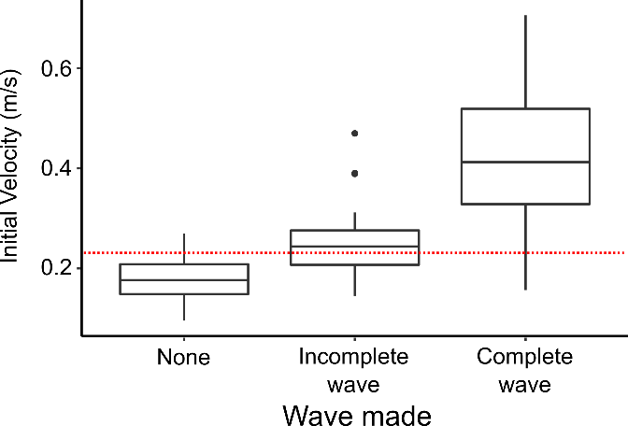
SM4: Supplementary Results - Validation of the model (Fig. S2, S3)
Fig. S2 Empirical validation of the assumptions about velocity that leads to capillary gravity waves that increase resistance. The minimum critical theoretical velocity resulting in capillary gravity waves, $c$, is 0.231 m/s (marked with the red doted horizontal line). Comparison of water strider A. paludum initial sliding velocity among sliding without visible waves, sliding with incomplete/weak waves and sliding with clearly visible waves shows that waves start being noticeable around the velocities similar to the critical velocity.
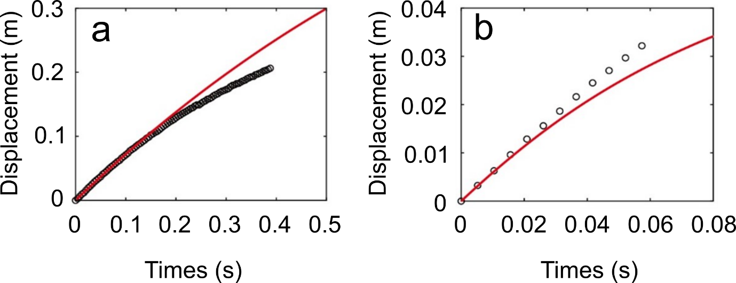
Fig. S3 Validation of the theoretical model accurateness in imitating sliding of larger and smaller species of Gerridae. (a) Empirical displacement of the larger species (G. gigas) sliding asymmetrically. (b) Empirical displacement of the smaller species (A. paludum) sliding symmetrically. The red solid line corresponds to theoretical predictions and the circles correspond to empirical data extracted from two movie clips of sliding.

SM5: Supplementary Results - General morphology and allometry in the study subjects (Fig. S4)
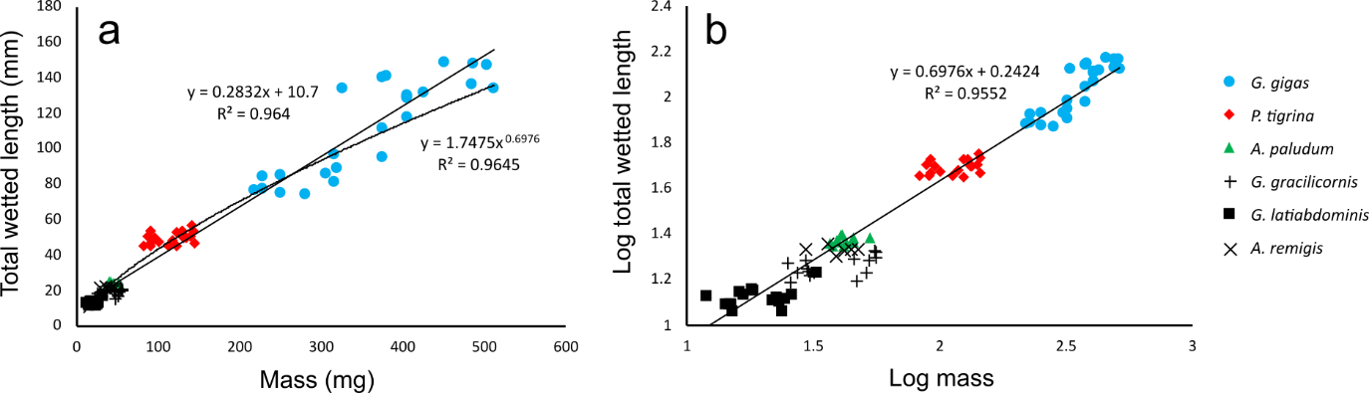
Fig. S4 Relationship between the total wetted length and body mass of the six studied species. Body mass and total wetted length are marked for Gigantometra gigas (blue circles), P. tigrina (red diamonds), Aquarius paludum (green triangles), Gerris gracilicornis (plus signs), G. latiabdominis (black squares), and A. remigis (cross-marks) in normal (a) and log scale (b).

SM6: Supplementary Results - Comparison of thrust with the resistance (Fig. S5, S6)
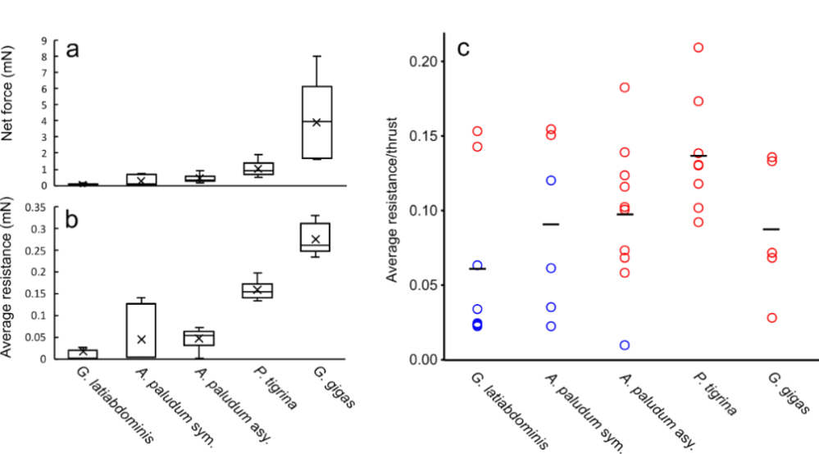
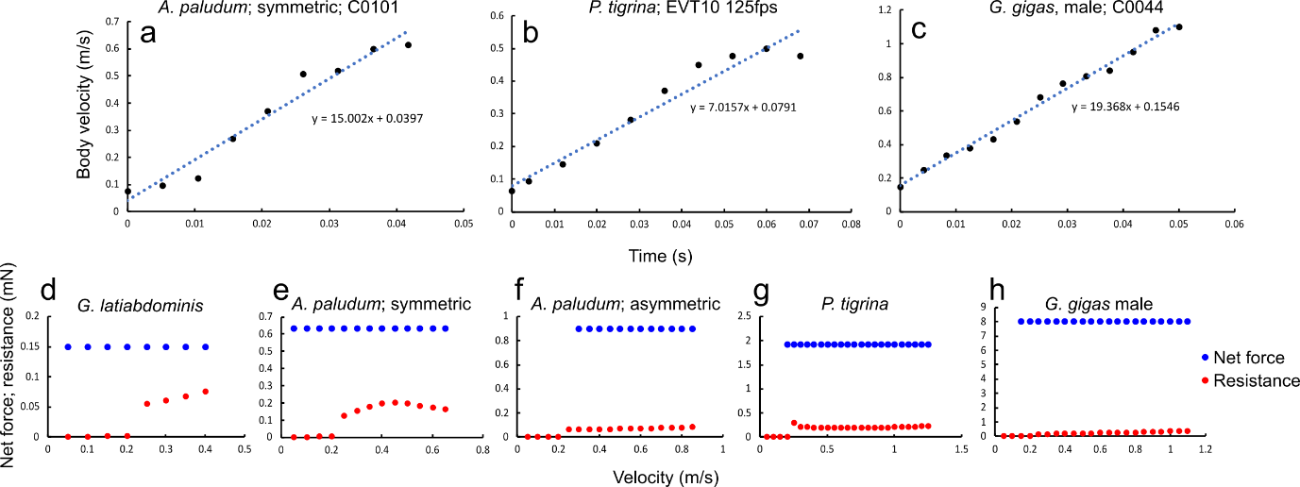
Fig. S5 Three examples of digitized thrusting phase of a stride to explain the method of extracting the thrusting phase acceleration as a slope of a regression line fitted to the data on body velocity versus time for each stride, and five examples of strides for which the net thrust force (based on the acceleration and body mass: $m*a$) and the theoretically predicted resistance force are depicted. (a) – a thrusting phase of a symmetric stride of Aquarius paludum; (b) – a thrusting phase of a symmetric stride of Ptilomera tigrina; (c) – a thrusting phase of an asymmetric stride of Gigantometra gigas male. These estimated accelerations for each stride of an individual of known body mass were used to calculate the thrust net force ($F=ma$) in each stride. Thrusting phase is defined as the duration from the first frame with leg pushing backwards till the frame with maximum body velocity; it varies among species as the range of velocity (m/s) on x-axis in d-h show. (d-h) – examples of force profiles during thrust phase where the empirically evaluated thrust net force (blue dots) and the theoretically predicted resistance (red dots) force (based on empirically measured body velocity profile) are displayed in single strides of Gerris latiabdominis (d; symmetrical stride), A. paludum (symmetrical stride in e and asymmetrical stride in f), P. tigrina (g) and G. gigas (h).

Fig. S6 Empirical net force and theoretical resistance for each species. Comparison of empirically derived (see Fig. S5) the net thrust force (a), which directly contributes to the momentum change of insect body during thrust phase of the striding, the theoretically predicted resistance force (b), which has to be countered by the insect using the thrust. (c) The proportion of the resistance in the total thrust produced by an insect (resistance / (net force +resistance)) in the chosen sets of strides in the four study species: Gerris latiabdominis striding symmetrically (n=8), Aquarius paludum striding symmetrically (n=6), A. paludum striding asymmetrically (n=10), Ptilomera tigrina striding symmetrically (n=8) and Gigantometra gigas striding asymmetrically (n=5). The average values for each species are marked as horizontal lines in (c). Red circles indicate striding at the body velocities that are higher than the theoretical body velocity threshold associated with surface waves (0.2313 m/s).

SM7: Supplementary Results - Movie clip captions and examples of body velocity profiles during observed striding (Fig.S7-S11)

Supplementary Movie 1 – G. latiabdominis striding in the water container; 1-10 s. – symmetric striding, slowed down 16x; 11-17s. – leaping, slowed down 16x.
Supplementary Movie 2 – A. paludum striding in the field and the water container; 1-6 s. – symmetric striding in the field, slowed down 8x; 7-9s. – symmetric striding in the water container, slowed down 8x; 10-17 s. – asymmetric striding in the field, slowed down 8x; 18-21 s. – asymmetric striding in the water container, slowed down 8x; 22-24 s. – leaping in the field, slowed down 8x; 25-28 s. – leaping in the water container, slowed down 8x.
Supplementary Movie 3 – P. tigrina striding in the field; 1-7 s. – symmetric striding in the field, play speed 1x; 8-35 s. – symmetric striding in the field, slowed down 16x.
Supplementary Movie 4 – P. tigrina grooming in the water-flowing container; 1-28 s. – asymmetric striding while grooming in the water-flowing container, slowed down 16x.
Supplementary Movie 5 – G. gigas striding in the field; 1-9 s. – asymmetric striding in the field to stay in one place on the slow current, play speed 1x; 10-25 s. – asymmetric striding in the field, slowed down 4x; 26-34 s. – asymmetric striding in the field, view from above, slowed down 4x.
Supplementary Movie 6 – G. gigas turning in the field; 1-4 s. – turning in the field, slowed down 4x.
Supplementary Movie 7 – C. costalis striding in the field; 1-5 s. – asymmetric striding in the field, play speed 1x; 6-15 s. – asymmetric striding in the field, slowed down 3x.

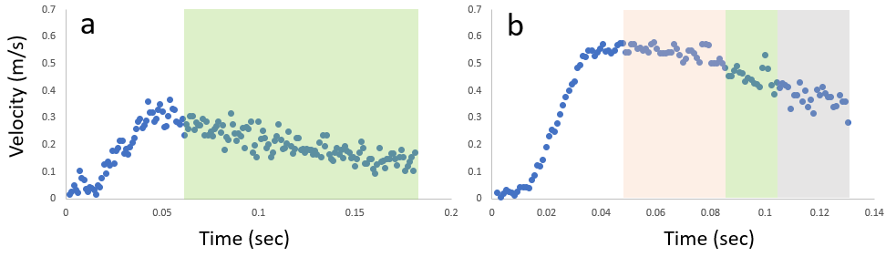

Fig. S7 Symmetric sliding and leaping of G. latiabdominis. Each one of the examples of symmetric sliding (a) and leaping (b) of G. latiabdominis Individual 1 (19.1 mg). Orange, green, and gray shading represent leaping, symmetric sliding, and resting phase, respectively.

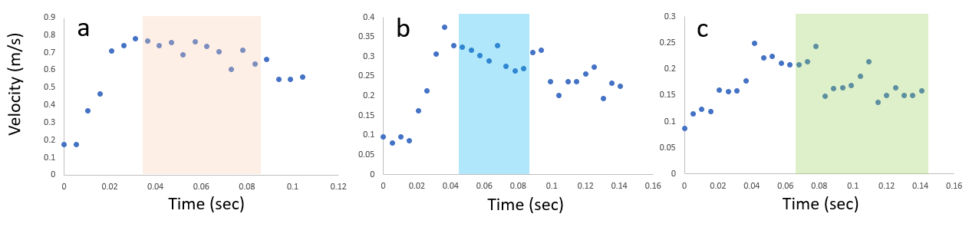
Fig. S8 Symmetric/asymmetric sliding and leaping of A. paludum. Each one of the examples of leaping (a), asymmetric sliding (b), and symmetric sliding (c) of A. paludum Individual 4093 (18 mg). Orange, blue, and green shading represent leaping, asymmetric sliding, and symmetric sliding, respectively.

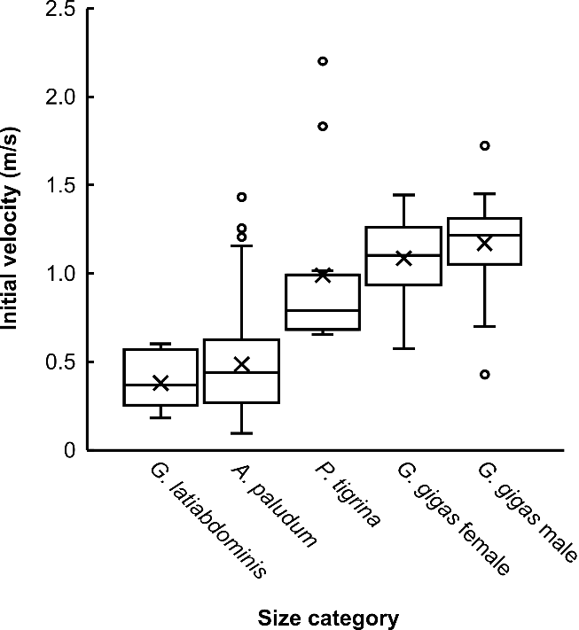
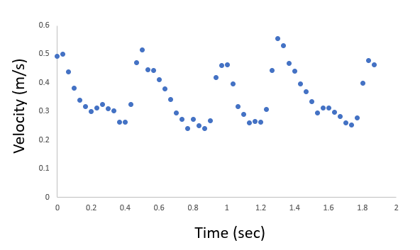
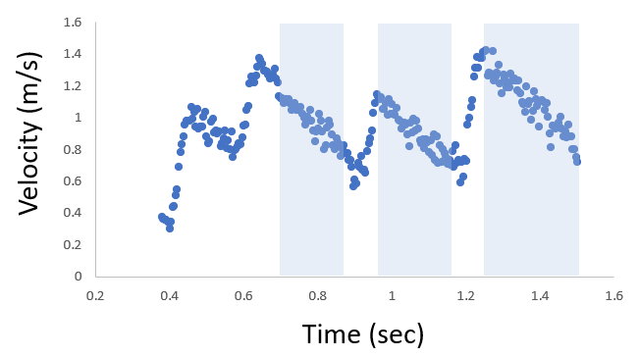
Fig. S11 Box-and-whiskers plot of initial striding velocity five size classes corresponding to five species/sex classes of study subjects: G. latiabdominis (n=13), A. paludum (n=236), P. tigrina (n=12), G. gigas females (n=23), and G. gigas males (n=27). For G. latiabdominis, velocities of symmetrical sliding (n=9) and leaping (n=4) are pooled. For A. paludum, velocities of asymmetrical sliding (n=136), symmetrical sliding (n=68), and leaping (n=32) are pooled. Initial velocity was chosen as a peak velocity before sliding in G. latiabdominis, P. tigrina, and G. gigas (See methods section for A. paludum).
Fig. S9 Series of striding of P. tigrina in the field. Velocity of body center of P. tigrina relative to the water surface by considering water flow speed in the series of striding locomotion.
Fig. S10 Series of striding of G. gigas in the field. Velocity of body center of G. gigas relative to the water surface by considering water flow speed in the series of striding locomotion. Blue shading represents asymmetric sliding.

SM8: Supplementary Results – Behavior of two smaller species (Fig. S12, Table S2-S5)
Table S2 Initial velocity for locomotion type of G. latiabdominis. Results The initial velocities were significantly different between sliding and leaping of G. latiabdominis (Wilcoxon Signed-Rank Test, p-value = 0.029).

Individual | Video | Locomotion | Initial velocity (m/s)
1 | C0030 | Sliding | 0.282334
2 | C0040 | Sliding | 0.373578
3 | C0053 | Sliding | 0.209729
5 | C0069 | Sliding | 0.191976
1 | C0035 | Leaping | 0.574271
2 | C0042 | Leaping | 0.596126
3 | C0057 | Leaping | 0.506352
5 | C0073 | Leaping | 0.390899
Table S3 Linear mixed model of initial velocity and sliding type of A. paludum. Results of the linear mixed model: Velocity ~ (Sliding type) + (1 | Individual) + (1 | Video:Individual), No. of observations: 236, No. of Individuals: 6, No. of random factor (Video:Individual) groups: 100. The reference passive phase type is Asymmetry. Results are shown in Fig. 5a.
 | Estimate | df | t value | Pr(>|t|)
(Intercept) | 0.43565 | 5.40296 | 10.495 | 8.51e-05
Leaping | 0.24132 | 188.12922 | 10.857 | < 2e-16
Symmetry | -0.07078 | 159.28365 | -3.525 | 5.54e-04
Table S4 Generalized mixed model of sliding distance and sliding type of A. paludum. Results of the generalized mixed model: Sliding distance ~ (Sliding type) + (1 | Individual) + (1 | Video:Individual), Family: ("Inverse Gamma"), No. of observations: 228, No. of Individuals: 6, No. of random factor (Video:Individual) groups: 100, Degrees of Freedom for the fit: 48.63265, Residual Deg. of Freedom: 179.3673. The reference passive phase type is Leaping. $E(distance)=sqrt\left(\exp\left(σ^{2}\right)\right)*exp⁡(μ)$. Results are shown in Fig. 5b.
$μ$ coefficient | Estimate | t value | Pr(>|t|)
(Intercept) | 2.72043 | 57.657 | < 2e-16
Asymmetry | 0.23134 | 3.665 | 3.25e-04
Symmetry | -0.38289 | -5.703 | 4.77e-08
$σ$ coefficient | Estimate | t value | Pr(>|t|)
(Intercept) | -0.91275 | -20 | < 2e-16

Table S5 Generalized mixed model of sliding duration and sliding type of A. paludum. Results of the generalized mixed model: Sliding duration ~ (Sliding type) + (1 | Individual) + (1 | Video:Individual), Family: ("Box-Cox-Cole-Green"), No. of observations: 228, No. of Individuals: 6, No. of random factor (Video:Individual) groups: 100, Degrees of Freedom for the fit: 52.71993, Residual Deg. of Freedom: 175.2801. The reference passive phase type is Symmetry. Results are shown in Fig. 5c.
 | Estimate | t value | Pr(>|t|)
(Intercept) | 43.907 | 26.799 | < 2e-16
Asymmetry | 37.615 | 11.913 | < 2e-16
Leaping | -15.615 | -9.218 | < 2e-16

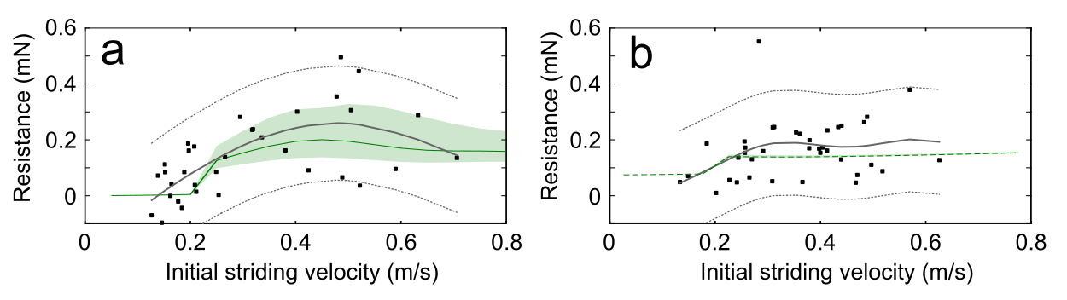
Fig. S12 Resistance for A. paludum’s sliding from mathematical model and from empirical calculations. Results of the model calculation and empirical analysis for symmetric (a) and asymmetric (b) sliding of A. paludum. Theoretical calculations from mathematical model are marked as green line and shadings. Black squares represent empirical data points, the generalized additive models from those data are marked as gray solid line, and 97.5% centiles are also marked with dashed lines. Resistance was calculated from the estimated deceleration (Table S6 on the next two pages) and body mass for each stride. The theoretical predictions in this figure were also used in Fig. 5d of the main text.

Table S6 Deceleration data of the sliding of A. paludum. Sliding events that have enough passive phase duration (50-80 ms) to calculate deceleration were chosen.
Individual | Mass  (mg) | Video | Striding  type | Initial  velocity (m/s) | Sliding/leaping  distance (mm) | Duration  (ms) | Last  velocity (m/s)
4091 | 53 | C0082 | Asy. | 0.283 | 6.432 | 45.879 | 0.077
4091 | 53 | C0076 | Asy. | 0.133 | 7.792 | 60.477 | 0.133
4091 | 53 | C0082 | Asy. | 0.148 | 4.812 | 32.324 | 0.139
4193 | 47 | C0176 | Asy. | 0.257 | 14.146 | 66.733 | 0.143
4193 | 47 | C0162 | Asy. | 0.184 | 10.036 | 64.648 | 0.149
4193 | 47 | C0158 | Asy. | 0.309 | 16.721 | 66.733 | 0.167
4193 | 47 | C0173 | Asy. | 0.201 | 12.991 | 72.99 | 0.176
4192 | 32 | C0144 | Asy. | 0.256 | 11.019 | 45.879 | 0.179
4191 | 40 | C0114 | Asy. | 0.227 | 12.461 | 56.306 | 0.185
4191 | 40 | C0113 | Asy. | 0.291 | 13.867 | 54.221 | 0.191
4193 | 47 | C0158 | Asy. | 0.256 | 16.158 | 71.947 | 0.192
4192 | 32 | C0144 | Asy. | 0.244 | 10.768 | 44.837 | 0.196
4191 | 40 | C0114 | Asy. | 0.312 | 15.115 | 55.264 | 0.197
4193 | 47 | C0153 | Asy. | 0.413 | 23.942 | 68.819 | 0.211
4091 | 53 | C0080 | Asy. | 0.265 | 16.433 | 58.392 | 0.213
4192 | 32 | C0144 | Asy. | 0.361 | 18.669 | 65.691 | 0.225
4193 | 47 | C0149 | Asy. | 0.241 | 17.414 | 68.819 | 0.227
4091 | 53 | C0082 | Asy. | 0.379 | 22.887 | 63.605 | 0.244
4191 | 40 | C0107 | Asy. | 0.269 | 13.093 | 43.794 | 0.245
4191 | 40 | C0107 | Asy. | 0.403 | 25.87 | 71.947 | 0.256
4191 | 40 | C0108 | Asy. | 0.308 | 13.699 | 39.623 | 0.261
4091 | 53 | C0081 | Asy. | 0.353 | 18.556 | 56.306 | 0.264
4191 | 40 | C0105 | Asy. | 0.412 | 19.452 | 46.922 | 0.266
4091 | 53 | C0078 | Asy. | 0.44 | 27.142 | 70.904 | 0.278
4192 | 32 | C0142 | Asy. | 0.47 | 28.366 | 60.477 | 0.287
4191 | 40 | C0106 | Asy. | 0.378 | 17.043 | 43.794 | 0.288
4193 | 47 | C0155 | Asy. | 0.569 | 30.39 | 67.776 | 0.3
4192 | 32 | C0134 | Asy. | 0.397 | 15.897 | 33.367 | 0.303
4191 | 40 | C0111 | Asy. | 0.399 | 25.955 | 62.563 | 0.307
4091 | 53 | C0076 | Asy. | 0.365 | 23.597 | 57.349 | 0.313
4093 | 18 | C0099 | Asy. | 0.496 | 30.037 | 64.648 | 0.316
4193 | 47 | C0153 | Asy. | 0.488 | 28.948 | 64.648 | 0.316
4192 | 32 | C0123 | Asy. | 0.517 | 26.537 | 52.135 | 0.331
4191 | 40 | C0121 | Asy. | 0.439 | 23.082 | 47.965 | 0.348
4091 | 53 | C0078 | Asy. | 0.483 | 23.584 | 46.922 | 0.361
4092 | 47 | C0092 | Asy. | 0.467 | 26.894 | 54.221 | 0.375
4092 | 47 | C0093 | Asy. | 0.433 | 25.654 | 59.434 | 0.387
4093 | 18 | C0099 | Asy. | 0.625 | 34.342 | 59.434 | 0.418
4193 | 47 | C0172 | Sym. | 0.196 | 8.823 | 69.862 | 0.061
4193 | 47 | C0148 | Sym. | 0.138 | 5.533 | 55.264 | 0.082
4193 | 47 | C0158 | Sym. | 0.151 | 7.782 | 51.093 | 0.123
4193 | 47 | C0162 | Sym. | 0.177 | 9.598 | 47.965 | 0.129
4191 | 40 | C0113 | Sym. | 0.207 | 9.132 | 49.007 | 0.134
4192 | 32 | C0134 | Sym. | 0.318 | 13.373 | 57.349 | 0.136
4193 | 47 | C0162 | Sym. | 0.126 | 8.748 | 52.135 | 0.136
4193 | 47 | C0151 | Sym. | 0.164 | 9.241 | 54.221 | 0.15
4193 | 47 | C0162 | Sym. | 0.197 | 8.095 | 38.58 | 0.155
4193 | 47 | C0151 | Sym. | 0.152 | 8.343 | 45.879 | 0.157
4091 | 53 | C0079 | Sym. | 0.145 | 8.076 | 39.623 | 0.157
4193 | 47 | C0149 | Sym. | 0.317 | 14.846 | 58.392 | 0.158
4192 | 32 | C0144 | Sym. | 0.188 | 10.622 | 52.135 | 0.16
4192 | 32 | C0135 | Sym. | 0.253 | 16.521 | 66.733 | 0.161
4093 | 18 | C0095 | Sym. | 0.249 | 14.698 | 69.862 | 0.163
4193 | 47 | C0156 | Sym. | 0.266 | 14.017 | 54.221 | 0.171
4193 | 47 | C0155 | Sym. | 0.208 | 13.218 | 64.648 | 0.174
4191 | 40 | C0120 | Sym. | 0.211 | 8.902 | 34.409 | 0.175
4091 | 53 | C0077 | Sym. | 0.162 | 7.8 | 36.495 | 0.192
4191 | 40 | C0116 | Sym. | 0.184 | 8.439 | 32.324 | 0.207
4193 | 47 | C0149 | Sym. | 0.294 | 16.8 | 64.648 | 0.215
4191 | 40 | C0121 | Sym. | 0.485 | 13.711 | 31.281 | 0.227
4191 | 40 | C0121 | Sym. | 0.403 | 13.998 | 31.281 | 0.246
4192 | 32 | C0126 | Sym. | 0.38 | 18.202 | 42.751 | 0.251
4193 | 47 | C0178 | Sym. | 0.336 | 16.381 | 47.965 | 0.27
4193 | 47 | C0173 | Sym. | 0.519 | 29.176 | 66.733 | 0.274
4193 | 47 | C0178 | Sym. | 0.477 | 24.928 | 56.306 | 0.294
4192 | 32 | C0139 | Sym. | 0.424 | 19.841 | 42.751 | 0.309
4093 | 18 | C0101 | Sym. | 0.488 | 25.563 | 47.965 | 0.348
4193 | 47 | C0176 | Sym. | 0.505 | 26.002 | 52.135 | 0.359
4193 | 47 | C0170 | Sym. | 0.632 | 35.399 | 59.434 | 0.422
4093 | 18 | C0100 | Sym. | 0.521 | 24.456 | 37.538 | 0.456
4092 | 47 | C0092 | Sym. | 0.589 | 30.869 | 45.879 | 0.483
4193 | 47 | C0164 | Sym. | 0.706 | 35.184 | 45.879 | 0.536

SM9: Supplementary Results from the literature of Matsuda 1960 and additional explanation (Fig. S13)
(based on the data from Matsuda, 1960)-reference nr 48 in the main text

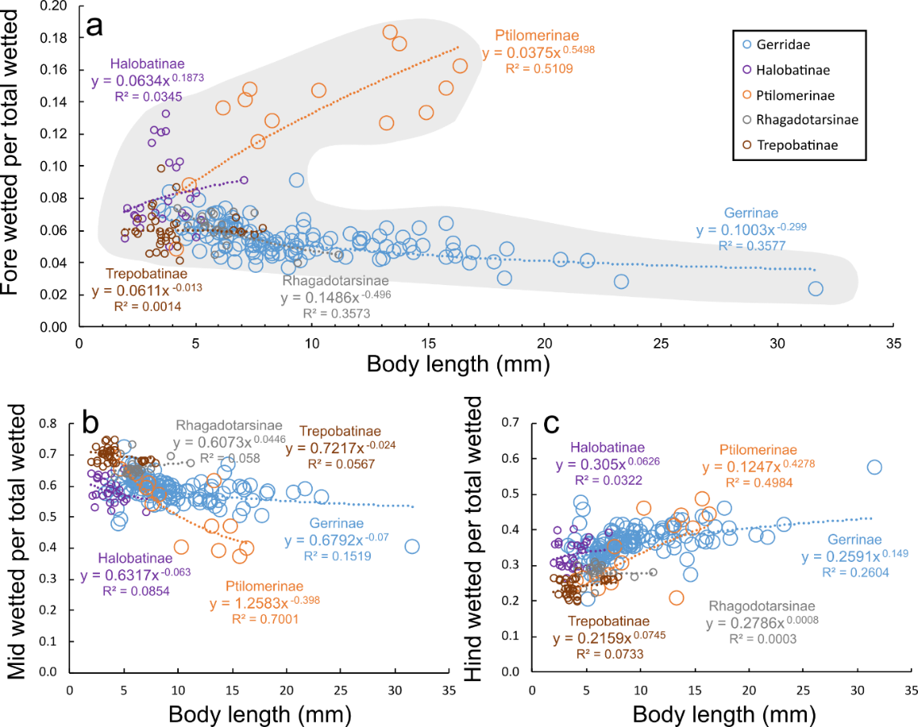
Fig. S13 Relationship between the body length and the “wetted leg geometry”. Relationship between the body length and the proportion of wetted forelegs (a), wetted midlegs (b) and wetted hindlegs (c) in total wetted legs length. The gray shaded area in (a) helps visualizing that with increasing body size the water striders adopt one of two “wetted leg geometries”, either “long-foreleg” or “short-foreleg geometry”. The species are represented by subfamilies: Gerrinae (blue circles), Ptilomerinae (orange circles), Halobatinae (purple circles), Rhagadotarsinae (gray circles), and Trepobatinae (brown circles). The data re from Table 16 in Matsuda 1969, and the subfamilies follow Matsuda 1960, which may be not entirely consistent with the more modern assignments of genera into subfamilies. Additionally, this is phylogenetically un-corrected relationship, and therefore it does not directly represent evolutionary processes shaping the evolutionary changes of leg morphology as a function of evolutionary changes of body size. The equations fitted to the data points for each family separately have the power form following the convention for allometric equations. However, we used body length because of the absence of data for body mass, absence of body width, height or diameter data, and absence of body length – body mass formulas for water striders over such a large body size range. We expect that from among the possible linear measurements of body (width, height, length) the length is relatively more correlated with the body mass (albeit not necessarily in a linear fashion) than are body width or height as they are relatively small and differ among species relatively less than the body length. We decided not to use body length³ (a possible alternative used occasionally in allometry) because of the elongated shape of the water striders.
For the overview of leg geometries in Gerridae of various subfamilies and various body sizes we used data from Table 16 in Matsuda (1960; see also Fig. 6 and Fig. S13 based on the same data). We converted the Matsuda’s units to metric measurement units (mm) using the information provided in Matsuda (1960) after one correction that was necessary to circumvent Matsuda’s apparent mistake. On page 32 Matsuda states the following rules: “In table 16, 82 units are equal to 10 mm. For those values with asterisks, 173.7 units are equal to 10 mm.”. However, we concluded that the correct rule is “10 mm is equal to the 173.7 units of measurements presented in Table 16” for all species listed there (regardless of whether they are marked with asterisk or not) because only this rule gives results that agree with body lengths of several species known to us, and with the body length of G. gigas listed by Matsuda in a different part of his book. Matsuda mentions on page 12 that that body length of G. gigas is 3.19 cm (“Gigantometra gigas (China), male. Length of body: 31.9 mm.”; Fig. 3), which is consistent with the calculation using the “173.7 units” rule but not the” 82 units rule” (predicted body length of G. gigas: 67.08 mm), which according to Matsuda’s erroneous advice is supposed to be applied to G. gigas as it is listed without an asterisk in Table 16. When we tried to convert body length by using the “173.7 units rule” to species without asterisks then the body lengths matched reasonably well with our observed data (e.g., ~31 mm for G. gigas, ~12 mm for A. paludum, ~13-16 mm for Ptilomerinae). Therefore, we used the “173.7 units rule” for data presented in Figures 6 and S13.

